James Turner (2304088)

ACCA4023
Introduction to Web and Database Concepts
Assignment 1 Databases

Contents
Section A 1
Part 1 1
Part 2 2
Part 3 2
Part 4 3
Part 5 3
Part 6 5
Part A 5
Part B 7
Part 7 8
Part A 8
Part B 9
Part 8 9
Part A 9
Part B 10
Section B 11
Part 9 11
Part 10 11

Section A

Part 1

There are many types of users who might access the DBMS for the Costal Tourism Management.
For example, there are the system administrators, whose job is to maintain the health and performance of the DBMS. They will also need to ensure that the data is held securely, and the appropriate steps are taken to avoid data breaches and data loss.
Then there is the marketing team, who need to be able to look at the tourists feedback and data to ensure the most effective marketing strategy is being used. The marketing team also need to access specific demographic data to develop personalised promotions and advertisements.
There is also the tour guides, who will require data on different attractions and landmarks to ensure the best experience for the customers. It would also be helpful to obtain tourist preferences to alter the experience with access to customer feedback.
Finally, there are also the local businesses, who will also need to be able to access the tourists preferences, to personalise their products and services as demand sees fit. They can also use the DBMS for financial reasons, to see what percentage of sales are from the tourists compared to the locals.

Part 2

There are many users who may need to access the CTMS.
Firstly, there are the tourists themselves, who need to be able to easily register and create an account for the CTMS. This will then allow them to look at various vacation packages and see the different itineraries, pricing and availability for each package. The CTMS should also be able to take in secure online bookings, allowing the tourists to choose their dates and number of visitors before doing so. Eventually, after the trip, the tourists should be able to use the CTMS to share reviews/feedback for their package, to help collect data for future trips.
Then, there are the local businesses, who should be able to collaborate and work with Costal Getaways to feature select products or services in the packages. This could include offering promotions or discounts for those with packages; updating information on their products/services; and accessing preferential data to best redesign those products.
There is also the support team, who work to handle requests and questions from the tourists via email/phone. They should be able to provide personalised assistance, from the registration process all the way to reservation and booking. They should be able to access data relating packages to see if anything might work or to let people know if anything has changed.
Lastly, there is the marketing team. They should be able to analyse data on tourist preferences and booking patterns (e.g. booking a hot trip during the colder months), as well as developing marketing strategies based on the data gathered. They should be able to measure the success of the strategies and be able to make changes to specific packages based on feedback and the data gathered.

Part 3

Entities:
- Customer
  - Attributes: CustomerID (Primary Key), FirstName, LastName, Email, PhoneNumber, Country, etc.
- Vacation Packages
  - Attributes: PackageID (Primary Key), PackageName, PackageDescription, PackagePrice, PackageDuration, etc.
- Booking
  - Attributes: BookingID (Primary Key), CustomerID (Foreign Key), PackageID (Foreign Key), BookingDate, etc.
- Reviews
  - Attributes: ReviewID (Primary Key), CustomerID (Foreign Key), PackageID (Foreign Key), CustomerRating, CustomerComment, DateOfPost, etc

Relationships between the entities:

- Customer to booking (One-to-many relationship)
  - A customer can have multiple different bookings, but each booking is specific to that single customer
- Vacation package to booking (One-to-many relationship)
  - A vacation package can have many different bookings from many different people, but a single booking will only be for a single vacation package
- Customer to Reviews (One-to-many relationship)
  - A customer can have many different reviews, but each review can only be for a single customer

Explanation for the entities and attributes
For the customer, I have added the general CustomerID for my primary key, as well as having a space for first name, last name, email and phone number, as a way of contact about the packages/bookings. I have also added a country option, as it will help gather information about habits for different countries,(such as some countries going to warmer places, etc)
For the vacation packages, I have the package ID as a primary key, as well as having the package name, a description of the package, the package price and duration, as these seemed like key information that would be of great importance when deciding a package.
The booking attributes have a booking ID as a primary key, while also taking in a customer ID, as each booking relates to a single customer, and the package ID, so the booking understands what package the customer wants. There is also a booking date attached, so there is no possibility of booking a package after the package has already ended.
I also added a review entity, as it allows the customer to leave reviews and feedback of their experience. This included a review ID as a primary key, as well as having the customer ID and package ID as foreign keys, to understand who wrote the review as well as what package the review was about. There are also rating and comment attributes, as well as a date of posting, as to see if there are any other complaints about that package from that time frame.

Part 4

Here is my Relational Database schema, made using access, it has the tables I would use along with the primary/foreign keys and of course the fields.
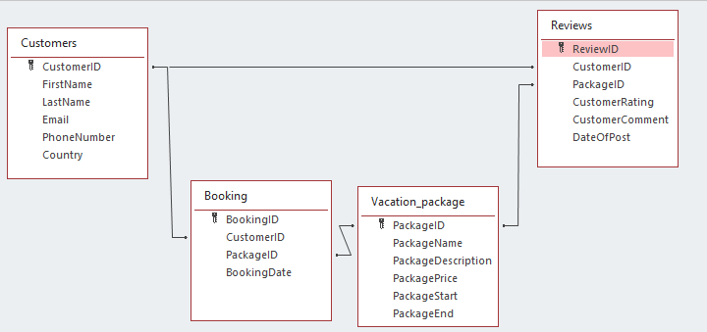

Part 5

This is the design for the customers table. For the phone number I added the following mask as well.
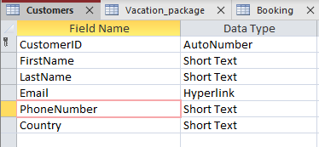
This is because the maximum length for an international phone number is 15 characters, so I have made sure that even those with long phone numbers can still put their phone number down. There is also the country code that is allocated to each phone, and as each country code can go up to 3 digits, there is the possibility to do so.

This is the design for the vacation_package table.
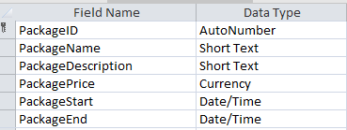
I originally had package duration, but package start and package end seemed more user friendly to work with

This is the design for the booking table. Booking date also has a default value of today’s date, so whenever the booking was created, the current date will be the date listed
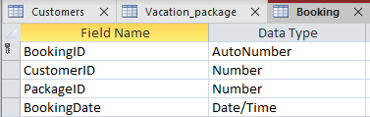

This is the design for the reviews table. It also has the default value =Date() from the previous table included in the dateOfPost attribute.
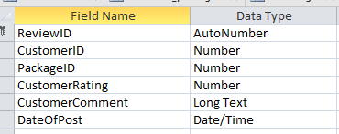

Part 6

Part A

For this question, I decided to use a combination of a form and a query to produce the report. Firstly, I started out with a form that was simply named DateRangeForm. This was to obtain the range of dates that would be included for the total revenue. 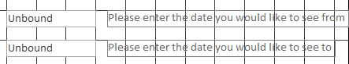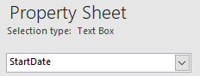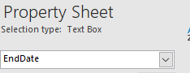
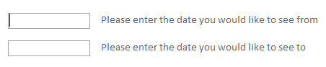
This had a text box to type in the desired start/end date for the time, and added a little label for extra help and usability.
This led into the query aptly named RevenueQuery. This handled managing the different packages and their prices, and would help return a total revenue. I also had a little expression that would get the desired dates from the form and compare them to the dates stored in the database. Between [Forms]![DateRangeForm]![StartDate] And [Forms]![DateRangeForm]![EndDate]. This expression directed access to look at the form DateRangeForm and look at the box named StartDate for the Start date, and looks at the box named EndDate for the end date. It will then grab the values in those dates and will help to organise when something was bought. 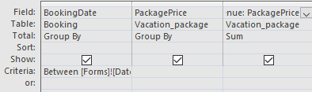
There is also an extra field there called TotalRevenue. This would organise the TotalRevenue per package per day, and return a nice table. Here is an example
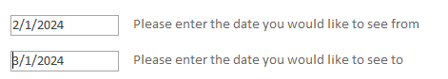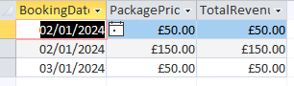

This was the table that was looked at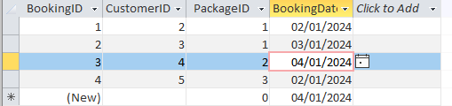
We finally move to the Revenue Report
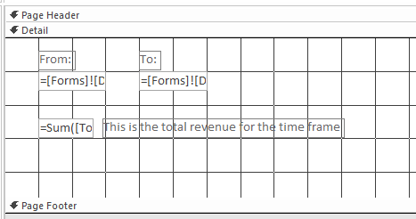
This will grab the StartDate and EndDates from the form, and will also total the TotalRevenue column and produce the total revenue for the specific time period.
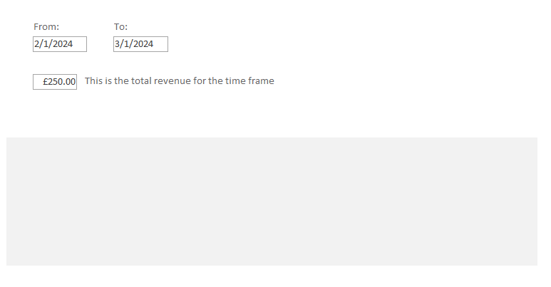
There is an error here, as the background changes, assuming another field of some kind. After doing research on the matter I was unable to fix this.

Part B

I decided to use the same premise as part A, but using just a query, instead of a form as well, as we are looking for all comments and ratings, rather than just a few.
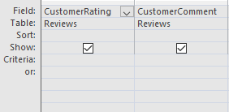
I created a query that would simply take in the customer rating and comment. I then used the Report wizard to create a report that would display the customer rating and if they left any comment.
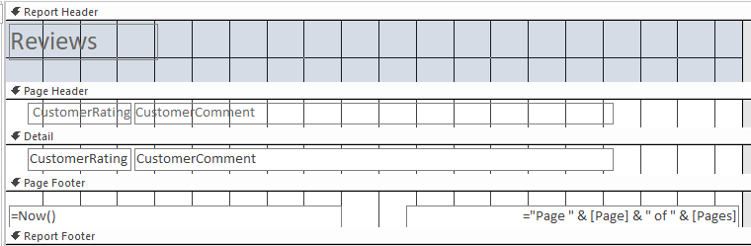
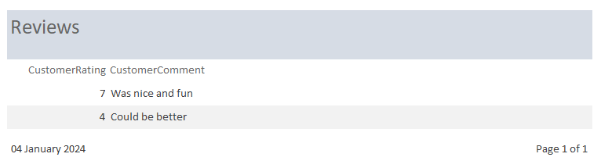

Part 7

Part A

This was the design used as a way for tourists to book a coastal vacation package.
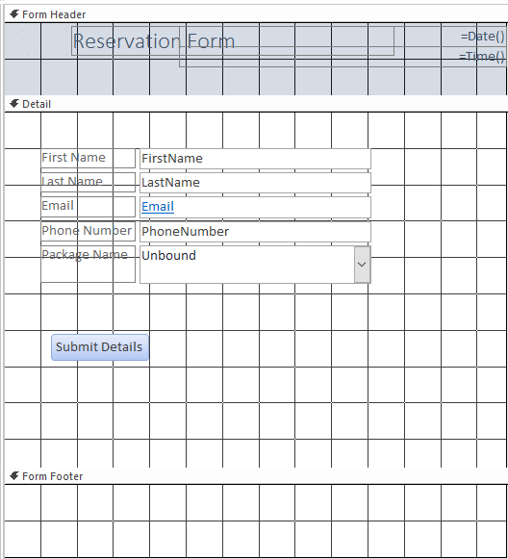
It included text boxes for your name, email address and phone number, along with the package name you desire. The submit details button will then create a new record with that information.
There was a validation rule for the email, and a continuation of the mask from earlier for the phone number.
The validation rule for email was “Is Not Null And ((Like "*?@?*.?*") And (Not Like "*[ ,;]*"))”, obtained from Microsoft’s Support Site. This means that you are required to add an email address, and you must have at least 1 letter before the @sign, after the @sign, and after the period at the end, generally denoting a country/use. This is so that we can ensure that the email address used could be valid, and that the user has not input a generally wrong email address.

Part B

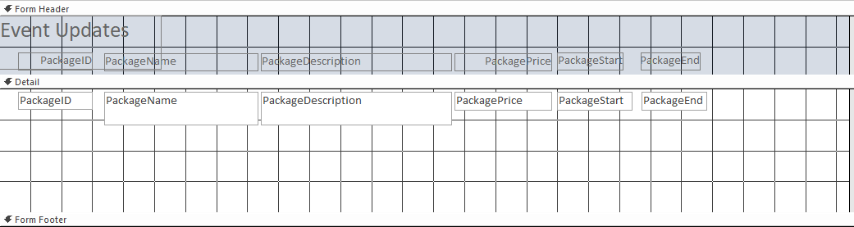
This is a simple form that allows the event owners to change pretty much everything about the event, the name of the event, description, price, start and end, etc.

Part 8

Part A

After searching around on how to make a main menu, I stumbled upon making a menu with a switchboard. A switchboard allows you to take a range of options, such as taking you to a form, creating a new record, running code, etc. I found this useful, and was the basis of my main menu. I created forms for each of my tables, so that I am easily able to click on the switchboard item, and will bring me to directly interact with the table via a form.
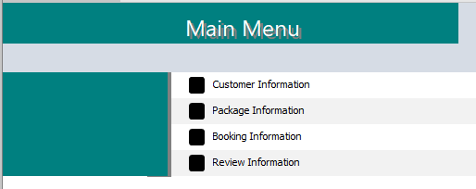
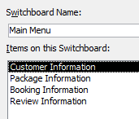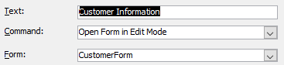
(example)

Part B

Switchboards also come with the ability to open directly upon opening the database, making it extremely useful for finding what you want to interact with. This was achieved by opening the settings and selecting the switchboard for the display form, and that will open the switchboard on open after closing
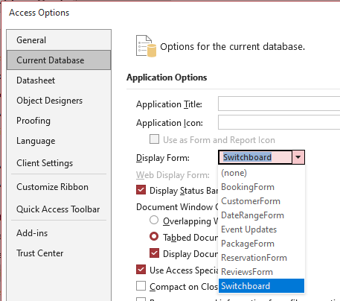

Section B

Part 9

There are many different benefits for developing and using a MS access database for the CTMS. Firstly, it provides data consistency and reduced redundancy as the data is stored in a centralised location. With it being centralised, you can efficiently retrieve necessary data and can use powerful queries to gain valuable information.
MS access can also be used for data analysis, as queries can be used to obtain important information, as well as being able to use SQL. Security is also improved due to the multitude of tools that MS access has access to, ensuring that all customer data is safe.
There is also the benefit of improved communication between teams in the company, as each team can be alerted to changes in the schedule and if any packages are unfortunately cancelled . This can also lead to greater resource management, as the teams on the ground can respond when necessary if a package is overbooked or under booked and staff accordingly.

Part 10

If there was a switch to a computer-based MS access system, there would be a few challenges that would need to be addressed. Firstly, the staff using the current system would have to learn the new system, which could take a long time and training the staff on MS access could be costly in terms of time and money. There is also an additional charge to even create the database, as the system would have to be created and existing data would have to be transferred over.
The DBMS however can help to address these issues. For one, MS access is a very popular tool around the world, and such, many different training programs have already been developed, and various guides and online resources are available to help realise the potential that MS access has. And while the initial setup might be costly, the eventual return on investment from the efficiency of the new DBMS is still something to think about
There are also a few benefits to a computer-based MS access system. Firstly, there is less chance for human-error, as nearly all inputs to the database are done by the database. The customer service experience will also increase, as you have a direct line to the customer, and can have any potential issues or comments previously made up alongside. There is also the ability to back-up the data remotely, which reduces the chances of data loss as well as replacing the database in the event of a fire/natural disaster.
The DBMS helps these benefits by allowing validation rules, which allows only the correct type of data to enter the database, and reduce the risk of errors. Also, the increased amount of data about the customer and the previous messages/calls can greatly increase the ability to resolve issues, which will increase the customer satisfaction rate. Finally, the data backups can not only be done to a remote location, but they can be done automatically, and can be managed to make sure only changed data is backed up over time, reducing the amount of data wasted with repetition.

