How a school develops one aspect of its SDP: a report that critically reflects on the actions, impact and evidence base.

 | Targed/target | Yr hyn yr wyf wedi'i wneud yn yr aseiniad hwn  What I have done in this assignment.
Targed/Target 1 | Ensure that literature is used throughout your assignment to support your assertions. | Literature is used throughout the assignment, with substantial literary support included in all sections
Targed/Target 2 | Try to meaningfully bring in multiple sources of literature, rather than relying on one source to make one point. Synthesising ideas and constructing arguments will enable greater critical engagement. | Multiple sources of literature are used in many paragraphs in the essay in order to attempt a vast improvement with argument synthesis
Targed/Target 3 | Try to establish links between theory and practice. Use literature to back up decisions you make, or compare results with theoretical concepts, etc. | Theory is used to inform why School X has made certain decisions, as well as to inform my reflections and suggestions for improvement.

Introduction
The aim of this study is to examine how a local school has developed an aspect of its school development plan, as well as reflect on the actions the school in question (henceforth referred to as “School X” in accordance with BERA, 2018, guidance) has taken, and impact those actions have had on the school in terms of achieving its targets.
The school critically analysed in this study is a large, English-medium primary school in the Neath Port Talbot locality. In 2019, the school had 474 pupils on role, with 19.6% of these eligible for Free School Meals (FSM) (My Local School, 2019). The school was inspected in 2015 and received an overall score of “Good” from Estyn. Estyn (2015) also stated that the pupils’ wellbeing outcomes were ‘good’, however wellbeing has become an integral part of the new curriculum being introduced in Wales (Welsh Government , 2020). Therefore, importance has been placed on improving the “good” level of wellbeing to an “excellent” level, with School X adopting wellbeing as a development target in the school’s development plan for the academic year 2019-2020.
Literature review
School development planning is an imperative aspect in driving school’s forward in their achievements. This argument is supported by Welsh Government (2014) guidance which states that the purpose of a School Development Plan (SDP) is to “set out the actions a school will take to improve learner outcomes” (p.3). The guidance sets out a clear pathway for schools to follow to undertake this process – self-evaluation, target setting of a short- and longer-term variety, a period of time should pass in order for the school to embed practices, and then a review of the impact should take place. This planning should be cyclic in nature, and the SDP should be a live document, updated regularly throughout the period it covers. This method is supported by early research completed by MacGilchrist and Mortimore (1997) which concluded that a “systematic audit of current strategies and weaknesses is an important element” (p.211), as well as an evaluative process including quantitative and qualitative methodologies is used to “formatively support the implementation” (p.212) of the changes characterised in the SDP. This research also concluded that the more complex and detailed the characteristics of the SDP, the more effective the plan seems to be. However, (Heinrich, 2015) puts forth the argument that SDPs curtail the autonomy of the individual teacher and therefore inhibit progress which they seek to create. Therefore, it is of utmost importance that teachers feel a sense of ownership over their own actions, as the National Foundation for Educational Research (2020) cites teacher autonomy as being highly associated with improved job satisfaction. This has been encouraged by Welsh Government (2019) in “Investing in an excellent workforce”, the national mission for teaching is clear that the teaching profession in Wales should be “outward-looking, and committed to raising the standards within and between schools” (p. 1).

Furthermore, placing importance on health and wellbeing is rapidly becoming an integral part of society today, with Moberly (2018) citing health and wellbeing as the most common reason for doctors taking a break from training, illustrating the long term effects of sub-satisfactory health and wellbeing in adulthood. Moreover, Bonell (2014) provides a further argument for schools prioritising pupils health and wellbeing, stating that students who are in better health mentally and physically achieve better academic attainment, and this links to a variety of other countries practicing integrating a health and wellbeing provision into subject learning or as a stand-alone protected subject such as Finland, Sweden, and Singapore. Incidentally, all of these countries currently rate higher than the United Kingdom on the PISA (Organisation for Economic Co-operation and Development , 2018) performance results. These results provide confirmatory evidence that it is prudent to embed the value of health and wellbeing early in pupils schooling, to enable the pupil to carry this value throughout their lives.

While a consensus view has traditionally pointed to a common-sense approach when deeming wellbeing an important aspect of school life, Vostanis et al (2012) stated that wellbeing interventions in school have predominantly been reactive and not evidence based. However, recently a proactive ethos towards wellbeing has become prevalent, not only on an individual school basis, but also at curriculum level. The current and ongoing educational reform in Wales has mirrored this development, adopting the approach of including health and wellbeing as a designated ‘stand-alone’ subject, rather than being incorporated into Personal and Social Education (PSE) has it had been under the previous ‘Curriculum for Wales’ (Welsh Goverment, 2008).

The new, developing Curriculum for Wales (Welsh Government, 2020) has earmarked ‘Health and Wellbeing’ as one of the six compulsory Areas of Learning and Experience (AoLE) which make up the curriculum. This educational reform was conducted following the results of an independent review of the current curriculum in Wales, completed by Donaldson (2015). Through research collated by Donaldson (2015) in his seminal review, he noted that children and young people would value a curriculum which had an emphasis on “general social competences (life skills and personal confidence) [and] personal and social education (PSE)” (p.17). Consequently, as a result of these findings, it seems prudent that schools in Wales should take an embracing view towards incorporating health and wellbeing into their daily school life ahead of the mandatory implementation of the ‘Health and Wellbeing’ AoLE as part of the new ‘Curriculum For Wales’ (Welsh Government, 2020), heavily complying with the Wellbeing of Future Generations Act (Welsh Government, 2015). This law ensures that public sector bodies, such as schools, have a duty of care to ensure future generations have a good quality of life, and sets forth a “wellbeing duty” and seven “wellbeing goals”. Such a law propels the importance of wellbeing to the forefront of school-based priorities, therefore it is understandable that School X chose this everchanging and developing action point, to further the wellbeing of its pupils, an admiral and governmentally encouraged goal.
Developing an action point
Drawing on the research explored above, School X has implemented the following target in its most recent SDP covering the academic year 2019-2020: “To continue to improve the emotional wellbeing of all our pupils including the most vulnerable pupils” (a redacted example of the SDP in question including the current target being discussed can be found in Appendix A; School X, 2019).
The SDP follows the guidance of Welsh Government (2014) mentioned above, and sets out what success will look like after two and three years, as well as setting out actions, aims for when these will be completed, the lead staff member who will take the action point forward, and detailing the positive impact that these actions will have on the school, its staff and pupils.
As part of a self-evaluation period recommended by Welsh Government (2014), questionnaires are completed by parents and pupils annually, during the summer term, in order to collate the results and put forward appropriate targets for the next academic year. However, as mentioned these targets will have incremental improvements across two and three years ahead of the present academic year. From this exercise, School X identified a number of development areas under the umbrella of the above target, one of which this report will focus on.
The action point that is being critically analysed here is as follows:
“Wellbeing Working Party to audit current provision and identify areas for development regarding the new curriculum. Research and review the most effective way to develop wellbeing for all providing a bank of ideas/resources. For example, every class to have an emotional check in, each area to have a calm down” (School X, 2019; Appendix B)
A strategic plan relating to this action point, which can also be seen as part of the SDP in Appendix B, was put into place by the Wellbeing Working Party. This included creating a separate action plan to be shared with staff, governors, parents and pupils, ensuring the creation of check in areas (duplicated on the SDP from above), ensuring “most pupils will be able to express their feelings to adults in school” and “lowering behavioural issues caused by trauma/emotional distress by 20%”.
This overarching action point, and the subsequent action points taken from the strategic plan will be discussed further. Foremost, the actions clearly link with the implementation of the new Curriculum for Wales (Welsh Government, 2020), it states explicitly that this is the case, indicating how the new curriculum is being positively embraced by School X.
It was observed during time spent attending School X that three of the action points allocated to the Wellbeing Working Party had been completed. Firstly, the Wellbeing Working Party had begun an audit into the areas that were in need of development, but as these were, as per the statement in the SDP, to be compiled in a separate action list, these actions did not appear to become part of the overall SDP and were not disseminated widely, at this time, as a result. However, it was understood that the Wellbeing Working Party were still engaged in the cyclical method encouraged when constructing action plans in Welsh Government (2014) guidance.
Secondly, a ‘calm down area’ was created in all classrooms, and was used very effectively, becoming an essential part of the classroom for some pupils who often became over-stimulated and distressed. These areas were usually adapted from walk-in cupboards, utilising communal spaces around the school, or a small corner of the classroom if none of these were available. McAllister and Maguire (2012) concluded from their research into inclusive classrooms, particularly for pupils with Autism Spectrum Disorders (ASD) that a “quiet room” (described similarly to the calm down areas in School X) as part of a classroom can be “essential” to allow pupils to “recharge their batteries if getting tired or … calm down if distressed” (p. 109). To conclude, this aspect of the SDP appears to be embedded in sound research and has been executed well at School X during the expected timeframe.
Thirdly, an emotional check-in had been placed in each classroom during the Autumn term. These were essentially a way that pupils were encouraged to self-assess their own emotions, aiming to improve ‘emotional literacy’. Emotional literacy has been defined as “the ability to perceive accurately, appraise and express emotion… and the ability to regulate emotions to promote emotional and intellectual growth” (Salovey & Sluyter, 1997, p. 10), and Roffey (2008) poses a link was found between emotional literacy, teachers valuing students emotions and putting this at the centre of a school ethos in improving pupil wellbeing. Therefore, improving emotional literacy is of clear benefit to School X.
In this instance, an identifier was used (such as a peg with a pupil’s name on, an example can be found in Appendix C) by the pupil who was encouraged to choose from a variety of emotions displayed on the board in front of them. However, it was observed first-hand that in practice, this was rarely used, especially in foundation phase classrooms. Contrastingly to research discussed previously, it seems far-fetched to imagine that pupils of foundation phase ages would be emotionally literate enough to complete this action to a correct standard as Sharpe (2001) states that this needs to be learnt and nurtured, as this is not an innate skill we are born with. Therefore, to expect pupils to identify emotions they are feeling, describe it using just one pre-set emotion of “happy”, “sad” or “angry” when they walk through the school door seems reductionist in its approach at best. Furthermore, pupils who are in fact feeling distress such as anxiety are believed to be predisposed to emotion dysregulation (Carthy, et al., 2010). Therefore, overall this action, which has been implemented at School X, may not have been as successful as School X hoped it would have been.
In relation to the latter points included in the strategic plan above, “most pupils will be able to express their feelings to adults in school” and “lowering behavioural issues caused by trauma/emotional distress by 20%” (School X, 2019), no evidence was seemingly collated on the prevalence of these issues. There was also no evidence of how the relationship between emotional distress and behavioural issues was being measured, such as using an accepted wellbeing scale, Heubner’s Student Life Satisfaction Scale (SLSS; as cited in Public Health England, 2015) for example, in addition to keeping stringent record of daily behaviour problems. These are important points that merit further discussion in the evaluation of the actions undertaken by School X.
Reflection and evaluation
Overall, the implementation of the SDP action points discussed demonstrate the positive intentions of School X. The school’s goal to develop pupils’ wellbeing is one that has been echoed from Welsh Government and actively encouraged in the new curriculum, as well as the new designated AoLE (Welsh Government, 2020). However, in spite of the positive intentions observed, there are a number of key issues that need to be addressed when evaluating the effectiveness of the implementation of the above action points.
In relation to the fourth action point, no evidence was observed that a method was in place to measure which pupils are currently unable to express their emotions to staff members. There is a lack of research conducted to conclude wellbeing issues in the school are of a result of pupils not being able to reach out to staff members, however some research
(Benard, 2001; Libbey, 2004; Cunningham, 2007) has cited ‘school connectiveness’ as being beneficial for pupil wellbeing. Perhaps an action encouraging communication between all school members, including between pupils as well as staff members, could be developed with beneficial results.
Furthermore, it is unclear where the arbitrary number that is provided of “lowering behavioural issued caused by trauma/emotional distress by 20%” (Appendix B; School X, 2019) has come from. From the SDP provided, and observations conducted at School X, no evidence was observed as to whether every behavioural issue is recorded and collated, in order to effectively assess whether these actions have actually obtained the desired effect of lowering behaviour by 20%. Without this data, the figure of 20% serves no purpose when developing an action point linked to wellbeing. Moreover, Welsh Government (2012) cited five models for potentially understanding a pupil’s behaviour; “biological, behavioural, cognitive, systemic and psychodynamic” (p.5) , and none of these explicitly state that behavioural issues are likely to be related to these two factors. In fact these models give many factors which could be affecting a pupil’s behaviour, to cite just two such reasons in the SDP seems, again, reductionist.
Further to the foregoing discussion, the data is also not available as to where pupils feel they are placed on a scale of wellbeing, in order to evaluate whether all of these actions have been effective or not. School X could have employed a test-retest method at the beginning and end of the year to observe whether these actions have made a substantive difference to the wellbeing of the pupils of School X. Marsh et al (2020) has successfully used the test-retest method recently to develop tools used to measure wellbeing. As mentioned, School X could employ this method as well as using Heubner’s SLSS (as cited in Public Health England, 2015) or adapting their own scale to ask questions which relate to the specific interventions undertaken. The SLSS is cited as being suitable for pupils over 7 years of age, and therefore would be able to provide an indication of the pupils’ wellbeing before the actions were undertaken and afterwards. This would then be able to demonstrate a positive correlation between the two, however a further scale would need to be considered or developed for foundation phase age children.
Conclusion
In conclusion, while School X has arguably a well-intentioned and beneficial overall goal “to continue to improve the emotional wellbeing of all our pupils including the most vulnerable pupils” (School X, 2019), there is limited substantiated evidence as to whether the pupils’ emotional wellbeing is being improved as a result of the actions which School X is taking.
The recommendations put forth would encourage data collation which could regularly be reported to stakeholders, such as parents and governors as well as pupils. This would ensure that School X is performing to the expected standard of the Wellbeing of Future Generations Act (Welsh Government, 2015), the ‘National Mission’ as set out by Welsh Government (2017), and implementing the recommendations for essential inclusion of pupil voice (Welsh Government, 2016).

Word count – 2745

Reference list

Benard, B. (2001) Fostering resiliency in kids. Educational Leadership, 67(2), pp. 44-48.

Bonell, C. (2014) Why schools should promote students' health and wellbeing. British Medical Journal, 13 May, Volume 348, p. 3078.

British Educational Research Association [BERA] (2018) Ethical Guidelines for Educational Research. 4th Edition ed. London: BERA.

Carthy, T., Horesh, N., Apter, A. & Gross, J. (2010) Patterns of Emotional Reactivity and Regulation in Children with Anxiety Disorders. Journal of Psychopathology and Behavioral Assessment volume, Volume 32, pp. 23-36.

Cunningham, N. (2007) Level of bonding to school and perception of the school environment by bullies, victims and bully victims. Journal of Early Adolescence, 27(4), pp. 457-478.

Donaldson, G. (2015) Successful futures: review of curriculum and assessment arrangements. [Online] Available at: https://gov.wales/successful-futures-review-curriculum-and-assessment-arrangements [Accessed 02 April 2020].

Estyn (2015) A report on Crynallt Primary School. [Online] Available at: https://www.estyn.gov.wales/sites/www.estyn.gov.wales/files/documents/Crynallt%20Primary_0.pdf [Accessed 25 March 2020].

Heinrich, M. (2015) Metamorphoses of pedagogical autonomy in German school reforms: continuities, discontinuities and synchronicities illustrated by empirical studies on school development planning, school profiling and school inspection. Nordic Journal of Studies in Educational Policy, Volume 2, pp. 51-62.

Libbey, H. (2004) Measuring student relationships to school: Attachment, bonding, connectedness and engagement. Journal of School Health , 74(7), pp. 274-283.

Maguire, K. & McAllister, B. (2012) Design considerations for the autism spectrum disorder-friendly Key Stage 1 classroom. Support for Learning, 27(3), p. 103–113.

Marsh, H., Huppert, F., Donald, J., Horwood, M. & Sahdra, B. (2020). The well-being profile (WB-Pro): Creating a theoretically based multidimensional measure of well-being to advance theory, research, policy, and practice.. Psychological Assessment, 32(3), pp. 294-314.

Moberly, T. (2018) Health and wellbeing is the most common reason for doctors to take a break from training. The British Medical Journal , Volume 362, p. 3097.

Mortimore, B. & MacGilchrist, P. (1997) The Impact of School Development Plans in Primary Schools. School Effectiveness and School Improvement, 8(2), pp. 198-218.

My Local School (2019) Crynallt Primary School. [Online] Available at: http://mylocalschool.gov.wales/School/6712236?lang=en [Accessed 25 March 2020].

National Foundation for Educational Research (2020) Teacher autonomy: how does it relate to job satisfaction and retention?. [Online] Available at: https://www.nfer.ac.uk/teacher-autonomy-how-does-it-relate-to-job-satisfaction-and-retention/ [Accessed 10 April 2020].

Organisation for Economic Co-operation and Development (2018) PISA 2018 Results. [Online] Available at: https://www.oecd.org/pisa/PISA-results_ENGLISH.png [Accessed 31 March 2020].

Public Health England (2015) Measuring Mental Wellbeing in Children and Young People, an Indicator Guide. [Online] Available at: https://assets.publishing.service.gov.uk/government/uploads/system/uploads/attachment_data/file/612109/Measuring_mental_wellbeing_in_children_and_young_people_technical_appendix.pdf [Accessed 10 April 2020].

Roffey, S.(2008) Emotional literacy and the ecology of school wellbeing. Educational and Child Psychology, 25(2), pp. 29-39.

Salovey, P. & Sluyter, D. (1997) Emotional development and emotional intelligence: Educational implications. New York: Basic Books.

School X (2019) School Development Plan.

Sharpe, P. (2001) Nurturing Emotional Literacy. 1st Edition. London: Routledge.

Vostanis, P., Humphrey, N., Fitzgerald, N., Deighton, J. & Wolpert, M. (2012) How do schools promote emotional well‐being among their pupils? Findings from a national scoping survey of mental health provision in English schools. Child and Adolescent Mental Health, 18(3), pp. 151-157.

Welsh Goverment (2008) Personal and social education framework for 7 to 19-year-olds in Wales. [Online] Available at: https://hwb.gov.wales/curriculum-for-wales-2008/key-stages-2-to-4/personal-and-social-education-framework-for-7-to-19-year-olds-in-wales/ [Accessed 02 April 2020].

Welsh Government (2012) Practical approaches to behaviour management in the classroom. [Online] Available at: https://gov.wales/sites/default/files/publications/2018-12/practical-approaches-to-behaviour-management-in-the-classroom-a-handbook-for-classroom-teachers-in-primary-schools.pdf [Accessed 01 April 2020].

Welsh Government (2020) Curriculum for Wales Health and Wellbeing. [Online]
Available at: https://hwb.gov.wales/curriculum-for-wales/health-and-well-being/
[Accessed 02 April 2020].

Welsh Government (2014) School Development Plans. [Online]
Available at: https://gov.wales/sites/default/files/publications/2018-03/school-development-plans.pdf [Accessed 31 March 2020].

Welsh Government (2015) Well-being of Future Generations (Wales) Act. [Online]
Available at: https://futuregenerations.wales/wp-content/uploads/2017/01/WFGAct-English.pdf [Accessed 01 April 2020].

Welsh Government (2016) Children and Young People’s Participation in Wales ... Good Practice 2016. [Online] Available at: https://gov.wales/sites/default/files/publications/2019-06/good-practice-guide.pdf [Accessed 03 April 2020].

Welsh Government (2017) Education in Wales: Our National Mission. [Online]
Available at: https://gov.wales/sites/default/files/publications/2018-03/education-in-wales-our-national-mission.pdf [Accessed 30 March 2020].

Welsh Government (2019) Investing in an excellent workforce. [Online]
Available at: https://gov.wales/sites/default/files/publications/2019-02/investing-in-an-excellent-workforce.pdf [Accessed 03 April 2020].

Appendices

Appendix A

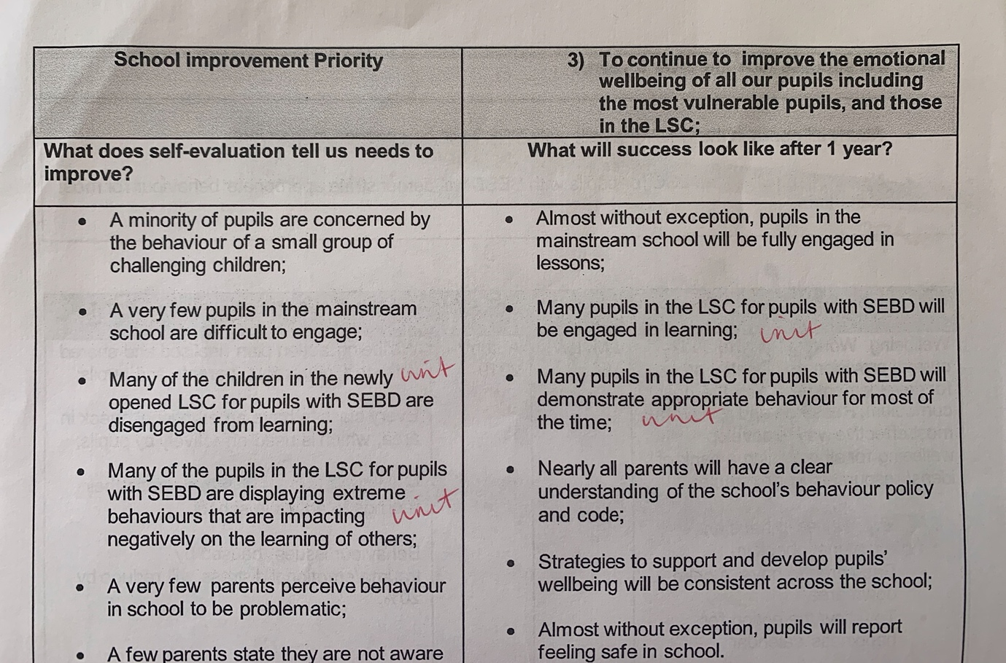

Appendix B
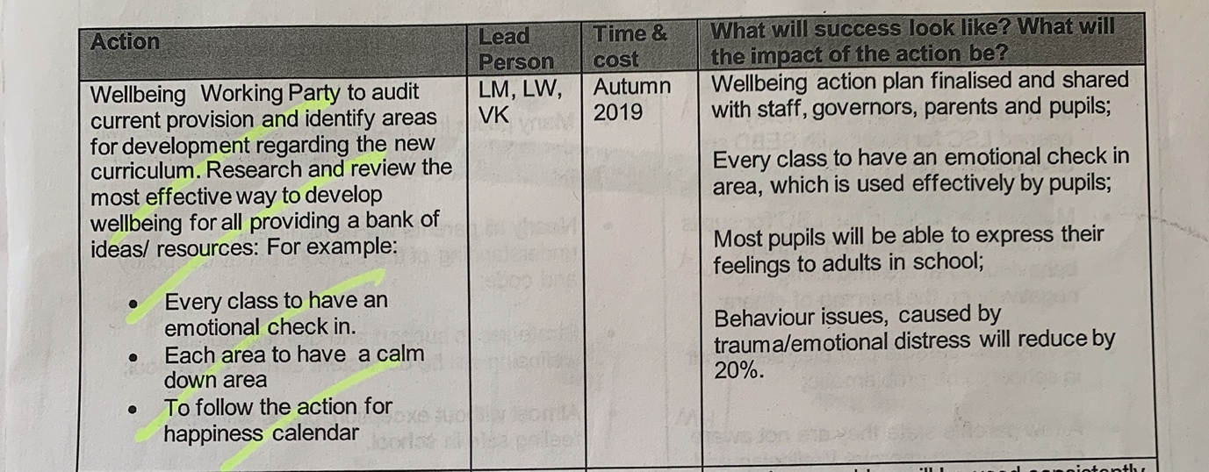

Appendix C


