

Matthew Evans 2319368 Computer Architecture and Operating Systems.

Table of Contents
Introduction 3
Key functions of general Operating Systems 4
PowerShell Commands 7
Get-Process 7
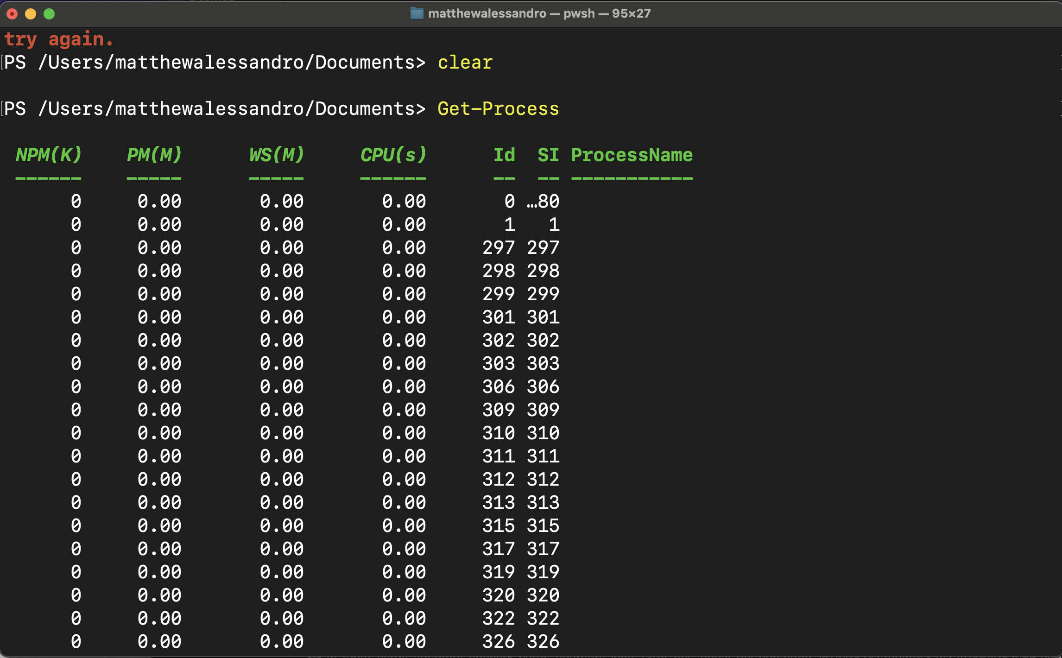 7
Getting user input with Read/Write Host 7
Utilising Get-Help 7
Getting Specific Process by referencing PID 8
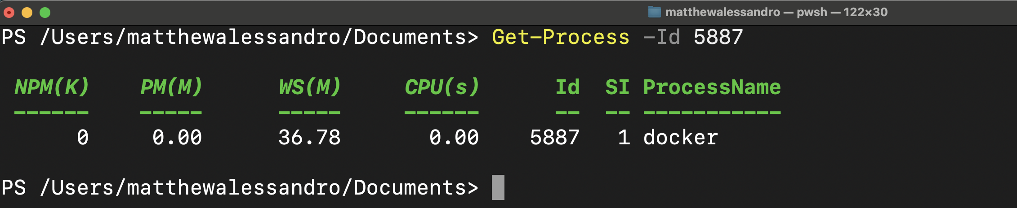 8
Checking Execution Policy 8
Making a new directory and adding a text file 9
Printing Working Directory 10
Bash Shell Scripting Documentation 11
Gathering first and last names from the user 11
Getting extension number from the user 11
Getting users access code (sensitive data) 12
Formatting the data in a CSV string and writing to a CSV file 12
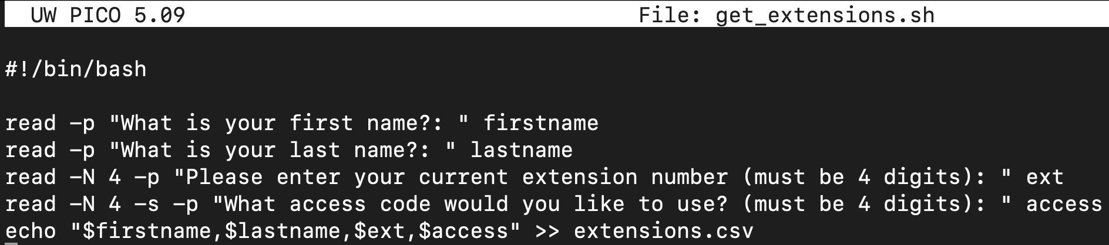 12
Testing my script + results 12
Executing the script 13
Appendices 16
PowerShell course screenshots 16
Introduction 16
Powershell Overview 17
Powershell Overview Quiz 20
Using Powershell 22
Chapter 2 Quiz 24
Taking PowerShell on Premises and Online 25
Exam 1st Attempt 26
Exam 2nd Attempt 26

Introduction

Throughout this report, I will be demonstrating my research and investigation into Computer Architecture and Operating Systems. I will discuss and explore the various key functions of a typical operating system and highlight my preferred measurement tools. Additionally, I will demonstrate my understanding of CLI (Command Line Interface) commands, and their use case across various operating systems and terminals. Appendices containing screenshots as evidence of learning and references supporting the findings are included for further scrutiny.

Key functions of general Operating Systems

Memory management in modern operating systems involves allocating and deallocating memory for programs and processes, and optimising system performance. Research by R.Sheldon suggests, memory management is the process of “controlling and coordinating a computer's main memory.”[1] This involves allocating memory for programs and processes to meet their storage requirements and deallocating memory when it's no longer necessary.

“Process management is a crucial aspect of operating systems that allows multiple processes to run efficiently on a single system.” [2] Process management in operating systems encompasses tasks like creation, scheduling, and termination. Scheduling refers to the OS mechanism determining the execution sequence of processes.

Based on A. Yernagula's research [3], file management organises system files hierarchically for efficient retrieval and management. Interestingly, Yernagula notes, “Before the advent of computers the term file system was used to describe a method of storing and retrieving paper documents”.

Monitoring and Management of an Operating System

For a detailed report on your systems overall resource usage, Hoffman [4] suggests Windows Task Manager is a “powerful tool packed with useful information, from your system's overall resource usage to detailed statistics about each process.”

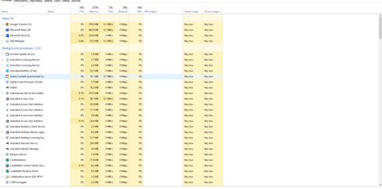
Can see how many applications are running concurrently and view their CPU and resource consumption.
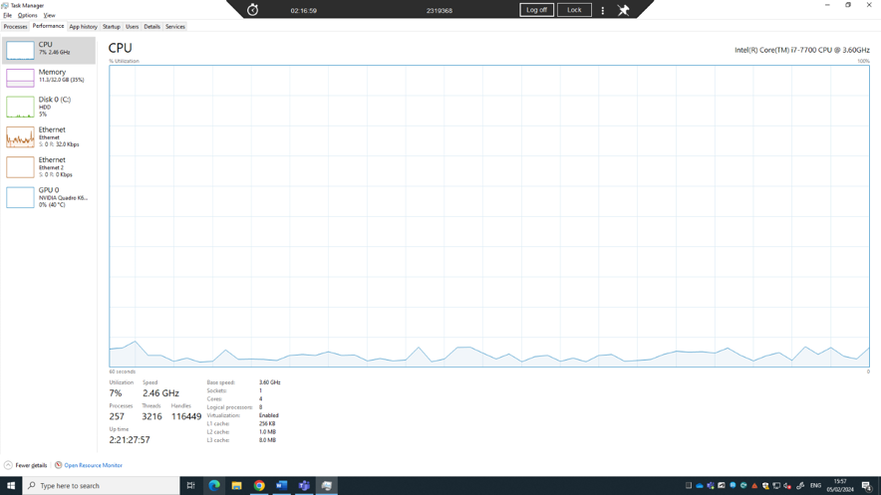
Ability to monitor CPU performance with a graph representing CPU usage over time.

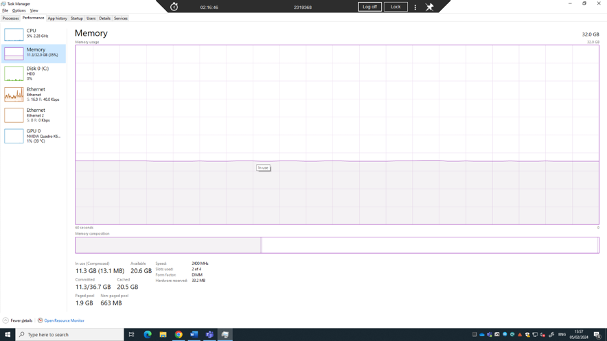
The memory section of Task Manager provides users with detailed insights into how memory is being utilised by the system and running processes.

Specifications of my MacBook Pro. Most modern operating systems provide some level of information about the hardware specifications of the computer on which they are installed.



Process Explorer

Microsoft Process Explorer is an advanced system monitoring and analysis tool.
According to Markruss [5], Process Explorer's unique features are invaluable for troubleshooting DLL-version issues, handle leaks, and gaining insights into Windows and application functionality.

Process Hacker

Evidenced in research from C. T. C. S. I. P. Ltd [6] Process Hacker is a powerful Windows utility that surpasses the native Task Manager, providing detailed process insights, advanced management options, and comprehensive system monitoring. It doesn’t however provide as much detailed information as Process Explorer.

Reliability Monitor

Determined by research from R. Chauhan [15] The Reliability Monitor provides a visual representation of your computer's stability history, including a timeline of system events such as application crashes, hardware failures, and system errors, along with relevant date and details.

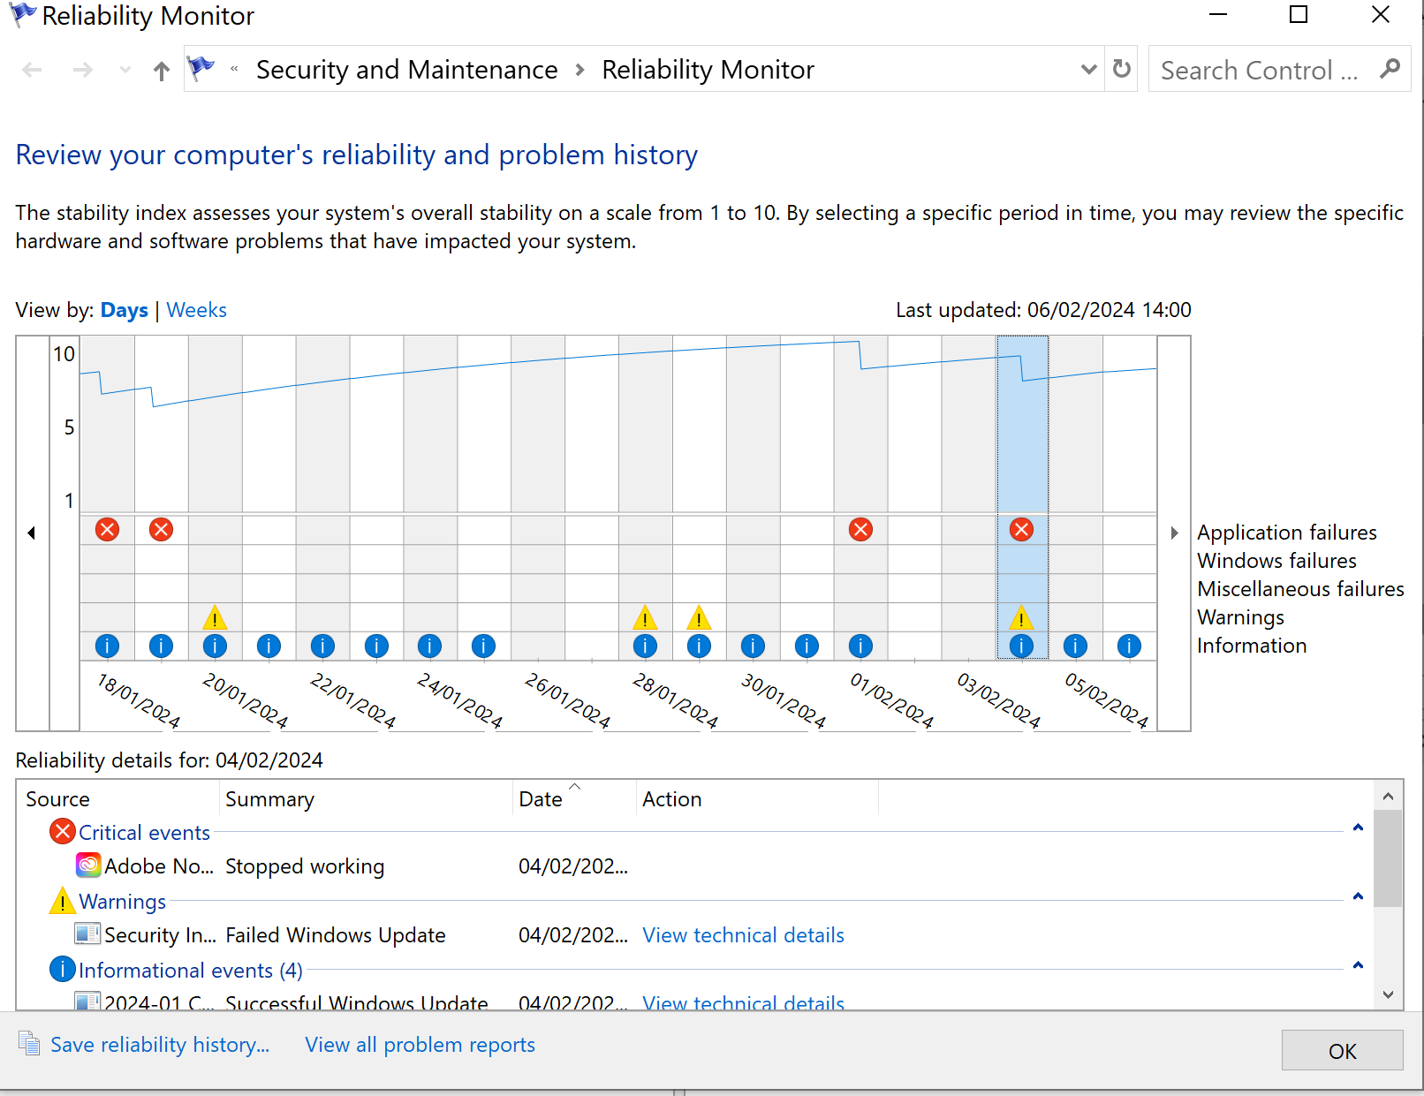

PowerShell Commands

Note: As a MacBook user, I have installed a version of PowerShell to run in local macOS terminal.

Get-Process
Show list of processes running on my computer with Get-Process. Posey [12] reports, “when used by itself, the Get-Process cmdlet displays a list of all processes running on the system.”

Getting user input with Read/Write Host
The Write-Host cmdlet is a wrapper for the older Write-Information cmdlet.
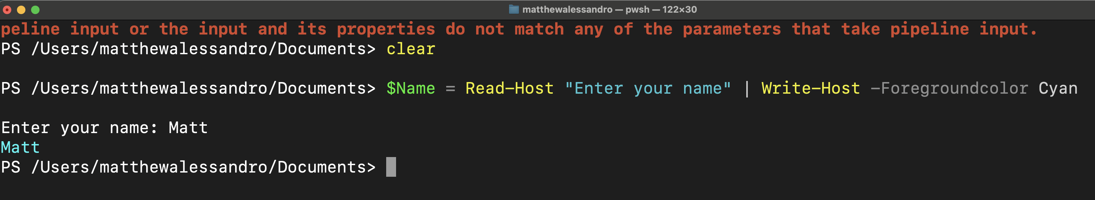

Utilising Get-Help
Brien Posey of ITPro today [13] tells us, “Whereas Get-Command can help you to find the name of a specific cmdlet, Get-Help can show you how to use a cmdlet.” Get-Help also provides a short description of what the cmdlet does.
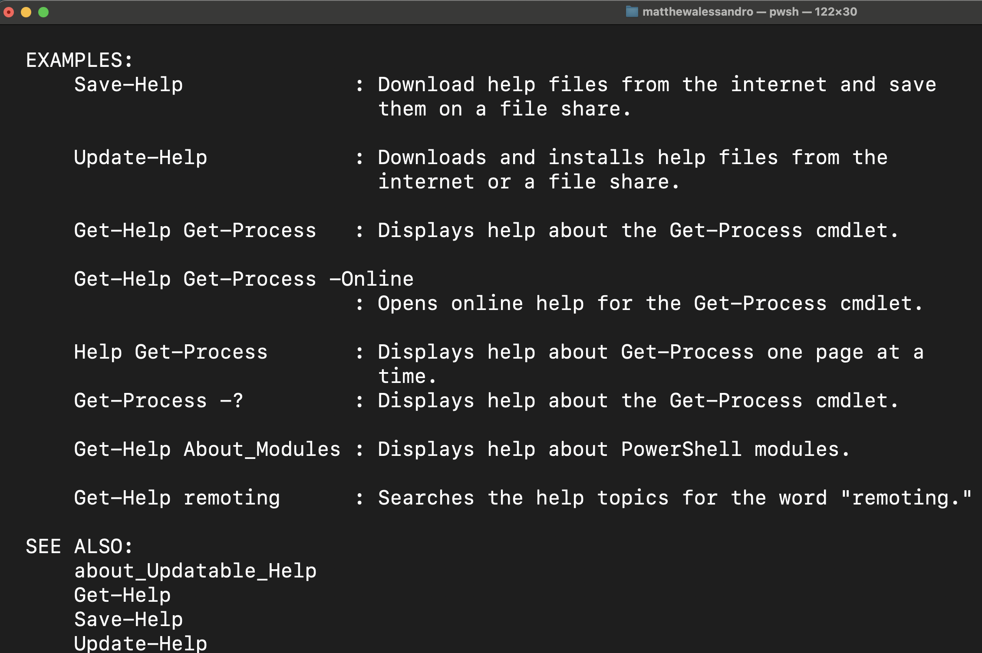

Getting Specific Process by referencing PID
Here I want to inspect the process assigned to Docker Desktop. I first located the process ID using Get-Process. Subsequently, I cleared the terminal and chained the -Id <number> command to Get-Process to inspect the desired process.

Checking Execution Policy

Restricted: This is the default execution policy. It doesn't allow any scripts to run, including those signed by a trusted publisher. [14]

Unrestricted: Allows all scripts to run without any restrictions. It's not recommended for security reasons unless you fully trust the source of the scripts. [14]

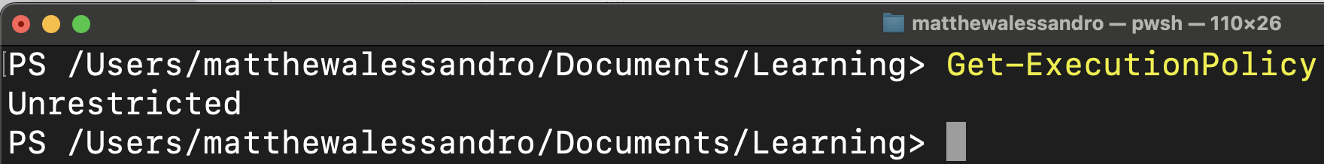

Making a new directory and adding a text file

Firstly, I need to change directories to find a suitable place to make my new directory.
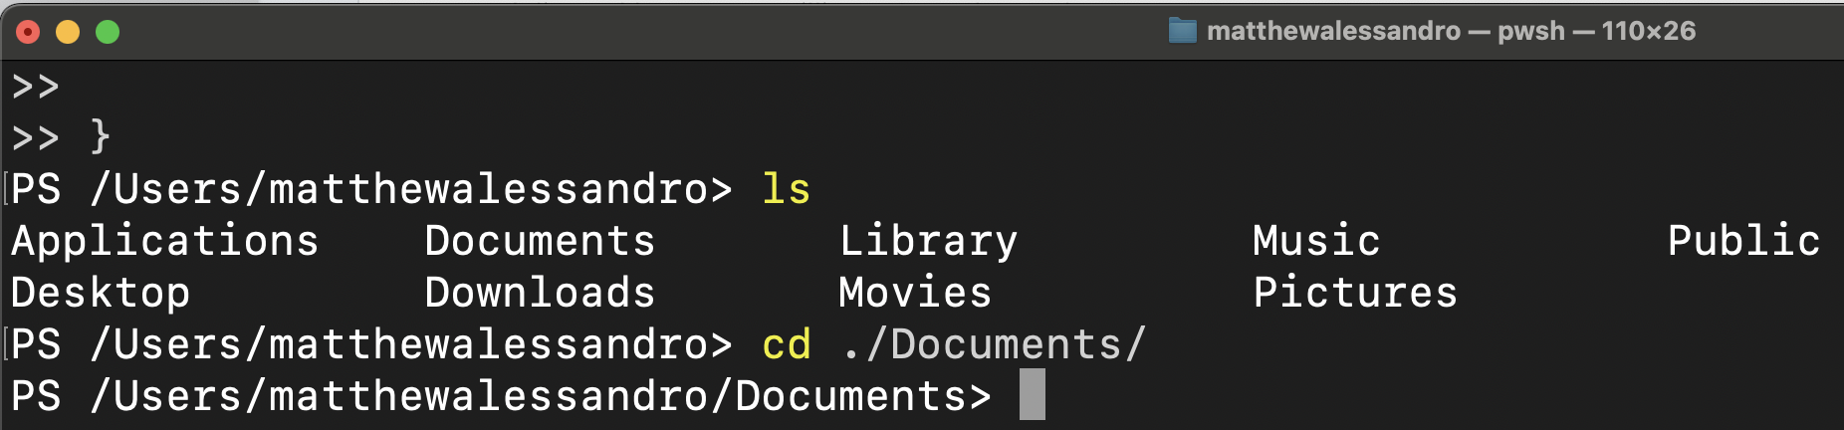

After navigating to the necessary directory, I then make a new directory called powershell_learning using mkdir.
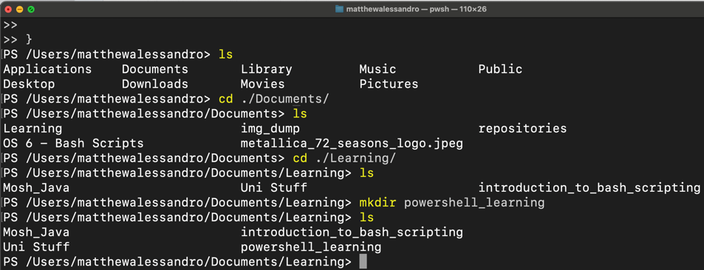

Next, I change directories to my newly created directory.
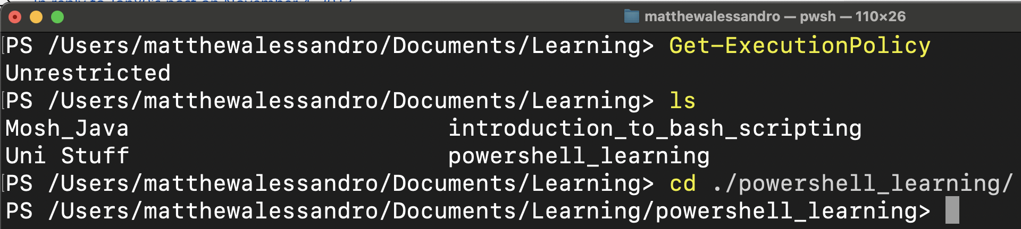

Finally, I can create a blank text file with the name ‘test.rtf’.
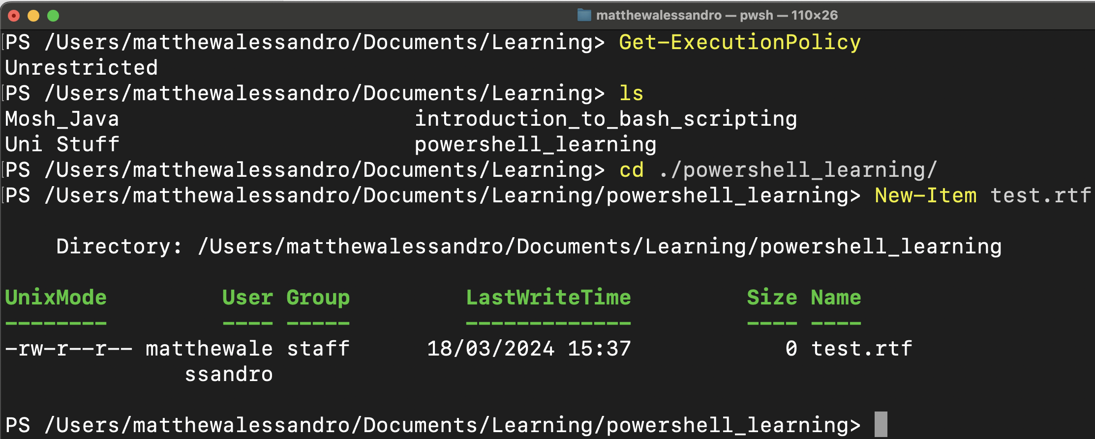
Here’s the test rtf file
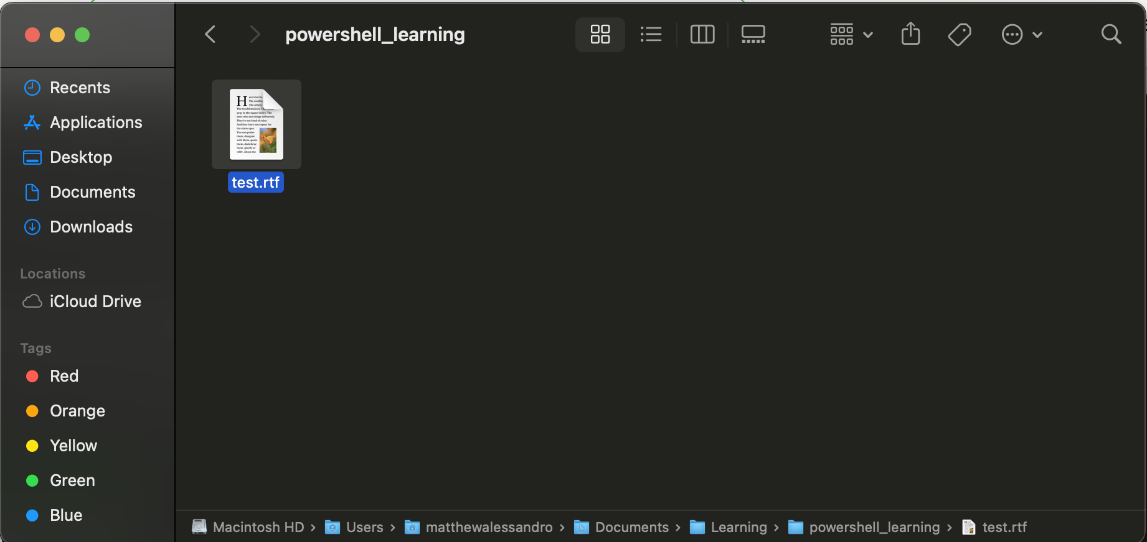

Printing Working Directory

Super useful command to print the working directory. This allows the user to understand where they are in each file system whilst inside a terminal.

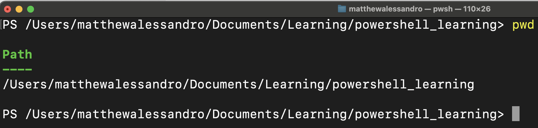

Bash Shell Scripting Documentation

Using GNU nano as it’s a simple and user-friendly text editor to build my BASH scripts.

Mini telecoms switchboard program in BASH to demonstrate taking user input and writing it to a CSV file.

Gathering first and last names from the user

Here I am typing the read command to read the input from the user, followed by -p prompt which allows me to provide a helpful message for the user inside double quotes [1]

I then save the users response for first name and last name in their respective variables.

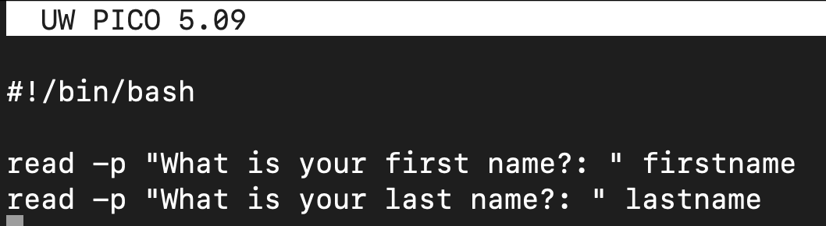

Getting extension number from the user
I want the users extension number to be strictly 4 digits long. As explained in the article published by phoenixNAP [2], I use the -N command to specify the maximum number of characters to read.
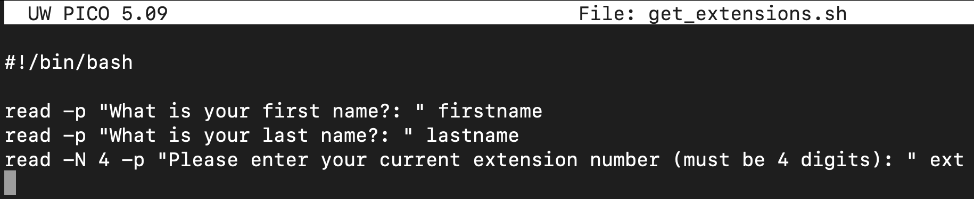

Getting users access code (sensitive data)
Here I am making use of the -s command to “read input in silent mode”[3], which is useful when requesting sensitive information from the user.
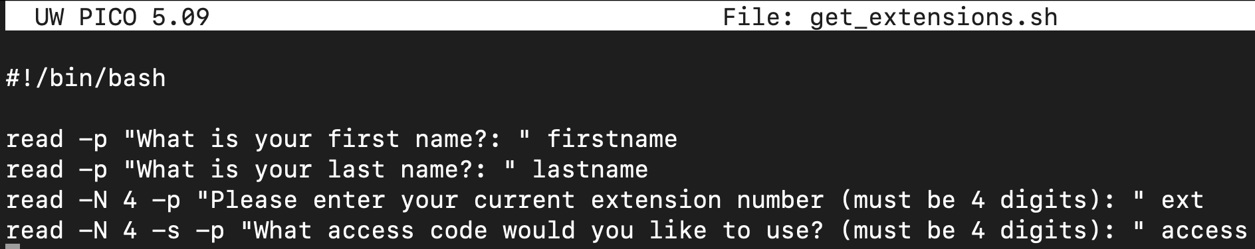

Formatting the data in a CSV string and writing to a CSV file
Using the ‘$’ command, I access the contents of the variables I have stored from the user inputs, each separated by a comma to comply to CSV standards.

Then, the shovel operator ‘>>’ allows me to re-direct the standard output of the echo command to write to a file called ‘extensions.csv’. [4]

Testing my script + results
As I would in theory be distributing this script to others for use in the company, I will give the permissions of 755 instead of 744 – According to the research of R Ludosanu of Warp dev [5] this will allow the owner of the file to have full permissions (read,write, execute).

I use the ‘ls -l’ command here to prove this in action.
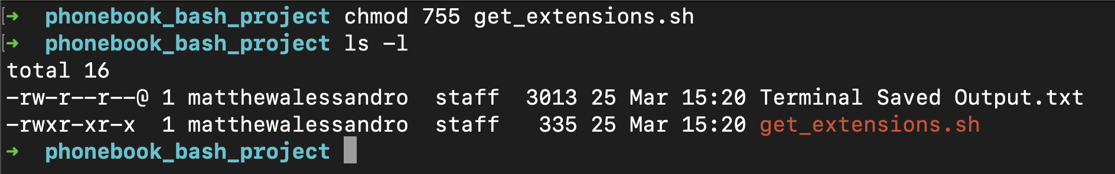

Executing the script
Here you can see me inputting some sample data.
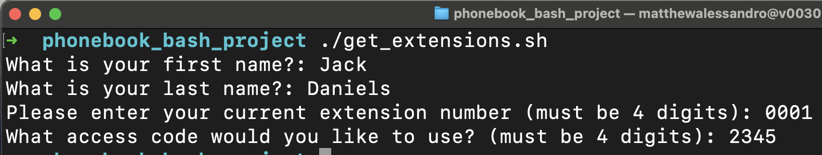
I then use the .cat command to print out the contents of the csv file saved in the same directory; however I noticed a slight formatting issue when printing the users out to the terminal.

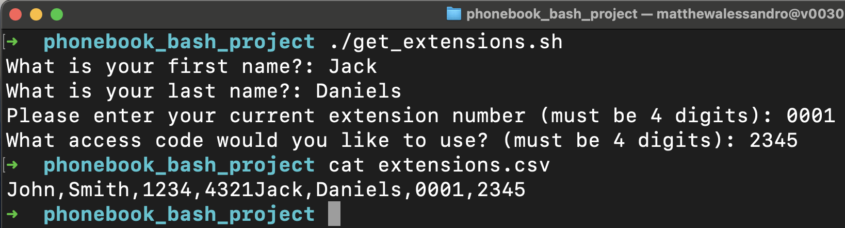

To fix this, I reopened my script and added in and ‘echo’ command to introduce an empty white line break between each -N command like so.

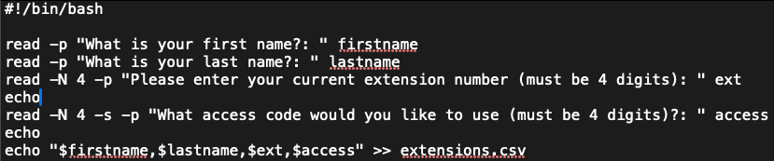

Now, when I re-run the script. Viola!

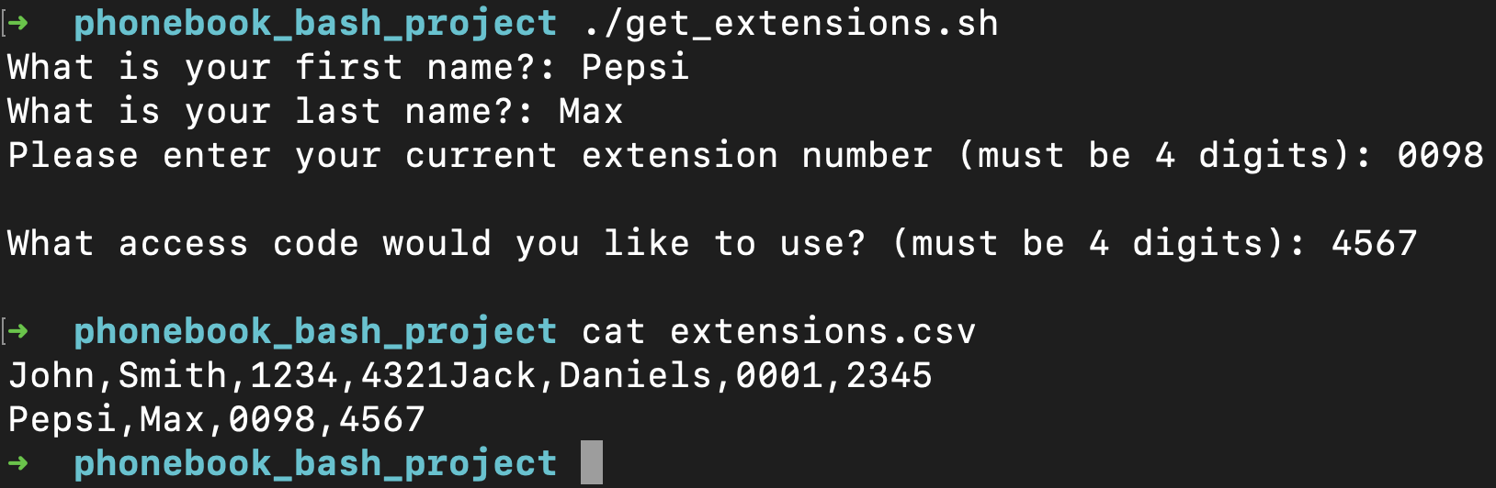

Batch Scripting

Average Goals per match calculator script
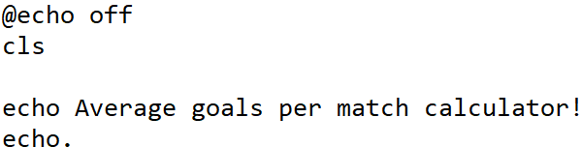
Clear the screen and displaying a welcome message.
@echo off is used here to suppress the echoing of commands in the script to the console.
Without the @echo command, my terminal displays the directory root which is noisy
Collect user input using the set /p command to store string variables.
Batch string interpolation used here by the double percentage symbols.

Using the ‘/’ division operator, I calculate the average number of goals scored per match by dividing the total goals by the total matches played.
For a bit of fun and practice with if statements, I have included three paths each with different messages dependent on what the user’s favourite team is.
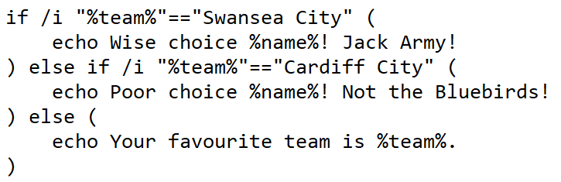
Finally, display the goals per game that the user’s team have scored.

Testing the script
Input as ‘Swansea City’
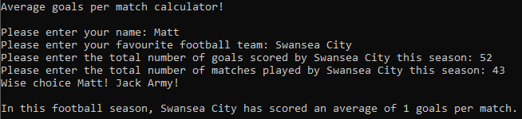
Input as ‘Cardiff City’
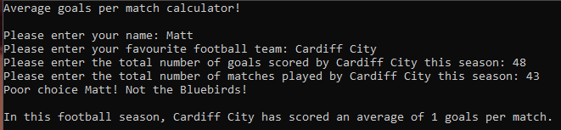

Lowercase matching
Script matches lowercase arguments aswell!
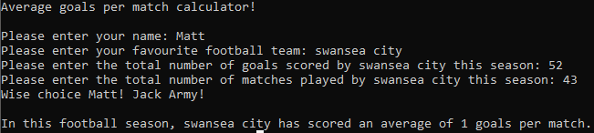

Doesn’t catch the space
The program doesn’t cater for user input without the correct spacing! Potential optimisation feature for the future.
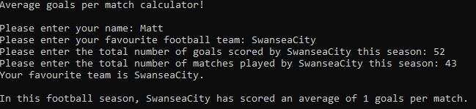

Bibliography
[1]
R. Sheldon, “What is memory management? - Definition from WhatIs.com,” WhatIs.com, Jun. 2022. https://www.techtarget.com/whatis/definition/memory-management#:~:text=Memory%20management%20is%20the%20process
[2]
A. Dhawan, “Everything about Process Management OS | DataTrained,” Data Trained Blogs, Feb. 27, 2023. https://datatrained.com/post/process-management-os/ (accessed Feb. 05, 2024).
[3]
A. Yernagula, “Understanding File Management System in Operating System,” Medium, Feb. 28, 2020. https://princeabhishek410.medium.com/understanding-file-management-system-in-operating-system-4c7fbfc306f2 (accessed Feb. 05, 2024).
[4]
C. Hoffman, “Windows Task Manager: The Complete Guide,” How-To Geek, Mar. 28, 2019. https://www.howtogeek.com/405806/windows-task-manager-the-complete-guide/ (accessed Feb. 12, 2024).
[5]
markruss, “Process Explorer - Windows Sysinternals,” learn.microsoft.com, Mar. 30, 2023. https://learn.microsoft.com/en-us/sysinternals/downloads/process-explorer (accessed Feb. 12, 2024).
[6]
C. T. C. S. I. P. Ltd, “Process Hacker,” Medium, Nov. 30, 2023. https://medium.com/@careertechnologymiraroad/process-hacker-01c3f0a093ac (accessed Feb. 12, 2024).
[7]
A. Jotwani, “Reading User Input in Bash | Warp,” www.warp.dev, Mar. 22, 2024. https://www.warp.dev/terminus/bash-reading-user-input (accessed Mar. 25, 2024).
[8]
M. Dancuk, “How To Use The Bash read Command {10 Examples},” Knowledge Base by phoenixNAP, Feb. 21, 2022. https://phoenixnap.com/kb/bash-read (accessed Mar. 25, 2024).
[9]
S. Kumar, “How To Use The Bash read Command?,” www.tutorialspoint.com, Jul. 13, 2023. https://www.tutorialspoint.com/how-to-use-the-bash-read-command (accessed Mar. 25, 2024).
[10]
Supakon_k, “How to generate csv file by bash script,” Medium, Feb. 12, 2022. https://supakon-k.medium.com/how-to-generate-csv-file-by-bash-script-15a7f526b83c (accessed Mar. 25, 2024).
[11]
R. Ludosanu, “Understanding Chmod 755 - Examples, Flags, and More,” Warp.dev, 2023. https://www.warp.dev/terminus/chmod-755 (accessed Mar. 25, 2024).
[12]
B. Posey, “Top PowerShell commands you must know, with cheat sheet | TechTarget,” SearchWindowsServer, Mar. 08, 2023. https://www.techtarget.com/searchwindowsserver/tip/Top-PowerShell-commands-you-must-know-with-cheat-sheet (accessed Apr. 13, 2024).

[13] B. Posey, “What Are the Basic PowerShell Commands?,” ITPro Today: IT News, How-Tos, Trends, Case Studies, Career Tips, More, Oct. 13, 2022. https://www.itprotoday.com/powershell/what-are-basic-powershell-commands#close-modal (accessed Apr. 13, 2024).
[14]
J. Shah, “Setting the PowerShell Execution Policy,” www.mssqltips.com, 2020. https://www.mssqltips.com/sqlservertip/2702/setting-the-powershell-execution-policy/ (accessed Apr. 15, 2024).
[15]
R. Chauhan, “Reliability Monitor vs. Performance Monitor: Comparing Two Underutilized Windows Tools,” MUO, Mar. 14, 2023. https://www.makeuseof.com/reliability-monitor-vs-performance-monitor/ (accessed Apr. 17, 2024).

Appendices

PowerShell course screenshots

Introduction

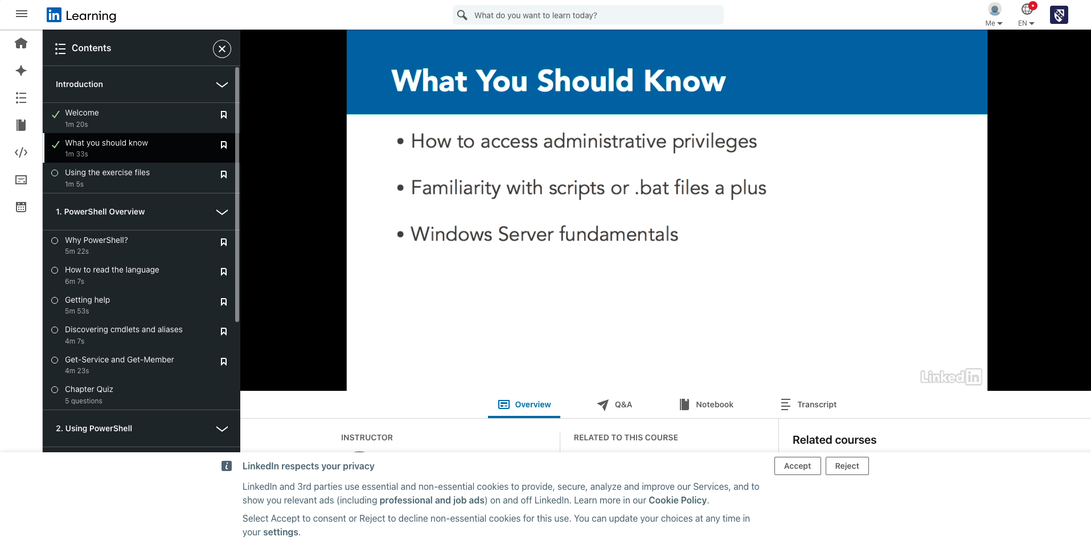

Powershell Overview

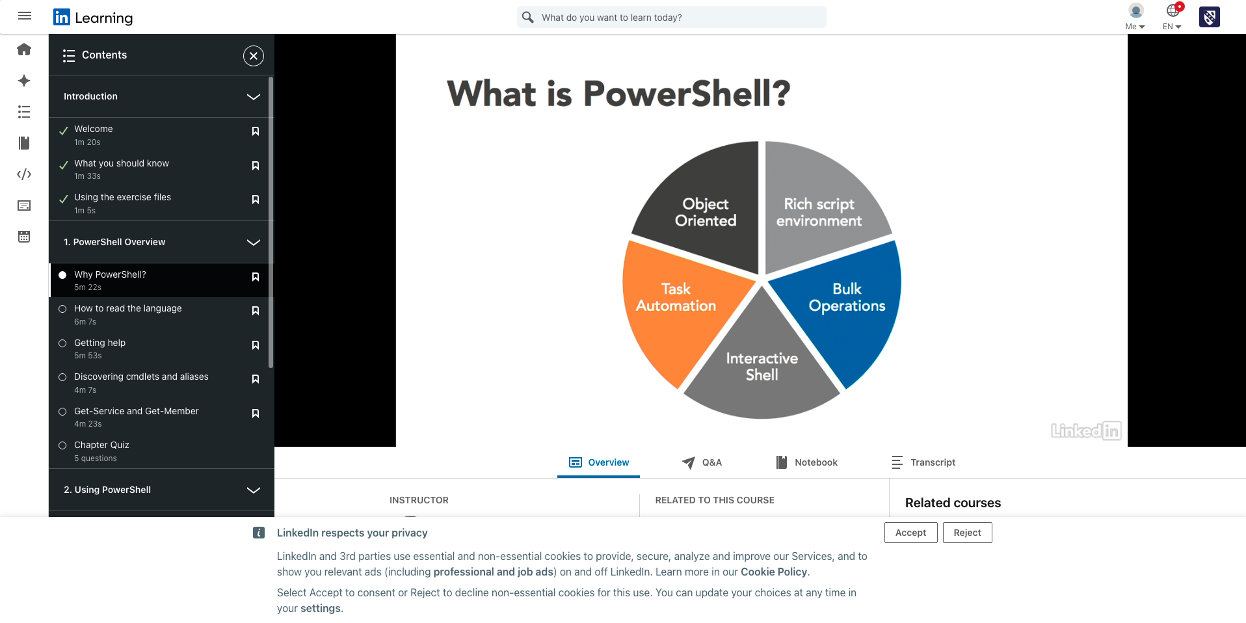

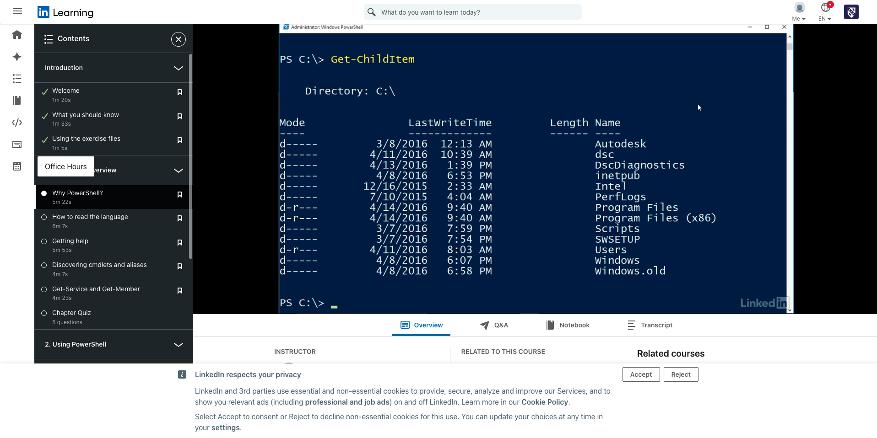

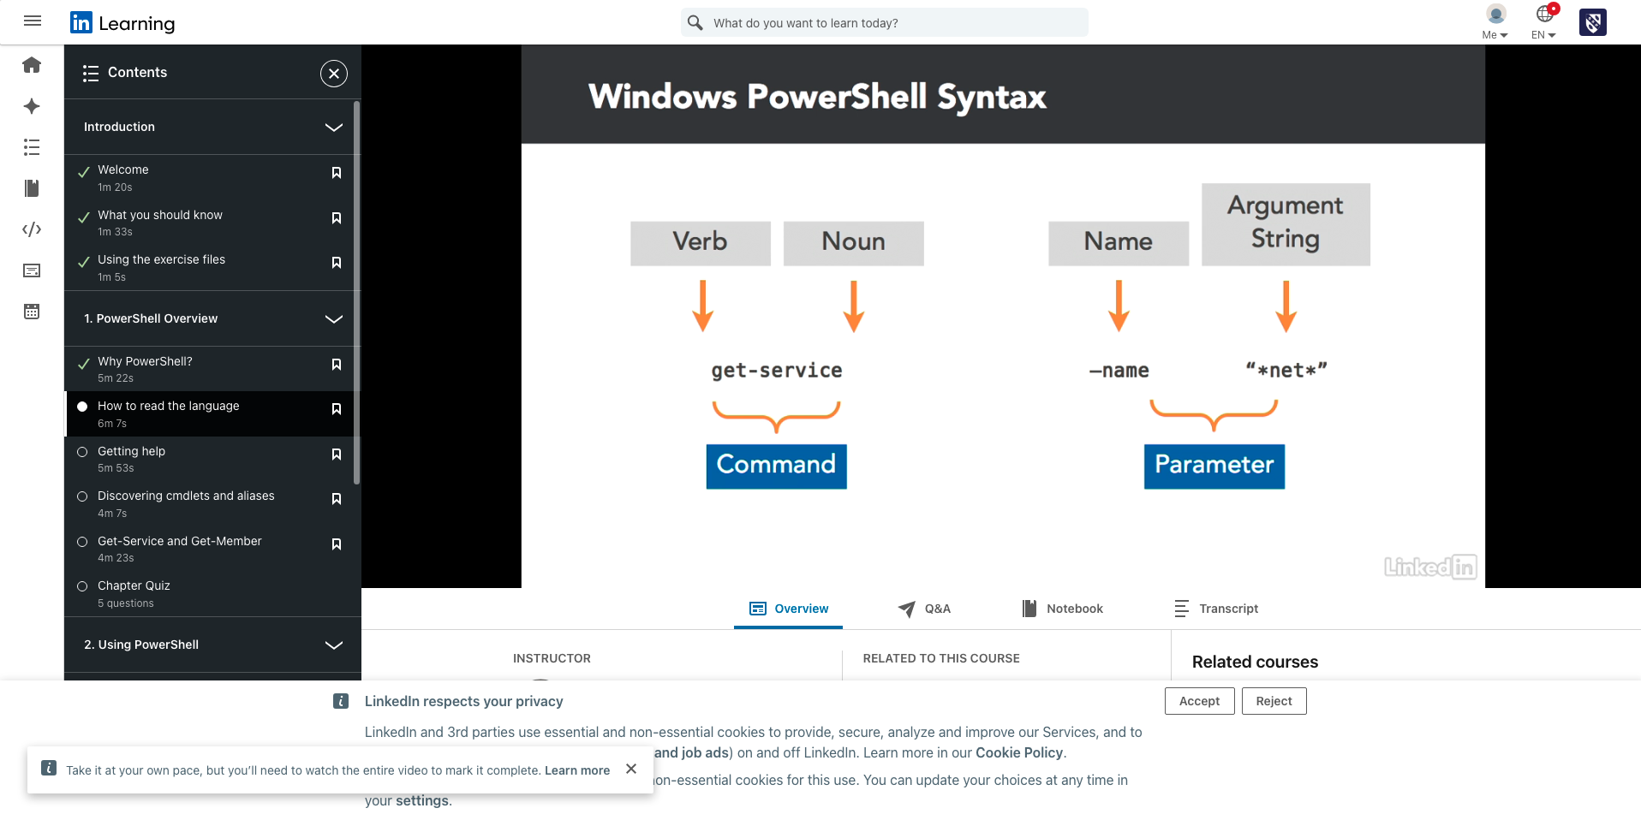

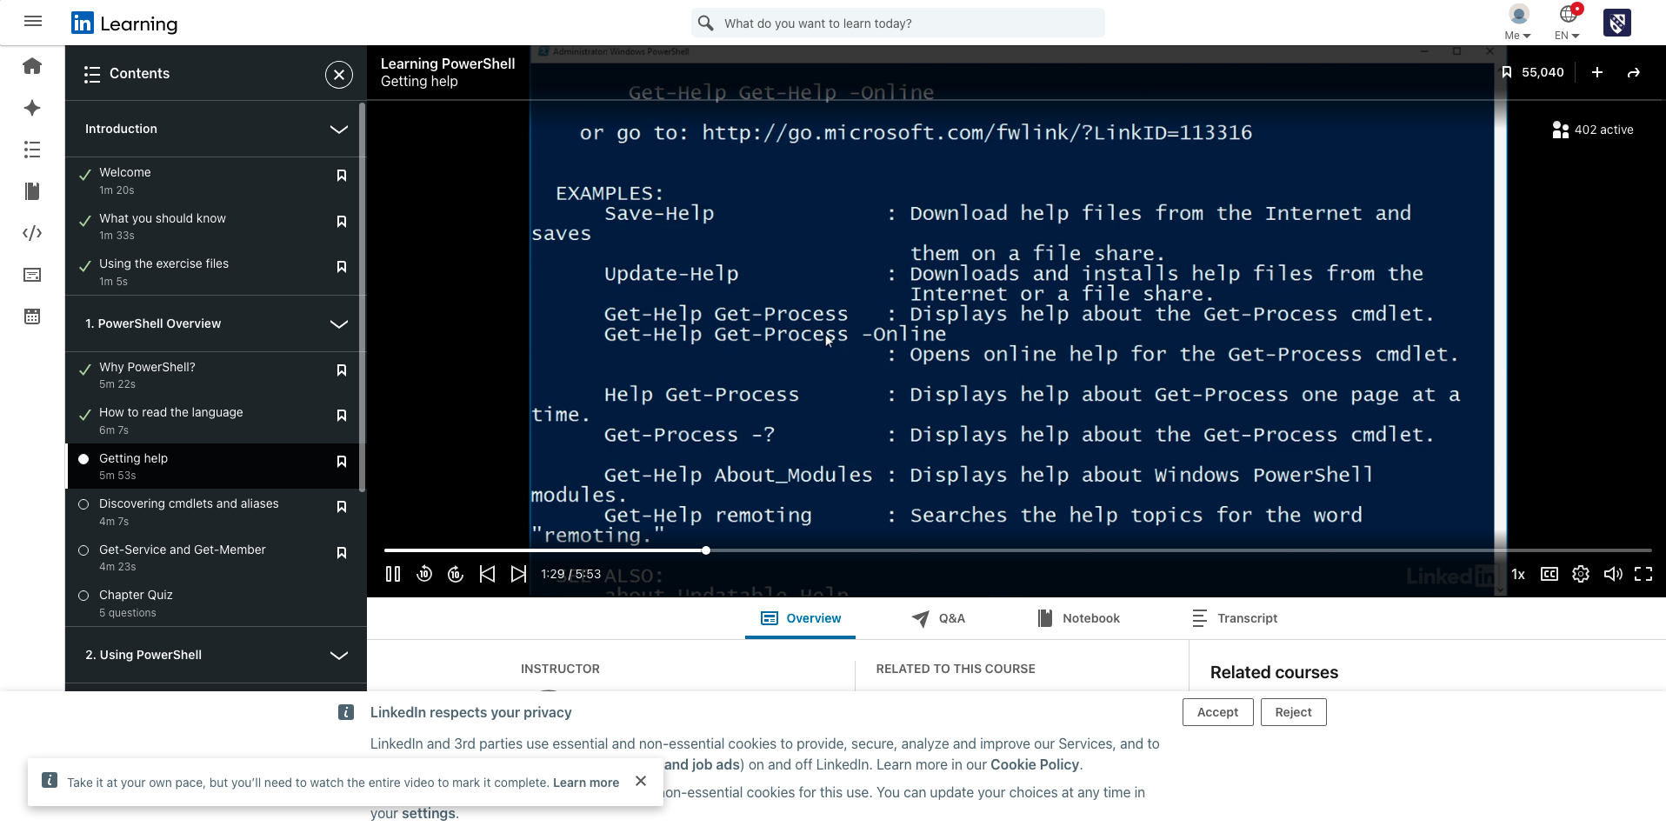

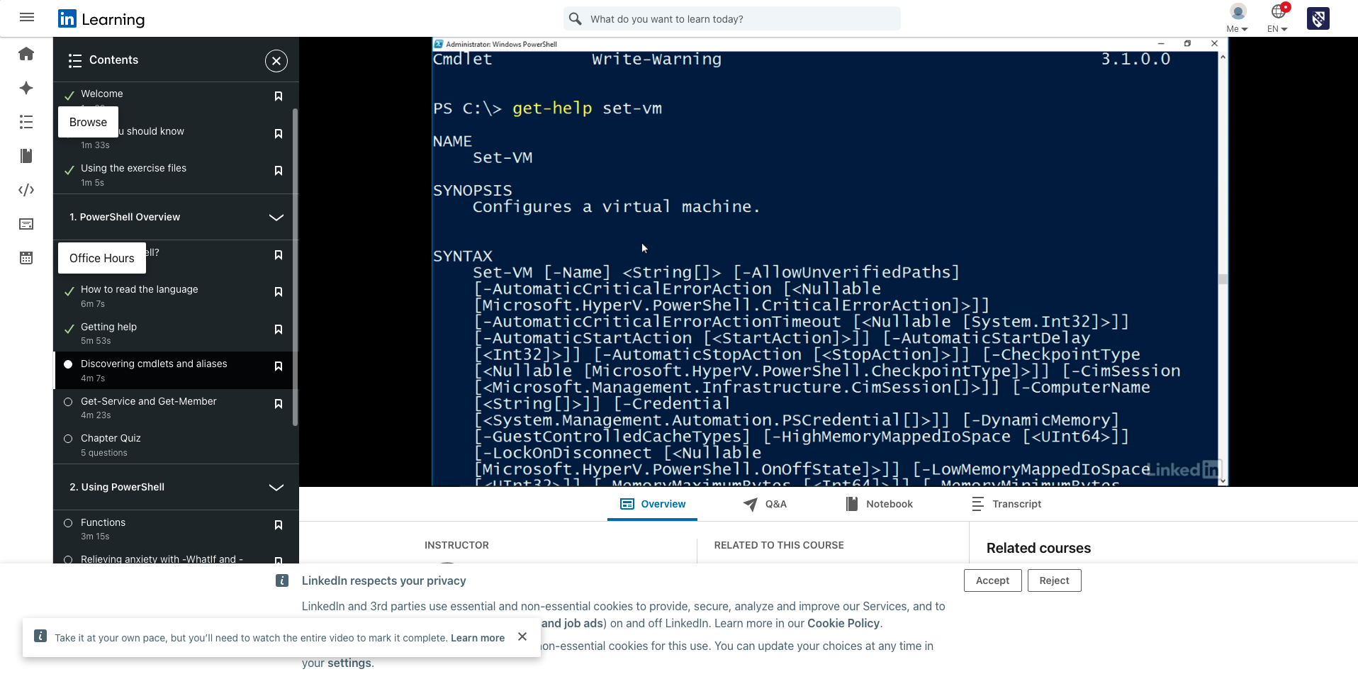

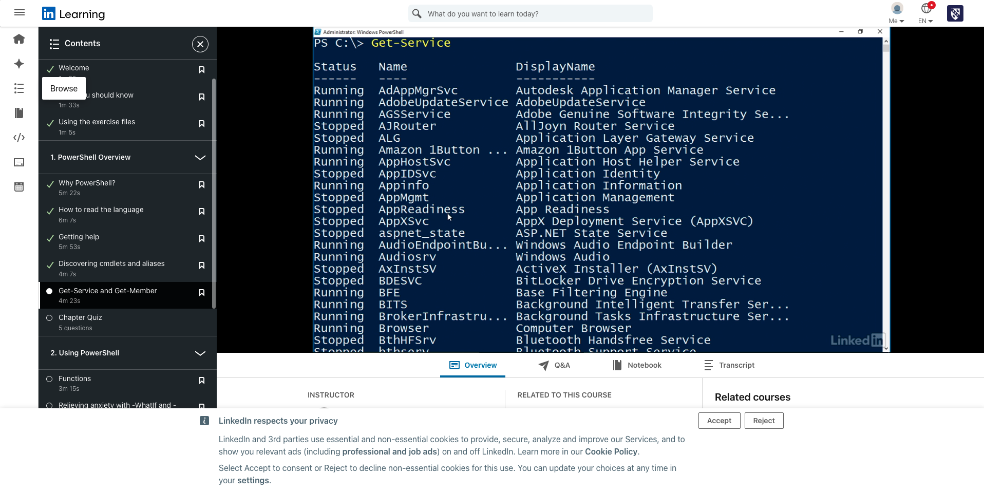

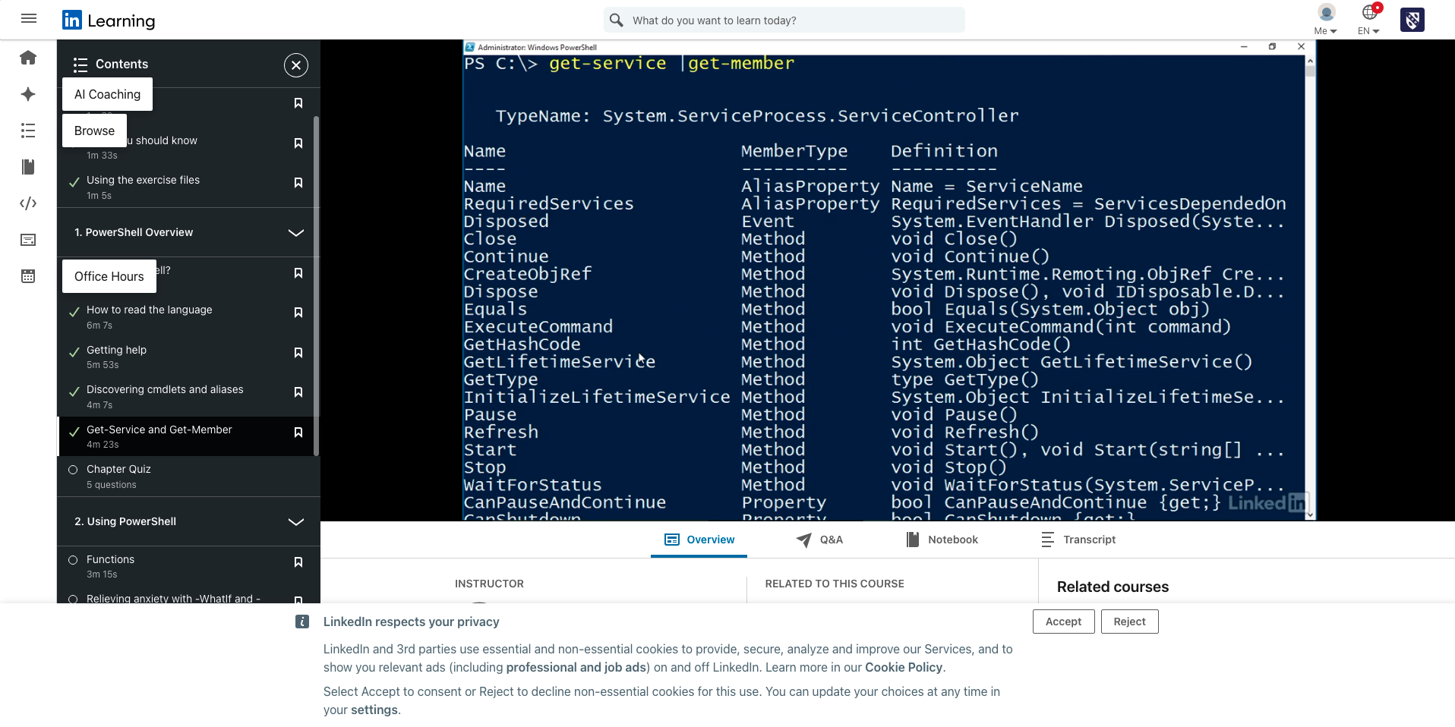

Powershell Overview Quiz

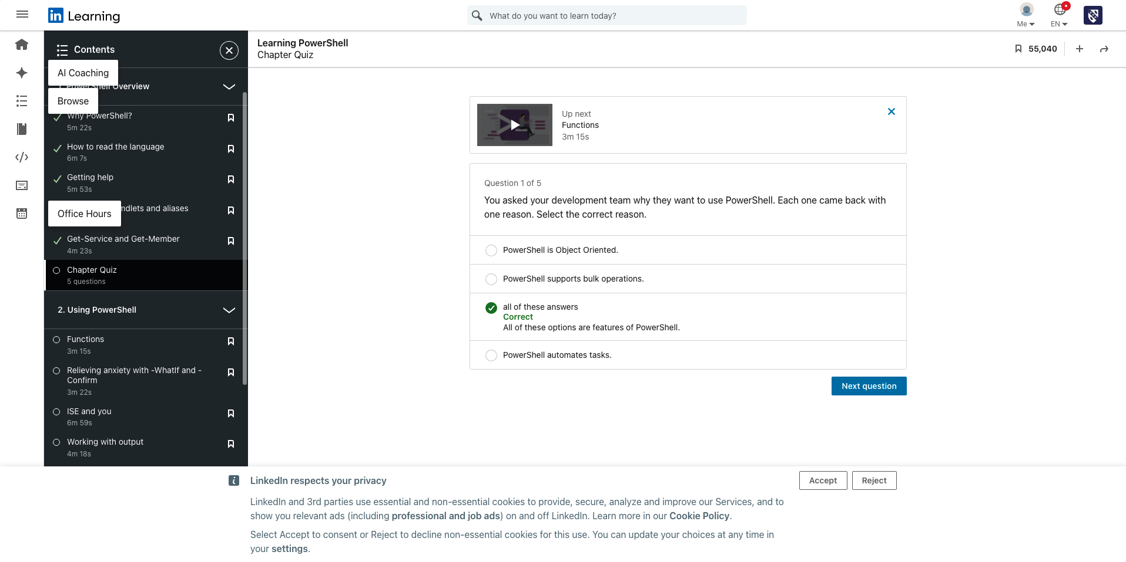

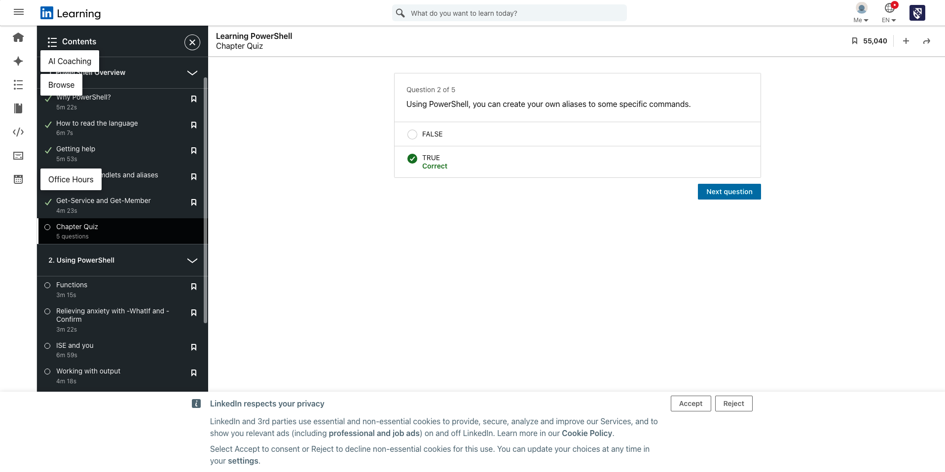

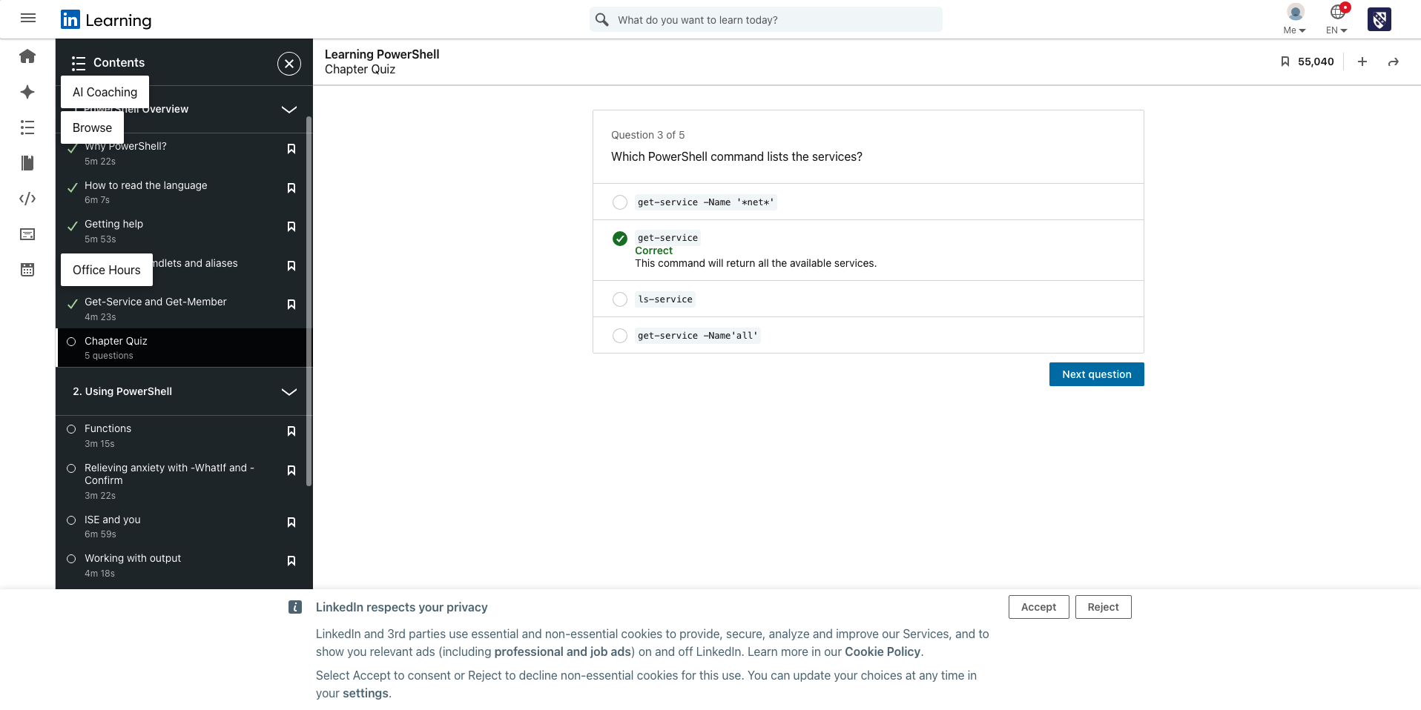

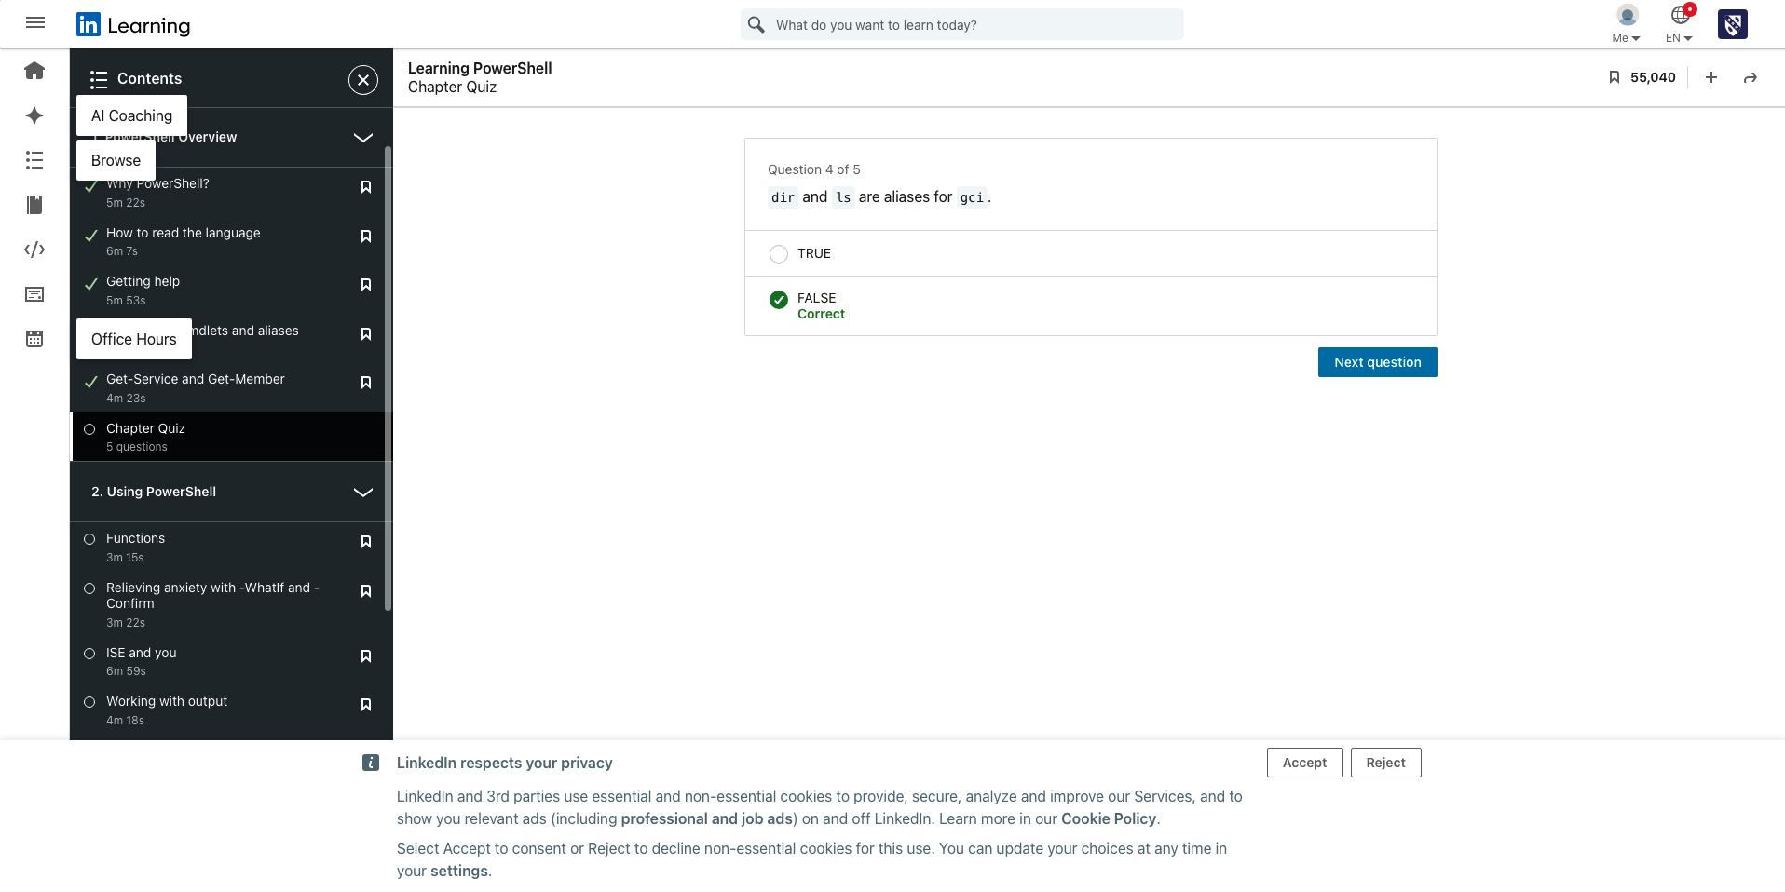

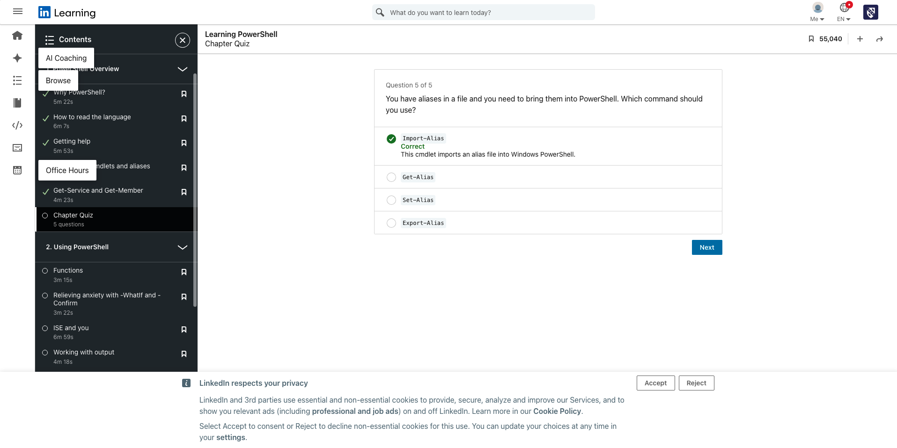

Using Powershell

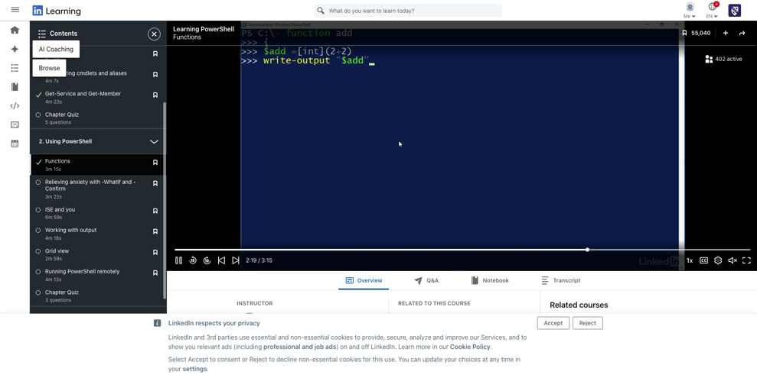

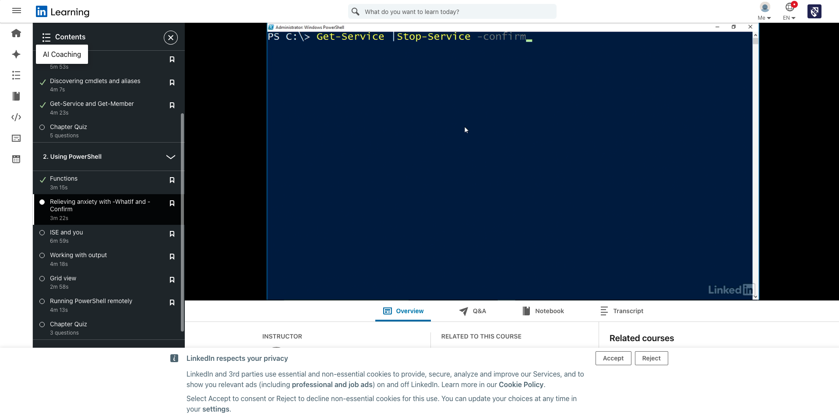

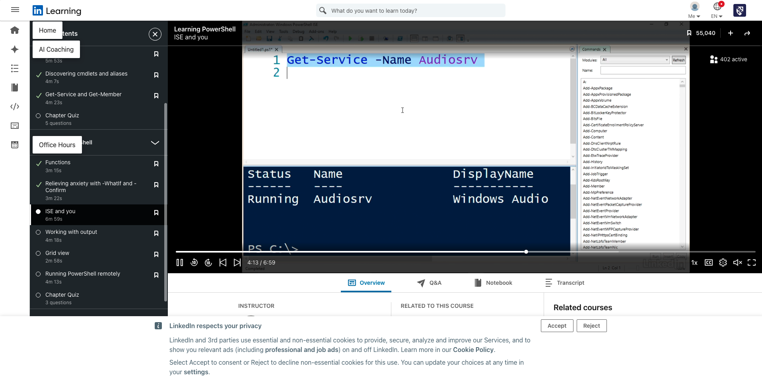

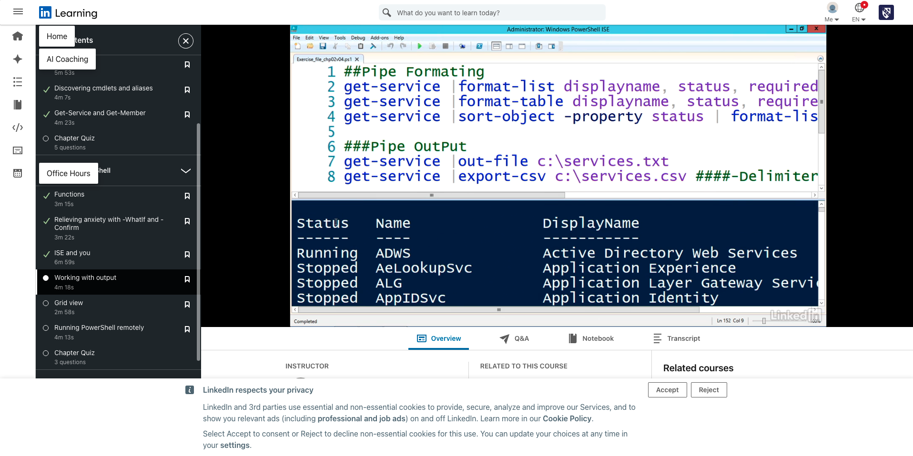

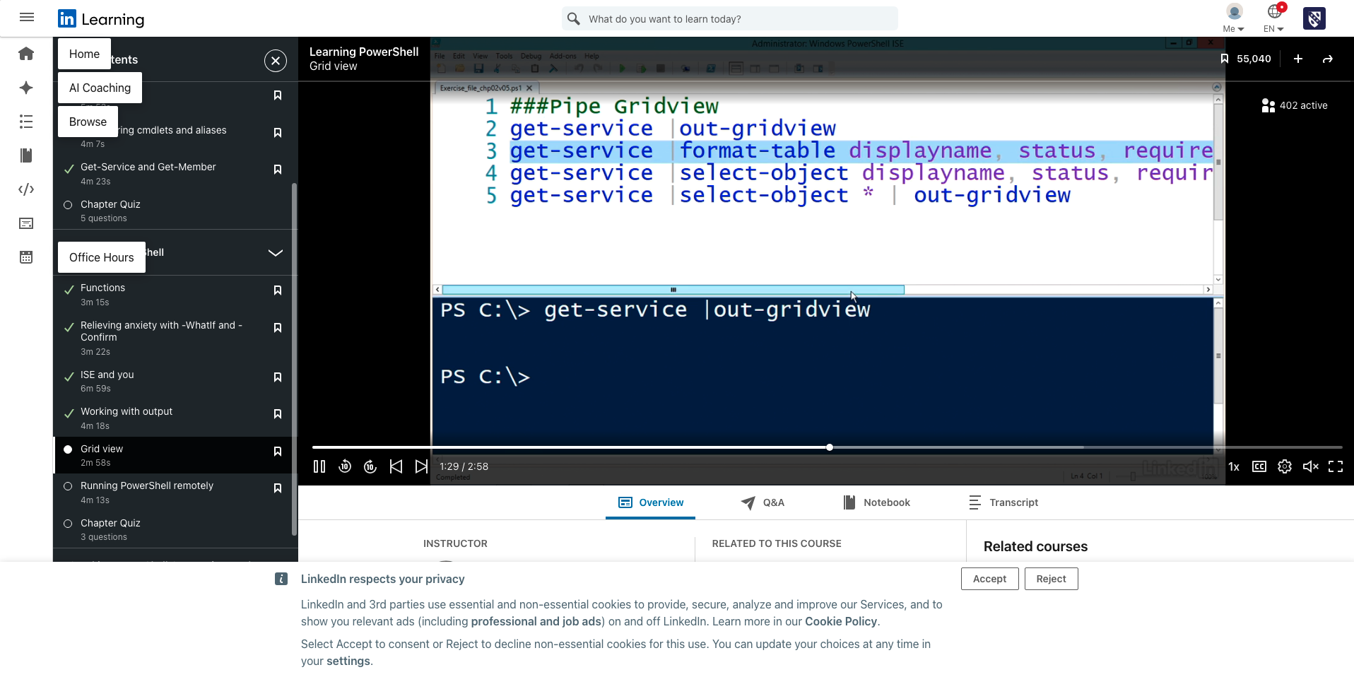

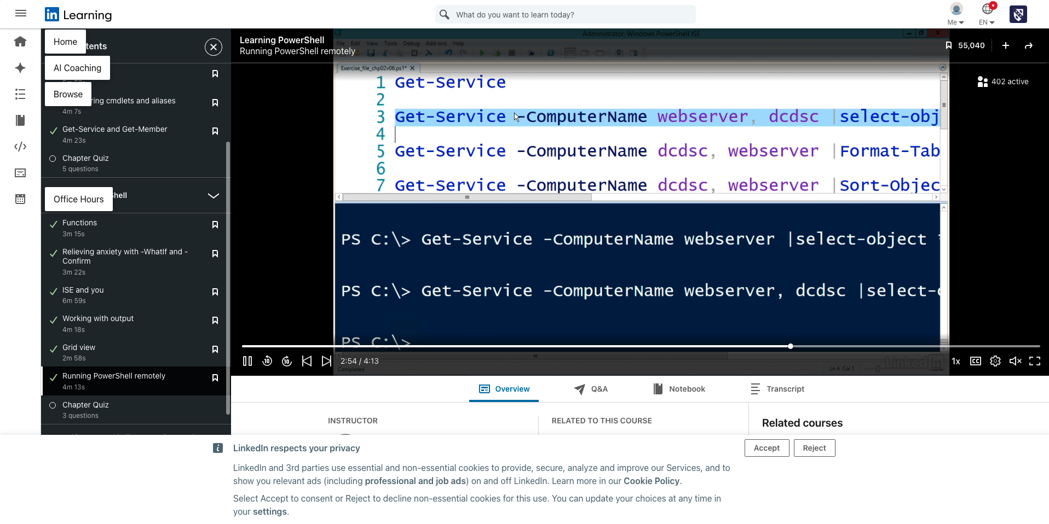

Chapter 2 Quiz

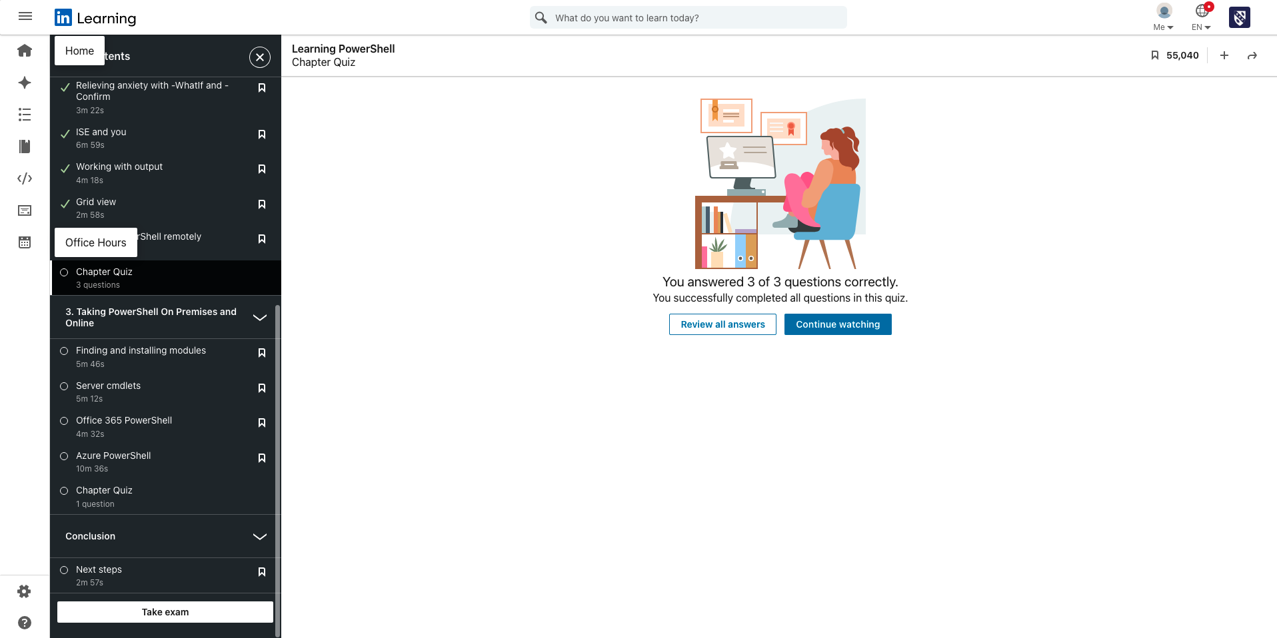

Taking PowerShell on Premises and Online
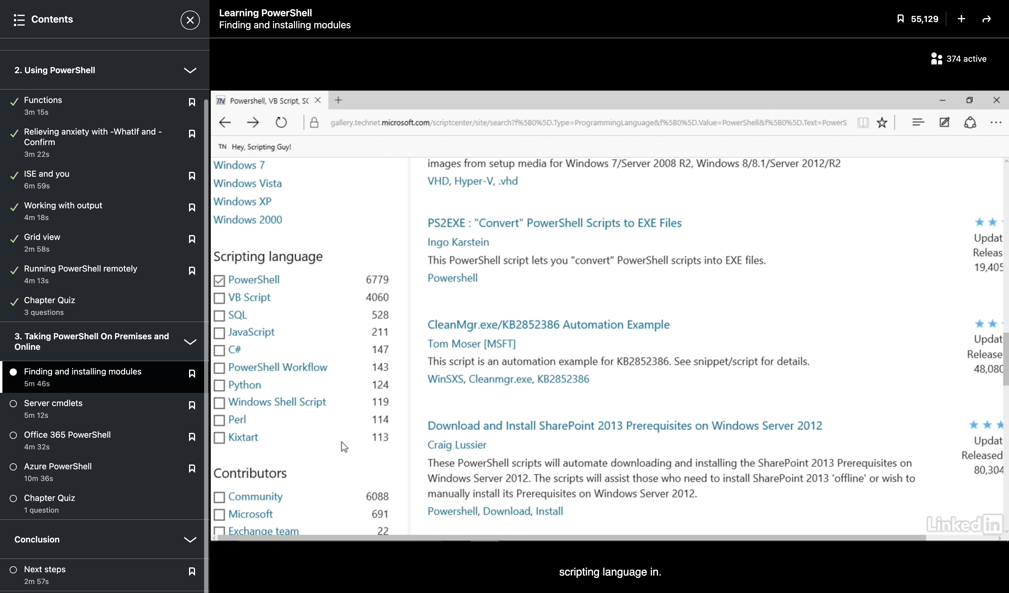

Learning where to get PowerShell modules and scripts from. These are installable.

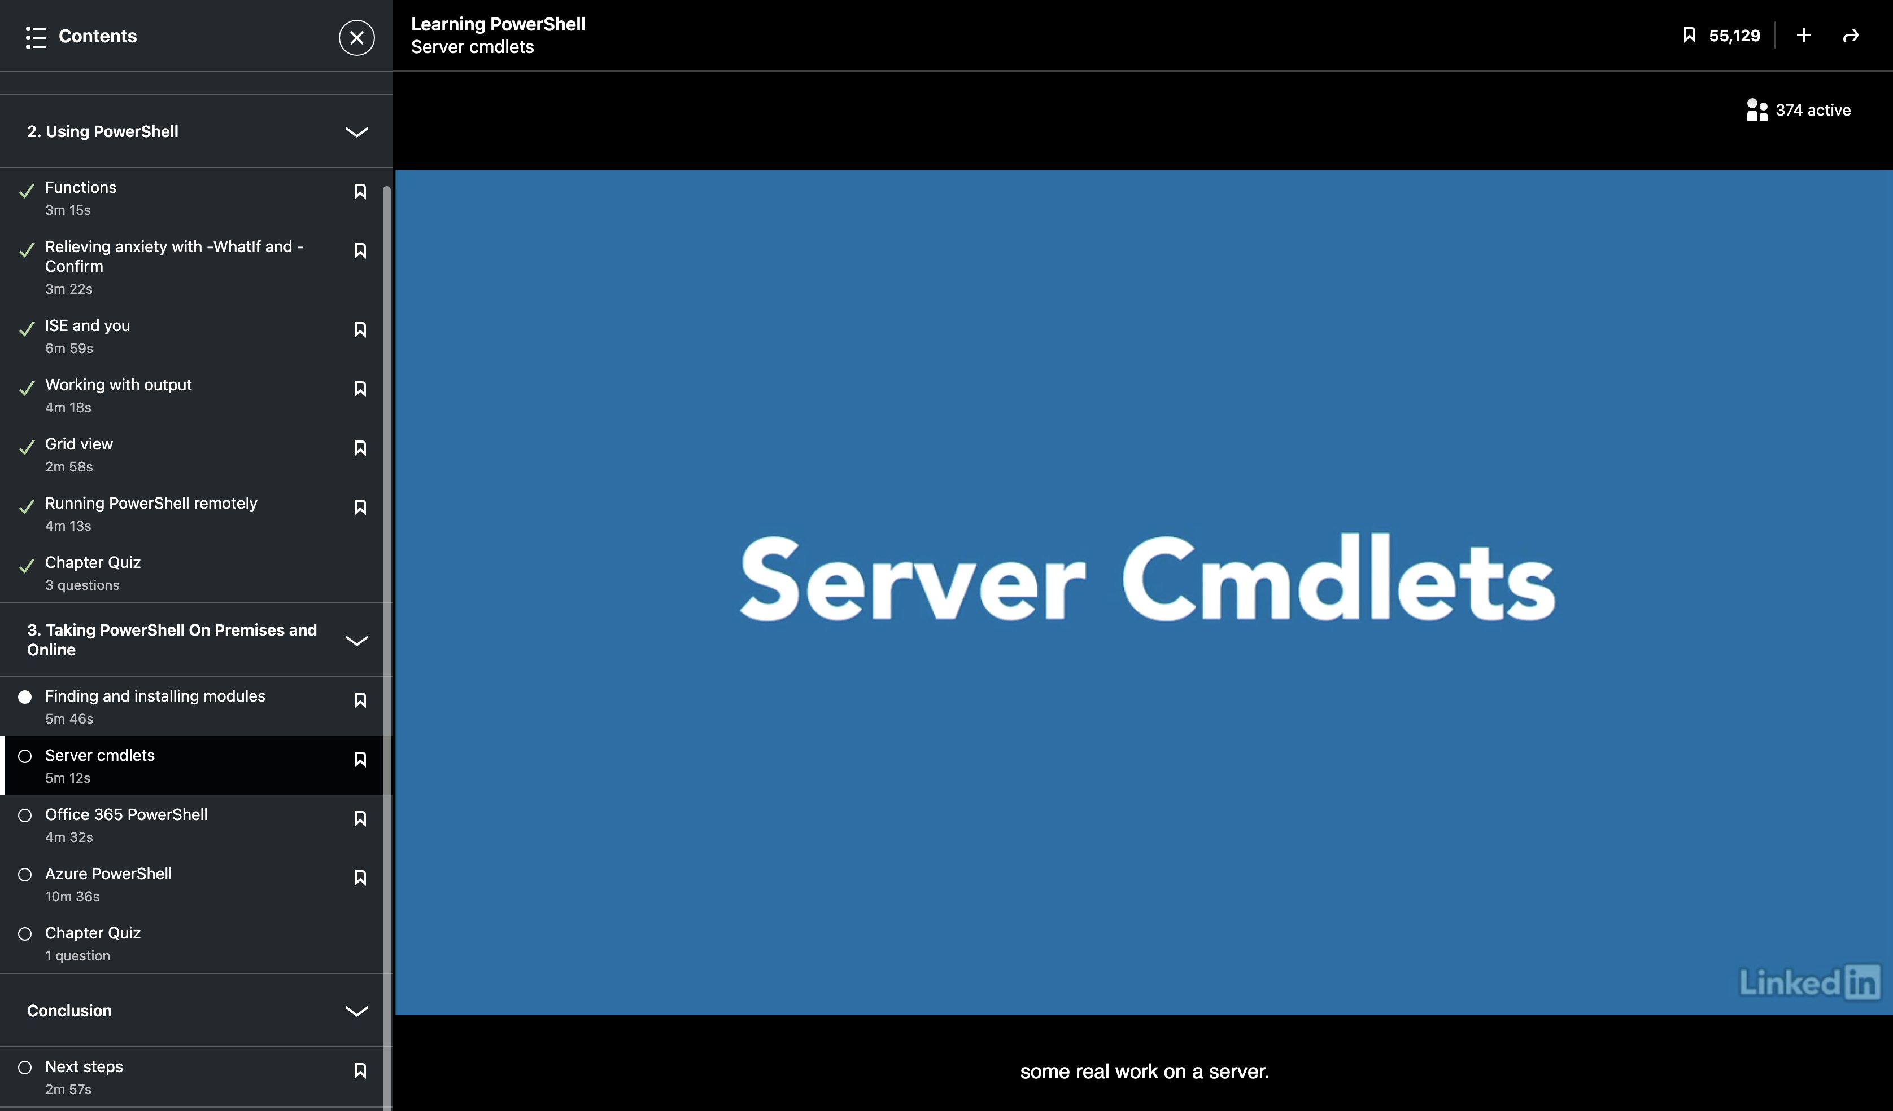

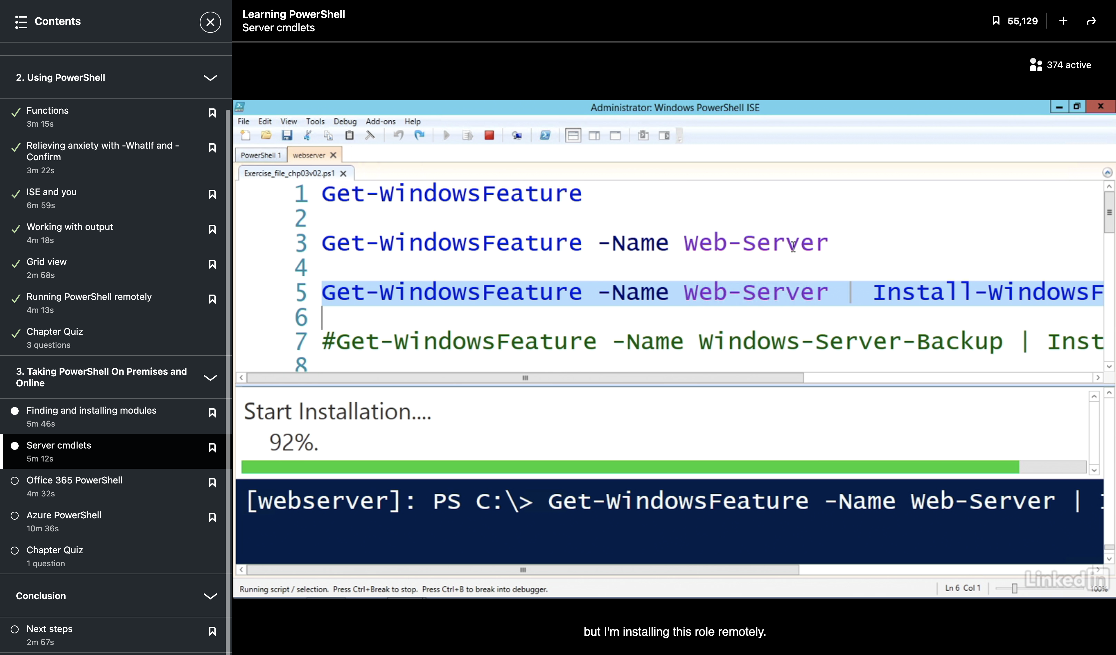

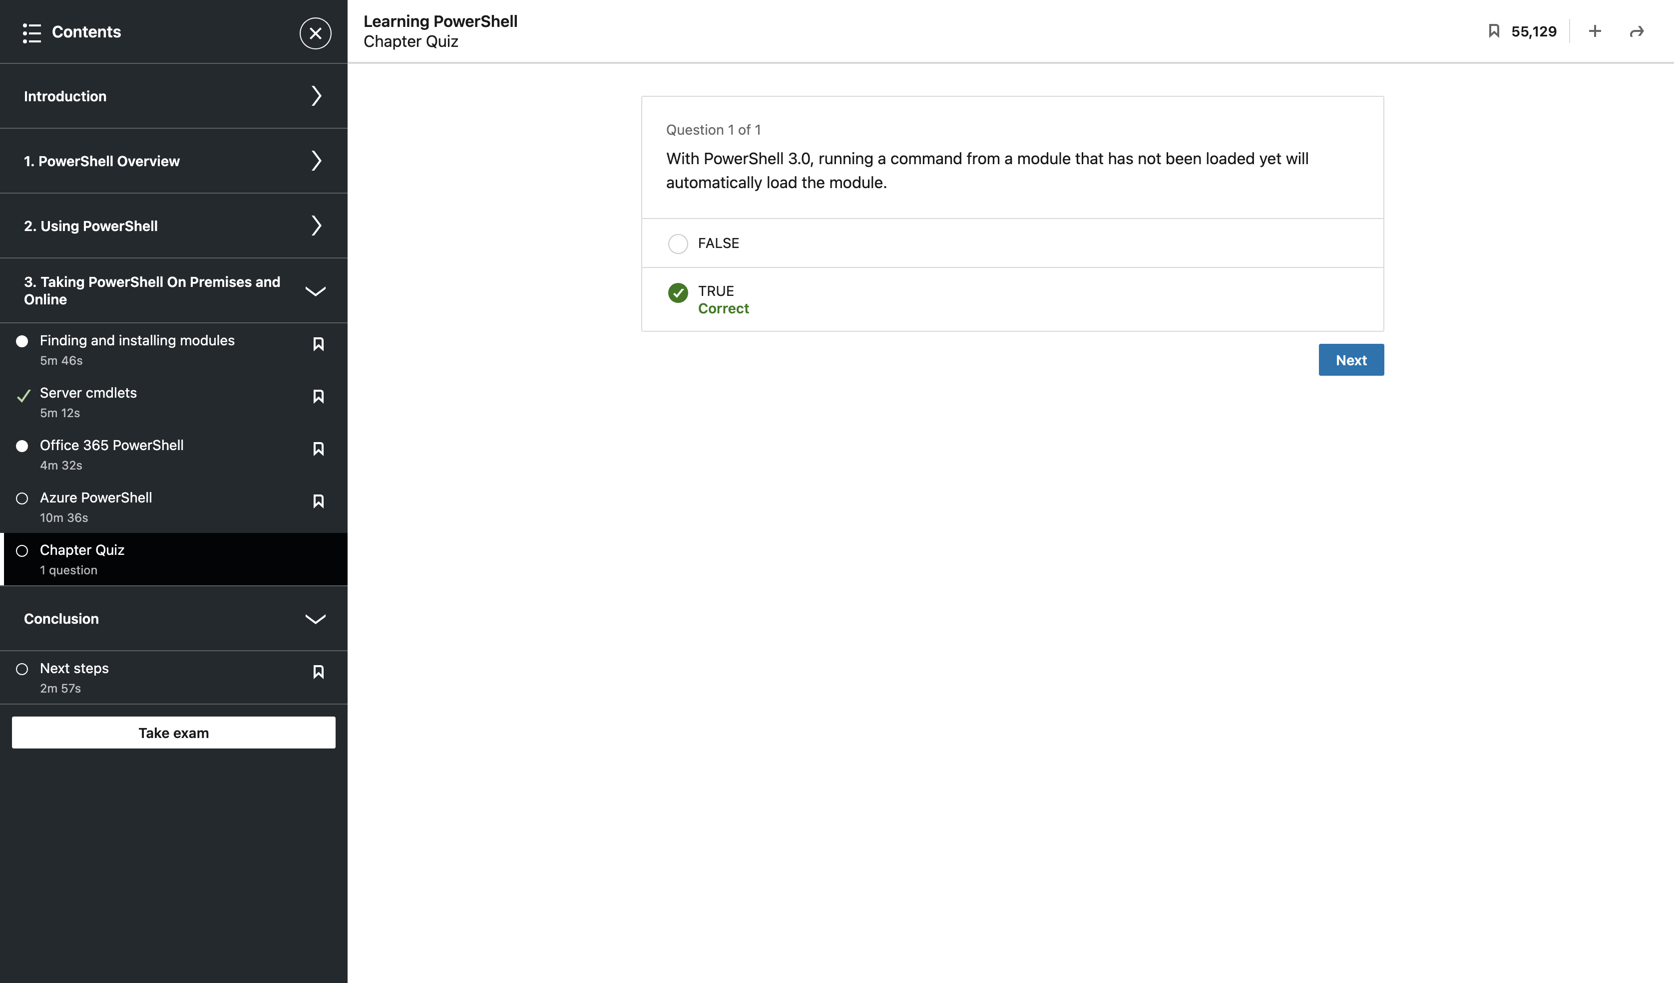

Exam 1st Attempt

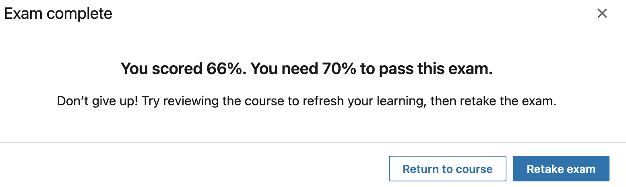

Exam 2nd Attempt



