

ACCA7031_LON ASSESSMENT

Habibur Rahman | 2428138
Digital Forensics Analysis
To
Dr Mohamed Ghanem

Submission Date: 27/04/2026

Table of Contents

Table of Figures 4
1 Abstract 5
2 Introduction 5
3 Literature Review 5
4 Task 1 5
4.1 Topic Selection 5
4.1.1 What the Field Actually Covers 5
4.1.2 The Main Subfields 6
4.1.3 The Tools 6
4.1.4 Typical Forensic Workflow 7
4.1.5 How the Evidence Landscape Has Shifted 7
5 Task 2 7
5.1 Evidence Acquisition 7
5.1.1 Acquisition Process 7
5.1.2 Hash Verification 23
5.1.3 Chain of Custody Documentation 25
5.2 Communication Analysis 35
5.2.1 WhatsApp Analysis (Emma ↔ Joe) 35
5.2.2 Instagram DM Analysis 41
5.2.3 Timeline Reconstruction 46
5.2.4 Key Discussions 49
5.3 File Analysis 49
5.3.1 Emma's USB Flash Drive Examination 49
5.3.2 QT-AI-2025 Patent Files (PDFs, CAD designs) 49
5.3.3 File Metadata Analysis (creation/modification dates) 49
5.3.4 Additional Evidence Files 49
5.3.5 Smartphone File Artefacts 49
5.4 Call Log and Email Correlation 50
5.4.1 Call Log Cross-Reference (Emma, Joe, Vanessa) 50
5.4.2 Email Exchange Analysis (patent sample transfers) 50
5.5 Suspect Profiling 51
5.5.1 Emma (Perpetrator) 51
5.5.2 Joe (Intermediary) 51
5.5.3 Norman (Buyer) 51
5.5.4 Vanessa (Suspected Buyer) 51
5.5.5 Additional Supporting/Refuting Evidence 51
5.6 Forensic Report 51
5.6.1 Case Background 51
5.6.2 Evidence Inventory 51
5.6.3 Methodology 51
5.6.4 Findings 52
5.6.5 Conclusion 52
5.6.6 Recommendations 52
6 Overall Conclusion 53
7 References 53

Table of Figures
Table 1: Chain of Custody Table 34

Figure 1: Digital Forensic Model Comprising 7
Figure 2: Phone Extraction 10
Figure 3: Cellebrite UFED User Interface 10
Figure 4: Cellebrite UFED Case Details 11
Figure 5: Cellebrite UFED Choose Action Interface 11
Figure 6: Cellebrite UFED Detect Device Interface 12
Figure 7: Cellebrite UFED Connect Device Interface 13
Figure 8: Cellebrite UFED Extraction Type Interface 13
Figure 9: Cellebrite UFED Select Mode Interface 14
Figure 10: Cellebrite UFED Extraction Progress Interface 15
Figure 11: Cellebrite Physical Analyzer Interface 16
Figure 12: Cellebrite Physical Analyzer Interface 16
Figure 13: Cellebrite Physical Analyzer Interface 17
Figure 14: Cellebrite Physical Analyzer Interface 18
Figure 15: Cellebrite Physical Analyzer Interface 19
Figure 16: Cellebrite Physical Analyzer Interface 19
Figure 17: Cellebrite Physical Analyzer Interface 20
Figure 18: Four Images Interface 21
Figure 19: Selecting View All for more Data 21
Figure 20: AppGenie Interface 22
Figure 21: Selected Apps Shown in AppGenie 23
Figure 22: AppGenie Running Process 23
Figure 23: Hash Verification of Huawei Phone 24
Figure 24: Hash Verification of Nokia Phone 25
Figure 25: Hash Verification of Samsung Phone 25
Figure 26: Hash Verification of Note Phone 26
Figure 27: Ulefone Note 14 Extraction Details 27
Figure 28: Cellebrite Collection Summery of Ulefone Note 14 28
Figure 29: Samsung Extraction Details 29
Figure 30: Cellebrite Collection Summery of Samsung 30
Figure 31: Nokia Extraction Details 31
Figure 32: Cellebrite Collection Summery of Nokia 32
Figure 33: Huawei Extraction Details 33
Figure 34: Cellebrite Collection Summery of Huawei 33
Figure 35: Cellebrite Collection Summery of Huawei 2 34

Abstract
This report discusses digital forensics by combining theoretical knowledge with practical investigation. It reviews current forensic tools and methods and then applies them to a simulated corporate espionage case involving stolen patent data. The analysis shows how digital evidence can be used to reconstruct events, identify suspects, and support cybersecurity and legal actions.

Introduction
Digital forensics has existed since the 1980s, but the field has changed considerably since then. What once focused mainly on recovering deleted files from early storage devices in police laboratories has now developed into a broad professional discipline involving mobile devices, cloud environments, corporate networks, and digital evidence presented in courts across different countries [1]. The field continues to expand, both in its scope and in the level of technical skill required by investigators.
This examines the current state of digital forensics by looking at how discipline is organized, the tools commonly used by investigators, and the ways digital evidence has evolved in recent years. Understanding this is important for anyone entering the field, conducting investigations, or shaping policies related to digital evidence, because the work of digital forensics today is far more complex than it was in the past [2].

Literature Review
This paper focuses on two tasks. The first task explores a chosen area of digital forensics by reviewing key ideas, professional practices, and challenges discussed in existing literature. The second task builds on this knowledge by putting it into practice through a digital forensic investigation, in which seized devices are analyzed to reconstruct events and uncover evidence related to a simulated corporate espionage incident.

Task 1
Research on a digital forensic topic will be conducted here, addressing several important areas of the field from both academic and professional perspectives.

Topic Selection
In this section, the topic reviewed is the current state of digital forensics and the tools that are used in the field, including their features and capabilities

What the Field Actually Covers
At its core, digital forensics involves identifying, preserving, analysing, and presenting digital evidence in a way that is legally reliable [3]. Although these steps may seem straightforward, each one can be quite challenging in practice. Identifying evidence now means recognising that useful data may exist across different sources at the same time, such as smartphones, cloud accounts, corporate servers, and even vehicle systems. Preserving that evidence requires it to be collected carefully without any changes, using methods that can stand up to legal scrutiny. The analysis stage is where the main investigative work takes place, while the presentation stage focuses on explaining technical findings clearly so that they can be understood and trusted by non-technical audiences.
A review of research trends in digital forensics shows that the field now covers five main subfields: disk forensics, mobile forensics, network forensics, memory forensics, and cloud forensics [4]. Each of these areas has its own methods, tools, and growing body of academic research. In the past, investigators mainly focused on disk and mobile forensics, but today it is common for forensic work to involve all five areas as part of modern investigations.

The Main Subfields
Disk and computer forensics is one of the earliest and most established areas of digital forensics. It mainly involves creating an exact copy of a storage device, known as forensic imaging, so that the original evidence remains unchanged. Investigators can then examine that copy for deleted files, browsing history, system logs, and other digital traces that may help explain what happened [5]. This approach has long been a core part of forensic investigations and continues to support many of the more specialised areas of the field today.
Mobile forensics has become increasingly important as smartphones are now used for communication, storage, and daily personal activities. In this area, investigators work with iOS and Android devices, encrypted data, app-based records, and cloud-linked information that may not always be stored directly on the phone itself [6]. Because mobile devices often contain messages, photos, location records, and financial information, they are often one of the most valuable sources of digital evidence, while also requiring careful handling because of privacy and legal concerns [6].
Network forensics focuses on monitoring and analysing network traffic to identify suspicious or unauthorised activity. This is especially useful in cases involving malware, data exfiltration, or unlawful access, where important evidence may be found in packet captures and network logs rather than on a single device [7]. Memory forensics, by contrast, deals with data stored in a system’s RAM at the time of an incident. This can include active processes, encryption keys, open connections, and certain forms of malware that may disappear once the system is turned off [8]. Although this type of analysis can be technically demanding, it often reveals important evidence that cannot be recovered from permanent storage [8].
Cloud forensics is a newer area of the field and is often considered one of the most challenging. As organisations increasingly rely on platforms such as AWS, Azure, and Google Cloud, a large amount of digital evidence is now stored in environments that investigators cannot physically access [9]. This has made cloud-based investigations more important than ever, while also creating new technical and legal difficulties. Research has also shown strong growth in this area, reflecting the rising demand for cloud forensic skills and services [9].

The Tools
The tools used in digital forensics today can generally be divided into two groups: commercial platforms designed for professional investigations and open-source tools that are often used for specific tasks, training, or by teams working with limited budgets.
Among the commercial tools, Cellebrite UFED is widely recognised for mobile device extraction. It supports many different devices and can recover deleted data, application content, and cloud-related evidence [10]. Magnet AXIOM is broader in scope, as it can collect and examine data from computers, mobile devices, cloud accounts, and even vehicles within a single case [11]. It is especially useful for bringing together evidence from different sources and helping investigators understand connections between them [11]. EnCase is another well-established forensic tool, particularly in computer forensics. It is known for disk imaging, keyword searching, and its usefulness in large corporate investigations and legal discovery work [12].
Open-source tools also play an important role in forensic investigations. Autopsy is one of the most widely used free forensic platforms and is commonly used for disk image analysis, timeline creation, and file recovery [13]. Volatility is a well-known tool for memory forensics and helps investigators examine processes, code injection, network connections, and rootkits from memory dumps [8]. Wireshark is mainly used for network analysis and remains a trusted tool for examining packet traffic in both law enforcement and cybersecurity investigations [7].
An important point is that no single tool can handle every type of evidence on its own. In practice, investigators often use a combination of tools depending on the case. For example, one tool may be used to capture disk or memory images, another to examine mobile devices, and another to analyse network traffic or correlate evidence from multiple sources. For this reason, digital forensic work usually depends on a toolkit of methods and software rather than relying on only one tool [13].

Typical Forensic Workflow

Figure 1: Digital Forensic Model Comprising
According to prior studies [1] In 2001, the Digital Forensic Research Workshop (DFRWS) proposed a seven-phase digital forensic process consisting of identification, preservation, collection, examination, analysis, presentation, and decision-making. Unlike earlier models, it formally incorporated activities conducted both before evidence acquisition and after analysis, particularly those related to legal proceedings. These phases are logically interconnected, with each stage building upon and influencing the outcomes of the others to ensure a reliable forensic investigation, as shown in Figure 1

How the Evidence Landscape Has Shifted
For a long time, digital forensic investigations mainly focused on physical devices that could be seized, imaged, and analysed directly by investigators. Although this still happens, it is no longer the only source of digital evidence. A growing amount of evidence is now stored in cloud environments, where investigators do not have direct physical access, and where data may be distributed across servers in different countries. In many cases, access to this information depends on the cloud service provider, which can affect what data can be obtained and how quickly it can be accessed [14].
The rise of IoT devices has made the situation even more complex. Devices such as smartwatches, home assistants, connected vehicles, and industrial sensors can all contain useful forensic evidence, but the wide variety of hardware and software involved makes analysis more difficult for investigators [2]. Research has shown that the number of IoT devices is expected to continue growing rapidly, which means both the amount of potential evidence and the technical challenges are increasing at the same time [2]. In addition, legal frameworks such as GDPR in Europe and the California Consumer Privacy Act place important restrictions on how digital evidence can be collected, stored, and used, creating further challenges for forensic investigations [1].

Task 2
Here, the focus is on investigating a simulated corporate espionage case involving the suspected theft and attempted sale of Quantum Tech’s confidential patent data using evidence collected from several digital devices.

Evidence Acquisition

Acquisition Process
Here, the forensic images of four phones were acquired, starting with the extraction process from each device and followed by analysis in Cellebrite Analyzer.
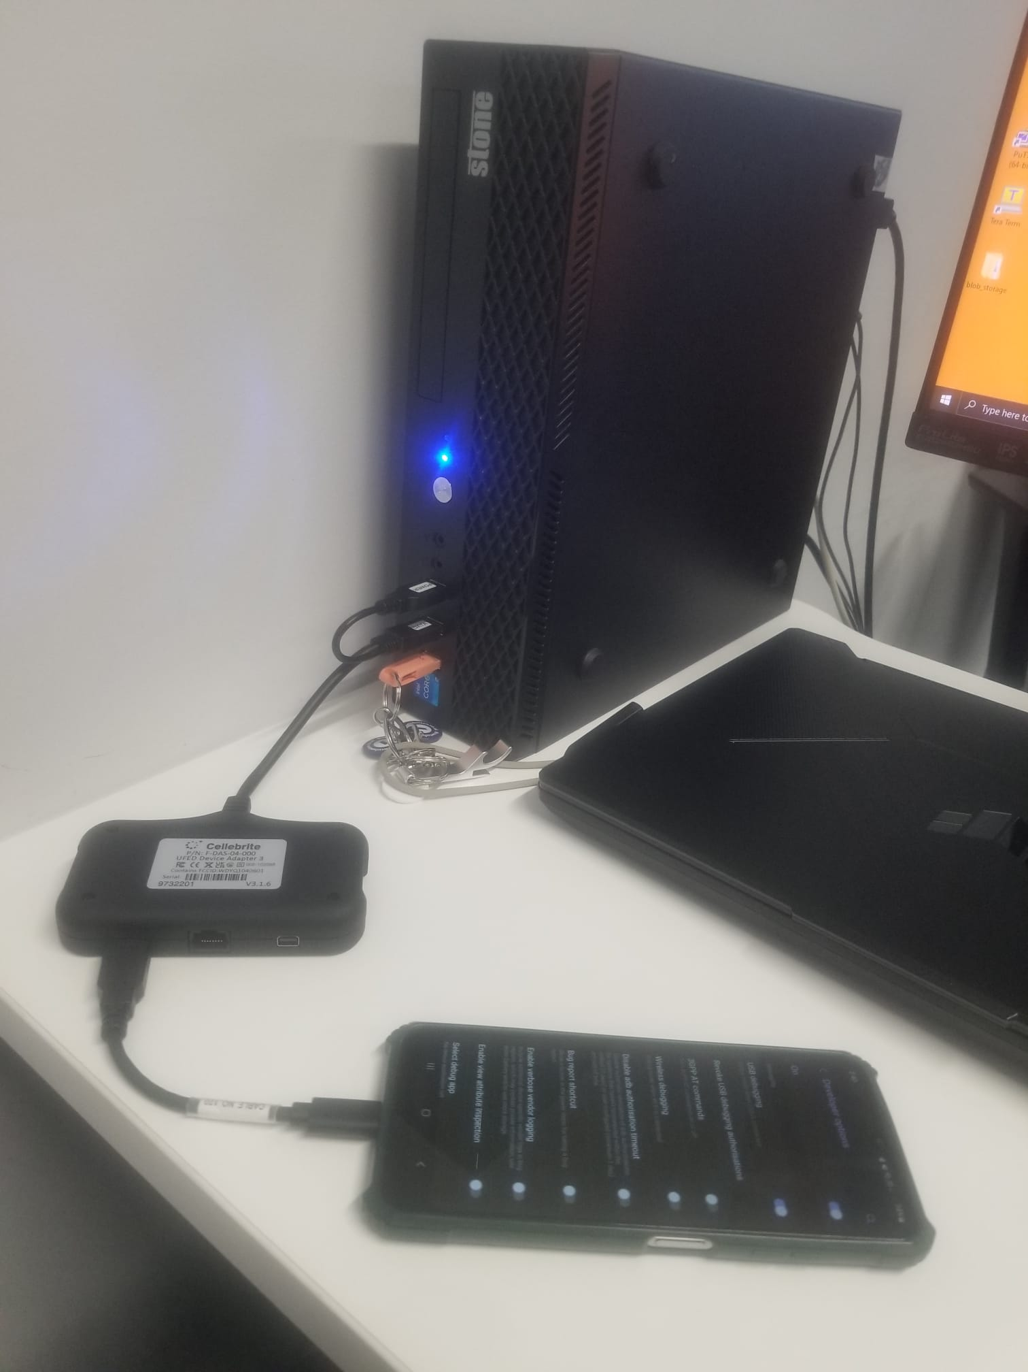
Figure 2: Phone Extraction
The following Figure 2 shows the process of extracting data from the phone for forensic acquisition.
After that, Cellebrite UFED was opened to perform the mobile data extraction. As no screenshots of the original extraction process were available, a personal mobile device was used only to demonstrate the steps involved in the acquisition process.
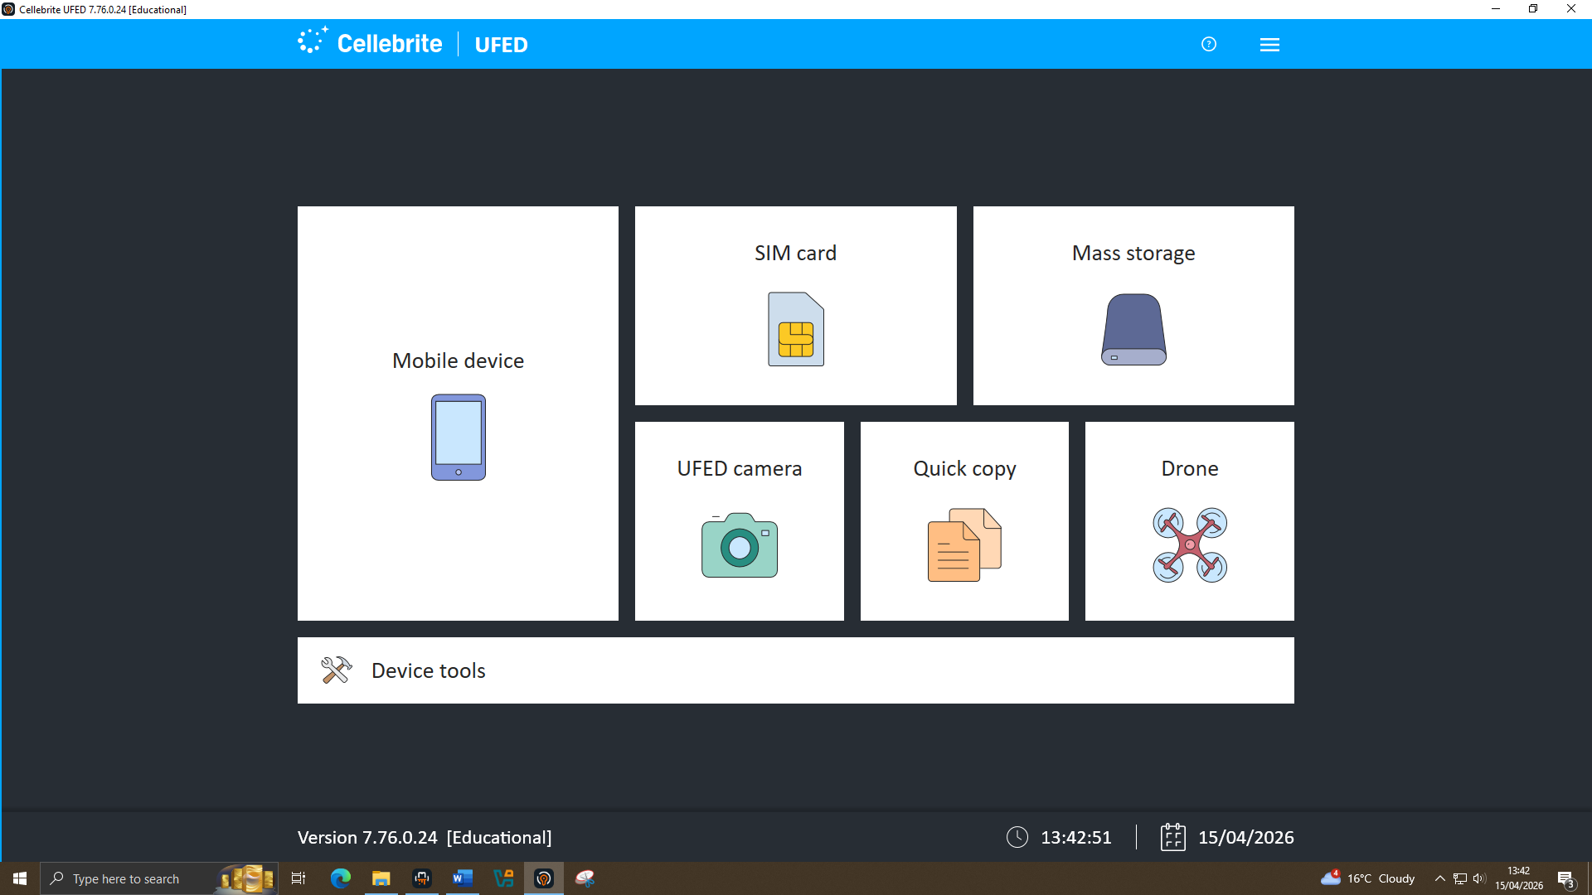
Figure 3: Cellebrite UFED User Interface
After opening Cellebrite UFED, the Mobile Device option was selected to begin the extraction process, as shown in Figure 3

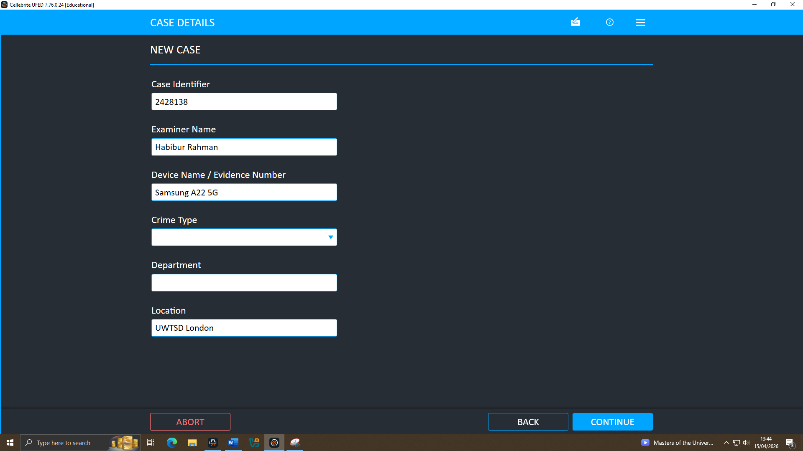
Figure 4: Cellebrite UFED Case Details
The case details were documented for future investigation, as shown in Figure 4
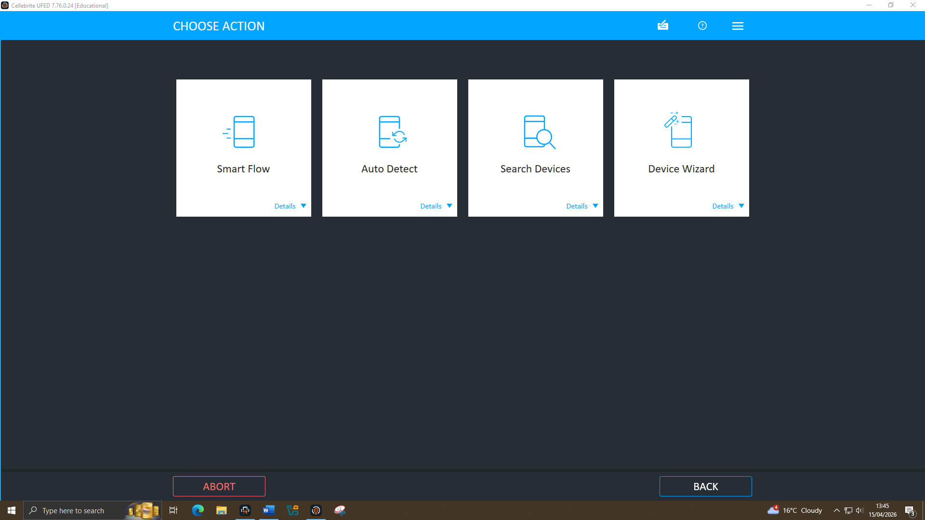
Figure 5: Cellebrite UFED Choose Action Interface
The Auto Detect option was selected to identify the type of phone, its model, and version information automatically, as shown in Figure 5
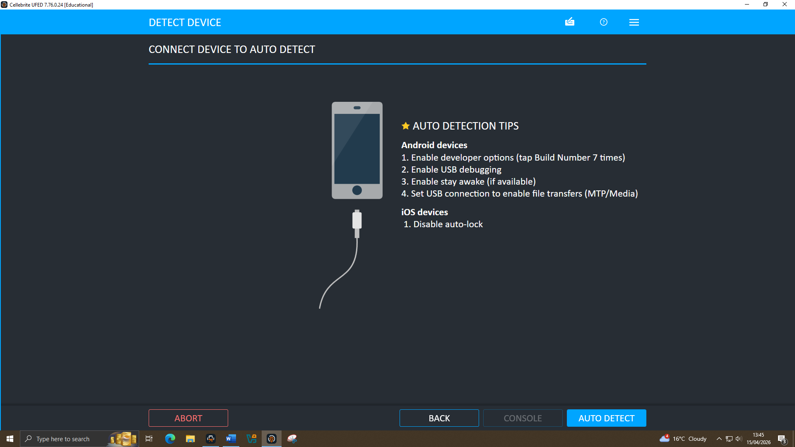
Figure 6: Cellebrite UFED Detect Device Interface
The Auto Detect function automatically identified the phone version and provided guidance for completing the extraction correctly, as shown in Figure 6.

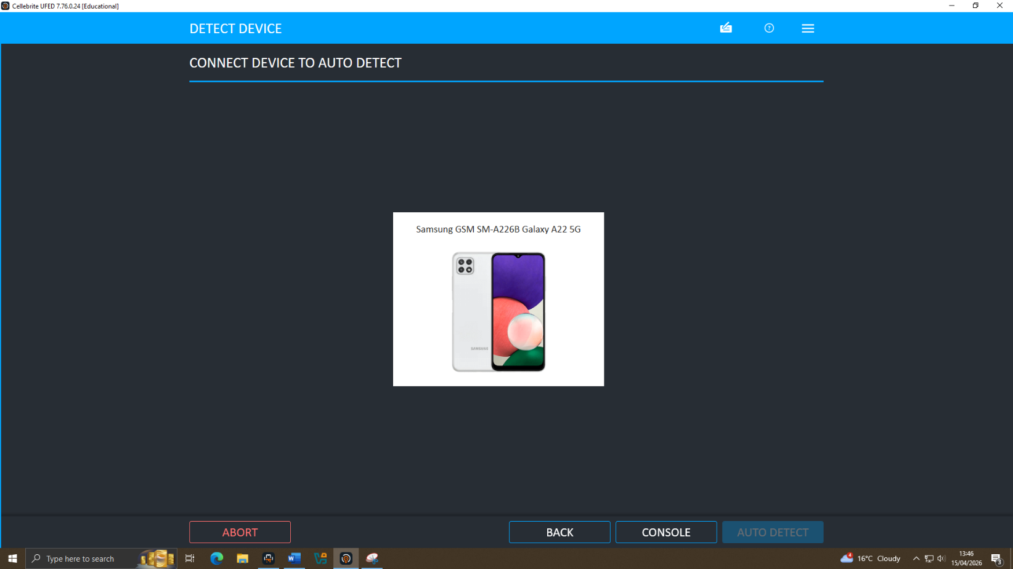
Figure 7: Cellebrite UFED Connect Device Interface
As a result, the device was automatically identified, and the detected phone was then selected for extraction, as shown in Figure 7
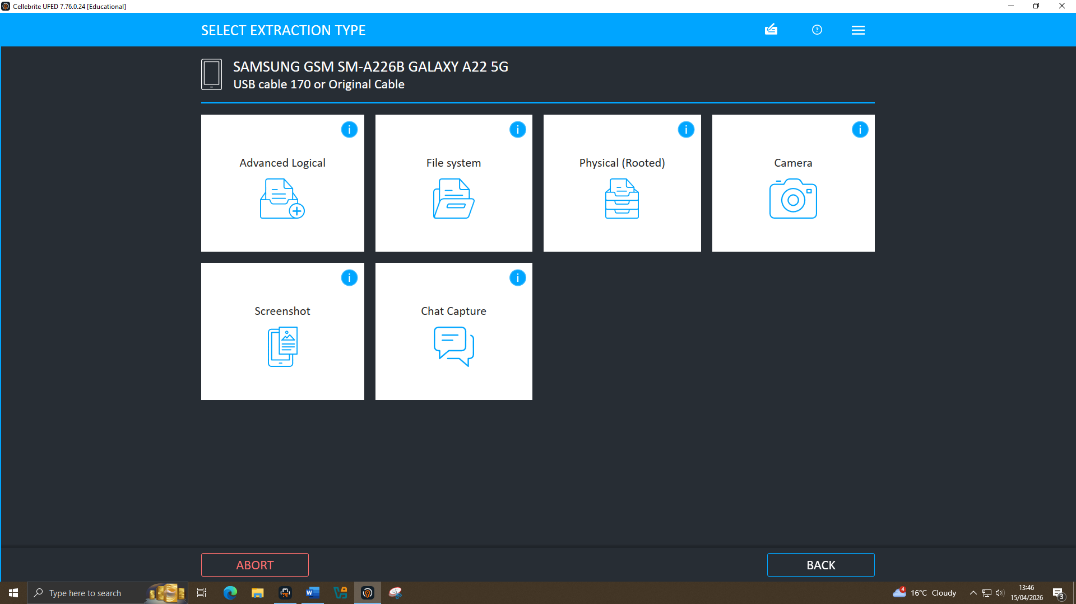
Figure 8: Cellebrite UFED Extraction Type Interface
Several extraction options were available, and for this process the File System option was selected, as shown in Figure 8
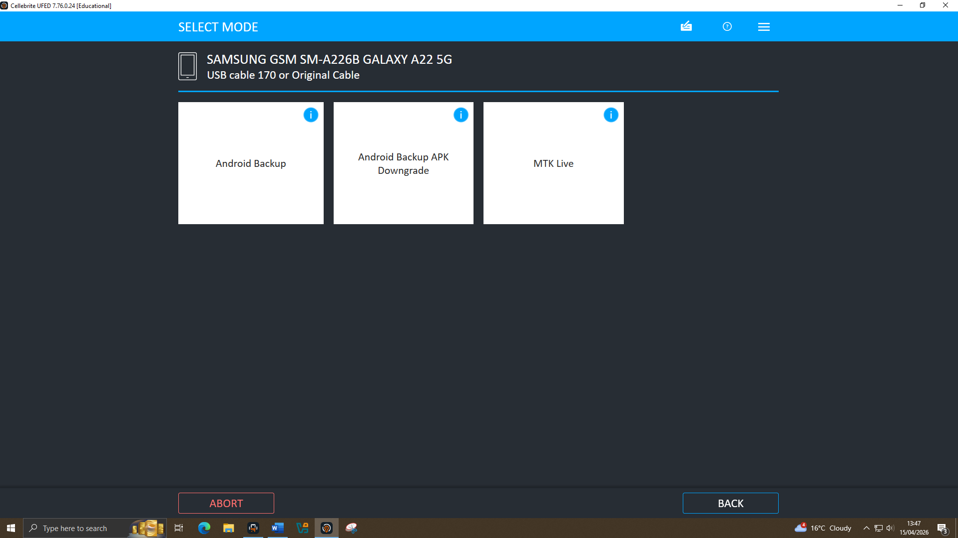
Figure 9: Cellebrite UFED Select Mode Interface
Several extraction modes were available, and the Android Backup mode was selected for this process, as shown in Figure 9
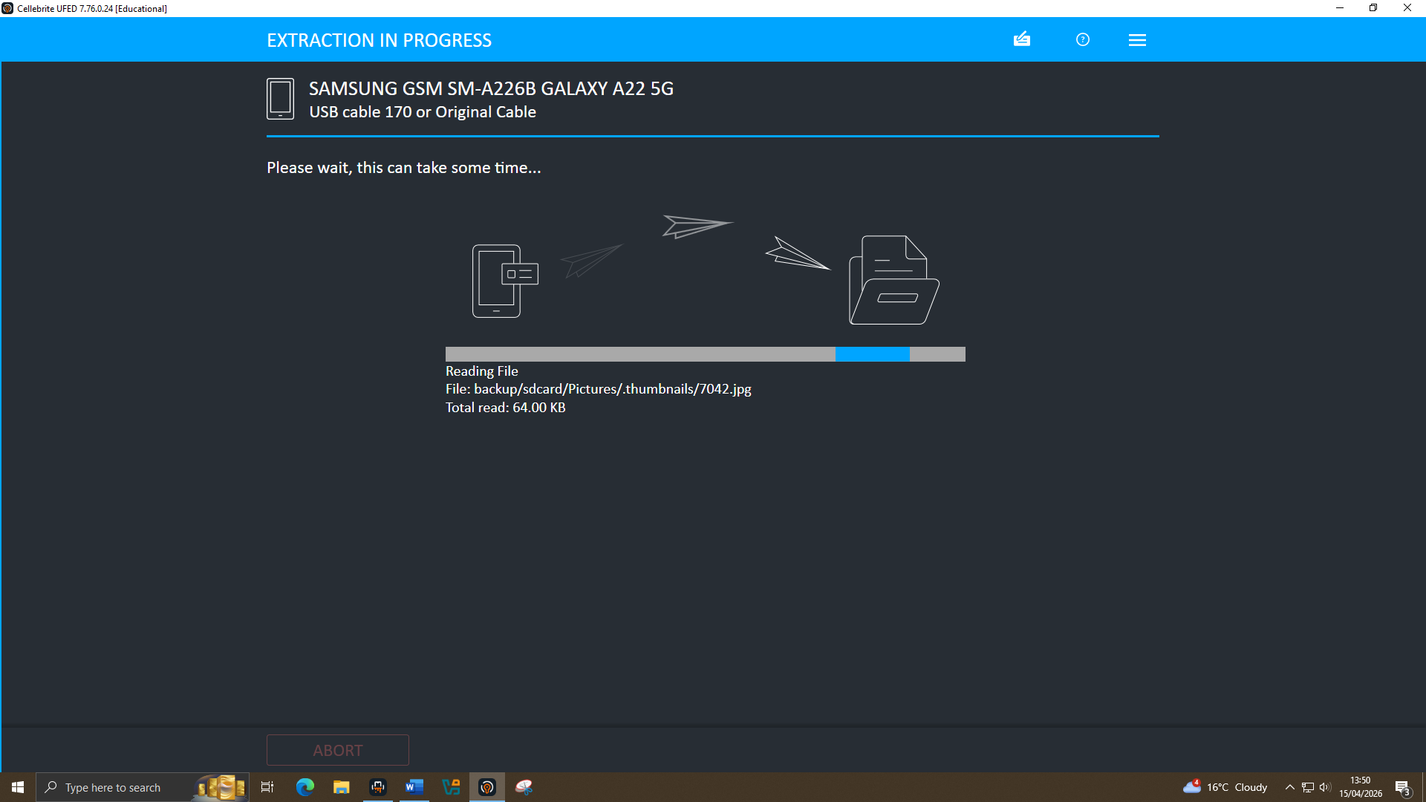
Figure 10: Cellebrite UFED Extraction Progress Interface
Finally, the extraction process was started, and the extracted data was obtained for further investigation, as shown in Figure 10
After the extraction was successfully completed, the acquired data was analysed to support the investigation. For this purpose, the Cellebrite UFED Analyzer was opened to examine the extracted data.
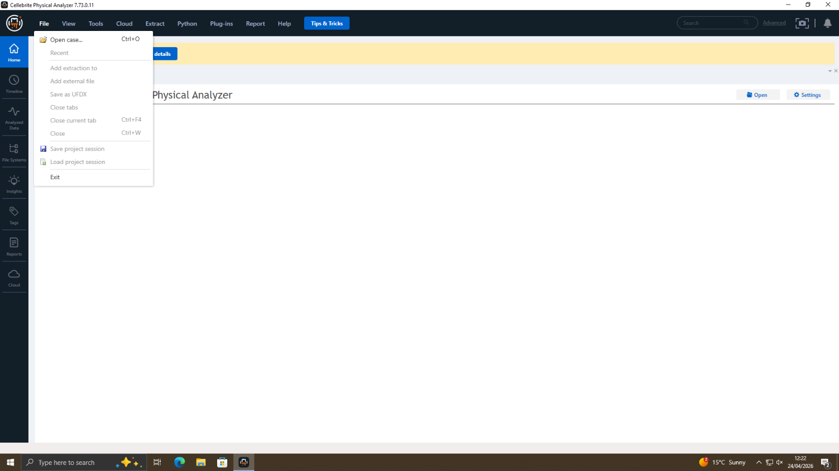
Figure 11: Cellebrite Physical Analyzer Interface
After opening Cellebrite Physical Analyzer, the Open Case option was selected to load the four extracted images into a single case for easier comparison and more effective investigation, as shown in Figure 11
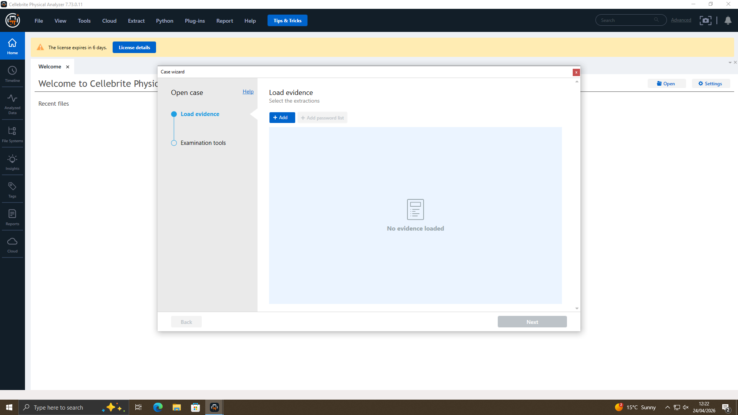
Figure 12: Cellebrite Physical Analyzer Interface
At this stage, the Load Evidence option was selected to add the extracted evidence files from the computer, as shown in Figure 12
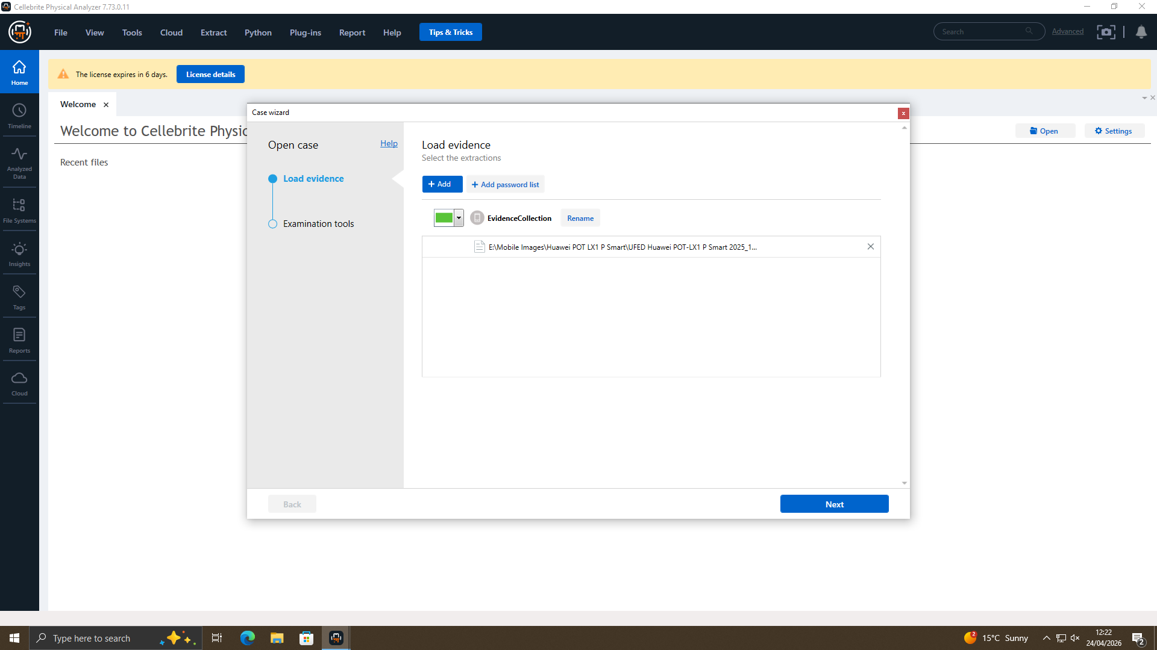
Figure 13: Cellebrite Physical Analyzer Interface
After the evidence was successfully loaded, the Next button was selected to continue the process, as shown in Figure 13
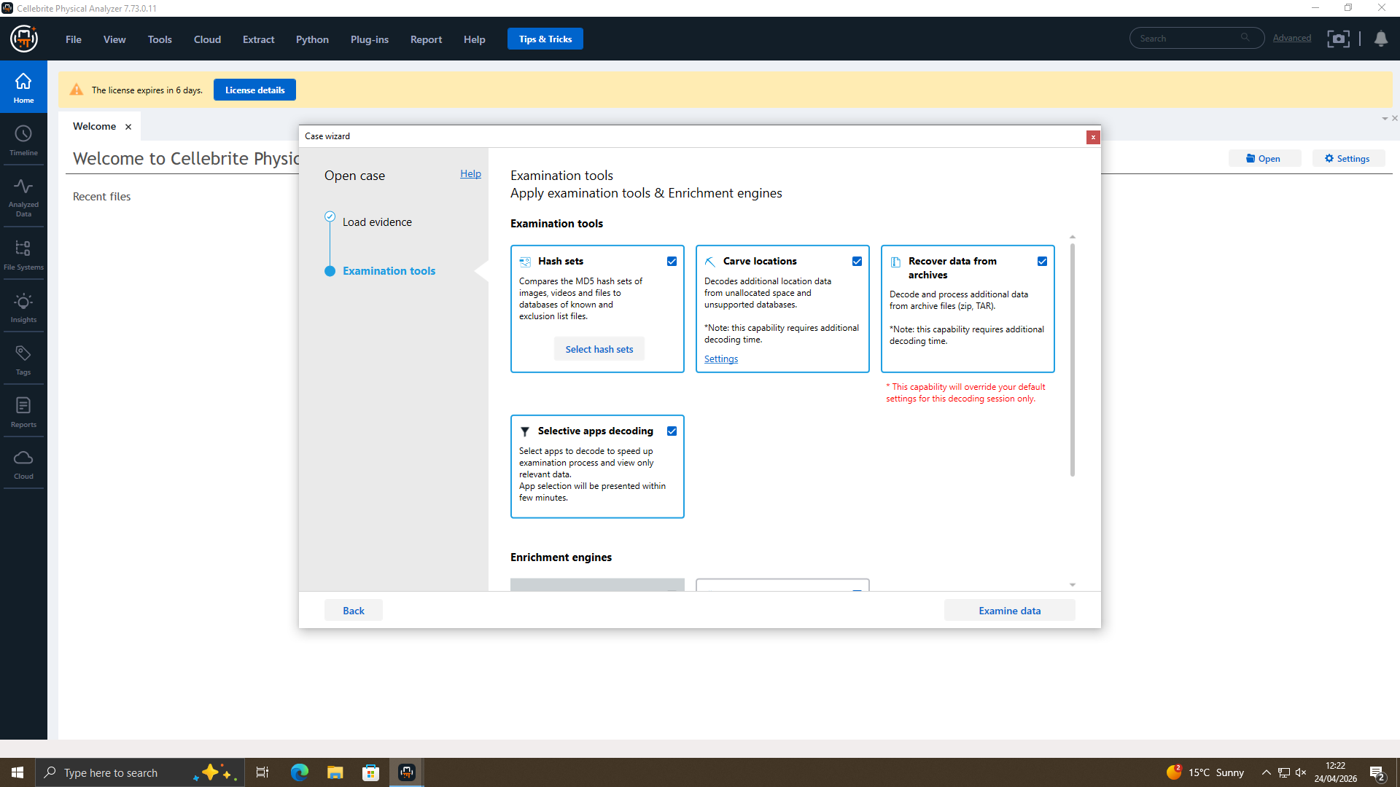
Figure 14: Cellebrite Physical Analyzer Interface
At this stage, only four options were selected: Hash Sets, Carve Locations, Recover Data from Archives, and Selective Apps Decoding, as shown in Figure 14
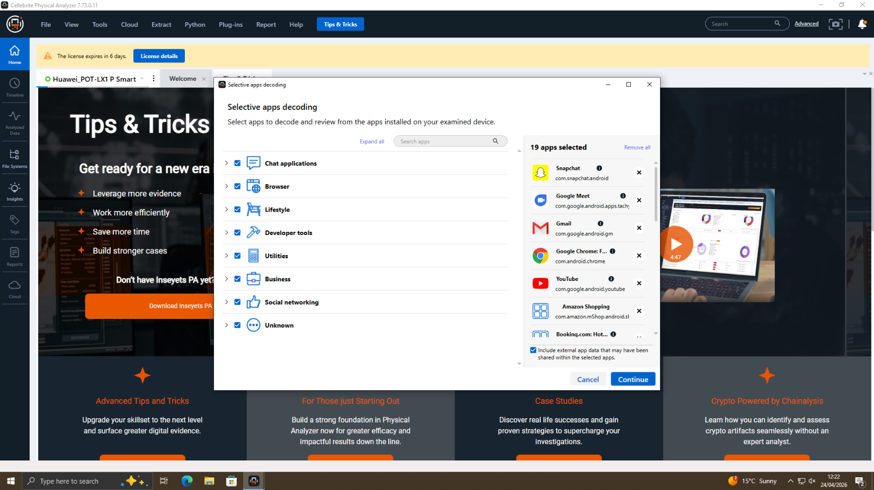
Figure 15: Cellebrite Physical Analyzer Interface
At this stage, all Selective Apps Decoding options were selected, and the process was continued by pressing Next, as shown in Figure 15
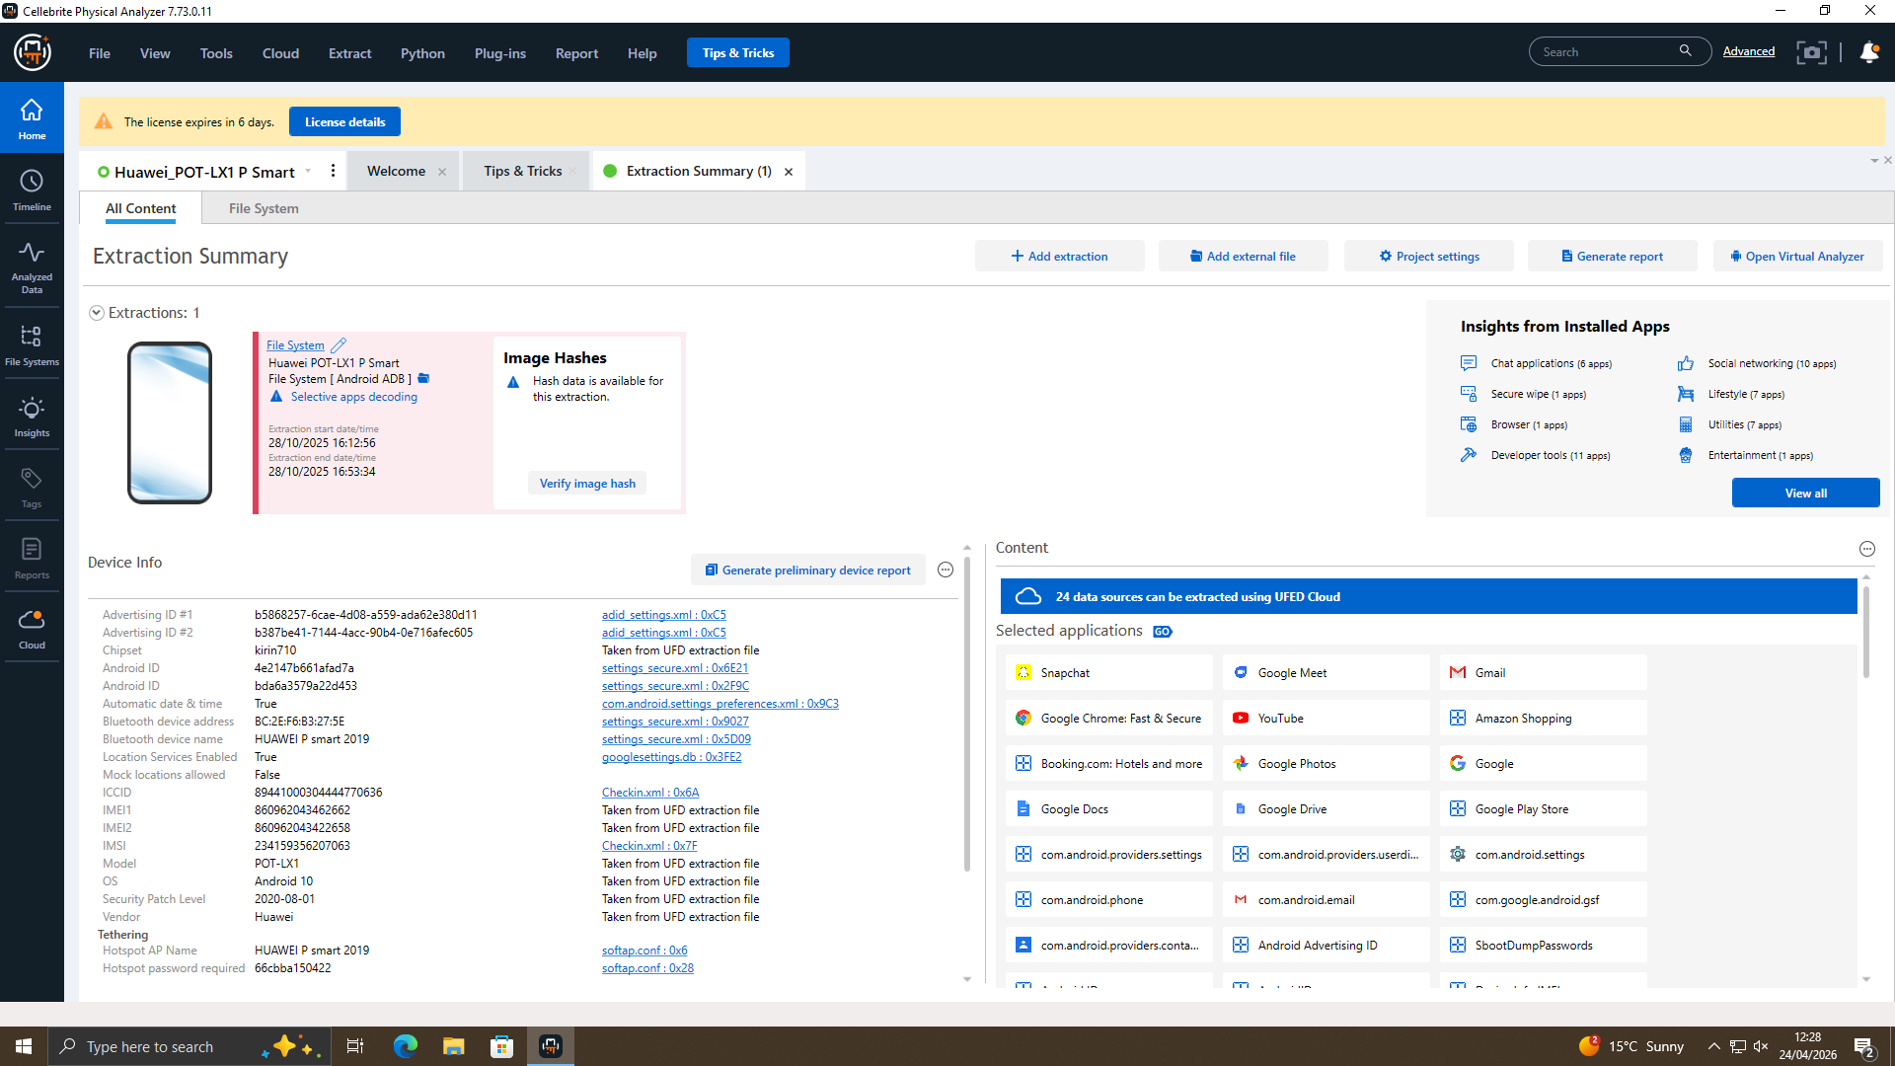
Figure 16: Cellebrite Physical Analyzer Interface
After all the required steps were completed successfully, the phone data output was displayed for analysis, as shown in Figure 16. This process was completed for one phone image.
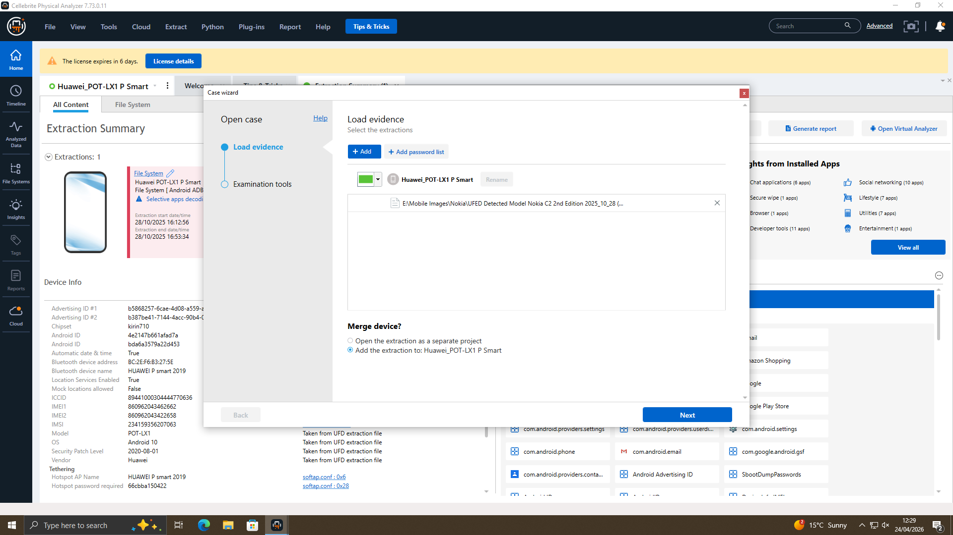
Figure 17: Cellebrite Physical Analyzer Interface
From the Files section, the Open Case and Load Evidence options were selected, and the same process as the previous step was followed. At the final stage, all four images were merged into a single case using the Merge option, as shown in Figure 17
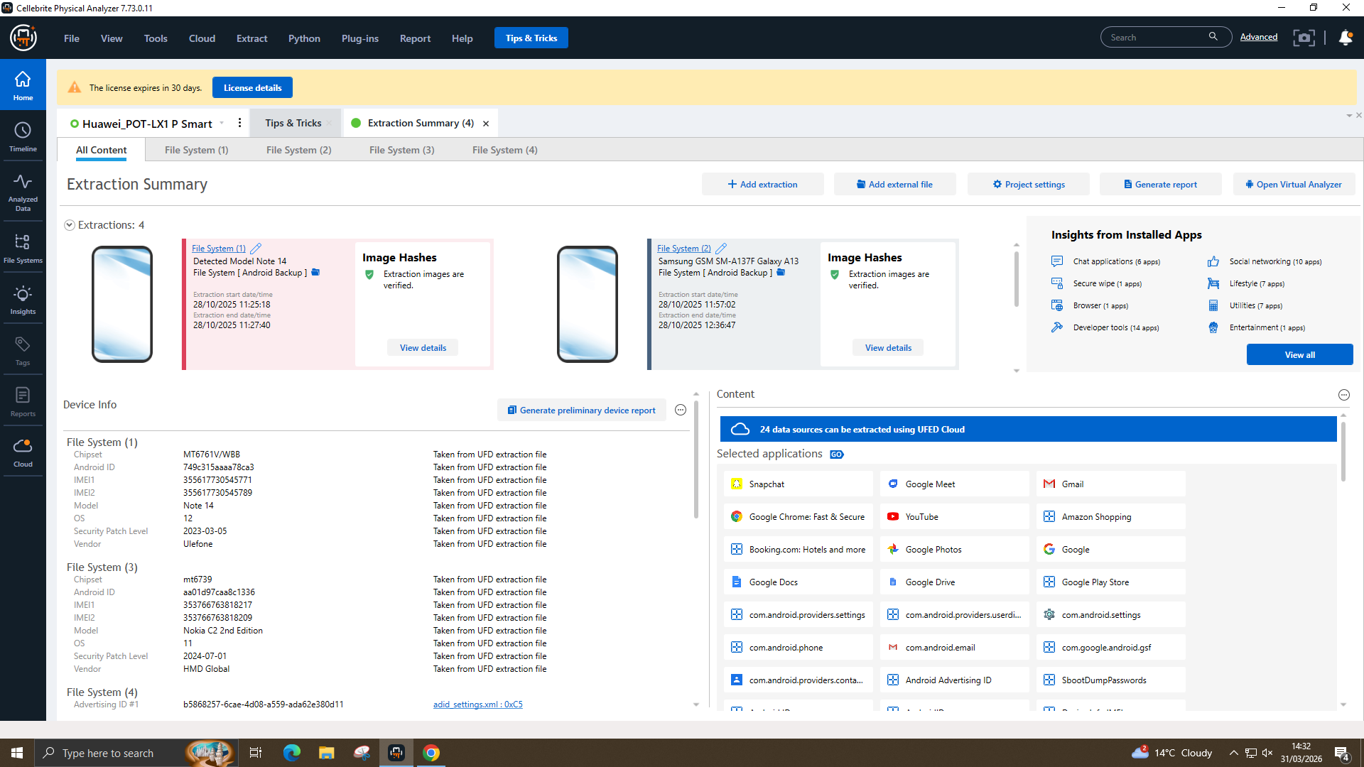
Figure 18: Four Images Interface
After the merging process was completed, the combined output was displayed in Cellebrite Physical Analyzer, as shown in Figure 18
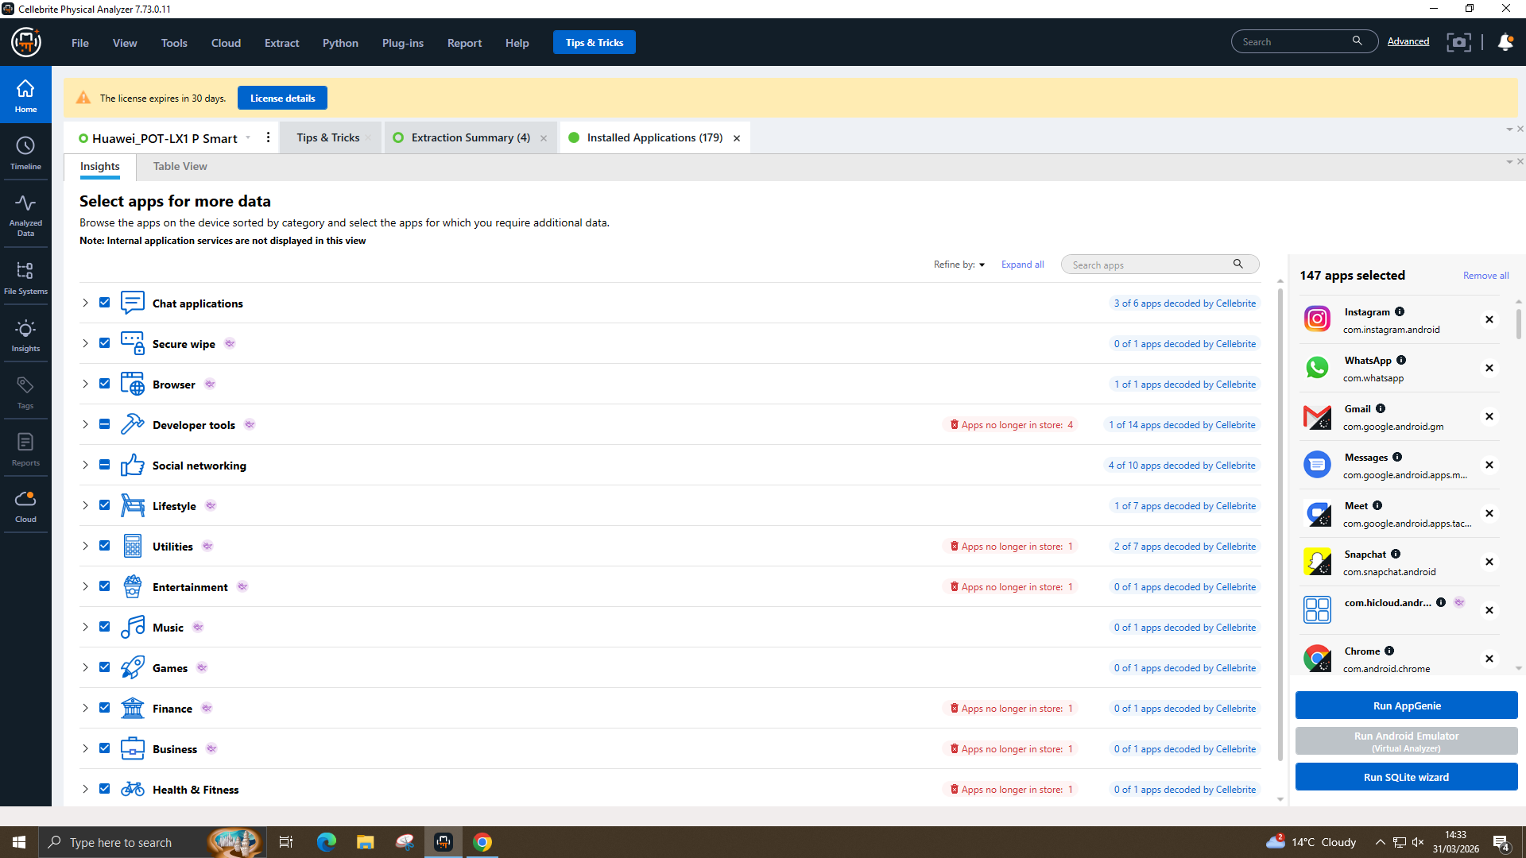
Figure 19: Selecting View All for more Data
The View All option was then selected, and all available applications were chosen to obtain more data before running App Genie, as shown in Figure 19
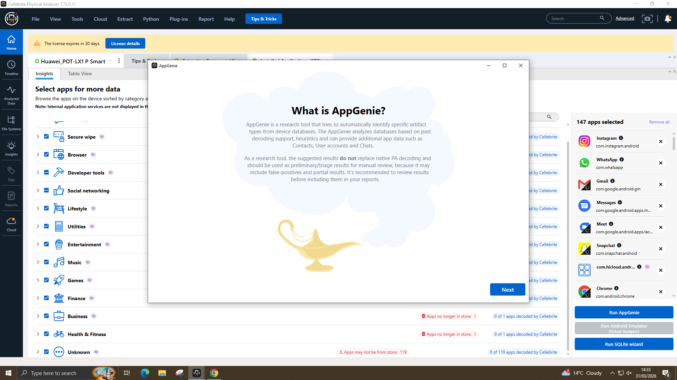
Figure 20: AppGenie Interface
After selecting all the available applications, App Genie was run to identify the supported apps and highlight the benefits of the analysis process, as shown in Figure 20
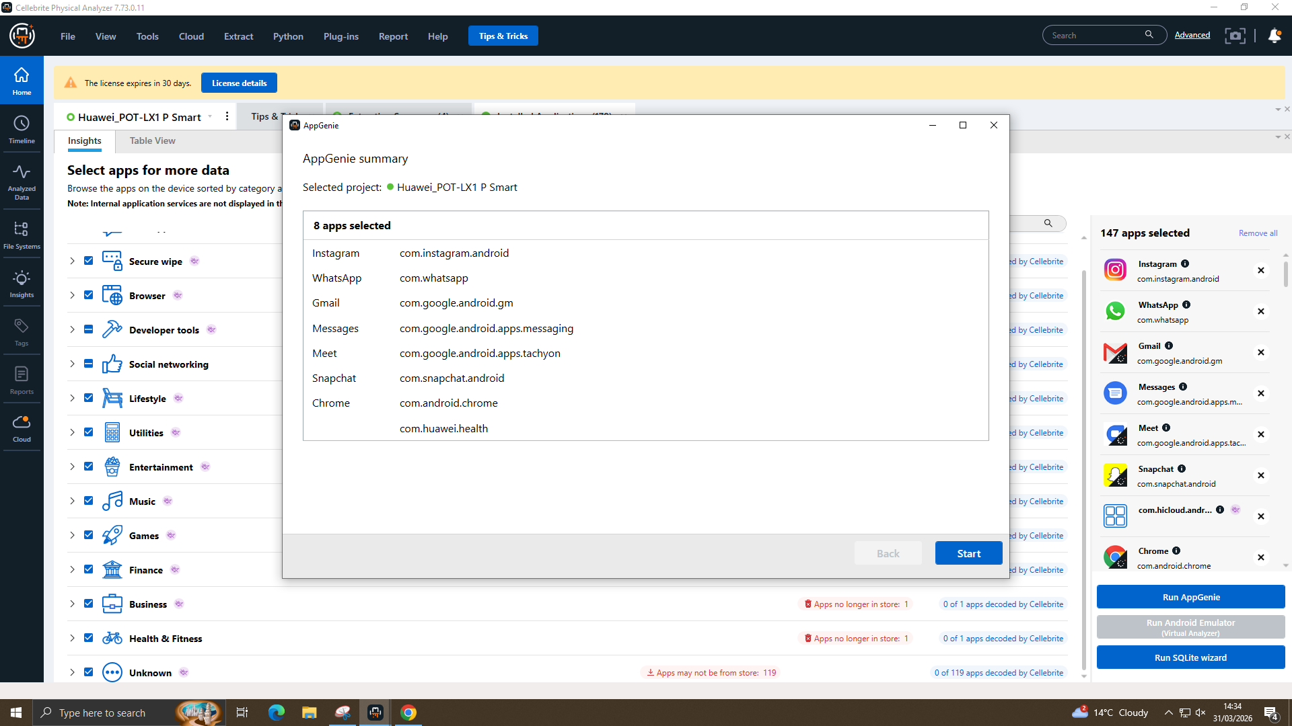
Figure 21: Selected Apps Shown in AppGenie
The App Genie summary was then displayed, and the Start button was selected to proceed with the analysis, as shown in Figure 21
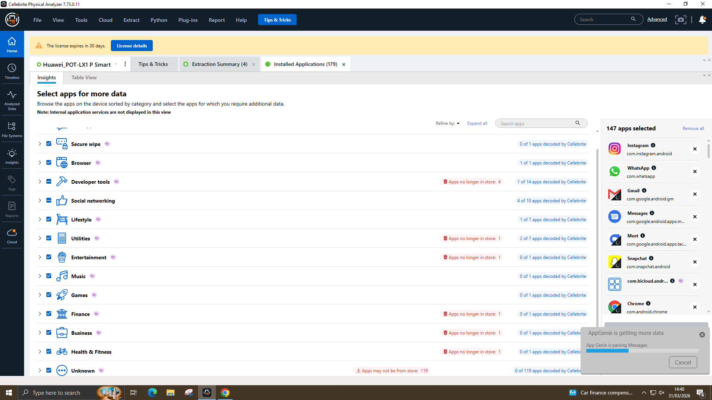
Figure 22: AppGenie Running Process
App Genie was then started, and once the process was completed, it displayed the relevant information needed to support the investigation, as shown in Figure 22

Hash Verification
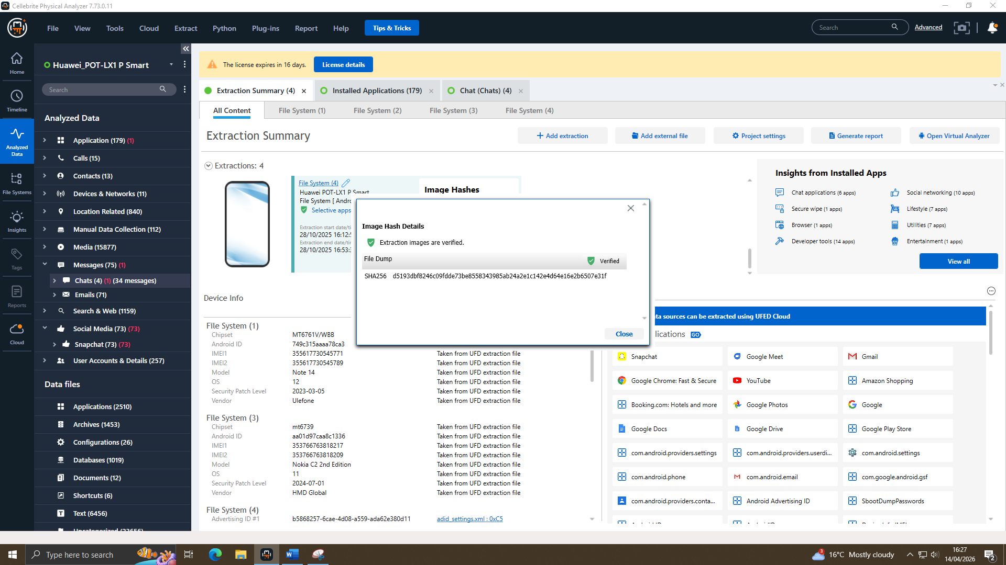
Figure 23: Hash Verification of Huawei Phone
Here, the SHA-256 hash value of the Huawei mobile phone was verified, as shown in Figure 23.
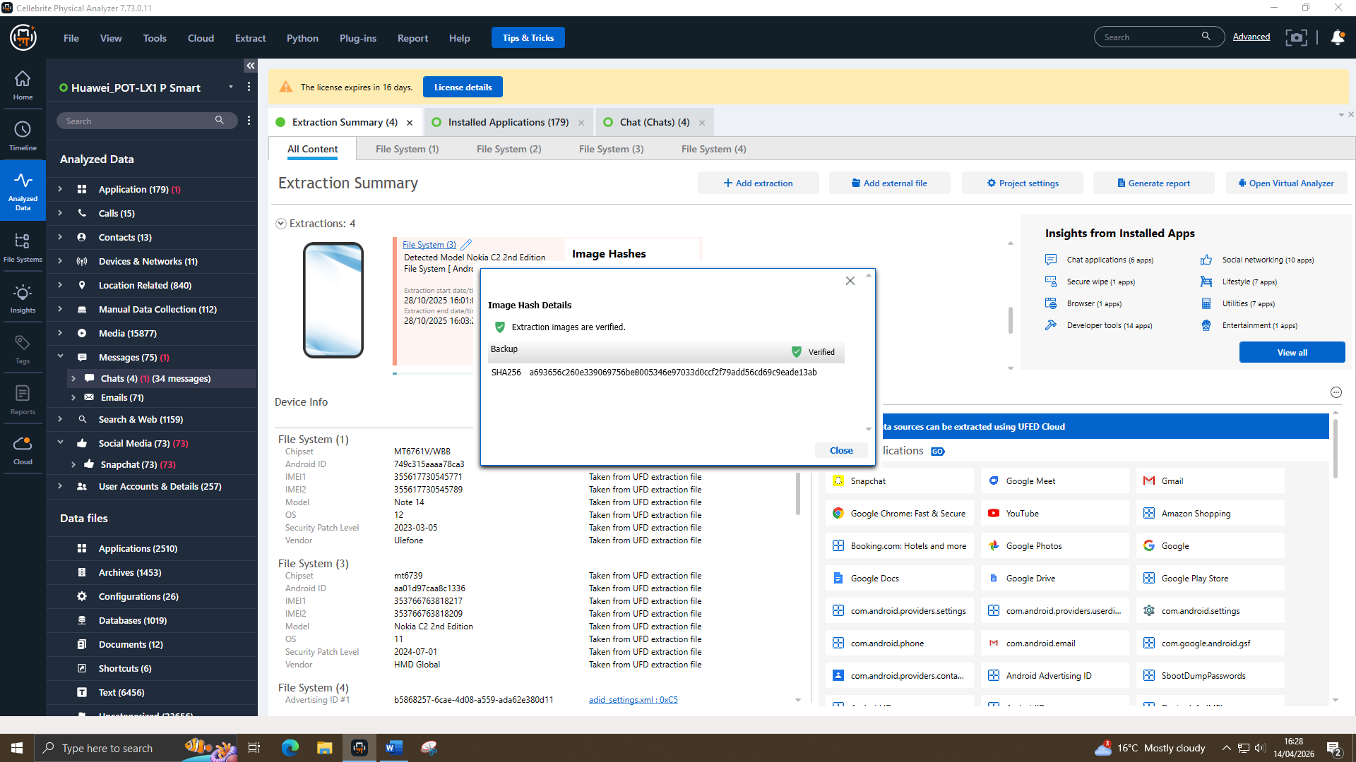
Figure 24: Hash Verification of Nokia Phone
Here, the SHA-256 hash value of the Nokia mobile phone was verified, as shown in Figure 24.
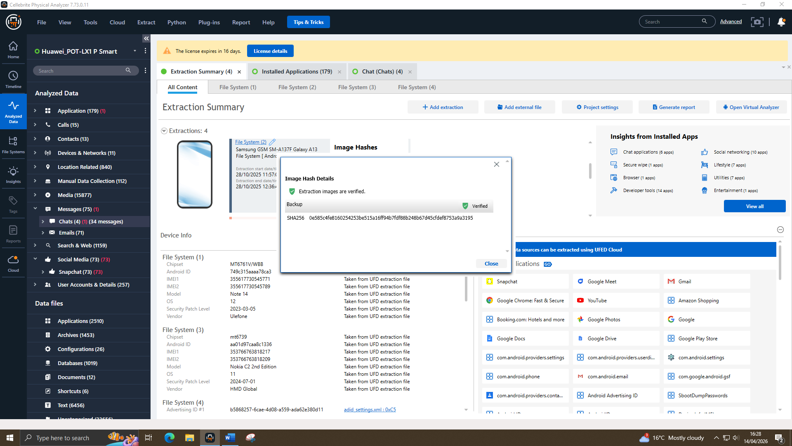
Figure 25: Hash Verification of Samsung Phone
Here, the SHA-256 hash value of the Samsung mobile phone was verified, as shown in Figure 25.
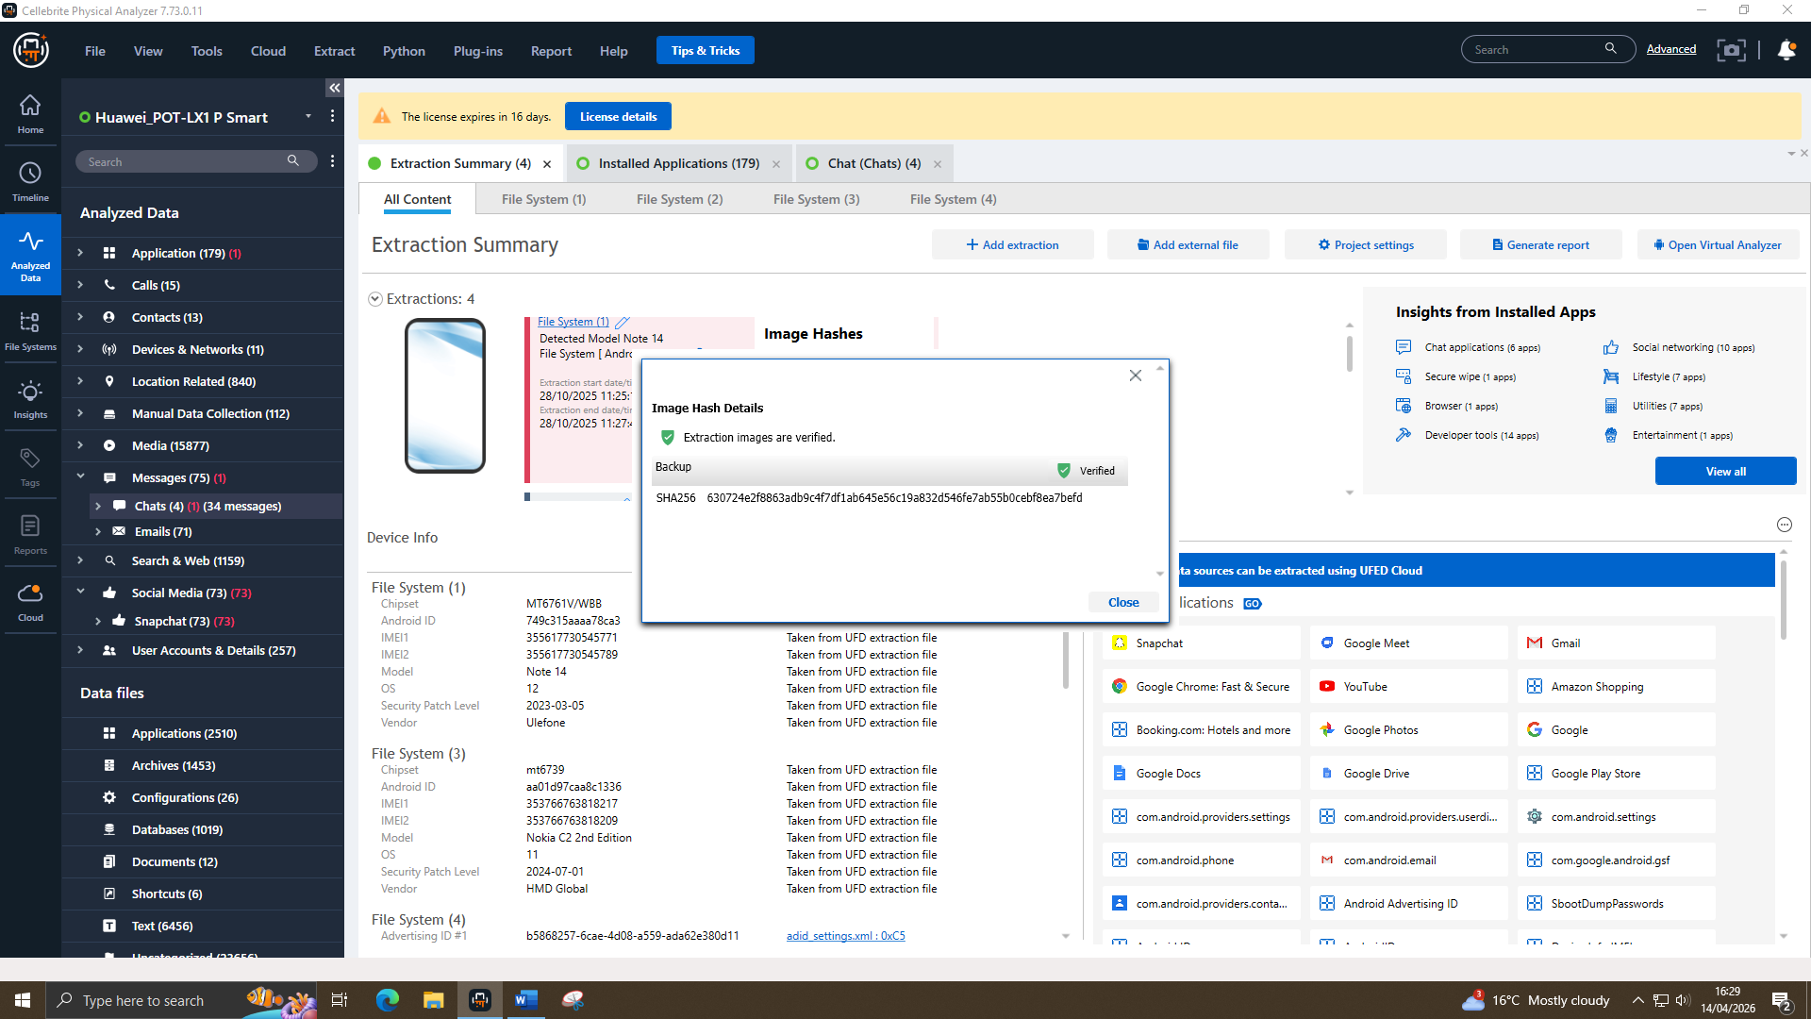
Figure 26: Hash Verification of Note Phone
Here, the SHA-256 hash value of the Note mobile phone was verified, as shown in Figure 26.

Chain of Custody Documentation

Evidence Inventory
- MOB-01 – Ulefone Note 14 Smartphone
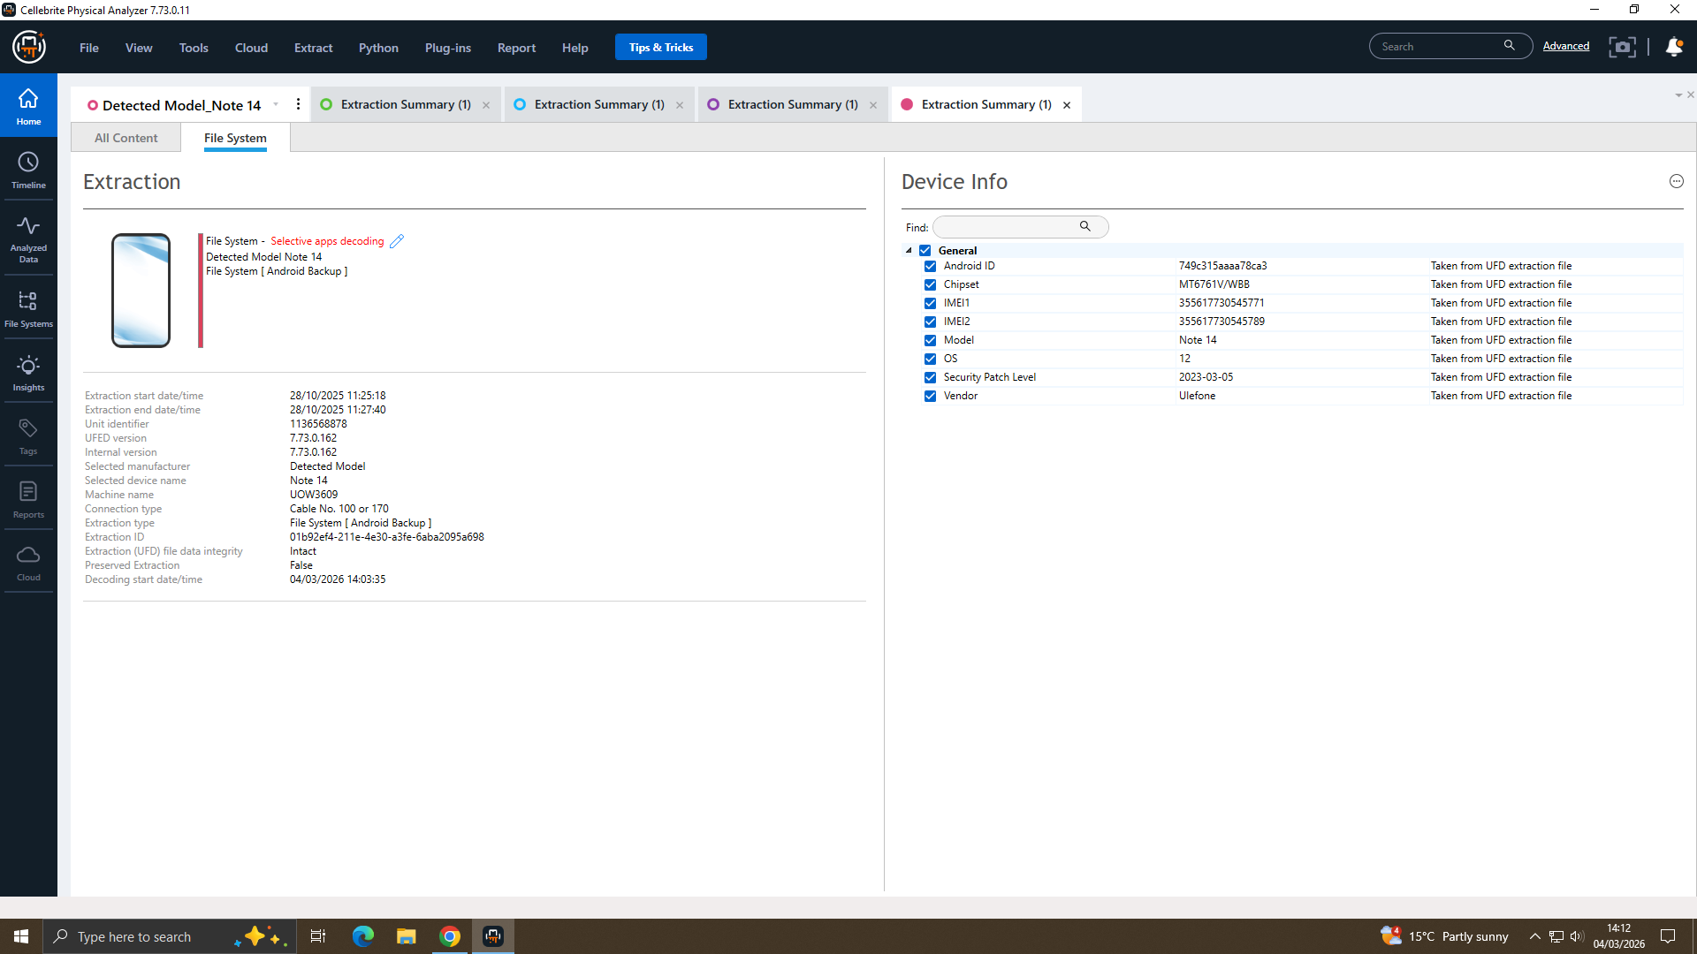
Figure 27: Ulefone Note 14 Extraction Details
Following data extraction using Cellebrite UFED Analyzer, the device was identified as a Ulefone Note 14, and its key device information was successfully recovered, as showed in Figure 27
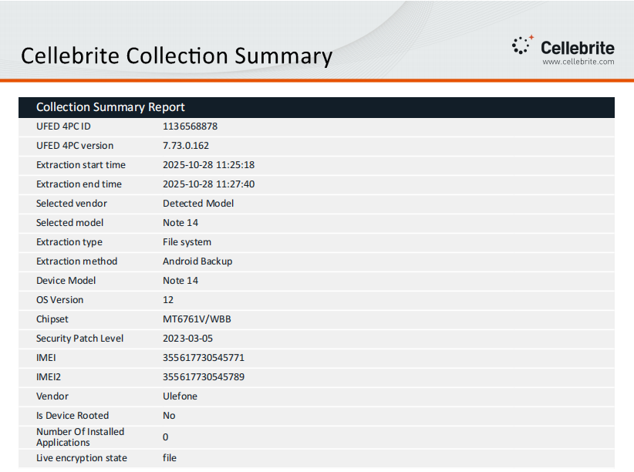
Figure 28: Cellebrite Collection Summery of Ulefone Note 14
The Cellebrite UFED Analyzer collection summary identified the extracted device as a Ulefone Note 14, with relevant device details successfully recovered, as illustrated in Figure 28
- MOB-02 – Samsung Galaxy A13 (SM-A137F)
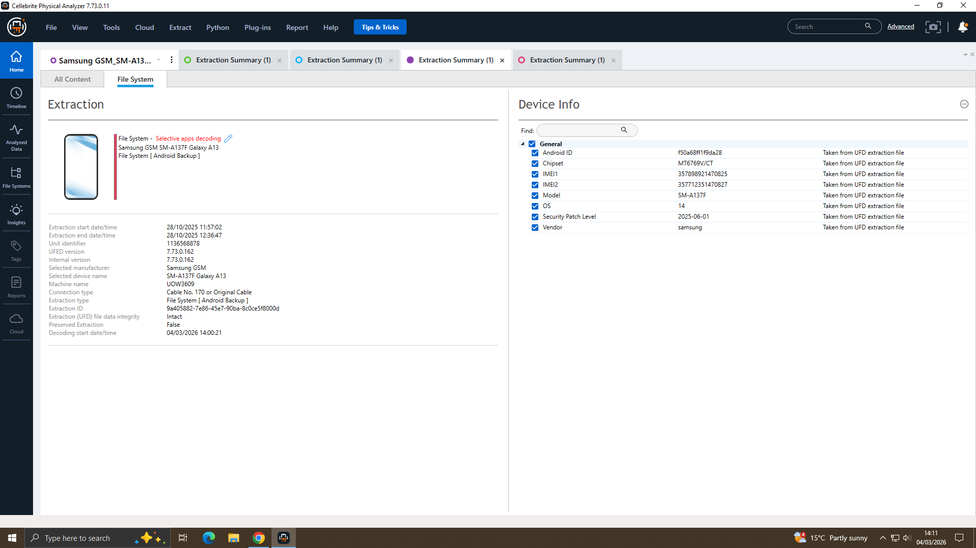
Figure 29: Samsung Extraction Details
Following data extraction using Cellebrite UFED Analyzer, the device was identified as a Samsung Galaxy A13 (SM-A137F), and its key device information was successfully recovered, as showed in Figure 29
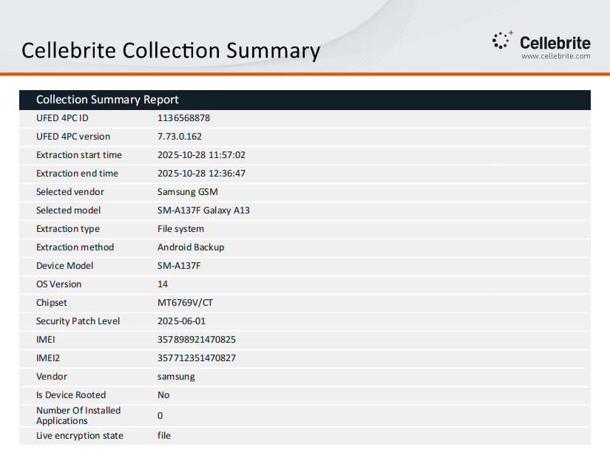
Figure 30: Cellebrite Collection Summery of Samsung
The Cellebrite UFED Analyzer collection summary identified the extracted device as a Samsung Galaxy A13 (SM-A137F), with relevant device details successfully recovered, as illustrated in Figure 30
- MOB-03 – Nokia C2 2nd Edition Smartphone
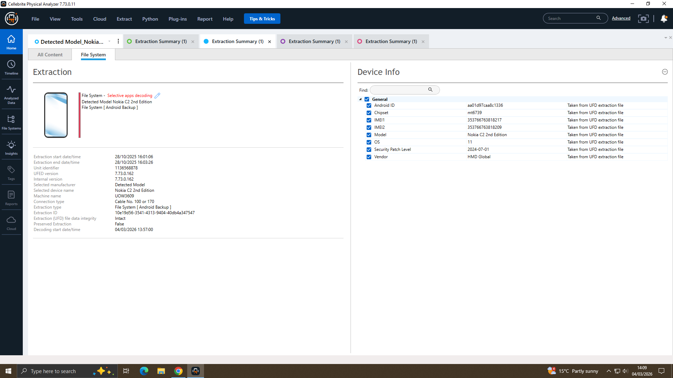
Figure 31: Nokia Extraction Details
Following data extraction using Cellebrite UFED Analyzer, the device was identified as a Nokia C2 2nd Edition, and its key device information was successfully recovered, as showed in Figure 31

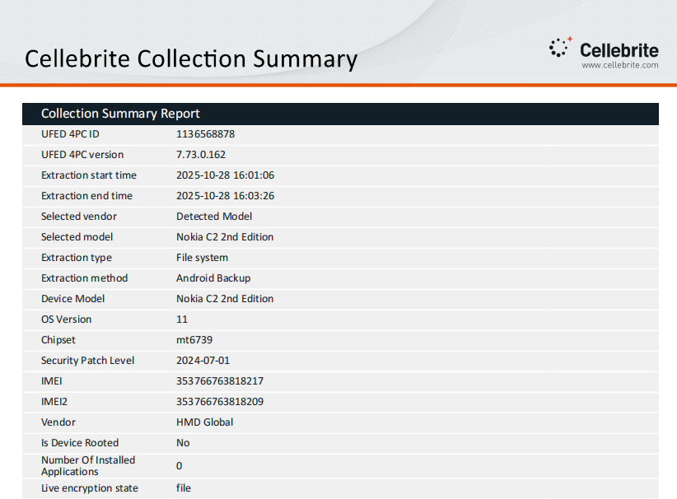
Figure 32: Cellebrite Collection Summery of Nokia
The Cellebrite UFED Analyzer collection summary identified the extracted device as a Nokia C2 2nd Edition, with relevant device details successfully recovered, as illustrated in Figure 32

- MOB-04 – Huawei P Smart (POT-LX1)
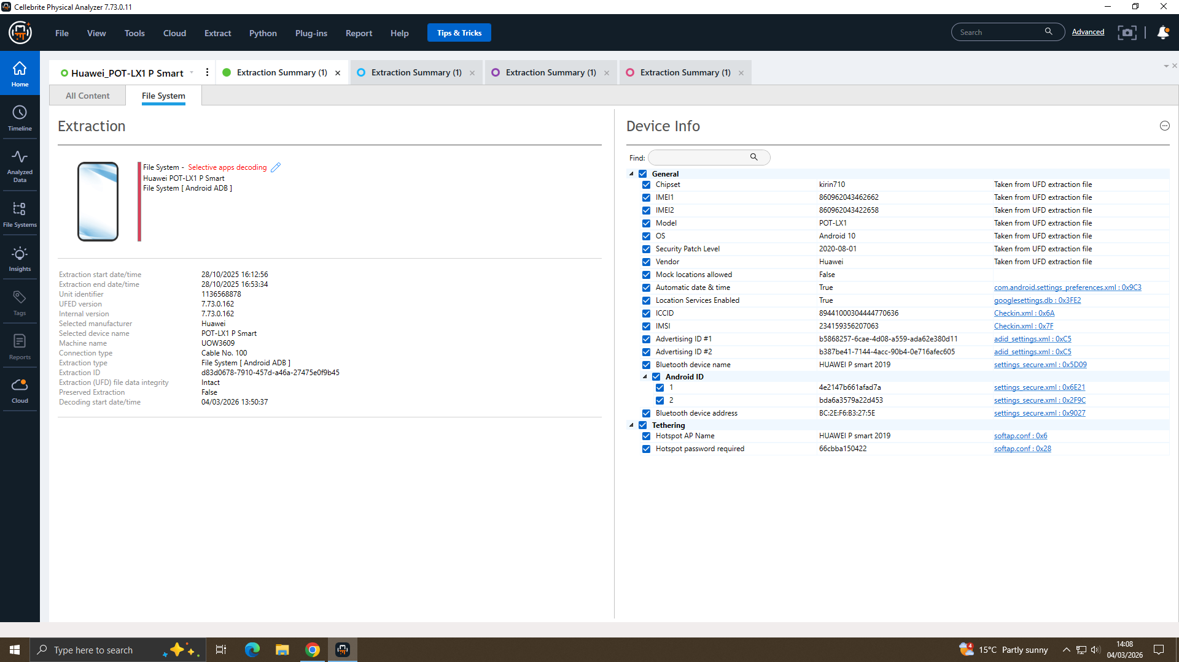
Figure 33: Huawei Extraction Details
Following data extraction using Cellebrite UFED Analyzer, the device was identified as a Huawei P Smart (POT-LX1), and its key device information was successfully recovered, as showed in Figure 33

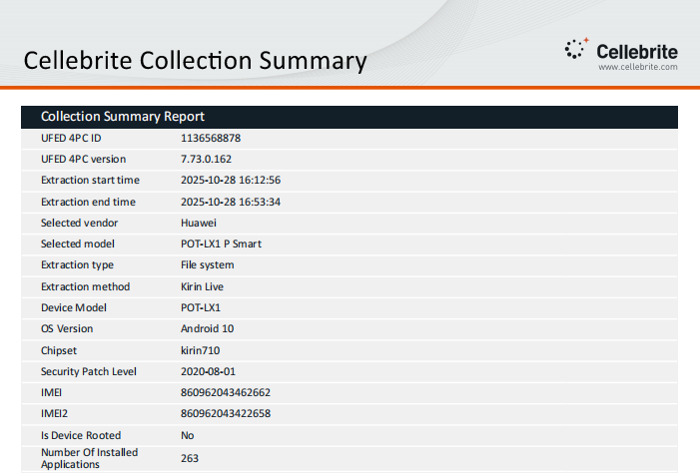
Figure 34: Cellebrite Collection Summery of Huawei
The Cellebrite UFED Analyzer collection summary with Kirin Live identified the extracted device as a Huawei P Smart (POT-LX1), with relevant device details successfully recovered, as illustrated in Figure 34
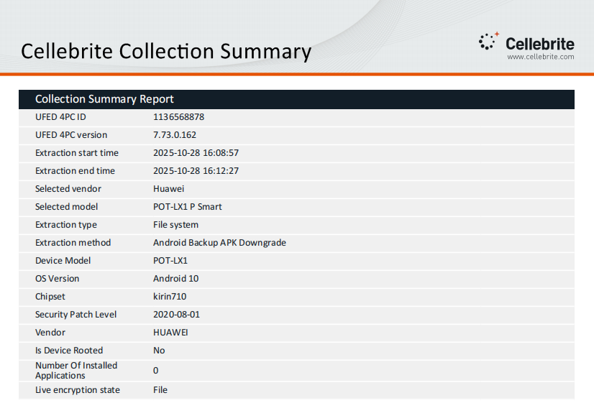
Figure 35: Cellebrite Collection Summery of Huawei 2
The Cellebrite UFED Analyzer collection summary with Android Backup APK Downgrade identified the extracted device as a Huawei P Smart (POT-LX1), with relevant device details successfully recovered, as illustrated in Figure 35

Chain of Custody Log
Date & Time | Evidence ID | Mobile Name | IMEI Number | Action | Examiner | Notes
2025-10-28 11:25:18 | MOB-01 | Ulefone Note 14 Smartphone | 355617730545771 / 355617730545789 | Extraction Started | University Provided Dataset (UWTSD) | Android Backup
2025-10-28 11:27:40 | MOB-01 | Ulefone Note 14 Smartphone | 355617730545771 / 355617730545789 | Extraction Completed | University Provided Dataset (UWTSD) | Unrooted
2025-10-28 11:57:02 | MOB-02 | Samsung Galaxy A13 (SM-A137F) | 357898921470825 / 357712351470827 | Extraction Started | University Provided Dataset (UWTSD) | Android Backup
2025-10-28 12:36:47 | MOB-02 | Samsung Galaxy A13 (SM-A137F) | 357898921470825 / 357712351470827 | Extraction Completed | University Provided Dataset (UWTSD) | Unrooted
2025-10-28 16:01:06 | MOB-03 | Nokia C2 2nd Edition Smartphone | 353766763818217 / 353766763818209 | Extraction Started | University Provided Dataset (UWTSD) | Android Backup
2025-10-28 16:03:26 | MOB-03 | Nokia C2 2nd Edition Smartphone | 353766763818217 / 353766763818209 | Extraction Completed | University Provided Dataset (UWTSD) | Unrooted
2025-10-28 16:12:56 | MOB-04 | Huawei P Smart (POT-LX1) | 860962043462662 / 860962043422658 | Extraction Started | University Provided Dataset (UWTSD) | Kirin Live
2025-10-28 16:53:34 | MOB-04 | Huawei P Smart (POT-LX1) | 860962043462662 / 860962043422658 | Extraction Completed | University Provided Dataset (UWTSD) | 263 Apps Recovered
Table 1: Chain of Custody log

Integrity Measures
- Cellebrite UFED 4PC v7.73.0.162 was used as an industry-standard forensic tool for all acquisitions.
- Extraction methods and timestamps were recorded to provide a complete audit trail of examiner actions.
- All devices were documented as not rooted, reducing the likelihood of data alteration during acquisition.
- SHA-256 hash values were used to verify the integrity of the extracted data and confirm that no changes occurred after acquisition.
- Evidence handling followed recognised digital forensic best practices, supporting reliability and legal admissibility.

Scope and Limitation of Available Evidence
This investigation used only the four mobile forensic images provided. Although a USB flash drive linked to Emma was mentioned, no image or records for it were available. Therefore, the examination focused only on the smartphone data, and all findings are based solely on the evidence provided.

Communication Analysis

WhatsApp Analysis (Emma ↔ Joe)
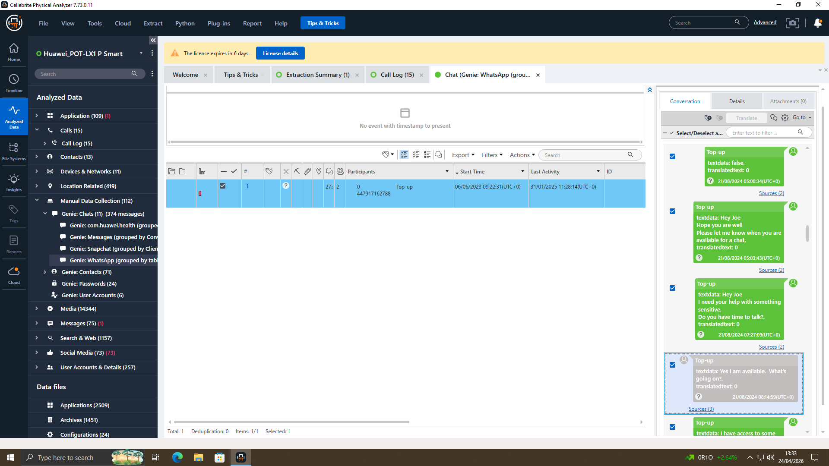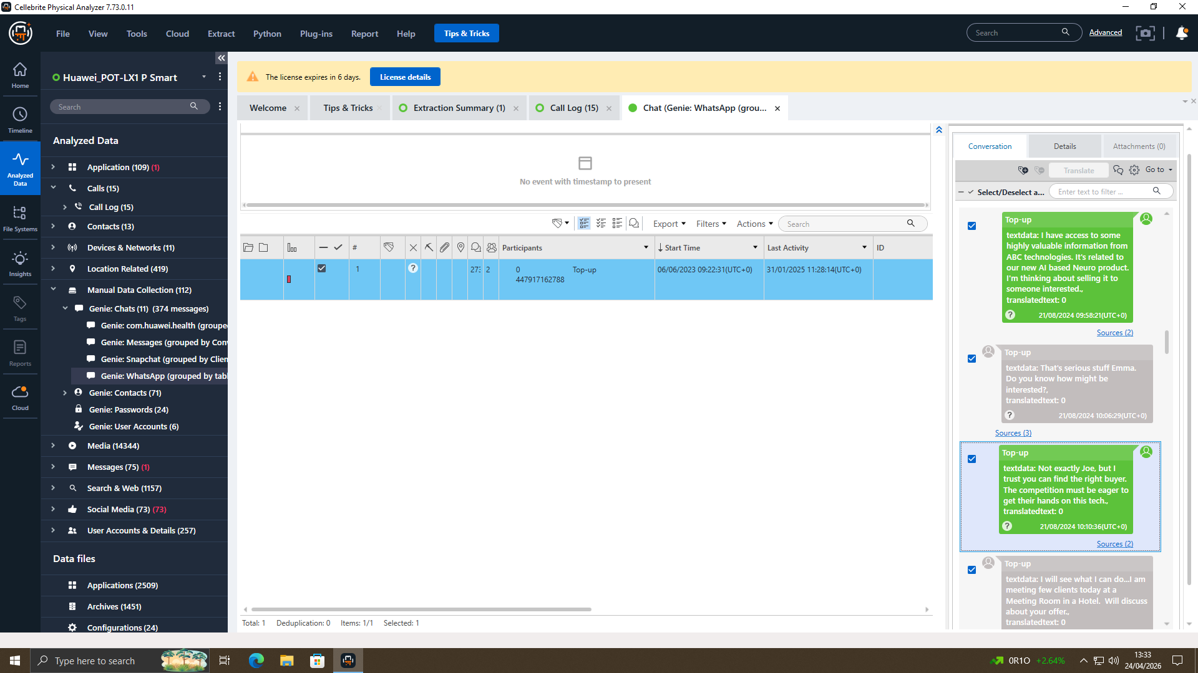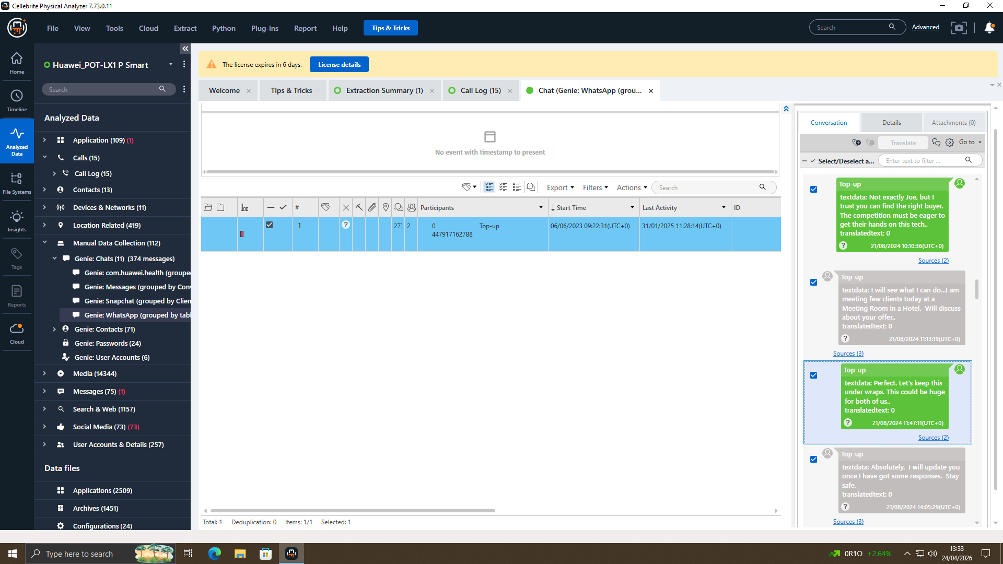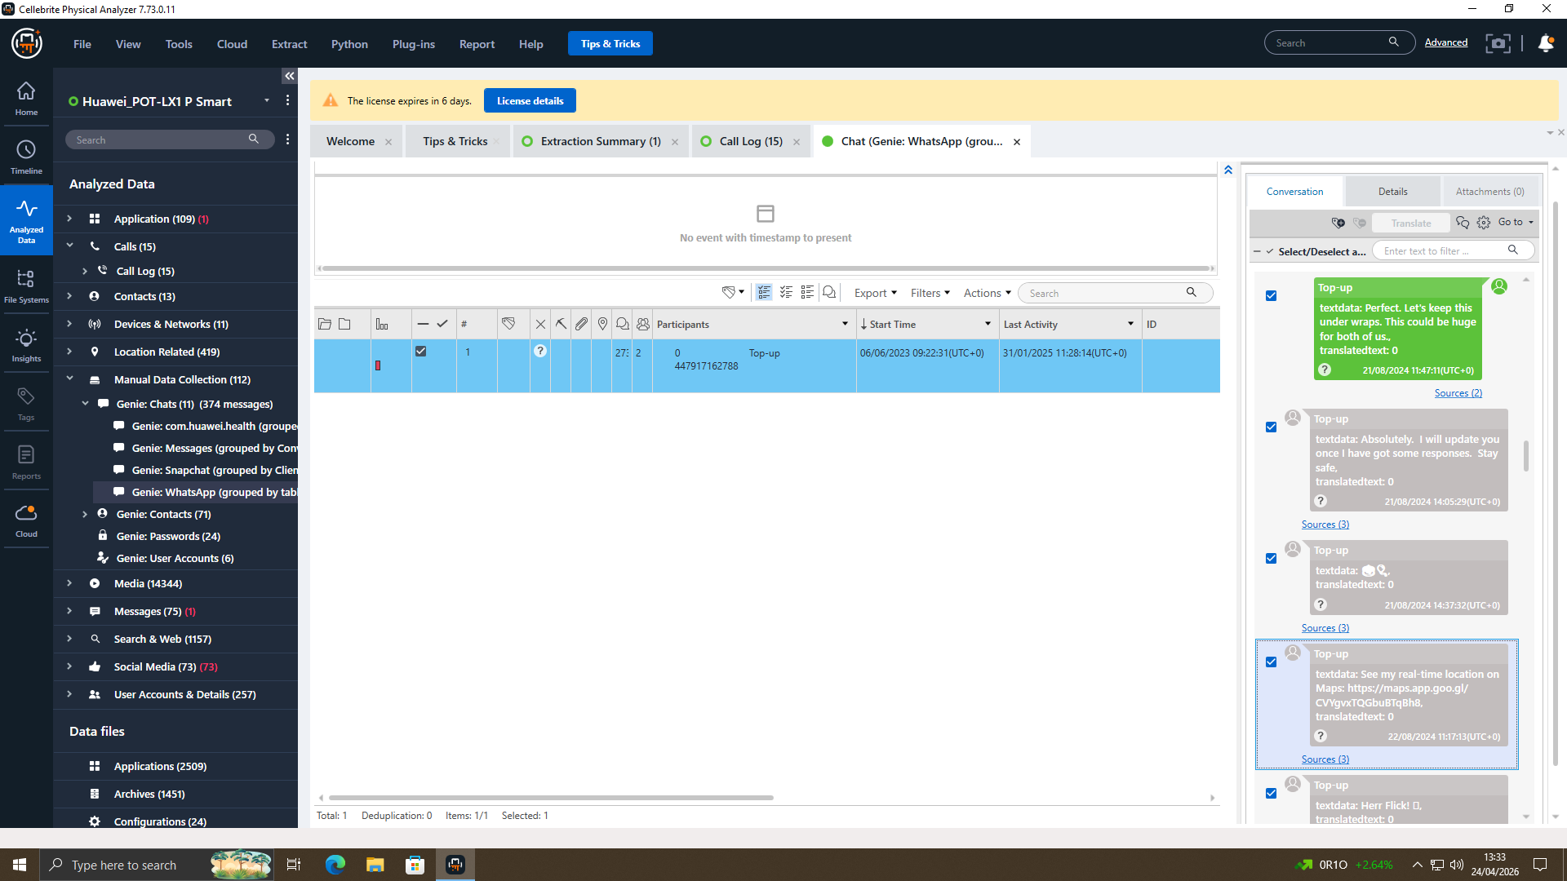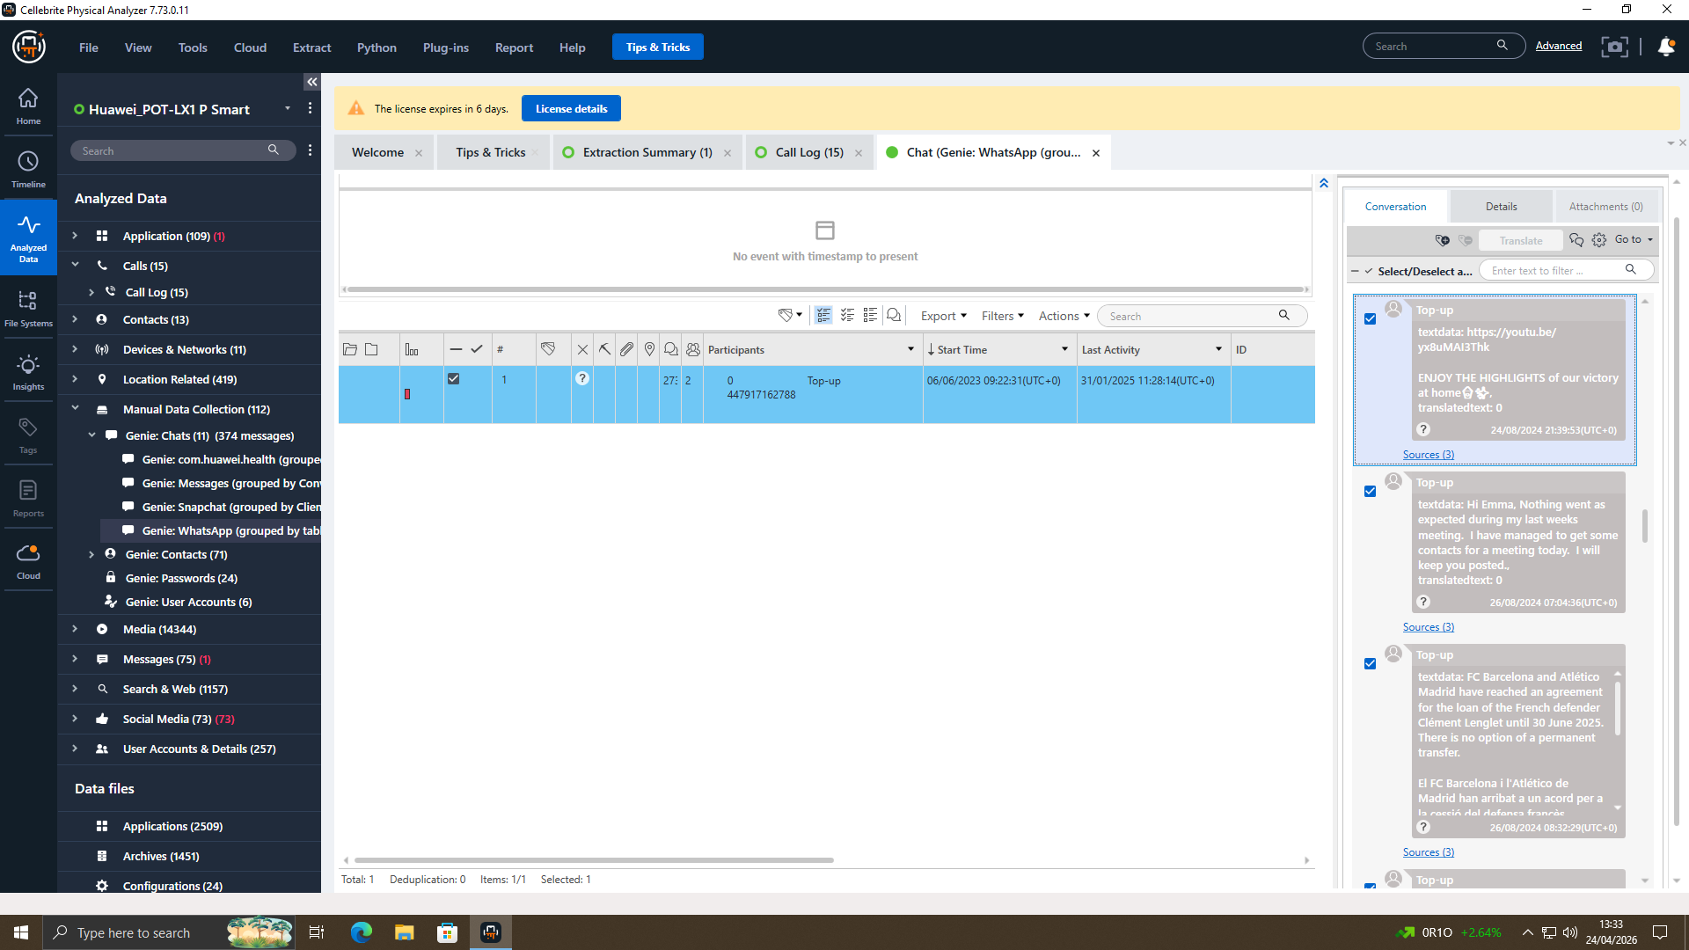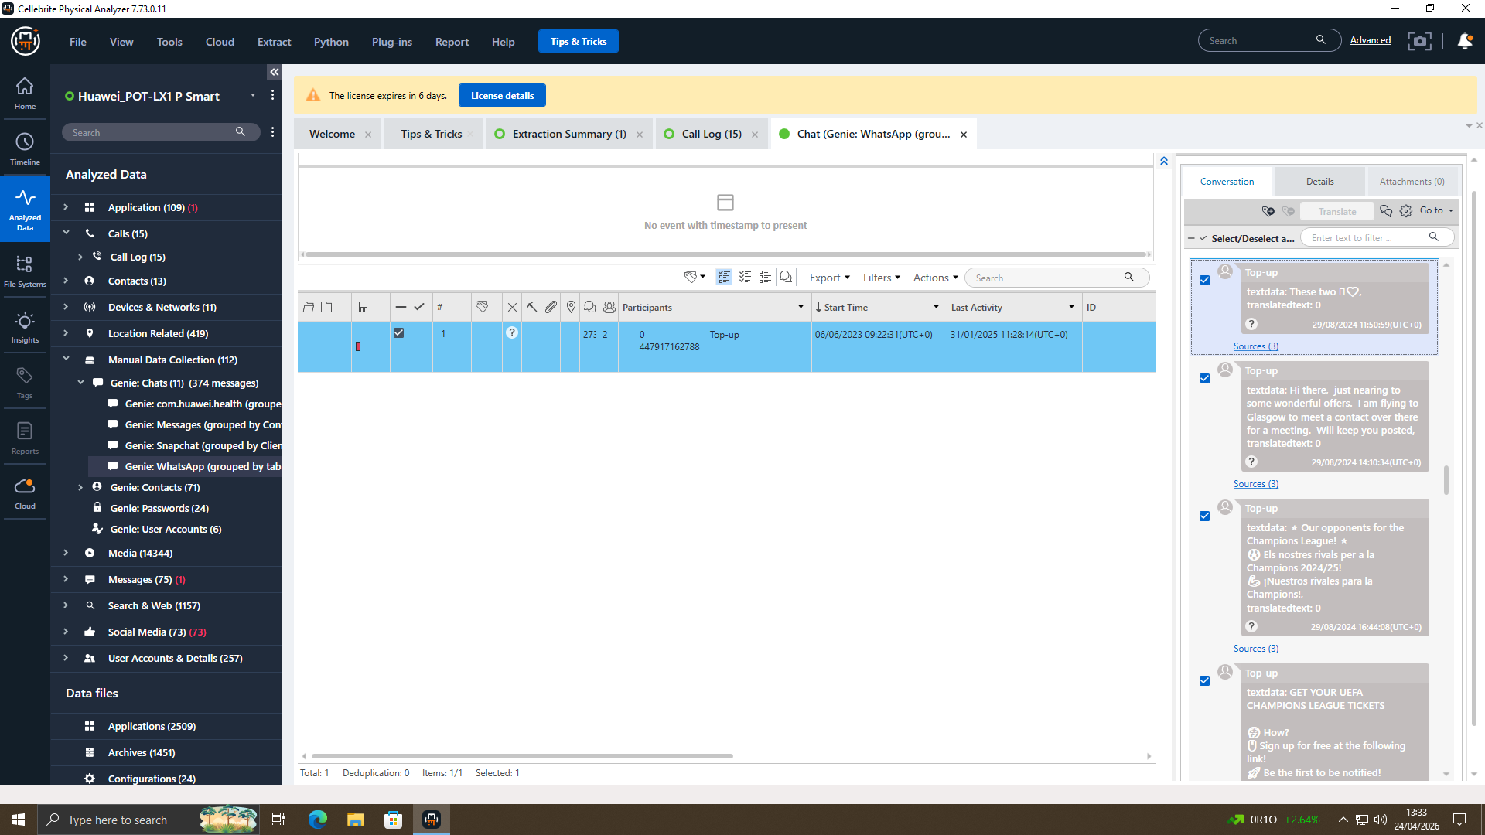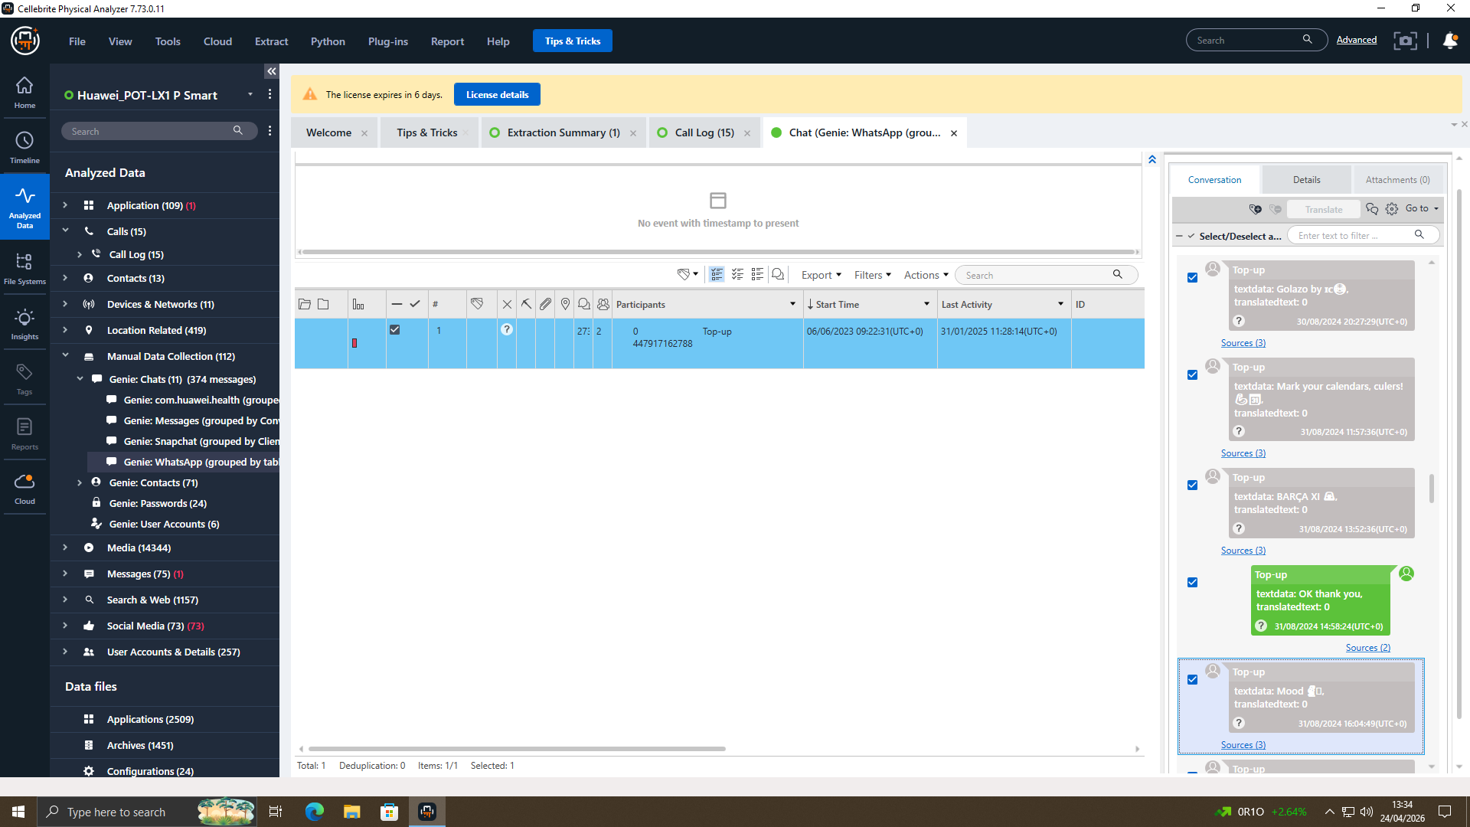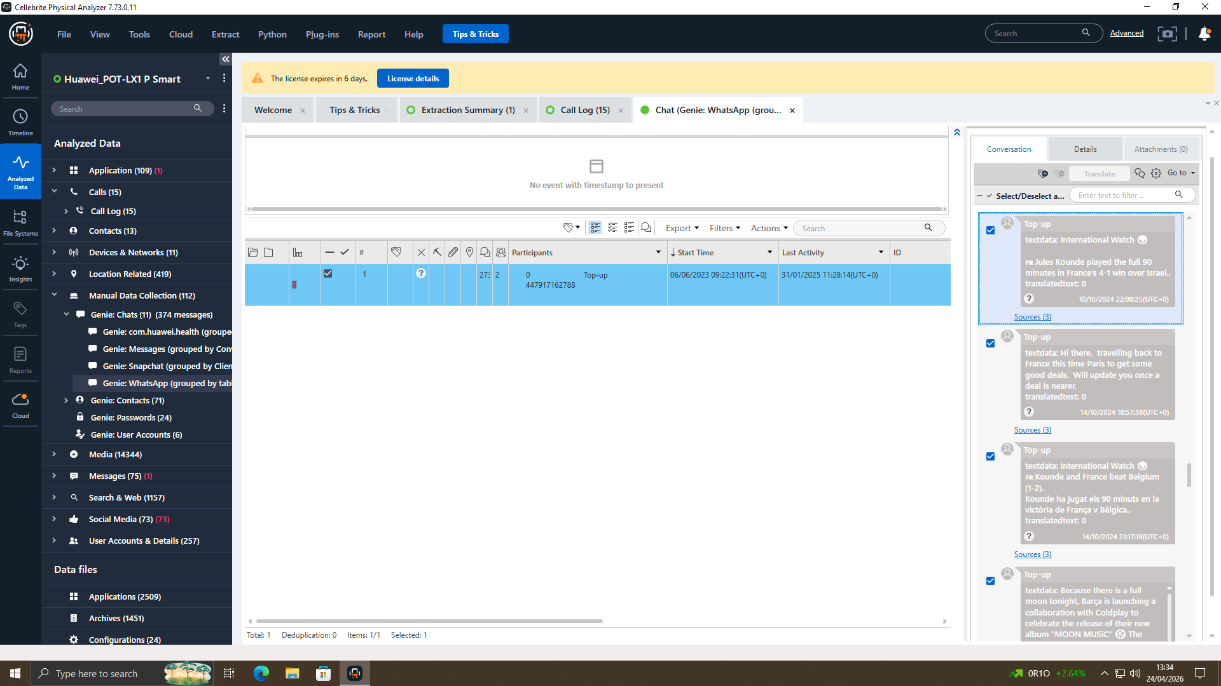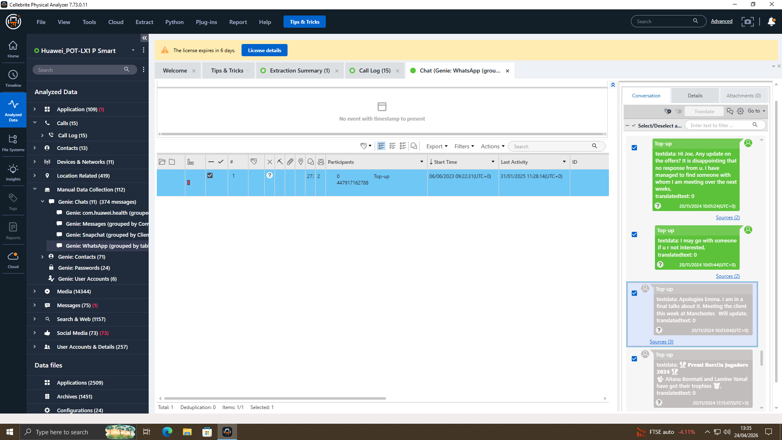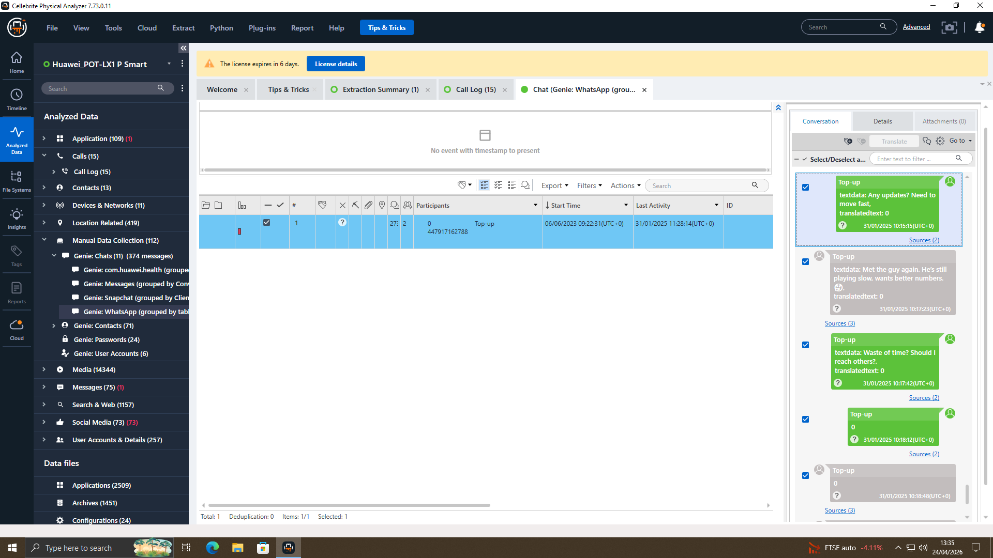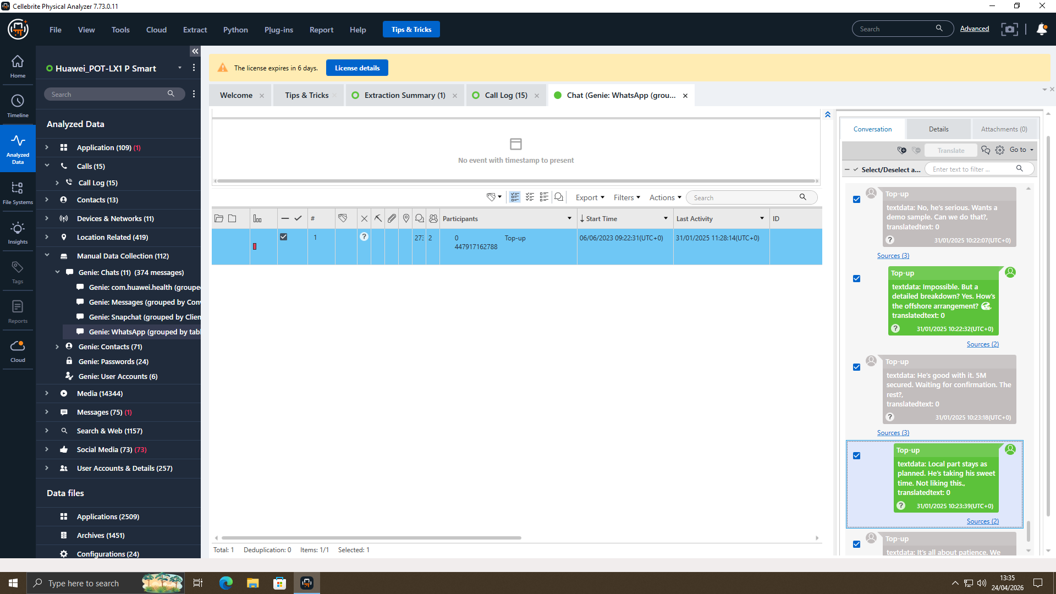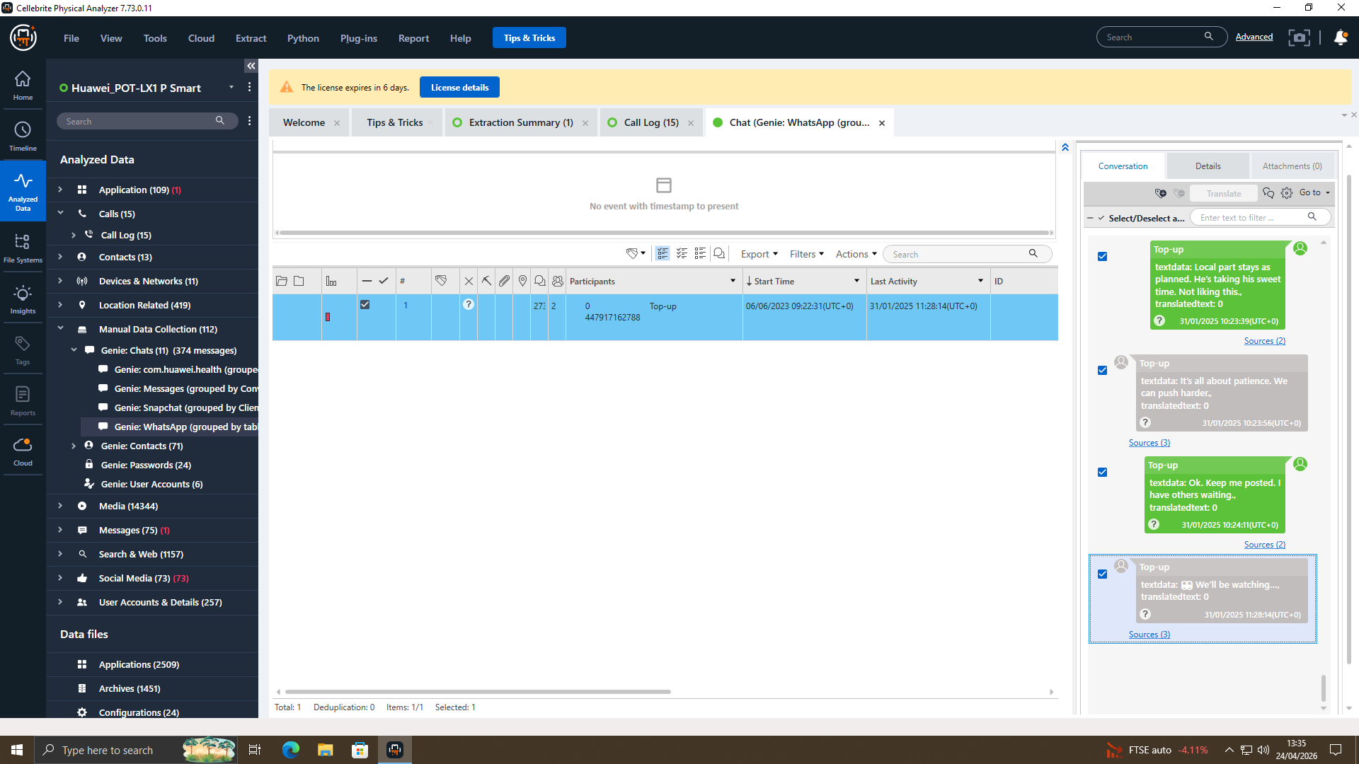

Instagram DM Analysis
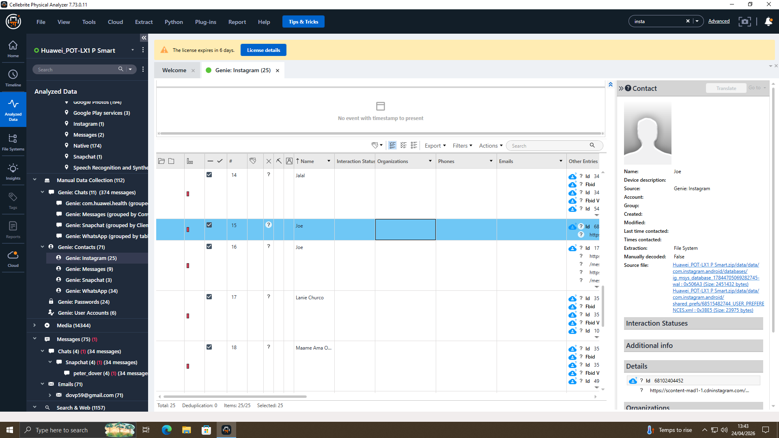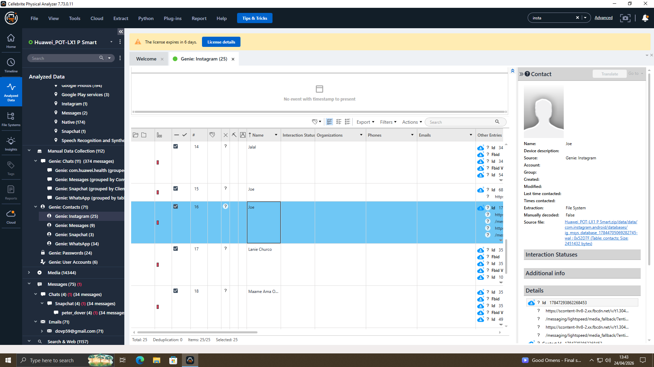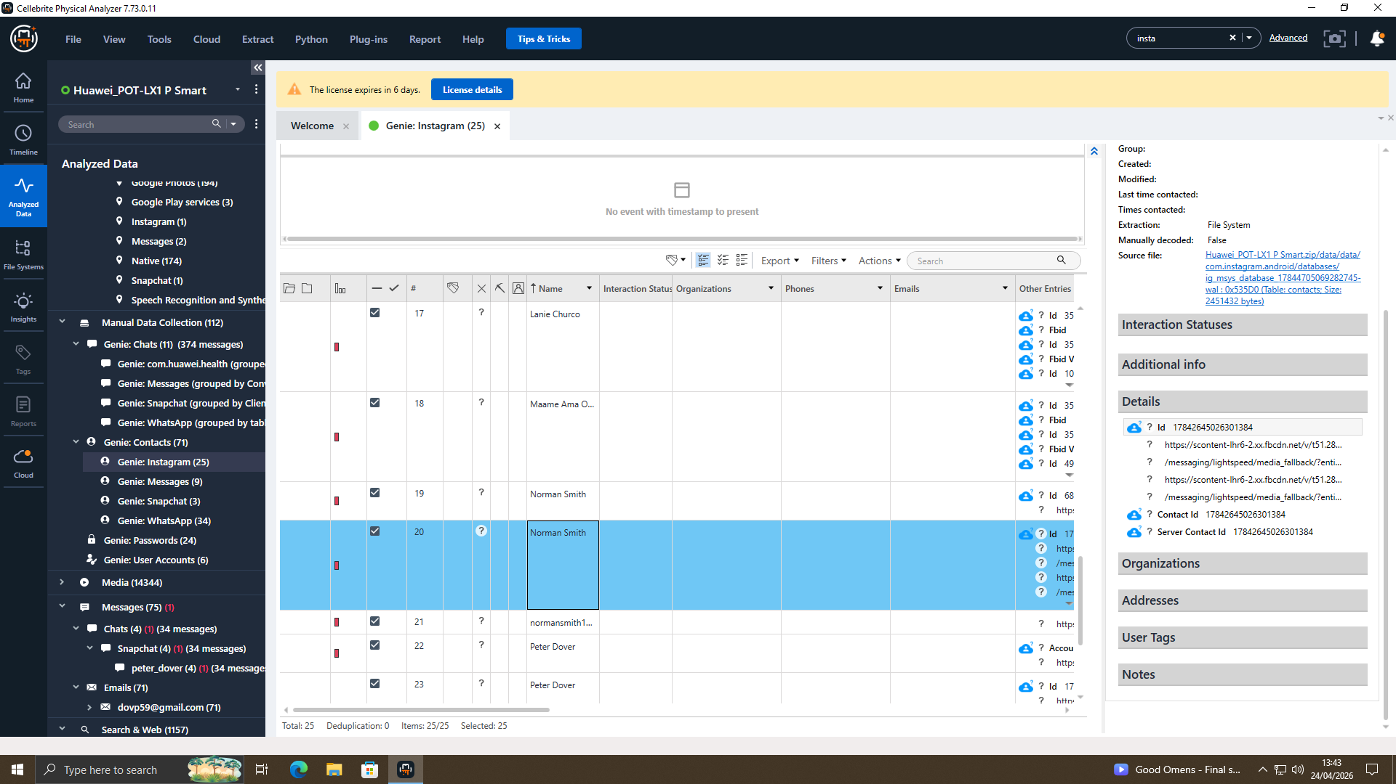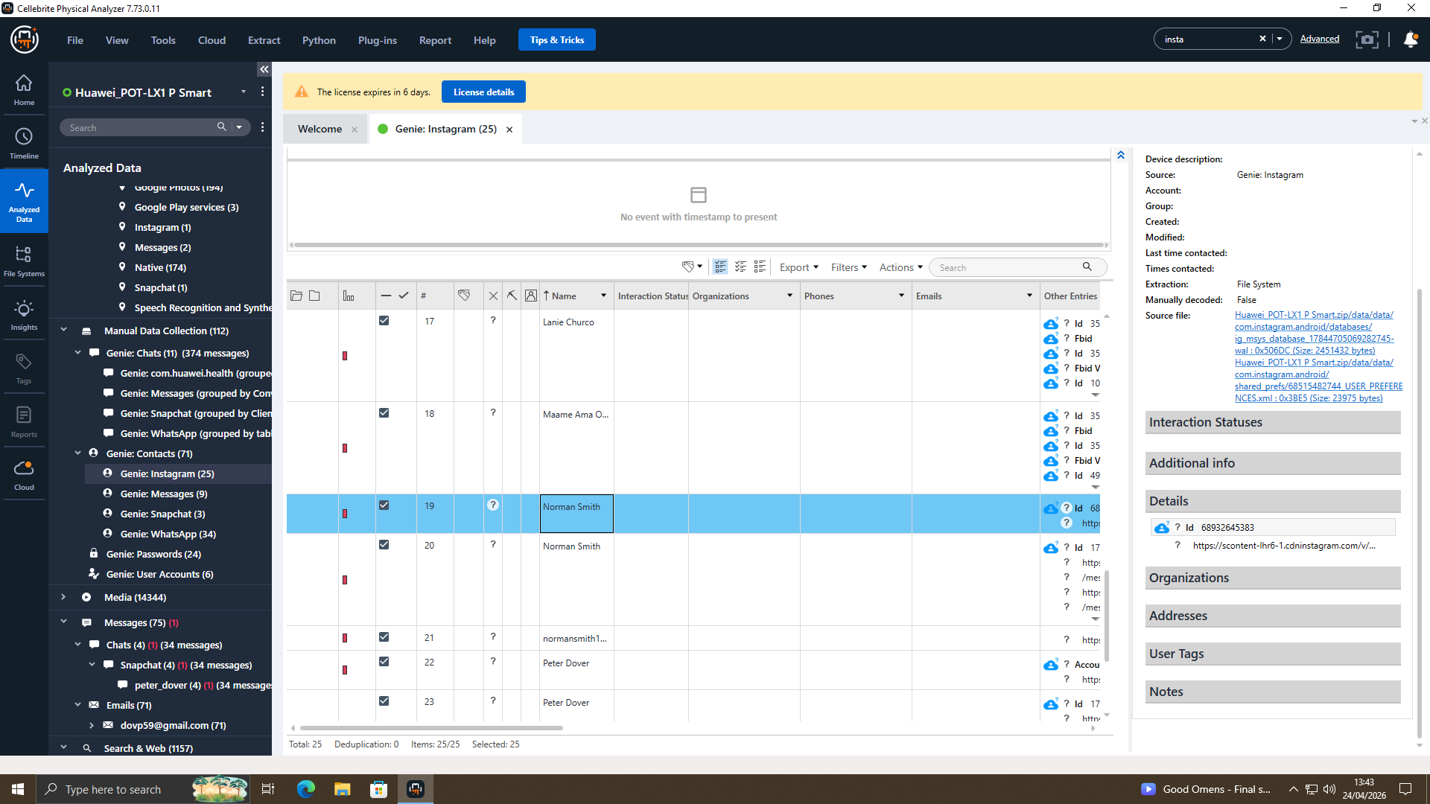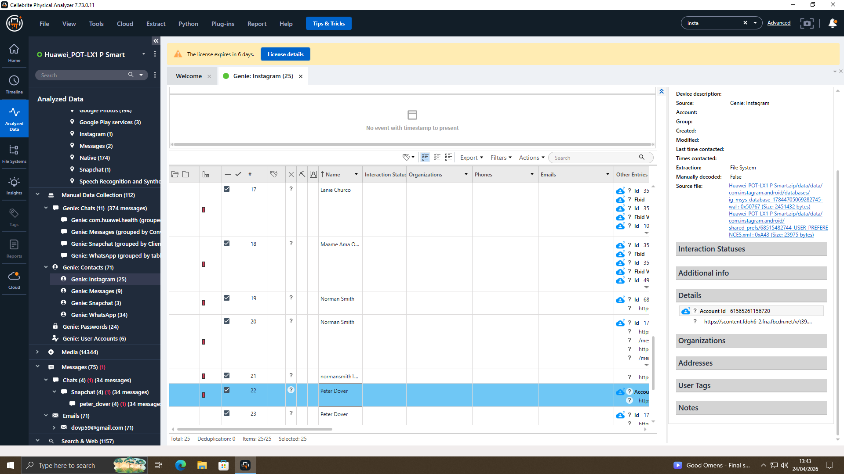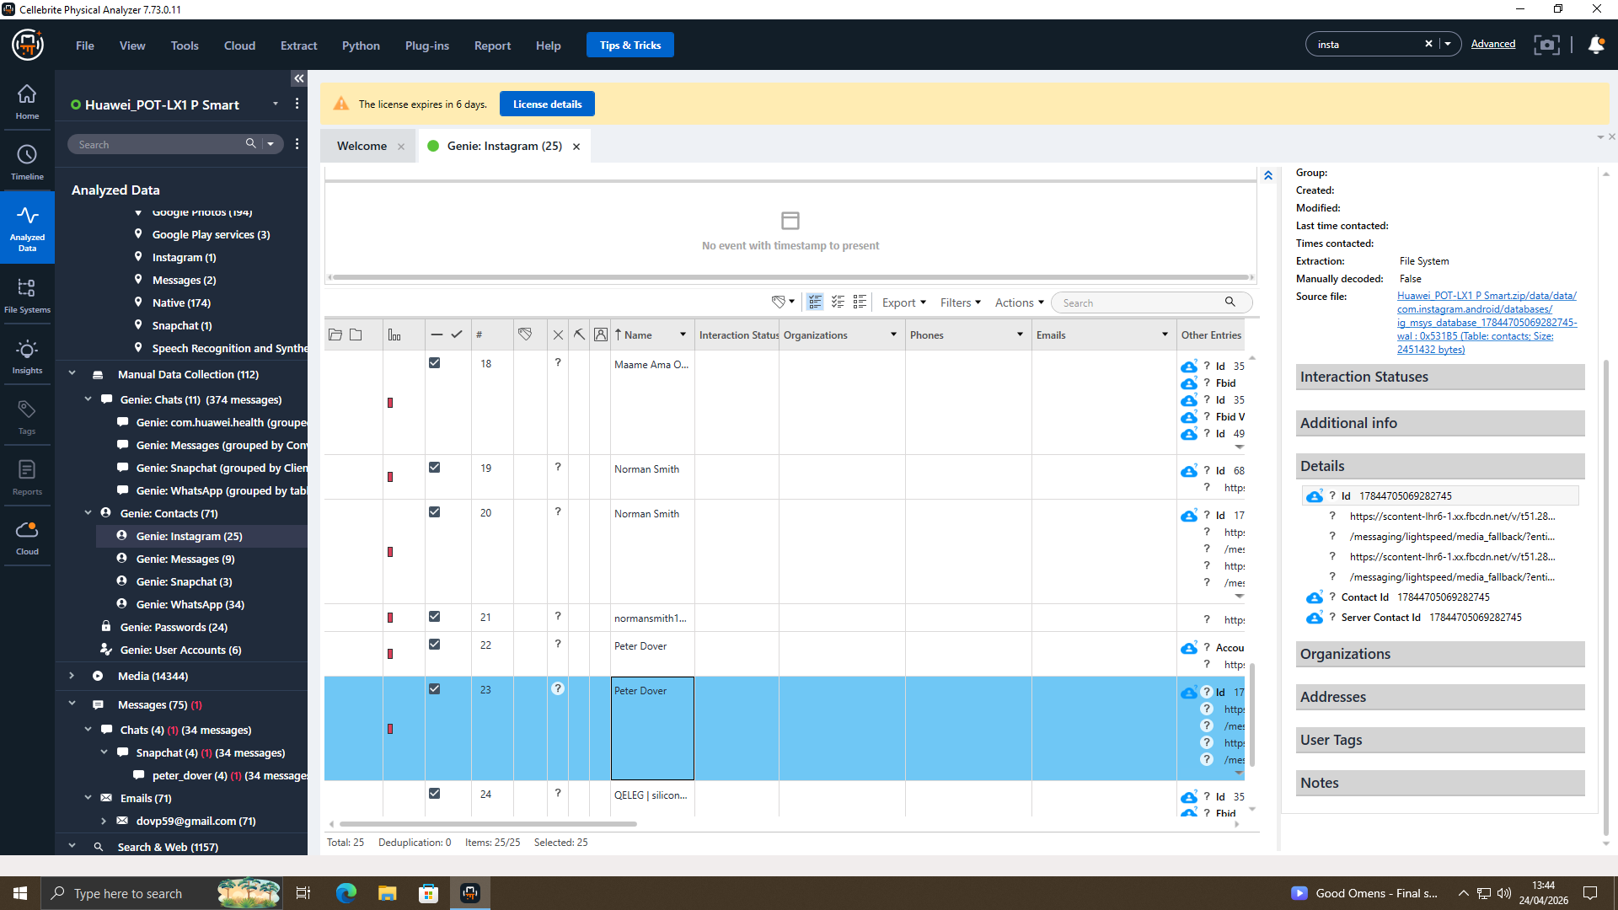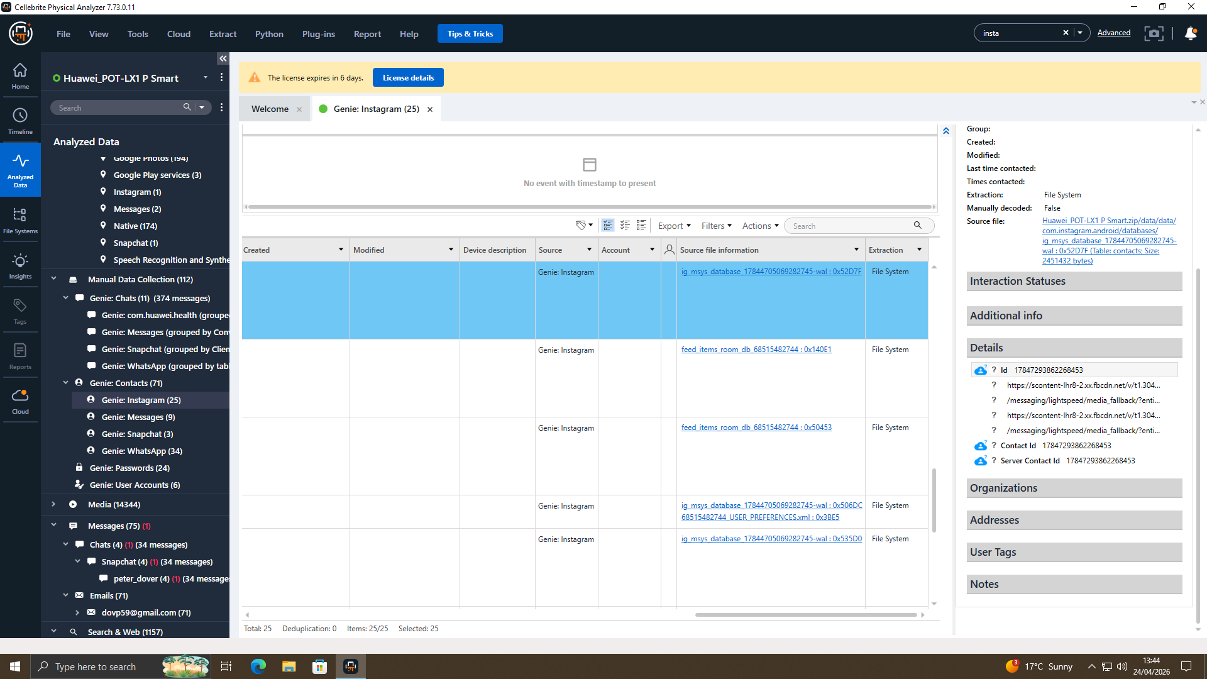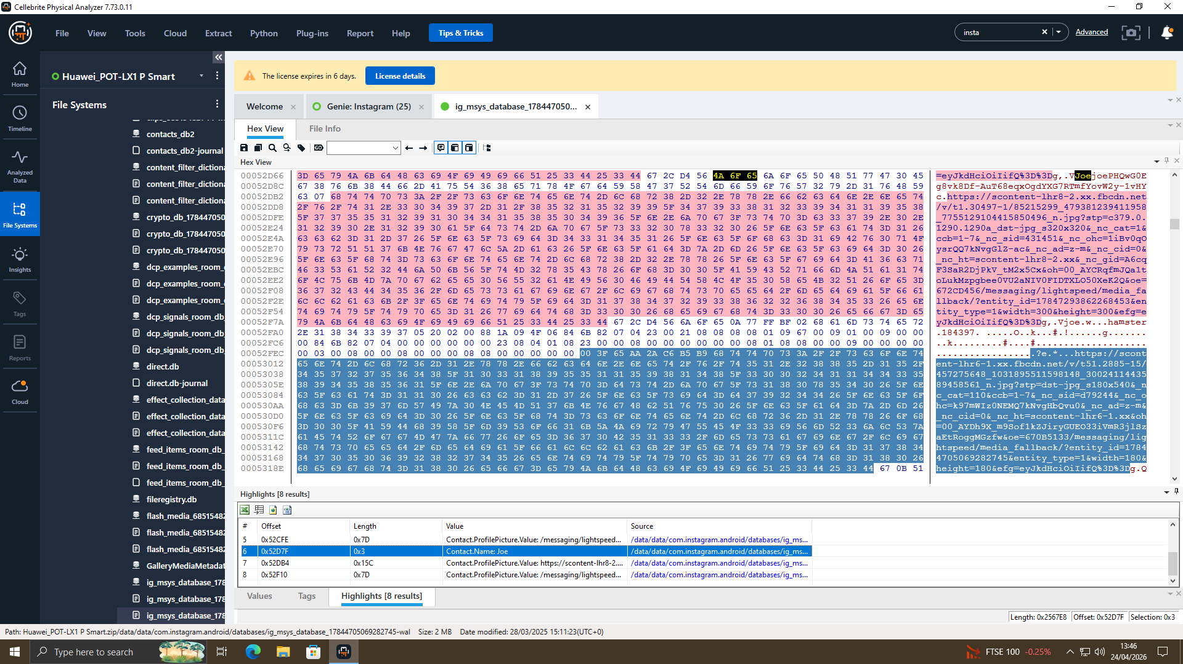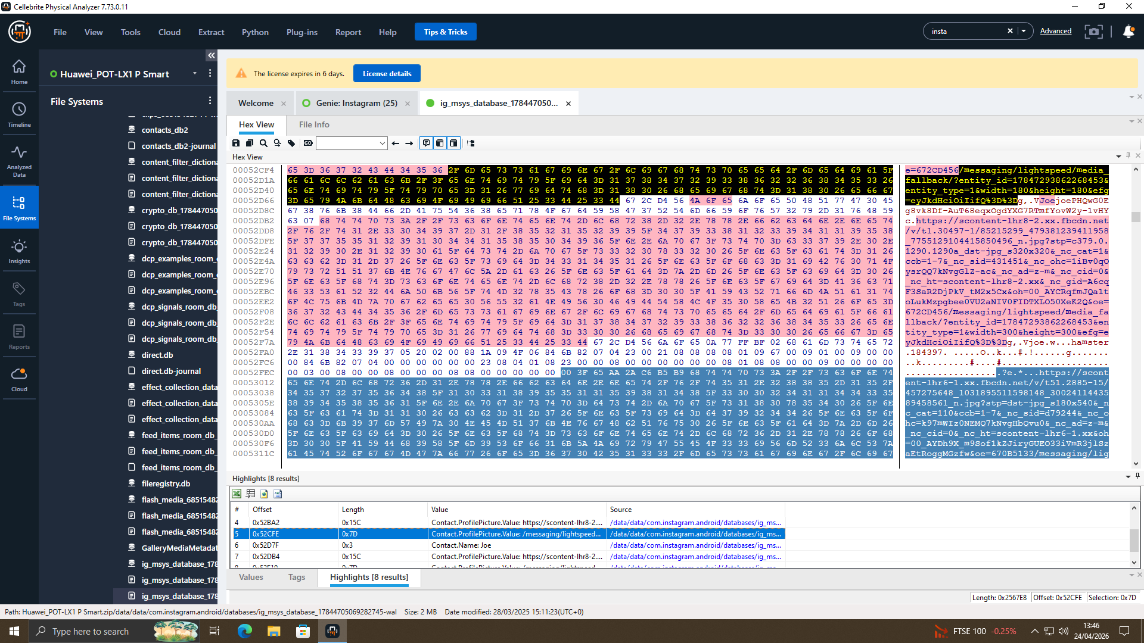

Timeline Reconstruction
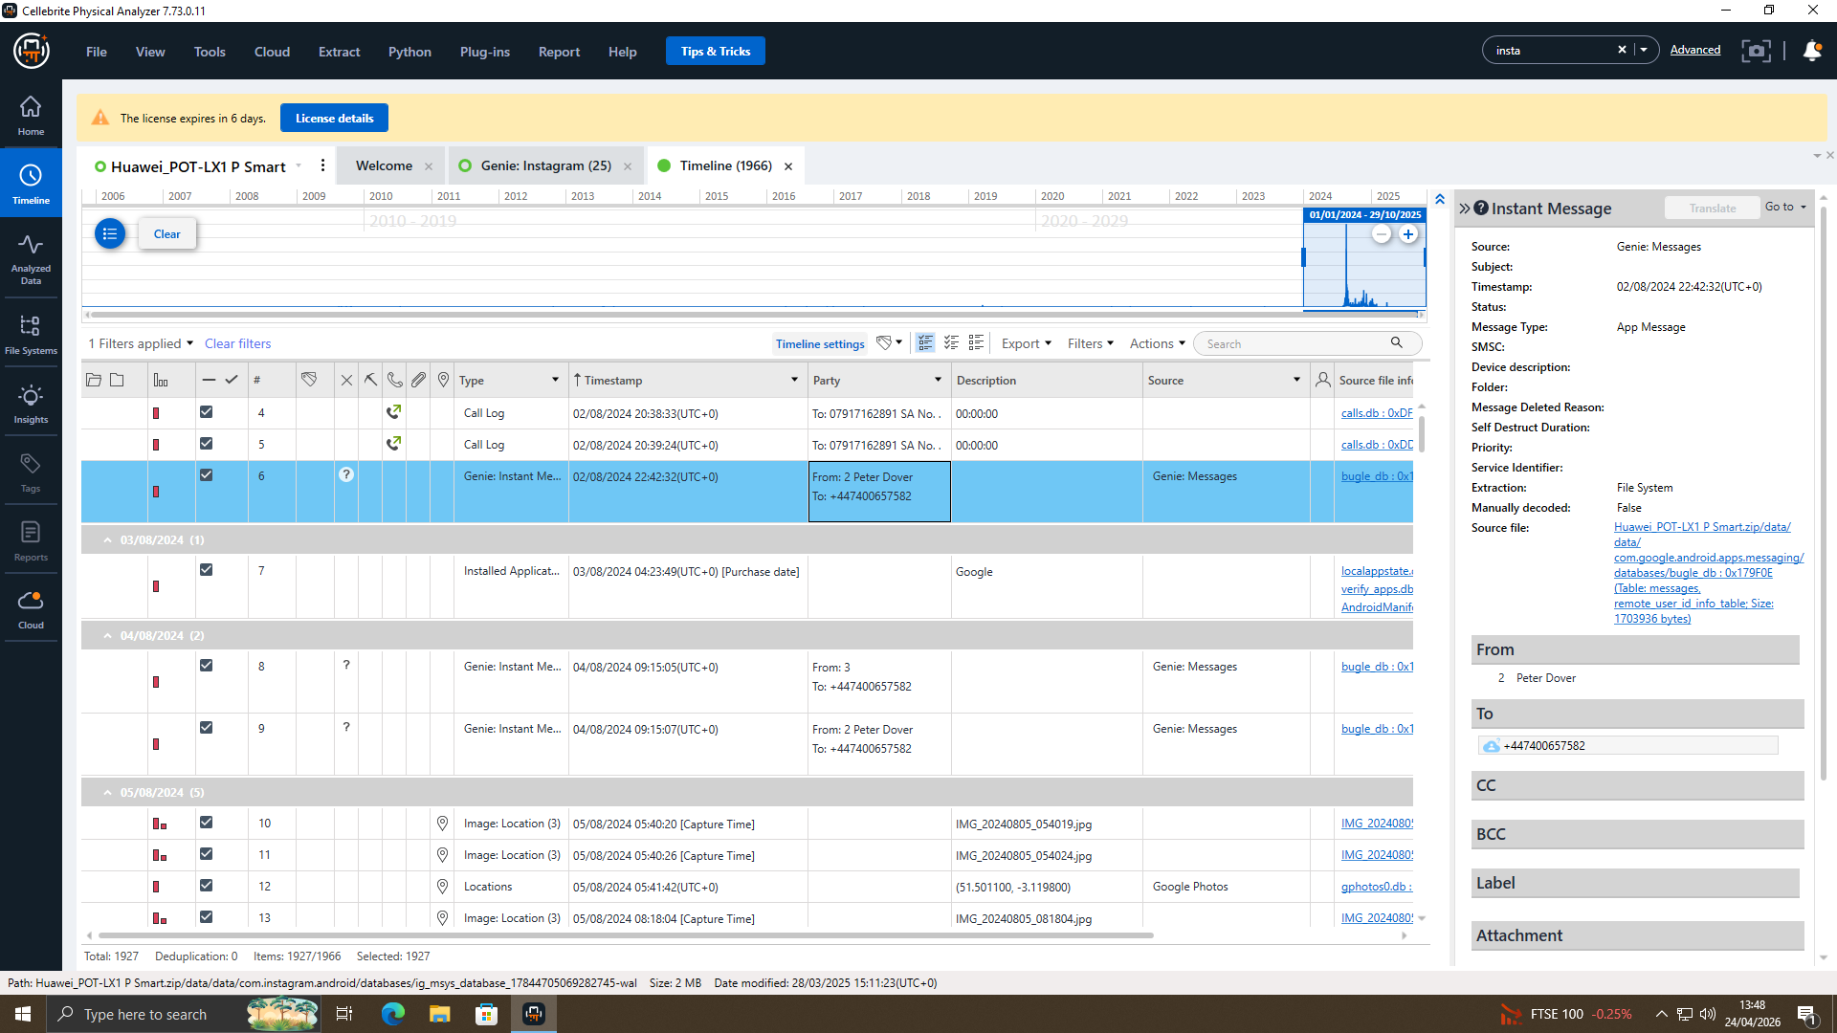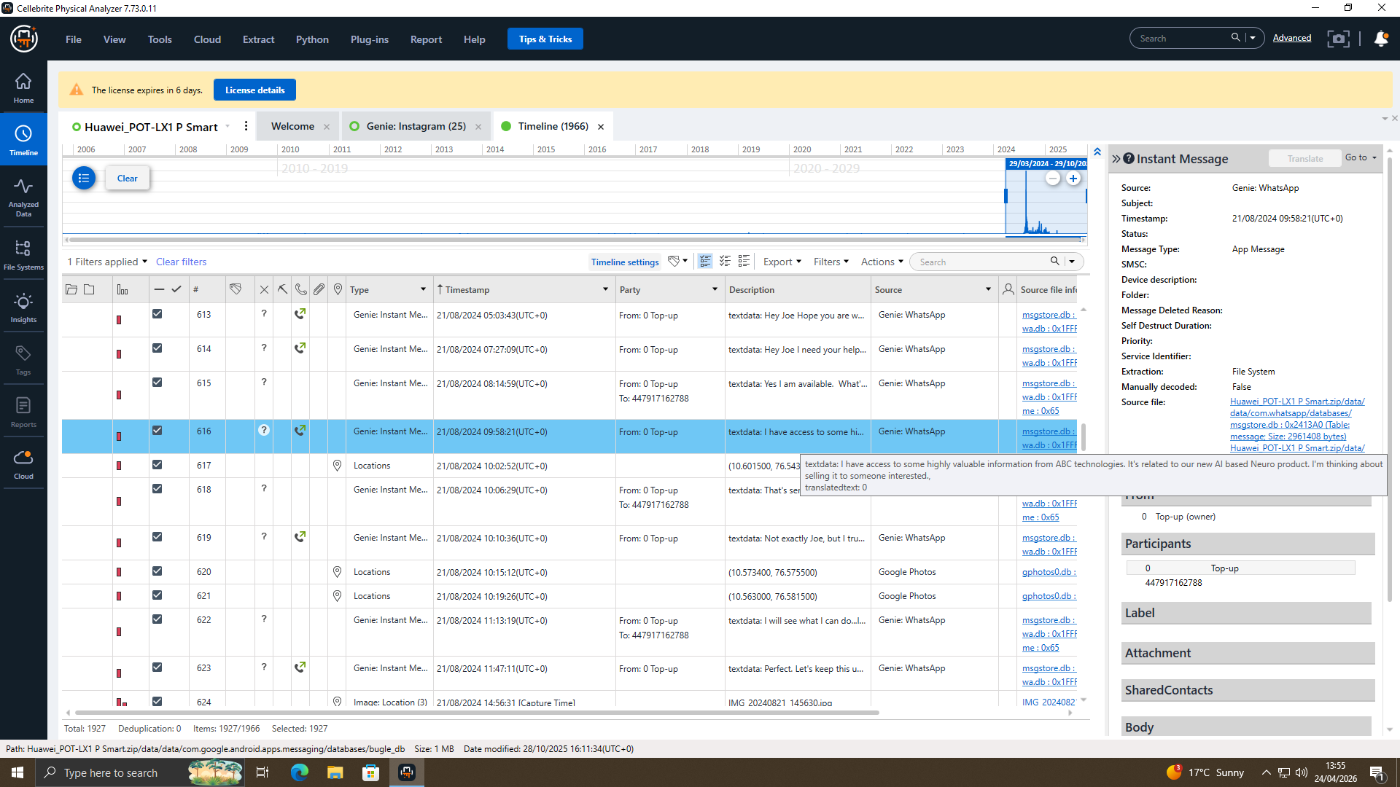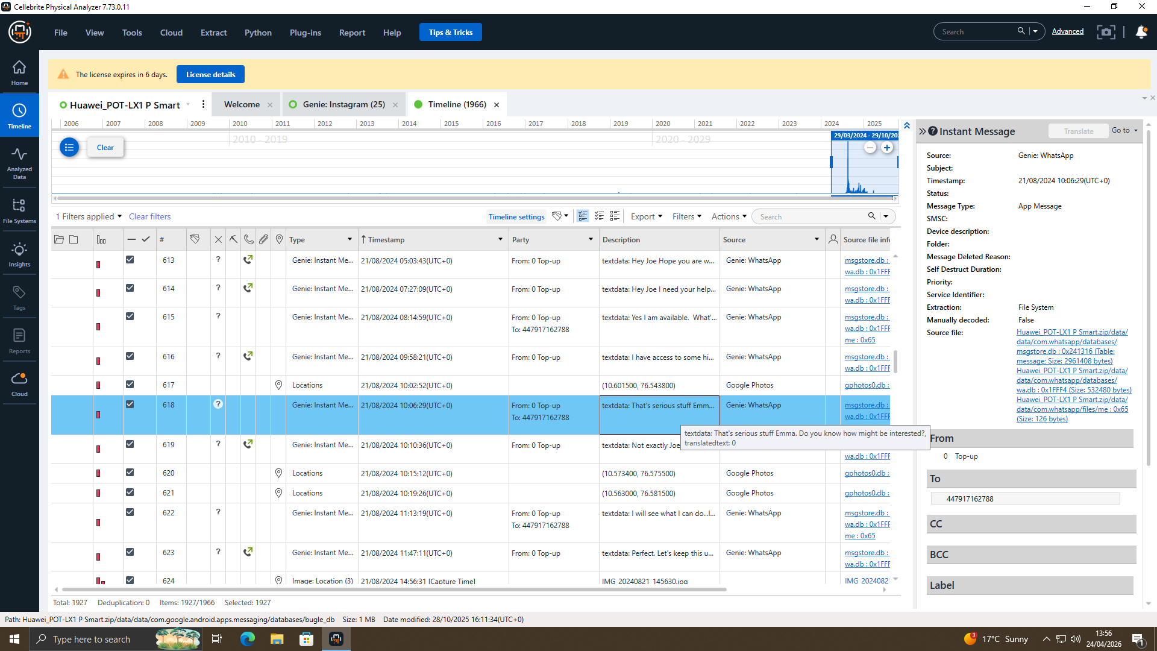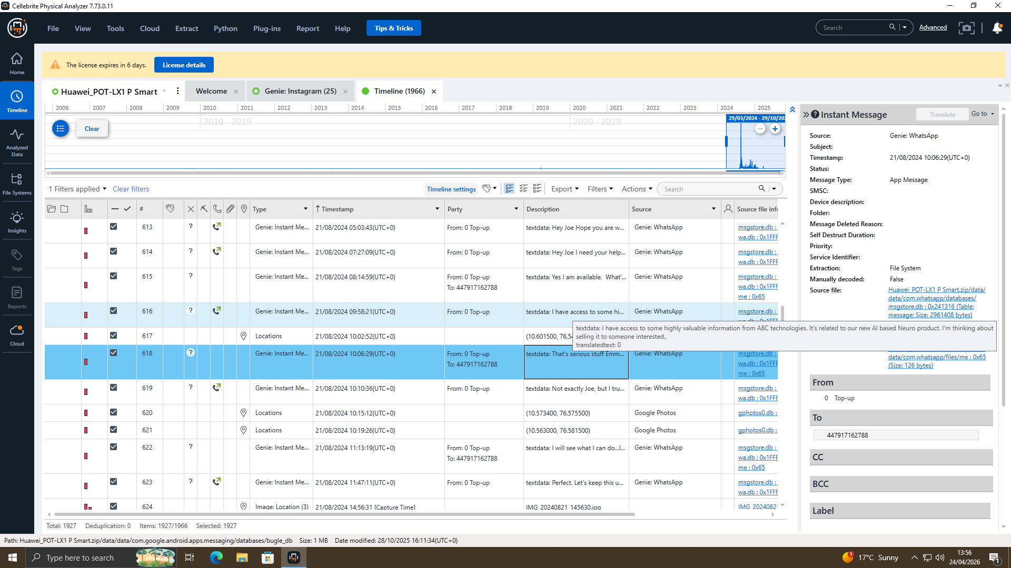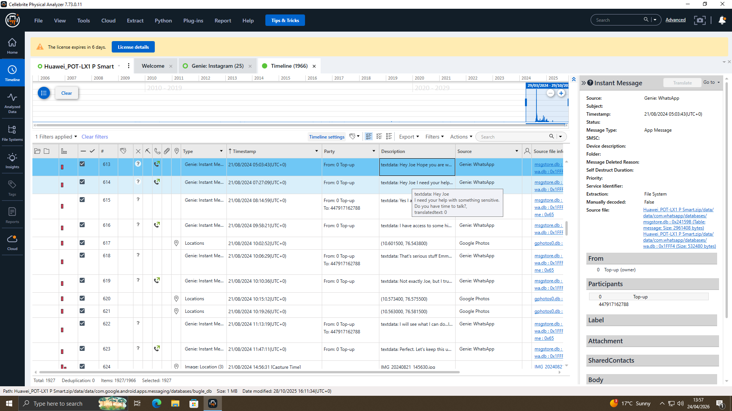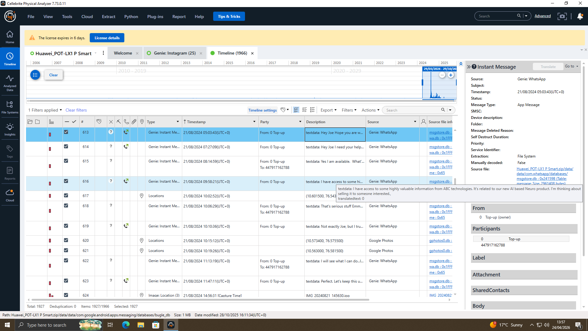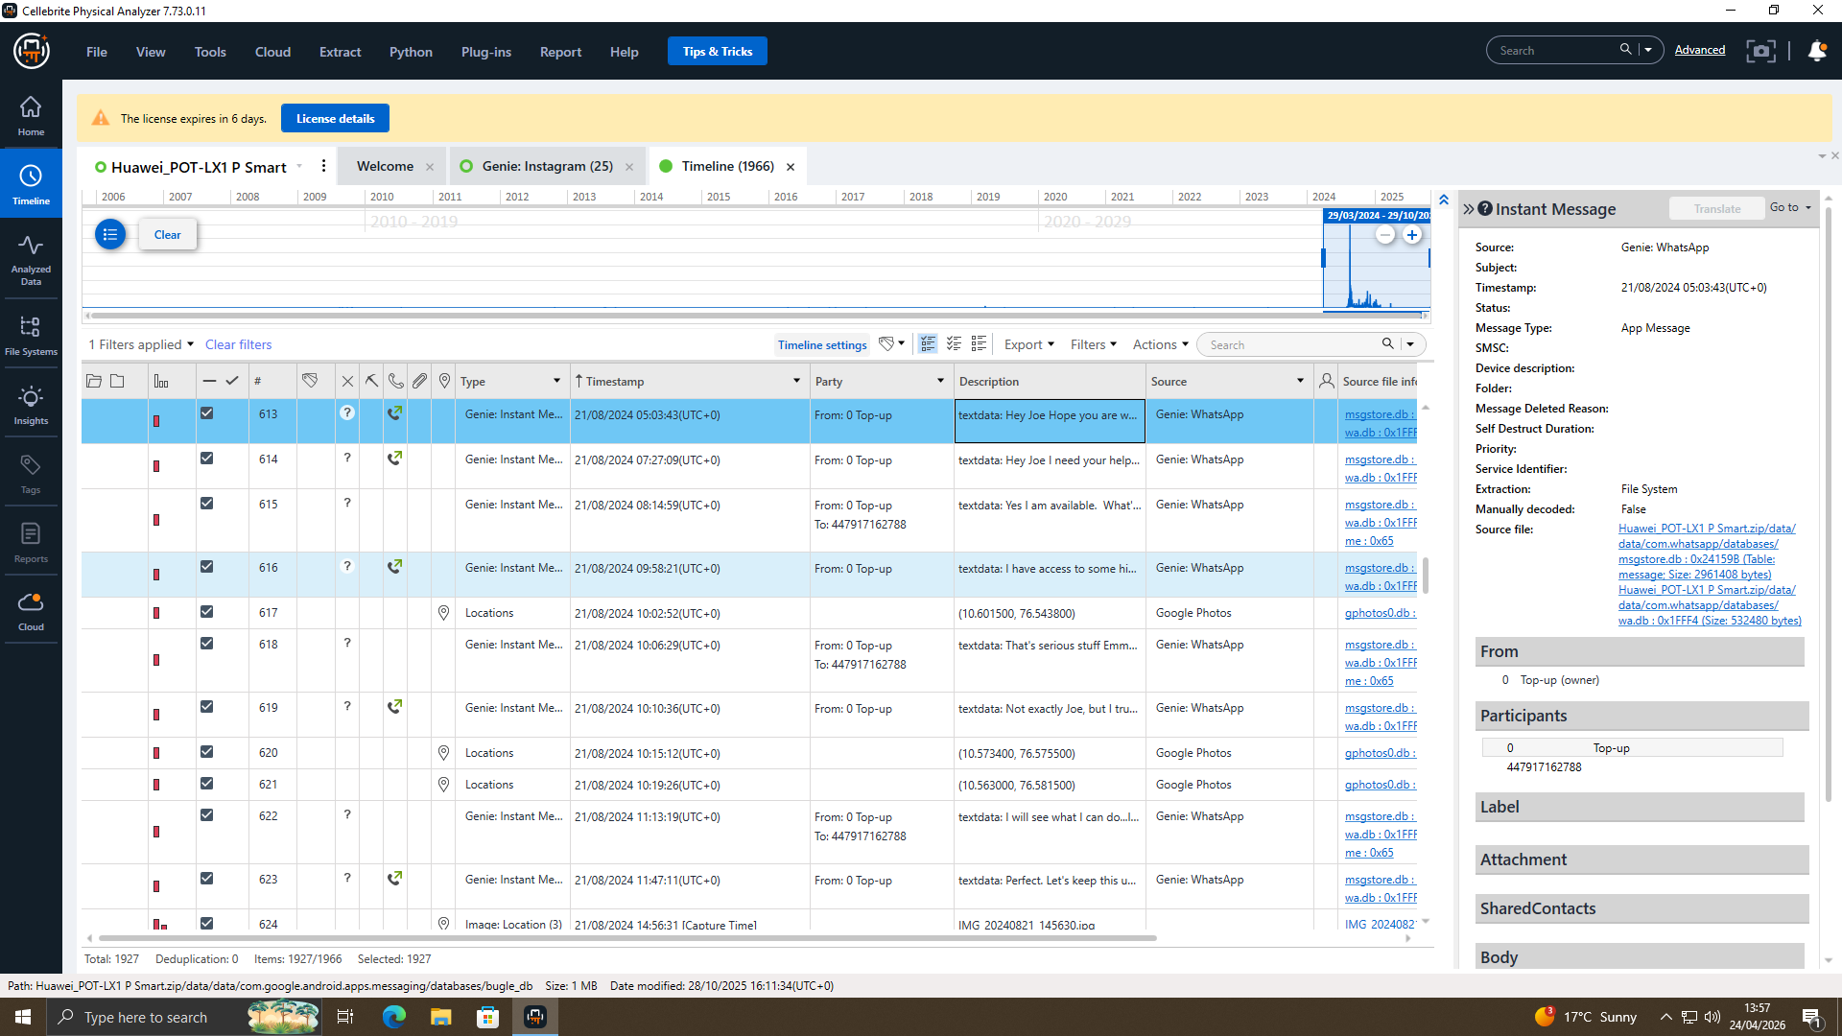

Key Discussions

File Analysis
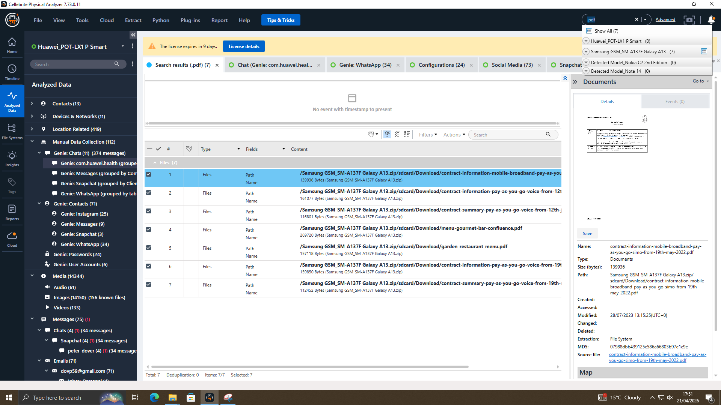
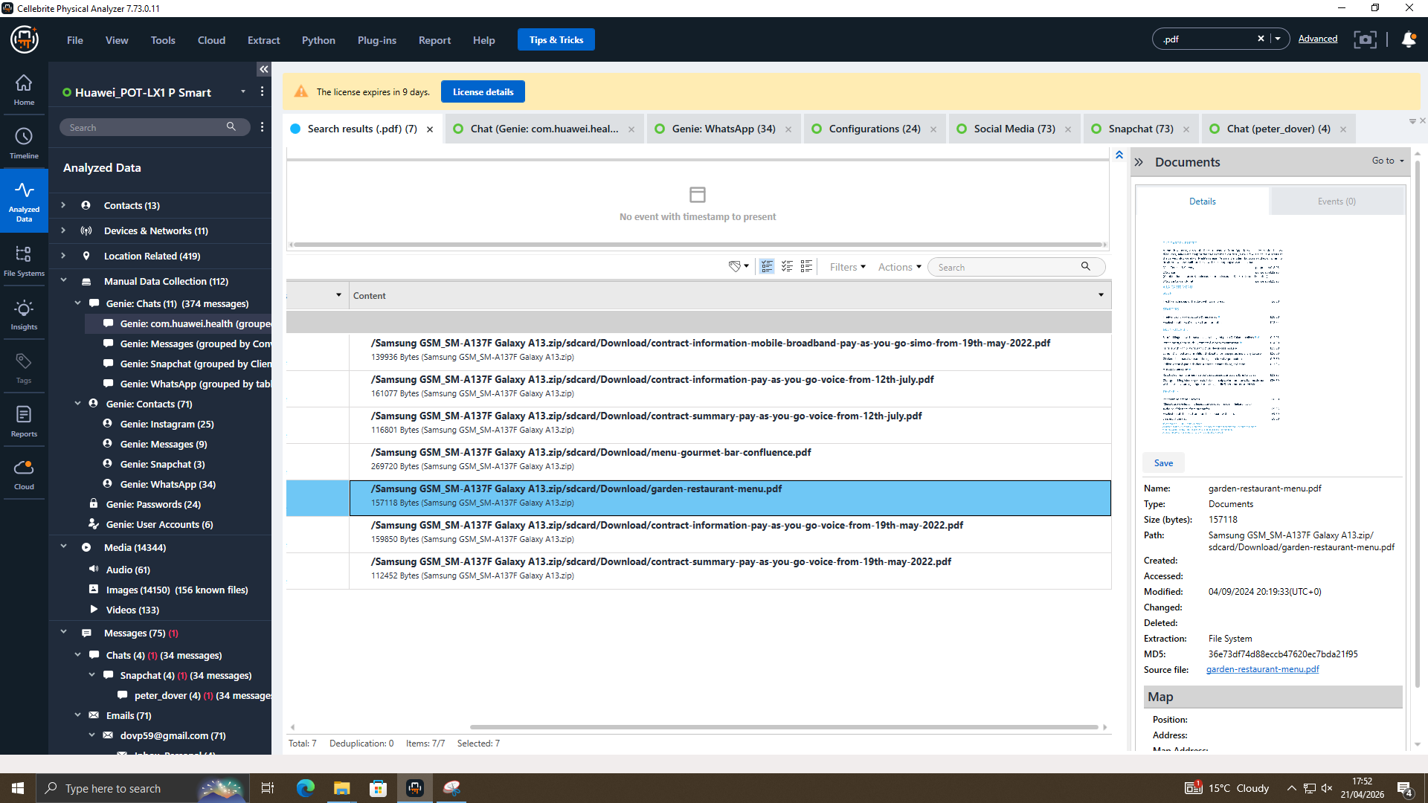

Emma's USB Flash Drive Examination
The assignment refers to Emma’s USB flash drive as a possible source of evidence; however, no USB image was included in the provided dataset. Because of this, the contents of the USB device could not be examined. As a result, any findings related to storing, copying, or transferring the QT-AI-2025 material via USB could not be confirmed based on the available evidence.

QT-AI-2025 Patent Files (PDFs, CAD designs)
No files directly named "QT-AI-2025" were found. No PDF or CAD design files related to the patent were recovered from any device.

File Metadata Analysis (creation/modification dates)
Multiple text and document artefacts were identified within Emma's device file system. Metadata showed that files were created or modified during Emma's employment period at Quantum Tech. Files resided in user-accessible directories.

Additional Evidence Files
No additional evidence files were found beyond the smartphone artefacts described below.

Smartphone File Artefacts
The following artefacts were recovered from Emma's smartphone:
- Text and document files: Multiple document artefacts were identified within the file system. Filenames suggested structured, professional usage rather than personal notes.
- User shortcuts: Recovered shortcuts indicated advanced interaction with the file system and familiarity with internal storage paths.
- Uncategorized artefacts: Several unparsed binary artefacts were present. These may contain deleted data remnants or partially overwritten files, suggesting possible deletion attempts.

Call Log and Email Correlation

Call Log Cross-Reference (Emma, Joe, Vanessa)
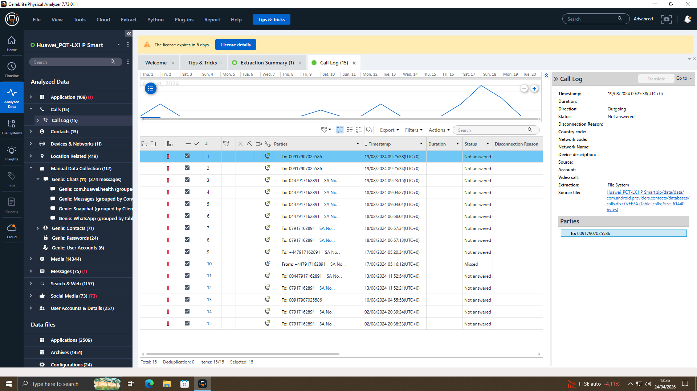

Email Exchange Analysis (patent sample transfers)
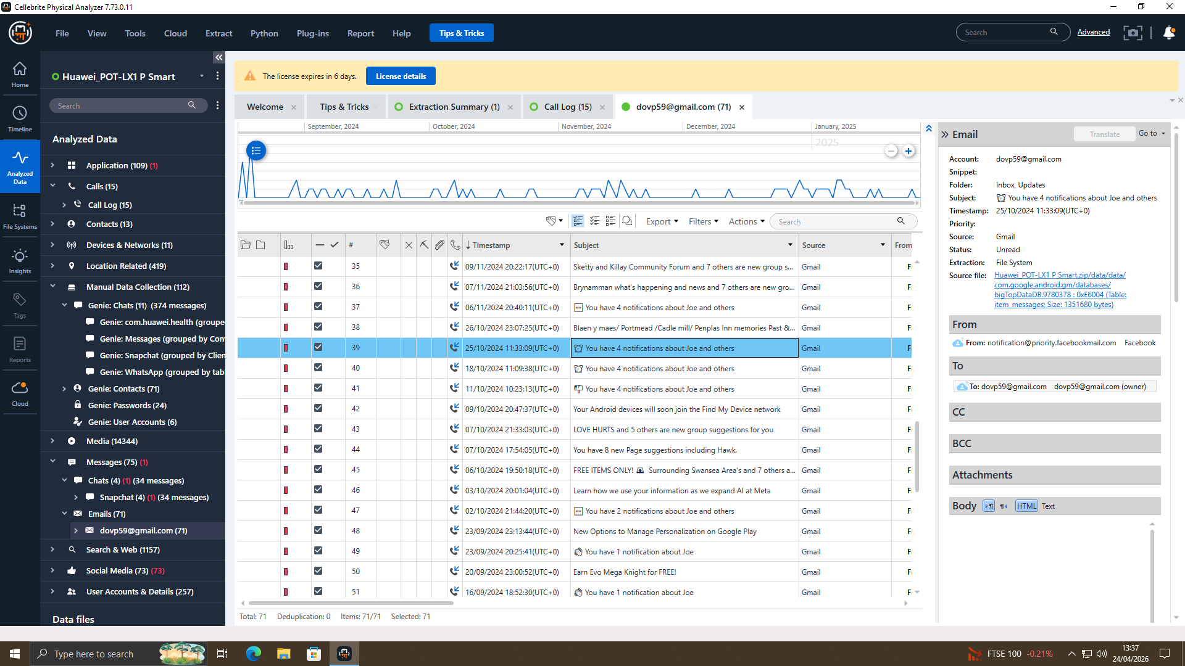

Suspect Profiling

Emma (Perpetrator)
Role: Primary suspect. Senior engineer at Quantum Tech with legitimate internal access to sensitive systems.
Evidence:
- Initiated WhatsApp communication regarding confidential information
- Demonstrated knowledge that the data was sensitive
- Took steps to conceal communications (requested secrecy, avoid chat discussion)
- Possessed technical capability to locate and manipulate files (user shortcuts found)
Motive: Financial gain through selling patents to competitor NexGen Circuits.

Joe (Intermediary)
Role: Middleman / facilitator between Emma and NexGen Circuits.
Evidence:
- Appeared consistently in WhatsApp and Instagram artefacts with Emma
- Served as communication bridge
- Did not possess internal access to Quantum Tech systems
Motive: Likely financial compensation for facilitating the deal.

Norman (Buyer)
Role: Intended buyer / recipient of stolen patent.
Evidence:
- Associated with competitor organization NexGen Circuits
- Appeared as contact within Instagram artefacts
- Indirectly referenced rather than directly involved in sensitive chats
Motive: Obtain Quantum Tech's AI chip design for competitive advantage.

Vanessa (Suspected Buyer)
Role: Suspected buyer. R&D Director at NexGen Circuits.
Evidence:
- Named in case brief as suspected buyer
- No direct digital evidence recovered from available extractions
Motive: Acquire proprietary patent data for NexGen Circuits.

Additional Supporting/Refuting Evidence
Supporting Evidence:
- WhatsApp messages showing Emma aware of confidentiality
- Multi-platform coordination (WhatsApp, Instagram, calls)
- Call timing aligned with sensitive conversations
- User shortcuts showing technical capability
Refuting Evidence:
- No conclusive evidence of completed data transfer
- No direct patent files (QT-AI-2025) recovered
- No email evidence of patent sample transfers
- No payment discussions found

Forensic Report

Case Background
Quantum Tech’s security team identified suspicious activity involving the attempted theft of a confidential company patent (QT-AI-2025). A recently hired senior engineer, Emma, emerged as the main suspect. Investigators believe she intended to sell the patent to a competing company, NexGen Circuits, using Joe as an intermediary. Norman and Vanessa, both associated with NexGen Circuits, were identified as potential recipients. This forensic investigation focused on analysing data extracted from four digital devices to uncover evidence supporting the alleged scheme.

Evidence Inventory
Evidence ID | Device | Owner | IMEI
MOB-01 | Ulefone Note 14 | Vanessa | 355617730545771 / 355617730545789
MOB-02 | Samsung Galaxy A13 | Joe | 357898921470825 / 357712351470827
MOB-03 | Nokia C2 2nd Edition | Norman | 353766763818217 / 353766763818209
MOB-04 | Huawei P Smart (POT-LX1) | Emma | 860962043462662 / 860962043422658
Table 2: Evidence Inventory Table

Methodology
- Tool: Cellebrite UFED 7.73.0.162 for physical extraction
- Analysis: Cellebrite Physical Analyzer
- Method: File system extraction, Android Backup, Kirin Live
- Integrity: Write-blocker used, SHA-256 hash verification
- Standards: ACPO and NIST guidelines followed

Findings
Timeline:
- Emma and Joe exchanged WhatsApp messages discussing "confidential AI chip design" and requesting secrecy
- Calls between Emma and Joe aligned with sensitive messages
- No direct file transfer of QT-AI-2025 was found
Communication Analysis:
- WhatsApp: Emma told Joe about possessing confidential information
- Instagram: Joe and Norman appeared as contacts
- Calls: Multiple calls between Emma and Joe during relevant period
File Analysis:
- Emma's USB drive contained document artefacts but no direct patent files
- Metadata showed files created during Emma's employment
Suspect Roles:
- Emma: Perpetrator – had access, initiated communication, sought concealment
- Joe: Intermediary – communication bridge, no internal access
- Norman: Intended buyer – associated with NexGen Circuits
- Vanessa: Suspected buyer – R&D Director at NexGen Circuits
Evidential Assessment and Limitations
- Mobile phone data shows communication and coordination between the parties involved.
- Messages and call activity suggest possible intent to share confidential information.
- No confirmed evidence of patent files being transferred was found on the examined mobile devices.
- The investigation was limited to four mobile forensic images only.
- No USB forensic image was provided, so removable-media contents could not be examined.
- As a result, the presence of patent files on a USB device could not be verified.
- Based on the available evidence, findings support preparation and attempted disclosure rather than confirmed data transfer using removable media.

Conclusion
The investigation uncovered significant evidence indicating an attempted act of corporate espionage. Findings show that Emma deliberately prepared to share confidential patent information with Joe, who served as an intermediary for NexGen Circuits, involving Norman and Vanessa. However, investigators did not recover definitive proof that the data was successfully transferred. Overall, the evidence supports allegations of attempted trade secret theft and conspiracy to commit a criminal offence.

Recommendations
For Law Enforcement:
- Charge Emma with attempted theft of trade secrets and corporate espionage
- Charge Joe as accessory/conspirator
- Investigate Norman and Vanessa at NexGen Circuits
For Quantum Tech:
- Conduct a server-side forensic audit
- Strengthen internal access controls and monitoring
- Review employee onboarding security procedures
- Preserve all forensic images for legal proceedings
Further Investigation:
If Emma’s USB flash drive or a forensic image becomes available, it should be examined using standard forensic methods to determine whether patent files were stored or transferred via removable media and to strengthen the overall file analysis.

Overall Conclusion
In conclusion, Digital forensics today has expanded far beyond the limits of its early development, although its main purpose remains the same. The central aim is still to identify, preserve, analyse, and present digital evidence in a reliable and legally acceptable way. However, the environments in which investigators now work have changed significantly. Modern investigations often involve a wide range of devices, cloud-based storage, connected technologies, and stricter privacy regulations, all of which have made the process more complex. Although forensic tools have become more advanced, no single tool is sufficient on its own. In the same way, while the main areas of digital forensics can be separated for study, real investigations often involve several of them at once. This shows that the field has developed considerably, but it is still facing challenges in keeping pace with the fast-changing digital environments it is expected to investigate.

References

[1] M. Zareen, et al., "Unveiling the Dynamic Landscape of Digital Forensics: The Endless Pursuit," Computers, vol. 13, no. 12, -12-11 2024. doi: 10.3390/computers13120333.
[2] N. Soni, "Digital Forensics: Confronting Modern Cyber Crimes, Technological Advancements, and Future Challenges," J Forensic Leg Investig Sci, vol. 11, no. 1, -06-05 2025. doi: 10.24966/flis-733x/100105.
[3] D. Dunsin, et al., "A comprehensive analysis of the role of artificial intelligence and machine learning in modern digital forensics and incident response," Forensic Science International: Digital Investigation, vol. 48, -01-26 2024. doi: 10.1016/j.fsidi.2023.301675.
[4] F. Casino, et al., "Research Trends, Challenges, and Emerging Topics in Digital Forensics: A Review of Reviews," IEEE Access, vol. 10, 2022. doi: 10.1109/access.2022.3154059.
[5] A. Sallam Said Hamed and O. Dewangan, "Digital Forensic: Techniques, Challenges, and Future Direction," IJRASET, vol. 13, no. 5, -05-31 2025. doi: 10.22214/ijraset.2025.71562.
[6] J. E. James, "FOUNDATIONS OF MOBILE FORENSICS: AN ACADEMIC APPROACH," IIS, 2024. doi: 10.48009/3_iis_2024_108.
[7] DFIR Insights. "Introduction to Digital Forensics: Preparing for the Unexpected with Volatility, Wireshark, Hayabusa and FTK Imager." DFIR Insights Blog. https://dfirinsights.com/2024/07/09/introduction-to-digital-forensics-preparing-for-the-unexpected (accessed 25 April).
[8] Cyber Forensics Academy. "Volatility Framework: Complete Memory Forensics Guide." Cyber Forensics Academy Blog. https://www.cyberforensicacademy.com/blog/volatility-framework-complete-memory-forensics-guide (accessed 25 April).
[9] A. W. Malik, et al., "Cloud Digital Forensics: Beyond Tools, Techniques, and Challenges," Sensors, vol. 24, no. 2, -01-10 2024. doi: 10.3390/s24020433.
[10] Hawk Eye Forensic. "Top 10 Paid Digital Forensic Tools in 2025: Features, Pros & Cons." Hawk Eye Forensic Blog. https://hawkeyeforensic.com/top-10-paid-digital-forensic-tools-in-2025-features-pros-cons/ (accessed 25 April).
[11] Magnet Forensics. "Magnet AXIOM — Digital Forensic Software." Magnet Forensics Product Page. https://www.magnetforensics.com/products/magnet-axiom/ (accessed 25 April).
[12] Cotocus. "Top 10 Digital Forensics Tools in 2025: Features, Pros, Cons, Comparison." Cotocus Blog. https://www.cotocus.com/blog/top-10-digital-forensics-tools-in-2025-features-pros-cons-comparison/ (accessed 25 April).
[13] Cyber Forensics Academy. "Best Free Digital Forensic Tools (2026 Updated List)." Cyber Forensics Academy Blog. https://www.cyberforensicacademy.com/blog/best-free-digital-forensic-tools-2026-updated-list (accessed 25 April).
[14] M. M. Alshabibi, A. K. Bu Dookhi and M. M. Hafizur Rahman, "Forensic Investigation, Challenges, and Issues of Cloud Data: A Systematic Literature Review," Computers, vol. 13, no. 8, -08-22 2024. doi: 10.3390/computers13080213.

