Procedural Generation Techniques for 2D trading game maps
Research Proposal
Francois Riches
Nathan Morgan
1480

Contents
1. Introduction 1
2. Background to the Proposed Research 1
2.1. Early Memory & Hardware Constraints 1
2.2. Noise & Fractal Methods: 1
2.3. Rule, Grammar & Agent Systems: 2
2.4. Search-Based Method: 2
2.5. Wave Function Collapse (WFC): 3
2.6. Implications for This Project 3
3. Research Problem statement 3
4. Research Aim & Objectives 4
5. Methodology 4
5.1. Methods 4
5.2. Materials 4
6. Project Plan 5
6.1. Gannt Chart 5
References 6

Introduction
Procedural content generation (PCG) is the algorithmic creation of game content, and it is widely used to add variation and replayability. Its earliest uses overcame hardware limits, as in the space trading game Elite (1984) [1] [2]. For a trading game, the map matters beyond appearance. It needs believable terrain and deliberate placement of towns, harbours and roads. Several techniques exist, including noise and fractals, rules and agents, search-based methods and Wave Function Collapse, but each covers only part of this. This proposal therefore asks which procedural generation technique is best utilised for a detailed 2D map in a trading game. It reviews the main techniques, states the research problem, aim and objectives, describes the methodology and gives a project plan.

Background to the Proposed Research

Early Memory & Hardware Constraints
The earliest uses of PCG (procedural content generation) emerged to overcome the technological limitations of 1980s home computer systems [1]. The space trading game Elite (1984) solved the storage constraints by procedurally generating its eight galaxies, each containing 256 planets with unique properties [1] [2]. In the video game Rogue (1980), dungeon levels were randomly generated each new game. This created a degree of replayability and content variation that expanded far beyond what the hardware limits would otherwise have allowed [1]. Modern games mostly use PCG to add variation and replayability, which is what this project aims to achieve.

Noise & Fractal Methods:
Procedural terrain is often stored as a grid of values (two-dimensional matrix) representing the height of the ground known as a heightmap [3]. Populating a heightmap with random values provides a result that is spiky, so to achieve a more natural look some relation is required between the values [3]. Interpolated noise achieves this by generating fewer random values and smoothly filling in the gaps between them [3]. Gradient noise (Perlin noise) improves upon this by replacing the random height values with random slopes, each rising or falling in a random direction [3].
Noise on its own produces hills and valleys of roughly the same width, so fractals add detail at various sizes to resemble real landscapes [3]. This can be done by stacking noise at several scales, weakening the strength at each new layer [3]. It can also be done with the diamond-square method, splitting a grid into smaller squares and adding finer detail each time [3].
These methods are fast and cheap, which will assist quick generation of game maps. A heightmap is a 2D grid of values and translates efficiently into a 2D map. This could be a base method to generate the game’s overall 2D world map. The values could be used in a tilemap to identify the correct tiles to place. However, there is limited ability to match neighbouring tiles intelligently, such as internal/external corners. Alternatively, coastlines could be drawn directly by marking everything above a chosen height as land and everything below it as water, with fractal detail giving them a natural shape. Generating detail with fractals risks unpredictable results compared with designing it by hand. The methods offer little control over the placement of cities, towns, roads, and other game specific items [3].

Rule, Grammar & Agent Systems:
Rules give designers control over the procedural generation process while still allowing variation [4]. Properly tuned rules help to ensure the generation of consistent map designs and functioning gameplay elements [4]. This is important for a trading game, where cities, towns and roads must be placed deliberately.
One way of applying rules is a grammar, which swaps symbols for more detailed ones, step by step, where the symbols can represent text, graph nodes or map tiles [5]. Grammars might be suited to placing towns and routes deliberately, but they can be difficult to design and control [5], so further research is needed during the project’s research stage to judge whether they are suitable.
Another way of applying rules is through agents, which follow simple rules to move through a space and make changes [3]. They have a degree of awareness of their surroundings, which they use to choose where to act [3]. Agents could be used to connect towns and cities within this project with realistic roads if designed carefully. They could also follow the heightmap to draw realistic rivers [3]. They can be complicated and time consuming to design. Even when carefully designed, they can produce unpredictable results and unplayable generations [4].

Search-Based Method:
A search-based method works by evolving candidates over several generations, scoring each with an evaluation function, until a good enough result is found [6]. The evaluation function can be designed for many criteria such as playability or fairness [6]. This method could be used in the project to evaluate a design created by noise and agents and, if necessary, make small changes to fix failures in playability. Writing a reliable evaluation function will likely be difficult [6].

Wave Function Collapse (WFC):
WFC starts with every cell undecided, with the potential to become any tile within its tileset [7]. Tiles can also be placed beforehand, either by a different design function or a human designer [7]. WFC then fills the cell with the lowest Shannon entropy (roughly, the fewest available options) next [7]. The available options are defined by each cell checking its surroundings and eliminating tiles that do not fit, based on predefined adjacency rules [7]. WFC can ensure that neighbouring tiles fit together, such as coastline edges and corners, which agents may not achieve reliably. On its own, however, it does not decide where towns are placed or guarantee that roads connect them.

Implications for This Project
Noise appears well suited to creating the landmass of the overall map and layering it fractally could add more detail. Rules will be needed to place the game’s functioning parts, such as roads, towns, harbours and cities. More research is required on grammars to understand their potential, and agents are difficult to design and can give unpredictable results. Search-based methods could help to identify and fix some small errors in the map’s playability. WFC could place hand-designed tiles, with the heightmap acting as a guide. Overall, no one method provides all the functionality the project needs, so a combination of them is likely to serve it best.

Research Problem statement
There are multiple techniques for designing game maps each with their strengths and weaknesses for a trading game map. A trading game needs an interesting and believable map. It needs a degree of control to correctly place cities, harbours, towns, rivers, and roads, all of which are aspects of a functional trading game. However, no single technique appears to provide all of this, so it is unclear which technique, or combination, best suits a trading game map. A poor choice of techniques will be costly with resources or effect the playability of the maps and by extension the game.
Question: Which procedural generation techniques are best utilised for a detailed 2D map in a trading game?

Research Aim & Objectives
Aim: To explore how different generative techniques are used to create a detailed map for a trading game.
- Critically review the development of procedural map generation techniques, covering noise and fractals, rule-based and agent methods, search-based methods and WFC.
- Implement at least three generative methods, or combinations of them, to create a 2D map for a trading game.
- Evaluate and compare the methods on efficiency, aesthetics, playability and control over feature placement.
- Recommend the technique, or combination, best suited to a detailed 2D trading game map.

Methodology

5.1. Methods
This project takes a pragmatist position, as its aim is practical: identifying techniques that produce a usable trading game map. Criteria drawn from the literature review will guide the design and testing of the prototypes. The strategy is design and creation (software development). Several generators, and combinations of them, will be implemented and compared, since the question of which technique is best can only be answered by building and testing them. A mixed-methods approach will be used. Generation time and playability, measured as the proportion of generated maps in which every town is reachable, will be recorded quantitatively. Control over feature placement will be judged by whether towns and harbours appear where specified. Aesthetics will be scored against a predefined 1-5 rubric, applied identically to the maps from every method.

5.2. Materials
Ethics: With no human participants and the data being generated output there are no ethical concerns.
Tools, with a role for each
- Python: prototyping generators and measuring results, such as generation time and whether every town is reachable.
- Godot (GDScript): displaying the maps in a game-like setting, since it supports 2D tile maps. Python can be used in Godot with a plugin [8].
- Aseprite: drawing the pixel-art tiles.
- Inkscape: vector graphics, such as map symbols or icons.

Project Plan

6.1. Gannt Chart
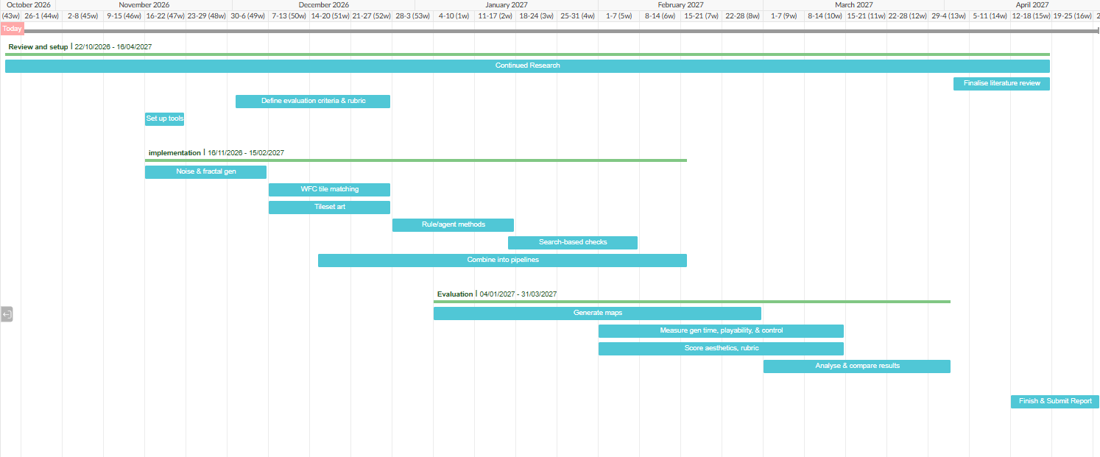
Figure 1: Gannt Chart for the proposed project plan.

References

[1] | J. Togelius, N. Shaker and M. J. Nelson, “Introduction,” in Procedual Content Generation in Games: A Textbook and an Overview of Current Research, Springer, 2016, p. 15.
[2] | A. Gazzard, “The Platform and the Player: Exploring the (hi)stories of Elite,” Game Stories, vol. 13, no. 2, 2013.
[3] | N. Shaker, J. Togelius and M. J. Nelson, “Fractals, noise and agents with applications to landscapes and textures,” in Procedural Content Generation in Games, Springer, 2016, pp. 57-72.
[4] | N. Shaker, A. Liapis, J. Togelius, R. Lopes and R. Bidarra, “Constructive generation methods for dungeons and levels,” in Procedural Content Generation in Games, Springer, 2016, pp. 31-55.
[5] | J. Togelius, N. Shaker and J. Dormans, “Grammars and L-systems with applications to vegetation and levels,” in Procedural Content Generation in Games, Springer, 2016, pp. 73-98.
[6] | J. Togelius and N. Shaker, “The search-based approach,” in Procedural Content Generation in Games, Springer, 2016, pp. 17-30.
[7] | M. Gumin, “Wave Function Collapse GitHub Repository,” 30 September 2016. [Online]. Available: https://github.com/mxgmn/WaveFunctionCollapse. [Accessed 21 October 2026].
[8] | nikz, “Python for Godot,” 2 April 2026. [Online]. Available: https://godotengine.org/asset-library/asset/3234. [Accessed 21 October 2026].

