

PROFESSIONAL CAREER DEVELOPMENT
BMSW-4005 London campus

Presented by: Cristian Radu (2125545)
Lecturer: Saqib Shamim

Contents

INTRODUCTION 2
Understanding the role of professional career development 2
Recruitment and Selection 2
Skills and Knowledge Which Contribute Towards Working Effectively 4
Personal Strengths and Areas for Further Development 5
SWOT Analysis 5
‌Personal Development Plan 6
CONCLUSION 7
REFERENCES 7
APPENDIX A 9
Questions Asked and Answered as an Interviewee in the Role Play. 9
APPENDIX B 13
Questions asked and answered as an interviewer in the Role Play. 13

INTRODUCTION

Understanding the role of professional career development
Professional career development is an ongoing process that involves setting goals, building skills and knowledge, and taking steps to achieve success in your chosen field. Whether you are just starting out in your career or are looking to advance to the next level, developing a plan for your professional growth can help you achieve your goals and achieve success.
Effective professional career development requires a combination of self-reflection, planning, and action. It involves identifying your strengths, weaknesses, and areas for improvement, setting specific and achievable goals, and taking steps to achieve those goals. This may include seeking out new job opportunities, building new skills and expertise, networking with ithers in your field, and staying up to date with industry trends.
By investing in your professional career development, you can build a fulfilling and successful career, and position yourself for growth and advancement in your field. With dedication, hard work, and a willingness to take on new challenges, you can achieve your professional goals and reach your full potential.
According to Indeed Career Guide. (n.d.). What is Professional Development? Definition and Examples. Professional development can increase your skills as an employee, which can lead to new opportunities and career advancement. Professional development includes advancing skills, traits and competencies that contribute to your success in the workplace.

Recruitment and Selection

Essex Roofing LTD, manager.
In this report, I will be using the Gibbs reflection cycle to reflect on a specific experience from my professional career and how it has impacted my development as a manager, by going through each of the six stages of the Gibbs reflection cycle - description, feelings, evaluation, analysis, conclusion, and action plan, I will be able to thoroughly reflect on this experience and identify any areas for improvement where I excelled.
I believe that my use of the Gibbs reflection cycle has helped me to grow and develop as a professional, and I am confident it will be an invaluable asset in my role as a manager at Essex Roofing LTD. I am excited to share my reflection with you and discuss how the Gibbs reflection cycle is helping me in my journey towards becoming a successful manage at Essex Roofing LTD.
According to The University of Edinburgh (2020). Gibbs' Reflective Cycle. Gibbs reflective cycle was developed by Graham Gibbs in 1988 to give structure to learning from experiences. It offers a framework for examining experiences, and given its cyclic nature lends itself particularly well to repeated experiences, allowing you to learn and plan from things that either went well or didn’t go well.

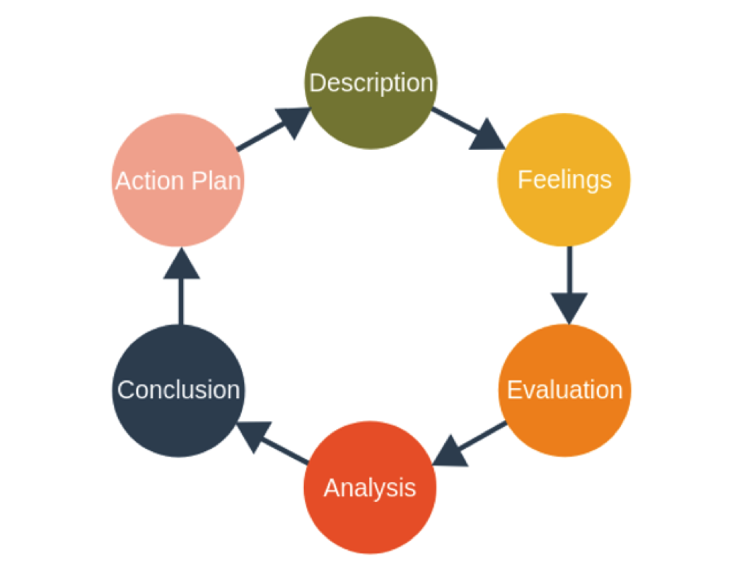
Description
During my manager position interview at Essex Roofing LTD, I was asked a series of questions about my previous experience, my management style, and my approach to problem solving.
Feelings
During the interview, I felt confident and prepared. However, I did feel a bit anxious at the beginning, as I wanted to make a good impression.
Evaluation
Overall, I think the interview went well. I was able to answer most of the questions effectively, and I feel that I presented my self in a competent manner. However, there was one question that I struggled with, as I wasn’t sure how to respond.
Analysis
After reflecting on the interview, I realize that I need to work on my ability to think on my feet and come up with quick responses to unexpected questions. This is an area that I can improve upon through practice and preparation.
Conclusion
Based on my performance during the interview, I feel that I am a strong candidate for the manager position role at Essex Roofing LTD. However, I also recognize that there are areas where I can improve, and I am committed to continuing to develop my skills and knowledge.
Action Plan
To prepare for future interviews, I plan to practice to unexpected questions and continue learning about best practices in management. I will also seek feedback from my peers and mentors to identify any areas for improvement.

Skills and Knowledge Which Contribute Towards Working Effectively

Technical Skills
Depending on your field of work, you may need specific technical skills to be effective. For example, a software developer will need strong programming skills, whilst a marketing professional will need strong skills in data analysis and marketing strategy.

Time Management Skills
Being able to prioritize tasks and manage your time effectively can help you get more done in less time.
Communication Skills
Being able to communicate clearly and effectively with others can help you collaborate better and get your work done more efficiently.
Problem Solving Skills
Being able to identify and solve problems as they arise can help you stay on track and make progress in your work.
Interpersonal Skills
Being able to work well with others and build positive relationships can make it easier to get things done and achieve your goals.
Creativity
Being able to come up with new ideas and approaches can help you find creative solutions to problems and challenges.

Personal Strengths and Areas for Further Development

SWOT Analysis
Strengths | Weaknesses | Opportunities | Threats
- Strong leadership skills  - Good communication and interpersonal abilities.  - Ability to motivate and inspire team members.  - Strong problem solving and decision-making skills.  - Knowledge and experience in industry. | - Limited technical in specific areas.  - Tendency to micromanage team members.  - Struggle with delegating tasks effectively | - Opportunities for development and training.  - Opportunities to take additional responsibilities and increase leadership experience.  - Opportunities to improve team performance and efficiency.  - Opportunities to build relationships with other departments and teams within the company. | - Competition for promotions or leadership positions within the company.  - Changes in the industry or market that may affect the company.  - Limited budget or resources.  - Negative company reputation or public image.

According to White, J. (2021). What is A SWOT Analysis? A SWOT analysis is a framework used in a business’s strategic planning to evaluate its competitive positioning in the marketplace. The analysis looks at four key characteristics that are typically used to compare how competitive the business can be within its industry. A proper SWOT analysis can give you a fact-based analysis to make decisions from, or it could spark your creativity for new products or directions.

‌Personal Development Plan

According to cpduk.co.uk. (n.d.). The importance of Personal Development Plan | The CPD Certification Service. Establishing a healthy work-life balance can be difficult, but it doesn't have to be the same old, same old. Indeed, by creating a personal development plan (PDP), you can position yourself for success. You can take control of your career and personal life by developing a personal development plan that benefits both you and your employer, which is useful when hoping for sponsorship. Of course, if you wish to change your career path your PDP may not be aligned with the goals of your current organization.
Your PDP serves as a road map to help you achieve your life objectives. It is a strategy for improving any aspect of your life - work, relationships, or fitness goals - and it is a necessary step toward success.

Leadership Skills | Attend leadership training workshops within the next 3 months | Lead a team or project within the next 6 months | Seek out additional leadership training or coaching within the next year
Technical Expertise | Identify specific areas where technical knowledge is lacking within the next month | Enrol in a course or workshop to improve technical skills within the next 3 months | Earn relevant certification within the next year
Communication | Attend a communication course workshop within the next 3 months | Practice active listening and seek out opportunities to present to groups or leaf meetings over the next 6 months | Provide regular and effective communication to team members over the next year
Interpersonal Skills | Practise empathy and emotional intelligence with team members over the next 3 months | Seek out opportunities to build relationships with colleagues within the company over the next 6 months | Lead team-building activities or events within the next year
Time Management | Set clear goals and priorities within the next month | Create schedule and learn how to say no to non-essential tasks within the next 3 months | Regularly review and adjust time management strategies over the next year
Creativity | Encourage creativity ad innovation within the team by setting aside time for brainstorming sessions over the next 3 months | Encourage team members to come up with new ideas over the next 6 months | Implement at least one new idea from the team within next year
Professional Development | Attend an industry conference within the next 6 months | Network with professionals in the next year | Enrol in a continuing education course within next year

CONCLUSION

Professional career development is an ongoing process that involves continually improving your skills, knowledge, and abilities to advance your career and reach your goals.
It is important to be proactive in seeking out opportunities for learning and growth, and to be open to new challenges and experiences. Building strong professional network and staying up to date with industry trends can also support your career development. Overall, investing in your own professional development is crucial for success and satisfaction in your career.

REFERENCES

cpduk.co.uk. (n.d.). The importance of a Personal Development Plan | The CPD Certification Service. [online] Available at: https://cpduk.co.uk/news/the-importance-of-a-personal-development-plan.
Indeed Career Guide. (n.d.). What Is Professional Development? Definition and Examples. [online] Available at: https://www.indeed.com/career-advice/career-development/what-is-professional-development.
The University of Edinburgh (2020). Gibbs’ Reflective Cycle. [online] Available at: https://www.ed.ac.uk/reflection/reflectors-toolkit/reflecting-on-experience/gibbs-reflective-cycle.
‌
White, J. (2021). What Is A SWOT Analysis? [online] Forbes Advisor. Available at: https://www.forbes.com/advisor/business/what-is-swot-analysis/.
‌

APPENDIX A

Questions Asked and Answered as an Interviewee in the Role Play.
Interviewer: Petrina Marian, General Manager Essex Roofing LTD
Interviewee: Cristian Radu, Candidate for manager position at Essex Roofing LTD
Question 1
Interviewer:
-Good morning and welcome to Essex Roofing LTD. My name is Petrina Marian, and I will be conducting the interview for the manager
position today. Can you tell me a little bit about yourself and why you are interested in this position?
Interviewee:
- Good morning, Mrs Petrina. Thank you for having me. My name is Cristian Radu and I have been working in the roofing industry for the
past 15 years. I am very interested in this position because I am passionate about roofing, and I believe that I have the skills and experience
necessary to lead the team at Essex Roofing.
Question 2
Interviewer:
-That's great to hear. Can you tell me a little bit more about your experience in the roofing industry?
Interviewee:
-Sure. I have worked on a variety of projects, ranging from small residential repairs to large commercial installations. In my previous role as
a project manager, I was responsible for overseeing all aspects of the project, including budgeting, scheduling, and coordinating with
subcontractors. I have also had experience managing a team of up to 15 people, so I am comfortable leading and motivating a team to
achieve our goals.

Question 3
Interviewer:
-That's impressive. How do you approach problem-solving and decision-making in your work?
Interviewee:
-I believe in gathering all the necessary information before deciding. I like to analyse the situation and consider multiple options before concluding. I
also believe in involving my team in the decision-making process, as their input and insights can be valuable. When it comes to problem-solving, I try
to approach it with a calm and logical mindset. I try to identify the root cause of the problem and come up with a plan to solve it efficiently.
Question 4
Interviewer:
-That’s great to hear. Can you give me an example of a time when you faced a challenge as a manager and how you approached it?
Interviewee:
-Sure. One time, we were working on a large commercial roofing project, and we encountered some unexpected challenges with the roof deck. We
had to make some changes to the original plan and come up with a new solution. I gathered my team together and we brainstormed different options.
I made sure to listen to everyone’s ides and ultimately came up with a solution that not only addressed the issue, but also saved the clients’ money.
I then communicated the plan to the client and made sure to keep him informed throughout the process.
Question 5
Interviewer:
-Great, thank you. How do you handle conflicts or challenges in the workplace?

Interviewee:
-I believe in open and honest communication when it comes to conflicts or challenges in the workplace. I try to listen to all sides and find a solution
that works for everyone involved. If necessary, I am not afraid to escalate the issue to a higher level for resolution. Above all, I prioritize
maintaining a positive and respectful work environment for all team members.
Question 6
Interviewer:
-That's good to hear. Do you have any questions for us?
Interviewee:
-Yes, I do. Could you tell me more about the team and culture at Essex Roofing? How do you foresee the role of the manager in this company?
Interviewer:
-Of course. At Essex Roofing, we value teamwork, professionalism, and continuous learning. As the manager, you would be responsible for setting the
tone and leading by example. You would be expected to motivate and support your team, as well as ensure that all projects are completed safely, on
time, and within budget. You will also be responsible for maintaining strong relationships with our clients and partners. Does that answer your
question?
Interviewee:
-Yes, it does. Thank you for the information.
Interviewer:
-Thank you for your time today, Cristian. We will be in touch soon to let you know the next steps in the hiring process.
Interviewee:
-Thank you, Mrs Petrina. I look forward to hearing from you!

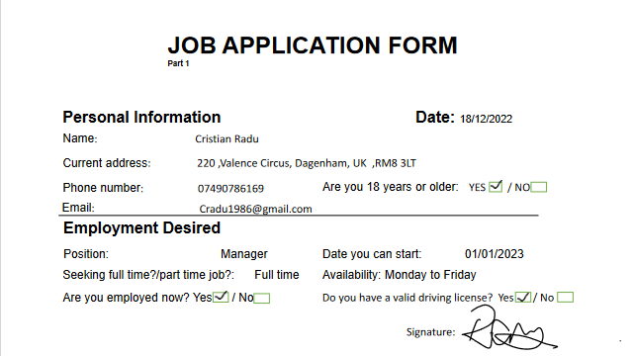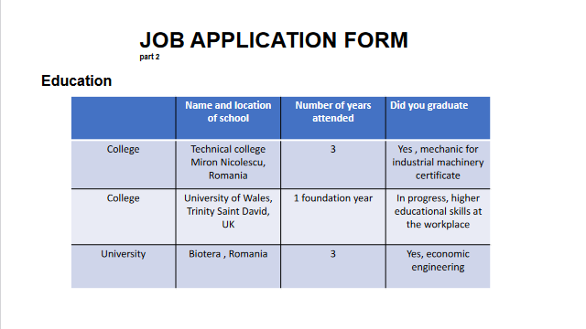
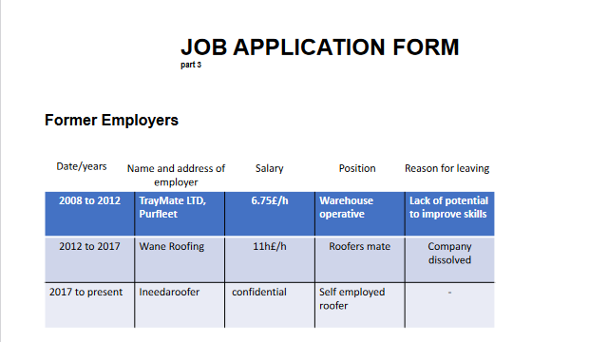

APPENDIX B

Questions asked and answered as an interviewer in the Role Play.

Interviewer: Cristian Radu, General Manager at MOZART LTD
Interviewee: Petrina Marian, candidate for marketing executive position at MOZART LTD

Question 1
Interviewer:
- Good afternoon, thank you for waiting. I am Mr. Radu, I am your interviewer for today. How are you? Could you please introduce yourself and tell us a little bit about your background in marketing?
Interviewee:
- Good morning, my name is Petrina Marian and I have over 10 years of experience in marketing. I developed successful campaigns across various platforms, including social media, email marketing, and paid advertising. I have also worked with a variety of tools and analytics platforms to track and measure the performance of my campaigns. Also, I have worked in various industries, with a focus on digital marketing.
Question 2
Interviewer:
- That sounds impressive. How do you stay up to date on the latest marketing trends and techniques?
Interviewee:
I make it a priority to stay informed about the latest marketing trends and techniques. I regularly read industry blogs and publications, attend conferences and webinars, and network with other professionals in the field.

Question 3
Interviewer:
- Can you give me an example of a successful marketing campaign you have led in the past?
Interviewee:
- Sure, I'd be happy to. In my previous role, I led a campaign for a healthcare client that focused on promoting their telemedicine services. We developed a targeted digital advertising strategy and created a landing page to capture leads. The campaign generated a significant increase in website traffic and leads, and the client was extremely satisfied with the results.
Question 4
Interviewer:
-Great! How do you approach creating and implementing a marketing strategy?
Interviewee:
- When creating a marketing strategy, I first start by identifying the target audience and defining the marketing goals. From there, I conduct market research to understand the competitive landscape and gather insights about the target audience. Based on this information, I develop a plan that includes tactics such as social media campaigns, content marketing, and paid advertising to reach the target audience and achieve the marketing goals. I then work with the team to execute the plan and track progress to ensure that we are meeting our goals.
Question 5
Interviewer:
-Impressive! Can you tell me about a time when you had to pivot a marketing strategy mid-campaign and how you approached that situation?
Interviewee:
- Absolutely. One time, I was leading a campaign for a retail client, and we noticed that the initial strategy was not performing as well as we had hoped. We identified that the target audience was not responding to the messaging and creative, so we had to pivot quickly. I worked with the team to come up with a new strategy that focused on a different target audience and messaging that resonated better with them. We also adjusted the budget to allocate more resources to the new strategy. Ultimately, the campaign was a success, and we exceeded our goals.
Question 6
Interviewer:
-Perfect! How do you develop and maintain relationships with clients or stakeholders?
Interviewee:
- Building and maintaining strong relationships with clients and stakeholders is crucial to the success of any marketing campaign. I believe in being transparent and open with communication, setting clear expectations, and consistently delivering high-quality work. I also try to understand the client's business and goals, and I work collaboratively to find solutions that meet their needs. Additionally, I follow up with clients regularly to check in on their satisfaction with our work and address any concerns they may have.
Question 7
Interviewer:
-Excellent! Do you have any questions for us?
Interviewee:
- Yes, I have a question, do you offer flexible working hours?
Interviewer:
- Actually, yes, I am open to flexible working hours, overall, I believe this can lead to increased productivity, employee satisfaction and overall success for the business.
Interviewee:
- That’s great! Thank you!
Interviewer:
- Thank you for your time. I will reach you within the next few days.

