University Of Wales
Trinity Saint David

MSc Property and Facilities Management

Building Services and Energy Performance

Lecturer: Alun Watkins Created By: Allyn Pritchard
Submission Deadline: 24th June 2022 Student No.: 1101011

Contents
1.0 Introduction 4
2.0 Case Study 4
2.1 Meyler House 4
2.2 Building Components 6
2.2.1 Building Layout and Fabric 6
2.2.2 Heating 7
2.2.3 Electrical System 8
2.2.4 Windows & External Doors 10
2.2.5 Roof 10
2.3 Thermal Comfort Strategy 11
2.4 Maintenance and Defects 12
3.0 Building Performance Data 12
3.1 Benchmarking 12
3.2 Data Sets 13
3.3 Pre Covid-Baseline 13
3.3.1 Electrical Data 14
3.3.2 Gas Data 16
3.3.3 Water Data 18
3.4 Post Covid-Baseline 19
4.0 Medium Term Retrofit Plan 21
4.1 Regulations & Guidance 21
4.2 Retrofit Plan Outline 21
4.3 Technology & Fabric Plan 22
4.4 Budget Plan & Timescales 23
4.5 Maintenance Strategy 24
4.6 Baseline Improve 25
4.7 Ongoing Costs & Savings 30
5.0 Conclusion 31
6.0 References 31
7.0 Bibliography 33
8.0 List of Figures 36
9.0 Appendixes 37
9.1 Appendix 1 37
9.2 Appendix 2 38
9.3 Appendix 3 39
9.4 Appendix 4 40
9.5 Appendix 5 41
9.6 Appendix 5 42
9.7 Appendix 6 43
9.8 Appendix 7 44
9.9 Appendix 8 45
9.10 Appendix 9 46
9.11 Appendix 10 48
9.12 Appendix 11 49

Introduction
This report aims to examine a case study building looking at firstly a thermal comfort strategy and current building maintenance/defects. The report will highlight how the building components are currently structured and what current capital works programmes are in place for the building, having strong asset management data is key to making informed decisions (María Carmen Carnero, 2017). It will highlight current known building defects, solutions to these defects will be woven into the proposed outcome of the report. The report will also look at current baseline data for the building in the pre and post covid world. This will help understand how the building was being used to how it will be used in the post covid world, this will be vitally important as Welsh Government would like to see more than 30% of Welsh workers work from home, even without covid restrictions (Felstead, 2020). Finally, the report will outline a medium term retrofit plan which will include a wide range of fabric, heating, energy, and social changes to ensure the building is “net zero” by 2050 (legislation.gov.uk, 2019). Undertaking building upgrades alone will not achieve net zero, social and infrastructure changes will be needed, currently the UK Government have set an ambitious target for 2035 for the electrical grid to be decarbonised (UK Government, 2021).
For the purposes for this report domestic dwellings will not be critiqued only the case study building which a commercial building, but the report will offer approaches that could be taken across both settings to ensure net zero by 2050. The report will conclude by offering innovative approaches and blue sky thinking to help solve the decarbonisation issue.

Case Study

Meyler House
The case study that this report will look at Meyler House, St Thomas Green, Haverfordwest SA61 1QP. This building the current head office for ateb group, a registered social landlord situated in West Wales, the organisation owns and manages over 3100 domestic and commercial premises throughout West Wales.
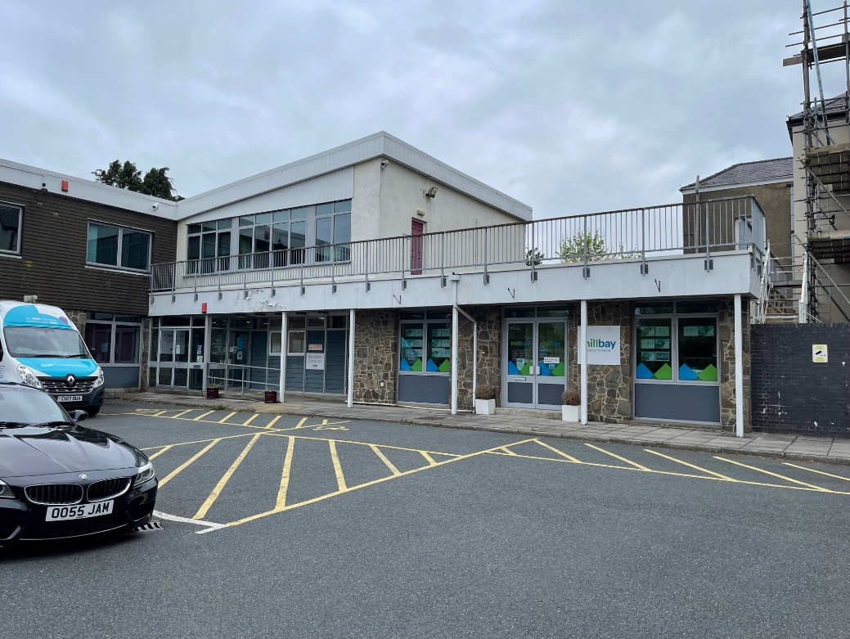

Fig. 1

Pre covid the building was at 100% capacity with over 150 people based at the offices from Monday to Friday. Post covid the building is being used in a hot desk set up with various meeting room set up for training and team meeting. Currently the organisation has over 250 employees with 90% of staff working from home for four out of the five working days, this is exceeding the Felstead report in which Welsh Government want up to 30% of Welsh workers to work from home in the future (Felstead, 2020). Below is the extract from a report commissioned by ateb (formally Pembrokeshire Housing Association) by Bullock Consulting. The extract outlines pre covid occupancy, occupancy hours and building m^{2.}

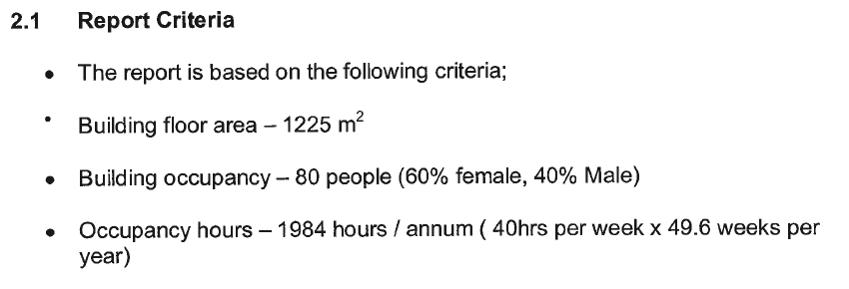

Fig. 2
(ateb - Water & Energy Audit. 2007)
Because of covid and the success of “work from home” the building now has ten bookable desks/rooms and eight training and meeting rooms, these rooms can be seen in Appendix 1.

Building Components

Building Layout and Fabric
Meyler House has two floors (ground and first floor) and is split into three zones as per the fire safety plans below and the main building components are listed within Appendix 2.

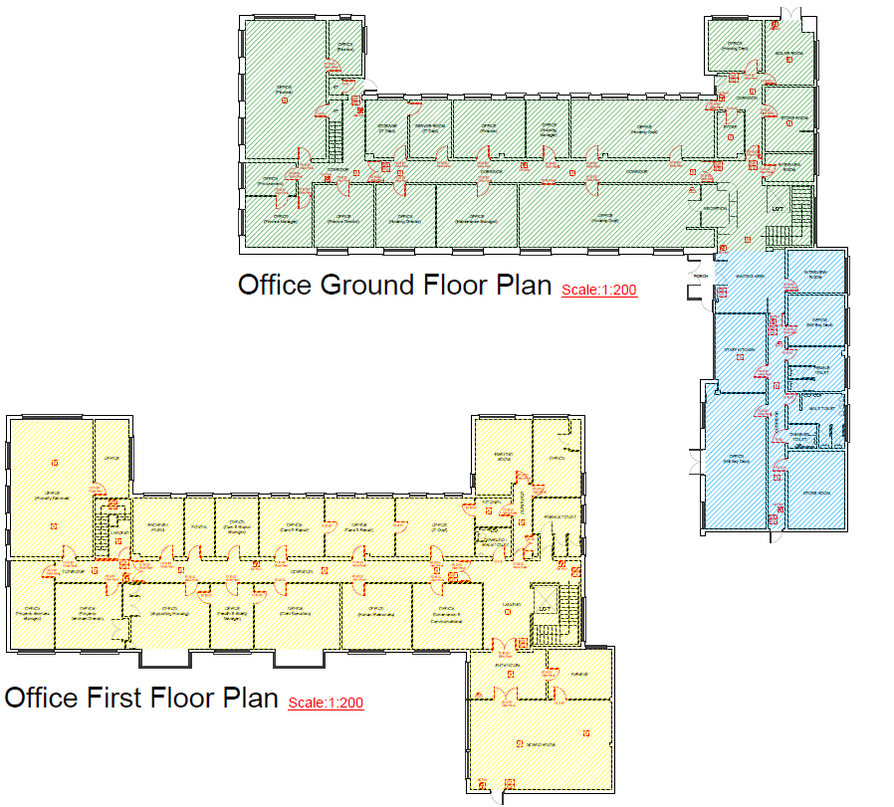

Fig. 3
(ateb – Fire Safety Plan. 2006)

Firstly, the fabric of the building is traditional render which is in average condition and aesthetically it looks ok due to a regular planned painting works. The site building has a cavity wall with no insulation and there are no additional extensions to the building since the initial construction. Access to all the external walls is unimpeded, there are various reaches in the fabric of the building for cables and pipework which will affect the overall heat loss from Meyler House.

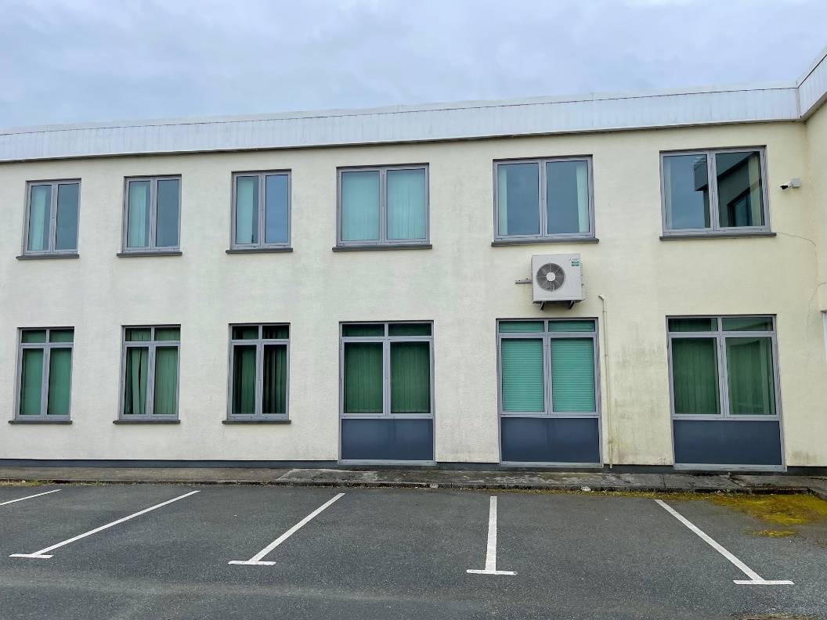

Fig. 4

Heating
The heating system for the building is situated on the ground floor plant room on the upper right-hand side of the green zone, as per the Fig. 3. There are two Hamworthy NGR 320 boilers installed, and these are used in conjunction with a plate heat exchanger to provide hot water to parts of the building. The boilers are housed within the plant room, which is approximately 43m³, the heating system is a one pipe heating system that is run in 28mm copper pipe which circulates the building and covers 90% of all rooms. The remaining rooms heating requirements are met via electric space heating, this is approximately ten rooms.
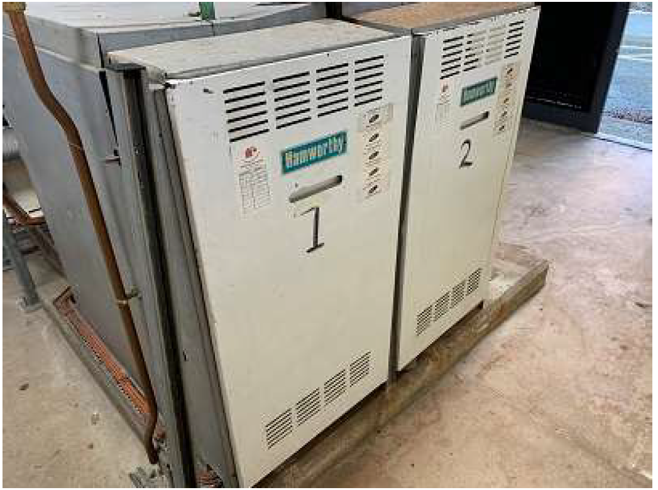

Fig. 5

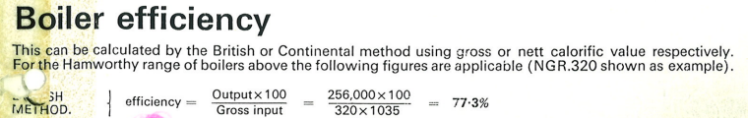
These boilers are 77.3% efficient as per the Hamworthy Gas Fired Modular Boiler Systems Data Sheet, please see extract below.

Fig. 6

Electrical System
The electrical supply to Meyler House is a three phase 300amp 415V supply, the distribution network operator (DNO) fuses are situated on the ground floor storeroom on the upper right-hand side of the green zone, as per the Fig. 3. The storeroom is approximately 21m³ which houses 3 x three phases distribution boards (Hager and Merlin Gerin). The system has several small single-phase boards located throughout the building serving rooms like the plant room, kitchen, etc. Only single-phase LV circuits are installed throughout the building with exception to the FP200 for the fire alarm panel and the data cables.
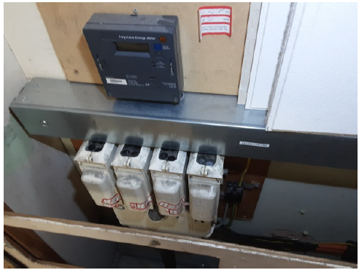

Fig. 7
Three phase service head with the 3x line and 1x neutral, 4x 100a amp ceramic fuses.
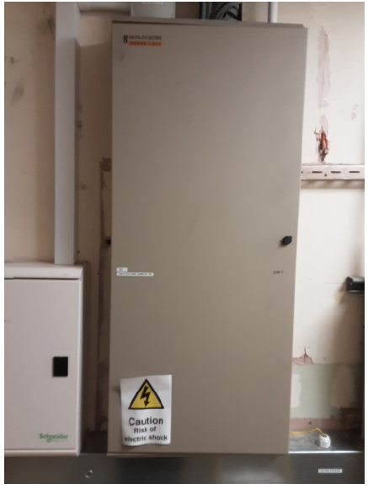

Fig. 8
Merlin Gerin three phase consumer unit situated with the storeroom.

Windows & External Doors
The windows on site are all grey composite which are in particularly good condition, as suggested from Appendix 2 (Lifespan). We have five external aluminium door(s) one of which is the main entrance, and the remaining are made up of emergency exits and plant room entrance.
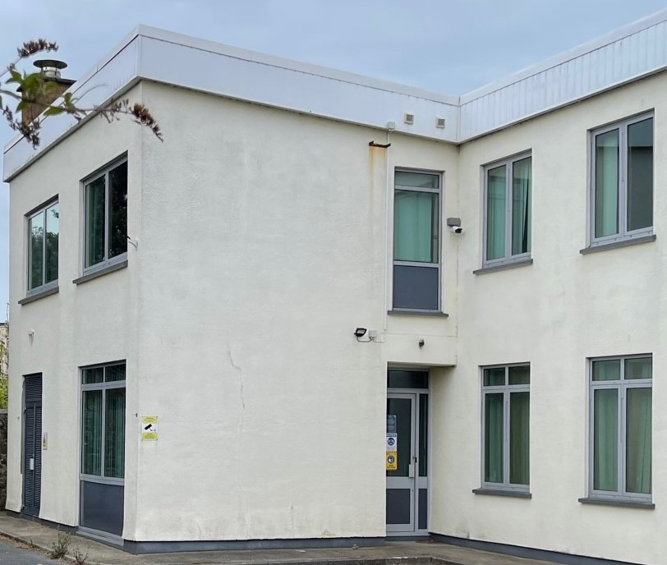

Fig. 9

Roof
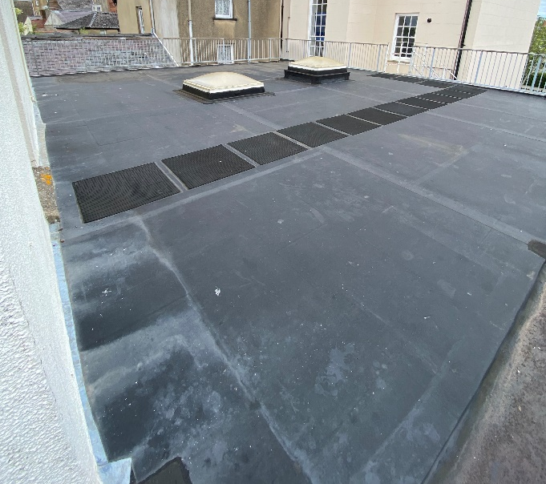
The roof is fiberglass and is approximately 1000m² and is split over two levels. Access to the roof is via an external staircase situated at the side of the main building and the first level of the roof has guardrails to provide fall protection. The main “upper” roof has no fall arrest system in place which is an issue when undertaking any works as scaffold is always required to undertake maintenance in a safe manner.

Fig. 10

Thermal Comfort Strategy
Thermal comfort is made up of six basic factors, four of which are environmental factors and two are personal factors. Each one of the factors are independent but all should be considered when looking at thermal comfort for a building or a person (Health and Safety Executive , 2021).

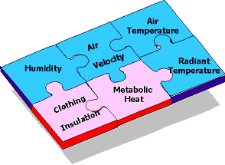

Fig. 11
(Health and Safety Executive , 2021).

Thermal comfort within Meyler house has not been considered holistically and the ateb have only really applied it during winter months. The buildings heating system is on 24 hours a day 365 days of the year which is controlled via one communal thermostat situated within the reception area which is not economical and does not allow for customisation of heat levels in each room. Ventilation is only achieved via opening windows which are limited and not all rooms have fully opening windows as some have restrictors installed, the kitchen and bathrooms have four six-inch domestic fans installed which provide ventilation in these rooms. Cooling (air conditioning) has not been a consideration for the thermal comfort, it has only been installed as part of a requirement for the server room only which is situated at the rear of the building. The current model for thermal comfort within Meyler House is not suitable and a more adaptive model is needed which would be able to provide a wider range of comfortable temperatures and be customisable, this in turn could provide significant energy and environmental savings (Liu Yang, 2014).

Maintenance and Defects
Maintenance of Meyler house has been sporadic/reactive for several years due to several changes in senior management and questions around the building ability to be fit for the future. Capital planned works have still gone ahead when due but recently several compliance services have raised major concerns with key building complaints. The currently electrical installation replacement has been flagged as urgent as per Appendix 2, this is due to ateb being issues a danger notice from our electrical contractor “John Ling Electrical”, please see danger notice in Appendix 3. The electrical installation in no longer fit for purpose and does not meet the requirements of BS7671:2022 (The Institute of Engineering & Technology, 2022), due to this the office is now being used in a limited capacity under a safe system of works. With this works needing to be done urgently this could be beneficial for the longer term retrofit plan, as we can now design a new electrical installation for Meyler House with the intention of it being retrofit ready.

Building Performance Data

Benchmarking
There are many ways to assess the energy performance of a building. Benchmarking is an accepted method, guidance documents such as CIBSE Guide F and CIBSE TM46 both provide benchmarking data for typical and good practice based on a per square meter approach for buildings categorised as being similar. Appendix 4 outlines the energy consumption benchmarks for existing buildings in kWh/m²/yr, Meyler would be classified as “Offices, Naturally Ventilated, Open Plan.” Below is an example equation this report will use for energy benchmarking.

Benchmark = Typical/Best Practice (CIBSE Value) X Building Floor Area
Benchmark = (kWh/m²) X m²

This report will use the average litre per day that South Staffordshire Water Company state as the average for the baseline, which is 50 litres per person per day (South Satffs Water, 2020), please see Appendix 5 for full details. Below is an example equation this report will use for water benchmarking.

Cubic Meter (m³) = Typical (Appendix 5 Value)
100 (Cubic Meter Conversion)
Total Working Days = 48 (Working Weeks) X 5 (Working Days Per Week)
People Working Days = Total Working Days X Employee Numbers
Benchmark = Cubic Meter (m³) X People Working Days

Data Sets
Data sets that are available for the purpose of this report are the following.

- Gas, Electricity & Water readings going back to 2002 (Not including covid lockdown period)
- Current Gas, Electricity & Water bills
- Energy & Water Audit (Conducted in 2007)
- Lifespan Asset Management Data
- Compliance Service Data

By using the data set available we should be able to get a picture of how Meyler House has been performing against typical and best practice as set out within CIBSE Guide F – Table 20.9 (CIBSE, 2021). By analysing data this should provide patterns of building energy performance over time which could be cross matched to environment and organisational events, this will allow the ateb to hopefully decrease energy use (Sokratis Papadopoulos, 2018).

Pre Covid-Baseline
Pre Covid the office was operating in a more traditional sense with around 150 employees in the building at any one time, energy and water data at this time was recorded monthly and store on spreadsheets on internal computer systems. The available data stretches from May 2002 to March 2020, which are electricity, gas, and water meter readings. The data from 2004-2006 has already be analysed by the Bullock Consulting Energy & Water Audit which outlined that the building was performing better than expected but recommended additional measures to ensure energy savings are maximised (Bullock Consulting , 2007), full details of the recommendations can be found in Appendix 5. So, for the purpose of this report the pre covid data that we will analyse will be between 2016 and 2020.

Electrical Data
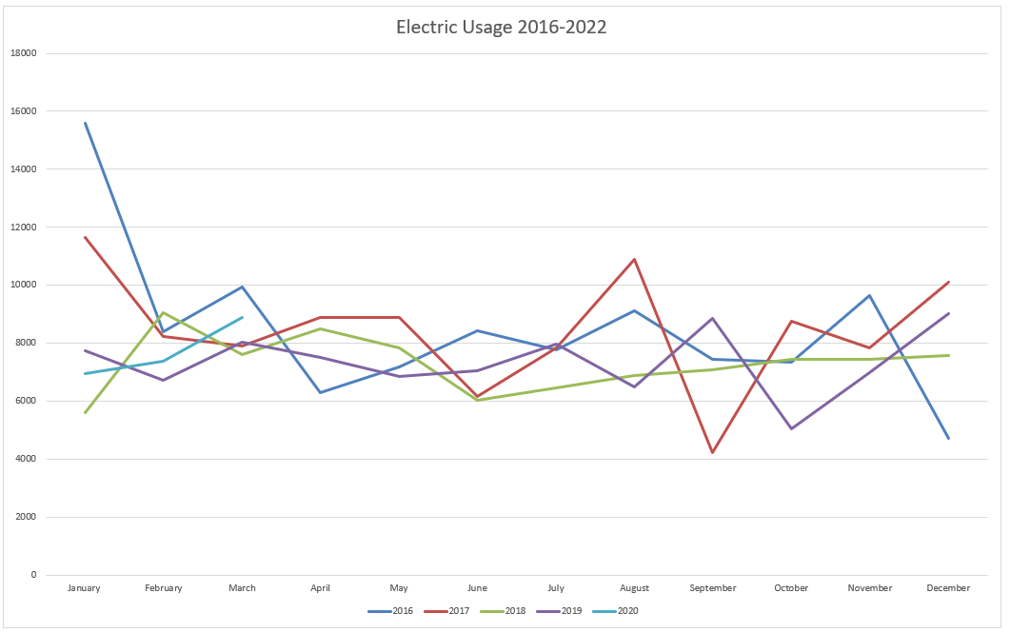

Fig. 12

Figure 12 shows consistent electrical usage throughout the year with small peaks and troughs but consistent.
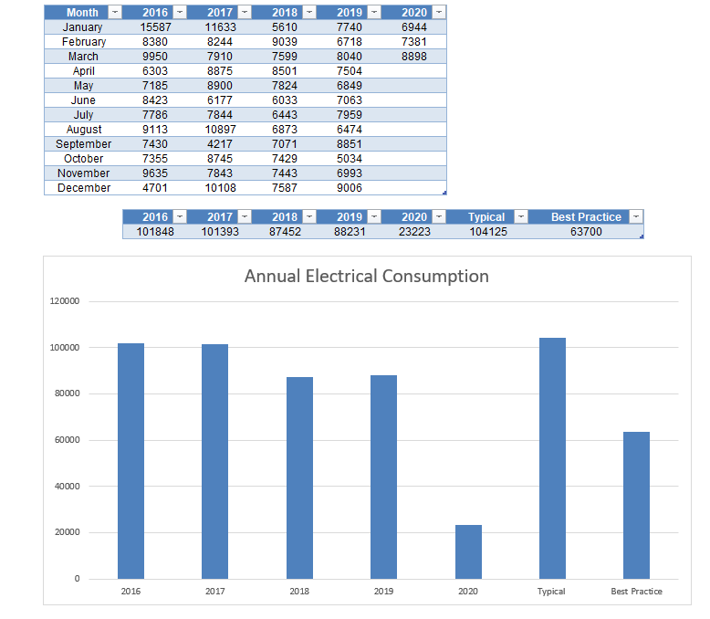
Fig. 13
Figure 13 provides the overall electrical consumption between January 2016 and March 2020. The best practice and typical benchmarks were calculated from the data provided by CIBSE Guide F – Table 20.9 (CIBSE, 2021).
What is evident from figure 12 & 13 is that pre covid the buildings electrical consumption in years 16-17 was comparable to the typical values recommended and then dropped below by some margin for years 18-19, this is impressive considering the equipment being used within the building (computers, space heating, T8/T10 lighting, etc). For the first three months of 2020 the energy consumption is again below the typical usage and is following the tread of the previous years.

Gas Data
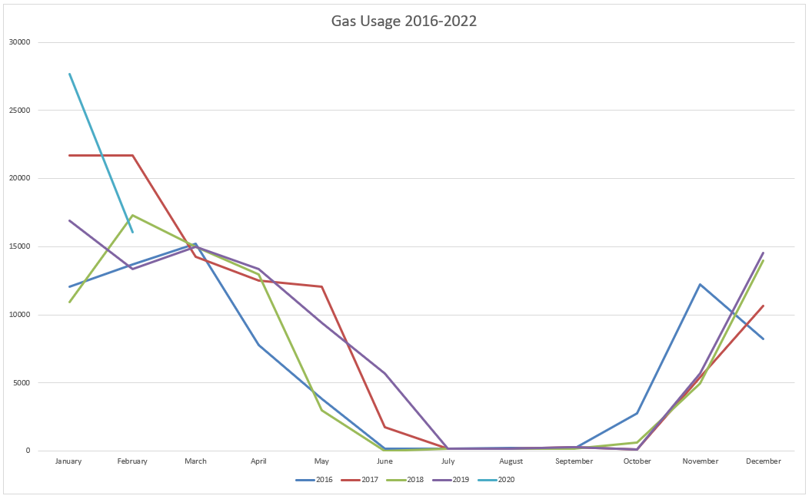

Fig. 14

Figure 14 shows expected peaks and troughs which would coincide with seasonal changes.

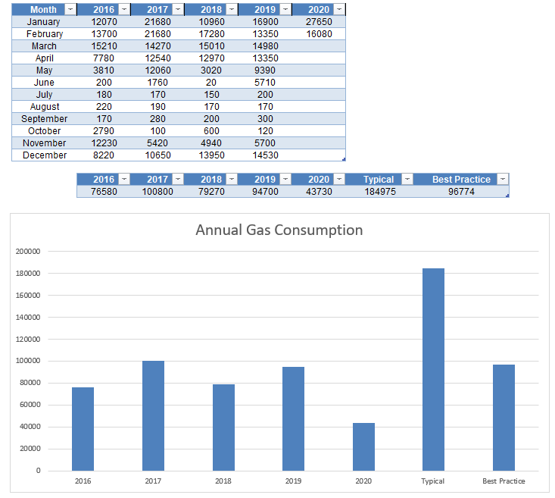
Fig. 15
Figure 15 provides the overall gas consumption between January 2016 and February 2020. The best practice and typical benchmarks were calculated from the data provided by CIBSE Guide F – Table 20.9 (CIBSE, 2021).
What is evident from figure 14 & 15 is that pre covid the buildings gas consumption is considerably below typical values recommended and some years (16,18,19) are below best practice values. One reason for this could be the exceptional repairs and servicing regime which is conducted entirely in-house, by ateb’s heating and plumbing team. Also, the data should not be considered in isolation as a plate heater provides hot water which is power via the electrical supply.

Water Data
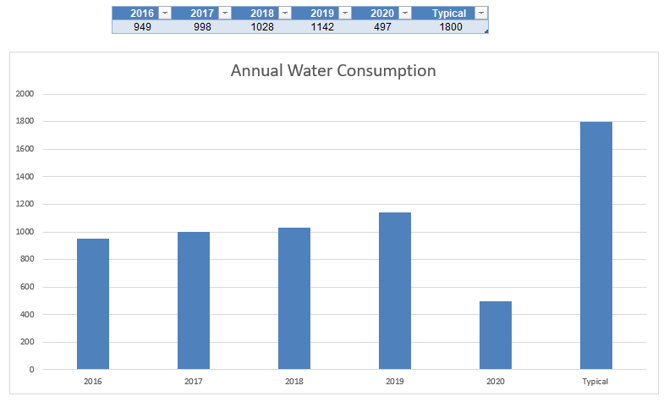
Fig. 16

Figure 16 provides the overall water consumption between January 2016 and February 2020. The typical benchmarks were calculated from the data provided as per appendix 5 and data from ateb Energy & Water Audit (Bullock Consulting , 2007). Water reading were only taken annually unlike electrical and gas metre readings which were taken monthly. The data does seem to suggest that the water usage is lower than recommended which is great but, the data does not take account the type of organisation and their employee types. The organisation employs people who are not situated in the office 100% of the time like tradespeople, surveyors and building managers. The property team in total accounted for approximately 43% of the workforce between these years, based on this percentage of occupancy this would bring the typical water consumption down to 102600 cubic meters (m³), which would mean the buildings water consumption is quite typical.

Post Covid-Baseline

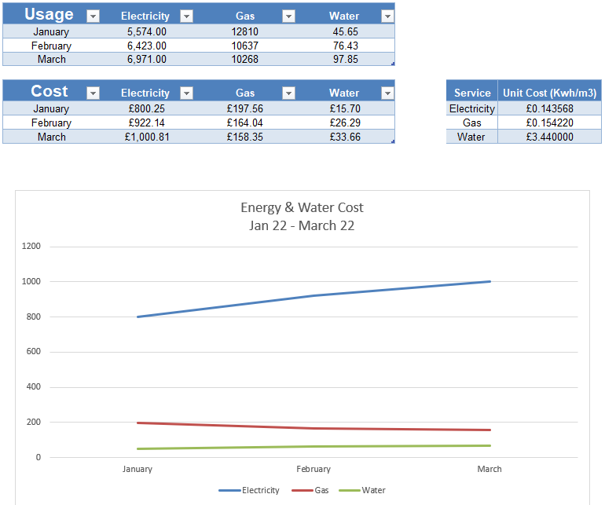
Fig. 17

Figure 17 provides the overall cost and usage of energy and water from January 2022 – March 2022 and the current individual unit cost for each. From January 2022 to March 20022 Meyler House was slowly opening back up after the latest covid-19 restriction, we can clearly see this within the data as both electricity and water consumption are increasing each month. This was due to more employees being able to work from the office.

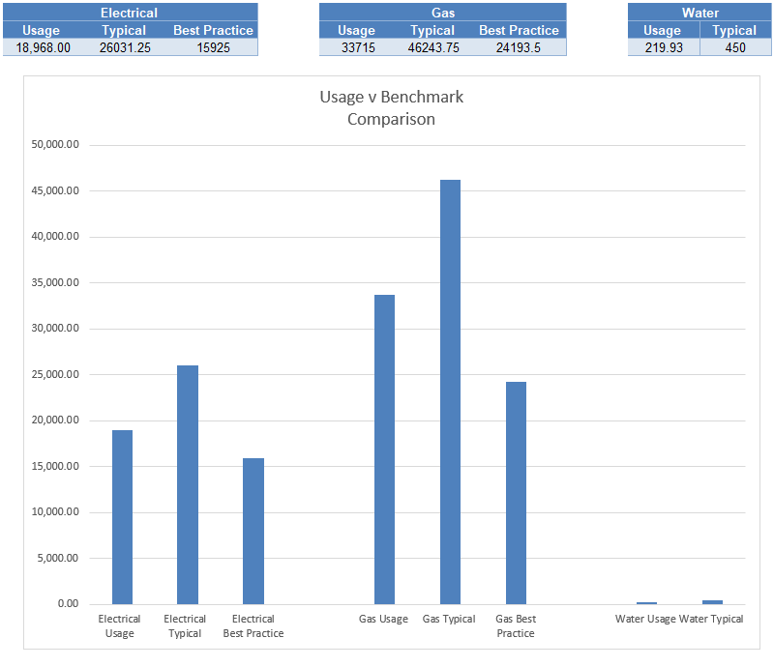

Fig. 18
Figure 18 provides a comparison for the three months against Typical and Best Practice for the quarter. Electrical, Gas and Water are all below typical values which is to be expected as the building was only being used for business-critical needs in January, while in February and March the building was opened back up for employees.

Medium Term Retrofit Plan

Regulations & Guidance
Current commercial regulation/guidance is lagging behind domestic, to be able to achieve net zero for the Wales and the UK, government will need to accelerate this area, so where gaps are present this report will reference domestic regulation/guidance in its place.
For ateb the main driver for decarbonisation of Meyler House and its wider stock is the UK Government target of net zero by 2050 (legislation.gov.uk, 2019). Understanding firstly how to achieve this ambitious goal is the first hurdle with a raft of new and emerging technologies needed developed and deployed across all buildings throughout the UK. These innovative technologies will unearth new challenges during the installation process and many of these innovative technologies/processes will be untested when combined with deep retrofit (Fylan, 2021). Looking at commercial building retrofit PAS 2038 will be the guidelines in which Meyler House will need to comply with, the aim of PAS 2028 is to improve energy efficiency and reduce energy demand (elmhurst energy , 2021). Further detail of the main stages of PAS 2038 retrofit can be found in Appendix 6.
Other specific guidance that will apply to Meyler House will be the need for building to be a “prosumer” for electrical which will mean rethink how the building generates and uses energy in the future (The Institute of Engineering & Technology, 2022).

Retrofit Plan Outline
Looking at what regulations and guidance is applicable, Meyler House will need to achieve below best practice in both and energy and water usage, the building will need to be energy management centric which will be combined with fabric, component upgrades, monitoring/control to manage the building. Currently there no applicable commercial case studies which could be drawn on for comparison within Wales but domestically this can be seen at the Mill in Cardiff, which is a Sero Home demonstration which seamlessly blends energy management, generation, storage, and other integrated technologies into the home (Sero, 2020). So, the retrofit plan will aim for net zero operational carbon (a full breakdown of whole and operational carbon can be seen in Appendix 7) but will follow a pathway approach, this will allow for the correct financial planning that is needed but more importantly it will allow for the pathway to be changed if the data changes or technology changes. Finally, to achieve net zero operational carbon we will need the electrical grid to be generating electricity from renewable sources only and have the ability for large scale storge and self-generation (National Grid, 2019).

Technology & Fabric Plan
The fabric and technology plan, which is outlined in Appendix 8, includes a major overhaul of all components within Meyler House. In phase one of the retrofit plan, the electrical system will need urgent replacement due to the current unsatisfactory electrical installation condition report. The new electrical installation will obviously ensure the safety of the building, but more importantly it will provide future cabling and capacity for photovoltaic, electric vehicle chargers, smart monitoring, ventilation, etc. This method of future proofing will save in future electrical works and will ensure the building is retrofit ready.
Phase two of the retrofit plan will include the upgrade of the roof to a rubber roof with the inclusion of lightning protection system and a man safe system. Phase two is more of an enabling phase in preparation for the 50KW solar PV system.
Phase three will include the installation of a 50KW standing mounted PV system with six 5KW batteries for energy storage, this system will allow for perfect angle and orientation during the installation as it will be mounted on top of the rubber roof (some of the issues around PV placement are outlined in Appendix 10). The installation of energy monitoring equipment will be carried out which will include smart meters and sub metering which will allow for the accurate tracking of energy usage within the building.
Phase four will undertake electrical vehicle charging point installations which will allow the building and organisation to be ready for the ban of new combustible engines in 2030 (UK Government, 2020). Cabling will already be pre-installed as per phase one of the retrofit programme.
Phase five will undertake the installation of 4 X 30KW air source heat pumps, radiator upgrades, zoned heating system with remote functionality. This will be the largest and most costly works to be undertake within the retrofit plan, all pipework will be completed renewed and resized according to the requirements of each room, this new installation will also now cover rooms previously covered by electrical space heating. The gas main will also be decommissioned at this stage and ateb will no longer be paying for gas.
Phase six will install a new full building ventilation system, this system will be key to ensuring the building is not overheating and all ductwork/breaches of the external fabric will be done prior to the EWI installation which is later on in the retrofit programme. At this stage water monitoring devices will be fitted throughout the building on all water outlets and will have smart functionality, this will allow easy access to water usage data throughout the building.
Phases seven & eight will look at installing new triple glazing external windows and doors, his will greatly improve the U values hopefully below 1 W/(m²K).
Phase nine will include the installation of 100mm EWI with textured coasted finish with a similar colour finish as the building currently has. This will be the final stage of the retro fit programme and will improve the U values to around 0.18 W/(m²K).

Budget Plan & Timescales
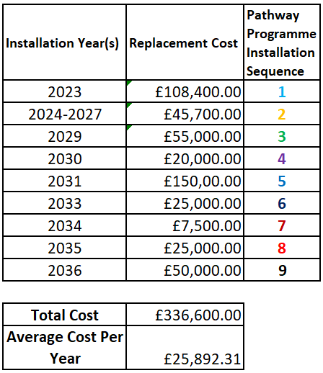

Fig. 19

Figure 17 provides a 13-year programme with an overall retrofit cost of £336,600.00, and an average cost per year of the programme would be £25,892.31. This would be a significant outlay for ateb, but the retrofit cost of Meyler house and or/other commercial buildings would be offset by the total cost in energy savings over a given period of time (Qiong He, 2021).

Maintenance Strategy
Ongoing maintenance of the new installations and systems will be challenging given the lack of sufficiently trained people within the sector in Wales and especially within Pembrokeshire given its rural setting. Because of this ateb will need to upskill its currently in-house workforce of and look at a restructuring its property team to be able to deal with the retrofit of Meyler house and its wider housing portfolio, Appendix 11 sets out a new structure to deal with the ongoing maintenance. The cost of ongoing training and upskilling will need to be budgeted and undertaken in sequence. This will need to be undertaken in a measured approach, it is estimated that the organisation will need to spend on average £5,000.00 per year on a programme on training and staff educating (in terms of how to use the new systems that have been installed).

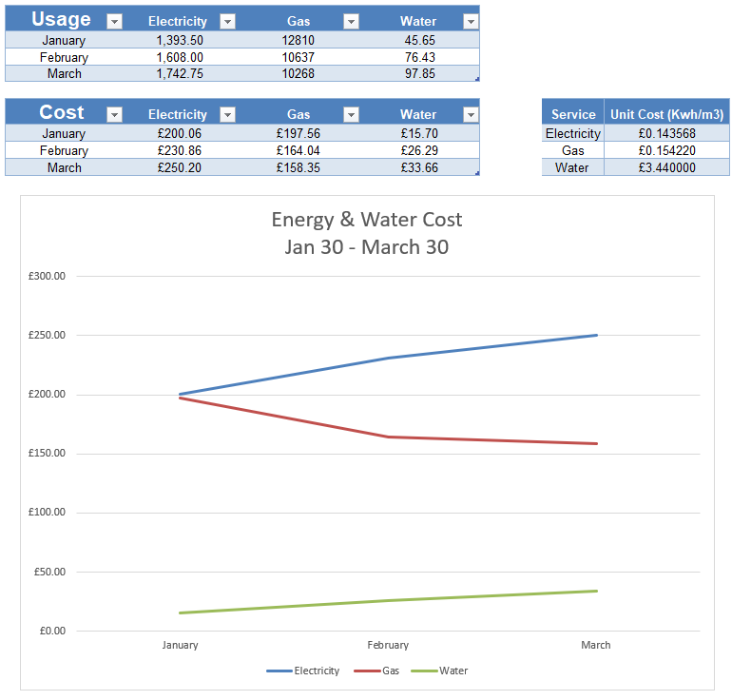
Baseline Improve
Fig. 20

Figure 20 provides estimated data during phase four of the retrofit plan (2030). It is estimated that due to the PV, battery and energy monitoring that would be installed at this point, that the building will have cut its reliance on energy from the grid up to three quarters and there would be a 75% reduction in electricity costs.

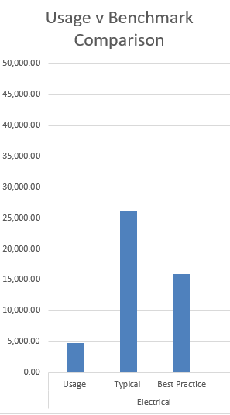

Fig. 21
Figure 21 provides usage data against typical and best practice and clearly shows the building will perform well below best practice electrically.

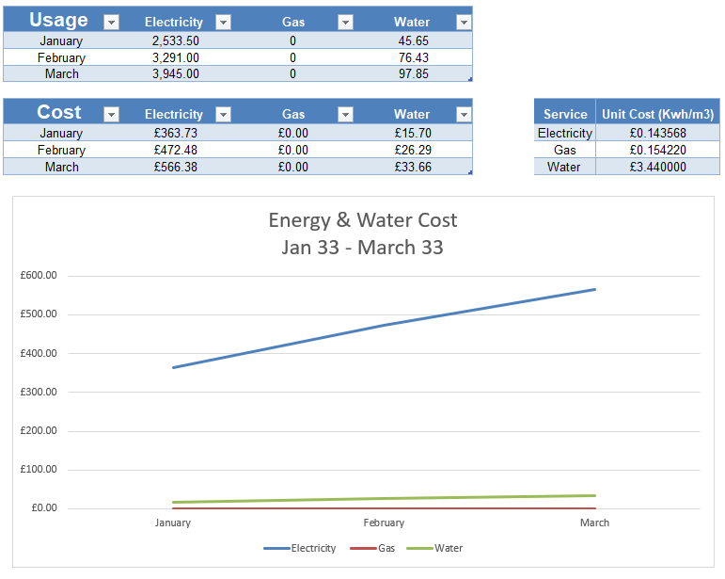
Fig. 22

Figure 22 provides estimated data during phase six of the retrofit plan (2033). It is estimated that due to the heating system being replaced for heat pumps and the gas mains being decommissioned, ateb will no longer pay any gas bill. The cost of electricity will increase due to the heating being electrified within the building.

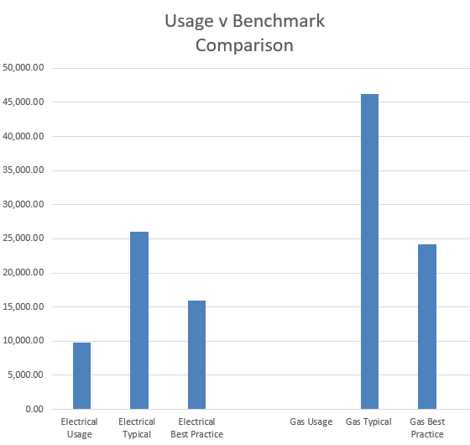

Fig. 23
Figure 23 provides usage data against typical and best practice and clearly shows the building no longer using gas but does show an overall increase in electricity usage.

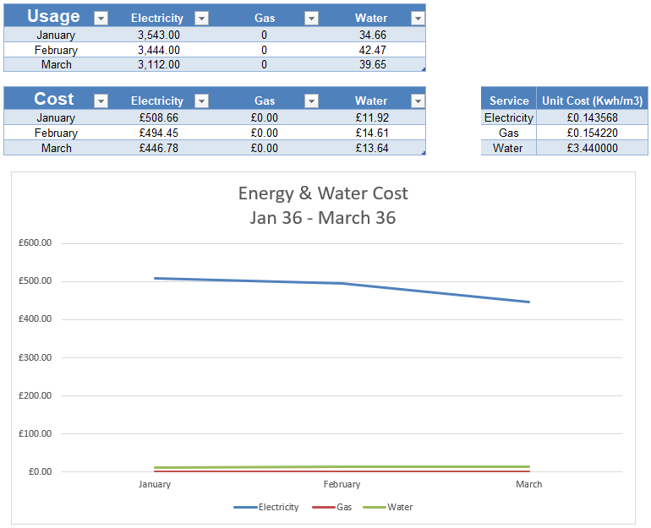
Fig. 24

Figure 24 provides estimated data during phase nine of the retrofit plan (2036). This will be the end of the retrofit plan and the cost of electricity will have decreased due to the installations EWI in phase nine and the completion of all the retrofit works. Water usage would have also decreased due to the new water monitoring devices, training, and the adoption of hotdesking and work from home.

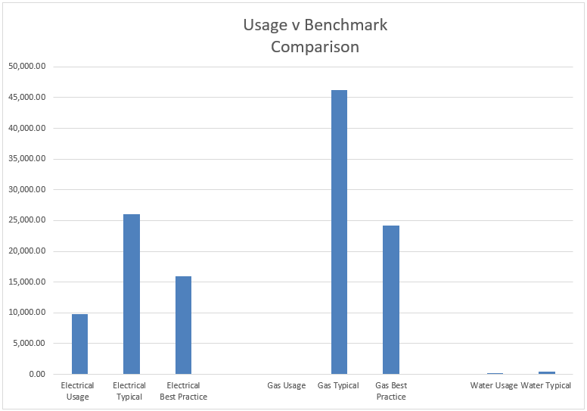
Fig. 25
Figure 25 provides usage data against typical and best practice and shows the building now is below best practice for electrical usage, gas is no longer being used and water is below typical usage. At the end of the retrofit programme the building will be net zero ready, the grid will take time to fully decarbonise (National Grid, 2019). At this point ateb will have also adopted the Welsh Government plan to see more than 30% of Welsh workers work from home in the post covid working world (Felstead, 2020).

Ongoing Costs & Savings
The main ongoing costs will be around future planned maintenance which will be planned in with lifespan, other costs will be around reactive maintenance and training in which the in-house maintenance team will be undertaking throughout the life of the components. It is expected that the main savings will be in the decreased energy bills, ateb will no longer pay a gas bill and it is expected that there will be around a 60% - 70% reduction in the electricity bill and the water bill should drop due water monitoring devices and staff education.

Conclusion
Looking at all the challenges that are posed by the target of net zero by 2050 in the context of commercial buildings, it is clear that there is a lack of specific guidance compared to domestic properties, but domestic guidance such a PAS 2035 and WHQS are useful as references. As for Meyler House the retrofit programme proposed within this report would be a significant investment for ateb but would allow the building to be net zero before the government target of 2050 (legislation.gov.uk, 2019). When the grid is fully decarbonised, the building can be fully classed as net zero. To realistically achieve the net zero goal within all commercial buildings, UK and Welsh Governments will need to financially support the legislation, this could be in the way of providing long term grant funding and meaning education and training support to help ensure commitments are met. Organisations like ateb are best placed to lead on decarbonisation works given the current funding support from Welsh Government on domestic properties like the optimised retrofit programme (gov.wales, 2021), these programmes will help inform retrofit plans for commercial building and help provide data to ensure costly mistakes aren’t made.

References
Beggs, C., 2013. Energy Managemnet, Supply and Conversation. 2nd ed. London : Routledge.
Boyle, G., 2012. Renewable Energy: POWER FOR A SUSTAINABLE FUTURE. 3rd ed. Oxford : Oxford University Press .
Bullock Consulting , 2007. Energy & Water Audit at Meyler House for PHA, Pembroke: Bullock Consulting .
CIBSE, 2021. CIBSE. [Online]
Available at: https://www.cibse.org/knowledge/benchmarking
[Accessed 12 June 2022].
elmhurst energy , 2021. elmhurst energy. [Online]
Available at: https://www.elmhurstenergy.co.uk/what-is-pas-2038
[Accessed 13 June 2022].
Felstead, A., 2020. Remote Working: Implications for Wales , Cradiff: Welsh Government .
Fiona Fylan, D. G., 2022. Barriers to domestic retrofit quality: Are failures in retrofit standards a failure of retrofit standards?. Indoor + built environment, 1 March, pp. 710-718.
Fylan, F. a. G. D., 2021. Barriers to domestic retrofit quality: Are failures in retrofit standards a failure of retrofit standards?. Indoor and Built Environment, p. 1420326.
gov.wales, 2021. gov.wales. [Online]
Available at: https://gov.wales/optimised-retrofit-programme
[Accessed 15 June 2022].
Health and Safety Executive , 2021. Health and Safety Executive. [Online]
Available at: https://www.hse.gov.uk/temperature/thermal/factors.htm
[Accessed 12 June 2022].
Jankovic, L., 2012. Designing zero carbon buildings : using dynamic simulation methods. London : Routledge.
legislation.gov.uk, 2019. legislation.gov.uk. [Online]
Available at: https://www.legislation.gov.uk/ukdsi/2019/9780111187654
[Accessed 15 June 2022].
Liu Yang, H. Y. J. C. L., 2014. Thermal comfort and building energy consumption implications – A review. HVAC & R research, Volume 115, pp. 164-173.
María Carmen Carnero, V. G.-P., 2017. Optimum decision making in asset management. Hershey: IGI Global.
Met Office, 2019. MetOffice.gov. [Online]
Available at: https://www.metoffice.gov.uk/research/climate/maps-and-data/uk-climate-averages/gcjjm7j5g
[Accessed 15 June 2021].
National Grid, 2019. National Grid. [Online]
Available at: https://www.nationalgrid.com/uk/electricity-transmission/network-and-infrastructure/infrastructure-projects
[Accessed 15 June 2022].
Parrish, K., 2013. Proposed Design Process for Deep Energy Savings in Commercial Building Retrofit Projects. Journal of architectural engineering, 1 May, pp. 71-80.
Qiong He, M. U. H. S. T. N. M. S. G. A., 2021. A cost-effective building retrofit decision-making model – Example of China’s temperate and mixed climate zones. Cleaner Production , Volume 280, p. 124370.
Sero, 2020. Sero Projects. [Online]
Available at: https://www.seroprojects.com/our-projects/the-mill/
[Accessed 15 June 2022].
Sokratis Papadopoulos, B. B. C. E. K., 2018. Applied Energy. Pattern recognition in building energy performance over time using energy benchmarking data, Volume 221, pp. 576-586.
South Satffs Water, 2020. South Satffs Water. [Online]
Available at: https://www.south-staffs-water.co.uk/media/1509/waterusebusiness.pdf
[Accessed 12 June 2022].
The Institute of Engineering & Technology, 2022. BS7671:2022 Requirements for Electrical Installation IET Wiring Regulations 18th Edition. London: British Standards Institution.
UK Government, 2020. gov.uk. [Online]
Available at: https://www.gov.uk/government/news/government-takes-historic-step-towards-net-zero-with-end-of-sale-of-new-petrol-and-diesel-cars-by-2030
[Accessed 15 June 2022].
UK Government, 2021. gov.co.uk. [Online]
Available at: https://www.gov.uk/government/news/plans-unveiled-to-decarbonise-uk-power-system-by-2035
[Accessed 15 June 2022].
UKGBC, 2019. UKGBC. [Online]
Available at: https://www.ukgbc.org/wp-content/uploads/2019/04/Net-Zero-Carbon-Buildings-A-framework-definition.pdf
[Accessed 15 June 2022].

Bibliography
Beggs, C., 2013. Energy Managemnet, Supply and Conversation. 2nd ed. London : Routledge.
Boyle, G., 2012. Renewable Energy: POWER FOR A SUSTAINABLE FUTURE. 3rd ed. Oxford : Oxford University Press .
Bullock Consulting , 2007. Energy & Water Audit at Meyler House for PHA, Pembroke: Bullock Consulting .
CIBSE, 2021. CIBSE. [Online]
Available at: https://www.cibse.org/knowledge/benchmarking
[Accessed 12 June 2022].
elmhurst energy , 2021. elmhurst energy. [Online]
Available at: https://www.elmhurstenergy.co.uk/what-is-pas-2038
[Accessed 13 June 2022].
Felstead, A., 2020. Remote Working: Implications for Wales , Cradiff: Welsh Government .
Fiona Fylan, D. G., 2022. Barriers to domestic retrofit quality: Are failures in retrofit standards a failure of retrofit standards?. Indoor + built environment, 1 March, pp. 710-718.
Fylan, F. a. G. D., 2021. Barriers to domestic retrofit quality: Are failures in retrofit standards a failure of retrofit standards?. Indoor and Built Environment, p. 1420326.
gov.wales, 2021. gov.wales. [Online]
Available at: https://gov.wales/optimised-retrofit-programme
[Accessed 15 June 2022].
Health and Safety Executive , 2021. Health and Safety Executive. [Online]
Available at: https://www.hse.gov.uk/temperature/thermal/factors.htm
[Accessed 12 June 2022].
Jankovic, L., 2012. Designing zero carbon buildings : using dynamic simulation methods. London : Routledge.
legislation.gov.uk, 2019. legislation.gov.uk. [Online]
Available at: https://www.legislation.gov.uk/ukdsi/2019/9780111187654
[Accessed 15 June 2022].
Liu Yang, H. Y. J. C. L., 2014. Thermal comfort and building energy consumption implications – A review. HVAC & R research, Volume 115, pp. 164-173.
María Carmen Carnero, V. G.-P., 2017. Optimum decision making in asset management. Hershey: IGI Global.
Met Office, 2019. MetOffice.gov. [Online]
Available at: https://www.metoffice.gov.uk/research/climate/maps-and-data/uk-climate-averages/gcjjm7j5g
[Accessed 15 June 2021].
National Grid, 2019. National Grid. [Online]
Available at: https://www.nationalgrid.com/uk/electricity-transmission/network-and-infrastructure/infrastructure-projects
[Accessed 15 June 2022].
Parrish, K., 2013. Proposed Design Process for Deep Energy Savings in Commercial Building Retrofit Projects. Journal of architectural engineering, 1 May, pp. 71-80.
Qiong He, M. U. H. S. T. N. M. S. G. A., 2021. A cost-effective building retrofit decision-making model – Example of China’s temperate and mixed climate zones. Cleaner Production , Volume 280, p. 124370.
Sero, 2020. Sero Projects. [Online]
Available at: https://www.seroprojects.com/our-projects/the-mill/
[Accessed 15 June 2022].
Sokratis Papadopoulos, B. B. C. E. K., 2018. Applied Energy. Pattern recognition in building energy performance over time using energy benchmarking data, Volume 221, pp. 576-586.
South Satffs Water, 2020. South Satffs Water. [Online]
Available at: https://www.south-staffs-water.co.uk/media/1509/waterusebusiness.pdf
[Accessed 12 June 2022].
The Institute of Engineering & Technology, 2022. BS7671:2022 Requirements for Electrical Installation IET Wiring Regulations 18th Edition. London: British Standards Institution.
UK Government, 2020. gov.uk. [Online]
Available at: https://www.gov.uk/government/news/government-takes-historic-step-towards-net-zero-with-end-of-sale-of-new-petrol-and-diesel-cars-by-2030
[Accessed 15 June 2022].
UK Government, 2021. gov.co.uk. [Online]
Available at: https://www.gov.uk/government/news/plans-unveiled-to-decarbonise-uk-power-system-by-2035
[Accessed 15 June 2022].
UKGBC, 2019. UKGBC. [Online]
Available at: https://www.ukgbc.org/wp-content/uploads/2019/04/Net-Zero-Carbon-Buildings-A-framework-definition.pdf
[Accessed 15 June 2022].

List of Figures

Figure 1 - Meyler House (Front) Pg. 5
Figure 2 - Energy & Water Audit (Extract) Pg. 5
Figure 3 - Fire Safety Plan Pg. 6
Figure 4 - Meyler House (Rear) Pg. 7
Figure 5 - Hamworthy Gas Fired Modular Boilers Pg. 8
Figure 6 - Hamworthy Boiler Data Sheet Pg. 8
Figure 7 - Three phase service head Pg. 9
Figure 8 - Three phase consumer unit Pg. 9
Figure 9 - Meyler House (Rear) Pg. 10
Figure 10 - Meyler House (Roof) Pg. 10
Figure 11 - Thermal comfort diagram Pg. 11
Figure 12 - Electrical usage data Pg. 14
Figure 13 - Annual electrical consumption Pg. 15
Figure 14 - Gas usage data Pg. 16
Figure 15 - Annual gas consumption Pg. 17
Figure 16 - Annual water consumption Pg. 18
Figure 17 - Energy and water costs Pg. 19
Figure 18 - Usage v Benchmark Data Pg. 20
Figure 19 - Retrofit cost and sequence table Pg. 23
Figure 20 - Data baseline improvement table 1 Pg. 25
Figure 21 - Usage v Benchmark Data 1 Pg. 26
Figure 22 - Data baseline improvement table 2 Pg. 27
Figure 23 - Usage v Benchmark Data 2 Pg. 28
Figure 24 - Data baseline improvement table 3 Pg. 29
Figure 25 - Usage v Benchmark Data 3 Pg. 30

Appendixes

Appendix 1
Below are available bookable room within Meyler House.
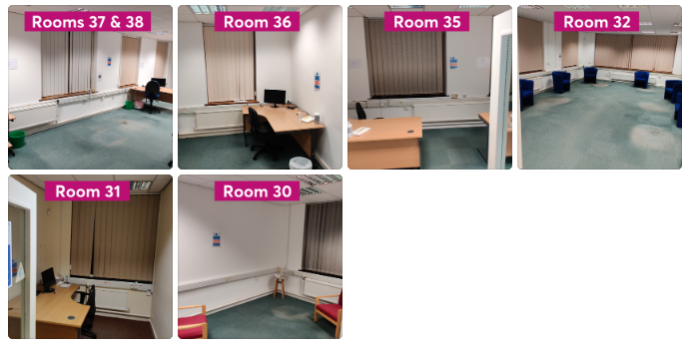

Appendix 2
Below is a component list of Meyler House that was generated from ateb’s asset management systems Lifespan.
Location | Sublocation | Attribute | Value | Description | Action Type | Replacement Year | Current Condition | Replacement Cost  (Like for like)
External Fabric | External Fabric | External Decoration Walls | Paint | Paint | Installation | 2023 | B - Good | £7,000.00
External Fabric | External Fabric | External Fabric | Tradtional Render | Render | Installation | 2028 | C - Average | £26,200.00
External Doors | External Doors | External Doors | Aluminium | Aluminium | Installation | 2024 | C - Average | £3,500.00
Windows | Windows | Windows | Composite | Composite | Installation | 2032 | A - Very Good | £20,400.00
Roof | Roof | Roof | Fiberglass | Fiberglass | Installation | 2024 | E – Very Poor | £19,700.00
Heating | Non-Domestic Gas Installation | Non-Domestic Gas Installation | Commerical Heating | Commerical Heating | Installation | 2028 | D - Poor | £120,500.00
Electric | Non-Domestic Electrical Installation | Non-Domestic Electrical Installation | Commerical Electrical | Commerical Electrical | Installation | 2021 | F – Urgent | £80,800.00
Electric | Non-Domestic Electrical Installation | Non-Domestic Electrical Installation | Commerical Emergency Lighting | Commerical Emergency Lighting | Installation | 2021 | F – Urgent | £5,000.00
Electric | Non-Domestic Electrical Installation | Non-Domestic Electrical Installation | Fire Detection System | Fire Detection System | Installation | 2021 | F – Urgent | £13,400.00
Landscape | Car Park | Car Park | Tarmac | Tarmac | Installation | 2035 | A - Very Good | £18,000.00

Appendix 3
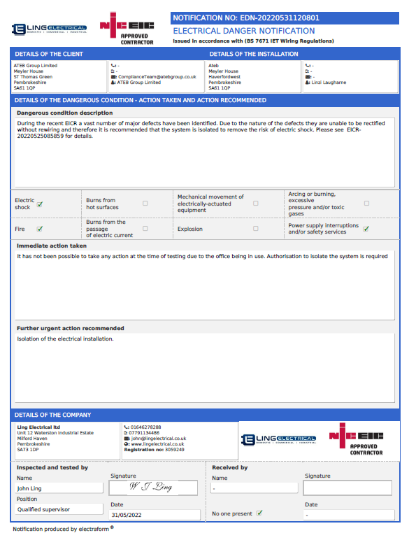
Below the danger notice issued to ateb for Meyler House as a result of an Electrical Installation Condition Report, The installation is no longer fit for purpose and is unsafe.

Appendix 4
Below is the benchmarking data taken from the CIBSE Benchmarking Tool Dashboard, Meyler House is classified as “Offices, Naturally Ventilated, Open Plan
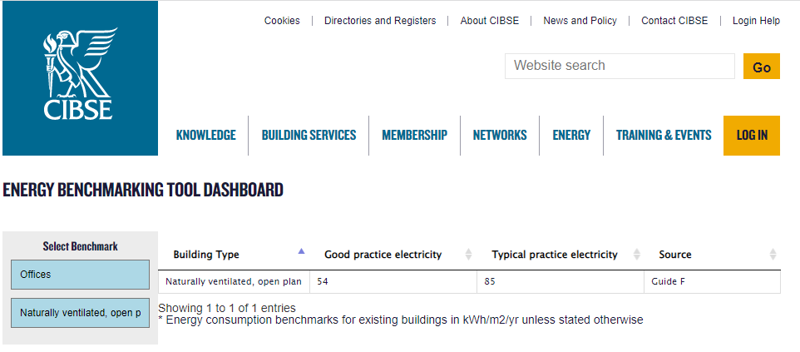
Electricity

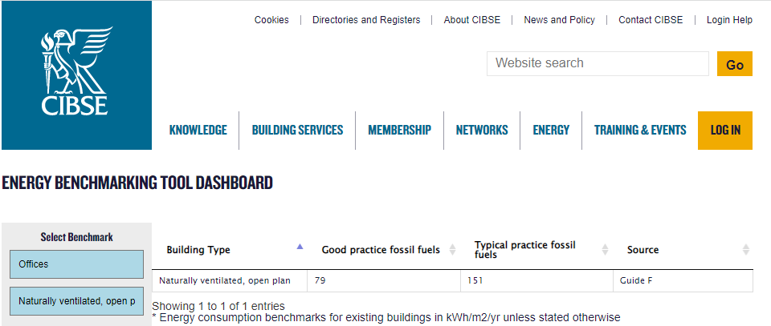
Fossil

(CIBSE, 2021)

Appendix 5
Below is the benchmarking data taken from South Staffs Water. which states on average in a commercial premise the average usage is 50litres per employee per day.

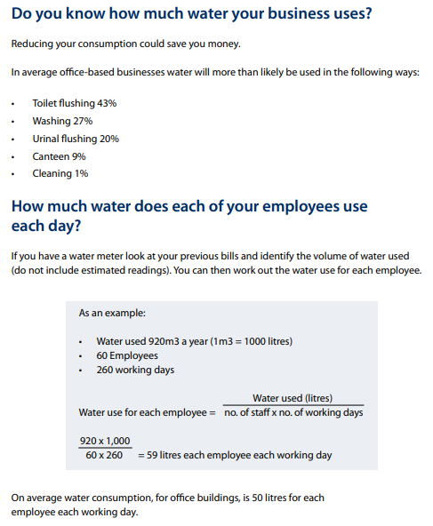

(South Satffs Water, 2020)

Appendix 5
Below are the recommendations that came from the Bullock Consulting Energy & Water Audit conducted in May 2007.
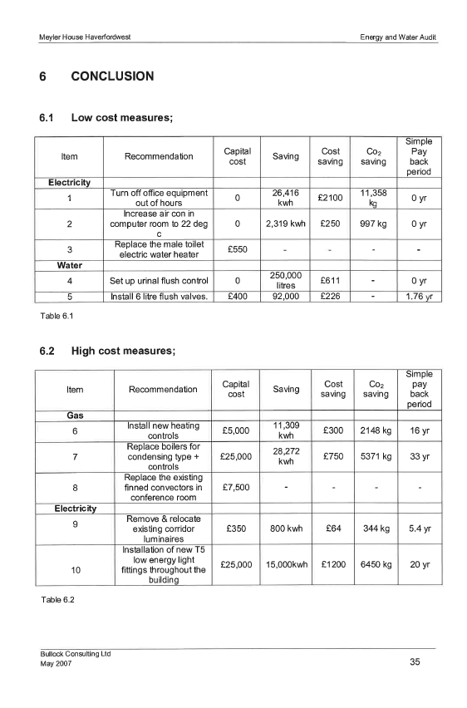

(Bullock Consulting , 2007)

Appendix 6

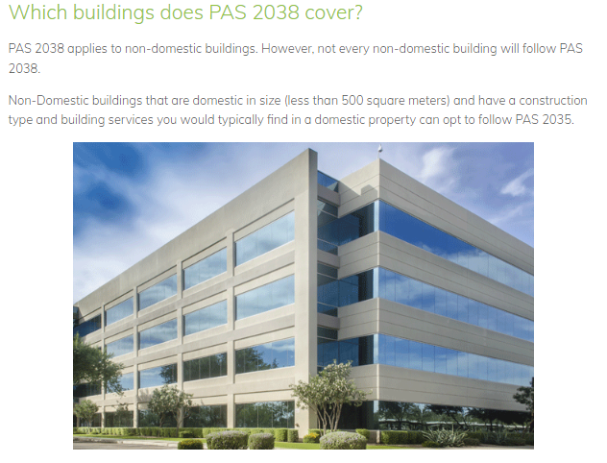

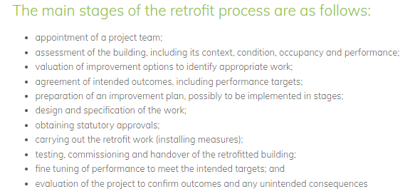

(elmhurst energy , 2021)

Appendix 7
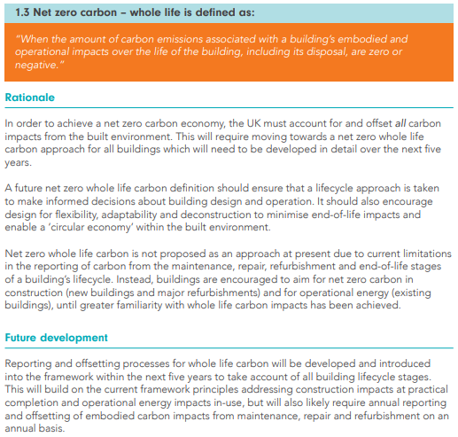

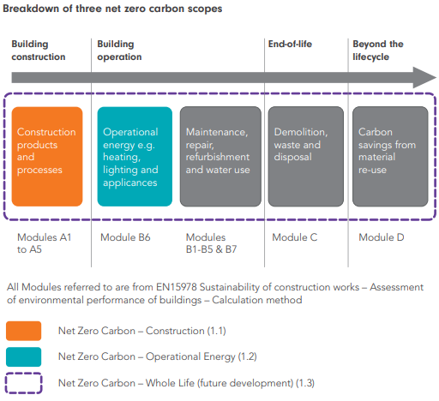

(UKGBC, 2019)

Appendix 8
Below is a full list of proposed retrofit works which will be undertaken on Meyler House

 | Structure | Windows/Doors (External) | Roof Construction | Electrical | Electrical Generation/ Storage | Heating | Additional Works
Current | Cavity Wall with Traditional Render Finish | Composite Windows and Aluminium Doors | Flat Roof - Fiberglass | Commercial Electrical System (Not Safe) | N/A | Twin Hamworthy NGR 320 Commercial Boiler – Mains Gas | N/A
Retrofit Works | 100mm EWI with a texture coated finish to match the current colour | New uPVC Triple Glazing Windows, take advantage of solar gains where possible. New Aluminium Triple Glazing Doors | Fully insulated warm rubber roof, reinforced to handle addition weight | New Commercial System, Including Emergency Lighting and Fire Detection systems | 50KW standing PV system to mounted directly onto the new roof, 6 X 5KW Tesla Batteries for storage and energy utilisation. Installation of 4 X free-standing 12KW chargers | 4 X 30KW Air Source heat pumps, radiator upgrades, zoned heating system with remote functionality. | Installation of Lightning protector on roof and installation of a ‘man safe’ system on roof. New Energy & Water Monitoring System

Appendix 9
Below is a component list and programme sequence of the retrofit plan
Current Component | Current Replacement Year | New Component | Replacement Cost | New Life Cycle (Yrs.) | Installation Year | Pathway Programme Installation Sequence
Commerical Electrical System | 2021 | Commerical Electrical System | £90,000.00 | 30 | 2023 | 1
Emergency Lighting System | 2021 | Emergency Lighting System | £5,000.00 | 30 | 2023 | 1
Fire Detection System | 2021 | Fire Detection System | £13,400.00 | 15 | 2023 | 1
N/A | N/A | Lighntening Protection System | £6,000.00 | 25 | 2027 | 2
N/A | N/A | Man Safe System | £10,000.00 | 40 | 2025 | 2
Roof - Fiberglass | 2024 | Roof – Rubber Warm Roof (Fully Insulated) | £29,700.00 | 35 | 2024 | 2
N/A | N/A | Photovoltaic System + Battry Storage | £50,000.00 | 25 | 2029 | 3
N/A | N/A | Energy Monitor System | £5,000.00 | 15 | 2029 | 3
N/A | N/A | Electric Vehicle Chargers | £20,000.00 | 30 | 2030 | 4
Commerical Heating System | 2028 | Air Source Heat Pumps + New System | £150,00.00 | 20 | 2031 | 5
N/A | N/A | Commerical Ventilation System | £20,000.00 | 20 | 2033 | 6
N/A | N/A | Water Monitoring System | £5,000.00 | 15 | 2033 | 6
Doors - Aluminium | 2024 | Doors – Aluminium  (Tripple Glazing) | £7,500.00 | 30 | 2034 | 7
Windows – Composite (Double Glazing) | 2032 | Windows – Composite (Tripple Glazing) | £25,000.00 | 30 | 2035 | 8
Paint | 2023 | External EWI | £50,000.00 | 35 | 2036 | 9
Render | 2028

Appendix 10
Some of the challenges around PV installation and optional placement are below
- Building types
- Orientation (azimuth) and Tilt (elevation)/Geographical location
- Peak Power rating of arrays
- Variation of efficiency with temperature
- External power reducing effects (Shading)
- Efficiency of PV Modules and Invertors
(Boyle, 2012)

The UK is at an advantage when it comes to efficiency and operating temperatures, typical solar PV panels have an operating temperature 25°C, every 1°C degree increase in this temperature and the panel will lose 0.5% efficiency (Beggs, 2013). So given that the average temperature in the UK is 12.46°C and the UK has an average 1,372.83 hours of total sunshine hours throughout the year (Met Office, 2019), PV installations within the UK should perform at peak efficiency.

Appendix 11
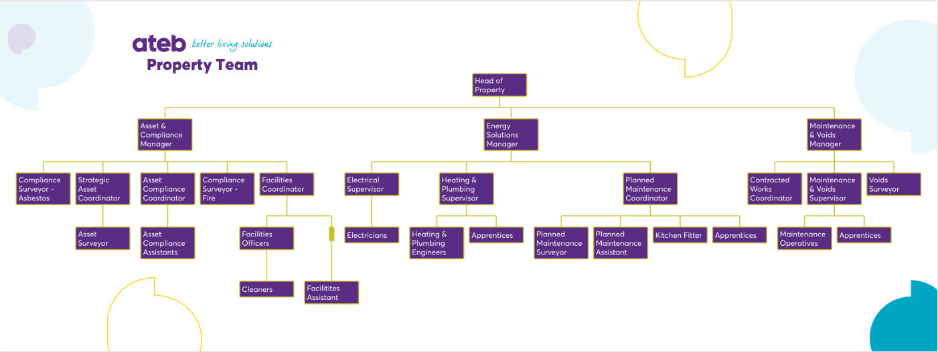
ateb restructure proposal due to the challenges posed by the maintenance of retrofit technology

