Module Title: Project Management
Module Code: LCLM5003_LON
Assignment Title: Reopening of Highway 5 Following the 2022 British Columbia Flooding
Student Name: Petrisor Iulian Linguraru
Student Number: 2331770
Lecturer: Xavier Matieni

Introduction
The catastrophic flooding experienced in British Columbia in 2022, triggered by an atmospheric river event, caused widespread destruction to critical infrastructure. One of the most significant impacts was the damage to Highway 5, a principal transportation corridor connecting the Lower Mainland to the rest of Canada. The closure of this corridor severely disrupted supply chains, emergency services, and economic activities, particularly affecting agriculture, logistics, healthcare access, and regional trade.

This Project Management Plan outlines a structured approach to the safe and timely reopening of Highway 5. The plan applies recognised project management principles and techniques to ensure effective coordination, risk mitigation, stakeholder engagement, and efficient use of resources.

2. Project Description

The project focuses on restoring Highway 5 to operational status following flood-induced damage, including landslides, bridge failures, and roadway erosion. The scope includes emergency stabilisation works, infrastructure reconstruction, safety verification, and regulatory approval processes.

The primary objective is to reopen Highway 5 to enable the resumption of transportation of goods and people, while ensuring compliance with safety, environmental, and regulatory standards. The project is classified as a high-priority infrastructure recovery initiative due to its national economic and social importance.

3. Project Scope

3.1 In-Scope
- Damage assessment of Highway 5 infrastructure
- Debris and landslide removal
- Repair and reconstruction of damaged road sections and bridges
- Slope stabilisation and drainage improvements
- Safety inspections and load testing
- Environmental compliance and mitigation measures
- Reopening of Highway 5 to controlled and then full traffic

3.2 Out-of-Scope
- Compensation for private property damage
- Long-term highway expansion beyond pre-flood capacity
- Reconstruction of unrelated regional infrastructure

4. Work Breakdown Structure (WBS)

The Work Breakdown Structure decomposes the project into manageable components:
- Project Initiation
1.1 Stakeholder identification
1.2 Regulatory approvals
- Damage Assessment
2.1 Structural inspections
2.2 Geotechnical surveys
- Site Preparation
3.1 Debris clearance
3.2 Temporary traffic controls
- Reconstruction Works
4.1 Roadbed repair
4.2 Bridge reconstruction
4.3 Drainage and slope stabilisation
- Quality and Safety Assurance
5.1 Engineering inspections
5.2 Load and safety testing
- Project Closure
6.1 Final approvals
6.2 Highway reopening

5. Quad Chart

The Quad Chart summarises the project as follows:
- Objectives: Restore Highway 5 safely and efficiently
- Scope: Infrastructure repair, safety validation, reopening
- Schedule: Accelerated recovery timeline (emergency response)
- Resources: Government funding, contractors, engineering teams

6. Gantt Chart

The project schedule is structured into sequential and parallel activities over an estimated 6–9 month period, including assessment, construction, testing, and commissioning. Critical path activities include debris removal, bridge reconstruction, and safety certification.

(A detailed Gantt Chart should be included as a figure and referenced in the text.)

7. Stakeholders’ Involvement

Key stakeholders include:
- Government of British Columbia
- Ministry of Transportation and Infrastructure
- Local municipalities
- Indigenous communities
- Construction contractors and engineers
- Logistics companies and agricultural producers
- General public and road users

Stakeholder engagement is managed through regular briefings, public updates, and consultation processes to ensure transparency and cooperation.

8. Allocation of Resources

8.1 Human Resources
- Civil and structural engineers
- Construction and safety personnel
- Environmental specialists
- Project management team

8.2 Financial Resources
- Provincial and federal emergency funding
- Contingency reserves for unforeseen conditions

8.3 Equipment and Materials
- Heavy machinery for earthworks
- Construction materials (steel, concrete, asphalt)
- Monitoring and safety equipment

9. Risk Analysis
Key project risks include:
Risk | Impact | Mitigation
Further extreme weather | High | Contingency scheduling and monitoring
Structural instability | High | leading engineering assessments
Environmental non-compliance | Medium. | Regulatory coordination
Supply chain delays | Medium | Multiple suppliers

10. Conclusion

The reopening of Highway 5 is critical to restoring economic stability, transportation connectivity, and public safety in British Columbia following the 2022 flooding event. This Project Management Plan demonstrates a structured and systematic approach to managing complex infrastructure recovery under emergency conditions. By applying established project management methodologies, the project aims to achieve timely completion while minimising risks and ensuring stakeholder satisfaction.

Part B – Reflections from the Feedback Received from Tutor and Peers

The feedback received from the tutor and peers provided valuable insights into the strengths of the initial project proposal and highlighted areas requiring improvement before the development of the final project management plan. Overall, the feedback confirmed that the selected scenario, focusing on the reopening of Highway 5 following the 2022 British Columbia flooding, was appropriate, relevant, and well aligned with real-world infrastructure recovery challenges.

One of the key strengths identified in the feedback was the clear articulation of the project context and problem statement. The proposal effectively explained the significance of Highway 5 as a principal transportation corridor and demonstrated an understanding of the economic and social impacts caused by its closure. Peers noted that the background information was concise yet informative, which helped establish the urgency and importance of the project. Additionally, the project objectives were described in a logical and structured manner, allowing stakeholders to easily understand the intended outcomes.

Another positive aspect highlighted was the initial identification of major stakeholders. The proposal successfully recognised the roles of government agencies, transportation authorities, local communities, and businesses affected by the flooding. This demonstrated an awareness of the complex stakeholder environment associated with large-scale infrastructure recovery projects. Leading feedback also acknowledged the relevance of applying established project management frameworks to manage uncertainty and time constraints in post-disaster scenarios.

Despite these strengths, the feedback identified several areas for improvement that have informed the development of the final project management plan. A recurring comment from both the tutor and peers was the need for greater detail in defining the project scope. While the proposal outlined key activities, it did not sufficiently distinguish between in-scope and out-of-scope elements. This created potential ambiguity regarding project boundaries and deliverables. In response, the final plan clearly defines scope inclusions and exclusions to reduce the risk of scope creep.

The feedback also emphasised the need for a more structured breakdown of project activities. The initial proposal lacked a detailed Work Breakdown Structure, which limited clarity around task sequencing and responsibilities. As a result, the final project management plan incorporates a comprehensive Work Breakdown Structure and an associated Gantt Chart to improve schedule visibility and resource planning.

Risk management was another area identified for enhancement. Although some risks were acknowledged, the proposal did not systematically analyse their potential impact or mitigation strategies. The final plan therefore includes a formal risk analysis section, supported by a risk register, to demonstrate proactive risk management in line with best practices.

In conclusion, the feedback received was constructive and instrumental in strengthening the overall quality of the final project management plan. The identified strengths have been retained, while the suggested improvements have been addressed through clearer scope definition, enhanced planning tools, and a more rigorous risk management approach. This reflective process has contributed to a more robust and professionally structured project plan.

References

Ahern, J. (2011) ‘From fail-safe to safe-to-fail: Sustainability and resilience in the new urban world’, Landscape and Urban Planning, 100(4), pp. 341–343.
British Columbia Ministry of Transportation and Infrastructure (2022) November 2021 storm response and recovery. Victoria: Government of British Columbia.
Chapman, C. and Ward, S. (2011) How to manage project opportunity and risk. 3rd edn. Chichester: John Wiley & Sons.
Government of Canada (2022) Canada’s disaster mitigation and adaptation fund. Ottawa: Government of Canada.
Kerzner, H. (2022) Project management: A systems approach to planning, scheduling, and controlling. 13th edn. Hoboken, NJ: Wiley.
Merrow, E.W. (2011) Industrial megaprojects: Concepts, strategies, and practices for success. Hoboken, NJ: John Wiley & Sons.
Project Management Institute (PMI) (2021) A guide to the project management body of knowledge (PMBOK® Guide). 7th edn. Newtown Square, PA: PMI.
Smith, D. and Petley, D. (2009) Environmental hazards: Assessing risk and reducing disaster. 5th edn. London: Routledge.
Transport Canada (2022) Transportation infrastructure resilience in Canada. Ottawa: Transport Canada.
Zhang, Y., Li, H. and Tam, C.M. (2014) ‘Risk management in construction projects’, International Journal of Project Management, 32(4), pp. 593–606

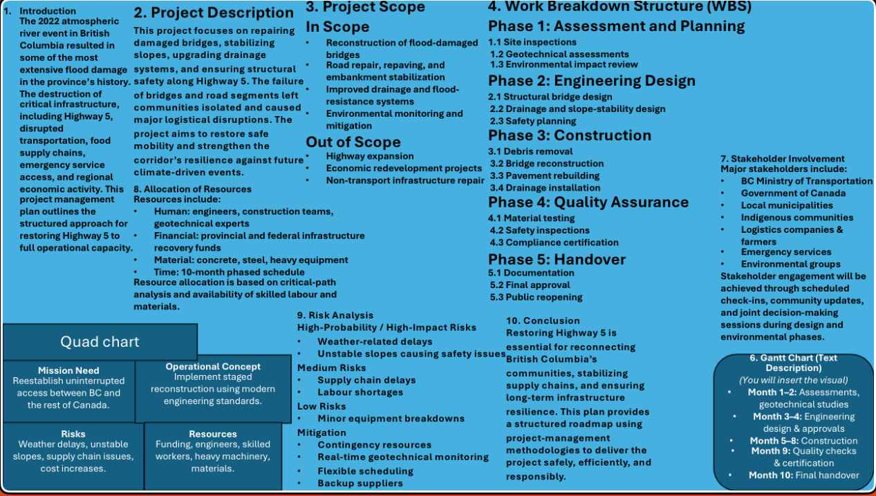
Part A: Poster

