

EXAMINATION PAPER
MARKS AND COMMENTS SHEET

PROGRAMME | OME Degree Apprenticeship
LEVEL | 4
MODULE | ACDB4011 Chemistry
STUDENT I.D. | 2427103
EXAMINER | Ewa Kazimierska | INTERNAL VERIFIER
Once completed marks only should be transferred onto the front of the examination paper (no comments other than ticks or crosses on the examination paper)

Question  Number | Comments | Marks available | Marks awarded | 2nd marker (sample) | 3rd marker (where necessary)
1 | 6/10 True/False items correct. Some misconceptions remain, particularly in atomic structure, stoichiometry, and catalyst behaviou | 15 | 9
2 | Incomplete Bohr model and incorrect ionic charge. Lewis structure flawed, though valence electrons correctly identified. Bond comparison partially understood. | 11 | 1.5
3 | Partial attempt at frequency calculation using incorrect equation and unit. Configuration and unpaired electron count were incorrect. Colour dependence on wavelength recognised | 10 | 0.5
4 | Incorrect chemical equation and no answers for subsequent parts. It is recommended revisiting combustion reactions and gas law applications. | 15 | 0
5 | Some awareness of oxygen balance's role in explosive performance, but no calculations or answers in remaining parts. | 16 | 0.5
6 | Misunderstood the concept of energy profile; Hess's Law incorrectly applied. Incorrect analysis of activation energy and reaction nature. | 7 | 0
7 | No heating curve or analysis. | 11 | 3
8 | Wrong method for molarity calculation (mL not converted); net ionic equation missing. Review titration basics. | 5 | 0
9 | No attempt made. Review calorimetry and specific heat calculations. | 5 | 0
10 | Oxidation numbers incorrectly assigned, and redox roles not identified. Second part left blank. | 5 | 0
 |  |  | 14.5

1st Marker Name | Ewa Kazimierska | 1st Marker Signature | 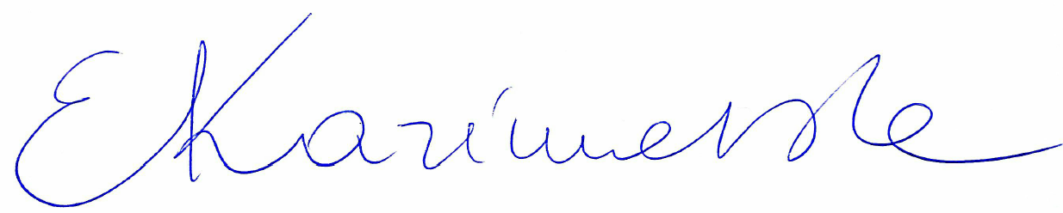
2nd Marker Name |  | 2nd Marker Signature
3rd Marker Name |  | 3rd Marker Signature
Reasons for awarding the final mark where there is more than one marker
Notes:
- The 3rd marker may be used where there is more than a 10 percentage point difference (in the TOTAL mark) between markers 1 and 2 OR when it is not possible to get agreement between markers 1 and 2. Reasons must be given where an agreed mark is given.
- This form is for internal use only and is NOT to be returned to the student. The final agreed marks must be transferred to the student feedback sheet in the assignment specification.
- The external examiner MUST be shown this form.

