The area of development this report will focus on is bilingualism in Wales and how this is used in schools. This report will include research in various literature to support the discussions on Curriculum Cymrieg and the use of bilingualism in schools. It will discuss the use of Welsh and examine how schools use Welsh and how they improve their bilingual aspect. This will involve research on what schools can do to improve or apply new targets and plans in regulation to the Welsh Curriculum incorporating Curriculum Cymreig.

Wales is proud to be bilingual, presenting the Welsh language visibly everywhere around the country, written in English and Welsh for the public to see, presented on traffic signs, letters, safety instructions etc. The Welsh language is one of the oldest living languages in Europe, unfortunately only a small amount (23%) speak the language, unlike the 1950’s where the majority spoke Welsh (90%). This was down to Henry VIII’s Act of Union in 1536, banning the use of Welsh, removing the official status of the Welsh language. This meant that working and communication transferred to English, making working environments and communication sufficient. This action transferred into Welsh schools, removing the learning of the Welsh native tongue. By the 20th century the language had almost died out, in spite of that native citizens created radio broadcast and formed Welsh language society’s top prevent the language falling (Poppy Jacob, 2019). Schools have no made the Welsh language compulsory to learn, to inspire and educate learners to adapt to the Welsh dialect. Pupils should be given the opportunity to use the Welsh language and be given the opportunity to do this in lessons at any given point. Studies have been made and evidence suggests that there are potential benefits to individuals, schools and societies in being bilingual, for example:
- Increased mental flexibility
- Improved inter-cultural skills
- Increased opportunities for global exchange and trade.
(Mehisto, 2012, pp 8, 18, 117)

Being a bilingual school is an Impressive achievement for a school to promote, and is currently the standard regulation throughout schools in Wales. ‘Since there is a Welsh dimension to all our school communities in Wales, it has become a worthy objective which should be within the grasp of every such school’ (Developing a Curriculum Cymreig, 1993, p.5). The Welsh Government wants to educate pupils or their background and build their skills in their native language. Applying to the curriculum, which aids the ‘spiritual, moral, cultural, mental and physical development of the learners in school and the community, preparing them for more opportunities, responsibilities and experiences of later life’ (Donaldson, 2015 p.22). The idea of bringing Welsh back into schools is to educate learners of their heritage, and to show them their culture and surroundings. The curriculum states ‘respect for where one lives’, pupils need to have a better understanding of their country and have a desire to want to learn. To comprehend Wales values, would engage them to learn about the society of which they are part of and become aware of the relevance and place in the present world (Curriculum Council for Wales. 1994, p.2). Teaching this to learners while in school, should potentially progress each year, resulting in the percentage of Welsh speakers, living in Wales to rise.

This report will discuss my current placement and the relations to this topic, I will do this by referring to my School as School X for confidentiality and ethics purposes (BERA, 2011). Firstly Introducing the classification of School X, as every school has different achievements and levels in bilingualism. School X has a very high achievement level and is a well known established school in Swansea because of its high level of achievement. The school is an English-medium from 11 to 16 years of age and a mixed ability comprehensive school. In the last Estyn report, it states there are 1,105 pupils, compared with 1,096 pupils when the school was last inspected in April 2013. The location of school X is in a privileged area with nearly 7% of pupils being eligible for free school meals, measuring much lower than the national average of 17%. The majority of the pupils come from an English speaking home or background. Many parents do not speak Welsh themselves and don’t feel their children need to either, resulting in very few pupils that speak Welsh as their first language, making the teaching of the subject problematic.
The school itself includes a full range of different abilities resulting in the pupils with special educational needs at 20.5%, hitting just below the national average (21.5%). However just over 4% of pupils have a statement of special educational needs, making School X higher than the national average of 2%. Pupil to teacher ratio is around 18, subtracting every other staff member in the school, (teaching assistants, etc.) meaning pupils have enough one on one time if needed. ‘The school hosts a local authority specialist resource’ for pupils with speech, communication and language difficulties. Through professional dialog from staff members at School X, has informed me that the SEN unit is known in surrounding areas for its achievement in this area and how other pupils in the school react with children from this department. This attracts pupils from different schools who join the school for this specific reason. This involves the employment of teaching assistances who cater to the needs of specific children who may need one to one support of a teaching assistant for their whole time in school. Most of pupils that attend the resource base have a diagnosis of autism. (Estyn. 2019)

During this report, the school improvement plan will be referred to as be referring (SIP) and the department improvement plan as (DIP). This will include the use of Welsh throughout within the context of the plans, and how this can improve pupils skills. I will include literature related to bilingualism, developing and focusing more on Welsh throughout. Stated in the SIP and DIP, for ‘improved levels of bilingualism in lesson and across schools, and giving pupils more opportunities for bilingualism’ (appendix 1) and ‘improved Welsh across the whole school, further development of whole school bilingualism’ (appendix 2).
The DIP is segregated into sections, the opportunity for my bilingualism falls under ‘Inspection Area 3: Teaching and Learning (appendix 1). This involves the quality of teaching, considering the breadth and balance of the curriculum and provision for skills.

School X already has remarkable standards and results throughout, but they need to promote the language from early stages of school. As the majority of the learners parents are English spoken, very little population of the school start secondary with knowledge of the Welsh language. School X has excellent progress in key stage 4 regarding their Welsh skills ‘key stage 4, the performance of pupils in Welsh second language is consistently well above national averages’ (Estyn, 2017).
For pupils to use the Welsh language regardless of the lesson they are in, means they need to consider ways to teach the pupils to become more independent with their native language. Stated in the SIP ‘appreciation and celebration of Welsh culture and language’ (appendix 2).

Evaluation and discussion will be made in regards to the use of strategic planing, to ensure there is a high standard throughout the School X and pupils progression. Strategic planning is the process of setting goals, deciding on actions to achieve those goals and gathering the resources needed to take action. (Thoughtexchange, 2019).
For any department or school, an improvement plan requires carful strategic planning to take place, requiring deep research and planning to carry out the initial target. Implementing targets into a school must somehow relate around the pupils wellbeing, showing how this will effect and help them to achieve a personal or overall plan. These targets may be ongoing from previous years or a new target set to meet high standards of teaching and learning. Strategic planning is considering internal and external factors of a school, analysing data and forming a plan to address future trends (Allison & Kaye, 2005; Fidler, 1998), but planning needs to be clear of the overall goal, ensuring future actions are a priority. To do this successfully involves ‘dependent creation of effective ways of getting information about implementation progress and problems from users in the classroom’ (MacGilchrist, 1997, p.9) and analysis on this information is key.
Schools are encouraged to spread their plans over a longer period of time, however change takes time, needs to be well managed and the pupils need to be the main focus for change (MacGilchrist, 1997, p.9) but does this make planning more difficult and less predictable? ‘Strategic planning is useful for the more predictable and controllable elements when planning’ (Davies and Ellison, 2003). So It is down to all staff members of the school to decide how to make a difference, how they can input, process and act on targets and for them to understand the importance of a strategic plan. They need to familiarise themselves with the SIP and DIP and react in the way that benefits the whole school and not just individuals. Considering this, it is also important to find out where teachers are in relation to change, before launching into a new project (Fullan, 1992, p.78). It Is clear that the school and staff have successfully used strategic planning to identify future actions and improve on existing targets for whole school and department improvements. ‘The school plans imaginatively and proficiently to develop pupils’ skills. There is a strong culture of professional learning, and staff demonstrate a willingness to embrace new ideas and strive for continuous improvement in whole-school development, in the curriculum, and in their teaching’ (Estyn, 2017, p.2). ‘Planning is the design of the future and an effective way of bringing it about’ (Ackoff 1970 p 1). Planning well helps to refine targets, thus helping create new ideas to make the end goal more accessible and successful. A school has to have targets in order to plan for the future, these need to be considered ‘no planning only exists when people have no objectives, when their actions are random and not goal-directed’. (Mintzberg, 2000).

To generate an effective plan has to incorporate requirements from the Welsh Government. These requirements have been set requiring to move toward the language continuum for Welsh. This is ensuring that resources that are commissioned by staff are developed in English and Welsh at the same time. Teachers and staff must also develop approaches to professional learning to ensure that all schools are better able to plan for curriculum change. The government are aiming for this change to be achieved and for criteria to be met by 2020, ready for the final feedback and new curriculum and assessment arrangements for schools by Easter 2019. The final change is to be completed by January 2020, and that all schools are using the new curriculum, by 1 September 2022. This is evoking schools to teach their learners more Welsh throughout their school years, meaning schools should ‘develop a transformational approach to the learning, teaching and assessment of the Welsh language with the aim of ensuring all learners will be able to use the Welsh language when they leave school’ (Welsh Government, 2017 p.18)
This is implemented by teachers and they should believe it is essential for schools to have a good approach in developing their goals and a broad definition of achievement in using Welsh. ‘David Hargreaves and colleges (ILEA, 1984) suggest that there are at various aspects of achievement that a school need to develop. Practical and verbal skills being two of the skills he refers to. This concerns the practical capacity to apply knowledge with an emphasis on problem solving and investigational skills’. These details would not succeed efficiently without the understanding of the school policy, researching into development plans and working with colleges to create an effective plan in bringing Welsh into the classroom. Applying the Welsh language featuring key words related to the subject lessons will soon build up a vast vocabulary, even if they only use a small number of key praises in one lesson. Schools will need to establish clear aims and policies to ensure that pupils are helped to explore the concepts of Wales from their own particular standpoints. Relating keywords and Welsh surrounding to the learners should improve their confidence and learning with the language, making communication easier and more fluent. Using personal and social skills, to communicate with and apply the Welsh language will relate to others, although this can concern personal characteristics such as initiative, self-reliance and leadership potential (The Whole Curriculum, 1991). Relating this to the learners, by motivating certain pupils to pursue speaking Welsh in lessons outside of their comfort zone will improve motivation and confidence in their abilities and persevere in the face of failure (MacGilchrist, 1997, p.4). Teaching and motivating the pupils to adapt to the language involves teaching them the culture in schools, suggested by MacGilchrist 1997 (appendix 3). the characteristics of an effective school culture, leading to professional leadership and management. This is all supported by the staff development, which effects the pupils in the school from learning environments, purposeful teaching, positive reinforcement resulting in high expectations, monitoring the progress the school and learner have made. Unfortunately this can only succeed if every staff member and teacher is dedicated to the overall goal. The biggest problem to overcome in the success, is the staff commitment to the change of the curriculum. A good quality and professional working relationship is essential for communication and success (MacGilchrist, 1997 p.16).

Simms (1978) conducted a study in Canada on the use of an elementary language in the art room by developing students’ in how they receive information, through listening, reading, viewing, touching, tasting, smelling. The study researched how learners understood the communication process as well as their role as receivers, processors or expresses in that process (Fullan, 2007, p.130). Experimental activities are crucial to underpin what will work and what does not, bringing in the Welsh culture or significant information related to the area of study. This will then give the topics and activities more relevance and meaning. ESDGC believes in experimental learning to be achieved both indoors and outdoors. By doing this, will help develop an awareness of the environment and the diversity of the people who live there, through to Lifelong Learning (WAG, 2008 p.5). Gaining learners attention by knowing the pupils and understanding what they will find interesting should promote their learning in the culture and knowledge of the language by making the subject relevant to them.

Advisory Paper 18, provided a framework where schools could develop the Curriculum Cymreig and define ‘specific elements which, taken together, constitute a Curriculum Cymreig’. The school could then develop specific elements relating to their learners and apply Curriculum Cymreig in lessons by:
- Giving pupils a sense of place and heritage
- Giving pupils a sense of belonging
- Helping pupils to become aware of the part played by language and literature in the history and life of wales
- Giving pupils a understanding of the creative and expressive arts in wales
- Giving pupils an awareness of the factors and why they have shaped the religious beliefs and practices of welsh people
(Curriculum council for Wales 1994 p.3)
This is something that can easily be progressed into lessons, regardless of the subject, as long as they are implanted well and effectively in lessons. Relating to ‘Dryden and Vos (1994, p. 95) have linked Gardner’s work to the way we learn. Each individual has a preferred learning and preferred working style that effects the way we learn. The importance in this is keeping the learners entertained and focused, leading to better understanding. (MacGilchrist, 1997 p.26). Regardless of how involved a pupil is in lesson, the goal can not succeed if the whole school and even the community aren’t on board with targets to implement improvements. ESDGC, now imbedded in the new curriculum for Wales, needs to be addressed by the whole school community, not just teachers and learners, but parents, carers, governors, visitors and non-teaching staff (WAG, 2008, p.6) McLaughlin and Talbert found that ‘a collaborative community of practice in which teachers share instructional resource and reflections in practice appears essential to their persistence and success involving classroom practice’ (Fullan, 2007, p.145). The community surrounding School X are mostly English speaking, with English as their first language. Tointerest the community and parents at home will make the learning process more effective ‘when community members do take an active interest in the adoption and implantation of particular innovations, their support for or against the change is likely to be a major factor in local decision-making and commitment’ (Fullan, 1992, p.51). Some teachers will be more successful with certain pupils compared to others and will understand what is best for that individual. Being able to share this information safely and securely with other members of staff, will improve their relationships and success with these learners, but this takes time to receive feedback, implement ideas, to then output the actions.

As change takes time, it is important to understand why and how things can change, where they can change and what needs to change. Hopkins, Ainscow and West (1994) have said ‘You don’t have to be ill to get better’ (MacGilchrist, 1997 p.xvi). Therefore bilingual education takes time, and is a complex undertaking which requires careful leadership involving:
- Researching bilingual education
- Designing an appropriate model and policy
- Planning and managing change
- Working with stakeholders
- Providing learning materials in different languages – finding, training and keeping teachers
- Monitoring and evaluation.
(Cambridge Assessment, 2017 p.2)

According to Leask (2013) pupils independence is vital in order to progress the personalisation of their learning. Encouraging learners to become Welsh oriented while discussing their work will encourage the learners to become more independent in the language. In relation Jones and Tanner (2006, p.60) stated ‘the main reason for involving pupils in their own assessment is to help them become independent learners’. However taking responsibility for their own learning and assessing peers and their own work is a skill in itself, requiring guidance, thus is only effective if pupils develop the skill of giving feedback (Black, et al, 2003). Learners need to adapt and learn this skill before they can understand how to create a bilingual conversation regarding their work. They cannot Independently develop academic knowledge and skills to discuss, construct or evaluate their work without guidance. Nor can they obtain academic language skills when lacking academic content (Cambridge Assessment, 2017).

Improving the Welsh language is not only a target for the department, but a target for the whole school. School X intends for more Welsh to be used throughout the school not just in certain lessons. The school has come up with ways to accomplish the Welsh language outside the standard Welsh lesson (appendix 2). Applying bilingual aspects into every lesson, will familiarise pupils with the Welsh language and should essentially help them understand why it is compulsory to do so. ‘If schools acknowledge the benefit likely to their pupils of developing a Curriculum Cymraeg, they will want to eventually involve all teachers and to have the commitment and full support of the school Management and the governors (Curriculum council for Wales, 1994, p.2). The SIP and DIP both state they want to improve on the use of welsh language in School X making the school overall more bilingual. In theory, a whole school approach to developing a Curriculum Cymreig needs:
- A whole school policy
- A Curriculum Cymreig incorporated into the school development plan
- A staff development plan
- A strategy for the co-ordination of the work
(Curriculum council for Wales, 1994, p.3)

The action required is for staff to have INSET bilingual training materials for all areas, not just Welsh speakers. Bilingual posters and banners around the school and in classrooms will make the language familiar outside of lessons. ‘It is our intention that all learners benefit in terms of learning experiences, wellbeing and outcomes from excellent teaching and learning’ and ‘our learners will: be increasingly bilingual with a strong grasp of other languages’ (appendix 2).
School X have an understanding of the different characters in their school, and how changes around the school will effect them, ‘research findings demonstrate that some schools can make much more of a difference than others, serving very similar intakes can give their pupils very different experiences and achieve different outcomes for their pupils’. (MacGilchrist, 1997 p.1) in the SIP (appendix 2) they believe the use of more banners and posters will advance and promote the Welsh language to the next level, but there is more they could do to improve this skill for the learners.

The DIP describes how ‘all staff have a clear understanding of expectations and have a consistent approach towards learning in the classroom’ and state they ‘approach to care and guidance is reflected in all classrooms to ensure pupils wellbeing and understanding’ (appendix 4). The school have a high understanding and plan of how to achieve the goals and have progressed plans in place. Each priority has a set of success criteria to enable the school to identify its progress. In establishing the plan, the school developed an improvement group, chaired by the headteacher and made up of a range of staff including support staff, teachers and leaders at all levels. It is receiving regular feedback from teachers and staff on what they believe is not working and what is, and how they feel they can improve certain areas of the school to advance skills throughout the curriculum. The headteacher then worked with a small group of students, presenting their views on how the school would be best placed to achieve these goals. ‘The process of middle leadership self-evaluation and improvement planning feeds into the whole-school process’ (Estyn, 2017). Including the pupils into their plans and listening to their view shows they have placed the learners at the center of the change and how improving the school will help them.

School X is progressing well in their plans in moving forward and developing skills. The SIP and DIP both have targets and solutions in creating a more bilingual school. There is very little Welsh spoken in various departments of School X and from the pupils themselves. Although many pupils at key stage 4 can speak basic Welsh, many do not feel they need to learn the language and don’t understand how this will benefit them. As mentioned before, they need to understand the importance and be shown a way to interest and relate to them to the topic. If all teachers and staff work together to underly issues within certain pupils, results in the individuals being recognised, followed by solutions made to suit and help them, will potentially progress the language.
There are many schools with the same targets and ambition to become a bilingual school and are successful in this area. Having spent my time in School X, I believe the Art department have made a great effort in the changes required in their teaching and planning. I feel from my research gathered, that further work could be done. I feel my ideas for school X will enable them to progress with the SIP and DIP in the near future. Firstly by taking into account different aspects of a young person’s development will help to understand how to apply the Welsh language, to create a well-rounded, personally effective individual. Applying this to lessons will take time for the learners to embrace as this is a change in their routine, but applying the language in something they do everyday while communicating and reflecting on their work will help them grasp the language. In New Zealand, children develop different skills through competency in thinking, using language, symbols and text. Presenting symbols and text resembling Welsh, relating to the artwork they are investigating or producing will be a good way to progress their learning. This could be a simple key word associated to a symbol or phrase.
The majority of learners have an understanding of the Welsh language and the basic communication of key words, but we need to improve this skill to enable an ‘ethical citizen and a member of an increasingly diverse society; as a member of the workforce and a creative contributor’ (Donaldson, G, p.23). School X has department folders on their system to share resources including PowerPoint presentations and work sheets. There is also files in relation to attendance and disadvantages regarding certain individuals their abilities. However there isn’t somewhere where staff can share ideas or solutions they face with pupils or issues when they teach, apart from discussions. A key principle of the new curriculum is that it must be appropriate to every learner in every classroom. It is not a matter of simply adapting the existing curriculum (Beta, p.17).
Citing Fullan (2007), teachers communication involving certain phrases or activities in Welsh and how they have applied this in their lessons, can link or adapt their plans from the outcomes. This could enhance the lesson for the individual or class, making them learn more effectively and pick up the language in a way that suits them. ‘Departments with a strong professional community, engaged in the making innovations that support student and teacher learning and success (Fullan, 2007, p.145) result in progress. Learning what worked well and what didn’t is something a teacher should face as a common affair. It’s everyday practice that teachers are handing out sample lessons they’ve done, and then discussed how it worked or how they would improve. (Fullan,2007, p.145-146). Meetings could be made for all staff to attend to present what they feel has worked in their lesson regarding implementing Welsh, how the pupils were affected and what skills and knowledge they learnt from the lesson. Teachers then could study these notes each week, working on issues they have discussed. For example the use of Welsh is to complicated for certain classes or individuals, they can adapt and accommodate for certain lessons recording their progress each week.

To conclude, after studying the SIP and DIP for School X and investigating INSET in their plans (appendix 2), including relevant literature and research, I believe they are using effective strategies and have relevant targets in place to help learners become independent individuals. They are using their time investigating and observing to ensure targets are met and that the pupils are at the centre of the change. Both the school and departments have their own targets, and are on schedule for success. The pupils are responding well to the change from what I have seen, as the achievement in exams and lessons are recorded at an excellent standard. Relating to literature, many teachers exceed in the Welsh language and are happy to apply this to their lessons and are adapting well to the changes taking place.

References

Curriculum Council for Wales, 1991, The Whole Curriculum 5-16 in Wales. Cardiff: Curriculum Council for Wales.

Curriculum Council for Wales, 1993, Developing a Curriculum Cymreig, Advisory Paper 18. Cardiff: Curriculum Council for Wales.

Ackoff, Russel L., 1970. A concept of Corporate Planning. Wiley, New York.

Mintzberg, H., 2000. The Rise and Fall of Strategic Planning. Financial Times/ Prentice Hall.

MacGilchrist, B., 1997. The Intelligent School. Paul Chapman Publishing.

Curriculum council for Wales (1994) Developing a Whole-school Approach to a Curriculum Cymreig. Cardiff: Curriculum Council for Wales.

BERA (2011) Ethical Guidelines for Educational Research. London: BERA.

Leask, M., (2013) Teaching Styles. In Capel, S., Leask, M., and Turner, T. (eds.) Learning to Teach in the Secondary School. 6th edition, London; Routledge.

Jones, S and Tanner, H., (2006) Assessment: A practical guide for secondary teachers, 2nd edition, London: Continuum International Publishing Group.

Estyn, 2019. Estyn. Available at: https://www.estyn.gov.wales. [Accessed 10 January 2019].

Mehisto, P., (2012) Excellence in Bilingual Education: A Guide for School Principals. Cambridge: CUP/Cambridge International Examinations.

Curriculum council for Wales (1994) Developing a Whole-school Approach to a Curriculum Cymreig. Cardiff: Curriculum Council for Wales.

Poppy Jacob. 2019. A Brief History of the Welsh Language. Available at: https://theculturetrip.com/europe/united-kingdom/wales/articles/a-brief-history-of-the-welsh-language/. [Accessed 01 January 2019].

Estyn. 2019. Planning and listening to pupils’ needs improves standards | Estyn. Available at: https://www.estyn.gov.wales/effective-practice/planning-and-listening-pupils’-needs-improves-standards. [Accessed 01 January 2019].

Donaldson, G., 2015. Successful Futures: Independent Review of Curriculum and Assessment Arrangements in Wales. Cardiff: Welsh Government.

Cambridge Assessment, 2017. Bilingual Learners and Bilingual Education. Available at:
https://www.cambridgeinternational.org/Images/271190-bilingual-learners-and-bilingual-education.pdf. [Accessed 05 December 2018].

Thoughtexchange. 2019. Strategic Planning in Education – 3 Keys to Success | Thoughtexchange. Available at: https://www.thoughtexchange.com/strategic-planning-in-education-3-keys-to-success/. [Accessed 25 December 2018].

Welsh Government, 2017, Education in Wales; Our National Mission. Cardiff, Welsh Government.
Welsh Assembly Government, 2008, Education for Sustainable Development and Global Citizenship. Cardiff, Welsh Assembly Government.

Black, P., Harrison, C., Lee, C., Marshall, B., And William, D., 2003.Assessment for Learning: Putting it into Practise, Maidenhead: Open University Press.

Fullan, M., 2007. The New Meaning of Educational Change. 4th ed. New York: Teachers College Press.

Fullan, M., 1992. Successful school improvement : the implementation perspective and beyond, Buckingham: Open University Press.

Appendices

Appendix 1
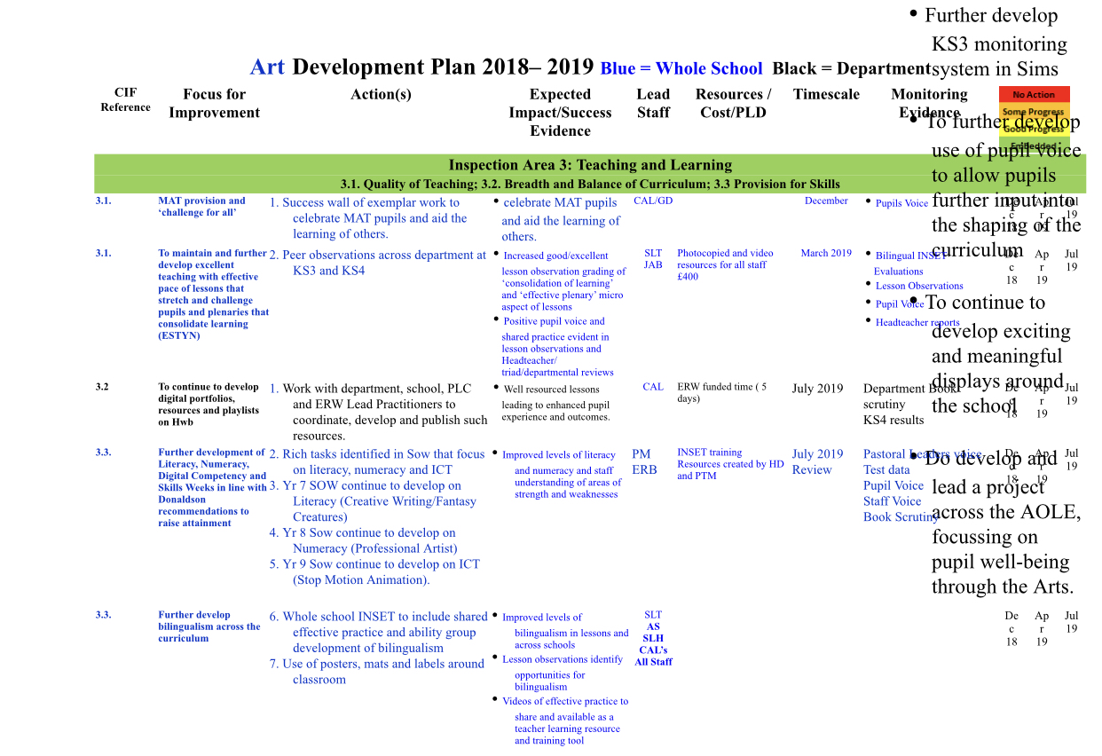

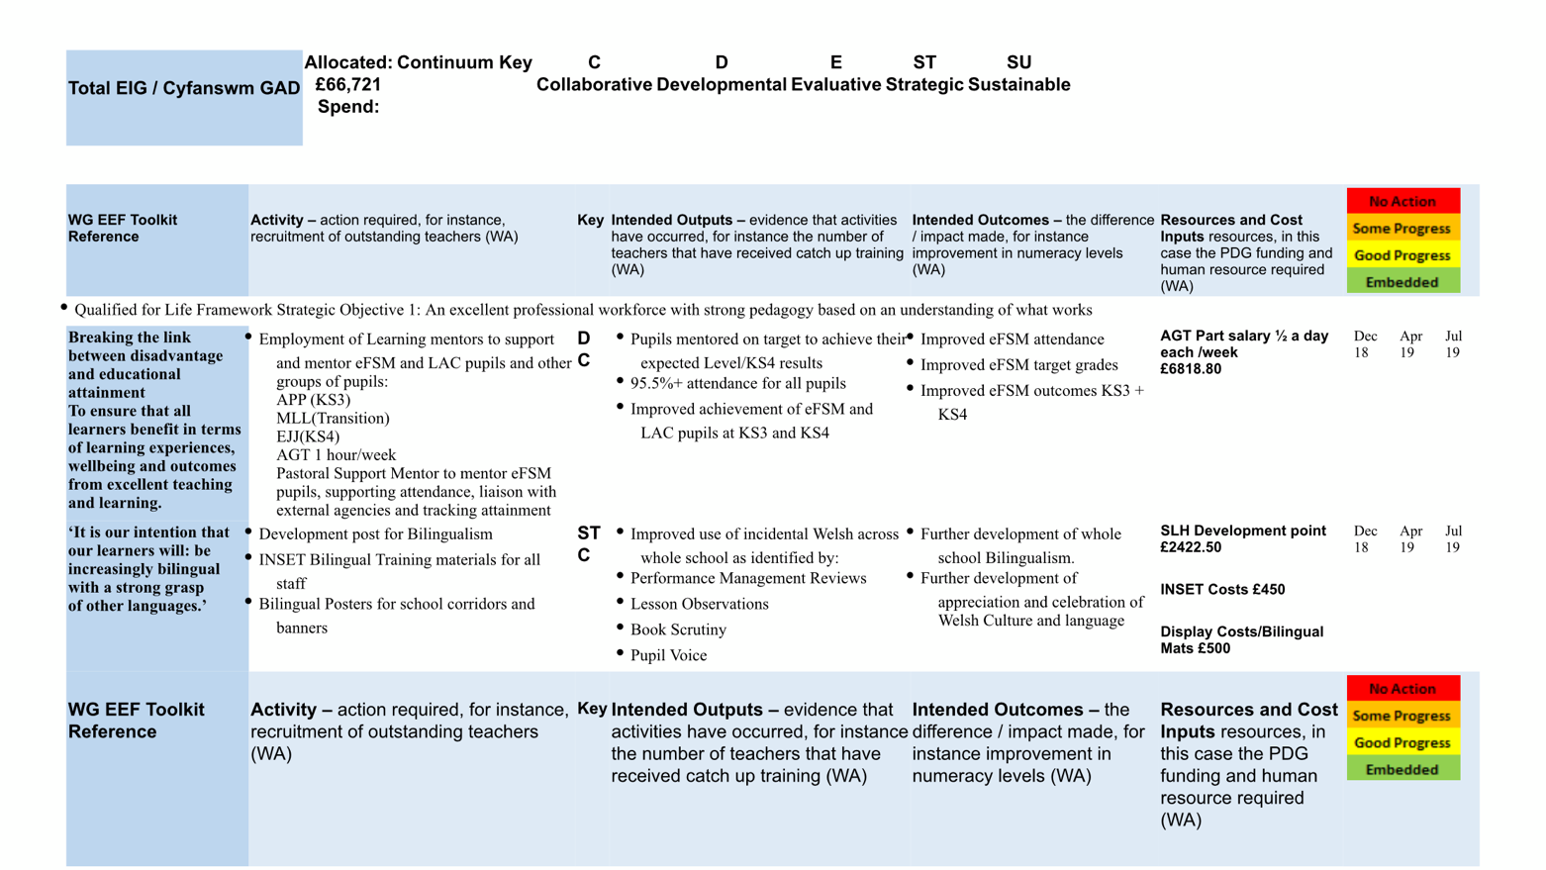
Appendix 2

Appendix 3
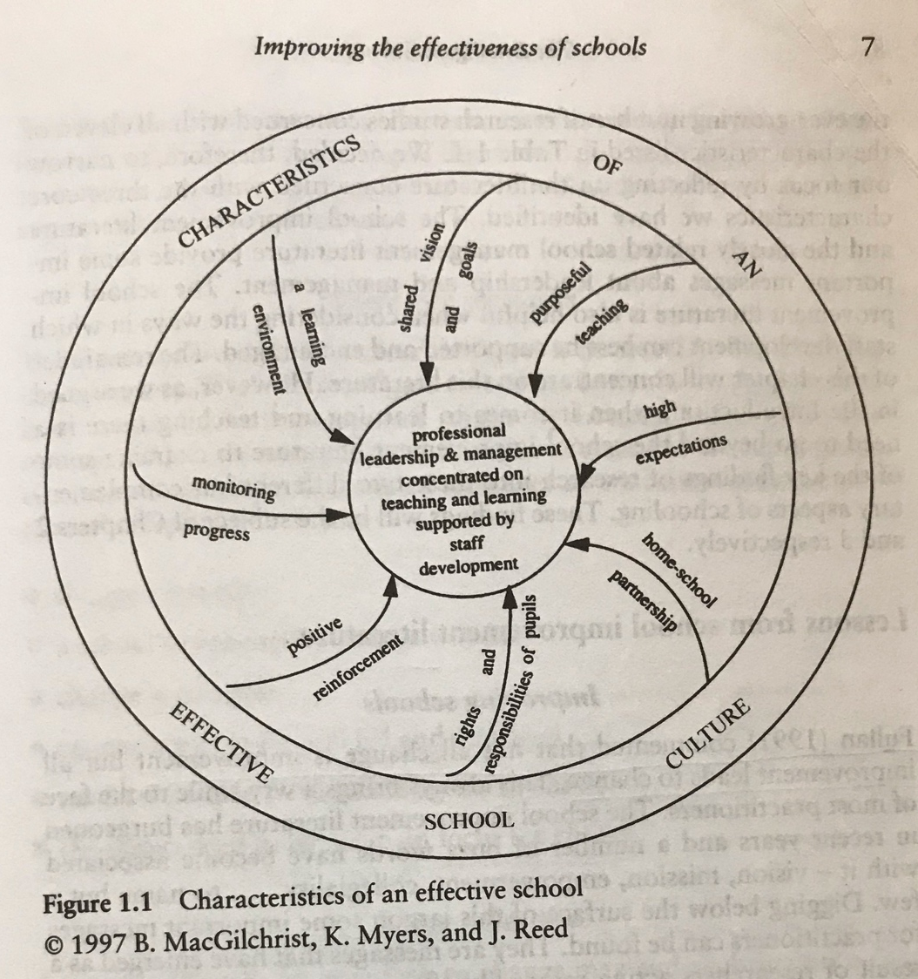

Appendix 4


