Marketing plan is written for

______________________ (Ritz Carlton)______________________________

Student Name

____________________ Mohammed Somru Miah__________________

Student Id.

_________2129682__________

Marketing Essentials BMIH4005

Lecturer

________________ Luciana Suardi ________________

Table of Contents
Introduction 3
Situation Analysis 4
SWOT analysis (Microanalysis) 4
Segmentation and Targeting 4
Porters five forces 4
Demonstrate an awareness of your organisation's B2B Relationships, Partnerships, and Franchises. 6
PESTLE (Macro analysis) 6
Objectives 7
SMART Objective 7
Strategy 8
Tactics 8
Marketing mix 8
Action 9
Control 10
Conclusion 11
References 12

Figure 1: Perceptual positioning maps (Self-made) 6

Introduction
When it comes to advertising, hotels and restaurants use a wide variety of methods. These practices aid in presenting a professional image to their clientele. American global corporation The Ritz-Carlton Hotel Company, LLC manages the posh hotel brand of the same name. Since the hotel industry was severely impacted by the Covid-19 outbreak, new marketing strategies are required to lure patrons to Ritz-Carlton. Here to see a report on the Ritz-Carlton Hotel Company's post-CoV-19 marketing plans. SWOT, PESTLE, Porter's Five Forces, and other frameworks will be used to compile this report.

Situation Analysis

SWOT analysis (Microanalysis)
Strength | Weakness
- Employees with a lot of autonomy mean a superior quality of service.  - More than 33,000 people employed in 25 different nations | - Expensive  - Falling profits
Opportunities | Threats
1 Raise sales by promoting business partnerships and offering discounted rates to existing customers (Baker and Huyton, 2021).  2. The growing international tourist industry | - The decline of the tourist industry is a result of things like natural disasters and terrorist attacks.  - Challenges from other famous hotels (Barker et al., 2017)

Segmentation and Targeting
Hotels by Ritz-Carlton may be found in more than seventy different locations; the chain's core customers are those who like a luxurious way of life. Ritz strives to focus on the common feature of "People with Lavish living," which it claims exists across all demographics. Thus, it is undeniable that Ritz Carlton uses a highly targeted approach to psychographic segmentation (Benaven, 2015).

Porters five forces
Competitiveness
Ritz-Carlton Hotels is a leading company in this highly competitive sector. There are a lot of different companies that compete with Ritz Carlton Hotels.
The threat of New Entrants
Due to its widespread distribution channels and prestigious brand name, Ritz Carlton Hotels faces little threat from upstart competitors (Benson et al., 2017).
Bargaining Power of Suppliers
Because of its commitment to enduring partnerships, Ritz Carlton Hotels has also shown concern for its suppliers.
Bargaining Power of Buyers
Ritz Carlton Hotels takes pride in maintaining happy guests. Because of this, Ritz-Carlton Hotels is often regarded as a customer-focused industry leader.
Threat of Substitutes
There has been a significant threat of substitutes since there are alternatives like Marriott and Hilton in the market (Burrow, 2021).
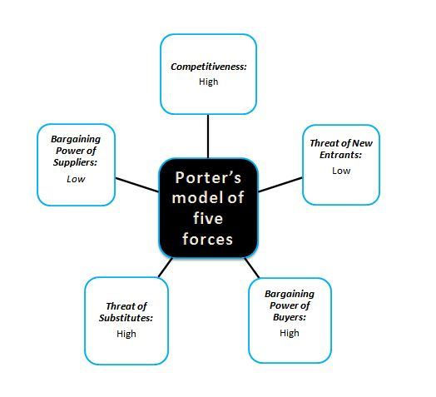
Figure 1: Perceptual positioning maps (Self-made)

Demonstrate an awareness of your organisation's B2B Relationships, Partnerships, and Franchises.
The Ritz Carlton Hotel Company's Service Values for staff show that they place a premium on relationship management. As a result, the product became available in new markets. The organisation operates as a Marriott International Inc (Deiss and Henneberry, 2017).

PESTLE (Macro analysis)
Political factors | Ritz-Carlton Hotel Co. is now operating in a variety of nations, each of which is rife with its own set of political issues. Ritz-Carlton Hotel Co. may have fewer prospects for expansion if global political tensions and instability continue to rise.
Economic factors | Foreign exchange/interest rates, labour market circumstances, inflation, saving rates, etc. all have a role in shaping the economic climate of the nation, making it crucial for Ritz-Carlton Hotel Co. to be aware of them (Giannetto, 2014).
Social factors | Information gleaned through social and environmental studies is used by the marketing team of Ritz-Carlton Hotel Co. to better target certain demographics and broaden the brand's appeal.
Technological factors | The Ritz-Carlton Hotel Company is one of several companies making use of the potential of social media marketing.
Legal factors | Ritz Carlton Hotel need to introduce Law and regulations regarding the theft of any important elements that customers carry to the hotel.
Environmental factors | Investment in renewable technology is subsidised in several nations. For the sake of long-term viability, Ritz-Carlton Hotel Co. may use it to fund the development of renewable energy sources (Hanna, 2020).

Objectives

SMART objective
Specific: To attract a greater number of clients.
Measurable: The goal is to get each guest to spend $25 more money.
The target can be reached, and there are well-defined steps that will lead to achievement.
Increase the number of room-and-meal deals sold.
Attainable:Staff at on-site stores should be retrained to use persuasion to generate more revenue.
Relevant: It may be in line with wider goals of increasing total revenues, better using on-site facilities, and/or improving profitability per visitor (Lynn and White, 2019).
Time-bound: The deadline for completion of the objective has been established for the year 2023.

Strategy
The real comfort and care of our guests are our priority at The Ritz-Carlton. They guarantee that visitors will always feel welcome in a setting that is at once casual and elegant. When one stays at a Ritz-Carlton, their senses will be piqued, their mood will be lifted, and all of their needs, even those one didn't know one had, will be met (Moutinho, 2014).
Through the use of its website and other promotional materials, Ritz-Carlton can inform clients directly of the values they provide. Advertising in traditional media cost them less than $100 million last year. They can now spend money on high-end ad spaces and spread their message across a wide range of media (Mullins, 2015).

Tactics

Marketing mix
Product
Ritz-Carlton provides its guests is nothing short of a spectacular and unforgettable experience. It stands out from the competition by providing services that its rivals don't. There is not a single Ritz Carlton hotel in the UK at present, they may expand their hotel to accommodate more guests (Westhuyzen and Merwe, 2017).
Place
Ritz Carlton must provide detailed directions to its hotels for their guests' convenient location-based services, both online and off, need to be addressed. Hotel locations may be determined from the user's browsing domain, third-party check-in, and check-out. The most efficient way to get customers to the hotel is to provide directions using Google Maps (Steve, 2022).
Price
It's no secret that many people's incomes have dropped since covid -19. The hotel administration did not reduce the price of their offering. Their service fee should be set according to age and occupation, and they should provide credit discounts for bulk reservations.
Promotion
Direct marketing strategies are at the heart of hotel management services. In this way, they may inform their actual clientele of their PR efforts. Optimal marketing and sales for the companies would strike a balance (Stieler, 2017).

Action
-Gannt chart of 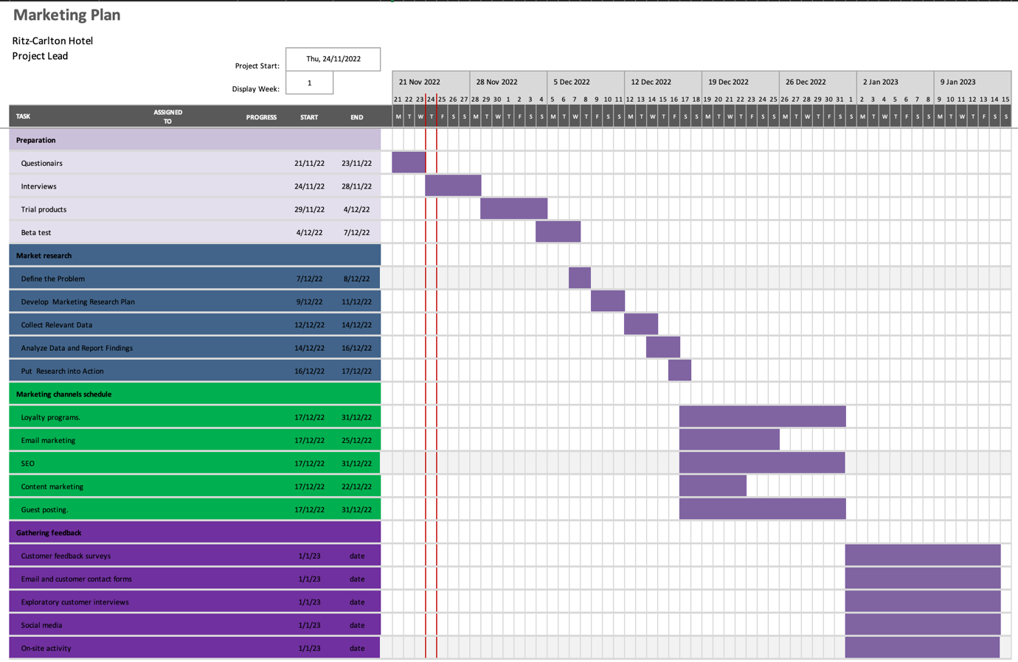
In the first phase, questionnaires will be made. Right after that interviews will be conducted, then trial products will be put out and lastly, a beta test will be conducted. The second phase, marketing research. Here problems will be defined, a marketing research plan will be developed, data will be collected, reports will be analysed and research will be put into action. In the third phase, many marketing channels will be introduced. Loyalty programs and guest posting will run from 17 to 31st December, but SEO and email marketing will be shorter than that. In the last phase, feedback will be gathered and the result will be measured (Vallen and Abbey, 2017).

Control
Staff members are encouraged to utilise their initiative and discretion in allocating corporate resources to develop novel approaches to customer service. Ritz highlights the novelty, excellence, and innovation of their product in comparison to the competition. Employees at the Ritz-Carlton are encouraged to utilise their initiative and discretion in allocating business resources to develop novel approaches to enhancing the quality of their service to guests.
Success, new customers, good sentiments towards the brand, and increased profitability will be tracked using ADR, RevPAR, Occupancy rate, and Online reviews by Ritz.

Conclusion
The Ritz-Carlton Hotel was the focus of the proposed advertising campaign to increase the hotel's clientele. The hotel's finances have worsened as a direct result of Corona. In this scenario, hotel management must organise events within the constraints of available funds. Now more than ever, guests want to be able to reach the hotel's management through various internet channels, but the hotel must maintain a highly active and effective online service. The Ritz-Carlton may engage qualified workers to ensure the quality and security of their services at a somewhat lower cost.

References
Baker, K. and Huyton, J. (2021) Hospitality management: An introduction. Elsternwick, Vic.: Hospitality Press.
Barker, M.S. et al. (2017) Social Media Marketing: A strategic approach. Boston, MA: Cengage Learning.
Benavent, C. (2015) SWOT analysis. Namur: 50minutes.
Benson, V., Tuninga, R. and Saridakis, G. (2017) Analyzing the strategic role of social networking in firm growth and Productivity. Hershey, PA: IGI Global, Disseminator of Knowledge.
Burrow, J. (2021) Marketing. Chicago, IL: Cengage.
Deiss, R. and Henneberry, R. (2017) Digital Marketing for dummies. Hoboken, NJ: Wiley.
Giannetto, D.F. (2014) Big Social Mobile: How digital initiatives can reshape the enterprise to drive business results. New York City: Palgrave Macmillan.
Hanna, N. (2020) E-transformation: Enabling new development strategies. New York: Springer.
Lynn, V.D.W. and White, L. (2019) Hospitality management. South Melbourne, VIC: Cengage.
Moutinho, L. (2014) The routledge companion to the Future of Marketing. London: Routledge, Taylor and Francis Group.
Mullins, L.J. (2015) Hospitality management: A human resources approach. London: Pitman.
Steve (2022) Research anthology on developing socially responsible businesses. Hershey, Pennsylvania (701 E. Chocolate Avenue, Hershey, Pennsylvania, 17033, USA): IGI Global.
Stieler, M. (2017) Creating marketing magic and Innovative Future Marketing Trends Proceedings of the 2016 Academy of Marketing Science (AMS) annual conference. Cham: Springer International Publishing.
Vallen, J.J. and Abbey, J.R. (2017) The art and science of hospitality management. East Lansing, MI: Educational Institute of the American Hotel and Motel Association.
Westhuyzen, B.V.der and Merwe, J.V.der (2017) The marketing mix. Mowbray, South Africa: Future Managers.

