

‘Research and Case Scenario in Data Security and Compliance’
Data Security and Compliance (ACCA5034)

Jonathan Lesmond (2300728)
BSc Applied Computing

Table of Contents
Table of Figures 3
Introduction 4
Research on Data Security Frameworks 4
Case Study (CyStresSolutions) 10
References 14

Table of Figures
Figure 1 - Image of NIST Cybersecurity Framework 3
Figure 2 - Image of COBIT 2019 Principles 5
Figure 3 - Image of COBIT Core Model 5
Figure 4 - Image of CIS Controls 6
Figure 5 - Proposed Information Security Team Structure 9
Figure 6 - Example of Weighted Factor Analysis Sheet.[7] 11

Research and Case Scenario in Data Security and Compliance
Jonathan Lesmond
Student, University of Wales Trinity St David, Swansea, Wales
2300728@student.uwtsd.ac.uk

Introduction
This report is split into two sections; Task 1 and Task 2, Task 1 will introduce you to widely known cybersecurity frameworks that are implemented within the computing industry and research papers relating to them, In task 2 I will delve into a case study where I set up a new information security department for a consultancy company, within the case study I will cover a range of aspects including; organizational structure, Policies and Procedures, Compliance, Governance, Risk Management, Contingency Planning and Protection Measures.

Research on Data Security Frameworks
Cybersecurity frameworks can be described as a general set of guidelines that cover a broad range of topics relating to information security within an organisation, although not required by law to follow any cybersecurity frameworks it still highly recommended to implement one or multiple frameworks in order to operate an effective cybersecurity department.[1] Popular frameworks that are implemented into organisations around the world include; NIST framework, COBIT 2019, CIS controls framework etc. [2], [3], [4]
NIST Cybersecurity Framework
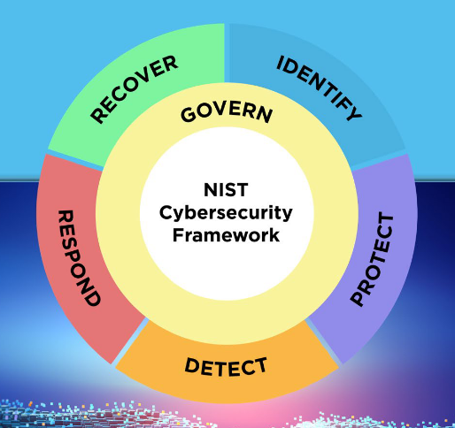
Figure 1 - Image of NIST Cybersecurity Framework
Also known as the National Institute of Standards and Technology (NIST) Cybersecurity Framework, was created to assist organisations in improving risk management across many important company assets, The framework consists of 6 core functions; Govern, Identify, Protect, Detect, Respond and Recover.[5]
The govern function looks at the initial stage of creation of a risk management strategy, in this stage the C-suite and stakeholders establish roles, responsibilities and the allocation of other resources to the strategy.[5]
The identify function is the stage where company assets are evaluated based on their level of risk, this is where keywords such as risk appetite and residual risk enter the frame, Risk appetite is a measurement of how much risk a company is willing to tolerate,[6], [7] while residual risk refers to the risk that still exist after the implementation of protection measures. Other publications such as the FIPS 199 also made by NIST gives guidance on how to categorise information or systems that interact with information based on potential impact in the event of an incident.[5], [8]. The NIST 800-53 is another publication that gives more details on specific protection measures ranging from content protection to access controls etc.
The protect function sees the implementation of physical and/or logical protection measures and technologies to important company assets, Examples of physical protection measures include RFID cards, security guards, mantraps etc.[5], [9] and logical protection measures include Backups, Authentication, Access levels/controls Firewalls etc.
The detect function initiates in the detection of a potential threat or confirmed threat where firewalls or intrusion detection/protection systems are used to track and analyse suspicious behaviour on a network or system.[5]
The respond function relates to the company’s response to an incident, The usual actions done in response to an incident mitigation of further damage during the incident and the production of an incident report in the aftermath of it.[5]
The recover function is where the affected assets are returned to normal operational level, most companies would have created a contingency plan for the event of a cybersecurity incident.[5]
Appendix A of the NIST framework document provides a lot more detail on what should be held into account within each of the functions mentioned.[5]
An example of successful implementation of the NIST framework can be found in one of the largest energy suppliers in the called Aramco, who operated in Asia, North America and Europe and had problems due to the different regulations in those 3 continents resulting in communication struggles between their facilities, which prompted them to use the framework alongside the C2M2 and CMMI Models for a risk assessment of company assets and to create new practices to achieve their objectives, this ultimately resulted in a new universal framework for Aramco that is adaptable across their multiple facilities across multiple continents that made it easier to communicate and govern.[10]
However, with the wide use of Machine Learning (ML) tools such as ChatGPT and Claude, researchers say that the framework could be potentially used to integrate machine learning into current security systems although the framework itself hasn’t been updated to mention machine learning. However, they also say that the usefulness of the NIST is heavily impacted when it comes to identifying new potential threats, specifically when it comes to time related or bias within the outputs of ML tools, it is also said that while the NIST framework still provides good guidance on security it falls short of other specific problems with ML tools such deceptive outputs.[11] ML training data
COBIT 2019
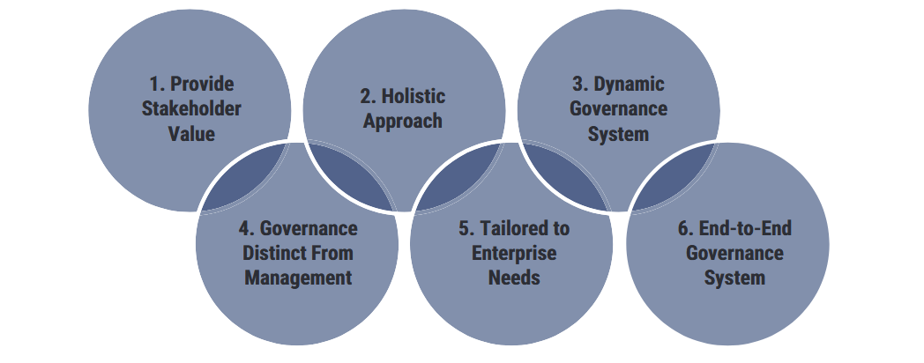
Figure 2 - Image of COBIT 2019 Principles
Also known as Control Objectives for Information and Related Technology (COBIT) is a framework created by ISACA to provide guidance on governance, governance in the topic of information security can be thought of as the process of maintaining or enforcing a security framework to ensure the fulfilment of objectives made by management relating to information security, these processes may include the creation of policies, having a procedure when interacting with a system etc.[12] COBIT 2019 specifically is an updated and improved version of COBIT 5 and added a 6th principle to the preexisting five that were stated in COBIT 5. As previously mentioned COBIT 2019 is made up of 6 principles that are based on the COBIT core model’s 5 domains (Evaluate, Direct, Monitor (EDM). Align, Plan, Organise (APO). Build, Acquire and Implement (BAI). Deliver, Service and Support (DSS). Monitor, Evaluate and Assess (MEA)) which are: Provide stakeholder value, Holistic approach, dynamic governance, governance distinct from management, tailored to enterprise needs, end to end governance system.[13]
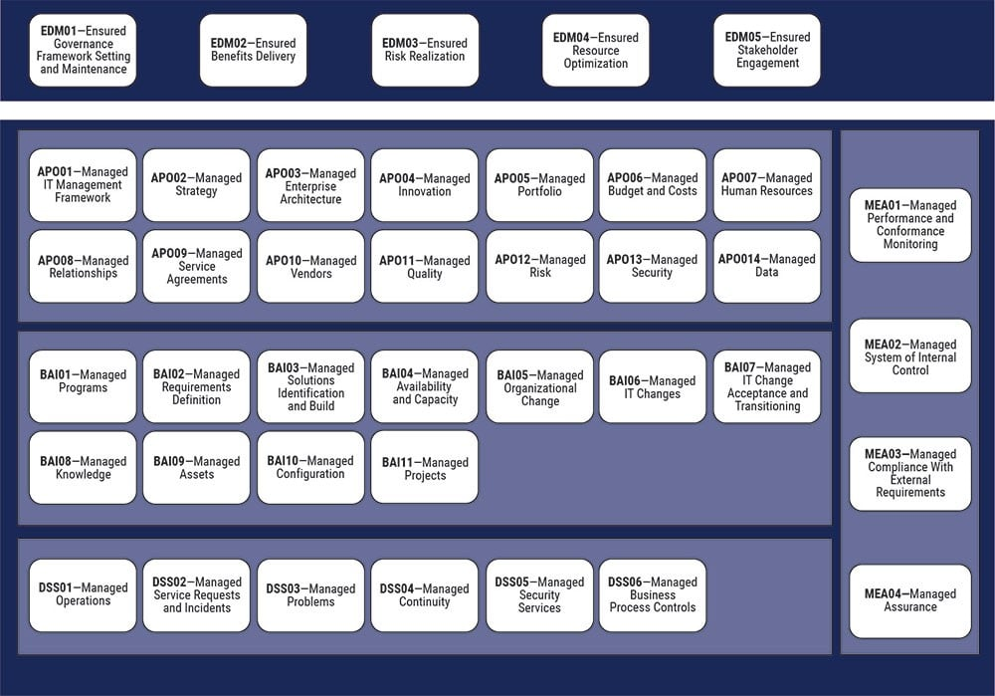
Figure 3 - Image of COBIT Core Model
‘Provide stakeholder value’ focuses on acquiring the agreement between departments and stakeholder’s objectives.[14]
‘Holistic approach’ refers to the importance of accountability and responsibility when it comes to governance, this principle covers how managers in a company manage the use of IT in the group that they supervise.[14]
‘Dynamic governance system’ looks at whether the governance system that they are creating is adaptable and how certain changes affect the system.[15]
The ‘Governance distinct from management’ principle looks at getting employees to know the difference between governance processes and management processes. Governance processes are focused on the practices done to optimize resources optimize risk management etc. while management process focus on maintaining infrastructure.[14], [15]
The ‘Tailored to enterprise needs’ principle simply states that the governance systems continuously adapted to the enterprises requirements.[15]
Finally, the ‘End-to-End Governance System’ principle is similar to the 5th principle and states how the governance needs to be applicable in all aspects of the company.[15]
The COBIT model(s) in general have been considered the popular choice of assessment for auditors, managers or executives, this can be down to the fact that the COBIT 5 documentation includes something called the Process Capability Assessment under chapter 7, the process capability assessment evaluates the usefulness of a company’s processes based on the goals each process is supposed to achieve, the evaluation is represented by a grades which are: N (Not achieved), P (Partially Achieved), L (Largely achieved) and F (Fully achieved).[16] There are also early studies that strongly suggest the improvement of performance and a degree of usefulness when implementing the COBIT models.[17]
However, there is an apparent lack of research or case studies relating to the evaluating the COBIT models specifically,[17], [18], [19] for example, the most recent success story on the COBIT model on the ISACA’s website is from 2016 despite the existence of the COBIT 2019 model which is an upgrade from COBIT 5 which was the current model at the time,[20] so there may be difficulty in seeing how well the COBIT 2019 holds in the current world.
Another problem that IT professionals and researchers talk about is the practicality of the framework, in particular the complexity of the model was a criticism, for example, COBIT 4 states more than 200 control objectives and 34 IT processes among other things, which causes organisations to use COBIT at a later stage or overlooked for other frameworks such as the ISO 27000 series due to the time it may take to understand and actually use the model, another criticism relating to the practicality of the COBIT models is that there is a lack of guidance when it comes to implementation, they say that the model does no give specific guidelines of procedures to take and that the model is too generic or flexible.[19]
CIS Controls Framework
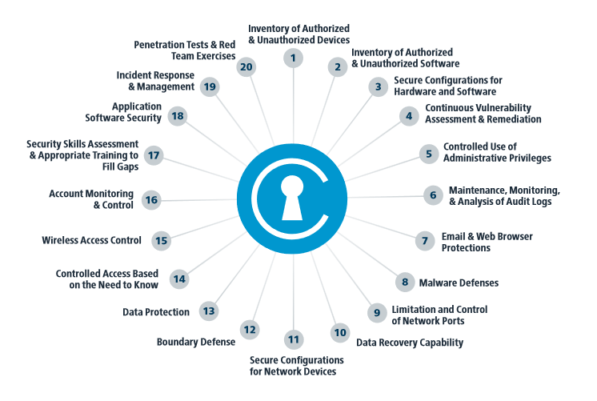
Figure 4 - Image of CIS Controls
Also known as the Centre for Internet Security’s Critical Security Controls, Is a collection of recommended controls that organisations should implement to improve data and system security, these controls are split into 3 categories: Basic, Foundational and Organisational.[2], [21]
The basic category can be described as very basic measures to improve security such as make sure software is updated and passwords are secure etc. The foundational category can still be described as basic controls but are more advanced than the ones mentioned in the basic category, these include access controls, baselines tests of systems etc. And the organisational category focuses more on controls that should be implemented to create an effective governance system which include policies, procedures, training etc.[2]
The framework also recommends which type of organisation should use certain controls, they categorise these different types of organisations into 3 ‘Implementation Groups (IG)’, IG1 refers to SMEs with limited assets and/or personnel specialising in cybersecurity, IG2 refers to an organisation that have cybersecurity staff but they have to work across multiple departments simultaneously due to more but still limited resources and IG3 refers to an organisation that has cybersecurity personnel that specialises in different aspects relating to cybersecurity such as risk assessments, penetration testing etc.[21]
There are other documentations directly related to the CIS controls such as the CIS controls implementation guide for SMEs (will be referred to as ‘CIS-CIGS’) which we will be focusing on provides a more summarized and digestible set of controls to use and also including cost effective tools to use, the CIS-CIGS divides each of their controls solutions into 3 phases; Know your environment, Protect your assets and Protect your organization.[22]
Phase 1 also dubbed ‘Know your environment’ looks at the various techniques used to monitor networks or systems these techniques include using network analysers, content protection/filters.[22]
Phase 2 also known as ‘Protect your assets’ focuses more on the security measures that can be implemented on devices such as removable media, Laptops/Desktops etc. in the guide they recommend establishing a performance baseline on systems, replacing removable media with cloud based storage, using encryption on all devices etc.[22]
Phase 3 which is called ‘Prepare your organisation’ looks at the procedures a company should take in preparation for a potential cyberattack which include using and managing backups, creating an incident response team or identify someone that will take lead in the event of a cyberattack, having the contact information of staff or other 3rd party services that provide security services to the company etc.[22]
The CIS controls framework is considered a very useful, versatile and easier to implement due to the fact that it gives detailed tools and practices to have, the CIS controls documentation also categorises the security controls into implementation groups based on the size of the organisation which allows them to incrementally add more advanced measures as the organisation grows,[21] the framework is also compliant with the Federal Information Security Act (FISMA)[2], [23] which is a law relating to the protection of government information within organisations.[24] The NIST also recommend documents relating to baseline testing in Microsoft Azure, SQL server etc. by the CIS within their checklist repository, which suggests that the CIS controls framework is actively being used in various government departments in the USA,[25] making it a strong framework to recommend.
However, there are some relatively major criticisms of the CIS controls framework according to researchers, one criticism that was made was the contradictory nature of it,[26] for example, the CIS controls describes itself as a list of security measures all organisations should be implementing, in the introduction of the document it says that it aims to change the question of ‘What should my company do?’ to ‘What should we all do?’, but later on in the introduction says that the framework is not a ‘one size fits all solution’ and that you are still required to do an internal assessment of your organisation to see what fits best and suggests that that framework does not fulfil its purpose properly. [21], [26] Another criticism of the CIS controls is that part of its target audience does not need to use the framework, they say that it is possible that large organisations also known as IG3 don’t need the framework as they may already have effective security structures in place, making the framework potentially sound more applicable than it may be in reality,[26] this can be also proven by the fact that there isn’t an implementation guide for large enterprises despite one existing for SMEs, but the whole point of most security frameworks is not to strictly follow everything but adapt its implementation based on an organisation’s objectives, large organisations may use alternatives to services/processes that the documentation recommends, alternatively if you are categorised as IG3 instead of directly following the framework’s recommendations you can adapt it to use it entirely as risk assessment criteria.
Conclusion

Case Study (CyStresSolutions)
Organization Structure
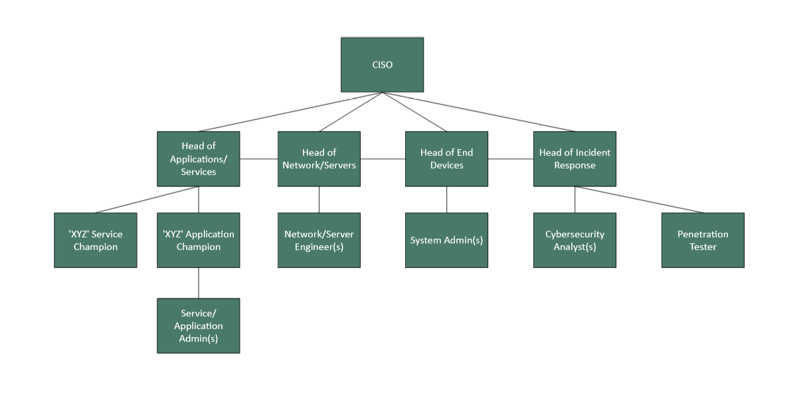
Figure 5 - Proposed Information Security Team Structure
At the top of the information security team hierarchy, I will have a Chief Information Security Officer (CISO) who can relay the information received from the various team members to the Chief Information Officer, The CISO will also be responsible the creation and governance of policies and procedures in the team and will lead the response to a cybersecurity incident.[3], [27], [28]
I will include a risk assessment specialist or cybersecurity consultant who only communicates to the CISO on security recommendations for them to evaluate but doesn’t communicate with the rest of the team.[29]
Below the CISO and security consultant/risk assessment specialist I will have ‘Heads of’ of the different aspects relating to information security who will report directly to the CISO, these aspects include Applications and Services, The Network/Servers, End Devices and Incident Response. I will also include specifically for the Applications and Services team managers/champions for each individual service/application that the organisation uses as they may have access to a lot of services.[28] The Incident Response team will also be responsible for the testing the security of systems within the organisation, hence the inclusion of penetration testers.
Below the managers/directors there will be the entry and mid-level roles such as the system admins, analysts and engineers who will actively manage and implement new policies/procedures on organisation’s assets and to report vulnerabilities or threats.[27]
Policies and Procedures
The procedures I will implement will take inspiration from the NIST framework and CIS Controls framework (Implementation guide for SMEs) mentioned earlier.
I will look to use various risk assessment methods to identify which assets are at risks, I will also look to categorise information or systems based on their level of impact in the event of a cybersecurity incident the keywords we will use for this are: Low, Moderate, High, Severe.[8] Which will be easier when it comes to risk assessments.
I will then utilize the CIS controls implementation guide for SMEs to identify which products/services the team should use when in operation.
- Implementation of NIST framework and CIS controls framework
Compliance
One of the regulations that CyStresSolutions has to abide by is the General Data Protection Regulation (GDPR), The objective of the GDPR is to state rules relating to the processing and transmission of personal data.[30] Article 5 of the GDPR presents the 6 principles relating to the processing of personal data which include processing data in a transparent manner and lawfully, collected data only for its specified purpose and shouldn’t be processed any further, you must have the correct amount of relevant data relating to its purpose, the data must be up-to-date and accurate, not allowed to store personally identifiable data longer than necessary.[30]
The PCI DSS is another set of regulations that CSS has to comply with, mainly for the salaries of the employees and for when a client is looking to buy our services. The Payment Card Industry Data Security Standards (PCI DSS) is a set of 12 requirements that all organisations that handle payment card data must follow, these include using and maintaining a firewall, changing passwords from the defaults, encryption the transmission of card information, using a regularly updated antivirus software, maintain the security of systems, appoint a unique identifier to any employees that can access company systems, monitoring access to card information, regularly test the security of systems etc.[31]
In the event that CyStresSolutions provides services to a company that is based in the USA, a law that we are required to comply with is the EU-US data privacy framework. The EU-US Data Privacy Framework (EU-US DPF) is a law that covers the transmission of data specifically between European countries and the USA and states rules relating to 7 principles which are: Notice, Choice, Accountability for transfer, Security, Purpose limitation, Access, Enforcement. The notice principle relates to companies being required to give notice to users that they comply with the EU-US DPF and provide a link the data privacy framework list which is a list of companies that comply with the framework, companies are also required to state the purpose of which the data they collect is being used for similar to the GDPR etc. The choice principle covers the requirements relating the users ability to choose whether their data can be used by a 3rd party or not, Accountability covers the transfer of personal data to a 3rd party assuming they have permission to do so, this principle also exercises purpose limitation to 3rd parties that have access to personal data, The security principle covers the protection of data from unauthorised access, Purpose limitation refers to using data only for its intended purpose which is also mentioned in the GDPR, The access principle requires that the data subject is given access to perform CRUD style operations on their data, finally, enforcement relates to governance over the use of data
Risk Management
Risk assessments are an essential part of risk management that we want to include into our information security team, the main types of risk assessments we want to use include a Weighted Factor Analysis and a Threat Vulnerability Assessment.
A weighted factor analysis includes assigning a score to an asset based on different criteria and then calculating the average of those scores to create the final ‘weighted score’.[7]
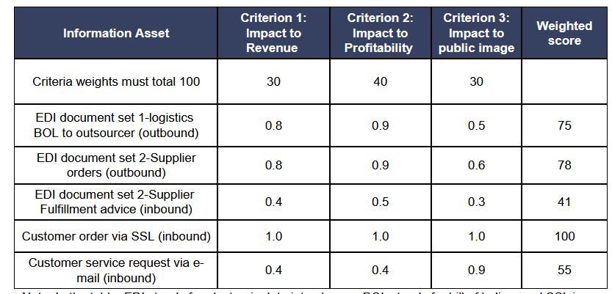
Figure 6 - Example of Weighted Factor Analysis Sheet.[7]
- Incident report consisting of:
  - Type of attack
  - Affected systems/assets
  - Estimate cost of damage
  - Time of attack etc.
  - Breach of laws/regulations (If applicable)
- Regular audits
  - Threat Vulnerability Assessment (TVAs) https://www.fortinet.com/resources/cyberglossary/vulnerability-assessment
Contingency Planning
Some extra measures we will utilise as apart of our contingency plan include having an offsite storage in the event that a natural disaster or other physical forms of attacks affect infrastructure and or data. [32]
A cold site may also be viable if enough physical damage has been made to the main office to be considered inoperable whether it is from a natural disaster or from vandalism. A cold site refers to an emergency facility with basic equipment to operate computer systems that is ready to use if a team has to relocate from their main office,[33] cold sites are also cheaper than warm or hot sites but also have less equipment installed than them and so transferring to a cold site in an emergency may take longer.[32]
We will also look to include using multiple power supplies for each individual critical system e.g. servers being powered by 2 power supplies simultaneously, this will ensure that critical systems are still operational if a power supply malfunctions.
Part of our incident report will include if any laws/regulations were breached from the incident, if so we will then be able to provide a notification to the corresponding governing body.[34]
- Move to backup storage or restore most recent versions of information (If information was affected)
- Contingency fund
  - Budget plan?
Protection Measures
We will look to include RFID cards that will be accompanied by an access controls system so that only the necessary staff have access to certain assets
Firewall will also be included as they are a necessity for network security, in addition to the offsite storage we will also implement regular backups of data.
Multi factor authentication will also be used to prevent unauthorised access if login details were stolen, and to ensure that end users are protected in addition to hardening computer systems.

References
[1] H. Taherdoost, ‘Understanding Cybersecurity Frameworks and Information Security Standards—A Review and Comprehensive Overview’, Electronics, vol. 11, no. 14, p. 2181, 2022, doi: 10.3390/electronics11142181.
[2] S. K. Shukla et al., ‘Cybersecurity Frameworks and Models: Review of the Existing Global Best Practices’, Productivity, vol. 65, no. 1, pp. 29–42, Jun. 2024, doi: 10.32381/PROD.2024.65.01.4.
[3] C. Campbell, ‘Lecture 4 - Information Security Management’, University of Wales Trinity Saint David. Accessed: Nov. 07, 2024. [Online]. Available: https://uowtsd-my.sharepoint.com/:p:/r/personal/2300728_student_uwtsd_ac_uk/_layouts/15/Doc.aspx?sourcedoc=%7B5a7b8ac8-c66a-4125-a8ec-84bdcdba85d9%7D&action=edit&uid=%7B5A7B8AC8-C66A-4125-A8EC-84BDCDBA85D9%7D&ListItemId=11877&ListId=%2Fpersonal%2F2300728_student_uwtsd_ac_uk%2FDocuments&odsp=1&env=prod
[4] S. K. Venkatachary, J. Prasad, A. Alagappan, L. J. B. Andrews, R. A. Raj, and S. Duraisamy, ‘Cybersecurity and cyber-terrorism challenges to energy-related infrastructures – Cybersecurity frameworks and economics – Comprehensive review’, International Journal of Critical Infrastructure Protection, vol. 45, p. 100677, Jul. 2024, doi: 10.1016/j.ijcip.2024.100677.
[5] National Institute of Standards and Technology, ‘The NIST Cybersecurity Framework (CSF) 2.0’, National Institute of Standards and Technology, Gaithersburg, MD, NIST CSWP 29, Feb. 2024. doi: 10.6028/NIST.CSWP.29.
[6] R. Barfield, ‘Risk appetite – How hungry are you?’, the journal.
[7] C. Campbell, ‘Lecture 5 - Risk Management’, University of Wales Trinity Saint David. Accessed: Nov. 09, 2024. [Online]. Available: https://uowtsd-my.sharepoint.com/:p:/r/personal/2300728_student_uwtsd_ac_uk/_layouts/15/Doc.aspx?sourcedoc=%7B69187E3E-A6BD-431B-98FA-772B50CC19C8%7D&file=Lecture%205-SC.pptx&action=edit&mobileredirect=true
[8] National Institute of Standards and Technology (US), ‘Standards for security categorization of federal information and information systems’, National Institute of Standards and Technology (U.S.), Washington, D.C., error: 199, 2004. doi: 10.6028/NIST.FIPS.199.
[9] C. Campbell, ‘Lecture 9 - Physical Security’, University of Wales Trinity Saint David. Accessed: Nov. 08, 2024. [Online]. Available: https://uowtsd-my.sharepoint.com/:p:/r/personal/2300728_student_uwtsd_ac_uk/_layouts/15/Doc.aspx?sourcedoc=%7BDBE0CA58-88A9-4803-8577-9EDCCF56AE5A%7D&file=Lecture%209-SC.pptx&action=edit&mobileredirect=true
[10] ‘Success Story: Saudi Aramco’, NIST, Jun. 2020, Accessed: Nov. 21, 2024. [Online]. Available: https://www.nist.gov/cyberframework/success-stories/saudi-aramco
[11] T. R. McIntosh et al., ‘From COBIT to ISO 42001: Evaluating cybersecurity frameworks for opportunities, risks, and regulatory compliance in commercializing large language models’, Computers & Security, vol. 144, p. 103964, Sep. 2024, doi: 10.1016/j.cose.2024.103964.
[12] P. Bowen, J. Hash, and M. Wilson, ‘Information Security Handbook: A Guide for Managers’.
[13] K. Harisaiprasad, ‘COBIT 2019 and COBIT 5 Comparison’, ISACA. Accessed: Nov. 14, 2024. [Online]. Available: https://www.isaca.org/resources/news-and-trends/industry-news/2020/cobit-2019-and-cobit-5-comparison
[14] L. Bunnell and H. R. Weistroffer, ‘Integration of the COBIT 5 Framework into the SDLC for Development of a User Access Attestation System’.
[15] G. Braga, ‘COBIT 2019 and the IIA 2019 Guiding Principles of Corporate Governance: Two Frameworks, Many Similarities’, ISACA. Accessed: Nov. 14, 2024. [Online]. Available: https://www.isaca.org/resources/news-and-trends/industry-news/2020/cobit-2019-and-the-iia-2019-guiding-principles-of-corporate-governance
[16] Information Systems Audit and Control Association, Ed., COBIT 5: a business framework for the governance and management of enterprise IT: an ISACA® framework. Rolling Meadows, Ill: ISACA, 2012.
[17] A. Abu-Musa, ‘Exploring the importance and implementation of COBIT processes in Saudi organizations: An empirical study’, Information Management & Computer Security, vol. 17, pp. 73–95, Jun. 2009, doi: 10.1108/09685220910963974.
[18] G. Mangalaraj, A. Singh, and A. Taneja, ‘IT Governance Frameworks and COBIT - A Literature Review’.
[19] S. Zhang and H. L. Fever, ‘An Examination of the Practicability of COBIT Framework and the Proposal of a COBIT-BSC Model’, JOEBM, vol. 1, no. 4, pp. 391–395, 2013, doi: 10.7763/JOEBM.2013.V1.84.
[20] ISACA, ‘COBIT Case Studies’. Accessed: Nov. 21, 2024. [Online]. Available: https://www.isaca.org/resources/cobit/cobit-case-studies
[21] Center for Internet Security, ‘CIS Controls V7.1’.
[22] Center for Internet Security, ‘CIS Controls Implementation guide for Small and Medium sized Enterprises’. Center for Internet Security.
[23] ‘Mapping and Compliance’, CIS. Accessed: Nov. 25, 2024. [Online]. Available: https://www.cisecurity.org/cybersecurity-tools/mapping-compliance/
[24] ‘Federal Information Security Modernization Act (FISMA) | CMS Information Security & Privacy Group’. Accessed: Nov. 25, 2024. [Online]. Available: https://security.cms.gov/learn/federal-information-security-modernization-act-fisma
[25] ‘NCP - National Checklist Program Checklist Repository’. Accessed: Nov. 25, 2024. [Online]. Available: https://ncp.nist.gov/repository?sortBy=modifiedDate%7Cdesc&keyword=CIS
[26] S. Groš, ‘A Critical View on CIS Controls’, in 2021 16th International Conference on Telecommunications (Con℡), Jun. 2021, pp. 122–128. doi: 10.23919/Con℡52528.2021.9495982.
[27] C. Campbell, ‘Lecture 11 - Security and Personnel’, University of Wales Trinity Saint David. Accessed: Nov. 15, 2024. [Online]. Available: https://uowtsd-my.sharepoint.com/:p:/r/personal/2300728_student_uwtsd_ac_uk/_layouts/15/Doc.aspx?sourcedoc=%7BD1435EB0-09E1-4842-B05E-410ED1A0F89D%7D&file=Lecture%2011-SC.pptx&action=edit&mobileredirect=true
[28] R. Neal, ‘Service-Oriented Security Architecture and its Implications for Security Department Organization Structures.’, Information Security Journal: A Global Perspective, vol. 17, no. 4, pp. 188–200, Jul. 2008, doi: 10.1080/19393550802369818.
[29] C. Campbell, ‘Lecture 1 - Introduction to Information Security’, University of Wales Trinity Saint David. Accessed: Nov. 16, 2024. [Online]. Available: https://uowtsd-my.sharepoint.com/:p:/r/personal/2300728_student_uwtsd_ac_uk/_layouts/15/Doc.aspx?sourcedoc=%7B6E4552A8-E1F7-4DE8-A98E-0B8826879ED6%7D&file=Lecture%201%20-%20SC.pptx&action=edit&mobileredirect=true
[30] E. Participation, ‘Regulation (EU) 2016/679 of the European Parliament and of the Council of 27 April 2016on the protection of natural persons with regard to the processing of personal data and on the free movement of such data (United Kingdom General Data Protection Regulation)(Text with EEA relevance)’, https://webarchive.nationalarchives.gov.uk/eu-exit/https://eur-lex.europa.eu/legal-content/EN/TXT/?uri=CELEX:02016R0679-20160504. Accessed: Nov. 16, 2024. [Online]. Available: https://www.legislation.gov.uk/eur/2016/679/article/5
[31] G. Ataya, ‘PCI DSS audit and compliance’, Information Security Technical Report, vol. 15, no. 4, pp. 138–144, Nov. 2010, doi: 10.1016/j.istr.2011.02.004.
[32] M. Swanson, P. Bowen, A. W. Phillips, D. Gallup, and D. Lynes, ‘Contingency planning guide for federal information systems’, National Institute of Standards and Technology, Gaithersburg, MD, NIST SP 800-34 Rev. 1, 2010. doi: 10.6028/NIST.SP.800-34r1.
[33] C. C. Editor, ‘cold site - Glossary | CSRC’. Accessed: Nov. 24, 2024. [Online]. Available: https://csrc.nist.gov/glossary/term/cold_site
[34] B. L. Hatchett-Bodle, ‘Group Health Plan Cybersecurity Considerations: Protecting Participant Information’, Journal of Pension Benefits, vol. 31, no. 3, pp. 45–47, Spring 2024, Accessed: Nov. 23, 2024. [Online]. Available: https://www.proquest.com/docview/3041529509/abstract/5BEE868AD8FF4DF2PQ/1

