3/16/2020
Nicholas Evans
1704662
Enterprise & Innovation Group Project
ACDA5003

Contents
Introduction 2
Ideation 3
Illustration and Design 3
Development 4
Production costs 5
Materials 5
QR Barcode 5
Future ideas 6
Conclusion 7
References 8

Figure 1 - Original Concept Figure 2 - Second Concept 3
Figure 3 - 3D Virtual Image Figure 4 - 3D Printed Product 4
Figure 5 - QR code costs 5

Introduction

The purpose of this report is to summarise the development of the product Medical Band by showing how an idea became a reality and the process of production behind necessary to accomplish this feat. As the production team was a group effort, the report will only show sections of the development that was personally worked on and to also give a small representation of other aspects of production to showcase how far the product has come.

Ideation

The idea behind this product was to come up with a way to help medical professionals in their line of work by designing something can would enable the medical staff to easily access critical health data on any patient, with this, the idea for the Medical Bracelet came into light. The band itself will hold patient’s personal data such as their medical records which can be accessed via simply scanning the QR code lasered onto the bracelet itself.

Illustration and Design

The initial design was highly discussed within the production team as to what materials and design would be best used for not just comfort, but also practicality. As a team, the decision was made to first use an RFID chip stored within the bracelet to hold the information necessary as the chip itself was very small and simple to install, yet the costs and production time would’ve been too much, with this in mind, the idea was presented to use the QR scanning system instead which saves on both cost and time.

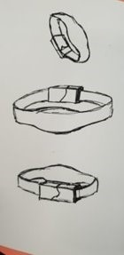
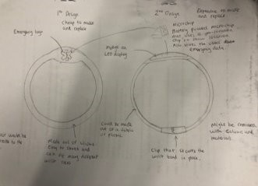

Figure 1 - Original Concept Figure 2 - Second Concept

As shown above within figures 1 and 2, The start of the project had brought a few challenges in terms of what would be best used to terms of design, but using drawings can only help the development of the product so much, as using certain materials might be great for how the bracelet would look, but with the purpose of the band itself being used by people with medical problems, the band itself has to be above all, comfortable to wear for long periods of time.

Development

Within the group, certain roles were distributed to individuals who was considered to be the best person for that role, After a time though it was clear that changes was needed to be made to help boost productivity of the production itself, with that the roles were then assigned to different people who showed more promise for that role than before. Thanks to this move, a member of the production team took it upon herself to help further the design of the product by using the software Autodesk Fusion 360 [1]. With this software, that member of the team was able to construct a virtual model of the product which also allows the user to print off the 3D design using a 3D printer to showcase which design worked best.
Below are images of what the product would’ve looked like after it is printed by displaying a virtual image and the other is the end result of the design fully printed. The oval shape of the band is to contain what was to be the RFID chip, helped give a nice platform for the now decided on use of QR codes to be plainly displayed upon the bracelet itself.

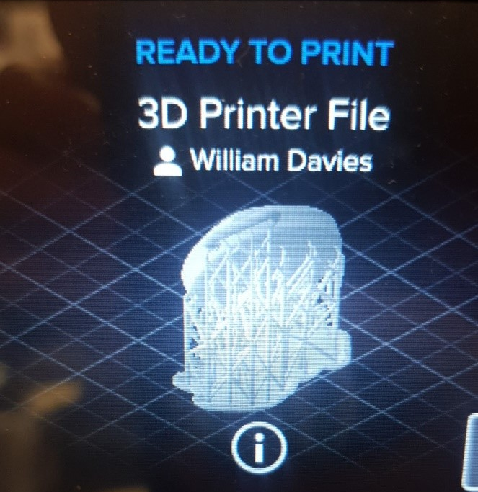
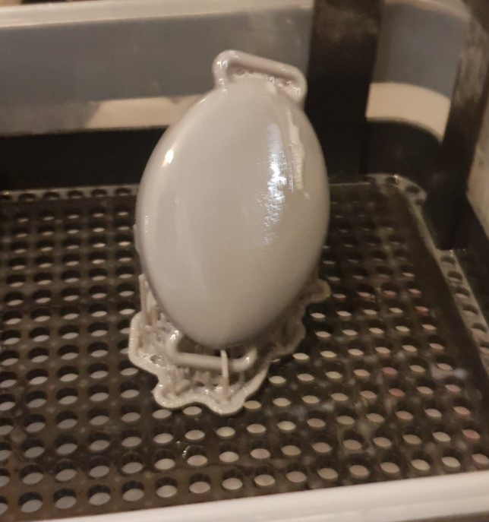
Figure 3 - 3D Virtual Image Figure 4 - 3D Printed Product

Even after thorough research into the idea, the product itself did have some competition on the market by very similar ideas, with this in mind during the production, the idea of also adding small features such as a GPS tracker being also installed into the product to help medical services locate the patient when necessary.

Production costs

Due to the nature of the product, the aim would be to have the whole production funded by the NHS or as a crowd fund as it would be a non profit product. With this in mind, instead of working out future sales figures that would be needed to help the product thrive once production begins, the idea of production cost alone was solely focused on as to make the product be financially productive to create. With this in mind, the decision to not include the strap was made to help in cutting costs, and to design the ‘compartment’ for the band itself to enable the attachment of whatever band the user wishes or feels most comfortable using.

Materials

The compartments material was heavily discussed as depending what was decided, could cost the most to produce during production of the product. The prototype of the product was created using resin via a 3D printer to actively witness the practicality of the design. Using resin as the main material though would be incredibly expensive as a litre of resin can cost about £50, and unpractical due problems such as comfort, water proofing and standard protection of the tech inside.
What the resin can do is help create a mould of the compartment to enable the use of other materials to be used instead such as the final decision of silicone. With the cost of silicone being still fairly high compared to other rubber materials, the advantages of the material outweigh the negatives in a very big way. A pound of silicone average cost is about £20 making it almost £10 cheaper per pound than printing resin making the process a lot cheaper in terms of mass production. Using the material silicone also offers the benefits of stability in its design as the material is known to last for at least 2 decades before degrading, it’s also waterproof, shock absorbing, flexible, low toxicity, high heat resistance and easily moulded into the shape needed.

QR Barcode

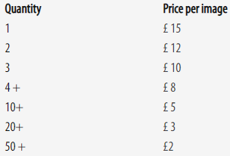
QR barcodes are free to generate thanks to many online sites that enable the users to do so, yet to have one for each product with a unique design that can be managed to track does have a cost. Like most things, buying in bulk helps reduce the price of designing unique barcodes in bulk as the table below suggests. [2]

Figure 5 - QR code costs
Using QR codes is a great way of keeping information without the need for any built in memory in the device as this allows the user to simply scan the barcode with a smart device to receive everything stored within. The idea behind this to keep the data secure is to have an app designed to only allow medical personal with authorisation on their devices can scan these codes and receive the data contained within.

Future ideas

The use of QR barcodes instead of using the RFID chip is down to the production team lacking the ability to code something so complex as to what would the chip be required to achieve and to help cut costs down further until such a time as the product becomes well received and the want of the product to be improved upon becomes apparent. This also goes for the GPS tracker, due to legal reasonings and limited access to free stable internet connections, the idea for these to work is impossible given the deadline of the projects end to have fully working.
This isn’t to say that these ideas have been written off though, as the potential for those applications within the device allows the product to become a necessary asset to all medical working everywhere.

Conclusion

Working within a group to not only come up with an idea for a product that can benefit people, but to also come up with an idea that people would want is a challenge in many aspects that many would not think about. Working in an assigned group of individuals can in itself be difficult as personalities could clash and production slowed due to inside commotions, disagreements about ideas going forward and design preferences. Having someone to be in charge is of utmost importance in this position as to have someone have the final say of what goes forward and to help resolve any disputes within the group.
The production of the idea itself is also a huge challenge due to the many factors involved such as original ideas that would’ve been worked on for a long time could come to a sudden halt for unknown reasons or simply unable to work as intended. Legal factors to research thoroughly in case of potential lawsuits against the production team and of course ethical reasons which is a minefield of potential problems with peoples varied opinions and beliefs.
And of course, the cost of everything from the paper used to help design the idea to materials and work hours spent in creating the product itself. The production of anything is without a doubt, an expensive and timely venture that shouldn’t go ahead without a huge amount of research and planning being done before hand to help minimise any risk preventing the product from failing to not only achieve the intended design and be wanted by the consumer, but to even get to the final stages without something unforeseen preventing the team from making the idea into a reality.

References

[1] | “autodesk.com,” [Online]. Available: https://www.autodesk.com/products/fusion-360/overview. [Accessed 25 02 2020].
[2] | [Online]. Available: https://barcode1.co.uk/qr-code/. [Accessed 05 02 2020].

