Mahmud Akbar
SN- 1711691
Module- Strategic Management for SMEs
Programme: BA (Hons) Leadership and Management - Skills for the Workplace
Code- BMSW6104
Lecturer- Paul Bocij

The case study of PRAN-RFL Company

Contents
Abstract 4
A Brief History of PRAN 5
Mission Statement 7
PRAN’s Mission 7
Vision Statement 7
PRAN’s Vision 7
PRAN’s Response to Covid 19 8
Scanning Tools 9
SWOT Analysis 10
Advanced SWOT Analysis 12
PESTLE Analysis 14
Porter’s Five Forces 16
The Threat of New Entrance 17
Balanced Scorecard (BSC) Method 18
A Brief Case Study 20
Boston Consulting Group (BCG) Matrix 21
PRAN’S Stakeholders 22
Recommendations 24
Conclusion 26
Appendix 28
1.1 Ethics 28
1. 2 Sustainability 29
1.3 Cost Leadership and Product Differentiation 29
1.4 Upgrading Machinery and Technology 30
References 31

Table of Figures

Figure 1: Pestle Analysis (Boyce 2020) 14
Figure 2: Porter’s Five Forces (Business to You 2016) 16
Figure 3: Balanced Scorecard (Kaplan Financial 2020) 18
Figure 4: BCG Matrix (Hanlon 2020) 21
Figure 5: Expectation of Stakeholders 22
Figure 6: Stakeholder Analysis (Meeting Sphere 2020) 23

Abstract
The mission is to produce an essay of distinction about a business organisation of one’s choice. After much deliberation, the chosen case study is about a company named PRAN. The essay focuses on the benefits of engaging in ethical trading, building sustainable resources, developing excellent customer relationships, nurturing the talents of employees and fulfilling the aims of the key stakeholders. All business organizations have objectives and aspirations to reach them, whether it is short or long-term. The research will appraise the utilization of environmental scanning to aid the organizations to draw up plans and a roadmap to achieve the company goals. By applying various scanning tools and techniques, it will examine how these virtues relate to the core fabric of PRAN’s existence and operation. It will strive to inform how the implementation of the organisation’s strategies provide the customers with exceptional quality at economical prices and excellent customer services. It will focus on green issues, helping to safeguard the environment and the surrounding communities. The essay will briefly touch on the implications of the COVID 19 on the PRAN enterprise.

A Brief History of PRAN
PRAN is an acronym for Programme for Rural Advancement Nationally. After retiring from twenty- five years of sterling service from the Bangladesh Army, Major General Amjad Khan Chowdhury, then aged forty- four made a radical career move (Rahman 2016). In 1981, he decided to become an entrepreneur and with the support of some family members his commercial venture started (Golden Business BD 2019). He set up the Rangpur Foundry Limited (RFL) in his hometown of Rangpur. As Bangladesh is predominantly an agricultural country, he and his colleagues researched on how best to help the farming industry. The RFL company pioneered agribusiness in Bangladesh by manufacturing essential agricultural equipment and water purifiers. The company’s policy was to provide quality products to farmers with guaranteed prices (Sobhan 2010). This policy made a great impact with the customers, as this built up an affinity and trust with the company.
The company was trading steadily but was not making the envisaged profits. In 1985, it dropped the RFL name and started to trade under the PRAN name. It added some new stakeholders and developed a new blueprint to implement its strategies successfully. The organisation decided to diversify, by investing in a different sector. They outsourced contracts to suppliers, to cultivate and grow the finest fruits and vegetables. These were then selected and processed in their modern and highly maintained factories to the utmost quality and delivered to customers in various parts of the country. Diversification is a one of the main corporate strategy that influences business growth (Ansoff 1958).
In 1993 the company made a strategic move which was to change its fortunes and enhance their reputation. They began the production of snacks, bakeries and sweets. It noticed there was a niche market, which some of their products could satisfy the demand. The executives decided to use the fruits into the production of juices. As this was a new concept for the organisation, they possessed limited knowledge. In order to overcome their shortcomings, they decided to hire experts from abroad to advise and direct them to the best utilisation of their resources and the installation of appropriate and modern technology. The fruit juices became their best sellers and the mango juice was the signature product of their brand, which propelled them into the number one business organisation in the country. The value of foreign expertise will enhance a company’s overall performance, in collaboration with the firm’s inputs (Lazear 1999). The PRAN brand became a household name and one which people trusted (Hollebeek 2011).
PRAN’s excellence has been rewarded with the prestigious certificate of ISO 9001:2000. They have been identified as being one the largest exporters, who meet the Halal and HACCP requirements.
Halal means permissible in Arabic and in the context of Halal food, it is food or products that adheres to Islamic law (Halal Food Authority 2020). The provision of Halal products has greatly appealed to the predominantly Muslim countries of the Middle East, who are big customers of PRAN.
Hazard analysis and critical control point (HACCP) presents a guideline to manage food safety. It is a preventative measure, that ensures the safety of food from the dangers of biological, chemical and other contaminations, during the production, procurement, manufacturing and distribution period (Food Gov 2020).

Mission Statement
A mission statement defines the nature of the business an organisation is involved in, keeping in mind the values and aspirations of the stakeholders. The mission statement highlights the intrinsic values and beliefs of the organisation, how it intends to remain sustainable competitively, briefly explains its chosen methods of operating (Hamel et al. 1989). How an organisation articulates what objectives it wants to achieve, it is best to include the SMART goals. This means being specific, measurable, achievable, relevant and time bound. By implementing SMART criteria, it clarifies the goals, time, resources, feasibility and ability of the company to attain its purpose and remain competitive in the long run (Drucker 1981).

PRAN’s Mission
Poverty and hunger are curses. Our aim is to generate employment and earn dignity and self-respect for our compatriots through profitable enterprises (Pranfoods 2020). At PRAN they aspire to minimise people’s wants by providing employment to many people who are involved in the entire operations of the enterprise, which allows them to earn an income in a dignified manner (Daily Sun 2016).

Vision Statement
The coherent defining of an organisation’s objectives and portraying a visualisation of its future, can be deemed as the company’s vision. A vision statement outlines the firm’s ultimate aims, the reason for its set-up and provides an envisaged image of a feasible future prospects of the organisation. A vision must provide a realistic, credible and attractive future for the organisation and appeal to its stakeholders (Bennis and Nanus 1997).

PRAN’s Vision
Pran means life in Bengali and the core vision of the company was to Improving Livelihood (Pranfoods 2020). The initial vision of the enterprise was to provide technology to purify water and improve sanitation methods. This led them to think about health, nutrition and wellbeing matters. They achieved this by introducing PRAN Foods.
The company's vision was to take care of the current customers, attain their loyalty and retain their custom. This would allow them to achieve competitive edge over all their competitors and provide leverage to boost sales and increase production volumes every seven to eight years. The long-term aim was to create a credible reputation globally in the fruit and vegetable processing industry and conduct business ethically (see appendix 1.1).
In the process, they have been hugely instrumental in improving rural livelihoods, exports and provided many employment opportunities. They have greatly endeavoured to fulfil their social and environmental sustainability responsibilities (turn to appendix 1.2).

PRAN’s Response to Covid 19
The PRAN company’s response to the Covid 19 portrays a mixed message. To manage revenue reduction, it has cut many jobs (Smith et al. 2020). Also, to keep most people in employment it has reduced wages by up to thirty per cent. There are no furlough schemes in Bangladesh, so the company’s primary aim is to keep the business afloat during these hard times.
On the other hand, it has practiced the corporate social responsibility by helping many poor people impacted by the pandemic. It has distributed essential food items to many parts of the country. The company has donated protective equipment to many essential workers. They have sponsored an isolation unit in one hospital to treat coronavirus patients.

Scanning Tools
There are many scanning tools companies can use to conduct internal and external analyses. All organizations must have some form of strategic direction, which it can implement to move towards its vision, create a pathway to get there and achieve its goals (Choo and Auster, 1993). The strategic direction statement of a company defines the objectives, scope and competitive advantage. A prerequisite requirement of a business is to design many strategies to achieve different purposes and satisfy differing needs and people in the long- term, the scanning systems provide a guidance for them. For the strategies to be effective, it can apply many scanning tools and techniques to give them a balanced direction to develop the organizational goals, the plan to attain them and the motivation for all members to focus their efforts to fulfilling them. The evaluation focuses on certain situations, trends, practices and relationships in the organization’s internal and external environment.
The subsequent mentioned scanning methods should help the business managers and executives to turn the information into knowledge to identify the current state of the organization environment and provide the wisdom to predict its future status.

SWOT Analysis
SWOT is a simple methodical analysis implemented to identify the Strengths and Weaknesses associated internally in the organization, allied with the Opportunities and Threats that the company experiences externally (Humphrey 2005). This analysis helps the organization to realise its current status and its desire to be in the future. It presents the assessors with pointers to retain its core strengths, improve performances, assess the external risks and compete better in the market.
A SWOT Analysis of PRAN
Strengths is an internal factor that provides a positive influence. This focuses on the what the company is good at, the resources and skills of the workforce at their disposal and their bargaining powers to deal with suppliers.
- Has a substantial share of the market. Possesses exceptional brand name.
- Provides quality products. Compliant with environmental and animal welfare requirements.
- Able to offer the lowest prices for products compared to similar standard of competitors.
- Has excellent logistical system.

Weaknesses is an inner aspect that identifies the negative factors in the business. It reveals some of the company’s deficiencies. It provides an impetus to iron out any negative influences in the company and improve the shortcomings such as a lack of investments, training or up to date technology.
- PRAN has received some adverse press reports. For example, poor relations with suppliers, substandard human and workers’ rights.
- Inadequate market research, for example sometimes they produce products which are inferior or do not sell well due to a lack of demand like PRAN Cola, consumers preferred the original drink.
- It has no flagship store, which would have given them a greater visibility.
- It has limited global presence.
Opportunities are external factors which give out positive influence. This examines how the external environment can be exploited, identify any weakness in the competitors which, can used to the firm’s advantage. PRAN needs to:
- Develop good relationships with suppliers, this will prompt them to deliver materials and better services.
- Displaying empathy and respect to the people it conducts business with will enhance the company’s reputation.
- Needs to focus more on environmental issues, this will increase public confidence and surpass the green issues criteria.
- The strong distribution channels allow to provide better national delivery services and scope to export more products abroad to expand the PRAN brand.
- Scope to invest into new sectors like electrical, pharmaceutical or health products.
- Upgrade the technology to enhance online services (see appendix 1.3).
- Customise training facilities for the emerging talents to be on par with international standards.
Threats are external factors that imposes negative effects in a business. The analysis alerts the company of any threats imposed by rivals that may harm or delay progress.
- The competition from PRAN’s rivals, such as ACI, Coca Cola, Rubicon and Shezan.
- The price war, competitors lowering prices affects PRAN’s revenues and provokes them to reduce some of their prices.
- New companies emerging into the market are a concern to the company.
- With the restrictions of COVID 19, people are going out less and are more concerned about buying staple foods, which has contributed to reduced sales and profits.
As the SWOT is a basic method, it does not give conclusive reading, it requires a deeper investigation, which an advanced analysis will provide.

Advanced SWOT Analysis
The aim of advanced SWOT analysis is to ascertain about the priorities of a company and improve accuracy. The first stage is to identify the most significant factors in your business and rate their importance. The Prioritization provides an in-depth insight into the organization and allows for calculations to determine the best possible strategies to implement.
An Advanced SWOT Analysis of PRAN

Strengths | Importance | Rating | Score
Brand Equity | 3 | 0.7 | 2.1
Investment | 2 | 0.5 | 1
Reasonable product prices | 3 | 0.7 | 2.1
Distribution | 2 | 0.6 | 1.2
Total | 10 | 2.5 | 6.4
Weaknesses | Importance | Rating | Score
Inadequate market research | 2 | 0.5 | 1
Negative press coverage | 3 | 0.7 | 2.1
Limited global market presence | 2 | 0.3 | 0.6
Total | 7 | 1.5 | 3.7

Opportunities | Importance | Rating | Score
Enhance organizational relationships with people involved internally and externally. | 3 | 0.5 | 1.5
Excellent logistics management provides pathway for international market. | 3 | 0.7 | 2.1
Modernise machinery and technology | 3 | 0.7 | 2.1
Total | 9 | 1.9 | 5.7
Threats | Importance | Rating | Score
Competitors | 3 | 0.7 | 2.1
Price wars | 2 | 0.5 | 1
Strikes | 2 | 0.7 | 1.4
Total | 7 | 1.9 | 4.5

PESTLE and SWOT need to be analysed in tandem to receive a more conclusive picture of the internal and external factors. The above evaluation reveals the PRAN company is in a stable position, but it has to improve to retain its status and invest wisely to make inroads into a larger market and secure the opportunities and ward off the threats.

PESTLE Analysis
An external analysis of an organization is vital, to identify the business environment. In the context of strategic management, an external analysis helps to study the business’ exterior forces to determine the organization’s goals, resources and the way it operates. An effective tool to evaluate the external aspects of an organization is to implement the PESTLE method. The six factors are not internally connected to the organization but have a bearing on the overall business environment.
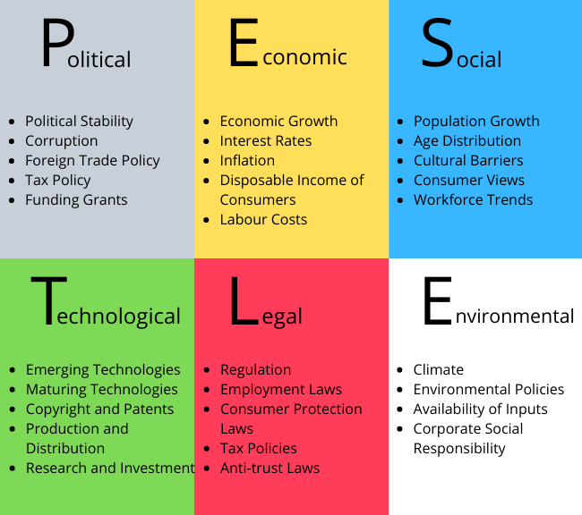

Figure 1: Pestle Analysis (Boyce 2020)

1. Political: Political issues can hinder a company immensely. PRAN group encounters this problem a few times every year. Different political issues impede their business. Bangladesh has history and culture of strikes and riots, which greatly disable the operations as the company is unable to have the employees come to work, they cannot bring in raw materials, distribute or export the merchandises in time. It causes damage to the company reputation and financial losses.
2. Economical: Economical situation of a country affects businesses significantly. PRAN organization faces problem with the fluctuating money exchange rates, if these are lower it affects the buying and selling power of the company. Inflation and rising interest rates affect the consumers spending power. These factors have an adverse effect on the business’ profitability.
3. Social: Social changes also affect a company. People’s circumstances and needs changes rapidly. The companies need to be focused and remain up to date with the changes. The PRAN group, try their best to comply with the latest trends, such as healthy fruit drinks or ordering online, which is still in the teething stage in Bangladesh.
4. Technological: Technology has a prominent function, that affect the business operations. Although PRAN had the machinery technology installed a long time back, it embraced modern technology and updated the machinery to operate efficiently and achieve high productions. It also makes it easier for customers to place their orders.
5. Legal: Legal factors are laws of the country and specific company policies that have bearing on the functioning of businesses. If the law and the acts are corporate friendly, it aids the companies to run smoothly. The tax policies in Bangladesh encourages businesses to export goods abroad. PRAN meeting the HACCP requirements, fulfil the health and safety standards. An improved employment law implementation would benefit the workers of PRAN to safeguard their jobs and rights.
6. Environmental: Environment factors are having a significant role in the 21st century. The practice of ethics and sustainability are more prominent, and the companies need to comply to laws and acts to maintain the environmental balance. There are many national and international organizations working collaboratively to save the environment. PRAN group subscribes to these laws to safeguard the environment.

Porter’s Five Forces

Porter’s five forces is a framework devised to analyse a company’s competitive environment. The subsequent stated components in the framework assist to investigate the impact of the five forces on a company’s profits and advancement.

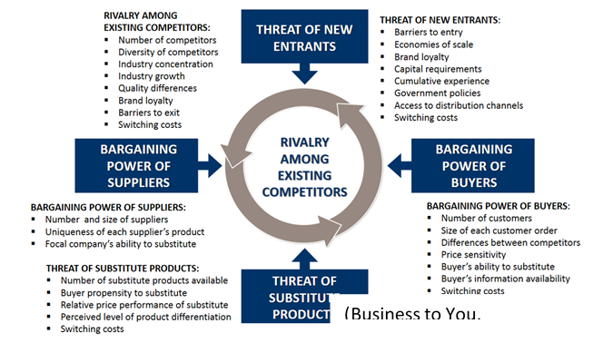
Figure 2: Porter’s Five Forces (Business to You 2016)
Bargaining power of the buyers
In the 21st century, customers are mostly more demanding than before. They are more educated, smarter and aware, they expect to receive the best quality products and services for the minimum price possible. Currently businesses are expected to match customers’ expectations or surpass them. This means the businesses provide good customer services, and a joyful experience. Nowadays, customers are more acquainted and know better how to conduct their purchases. The customers have lot options, with many channels available to conduct their buying. The power of consumers can put a lot of pressure on companies if similar products and services are available elsewhere. They may need to give discounts or provide something special to retain the customers. The bargaining power of customers can have a profound impact, as their decisions can delay things and they are able switch from one company to another if there is no penalty to pay. This is where the PRAN company was savvy to attain a competitive edge. Being more customer-oriented and fulfilling their needs, increased customer satisfaction, loyalty and reduced defection.

Bargaining Power of Suppliers
The more suppliers available, the better the options for a company. The suppliers will have less power and one does not become too reliant on them. For example, a rise in prices or frequent delays in deliveries, then one can switch to a cheaper or more efficient supplier. Some suppliers to have the upper-hand, tie in customers to long term contracts or high switching costs. They are able to stay in control and exert bargaining power on the buying companies, by determining delivery dates or increasing prices which may affect profitability. For example, in 2008 the price of rice increased drastically by about fifty percent (Reuters 2008). However, the catering industry was only able to increase their menu prices by only ten to fifteen percent.
PRAN purchased raw materials and food stocks from various suppliers, which gave them more control in bargaining, being a Bangladeshi company, they were deft in negotiating and acquiring the best deals. The impact of higher supplier- power, can reduce the profitability of the buying companies. If the company has the financial means, they can counteract by buying in bulk, at discounted prices.
Two examples of where companies have been successful in managing the supply chain brilliantly are Costco and Walmart. This gives them an edge over rivals, and they are able to keep their customers happy by maintaining lower prices.

The Threat of New Entrance
In every industry competition is widespread. The level and number of competitors affect market share and profits. However, the threat of new entrants can have a positive influence, successful entrepreneurs flourish when performing under competitive pressure.
It requires a lot of research, resources and investments to set up a manufacturing company. As it is time consuming and difficult to comply with the government’s stringent laws and regulations, the entry of new businesses is low.
However, an entrepreneur who wants to start a business in foods and drinks is fairly easy, thus entry level is quite high. The PRAN company implements cost leadership and product differentiation strategies to minimise the threat of new entrants (refer to appendix 1.3).
The Threat of Substitute Products
A substitute product is a similar item a consumer can purchase if the businesses are unable to satisfy their needs. By buying a different product, going to an alternative service or provider, this can weaken a company’s power.
In the case of PRAN, threat of substitute products was moderate as the alternative local products were not as good, but some imported drinks and foods were as good, and one brand was much better. By being customer oriented and innovative PRAN was able to mitigate the threats of substitutes. The firm quickly built up an excellent customer data base, so it was able to offer exceptional services and maintain acceptable price. This has mutual benefits, customers receive value for money, the company retains their loyalty, which helps to safeguards its competitive edge.
In reviewing the five forces analysis, it can be stated it aids to evaluate the power of the company’s market status. It provides the analysers with basic competitive environmental features of the industry it is in.

Balanced Scorecard (BSC) Method
In an organization, to evaluate the operations performance measurement, it needs to focus on the external, internal, short-term, long-term, soft and hard skills measures. Soft includes interpersonal skills, which help to build strong relationships, effective interactions with other people and collaborating to solving problems. Hard skills are abilities like reading, writing, technical, presentation and management prowess (Black and Porter 1995).
A business needs to align activities to the vision and strategy of the organisation. One method that helps its strategic planning is the balance scorecard. It is implemented to improve internal and external communications and evaluate organisation performance against strategic goals (Kaplan and Norton 2001). As the name suggests it is a framework for firms to employ to measure and report performance in a balanced manner.
Kaplan and Norton (2001) asserted that traditional financial measures were insufficient to assess the objectives. They identified three major components that needed to be applied in addition to the financial data:
1.Management- the running of the company by the leaders, how decisions are reached and put into practice.
2.Business- the internal processes such as the way products are designed, orders dispatched adequately, attaining the satisfaction of customers and employee happiness.
3.Work- the efficiency of working methods, how goods are purchased or manufactured and stored. The benefits of innovation and learning to improve the overall performance (Slack et al. 2013).
The authors proposed four strategy perspectives that should be applied to all scorecards to obtain a holistic outcome of a selected policy.
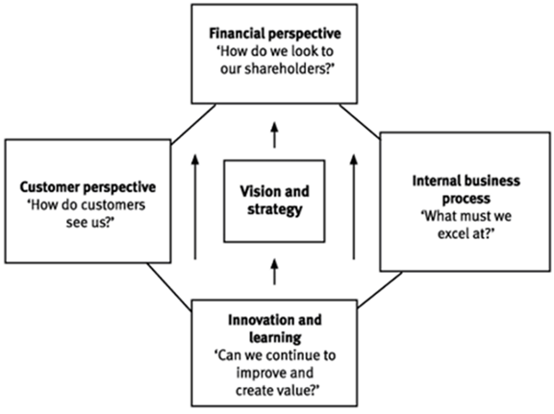

Figure 3: Balanced Scorecard (Kaplan Financial 2020)

 | Objectives | Measures | Targets | Initiatives
Financial | 1.Lower costs of production  2. To increase sales and grow profitability | Review the suppliers’ invoices. Business growth strategies. | 10%. 10- 15% | Buy in bulk and negotiate for discounts with suppliers. Efficient financial management.
Customer | 1.Best product value for price  2.Build good long-term customer relationships | Customer reviews.  Customer satisfaction surveys. | Maintain the value and strong bond reputation long-term. | Implement cost differentiation method. Improve the CRM team.
Internal Processes | 1.Efficient environment and safety management  2. Good financial management | Reports from health and safety agency. Accounts statements | Review annually. | The managers should have health and safety certificates and the company must be HACCP compliant. Conduct business transparently.
Learning & Growth | 1. Develop employees operational management skills  2. Invest in research and development | Internal human resources department. Financial policies. | Give the trainees half days off for 10 weeks to acquire the knowledge. Have postgraduates on board to carry out the researches. | Enrol staff with a reputable training centre, e.g. the UWSTD. Create an innovation and development section appoint a small team, who are highly skilled in research and provide them with the resources for product development.

As the company in the case study is involved in manufacturing goods and distributing them, the BSC method will aid them to evaluate the operational efficiency. The above chart illustrates the means and ways the organization can attain the goals and maintain their business relationships honestly.

A Brief Case Study
The case study of Aarhus Region Customs Tax unit in Denmark exemplifies the method of successfully implementing the balanced scorecard approach (Eskildsen et al. 2002). They developed an award-winning quality initiative focused on keeping the customer first. By providing an efficient, polite and professional service they were able to collect the correct taxes on time.
The learning outcome of the case study is by providing the staff training to develop the relevant skills, sharing ideas with colleagues and accepting greater responsibilities led to excellent performances.

Boston Consulting Group (BCG) Matrix
Developed by Bruce Henderson in 1968, the BCG matrix aids a company to develop long term strategic planning growth opportunities (Hambrick et al. 1982). As the PRAN company sells a lot of products, it is wise for them to administer this method to evaluate the choice of the strategies and the directions they want adopt. This analysis can determine which group the products sales fall in.
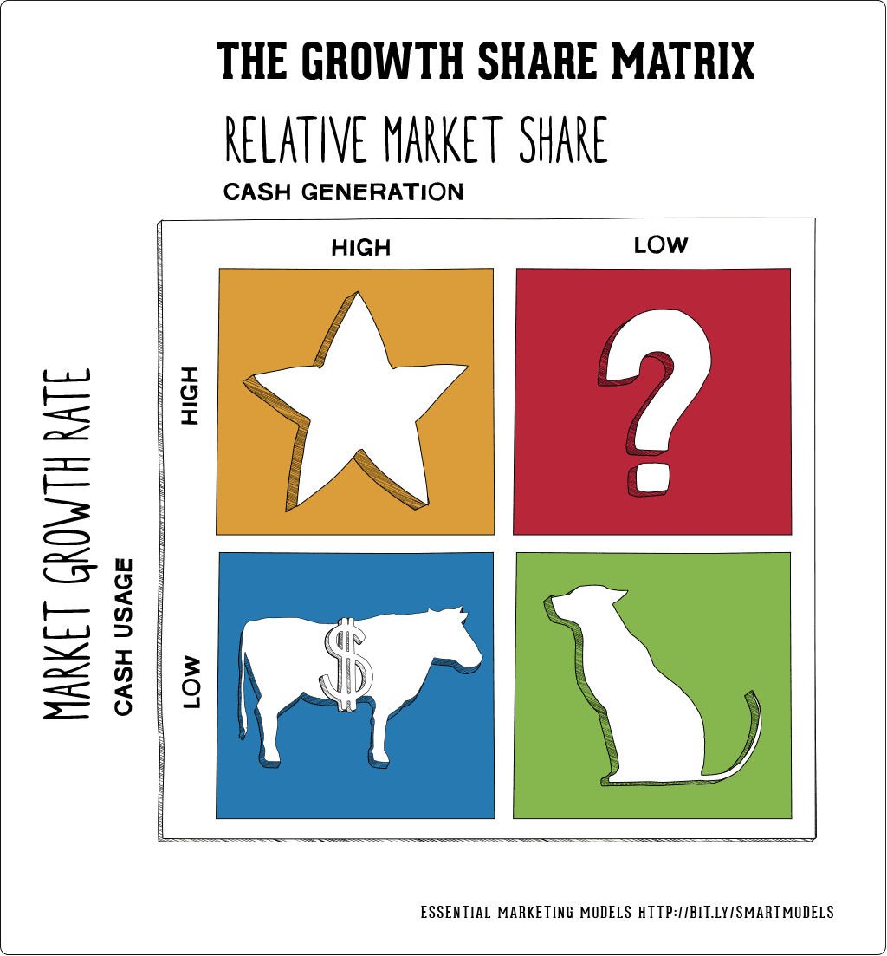

Figure 4: BCG Matrix (Hanlon 2020)
1.Stars: Products in this sector have the ability to be leading the market sales and generate excellent profits. Focus more on getting better returns from star products, as the company has invested a lot of money on these.
2.Cash cows: As the name suggests these products have milked a lot of income for the company. The company should stay loyal to the products that fall in the cash cows’ segment, which propelled them to the top level.
3.Problem child: Like a problem child with a lot of potential, who need encouraging to fulfil their promise, these products likewise need a lot of attention and investment to realise their prospects. The goods in the problem child section, sometimes referred to as question marks, need to be improved and marketed better.
4.Dogs: As the company produces a lot of products, many will fail to generate much income, these fall under the dogs’ unit, the barking with no biting power.
Although this matrix has limitations, it is still able to provide information and strategic options. The company can use it to decide whether to perceive or eradicate the sale of certain products.

PRAN’S Stakeholders
The stakeholders in a company play an important part in the business. Stakeholders have a vested interest in a company and are able to influence or be affected by a business’ operations and achievements. An organization that engages their stakeholders on important issues has the best access to the ideas and advice of experts and people with the best interests of the business. By creating shared values (CSV), this helps to develop and improve the company policies, commitments, increase the business profile and satisfy the societal expectations.
There are two types of stakeholders involved with the organization, internal or external. The contrasting range of stakeholders that influence PRAN, are internally the owners, shareholders, investors, directors, employees and customers. The external shareholders, who do not directly work for the company but have an important involvement, are the suppliers, government, upazila (the local council), trade associations, farmers movement and the media (Pran 2020). The principal stakeholders are the owners, who started the business and are prominently responsible for its success. They are the main strategists, who provided the capital, the planning, formed the legal contracts and initially worked tirelessly to establish the business. Next the shareholders and investors are vital stakeholders, as the risks and profits are shared with them. The employees are an integral part of the organization, they are encouraged by the owners to be polite, industrious, innovative and collaborative. This motivates them to be enthusiastic, which leads to good performances and providing excellent customer services. The fundamental aim of a business to create and retain customers. The customers rely on the firm’s infrastructure, facilities, products and services. The customers are vital as they buy the products and the company depend on their support, which provides the impetus for them to continue in business.
All organizations have stakeholders with different interests, priorities and responsibilities. Stakeholders tend to have conflicting interests, which need to be managed tactfully and sometimes with political skills. It is vital to identify the key stakeholders from a strategic management approach to discriminate between the power of their influence on the organization and their interest in being involved.
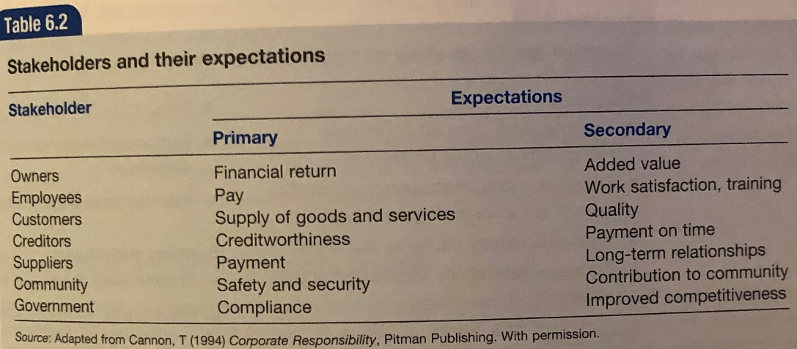

Figure 5: Expectation of Stakeholders
Stakeholder analysis is carried out to identify and appraise the influence and eminence of key people.

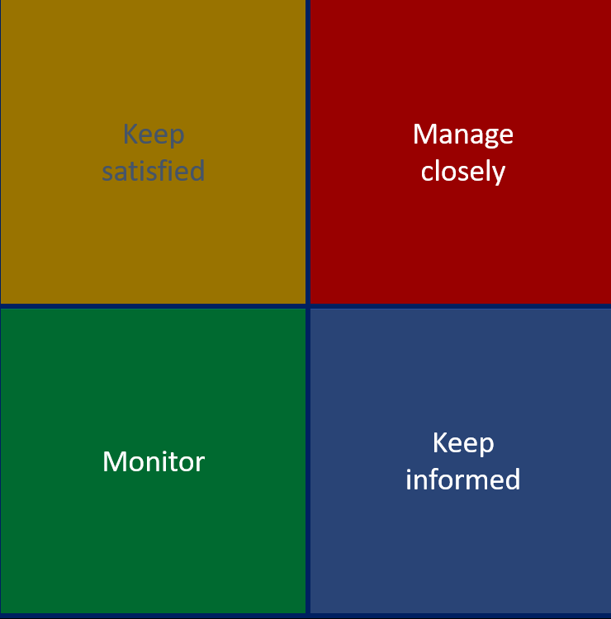
High
shareholders
Directors

Investors
Power
Government
Employees
Customers

Media
Suppliers
Local Authority
Low
Low
High
Interest

Figure 6: Stakeholder Analysis (Meeting Sphere 2020)

Recommendations
A number of studies prove environmental scanning improve organizational performances (Miller and Friesen 1978). A study based on scanning and performance in US Fortune 500 companies, found firms utilising advanced scanning systems, achieved higher growth and profitability than companies who did not implement these systems (Subramanian et al. 1993).
As pioneers in their field, PRAN cannot afford to rest on its laurels, it needs to actively continue being innovative to stave off stagnation and compete with the emerging enterprises in the knowledge and technology era. It is in their best interest to it must invest in upgrading the management skills and technology, which allows them to consistently ward off the threats of fast developing new companies. A company that develops its strategic knowledge will be able to remain attractive and influential (Zack 1999).
On the subject of technology, one suggests that PRAN adopts social media, to visit the sites, where rival customers may be. For example, Facebook, Twitter and Snapchat to optimise the company’s online marketing and visibility.
PRAN needs to optimise their employees’ efforts and experiences by offering a wide range of development opportunities. This will empower the organizations to recruit, train and retain the future managers. The managers must ensure new recruits are properly trained to be orientated with the organization’s modus operandi. This will enable them to be on equal level as their colleagues (Snell and Bohlander, 2007). This will enhance performances, boost sales and profitability.
As the PRAN company has the power to buy in bulk, it is wise for them to tie-in prices with suppliers, which means they receive goods at a better rate than others. This would allow them to apply economies of scale, which would give them the ability to produce products at lower costs, which the rivals cannot match. This strategy would boost the company’s profits.
The PRAN company has received adverse reports into the way they manage workers’ rights. They need to address this by allocating dedicated leaders, who will be able train special teams within the firm to improve this sensitive issue. Also use this opportunity to enhance the customer services department, which will support customers’ needs at this uncertain time.
It is endearing to receive positive feedback, as it inspires employees and energises them to surpass the standard expectations (Cleveland et al. 1989). A progressive organisation like PRAN needs to recognise the employees’ efforts and achievements. A rewards policy is a vital factor in inspiring employees into striving to give optimal performances (Baron and Armstrong 2007).
There is no need to be over-ambitious and sell two hundred products to be successful. Half of the products at PRAN are probably irrelevant and substandard. The BCG matrix is an excellent method to decide the wisdom of investing, developing or discarding products. As market leaders, PRAN should protect their brand equity, focus on their strong product portfolio. For long term success it is highly advisable for the company to develop and maintain quality products, not quantity.
In relation to PRAN and other organizations implementing the appropriate environmental scanning tools and techniques, it is vital for them to monitor the effects every three to six months. This will allow the analysers to evaluate the results and take the requisite actions.

Conclusion
Executing growth strategies in an organization requires wholehearted and enduring commitment from the senior leaders to the subordinates. The successful organizations are able to be strategically aligned, from the top level to the bottom by adopting and implementing scanning tools. Small enterprises with limited resources are able to utilise the basic strategies like SWOT AND PESTLE to keep their businesses functioning smoothly and growing slowly. They may use other techniques if it matches their ambition and they want to develop further in the future.
Medium and large enterprises have the benefit of extensive resources and are able to implement several scanning tools to keep their businesses competitive and attractive. They are able to use the most effective strategies and develop advanced processes to manage any problems and overcome the competition. As they have the assets and possess a multi-talented workforce, they will be able to allocate roles to the appropriate people to manage the strategies. Different people have varying skills, for example the managers can utilize the SWOT and PESTLE to examine the micro and macro factors of the organization. The accounts department use the Balanced Scorecard to analyse the financial state of the business. The company’s buyers use the Porter’s Five Forces to negotiate the best prices for supplies. As the company sells many products the BCG method will be an effective indicator for product management and discarding of low sellers. The sequence of theory methods applied provide qualitative data analysis, which give the organization a holistic view of the environmental scanning phenomenon.
In relation to the case study, the research provided information that was relevant for enabling a holistic approach to the environmental scanning of the organization. PRAN promotes diversity and equity and it allows a person to start working for them and progressively build a successful career. The organisation firmly believes and preaches excellence is built on hard work, fulfilling your responsibilities and the application of scanning methods. The human resource department can use reviews from the investigations to allocate training. Consequently, this prompts employees to remain loyal to the company and continue to provide high levels of commitment and service.
The PRAN company has become a Bangladeshi institution and is probably the most well-known and respected organisation in the country and some parts of the world. By implementing various scanning tools, they have managed to identify priorities and optimise the business needs. This has helped to build its unique reputation, supported by its key brand values of being innovative, displaying integrity, providing quality, freshness and exceptional services. The company now sell about two hundred different products and employs approximately 80,000 people from different parts of Bangladesh and is committed to developing their workforce.
The implementation of an ethical approach and maintaining a policy on sustainability will help to subside inefficiencies, inequalities and thwart damages to the environment. A sustainability policy will define the company’s commitment to reducing waste, the use of chemicals, minimising their carbon footprint and helping to preserve the natural surroundings. This practice will make a good impression with environmentally conscious customers, stakeholders and fulfil the environmental legislation.
The purpose of business is to create customers, retain them and procure profits for the owners and stakeholders. (Drucker 1981). The key to the success is depends on the PRAN company’s prowess to build a good relationship with their customers and stakeholders and maintaining corporate social responsibility. The implementation of key components such as ethical behaviour, dedication, transparency and good communication contribute to forging this association. The environmental scanning method will help strategic planning and provide the relevant information for the company leaders to implement for future growth and sustainability.
As the company is based in Bangladesh, it has been a challenge for the author to gather credible information. Along the way it has been a great learning curve for him to research on a reputable enterprise from his country of birth. The aim of the findings is to inform the researcher and readers to the organization’s history, operations, strategies, strengths, weaknesses. The changes, improvements and ways to ascertain and seize opportunities that are crucial to maintaining outstanding customer relations and keeping the company competitive and attractive.
On a personal level, the researches have been a great way to enhance knowledge, means to understand various topics and techniques and learning how it helps to increase business success.

Appendix

1.1 Ethics
Ethics are high moral standards and principles that determine a person’s or organization’s conduct, etiquette or influences their manner of operating a venture or business (Baron et al. 2006). Some aspects that govern ethics are, character, cultures, philosophies, religions and epochs.
For example, if conducting a business deal with a Bangladeshi organization, be prepared for some social chat as a prelude to the main negotiations. From one’s personal experience, in the event of a male formally meeting a female for business talks in Bangladesh, shaking hands is at the discretion of the lady. One tenderly shakes hand, only if the lady puts forward her hand first (Cultural Atlas 2020).
An ethical business practices the principles of fairness, integrity, lawfulness, respect and transparency. In the scenario of ethical dilemmas arising, subordinates, managers and leaders in an organization must follow a code of conduct and must remain calm and display righteous behaviour. The management must define the rights and duties of people in the organization and formulate some principles that can be incorporated into businesses to practice ethically and wisely (Mullins 1996).
The managers at PRAN ensure people from different backgrounds are respected and able to work without fear or intimidation. This management policy needs to be implemented wholeheartedly as it has huge repercussions on the organization’s modus operandi. This practice will inspire people to embrace tolerance, unity and galvanise them to form strong relationships.
It offers essential facilities, like toilets, cloakrooms, canteens and a room for employees to perform prayers.
Every year PRAN is making substantial contributions to the local communities. They have set up a small team to strengthen their relationships with the local community. They are working together to raise funds for charities and some needy people in, especially in times of a crisis like the floods or the Covid 19.
PRAN was very active in initiating in the eradication of plastic carrier bags in Bangladesh in 2004, a decade before the UK. This has contributed to the reduction of usage and disposing of plastic bags.
PRAN is implementing some principles of the Ethical Trading Initiative (ETI). The company is endeavouring to ensure farmers and workers involved in the primary production are permitted good working conditions and paid a fair wage (Ethical Trade 2011). According to its core values, it focuses on consumer, supplier, employee and trade care.
In Bangladesh, a lot of inorganic fertilisers and chemicals are used in the farming sector and in the growing of fruits and vegetables. As the PRAN company outsources the growing of its raw goods, it needs to pay attention to the usage of harmful chemicals used in the growing process. This kind of practice has deterred a lot of people to buy the products. A lot of companies turn a blind eye to this kind of farming, the authorisers need to be very firm and outline the importance of avoiding the need to use harmful substances.

1. 2 Sustainability
Sustainability seems to be a buzzword of the 21st century. Utilizing nature’s resources for commercial gains, it is a fundamental duty of human beings to responsibly safeguard the depletions and keep the ecological system in balance. In the commercial world, it is the organizations’ responsibility to treat environmental resources as having certain intrinsic rights and endeavoring to protect and minimize the damage and disruptions to nature and the environment and helping the people who live there.
The agricultural, industrial and digital revolution have greatly innovated and transformed farming, production, technology, people’s working methods and ways of conducting business. All this has immensely contributed to the enhancement of the world of commerce, manufacturing and society. It has advanced the world and humankind, but at what cost? It has hugely impacted the environment and caused damage to the natural earth. It has largely contributed to pollution and the depletion of natural resources. Some of the negative impacts are global warming, the deterioration of many habitats, poverty and many other green issues.
This means to achieve sustainability humankind should change the ways it utilizes natural resources to create products and support to replace or stabilize the environment burden (Boersema 2009).
It is not possible to effectively operate organically, but most organizations are implementing positive initiatives to address some of the environmental issues. Some examples are supporting to grow more trees and plants, alternative energy utilization, such as solar and wind energy is less exhausting on the earth’s resources.
Crop Rotation is the cultivation different crops on the same land. This method of farming concentrates on increasing productivity by being chemical-free, to protect the soil and maintain long term sustainability (Bullock 1992). The PRAN company fundamentally needs to advocate this practice to its group of farmers.
To offset some of the damage to the environment, it is highly recommended to practice the use of minimal plastic packaging, banning plastic carrier bags, recycling materials, managing waste disposal, using energy saving light bulbs, reducing transport-related energy and emission pollution.
One inspirational example of supporting green issues was displayed in India in 2019. Amitabh Bachchan, the greatest actor of all time, is immensely respected and for some people revered as an idol in India. Despite that, in 2019 when he suggested the felling of trees to make way for a new metro line was met with disdain. He tweeted, by reducing traffic pollution, was a good solution as more people will use the trains. Despite idolizing him, environmentalist activists criticized and protested him. Their actions prevented the forest being cut in Mumbai (India Today 2019).

1.3 Cost Leadership and Product Differentiation
To accomplish the corporate goals, PRAN implemented the basic strategies of cost leadership and product differentiation, which provided them with huge advantage in how they operated. Cost leadership is a business strategy implementing the lowest cost of operation in the industry to acquiring a competitive advantage (Porter 1995). A company’s capacity to offer superior products and outstanding services at the lowest costs, increases sales and enhances the company’s profile. As the company was manufacturing their own products, this paved the way for them to gaining a huge advantage over their rivals. The firm were in the privileged position, whereby they had the means to reallocate some of the savings to the customers, by offering lower prices. This gave the PRAN company a leverage, as they were able to increase the market shares and still making a substantial profit because of high volume of sales.
Product differentiation is the marketing strategy of advocating as to why an organisation’s product or services is different or better from the competitor’s (Magin 2007). Cost differentiation focuses on the unique features and benefits of the firm’s product compared to its competitors. This promotes the company brand, resources communication methods and customer satisfaction. It conveys a credible message of offering excellent value to the customers, which instils confidence to them to select the company from other providers or brands. PRAN, cleverly adopted the principles of fair pricing and product differentiation to become the market leaders in their respected domain.

1.4 Upgrading Machinery and Technology
Technology is constantly changing in the 21st century, the era of knowledge at a person’s fingertips. The advancements in technology has radically changed the way businesses operate and people’s everyday life in the last twenty years. This has had a profound effect on business operations, as all organizations use some type of process technology. It can be a simple laptop, internet, juicers or sophisticated automation machinery. The operation managers need to advocate the benefits of emerging technologies and how it can be implemented in their organizations to greatly enhance operations.
A company’s existing devices could be dated or worn out and not adaptable to new technology. A business investing in new technology will be able to improve. The PRAN company has embraced the new technology systems, but it needs to update some of the automation machines to increase efficiencies.
For many decades the Kodak company dominated the photographic and film makers markets. Kodak is a classic case of a firm, who went bust in 2012 due to their reluctance to implement new technology. The sad thing is they were the pioneers of the digital camera, yet they refused to market it, because they were masking huge profits from selling films for the analogue cameras. They had so much technology in the laboratories, all the resources and technicians in place, but they were complacent and lacked the business acumen to make the most of it. The sad irony is many organizations do not have the technological knowledge, yet they embrace it and learn to use it along the way, but Kodak were the masters, who threw it all away (Economist 2012).

References
Ansoff, H.I. (1958). A model for diversification. Management science, 4(4), pp.392-414
Baron, A. and Armstrong, M. (2007) Human Capital Management. London: Kogan Page Ltd.
Baron, M., Pettit, P. and Slote, M. (2006) Three Methods of Ethics: A Debate. 1st edn. Malden (Mass.): Wiley-Blackwell
Basit, A. (2014) PRAN Foods expects 60% sales growth in 2014 [online] available from <https://www.khaleejtimes.com/business/markets/pran-foods-expects-60-sales-growth-in-2014> [15 October 2020]
Bennis, W. G. and Nanus, B. (1997). Leaders: The Strategies for Taking Charge, HarperCollins, New York.
Black, S.A. and Porter, L.J. (1995) An empirical model for total quality management. Total Quality Management 6 (2),149–164
Boersema, J. (2009). Environmental Sciences, Sustainability, And Quality. Principles of Environmental Sciences 3-14
Boyce, P. (2020) PESTLE Analysis Definition and Template [online] available from <https://boycewire.com/pestle-analysis-definition-and-template/> [15 November 2020]
Bullock, D. (1992) "Crop Rotation". Critical Reviews in Plant Sciences 11 (4), 309-326
Business to You. (2016) Porter’s Five Forces [online] available from <https://www.business-to-you.com/porters-five-forces/> [15 November 2020]
Choo, C.W. and Auster, E. (1993) Environmental Scanning: Acquisition and Use of Information by Managers. Annual Review of information Science and technology (Arist), 28, pp.279-314.
Cleveland, J.N., Murphy K.R. and Williams R. E. (1989) Multiple uses of Performance Appraisal: Prevalence and Correlates. Journal of Applied Psychology.
Cultural Atlas. (2020) Bangladeshi Culture - Business Culture [online] available from <https://culturalatlas.sbs.com.au/bangladeshi-culture/bangladeshi-culture-business-culture> [14 November 2020]
Daily Sun. (2016) PRAN aims at poverty cut, employs over 10 lakh workers [online] available from <https://www.daily-sun.com/arcprint/details/149796/PRAN-aims-at-poverty-cut-employs-over-10-lakh-workers/2016-07-10> [15 October 2020]
Dessler, G. (1999) Essentials of Human Resource Management. Upper Saddle River, NJ: Prentice Hall
Drucker, P. (1997) "Toward the New Organization". Leader to Leader 1997 (3), 6-8
Drucker, P.F. (1981). What is business ethics? The Public Interest, 63, p.18.
Economist. (2012) Gone in A Flash [online] available from <https://www.economist.com/schumpeter/2012/01/19/gone-in-a-flash> [14 November 2020]
Eskildsen, J., Kristensen, K. and Jørn Juhl, H. (2002) "Trends in EFQM Criterion Weights; The Case of Denmark 1998‐2001". Measuring Business Excellence 6 (2), 22-28
Ethical Trade. (2011) Ethical Trade [online] available from <https://www.ethicaltrade.org/issues/living-wage-workers> [15 October 2020]
Food Gov. (2020) Hazard Analysis and Critical Control Point (HACCP) [online] available from <https://www.food.gov.uk/business-guidance/hazard-analysis-and-critical-control-point-haccp> [15 October 2020]
Golden Business BD (2019) [online] available from <https://www.goldenbusinessbd.com/content/606.html> [2 November 2020]
Halal Food Authority (2020) Definition of Halal [online] available from <https://www.halalfoodauthority.com/definition-of-halal> [2 November 2020]
Hambrick, D., MacMillan, I. and Day, D. (1982) "Strategic Attributes and Performance in The BCG Matrix—A PIMS-Based Analysis Of Industrial Product Businesses". Academy of Management Journal 25 (3), 510-531
Hamel, G. Doz, Y.L. and Prahalad, C. K. (1989). Collaborate with your Competitors and Win Harvard Business Review. January - February: 133- 139
Hanlon, A. (2020) How to use the BCG Matrix model [online] available from <https://www.smartinsights.com/marketing-planning/marketing-models/use-bcg-matrix//> [11 November 2020]
Hollebeek, L. (2011) "Exploring Customer Brand Engagement: Definition and Themes". Journal of Strategic Marketing 19 (7), 555-573
Humphrey, A. S. (2005). SWOT analysis for management consulting. Stanford University, California: SRI Alumni Newsletter.
India Today (2019) Aarey colony dispute: Amitabh Bachchan faces string of protests, HC reserves judgment [online] available from <https://www.indiatoday.in/india/story/aarey-colony-dispute-amitabh-bachchan-faces-string-of-protests-hc-reserves-judgment-1601034-2019-09-19/> [15 October 2020]
Kaplan Financial (2020) The Balanced Scorecard [online] available from <https://kfknowledgebank.kaplan.co.uk/the-balanced-scorecard/> [15 October 2020]
Kaplan, R.S. and Norton, D.P. (2001) Transforming the balanced scorecard from performance measurement to strategic management: Part I. Accounting horizons, 15(1), pp.87-104.
Klaus, P. and Maklan, S. (2013) "Towards A Better Measure of Customer Experience". International Journal of Market Research 55 (2), 227-246
Lazear, E.P. (1999)” Globalisation and the market for team-mates”, Economic Journal
Lucco, J. (2020) A Full & Exhaustive Balanced Scorecard Example [online] available from <https://www.clearpointstrategy.com/full-exhaustive-balanced-scorecard-example/> [15 October 2020]
Magin, V. (2007) Competition in Marketing. Wiesbaden: Dt. Univ.-Verl
Meeting Sphere. (2020) Stakeholder Analysis [online] available from <https://www.meetingsphere.com/stakeholder-analysis/> [15 October 2020]
Miller, D. and Friesen, P.H. (1978) Archetypes of strategy formulation. Management science, 24(9), pp.921-933.
Mullins, L. (1996) Management and Organisational Behaviour. London: Pitman
Pran. (2020) About Us [online] available from <https://pranbd.org/about/> [15 October 2020]
Pranfoods. (2020) Mission & Vision [online] available from <https://www.pranfoods.net/about/mission-vision> [15 October 2020
Rahman, M. F. (2016) In memory of the man who built Pran [online] available from <https://www.thedailystar.net/business/global-business/memory-the-man-who-built-pran-1250362> [15 October 2020]
Reuters. (2008) Why have rice prices surged to record highs? [online] available from <https://uk.reuters.com/article/uk-food-rice-idUKSP13081120080425> [15 November 2020]
Slack, N., Brandon-Jones, A. and Johnston, R. (2013) Operations Management. Pearson
Smith, B., Wilson, J. and Curtis, J. (2020) UK Job Losses: All the Companies Axing Staff Amid Coronavirus [online] available from <https://www.telegraph.co.uk/business/0/job-losses-uk-coronavirus-covid/> [14 November 2020]
Snell, S. and Bohlander, G. (2007) Human Resource Management. Mason, OH: Thomson.
Sobhan, R. (2010) Challenging the Injustice of Poverty. New Delhi: SAGE
Subramanian, R., Insley, R. and Blackwell, R. (1993) Performance and Readability: A Comparison of Annual Reports of Profitable and Unprofitable Corporations. Journal of Business Communication 30 (1), 49-61
Zack, M. (1999) Developing A Knowledge Strategy. California Management Review 41 (3), 125-145

