Dobrinka Kiryakova 1818047
MODERN workplace
TESCO
MOLLY JACK
Structure and Culture TESCO

1.Intruduction
2.TESCO Structure
3.TESCO Culture

1.Intruduction Tesco

The Tesco it’s a created at 1919 and 1920 in London by Jack Cohen. When he It come to be a seler that year has believes it’s been to provide a good food for everybody, on the end of the first day he makes the profit from 1 pound. In 1924 the name Tesco it born and that year the first own brand tea Tesco. In 1929 the first Tesco shop its opened in London. In 1934 its been opened the first modern food warehousing 1937 Jack Cohen start to buy a shop’s around the country, the company its start to growing up. IN 1940 s come the first self-service’s, idea it’s come from America and change the British way to shopping. 1948 its open the first self-service store. In 1958 it opened the first supermarket in Essex. In 1968 they sale food and non-food goods, in the same year they bought the Victor value chain. In 1979 the Jack Cohen its passes away and that its end of that era. In 1995 Tesco open a store at Central Europe. In 1995 Tesco interduce the first Tesco club card, in that year five million people it’s been attracted. 1997 Tesco move to the personal finance. In 1998 it created a Tesco fines it’s been opened to fill the gap in the market for more influent customer. In 2000 Tesco open online market. In 2001 they support the cause raise for life and invite and the customer to come and raise with them.

Tesco structure:
Tesco it’s a public limited company and it’s a general grocery and merchandise retailer in United Kingdom. Tesco has a tall organisational structure because the organisation is a tall. The traditional we have four types of organisations structure functional, divisional, matrix and flat. The public limited company have limited liability or legal protection for the shareholders. The shareholder it’s has allot restrictions they cannot sell their part without to offer the other shareholders. The company cannot be sold or trade, bought, by anyone. The company like Tesco it’s have a restriction by the low to publish the true financial position like than the investors can determine the shear. Down in this chart we can see the major shareholders Tesco

Major Shareholders Tesco
Major shareholders | % holding
BlackRock, Inc. | 6.64
Norges Bank | 4.03
Schroders plc | 4.99

Next chart as the management structure on Tesco
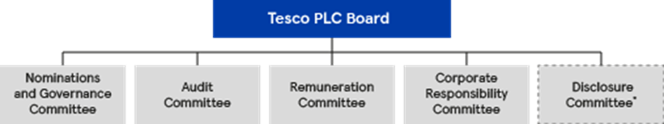

How we can see on the top in that chart the main responsibility and decision it’s taken by the Tesco PLC Board. In nominations and Governance Committee it’s has a 13 people witch its responsible for different task. Dave Lewis it’s a Group Chef Executive he it’s have a allot of experience in different sector, like the brand market, customer management and general depigmented have experience in cross the Europe. The next one it’s an Alan Steward he is a chief financial Officer he its response for the finance on the company he has allot experience in accounting. Natasha Adams it’s a Chief people officer she its responsible for the people and strategy on the company and plans. Alexandra Bellini Chef customer officer she its response for the building brand globally. Cristine Heffernan Group Communication Director she its response for the rebuilding Tesco brand. Tony Hogget Chiefs operation Officer its responsible for the strategy developing and well lending the UK business. Alison Horner it’s a CEO in Asia and Thailand Tesco. Gerry Mellon it’s a Chef executive Tesco Bank he its responsible for the Tesco Bank he it’s a personal and financial service. Adrian Morris group general counsel he its repose for the governmental and legal function. Mat Simister CEO Central Europe he its response for the Hungary Poland and Slovakia. Jason Terry he it’s a CEO un UK.CEO Booker its response for delivering and driving in the UK. Andrew Yaxley chief product officer he its response for the he it’s a direct response for the UK Managing.

BOARD TESCO:

John Allan Non-executive chairman. Dave Lewis Group Chief Executive. Alan Steward Chiefs financial Officer. Deanna Oppenheim senior independent Director. Mark Armour Non-executive director. Melisa Bethel Non-executive Director. Steward Gilliland, Steve Goolsby, Byron Grote, Michael Olsson, Simon Patterson, Alison Platt, Lindsey Pownall, all of them it’s a Non -executive Directors. Robert Welch Group company secretary.

Tesco Suppliers:
The Tesco suppliers it’s a from Europe, Japan and South Korea, USA, Canada. They work with allots suppliers and manufactures’ and try to provide a good quality they have a thousand of suppliers around the word.

Tesco own products:
Tesco have a them own product like the Tesco Mobile, Tesco Bank, and Tesco Fines, Tesco grocery. They provide different types of product with high quality and variety.

Tesco place:
Tesco have a 6,800 around the word the store its allocated in Hungary, Poland, Slovakia, Malaysian, China, India.

Tesco competitor:
Top 9 Tesco Competitors
- Top 9 Tesco competitors.
- 1) Sainsbury's.
- 2) Asda.
- 3) Morrison's.
- 4) The Cooperative.
- 5) Aldi – 6.2%
- 6) Waitrose.
- 7) Lidl – 4.5%

Tesco sales chart 2019:
Sale chart for Uk:
UK & ROI | 38,228 | 37,189 | 37,692 | 38,656 | 44,883
Sales chart for Central Europe:
Central Europe | 6,186 | 5,268 | 5,977 | 6,343 | 6,030
Tesco Clubcard:
Tesco it provides for the customer a Clubcard, this card it’s a part of the structure, and it provide different type of discount for the customer. With that card the customer receives a point witch they can use for four travel, food, fuel, and clouds. With the Clubcard the customer receives and allot of rewards.

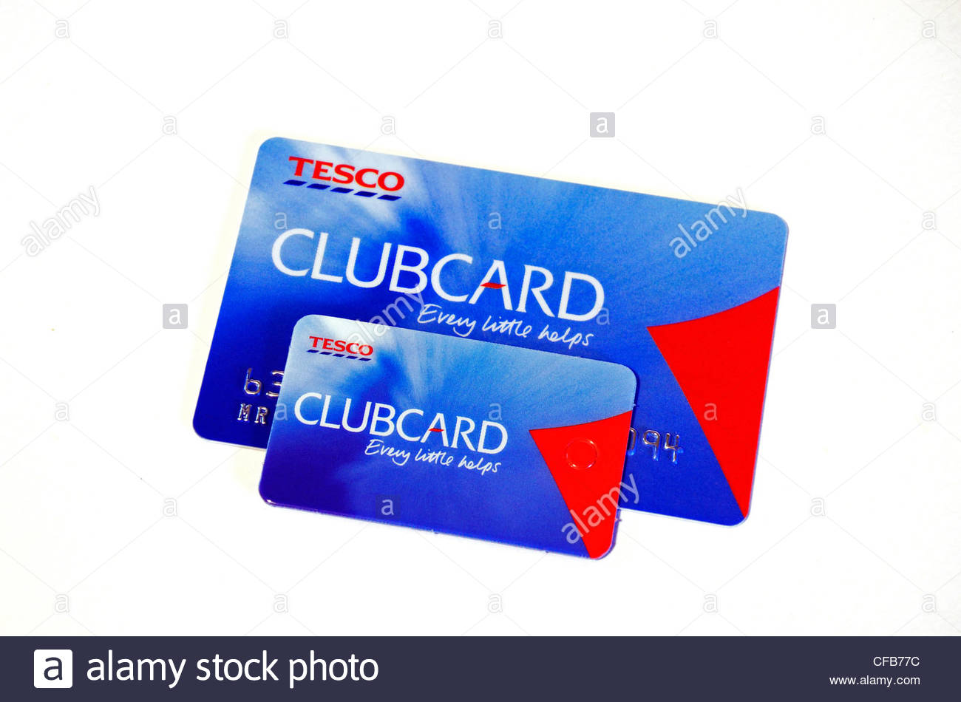

Tesco and Employees:
Tesco provide an opportunity for every worker to receive a good training and opportunity. Tesco provide for the worker allot of discount for the worker and the family. Tesco provide a different training programs for the young people to help them to show all the potentials. Tesco have a web site wear the workers can writhe a complain and suggest. Tesco have a politic for the employee where they have health and safety policy, for the employee they provide a different type of training and opportunity for improvement. They provide for the employee the minimum wage policy. Tesco have a politic to support and people with disability and provide a work for them and support.

Tesco culture Schein model:
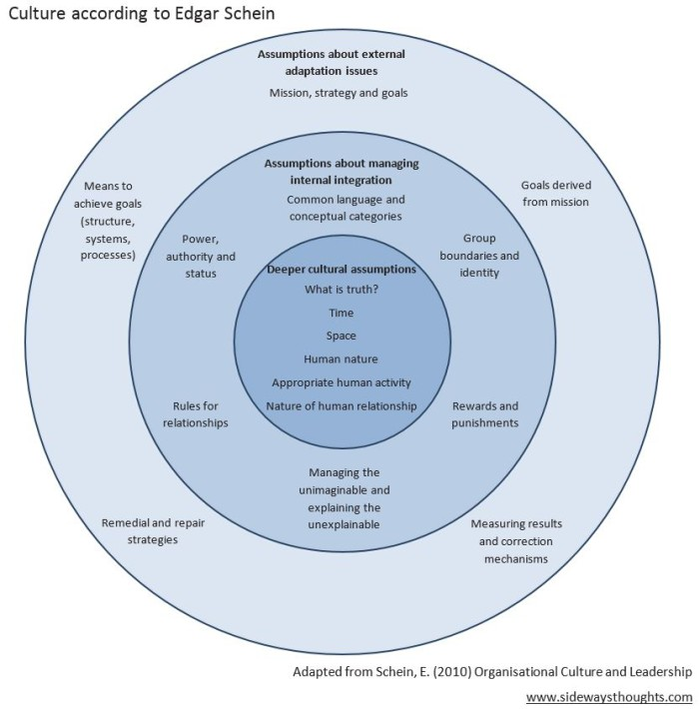

The Tesco culture it’s has a mission to provide a high-quality product for the customer. They provide what the customer needs the quality product and value price. Tesco culture it’s a everything for the customer they try to provide a good service from the employee to the customer.
Tesco value influence:
The value Tesco it’s a centre to them business help and understand how to put a core value into the practice. For the Tesco culture it’s has 3 important points.
- No one tries harder for customers
- We treat people how they want to be treated
- Every little help makes a big difference:

Little helps plan Tesco:

Every little help make a difference it’s a core value of Tesco it what they do for the thousands of the colleagues and customer around the word. They operate to serve for a million customer It is also the idea at the heart of the Little Helps Plan, which sets out how Tesco will make a difference to the social and environmental challenges that meter to the environment. They make a greater contribution by focusing on the people, product, and place. They try to operate in a different number of areas and try to cover the issues like the carbon reducing, health and safety, cyber security and anti-bribery. They business try to create a good where the client can eat health and help them to make a right choose, and to enjoy to the good quality products. They try to be Shure the food can been eaten its not hasten. reduce the environmental impact of packaging. They support the community. Since launching the Little Helps Plan in 2017, they make a good progress.


Tesco value:
Tesco it does the independent research for the community to understand the roll they play in the community across the UK. They try to understand what more they can do for the customer.

Tesco and WWF partner:

Tesco work with partnership with WWf and try to be reducing the plastic use in the different product they switch off the lights for one hour every year to support the campaign of wwf. Tesco try to work with the suppliers and make them to work to reduce the plastic use.

Tesco innovation:

The innovation process at Tesco they have an online shop their you can shop from your home and everything to be delivered to your home. Author technological part its itself service in the store you can scan your product.

Human relation:
Tesco it says its not be Tesco without the colleges. They it’s an important for the quality service customer for that Tesco it provide for the employee a good training system to provide a quality service. For the employee they provide a different type support depends of the needs. Tesco have a program for the employee like the loyalty card for the employee and family.

Tesco changing culture:

Tesco need to change the culture the new executive president says in the interview Dave Lewis. In an email to thousands of staff in the wake of a £250m accounting scandal, Lewis said: “Turning our business around will require change in our culture, as well as in our processes and our brand proposition. We want to work in a business which is open, transparent, fair and honest. We all expect Tesco to act with integrity and transparency at all times.”

Conclusion:
Why the organisation is important?
The organisation is important for every company small or not. Organisation structure is important for any company to provide a specific clear human resource and issues. The company its thinking from the beginning growing stage of the company and create a structure for the future. For the tall structure like the Tesco they need a good correspondence between the different department they need to have a clear definition of authority and responsibility and beater understanding the facilities objectives and policy. Organisation it lay down both channels and the patterns of communication. It facilitates proper administration. Help to organisation to coordinate the combinate the activities and goals of the organisation. With the good organisation you can help to the employee to understand the good perception in the organisation and to increase the gabs the organisation its help to the employee easier to stimulate the creative thinking.

Why it’s important the culture:

The culture its important for every organisation the Tesco culture its help to understand the core value of the organisation to conduct the team understand the customer. Strong culture it makes to add a value to the company and help to keep the best people. The susses organisational culture bring together the people at the company and make them see clearer the conception of the organisation. The culture its important and for the customer and the society because its impact on them the organisational culture and structure its help to fine the existing gab easier and to resolve them.

Reference: Dobrinka Kiryakova
https://www.telegraph.co.uk/finance/markets/2788089/A-history-of-Tesco-The-rise-of-Britains-biggest-supermarket.html.
https://www.tescoplc.com/about/100-years-of-great-value-1/.
http://www.businessdictionary.com/definition/public-limited-company.html.
http://www.businessdictionary.com/definition/public-limited-company.html.
https://www.tescoplc.com/about/board-and-executive-committee/board/.
https://www.tescoplc.com/about/board-and-executive-committee/board/.
https://www.theguardian.com/business/2014/sep/26/tesco-must-change-culture-reinvent-brand
https://www.tescoplc.com/about/board-and-executive-committee/board/.
https://www.tescomobile.com/.
https://www.tescobank.com/online-banking/.
https://www.tesco.com/groceries/en-GB/zone/tesco-finest.
https://www.tescoplc.com/about/our-businesses/.
https://www.google.com/search?rlz=1C1AVFC_en-GBGB874GB874&ei=Rj7qXYzQE4GV1fAP58SGqAY&q=tesco+competitors+2019&oq=tesco+competitors+analysis&gs_l=psy.
https://www.google.com/search?q=schein+culture+model&rlz=1C1AVFC_en-GBGB874GB874&sxsrf=ACYBGNR9vMglFLTRdiy8GA_KDf_qG_ZR1A:1576227367104&tbm=isch&source=iu&ictx=1&fir=wH5tG7nzTnFb5

https://www.tescoplc.com/investors/reports-results-and-presentations/financial-performance/five-year-record/.
https://secure.tesco.com/clubcard/.

