Joshua Todd Flights and Accommodation
Fights Out
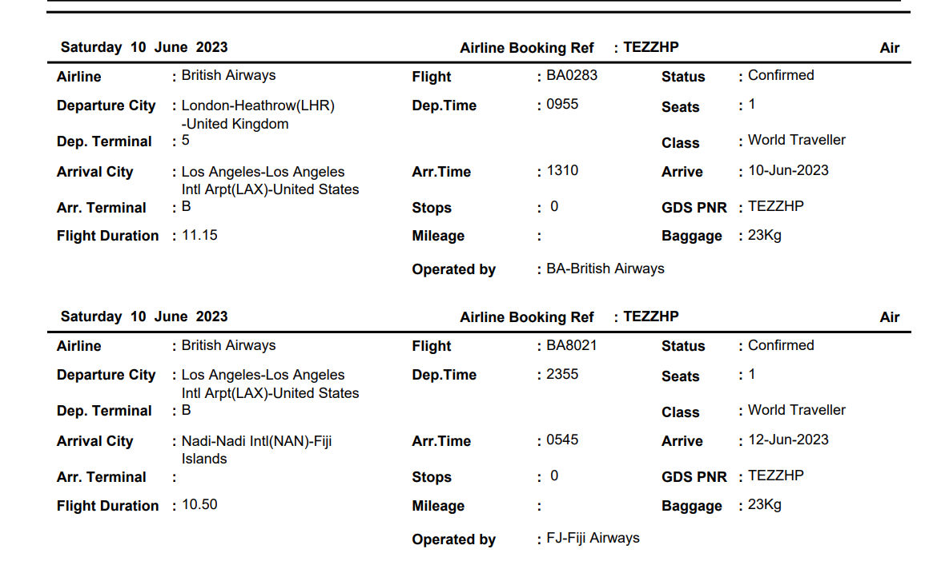

Smugglers Cove Beach Resort & Hotel
Wailoaloa Beach Rd, Nadi Bay, Nadi, 10409, Fiji
020 3966 8654

Flights Back


