
Introduction to Web Development
Module Number: ACCA4003
Author: Callum Cross
Student Number: 1705149
Lecturer’s Name: Kemi Ademoye

January 10, 2018
UNIVERSITY OF WALES TRINITY SAINT DAVID

Table of Contents
Abstract 1.0
Requirements 2.0
Site Map 2.1
Wire Frame Diagram 2.2
Implementation 3.0
Evaluation 4.0
Recommendations for future improvements 4.1
References 5.0

1.0 Abstract
The purpose of this report is to examine the understanding of the standards, concepts, principles and practice required in the implementation of websites. The following will show examples of a hand-coded website with the essential skills needed to progress onto a career in web development. Finally this report will show the subject matter for this website describing its purpose, relevance and target audience.
2.0 Requirements
The website that the author has created, has been based upon an interest he has taken up in recent times. The purpose for this creating was to attract an audience of all ages who would like to gain knowledge on the ever growing auto-mobile sport “Formula 1”. The website allows the users to access a wide range of knowledge, including the drivers that are currently participating in Formula 1 and inside facts about them and also a bibliography of the driver. The Website also provides a wide range of knowledge on the auto-mobile cars and the latest tracks that are in use for the Grand Prix today.
2.1 Site Map
Shown below is a site map the author has created to demonstrate how all of the pages on the website are connected. As you can see below the diagram demonstrates that each web page can be selected from any location on the website.
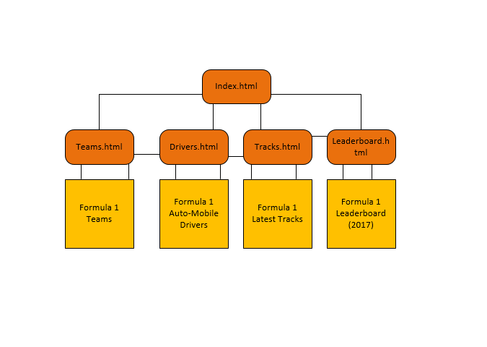

2.2 Wireframe Diagram
LOGO
Navigational Bar
Home Formula 1 Teams Tracks Drivers Leaderboard

Footer Text
TEXT BOX
TEXT BOX
TEXT BOX
TEXT BOX
IMAGE TITLE
IMAGE TITLE
IMAGE
IMAGE
IMAGE
IMAGE
IMAGE TITLE
IMAGE TITLE

3.0 Implementation
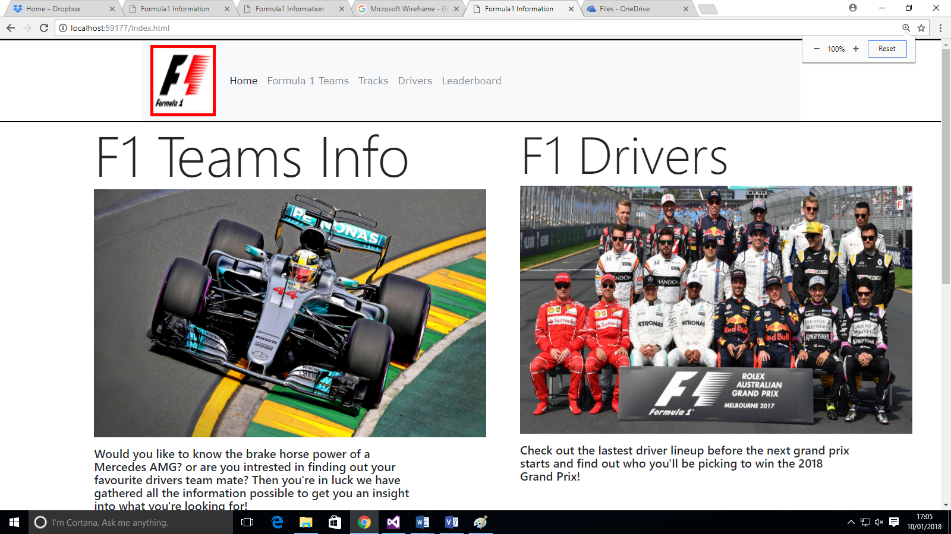
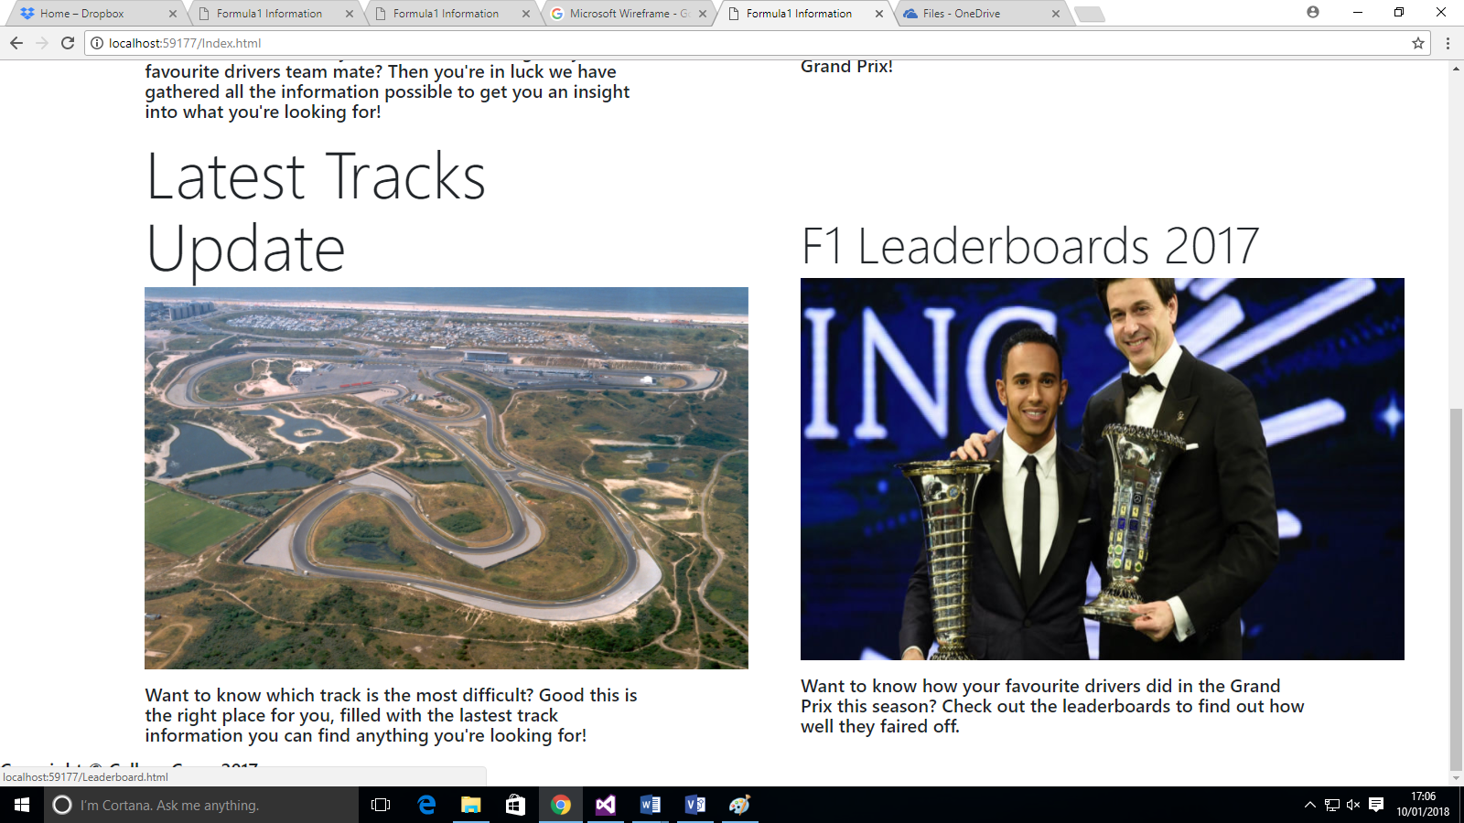
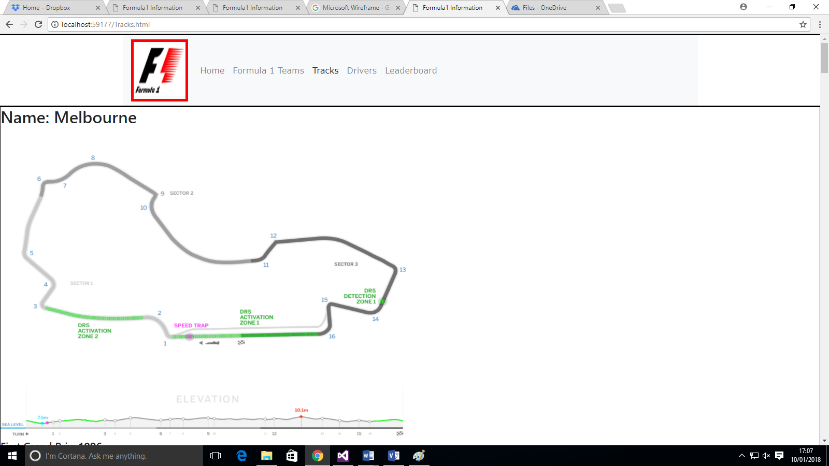
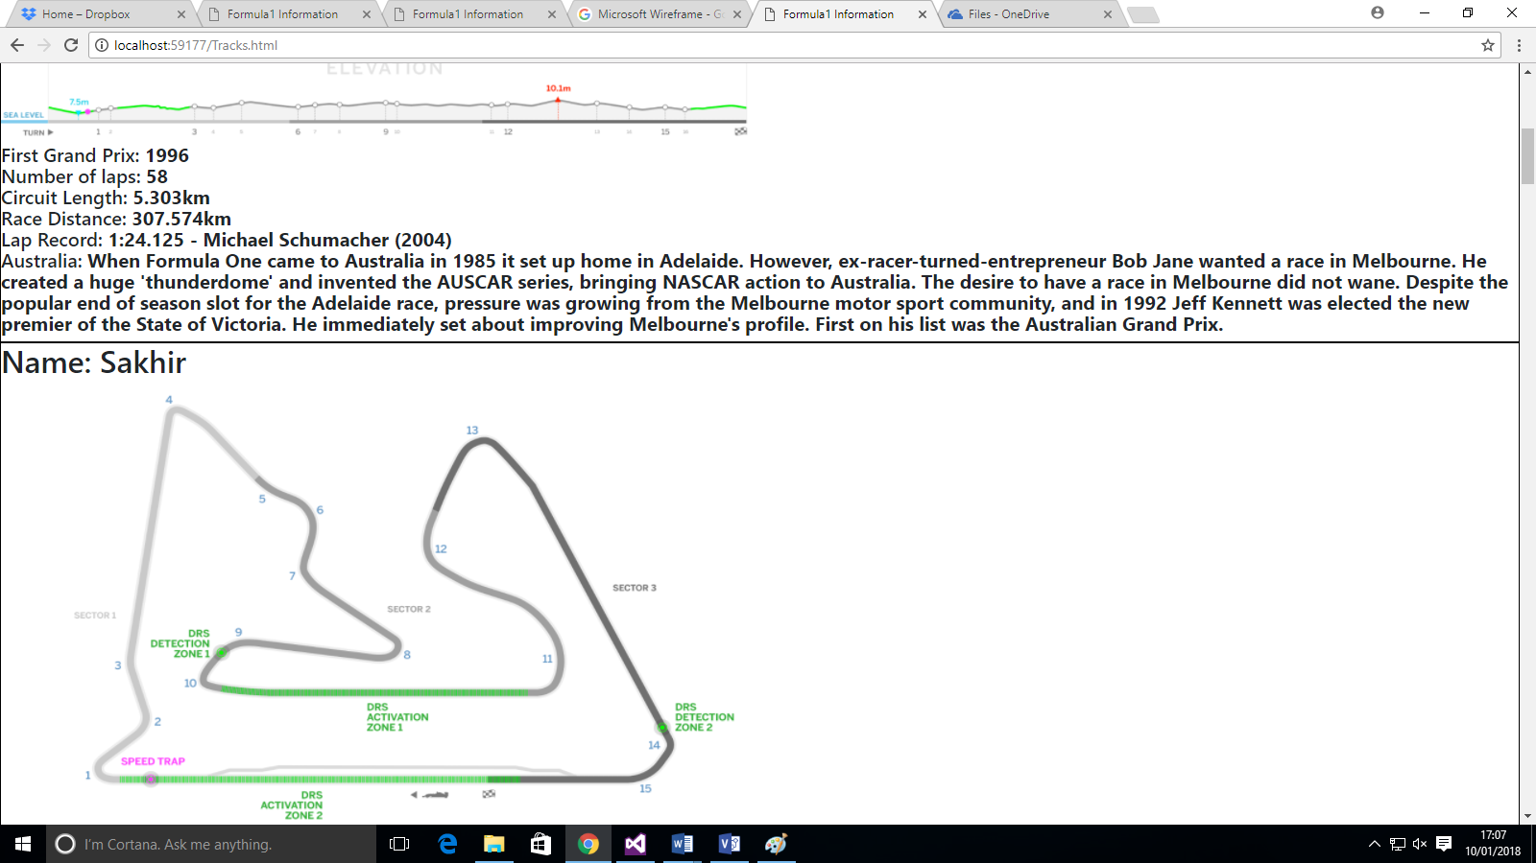
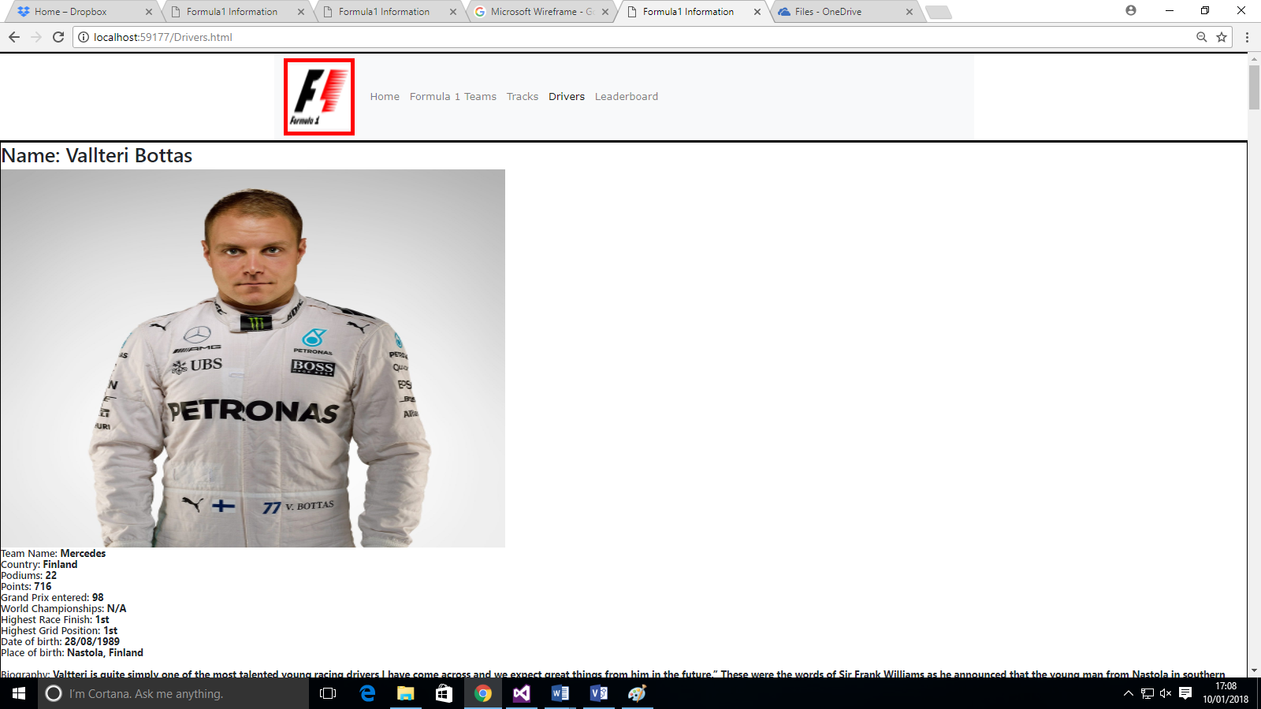
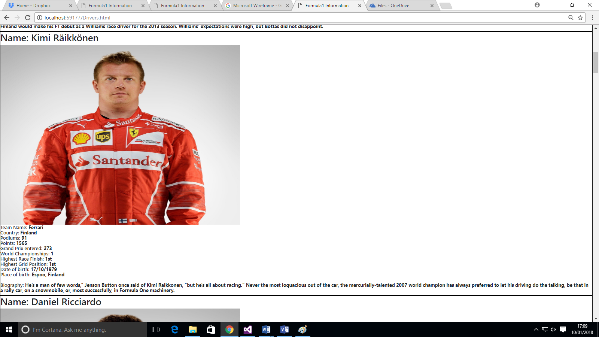
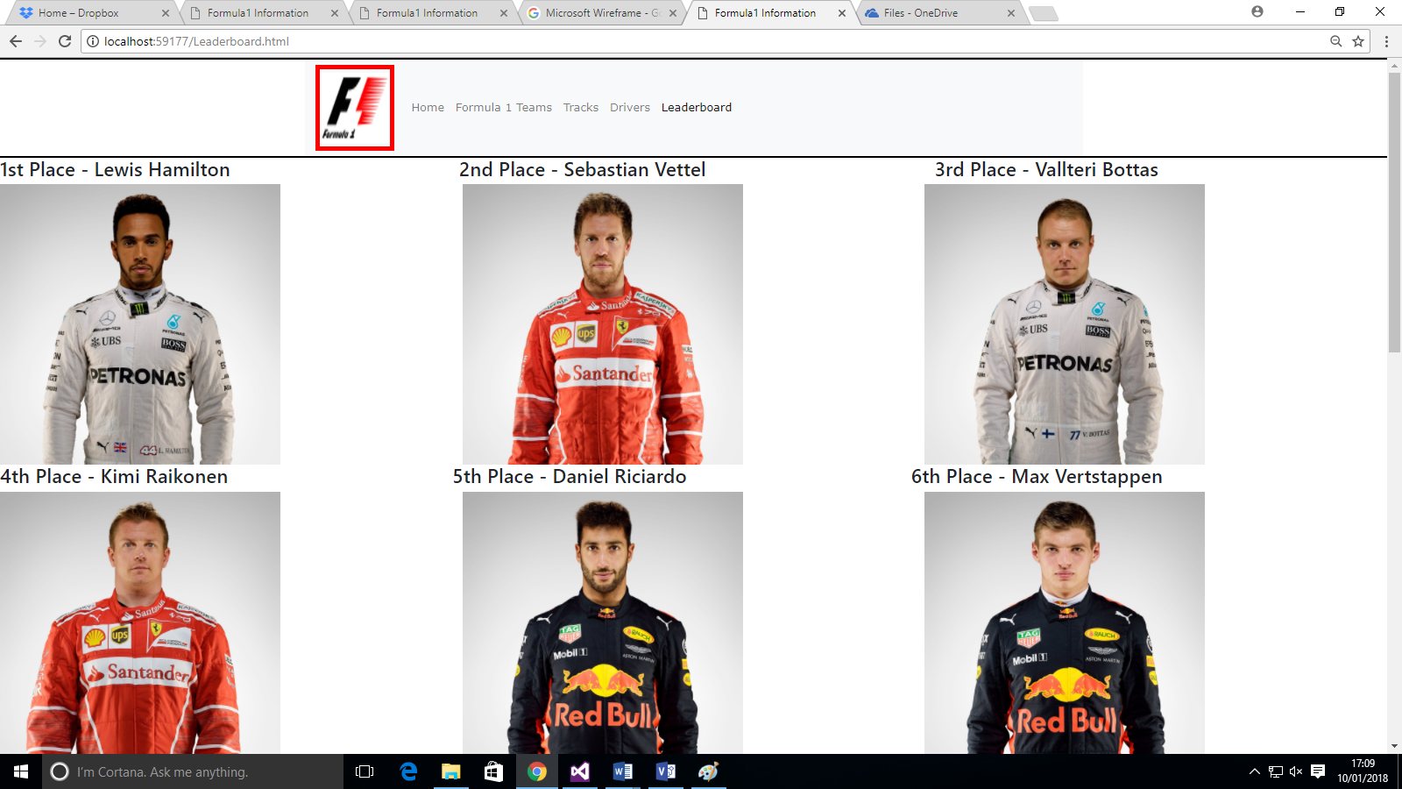
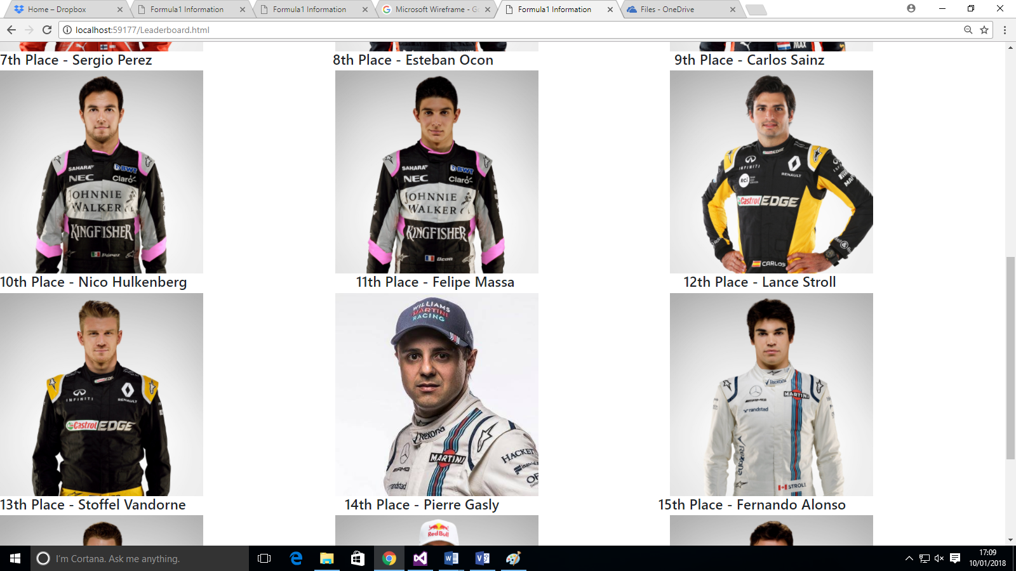
3.1 Validation
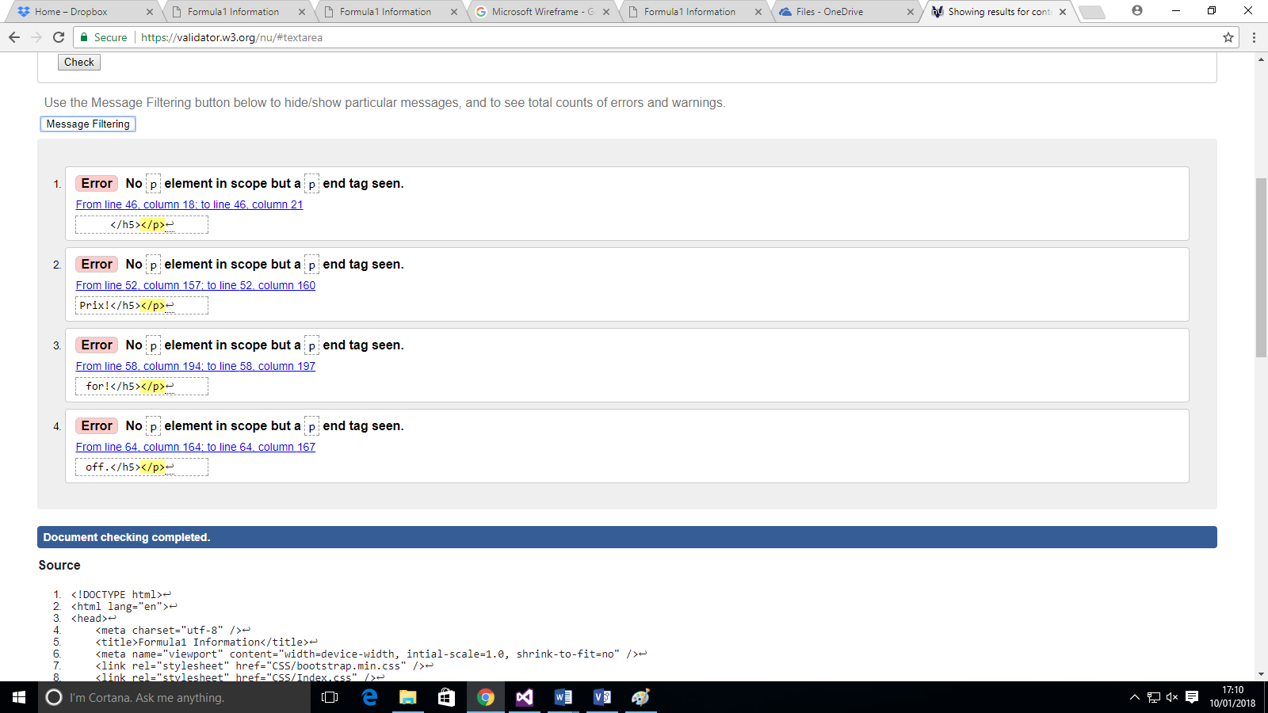

After the author of this report had validated both their HTML and CSS file, They had received errors from only one validation, this error report had arisen from their “Index.html” file with the errors quote “No <p> element in scope but a <p> end tag seen.”. This has created four errors. These errors are stating that the Author of this report has mistakenly put a “</p>” at the end of an element without actually starting the statement with “<p>” resulting in those errors.

4.0 Evaluation
We will now look at an evaluation of the website following the standards and rules of accessibility. This evaluation will be completed via the criteria of WCAG 2.0 [1]. Following this criteria allows the author to analyse what part of their website they could improve for users with impairments or disabilities.
Headings for the website were all organized into their own sections and that each section had a heading which existed. The objective of ensuring that each heading has its own section is for ease of identification. After sufficient evidence the author has followed the WCAG 2.0[1] Guidelines this has allowed accessibility [2].
The information structure and relationships conveyed through the Authors HTML code has been reviewed. It seems the Author of this report had been using a tool called “Visual Studio” this allowed the user to structure his HTML code and connect relationships to the website pleasantly; this allowed effortlessness of reading HTML. Visual Studio also helped design the CSS of the web pages with its own syntax built into it, to allow the user to develop in a quick and efficient manner.
Images within the Authors website had been given great thought into how they would structure their website; this allowed them to follow the criteria of WCAG 2.0[1][2], which quotes “Images must have text alternatives that describe the information or function represented by them.” And after careful evaluation it seems the author of this report has followed these guide line and have added an “alt=’’” statement to every image allowing a safety check if the image fails to load.
Scalable text content was the next element of the criteria and after checking the HTML code I can say that this accessibility was added and used the accurate approach to allow users with impairments to vision are able to access and visually inspect the website with easiness.
The main colours used in the author’s website were White, Black and Red this allowed users with colour-blindness to visually use the website with no limitations as users can see the information displayed on the web page this passed the criteria used by WCAG 2.0[1][2]. The Author of this report stated that they had used multiple tools to check that users with colour-impairment could see their website clearly.
The tools used for colour contrast tests were as followed:
https://webaim.org/resources/contrastchecker/
https://contrastchecker.com/
http://juicystudio.com/services/luminositycontrastratio.php
Navigation was used in the authors’ web page and was enabled across the website allowing users to be able to quickly switch between web pages without having to return to the last page they were on allowing multiple ways to get across the website. The navigation bar was also labelled with the correct usage of words that directed them to the correct location once clicked.

Finally the user stated they had used a tool call “WAVE Evaluation tool” to check each webpage. This tool will allow the creator of the website to check for any accessibility errors whilst in development this will allow the creator to develop a website that follows the criteria stated by WCAG 2.0.
The website was also taken through a judgment of the design, usability and content it provided to the users. The design of the website was well thought out, with the grids set in place to make the website nicely organised and a structured background. The usability of the website was great, entirety was working until we had changed to the web page “Formula 1 Teams” this is when the web site had a slight let down. The grid that was being used seemed it had mal-functioned and decided to allow the user to scroll to the far right of the web page. This seemed like it was a grid positioning error that occurred whilst in use.
The feel of the website was fantastic it was smooth and responsive in all aspects of the web site and web pages. The feel of the web page well thought out and from that provided the user with a great interactive experience with all the knowledge they could gain.
The content the website provided was phenomenal it had all types of data that a user could use. This included allowing the user to check every driver that was in the Formula 1 Grand Prix. The user could then check which driver was part of a certain team. The user could also check stats of Grand Prix tracks including information like, fastest lap time and who set that time, first Grand Prix Race, how many laps in a race and much more.

4.1 Recommendations for future improvements
The overall experience of the author’s website was fantastic, there are a few improvements the website could have had though. The following are a list of improvements that the author of this report could follow.
- The “Formula 1 Teams” page could be fixed and changed to a nicer grid layout allowing the user to have a pleasant viewing experience whilst looking at the web page.

- The website could have followed a bit of consistency on all web pages. The navigation bar is very consistent but it felt that the information that was being shown was not. To improve the author of this report could have created a consistent grid system that allowed the author to change to his liking whilst keeping the consistency between all web pages.

- The sizes of images compared to some on the same web page differed; this created a distorted effect on the image sometimes making it un-clear to what is being show. An improvement to this would be to make all images the same size and use their native size on the web page this will halt the images from being distorted.

4. The leader board’s web page was a bit bold of information. There were only images being shown on the leader boards allowing un-clear information on how the Grand Prix in Formula 1 is won. To improve this would be to add more information to the leader boards section. Examples of more information would be, the amount of points the driver has earned for the Drivers’ Championship, the amount of points the driver had gained for his team in the Constructors Championship.

5. Lastly to follow up was to add both the Drivers’ Championship and the Constructors Championship to the leader boards web page allowing more information to be displayed and allowing the user to not only look at how well a driver is doing in the Grand Prix and allow the user to look at how well a certain team is doing in the Grand Prix, This will create a lot more insight into how the sport is run.

5.0 References
W3Schools.com. (1999). CSS Syntax and Selectors. Retrieved January 10, 2018, from https://www.w3schools.com/css/css_syntax.asp
WCAG. (2017). WCAG Overview | Web Accessibility Initiative (WAI) | W3C. Retrieved January 10, 2018, from https://www.w3.org/WAI/intro/wcag
Lancharshire County Council. (2017). Web standards for developers - Accessibility levels A and AA. Retrieved January 10, 2018, from http://www3.lancashire.gov.uk/corporate/web/?siteid=5495&pageid=29664&e=e
WebAccessbility. (2012). About Web Accessibility for Disabled People. Retrieved January 10, 2018, from http://www.web-accessibility.org.uk/

