
Programme: Master of Business Administration
Module: LCMB7034 International Business Concepts

Name of Student: Prit Jenishbhai Jariwala
Student ID: 2503896
Word Counts: 5070 Words
Lecturer name: Jean wang
Submission date: 27/04/2026

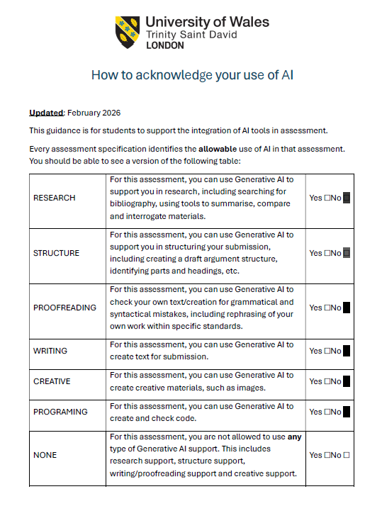

AI USE DECLARATION:

I confirm that no AI tools (including ChatGPT or similar to it) were used in the preparation of this assignment. All work submitted is my own.

Table of Contents
Section 1 4
1. Introduction 4
2. Industry and Country Overview 5
a. Overview of e-commerce Industry within India 5
b. Size, scope, and economic importance of e-commerce industry 6
c. Domestic and multinational firms and evaluation of key companies through comparison 9
3. Application of Michael Porter’s Diamond Model 11
4. Critical Evaluation of Amazon’s Operations in India 17
Amazon as a Major Foreign MNC in India’s E-Commerce Industry 17
PESTLE Analysis 18
Overall Evaluation of Market Attractiveness 30
5. Conclusion 31
Section 2 32
References 36

Section 1

1. Introduction
The report will emphasise the multifaceted aspects of international business operations and their implications on the business organisations. International business operations play a vital role for businesses by helping them in risk mitigation, market diversification, customer-base expansion, revenue growth, and competitive advantage. In order to assess the impacts of international business operations, the report will select Amazon, a renowned global e-commerce platform and India as their foreign functional market. Along with the brief description on the e-commerce industry of India, the report will describe the several multinational and domestic companies operating in the Indian e-commerce market through conducting a comparison between their market positioning, performance, and strategies. Additionally, the report will analyse global competitiveness in the Indian market for Amazon through applying the Michael Porter’s Diamond framework. The report will also use the PESTEL framework to analyse the business environment within the Indian e-commerce market for Amazon.

2. Industry and Country Overview

a. Overview of e-commerce Industry within India
The e-commerce industry is the fastest growing industry in India due to the changing customer behaviour, digital transformation and growing internet penetration.
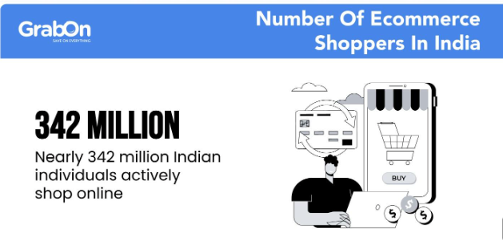
Figure 1: Online Shoppers in India
(Source: Saxena, 2025)
One of the significant reasons behind the rapid growth of the e-commerce industry within India is the digital adoption within the customer base. According to the latest report, there are 342 million online shoppers in 2025 within India and is expected to reach 420 million online shoppers by 2030 (Saxena, 2025).
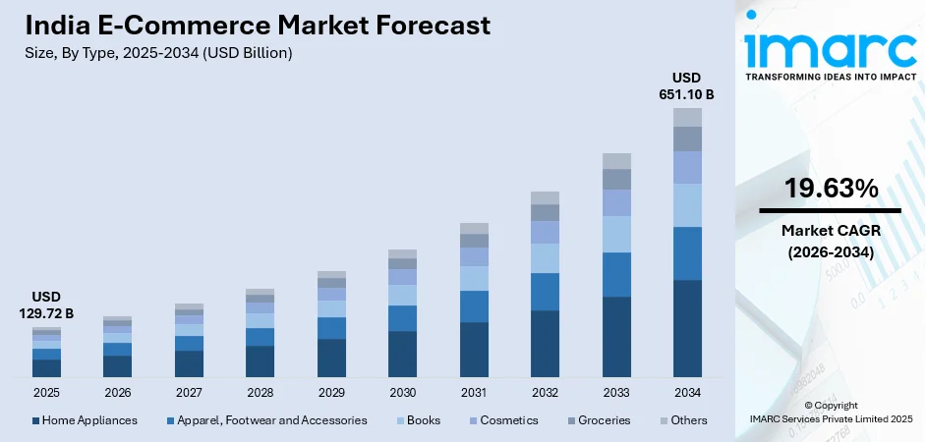
Figure 2: Market value of e-commerce industry in India
(Source: IMARC Group, 2025)
The current report indicates the total market value of the e-commerce industry in India is $129.72B in 2025 and is estimated to reach $651.10B within 2034, showcasing rapid growth (IMARC Group, 2025).

b. Size, scope, and economic importance of e-commerce industry
Size of e-commerce industry
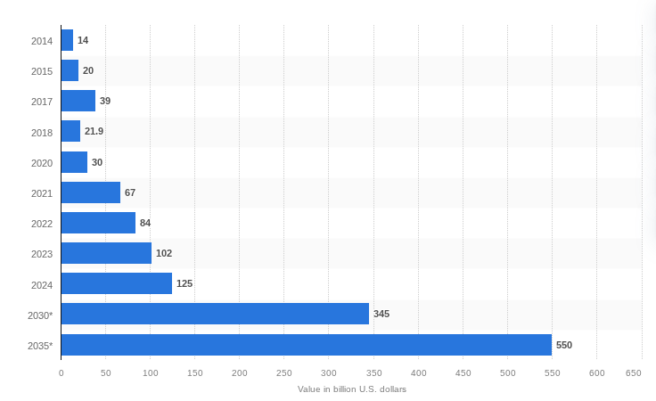
Figure 3: Market size of e-commerce industry in India
(Source: Statista, 2024)
The e-commerce industry is one of the significant industries in India that witnesses rapid growth. The market size of this industry in India is $211.6 billion in 2025 and is expected to reach $345 billion by 2030 and $550 billion by 2035 (Statista, 2024).
Scope of the industry
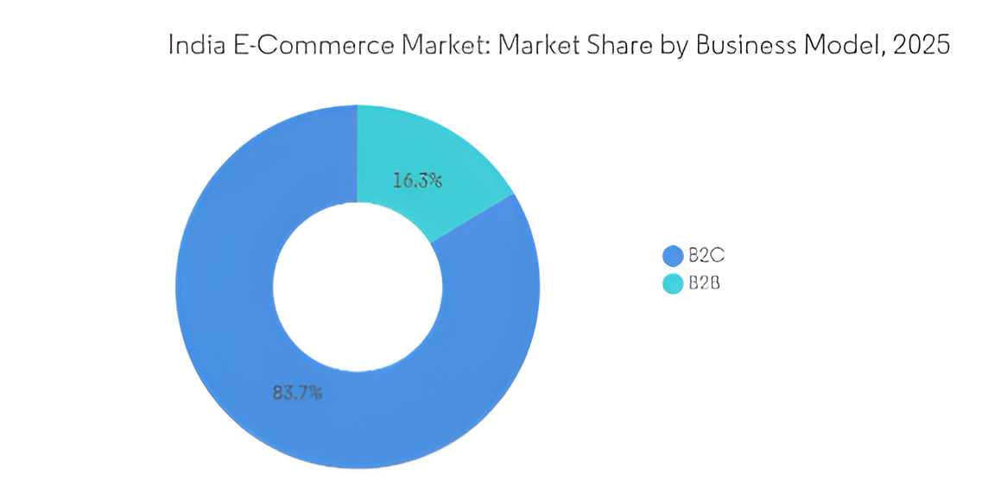
Figure 4: Business model Segments in e-commerce industry within India
(Source: Mordor Intelligence, 2025)
The e-commerce industry has a broad scope within various sectors, business models and geographic markets in India. There are three market segments in the e-commerce industry in India such as B2C, B2B and D2C. As per current data the B2C segment covers 86% of the total market share of the e-commerce industry in India. The e-commerce industry within India includes mainly the product segments of grocery, fashion and electronics. The current survey indicates that 60% of e-commerce transactions occur from tier 2 and tier 3 cities of India (Mordor Intelligence, 2025).
Importance of the industry
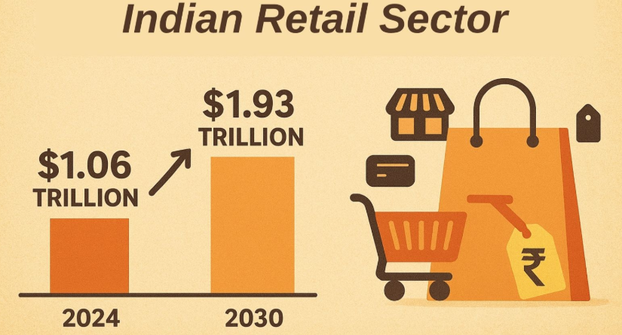
Figure 5: Retail market within India
(Source: Indian Retailer, 2026)
The e-commerce industry is the significant contributor to the retail Industry of India (Indian Retailer, 2026). As per current report the retail Industry in India is expected to reach $1.93 trillion by 2030 (Deloitte, 2025). Within 2024 the e-commerce industry accounts for 8% of the overall retail sector in India and is estimated to grow by 14% within 2030, indicating a significant scope of growth (PCMI, 2024).
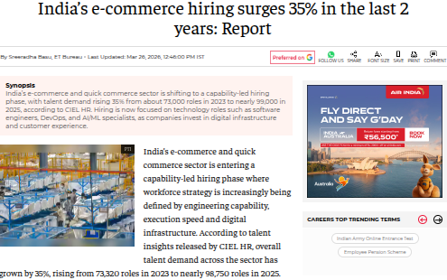

Figure 6: Employment in e-commerce within India
(Source: Basu, 2026)
The e-commerce industry in India also generates a significant amount of employment. According to the current report, between the time duration of 2023 to 2025, the e-commerce industry witnessed a 35% hike in employee hiring in India, contributing to the digital economy of India (Basu, 2026).

c. Domestic and multinational firms and evaluation of key companies through comparison
Major domestic and international companies
There are multiple domestic and multinational companies operating in the e-commerce industry within India including Amazon, Flipkart, Reliance Retail and Meesho. Among the companies Amazon and Walmart owned, Flipkart are the multinational firms, whereas Meesho and Reliance Retail are the domestic companies in the e-commerce sector of India (Raju, 2025).
Comparison between international and domestic firms in Indian e-commerce industry
Competitive Aspects | Amazon | Flipkart | Meesho
Strategy | Differentiation strategy | Hybrid strategy | Cost-leadership strategy
Revenue | $3.6B | $2.5B | $1.1B
Market segment | Premium and urban customer base | Semi-urban and urban customer base | Customer base in Tier 2 and 3 regions
Market Positioning | Premium global brand | Value for money brand | Company that provides products in the cheapest rates

Table 1: Comparison between international and domestic e-commerce
(Source: Self-made)
Evaluation
Amazon is one of the significant international companies that operates in the Indian e-commerce sector. The company operates through differentiation strategy where they mostly emphasise on their significant logistic networks, AI-powered operational system, and fast-delivery to distinguish their brand from their competitors in the e-commerce market within India (Abrar, 2025). Conversely, Flipkart, another international firm follows hybrid business strategy through which it focuses on providing significant discounts in wide ranges of products to attract customers. Meesho, a renowned domestic e-commerce company practices cost-leadership strategy where they keep their product pricing ultra-low to increase customer affordability (Acharya, 2025). According to the current report, the revenue of Amazon in the Indian e-commerce sector is $3.6B (Acharya, 2025a). Flipkart has generated $2.5B Revenue in 2025 (Abrar, 2025b). Meesho has produced $1.1 billion revenue in 2025 with 26% growth (Ghosh, 2026). Amazon caters to generally premium to middle class urban customer base, whereas Flipkart targets majorly the middle-class consumers. With the help of a low pricing-strategy Messho generally targets the low-income consumer base that prioritises affordability. As per the study Amazon positions their brand as a premium e-commerce platform. In other ways, Flipkart promotes their brand as a value for money e-commerce platform. Meesho projects their brand as a budget conscious e-commerce company in India.

3. Application of Michael Porter’s Diamond Model
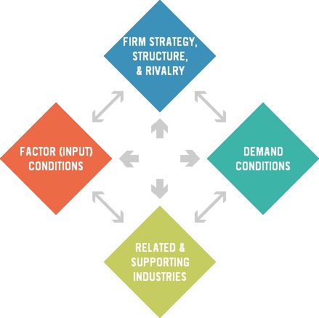
Figure 7: Michael Porter’s Diamond Model
(Source: Ketels, 2024)
Michael Porter’s Diamond Model refers to the strategic framework through which businesses can identify the regions and countries which can provide them special competitive advantages while working in a specific industry (Ketels, 2024). The framework consists of several key factors such as factor conditions, demand conditions, supporting industries, company structure, strategy, and the government. In order to assess the effectiveness of the Indian market in the e-commerce industry for Amazon, the report has used this framework to analyse global competitiveness.
Factor conditions
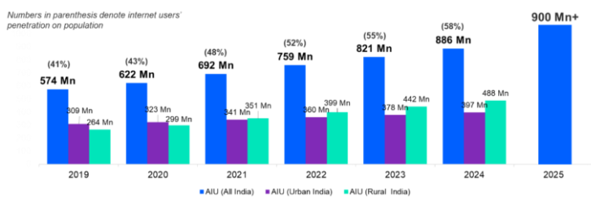
Figure 8: Internet users in India
(Source: Tandon, 2025)
The factor conditions demonstrate the necessary resources that the company requires while operating in the specific region which includes infrastructure, workforce, and advanced technologies (Tandon, 2025). India provides these resources in a significant amount to Amazon. For instance, according to the recent data that total internet users in India is 900 million in 2025, indicating the emerging digital ecosystem (Sourabh, 2025). Conversely, the US, one of the key markets of Amazon, has only 324 million internet users, highlighting limited scaling advantage (Statista, 2025b).
Additionally, the current population of India is 1.43 billion which can provide Amazon a large skilled labour pool (World meter, 2025). Whereas, the current population of the United States is 335 million (US Census Bureau, 2025). A significant population can help Amazon to build cost-effective operation centres with adequate low-cost labour abundance.
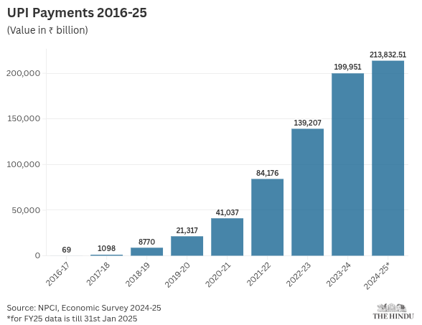
Figure 9: UPI transaction in India
(Source: The Hindu, 2025)
Moreover, the rapid digital adoption in India also makes it an effective operation centre for Amazon. India has significantly established a mobile-first economy through digital payment systems like UPI. Making the overall online transaction easy and faster, Amazon can get help on leveraging these fintech innovations for their smooth operations. The total UPI user in India is 491 million and the transaction volume is 228 billion ($2.45 billion) in 2025 (The Hindu, 2025).
Demand factors
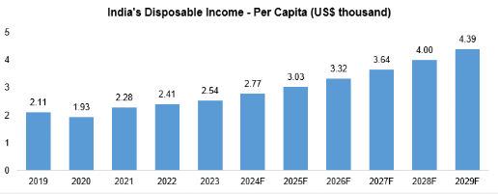
Figure 10: Disposable income in India
(Source: IBEF, 2025)
Another significant aspect that makes India an attractive operation centre for Amazon is their growing customer demands. According to the current data, India has over 300 million customers who are more likely to shop from online channels and the number of online shoppers is expected to reach 440 million within 2030 (DD News, 2026). Increasing disposable income of Indian customers can also help Amazon to generate adequate demand for the service and products within the market. As per current report, the disposable income per capita in India is $3.03k (IBEF, 2025). In contrast, the US has only 259 online shoppers with higher disposable income (Antom, 2025). On the basis of the analysis, it can be stated that Amazon can get a significant amount of growth and scale for their businesses within India.
Supporting industries
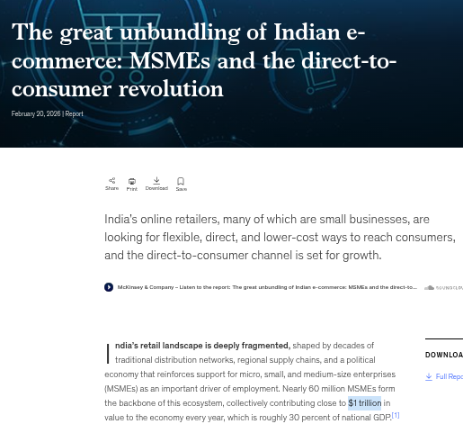
Figure 11: MSMEs in India
(Source: (Mundra, 2026)
It defines the related industries and supplier network that help companies like Amazon to outsource specific services and components to increase their product range and improve functional competencies within the specific country like India. There are a large number of logistic networks, MSMEs, and a significant fintech ecosystem in India which provides adequate support to Amazon to sustain within the competitive market of e-commerce. As per data, India has 60 million MSME which contributes $1 trillion to their GDP in 2025, indicating significant scope for Amazon (Mundra, 2026). However, limited standardisation in the supply-chain base can cause functional hindrance before Amazon in India in comparison to the significant market of UK and US.
Firm structure, rivalry and strategy
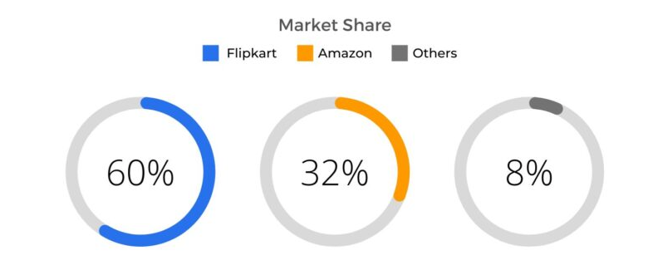
Figure 12: Market share of Amazon in India
(Source: Singh, 2024)
It is the factors of the model that helps business organisations to manage their operations within the competitive market by optimising their structure and strategies. India has a highly competitive market for Amazon where they hold 32% market share in the e-commerce industry which generates less profits (Singh, 2024). Contrarily, despite having significant competition by the competitors like eBay and Walmart the US e-commerce market acts more mature for Amazon, providing Amazon stable profits (Commerce Engine, 2025).
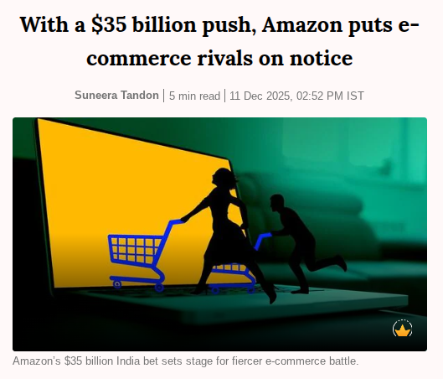
Figure 13: Investment of Amazon in India
(Source: Tandon, 2025b)
As the Indian e-commerce market is highly competitive and fragmented, Amazon needs to adopt innovative solutions within their functional strategies to create a distinct product and service portfolio for their brand. For instance, the company has planned to invest $35 billion to improve supply-chain functions and infrastructure in India by 2030, highlighting the necessity of optimising functional strategies within national conditions (Tandon, 2025b).
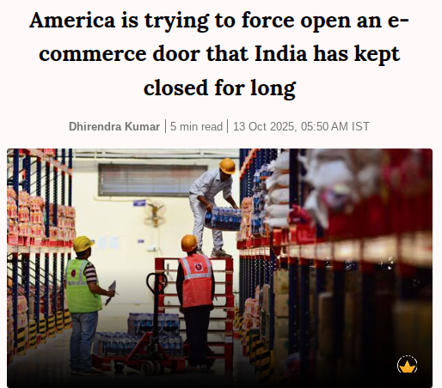
Figure 14: Regulatory hindrance for Amazon in India
(Source: Kumar, 2025)
Furthermore, the regulatory authority within India prevents companies like Amazon from holding their own inventory systems and forces them to act as a mere e-commerce marketplace. It causes functional constraints for Amazon in India. whereas, Amazon follows an inventory-based business model within the US due to their stable regulatory environment, providing them functional efficiency (Kumar, 2025).

4. Critical Evaluation of Amazon’s Operations in India

Amazon as a Major Foreign MNC in India’s E-Commerce Industry
In Indian ecommerce industry Amazon is one of the leading multinational companies. The company entered in India in 2013 (About amazon, 2023) and since then it has expanded its operations and markets significantly with the help of substantial investments in digital infrastructure, logistics, and seller ecosystems. The company is growing rapidly in India and giving tough competitions to other domestic or multinational companies in India. Amazon India has crossed the $20 billion ecommerce export milestone ahead of its 2025 objective with the help of the Amazon Global Selling program, which was introduced in 2015 (Amazon Staff, 2025). This effort has enabled more than 200,000 Indian exporters to sell 750 million 'Made in India' items worldwide. Amazon now aspires for $80 billion in total exports by 2030, following a 33% increase in its seller base over the previous year, which includes entrepreneurs from 28 states and over 200 cities throughout India(Amazon Staff, 2025).
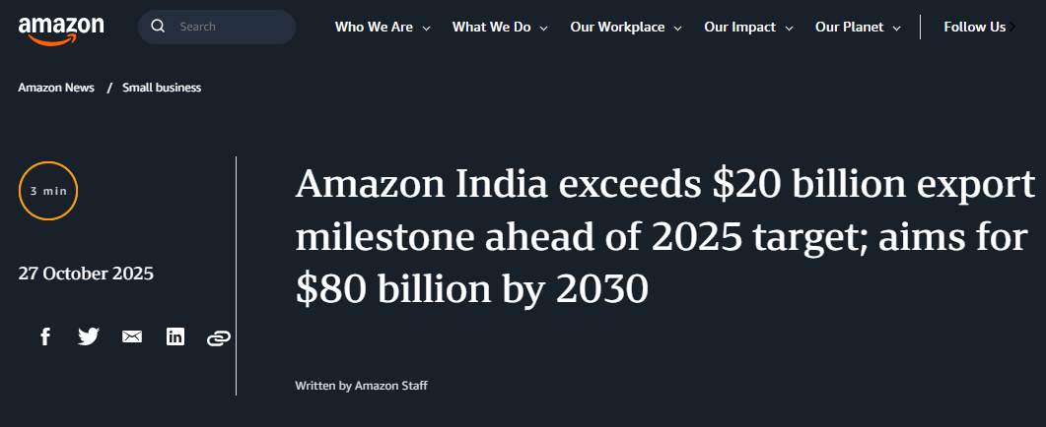
Figure 15: Performance of Amazon in India
(Source: Amazon Staff, 2025)
This is an opportunity for the company to ensure its growth because India is a high growth emerging market with more than 800 million Internet users and has a continuously increasing number of online customers. However, multinational companies operating in India face both opportunities and threats because of the complex political, environmental, legal, technological, social, and economic factors in the market. PESTLE framework is an effective environmental analysis tool that can help companies to understand external macro factors that have a great impact on their strategic decisions. Success factors of Amazon is evaluated through a PESTLE framework to understand success factors and challenges Amazon is facing in Indian market. This analysis is supported by recent statistics as well as industry trends.

PESTLE Analysis
Political Factors
Amazon's overall operations in India are impacted by the political environment as it applies to the business environment, specifically by the government's regulatory policies regarding FDI in the E Commerce Business.
Government Policies and FDI Regulations
As far as FDI in E-Commerce is concerned, the Indian government does allow for 100% FDI under a Marketplace E-Commerce model (Narayan and Panda, 2025). However, the government does have restrictions on FDI occurring under an Inventory Model. Therefore, Amazon is unable to sell its own inventory directly, as a retailer to consumers; rather, the way it operates is as an intermediary that connects buyers and sellers via its Marketplace Platform (Sidhartha, 2023).
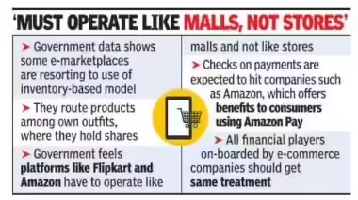
Figure 16: E-commerce rules in India
(Source: Sidhartha, 2023)
This creates challenges for Amazon, relative to domestic competitors as they cannot control pricing, but rather must compete with the domestic retailer on price.
Protection of Domestic Retailers
There are numerous government policies in place that are designed to protect small domestic retailers (Kirana stores) when competing with large international retailers like Amazon. Many of the government policies do create disadvantages for Amazon when attempting to compete with its domestic competitors. Examples of this include restrictions on the exclusive launch of products as well as restrictions on deep discounting (India connected, 2024). Therefore, Amazon is at a disadvantage compared to domestic retailers such as Reliance Retail and Meesho.
Government Initiatives
The Indian government is stepping up efforts to create a digitally empowered economy, with the assumption that core digital industries such as information technology and electronics manufacturing will dramatically boost their GDPs. McKinsey estimates that the 'Digital India' effort would boost the digital economy to $1 trillion by 2025, up from $200 billion in 2018 (IBEF, 2025).
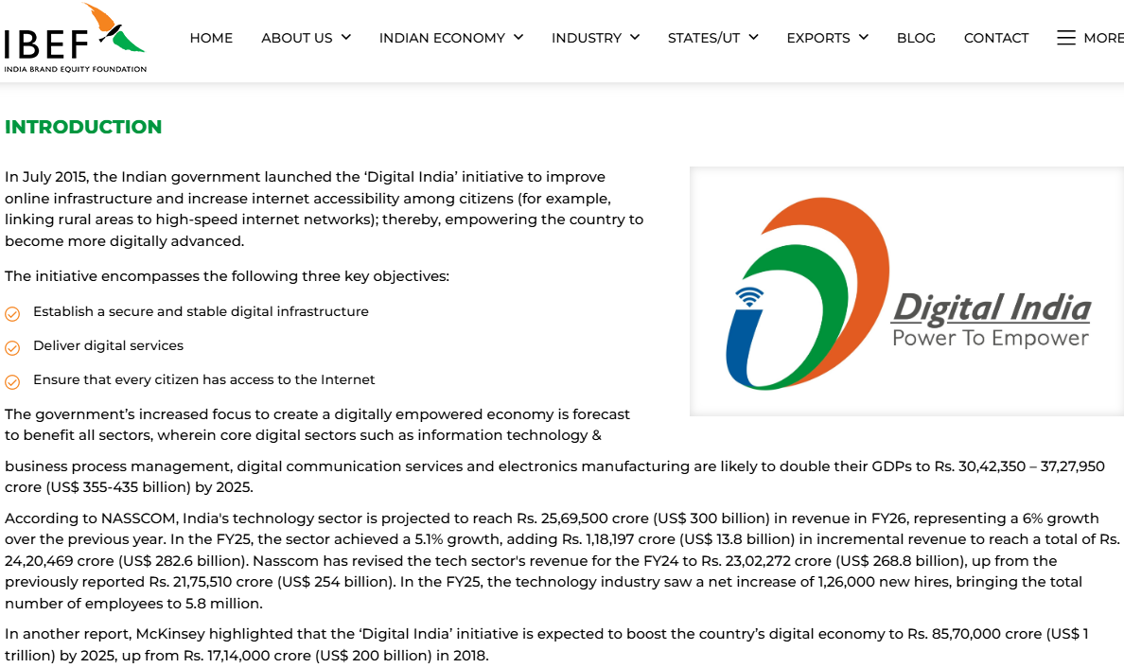
Figure 17: Government initiatives
(Source: IBEF, 2025)
Amazon can capitalize on these government initiatives to increase the penetration of internet use, and improved digital literacy in India, resulting in a broader potential customer base for Amazon.
Evaluation
The political environment in India provides Amazon with growth opportunities via government digital initiatives. However, because of the regulatory restrictions regarding FDI in India, and the challenges created by protectionist policies, Amazon will continue to encounter operational challenges and limited strategic flexibility.
Economic Factors
Amazon's success in India is driven by the favourable business conditions and dynamic market forces along with structural impediments.
Market Growth and Consumer Base
According to NASSCOM projections, the IT sector's income would increase by 6% to $300 billion in FY26, up from the previous fiscal year (IBEF, 2025). The industry grew by 5.1% in FY25, earning an additional $13.8 billion in revenue, bringing the total to $ 282.6 billion. Employment in the IT industry has increased by 126,000 new employments with the total of 5.8 million (IBEF, 2025). India’s E commerce market is growing at a CAGR of 19% (Bhaisora, 2024)
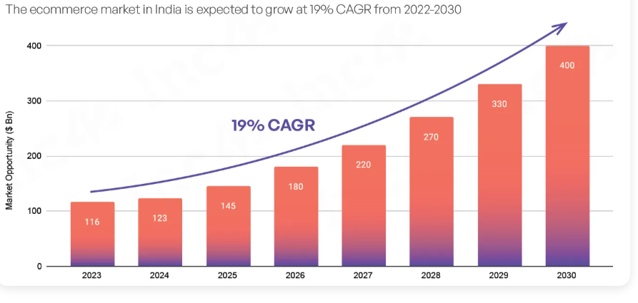

Figure 18: Growth ofe-commerce market across India
(Source: Bhaisora, 2024)
If trends in penetration and usage of online shopping apps continue, the number of online customers will exceed 420-440 million by 2030 (Kumar, 2026).
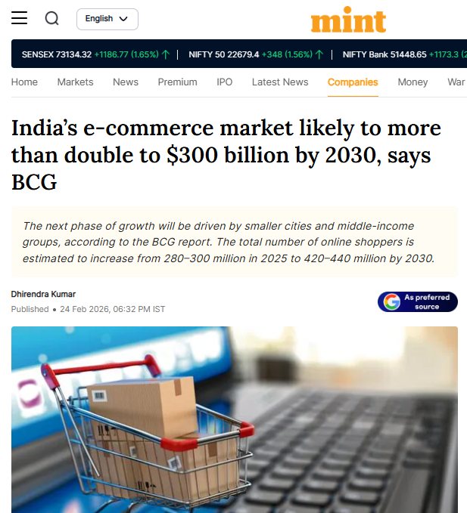
Figure 19: Online users in India
(Source: Kumar, 2026)
With this large and continually growing customer market, India is an attractive place for Amazon to do business.
Rising Middle Class and Income Levels
Almost 31% of India’s population that is classified as middle class (Bardhan, 2025), consumers with adequate disposable income to purchase a wide variety of products, is resulting in increased spending patterns and increase demand for convenience, swift delivery times, and premium/added value services such as those that Amazon offers through its Prime service.
Price sensitivity
Despite consumers' growing disposable income, India remains a price sensitive market (Mukherjea and Rajhansa, 2026), with incumbents such as Flipkart and Meesho offering aggressive pricing strategies. In general, Amazon's competitive advantage is based upon the company's differentiation strategy like focusing on service quality, logistics. Therefore, Amazon's focus on differentiation may not translate to relevant price points for the price-focused Indian consumer.
Infrastructure challenges
Although the logistics network and overall supply-chain infrastructure in India are improving, significant issues remain, particularly in rural and lower-tier cities. For example, the delivery cost associated with serving customers in distant locations reduces the potential profit margin for Amazon (Wu et al., 2022).
Evaluation
There is considerable economic opportunity for Amazon to develop in India given the significant size and tremendous growth of the marketplace; however, price sensitivity and infrastructure shortages require Amazon to balance product cost effectiveness (low prices) with product/service differentiation.
Social Factors
The cultural and social factors that impact how consumers act, play an important role in how Amazon has adapted its strategy to the Indian market.
Demographics and Population
With over 1.4 billion people (World meter, 2026), India represents a significant opportunity for the company based on its massive population.
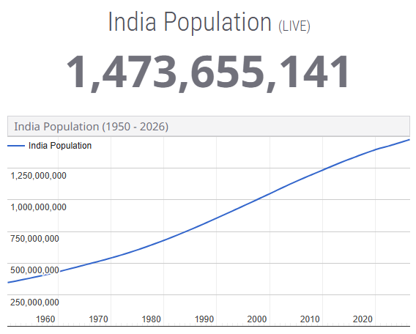
Figure 20: Indian population
(Source: World meter, 2026)
One of the reasons for the rapid growth of online shopping brands is the sheer number of younger, tech-savvy consumers in India.
Change in Consumer Behaviour
There is a clear move toward consumption in a digital format, the need for convenience and 'mobile-first, -consumption.' Today, more than 60% of credit card transactions take place from tier-2 and tier-3 cities (Irani, 2025), showing Amazon's growing penetration into the Indian market.
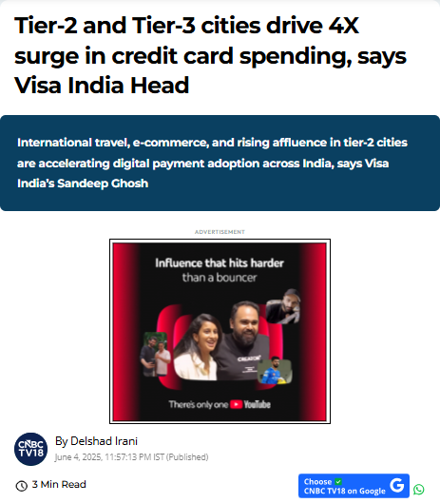
Figure 21: Credit card transaction in Indian cities
(Source: Irani, 2025)
Trust and Payment Preferences
Historically, Indians have preferred COD as a payment method due to trust issues when it comes to online shopping (Chhapia, 2024). There has been a sharp increase in digital payments (UPI, for example), but trust will continue to be a major factor in how and if consumers make a purchase.
Cultural Diversity
India is one of the most culturally diverse countries in the world. There are many different languages, cultures and preferences throughout the country. Therefore, it is vital for Amazon to use localised customer interfaces and to target regular marketing campaigns.
Evaluation
The social factors that support Amazon’s continued growth are the strong demand for digital, and the demographics of the country. Amazon must use localisation and adaptation methods due to cultural diversity and trust issues; these social and emotional factors will continue to support the company's growth in Asia.
Technological Factors
Amazon has strong leverage in Technology in India for its success.
Digital Infrastructure and Internet Penetration
Since 2016, the rapid expansion of affordable Smartphone and data packages helped to accelerate online e-commerce adoption (Jyoti et al., 2025). India has 900 million internet users in FY2025 regularly accessing online e-commerce platforms (ETtech, 2025).
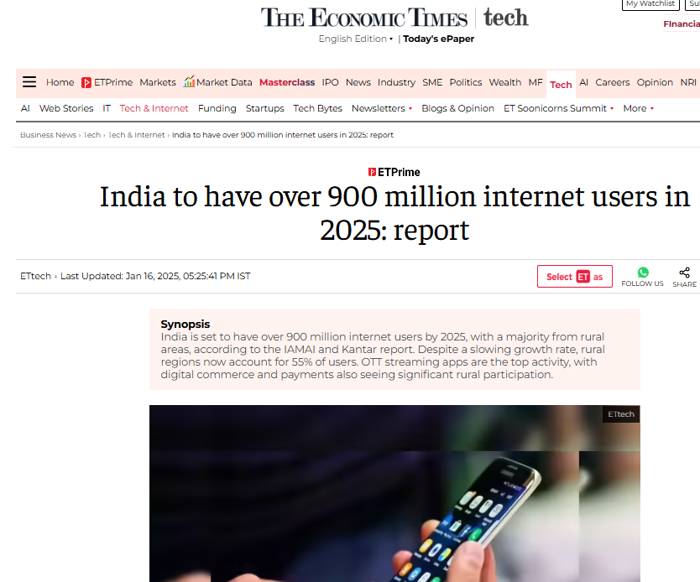
Figure 22: Internet users in India
(Source: ETtech, 2025, 2025)
Digital Payment Systems
Indians are heavily using the home-grown digital payment system Unified Interface Payments (UPI) with 491 million users processing 18.39 billion annual transactions amounting to ₹240.30 Billion (TOI Business Desk, 2025).
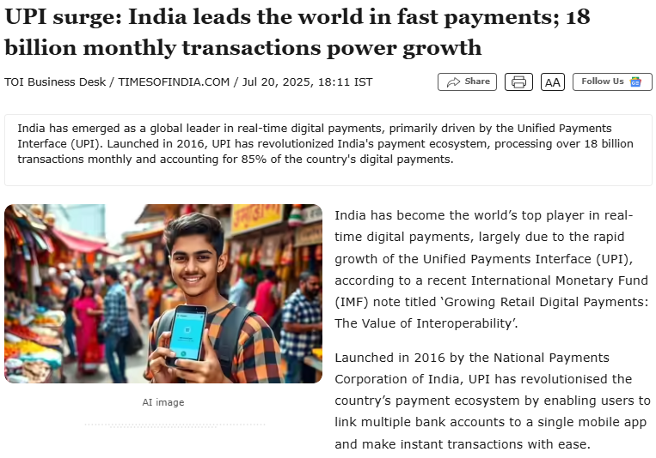
Figure 23: UPI surge in India
(Source: TOI Business Desk, 2025)
It supports the transaction ecosystem of Amazon with rapid payment (Amazon Staff, 2024).
Logistics and AI Integration
Amazon has strong logistical networks like replenishment (fulfilment) centres and last-mile delivery systems giving real-time competition to competitors (India Briefing, 2025). Amazon has strong Artificial Intelligence (AI)-Machine Learning (ML) and data analytics for inventory management, demand forecasting, and customised recommendations (Amazon, 2025).
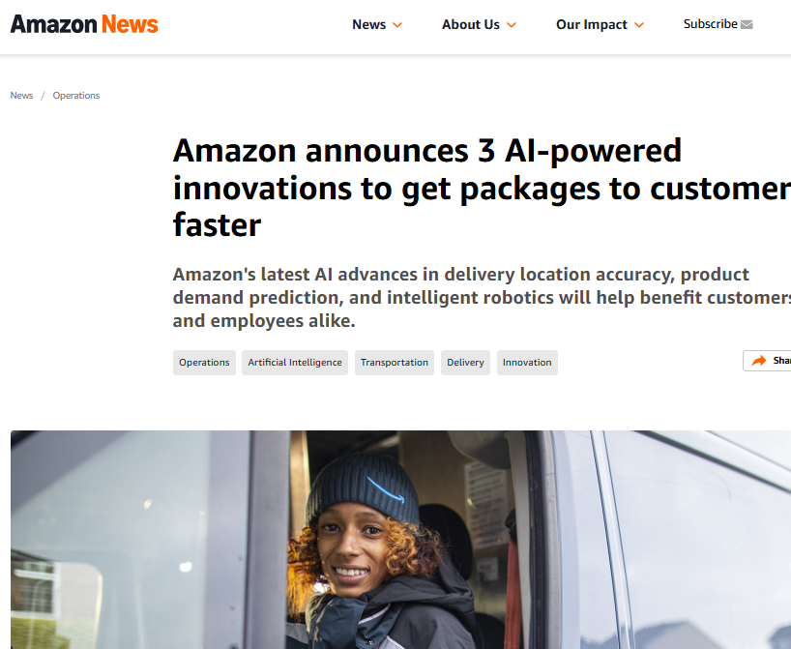
Figure 24: AI-powered innovation at Amazon
(Source: Amazon, 2025)
Competition in Technology
Indian origin and now Walmart-owned Flipkart is also investing heavily in AI-ML tech, inventory management, and supply chain networks to compete which reduces Amazon’s relative advantage (Mulani and Nagne, 2025).
Evaluation
Technological factors strongly support Amazon in India but the innovation from competitors also forces Amazon top invest heavily in this sector to maintain competitive advantage in the online e-commerce market segment.
Legal Factors
Amazon is facing critical challenges in India for legal factors.
E-Commerce Regulations
India has strict e-commerce regulations putting restrictions on inventory ownership, unethical discounting/offers, and exclusive partnerships. These regulations limit Amazon’s ability to copy its global business model in India.
Data Protection and Privacy Laws
Companies like Amazon must store its data locally for the data protection regulations which increase compliance increasing operational.
Taxation Policies
Government of India introduced Goods and Services Tax in 2017 to simplify corporate taxations which eventually increased compliance need for third-party sellers in Amazon’s marketplace (Amazon seller central, 2026).
Anti-Competition Scrutiny
Amazon has faced challenges pertaining to scrutiny for anti-competitive practices with preference to certain third-party sellers or displaying own products (Conover, 2025).
Evaluation
The legal environment in India is rapidly evolving with fast implementation of changes. It ensures fair competition but increases challenges like high compliance costs lowering profitability and smooth operations for Amazon.
Environmental Factors
Amazon’s corporate strategy and operations are shaped by environmental concerns.
Sustainability Pressures
Indian customers are much aware of sustainability and environment. The regulators are forcing companies to increase eco-friendly practices lowering carbon emissions. Amazon has committed to net-zero by FY2040 (Amazon, 2025).
Packaging Waste
Amazon has introduced recyclable paper-based packaging reducing plastic waste to address the concern of e-commerce plastic packaging waste (TOI Tech Desk, 2024).
Logistics and Carbon Emissions
Amazon is investing heavily in electric delivery vehicles with deploying 10,000 EVs in India and green logistics in India as last-mile delivery increases carbon footprints (Williment, 2025).
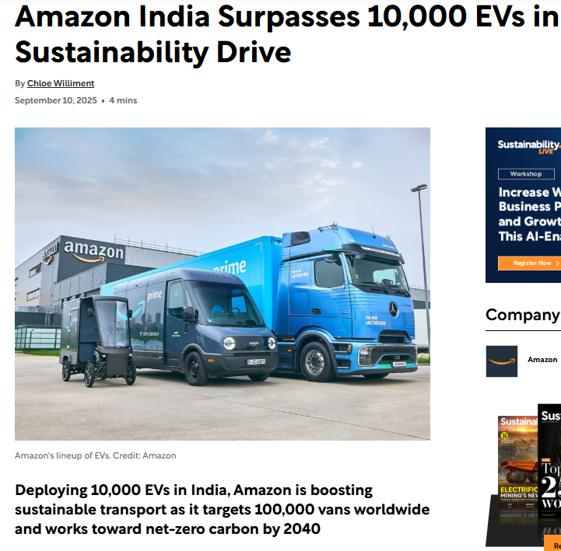
Figure 25: Green initiatives by Amazon
(Source: Williment, 2025)
Evaluation
Sustainable practices can boost Amazon’s brand reputation but need significant investment as environmental factors pose both opportunity and challenge.

Overall Evaluation of Market Attractiveness
Using the PESTLE framework, India can be considered a highly attractive yet complex market for Amazon due to its rapid digital transformation and evolving regulatory landscape.
Opportunities | Challenges
- Rapid market growth: India’s e-commerce market is valued at $129.7 billion (2025) and is projected to exceed $650 billion by 2034 (IMARC Group, 2026), indicating strong expansion potential. | - Regulatory constraints: Strict FDI policies restrict inventory-based models, limiting Amazon’s control over pricing and supply chains.
- Expanding consumer base: Online shoppers are expected to increase from 300 million in FY2025 to 440 million by FY2030, driven by digital adoption (DD News, 2026). | - High price sensitivity: Indian consumers are highly price-conscious, benefiting competitors like Flipkart and Meesho.
- Strong digital ecosystem: Over 900 million internet users and 491 million UPI users enable seamless digital transactions and mobile commerce growth (TOI Business Desk, 2025). | - Intense competition: Domestic players and large conglomerates increase market rivalry, limiting Amazon’s market share growth.
- Government support: Initiatives such as Digital India and improved logistics infrastructure enhance the overall business environment (PIB, 2025) | - Infrastructure gaps: Logistics challenges in tier-2 and tier-3 regions increase delivery costs and operational complexity.

Table 2: Market Evaluation of Indian e-commerce market
(Source: Self-made)

5. Conclusion
International business concepts and their significance on the modern-day business scenario has been demonstrated in this report. International business concepts refer to the business activities through which businesses can operate their functions in multiple regions, providing them adequate opportunity for ensuring financial growth. The report has selected Amazon to analyse their business operations in the foreign market of India within the e-commerce industry. The report has provided a detailed overview of Amazon and e-commerce industry. The report has also described the fast-evolving and growing e-commerce industry in India by assessing their economic importance, size and scope. There are multiple international and domestic e-commerce companies such as Amazon, Flipkart, and Meesho operating in India. The report has conducted a detailed comparison among these firms by focusing their differences on strategies, brand positioning, performances, and market segments. The report has also applied Michael Porter’s Diamond Model on Amazon to analyse the effectiveness of the Indian e-commerce market for global competitiveness. By assessing factors like factor conditions, demand conditions, related industries, firm rivalry, structure and strategy, the model has helped to demonstrate the growth potential of the Indian e-commerce market for Amazon. In addition, the report has also used PESTEL analysis to study the external business environmental factors like political, cultural, legal, and economic factors that influence the functions of Amazon in India within the e-commerce industry.

Section 2
During the course of working on the assignment of international business concepts, I have gone through multiple learning experiences. In order to assess the effectiveness of my learning journey during the assignment, Gibbs Reflective model has been used here. It refers to a structured framework through which an individual can analyse their learning journey and outcomes.
Description
While working on this project, I have conducted a detailed analysis on the e-commerce industry of India to assess the competitive positioning of Amazon in the global business context. I have applied the Potter's Diamond model on Amazon to conduct an effective comparison in global markets such as India and the US. While analysing the market aspects, I have gone through several credible information sources such as recent and relevant newspaper articles, business reports, industry data, and case studies. I have conducted deep analysis through assessing both quantitative and qualitative data on industry size, scope, growth rates and revenues. In addition, I have also conducted a detailed analysis on Amazon to analyse the external business environment of the Indian e-commerce industry. The analysis on the external business environment helps me to identify several opportunities and potential challenges that may appear before Amazon while operating in India within the e-commerce industry. The potential challenges include lack of infrastructure, intense market competition, and cost sensitivity of the Indian consumer base. In other ways the expected opportunities may incorporate the rapid growth, digital adoption and increasing government support which may play a crucial role in influencing the overall business performance of Amazon in India.
Feelings
Initially while working on this project, I was struggling to find credible information sources where I could find the recent and relevant industry and company data. I was feeling overwhelmed with the extensive amount of industry and company data which I found in online databases, newspaper articles, and industry reports. It was difficult for me to identify the relevant data which I could use in my further analysis on Amazon in the Indian e-commerce industry. I also struggled to align the real-world data with the theoretical frameworks such as PESTEL and Michael Porter’s Diamond Model. However, later I started becoming more confident in identifying credible information sources due to the continual engagement. As I progressed, I started understanding the market comparison factors more effectively which helped me to identify the crucial aspects which may make the Indian e-commerce market one of the first growing markets for Amazon.
Evaluation
One of the benefits which I get by involving in this assignment is that I have developed better comprehension on the functions of the global e-commerce industry by applying multiple theoretical frameworks on Amazon in their one of the key foreign markets like India. I have also learnt to find credible information sources and use them on industry analysis. However, due to my poor time management, I struggled to incorporate multiple relevant data and statistics regarding the analysis of the e-commerce industry in India for Amazon. Moreover, due to my lack of structured writing capabilities, I found difficulty in concising all the collected data and reports in my writing assignment in more effective ways.
Analysis
Throughout the assignment, I have successfully critical evaluated how theoretical frameworks can be applied to a real-world business context. I have gained an in depth understanding about the influence of internal and external factors on multinational companies like Amazon in an emerging and complex market like India with the help of Porter’s diamond model and the pestle analysis. I came to know that theoretical models help in achieving a structured guidance but real-world business environments are dynamic as well as interconnected. For example, I understood that the connection between political regulations and economic situation effects operational flexibility of Amazon significantly. In addition to this, I have used both qualitative and quantitative data for analysis, enhancing myocardial ability to interpret market trends and develop logical arguments. However, I struggled to synthesis a large amount of data into a coherent analysis. I also phased difficulties in balancing critical evaluation with descriptive information, indicating the importance of analytical thinking. It also highlighted the importance of the ability to connect theory with practical implications in multinational business.
Conclusion
I have developed much insight into the necessity of performing an extensive market analysis before being able to make strategic business decisions in an international arena. In addition, I have learned about the ways in which the various frameworks support each other to analyse multiple aspects of a business’s environment. In addition, the paper has improved my research abilities, particularly in locating credible sources and effectively using pertinent material. One area in which I have recognised a need for improvement is within my ability to critically evaluate my work. To do so, I need to present more concise arguments, with less descriptive detail than has been my past practice. Overall, the completion of this paper has added to my understanding of how businesses operate on a global level and the obstacles that companies face in emerging markets, such as India, as they expand globally.
Action plan
Area of Improvement | Action Steps | Timeframe | Expected Outcome
Critical Thinking | Practice analysing case studies and apply business frameworks regularly | Weekly | Improved ability to evaluate real-world business problems critically
Analytical Writing | Structure assignments with clear arguments and balance description with analysis | Every assignment | More coherent, concise, and academically strong writing
Research Skills | Use academic journals, reports, and credible databases for information | Ongoing | Higher quality and reliability of data used in assignments
Data Interpretation | Practice linking statistical data with business strategies and insights | Weekly | Better understanding of data-driven decision making
Feedback Utilisation | Seek feedback from peers and instructors and implement suggestions | After each task | Continuous improvement in academic performance and skill development
Time Management | Allocate dedicated time for planning, research, and revision | Per project | More organised workflow and reduced last-minute pressure

Table 3: Action plan
(Source: self-made)
With this structured action plan, I can enhance my academic as well as practical business analysis skills significantly. These skills will ensure my growth in academic and professional career and enhance my productivity.

References

About amazon (2023). 10 years of Amazon in India. [online] IN About Amazon. Available at: https://www.aboutamazon.in/10-years-of-amazon.
Abrar, P. (2025a). E-commerce giants adopt fiscal discipline to trim losses, stave off rivals. [online] @bsindia. Available at: https://www.business-standard.com/companies/start-ups/e-commerce-fiscal-discipline-trim-losses-amazon-flipkart-meesho-2025-125102901374_1.html [Accessed 1 Apr. 2026].
Abrar, P. (2025b). Flipkart Internet FY25 revenue rises 14%, losses narrow 37% on IPO prep. [online] @bsindia. Available at: https://www.business-standard.com/companies/news/flipkart-internet-fy25-revenue-rises-14-losses-narrow-ipo-prep-125091300087_1.html [Accessed 1 Apr. 2026].
Acharya, D. (2025a). Amazon India units rein in costs to trim FY25 losses, growth ticks up. [online] The Economic Times. Available at: https://economictimes.indiatimes.com/tech/technology/amazon-india-units-rein-in-costs-to-trim-fy25-losses-growth-ticks-up/articleshow/124769082.cms?from=mdr.
Acharya, D. (2025b). Meesho IPO: Ecommerce platform files updated papers for $800 million IPO; eyes December 2025 listing. [online] Economictimes.com. Available at: https://m.economictimes.com/tech/startups/meesho-files-updated-papers-for-800-million-ipo-eyes-december-2025-listing/amp_articleshow/124675760.cms [Accessed 1 Apr. 2026].
Amazon (2025a). Amazon announces AI-powered innovations in delivery, inventory, robotics. [online] Aboutamazon.com. Available at: https://www.aboutamazon.com/news/operations/amazon-ai-innovations-delivery-forecasting-robotics.
Amazon (2025b). Driving Climate Solutions. [online] Sustainability (US). Available at: https://sustainability.aboutamazon.com/climate-solutions.
Amazon seller central (2026). Amazon. [online] Amazon.in. Available at: https://sellercentral.amazon.in/help/hub/reference/external/GPBKBKXHUQ6E6QUM.
Amazon Staff (2024). How India Pays: Kearney-Amazon Pay study shows how digital payments are soaring. [online] IN About Amazon. Available at: https://www.aboutamazon.in/news/retail/how-urban-india-pays.
Amazon Staff (2025). Amazon India hits $20B Indian export milestone early, targets $80B by 2030. [online] IN About Amazon. Available at: https://www.aboutamazon.in/news/small-business/amazon-india-exports-20-billion-milestone-global-selling.
Antom (2025). What sellers need to know about the US e-commerce market. [online] Antom.com. Available at: https://knowledge.antom.com/what-sellers-need-to-know-about-the-us-e-commerce-market.
Bardhan, A.R. (2025). Bigger Middle Class, Richer Middle Class. [online] Ddnews.gov.in. Available at: https://ddnews.gov.in/en/bigger-middle-class-richer-middle-class/.
Basu, S. (2026). India’s e-commerce hiring surges 35% in the last 2 years: Report. [online] The Economic Times. Available at: https://economictimes.indiatimes.com/jobs/fresher/indias-e-commerce-hiring-surges-35-in-the-last-2-years-report/articleshow/129818183.cms [Accessed 1 Apr. 2026].
Bhaisora, S.S. (2024). India’s $400 Billion E-Commerce Opportunity: Driven by Digital Growth & Quick Commerce. [online] Wright Research. Available at: https://www.wrightresearch.in/blog/indias-dollar400-billion-e-commerce-opportunity-driven-by-digital-growth-and-quick-commerce/.
Chhapia, H. (2024). Cash on delivery remains a preferred mode of payment among consumers. The Times of India. [online] 18 Feb. Available at: https://timesofindia.indiatimes.com/city/mumbai/cash-on-delivery-remains-a-preferred-mode-of-payment-among-consumers/articleshow/107800864.cms.
Commerce Engine (2025). Who Are Amazon’s Competitors | USA | Similar to Amazon? [online] Commerce Engine. Available at: https://www.commercengine.io/blog/who-are-amazon-competitors.
Conover, M.C. (2025). FTC v. Amazon: A T on: A Turning P urning Point for Antitrust Law? oint for Antitrust Law? [online] Available at: https://scholarlycommons.law.wlu.edu/cgi/viewcontent.cgi?article=1600&context=crsj.
DD News (2026). India’s e‑commerce to nearly double by 2030 to $300 bn: Report | DD News. [online] Ddnews.gov.in. Available at: https://ddnews.gov.in/en/indias-e%E2%80%91commerce-to-nearly-double-by-2030-to-300-bn-report/.
Deloitte (2025). India’s US$1.06 trillion retail sector is set to reach $1.93 trillion by 2030 per Deloitte–FICCI report. [online] Deloitte. Available at: https://www.deloitte.com/in/en/about/press-room/india-s-us-1-06-trillion-retail-sector-is-set-to-reach-1-93-trillion-by-2030.html.
ETtech (2025). India to have over 900 million internet users in 2025: report. [online] The Economic Times. Available at: https://economictimes.indiatimes.com/tech/technology/india-to-cross-900-million-internet-users-this-year-says-iamai-report/articleshow/117290089.cms?from=mdr.
Ghosh, A. (2026). Meesho reports 26% revenue growth, turns free cash flow positive in Q3. [online] Business Line. Available at: https://www.thehindubusinessline.com/companies/meesho-reports-26-revenue-growth-turns-free-cash-flow-positive-in-q3/article70570668.ece [Accessed 1 Apr. 2026].
IBEF (2025). Decoding the Indian Consumer Basket. [online] India Brand Equity Foundation. Available at: https://www.ibef.org/blogs/decoding-the-indian-consumer-basket.
IBEF (2025). Digital India | IBEF. [online] India Brand Equity Foundation. Available at: https://www.ibef.org/government-schemes/digital-india.
IMARC Group (2025). India E-Commerce Market Share, Size, Growth & Industry Analysis. [online] www.imarcgroup.com. Available at: https://www.imarcgroup.com/india-e-commerce-market.
IMARC Group (2026). India E-Commerce Market: Size, Growth Trends, Top Companies & Opportunities 2026-2034. [online] openPR.com. Available at: https://www.openpr.com/news/4420246/india-e-commerce-market-size-growth-trends-top-companies.
India Briefing (2025). Amazon’s India Fulfillment Network: Scale and Strategy 2025. [online] India Briefing News. Available at: https://www.india-briefing.com/news/amazon-india-logistics-infrastructure-overview-40416.html/.
Indiaconnected (2024). e-commerce in India. [online] IndiaConnected. Available at: https://www.indiaconnected.co.uk/blog-articles/market-focus-e-commerce-in-india/.
Indian Retailer (2026). IndianRetailer.com. [online] Indian Retailer. Available at: https://www.indianretailer.com/article/retail-business/retail-trends/indias-retail-market-set-soar-193-trillion-2030.
Irani, D. (2025). Tier-2 and Tier-3 cities drive 4X surge in credit card spending, says Visa India Head. [online] CNBCTV18. Available at: https://www.cnbctv18.com/business/india-credit-card-growth-tier-2-tier-3-cities-spending-visa-market-opportunity-19615744.htm.
Jyoti, S., Kumar, M. and Sree, J. (2025). E-commerce and Rural India’s Growth. [online] Available at: https://www.amoghvarta.com/uploads/current_issue/1754531270-commerce-and-Rural-Indias-Growth.pdf.
Ketels, C. (2024). Porter’s diamond model. [online] www.elgaronline.com. Available at: https://www.elgaronline.com/display/book/9781800884045/ch84.xml.
Kumar, D. (2025). America is trying to force open an e-commerce door that India has kept closed for long. [online] mint. Available at: https://www.livemint.com/news/india/us-india-trade-bilateral-talks-market-access-e-commerce-inventory-operations-amazon-flipkart-11760240067935.html [Accessed 1 Apr. 2026].
Kumar, D. (2026). India’s e-commerce market likely to more than double to $300 billion by 2030, says BCG. [online] mint. Available at: https://www.livemint.com/companies/india-e-commerce-future-quick-commerce-msme-growth-consumer-spending-bcg-11771929077061.html.
Maggioli, G.D. (2025). New Trends in Reflective Practice in ELT. English language teaching, pp.107–123. doi: https://doi.org/10.1007/978-981-96-4839-9_7.
Mordor Intelligence (2025). India E-Commerce Market Growth, Trends & Analysis | 2022-27. [online] www.mordorintelligence.com. Available at: https://www.mordorintelligence.com/industry-reports/india-ecommerce-market.
Mukhanova (2025). Reimagining Differentiation: A Reflective Inquiry Using Gibbs’ Model. [online] Camtree.org. Available at: https://library.camtree.org/entities/publication/ba66a815-270a-4cd2-86de-dad9f2d1b44c.
Mukherjea, S. and Rajhansa, N. (2026). India’s middle class is educated and employed - but still struggling. BBC. [online] 29 Mar. Available at: https://www.bbc.com/news/articles/cvg5g3pjy06o.
Mulani, M. and Nagne, A. (2025). Innovation In E-Commerce: A Study On Amazon And Flipkart. [online] 13(7), pp.2320–2882. Available at: https://ijcrt.org/papers/IJCRT2507215.pdf.
Mundra, N. (2026). The great unbundling of Indian e-commerce: MSMEs and the direct-to-consumer revolution. [online] mckinsey.com. Available at: https://www.mckinsey.com/industries/logistics/our-insights/the-great-unbundling-of-indian-e-commerce-msmes-and-the-direct-to-consumer-revolution.
Narayan, B. and Panda, P. (2025). FEMA & FDI Rules for E-Commerce Marketplaces: 100% Automatic Route Review. [online] Available at: https://www.icsi.edu/media/webmodules/CSJ/Dec2025/16.pdf.
PCMI (2024). India’s E-Commerce Market Growth: Trends & Key Data 2024-2025. [online] Payments and Commerce Market Intelligence - Global payments market research and insights. Available at: https://paymentscmi.com/insights/india-ecommerce-market-growth-trends/.
PIB (2025). PIB Headquarters. [online] Pib.gov.in. Available at: https://www.pib.gov.in/PressNoteDetails.aspx?NoteId=155038&ModuleId=3&reg=3&lang=2.
Raju, S. (2025). Top 15 eCommerce Companies in India 2025 | Guide. [online] Goodseva.com. Available at: https://www.goodseva.com/blog/top-15-ecommerce-companies-india/.
Saxena, E. (2025). India’s Ecommerce Market Size, Demographics & Trends (2025). [online] GrabOn’s Indulge - Online Shopping Tips, Buying Guide, Savings. Available at: https://www.grabon.in/indulge/statistics/india-e-commerce-statistics/ [Accessed 1 Apr. 2026].
Sidhartha (2023). New e-commerce rules may block inventory-based sales. [online] The Times of India. Available at: https://timesofindia.indiatimes.com/business/india-business/new-e-commerce-rules-may-block-inventory-based-sales/articleshow/98530360.cms.
Singh, B. (2024). Amazon Vs Flipkart: Who is dominating Indian Ecommerce? [online] Logistics Brew. Available at: https://stockarea.io/blogs/amazon-vs-flipkart-who-is-dominating-indian-ecommerce/.
Sourabh, P. (2025). How Indian MSMEs are navigating e-commerce supply chain hurdles. [online] Itln.in. Available at: https://www.itln.in/supply-chain/how-indian-msmes-are-navigating-e-commerce-supply-chain-hurdles-1355397.
Statista (2024). India - e-commerce market size 2014-2027. [online] Statista. Available at: https://www.statista.com/statistics/792047/india-e-commerce-market-size/.
Statista (2025a). India: retail market size 2030| Statista. [online] Statista. Available at: https://www.statista.com/statistics/1021352/india-organized-retail-market-value/?srsltid=AfmBOoocNaOxTePz_ttb08D-mMyQw_lBAKAkyHRmCwFFHhYpNRFHL618 [Accessed 1 Apr. 2026].
Statista (2025b). Number of internet users in the United States 2025| Statista. [online] Statista. Available at: https://www.statista.com/statistics/276445/number-of-internet-users-in-the-united-states/?srsltid=AfmBOoqUA1ACpOeOU_P0jrZ0qiiQjV7DL5RKx8ygyzABYX9VJ-Z71G1W [Accessed 1 Apr. 2026].
Tandon, A. (2025a). Internet users in India set to cross 900 million | Communications Today. [online] Communications Today. Available at: https://www.communicationstoday.co.in/internet-users-in-india-set-to-cross-900-million/.
Tandon, S. (2025b). With a $35 billion push, Amazon puts e-commerce rivals on notice. [online] mint. Available at: https://www.livemint.com/companies/news/amazon-india-investment-ecommerce-competition-quick-commerce-market-share-digital-future-delivery-11765436664615.html [Accessed 1 Apr. 2026].
The Hindu (2025). UPI transactions in January surpass 16.99 billion, highest recorded in any month. [online] The Hindu. Available at: https://www.thehindu.com/business/upi-transactions-in-january-surpass-1699-billion-highest-recorded-in-any-month/article69273704.ece.
TOI Business Desk (2025). UPI surge: India leads the world in fast payments; 18 billion monthly transactions power growth. [online] The Times of India. Available at: https://timesofindia.indiatimes.com/business/india-business/upi-surge-india-leads-the-world-in-fast-payments-18-billion-monthly-transactions-power-growth/articleshow/122797610.cms.
TOI Tech Desk (2024). Amazon is replacing plastic air pillows from its packaging with paper fillers, here’s why. [online] The Times of India. Available at: https://timesofindia.indiatimes.com/technology/tech-news/amazon-is-replacing-plastic-air-pillows-from-its-packaging-with-paper-fillers-heres-why/articleshow/111165373.cms.
US Census Bureau (2025). Census Brief: Warmer, older, more diverse: State-by-state population changes to 2025. [online] Census.gov. Available at: https://www.census.gov/library/publications/1996/demo/cenbr96-01.html.
Williment, C. (2025). Amazon India Surpasses 10,000 EVs in Sustainability Drive. [online] Sustainabilitymag.com. Available at: https://sustainabilitymag.com/news/amazon-india-crosses-10-000-evs-in-sustainability-effort.
World meter (2026). India Population. [online] Worldometers.info. Available at: https://www.worldometers.info/world-population/india-population/.
Wu, Y., Lu, Y. and Huang, S. (2022). Impacts of Delivery Charge on the Possibility of Consumers Using Online Food Delivery. Sustainability, 14(3), p.1795. doi:https://doi.org/10.3390/su14031795.

