Module Introduction to Digital Electronics
Module Code ACDA4016
Assignment Title Digital Circuit Design
Instructor Stalin Jacob
Submission Due May 11,2023

Table of Content:
1. Generate the Logic symbols and truth tables 3
2. Design a logic circuit using a software 5
3. Determine the Boolean expression for the circuit 5
4. Design a 4 bit Synchronous counter circuit using Porteous software 6
5. Types and Application of Sequential Circuits….……..………………………………………7

- Generate the Logic symbols and truth tables for the following
  - An AND gate.
Logical Symbol
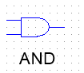
Truth Table
A | B | Output
0 | 0 | 0
0 | 1 | 0
1 | 0 | 0
1 | 1 | 1
Logical Expression
$$Output=A.B$$
  - A OR gate.
Logical Symbol
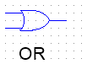
Truth Table
A | B | Output
0 | 0 | 0
0 | 1 | 1
1 | 0 | 1
1 | 1 | 1
Logical Expression
$$Output=A+B$$
  - A XOR gate.
Logical Symbol
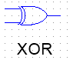
Truth Table
A | B | Output
0 | 0 | 0
0 | 1 | 1
1 | 0 | 1
1 | 1 | 0
Logical Expression
$$Output=A⊕B$$
  - A NAND gate.
Logical Symbol
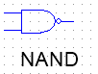
Truth Table

A | B | Output
0 | 0 | 1
0 | 1 | 1
1 | 0 | 1
1 | 1 | 0
Logical Expression
$$Output=\overline{A.B}$$
  - A NOR gate.
Logical Symbol
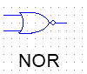
Truth Table
A | B | Output
0 | 0 | 1
0 | 1 | 0
1 | 0 | 0
1 | 1 | 0
Logical Expression
$$Output=\overline{A+B}$$

- Design a logic circuit using a software for the following equations
- $Y=\left(\overline{AB}\right)C+\overline{A}B\overline{C}+\overline{A+C}$

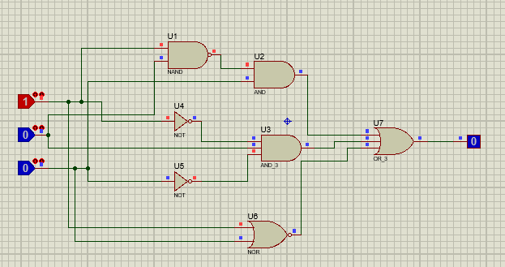
Figure 1: Circuit diagram
- $Y(A,B,C, D) =$ $\sum_{m}{(0,1,5,6,9)}$
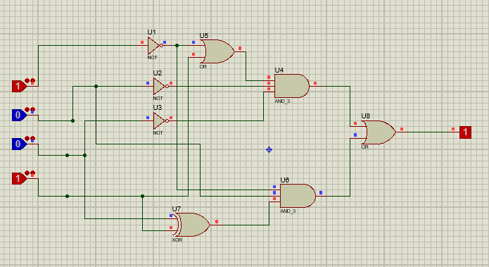
Figure 2: Circuit diagram
- Determine the Boolean expression for the circuit shown below. Simply the Boolean expression and design circuit for the simplified equation using the software. Draw the truth table for the same.
Logical Expression:
$$Y=\left(\overline{A^{'}+B^{'}}\right).B.C$$
Modified Logic Expression:
$$Y=A.B.C$$

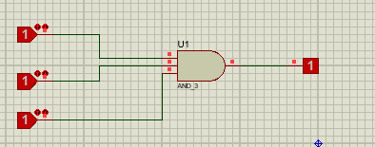
Figure 3: Circuit diagram

Truth Table
A | B | C | Y
0 | 0 | 0 | 0
0 | 0 | 1 | 0
0 | 1 | 0 | 0
0 | 1 | 1 | 0
1 | 0 | 0 | 0
1 | 0 | 1 | 0
1 | 1 | 0 | 0
1 | 1 | 1 | 1
- Design a 4 bit Synchronous counter circuit using Porteous software. Draw a truth table for the input and outputs.

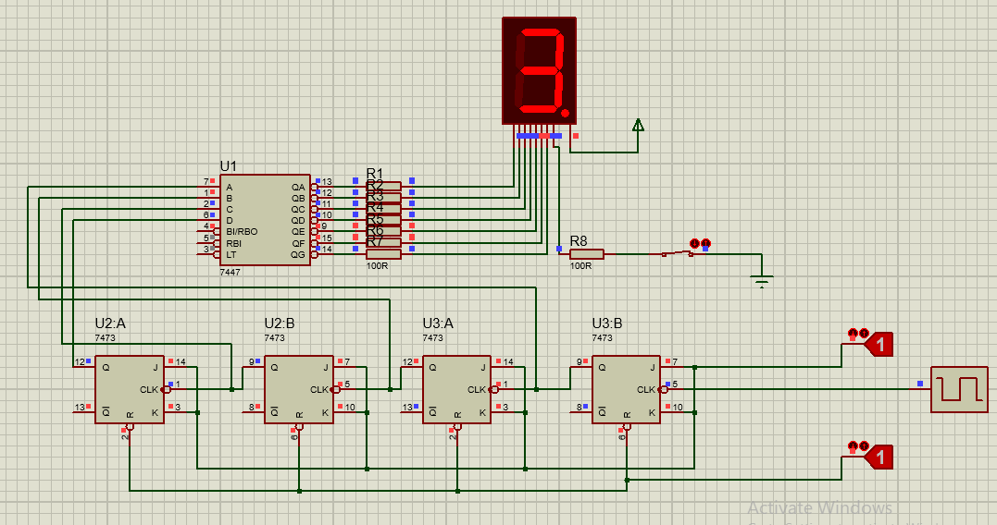
Figure 4: Circuit diagram

Truth Table:
Count | A | B | C | D
0 | 0 | 0 | 0 | 0
1 | 0 | 0 | 0 | 1
2 | 0 | 0 | 1 | 0
3 | 0 | 0 | 1 | 1
4 | 0 | 1 | 0 | 0
5 | 0 | 1 | 0 | 1
6 | 0 | 1 | 1 | 0
7 | 0 | 1 | 1 | 1
8 | 1 | 0 | 0 | 0
9 | 1 | 0 | 0 | 1
10 | 1 | 0 | 1 | 0
11 | 1 | 0 | 1 | 1
12 | 1 | 1 | 0 | 0
13 | 1 | 1 | 0 | 1
14 | 1 | 1 | 1 | 0
15 | 1 | 1 | 1 | 1

Describe the types and applications of Sequential Circuits.
The digital circuits that are able to hold the previous state and their output is dependant on current as well as previous state are known as sequential circuits.
Types.
There two main types of sequential circuits
Synchronous that uses additional clock or level input to drive the circuit functionality.
Asynchronous circuits do not use the additional input clock instead such circuit are being driven by pulses of inputs.
Applications
Applications of Sequential Circuits lies in developing the memory units like
- Registers
- Flip flops
- ADC Converters
- Digital Counters and clocks
- Registers in Microprocessors and Controllers.

