
Applied Leadership and Management
Module Assignment Submission
Student Name: | Harley Scott
Student Number: | 2225835
Module No: | BMSK4003
Module Title: | Learning in a Digital Era

Statement of Confirmation of Authenticity
By the act of making this submission, the student declares that this is the work of the student named above. The work has not, in whole or in part, been knowingly presented elsewhere for assessment, or where assessment has been built on a previous assessment, this has been identified. Where materials have been used from other sources it has been properly acknowledged. If this statement is untrue, the student acknowledges that an assessment offence has been committed.
Attention is drawn to the plagiarism and unfair practice policies of both the University and of ILM.

Section 1: Explain how I can prepare for studying in Higher Education
  - Explain aspects such as: time management, academic writing, referencing, criticality, reflection and other skills needed (1000 words)

The way I can prepare myself for higher education is to be organised and realistic. I work a full-time job and have a family there for it is not realistic to leave my job and attend a full-time higher education course. But I want to further my education. I come across a course Applied Leadership and Management in the workplace in which the classes were once a week in the evening and one Saturday a month. My goal is to eventually become a manager within my workplace and feel this course will help with furthering my knowledge within the managerial role.
“Time management is the practice of using the time that you have available in a useful and effective way.” (Cambridge dictionary, 2023)
By organising my time management, I will be able to work around my job to attend evening classes as I work 7.30am – 2.30pm Monday – Friday and have plenty of evening time to complete the work. My wife works from home so she will be able to watch the children while I spend time doing the work. I pick my children up from school daily after I finish work, however I am home by 4pm. I take my children to Jiujitsu training on a Tuesday evening which takes about 3 hours, which leaves minimal time to do work on a Tuesday however I have no plans on other weekday evenings in which I can complete the work. Weekends I like to go out and spend time with my family, but if I organise my work and prioritise what needs to be done throughout the week to be able to complete assignments, I will still be able to have family time. I prioritise my time by using a white board and writing a checklist. I write what needs to be done by when which helps me manage my time daily. This helps me set goals to brighten my future.
One of the skills required to achieve my goal is academic writing which is defined as being ‘a formal style of writing.’ It is well structured and precise and needs to be objective, which involves minimising emotion and dramatic emphasis in order to focus on the evidence (Oxford Brookes, 2023). Learning how to write in an academic style will help me complete assignments. Academic writing is a formal style of writing used in universities and scholarly publications. The purpose of it is to produce clear and precise information for the reader to understand and take on board. This is done by writing what the evidence tells you, not by writing personal opinions. Providing clear non-subjective descriptions, by being direct so that the reader knows what you are talking about. By having clear written communication your work will be easier to understand. It needs to have a purpose, simple and direct to the point. It is important to use correct spelling and grammar as this will create better communication and understanding from the reader. Proper grammar is necessary for credibility, readability, communication, and clarity. By having incorrect grammar the information you are providing may be portrayed in a different way. In all academic writing, it is important to reference and citate your work. Nyadzi (2023) states that it gives credit to the original sources of information, and it enables readers to locate such source. By following the APA 7 referencing convention I will be able to learn to reference and citate my work. It shows the different ways to citate and how to construct a referencing list. By referencing correctly, it will help to avoid plagiarism.
“Plagiarism is the process of practice of using another person’s ideas or work and pretending that it is your own.” (Cambridge Dictionary, 2023)

Critical writing involves analysing information to understand a problem or a topic from more than one perspective. Critical thinking means learning to use the literature to support the argument and assumptions you want to make in your writing. By being able to think critically it gives you the ability to identify is a source is creditable or fake, it helps you to be able to evaluate and respond to an argument. By following the CRAPP test you will be able to find out how reliable a source is and whether to use it to support your writing. The CRAPP test is - Currency, is the information up to date, has anything changed recently.
- Relevancy, does the source tie in with the topic, does it add any more information?
- Authority, are they recognised experts, and do they know what they are talking about?
- Accuracy, is the information correct and can it be proven?
- Purpose, how true is the information, is it a fact or an opinion. Is the information biased at all?
By learning this skill and applying the CRAPP test to my work I will be able to write and think critically.
Whilst in education I will develop my role as a reflective practitioner I will ‘think about experiences in practice and view them as opportunities to learn’ (Procee, 2006). Gibbs Reflective Cycle will allow me to reflect on the work that I produce. I will be able to describe what I have done, how I felt about it, evaluate the work to decide if I think it is good or bad, analysis my work, conclude and decide what else I could do, create an action plan to decide if I need to do something different next time or would I do the same thing. By following this I will be able to find out what my strong points are and where I need to improve. I would say my learning style is auditory. I learn better by having a tutor speak to me rather than read online and from books. I struggle to take in the information if I just read it. I enjoy working as part of a group as I like to hear other people’s points of views and understanding how other people think.
Skills that I already have that are transferable are that I have good digital skills, I am not shy to speak in front of groups and I feel I have good written English. I can spell and punctuate my work. Skills I feel I can improve on are essay writing, being able to write less as I struggle to keep to a word count and referencing which I really struggle with.

By taking all these steps into consideration I feel I will be well prepared for taking on a higher education and it will only benefit me in the long run. Giving me new skills and helping me grow intellectually and mentally.

  - Create a mind map (500 words max) that shows the skills identified, and how they interconnect to create transferable skills study, life, and workplace
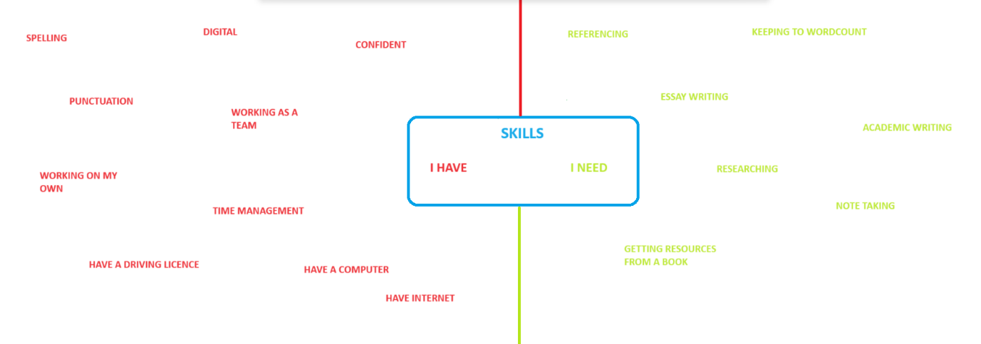

A mind map is an organised way of writing down ideas and information. The idea is that you put the point of interest in the middle and branch of relevant information to the point. The information can be as minimal or as extreme as you like. This helps you to organise your ideas, helps develop new ideas, easier to read as minimal words used compared to sentences and is used by anyone from businesses to home life. (Mind maps, 2023).
My starting point on this mind map was focusing on what skills I already have that are transferable. These are that I am good at working with computers and can work my way around them easily, I have my own and have internet to be able to do work. I have good spelling and punctuation. I work well on my own and within a team and feel I am a confident person. I can speak to anyone and am not afraid to ask for help when it is needed. I can drive and have my own car to be able to attend classes. I have good time managing skills due to working full time and having a family. Skills that I need to improve on that will become transferable skills are referencing, this is something I struggle to do. I find it difficult to write an essay which has a word count, also academic writing is new to me so it is something that I will need practise with. If I practise the CRAAP theory this will help when it comes to having to critically think and write. I don’t tend to write notes when being taught something which later on causes difficulties if I don’t remember something that was said. Reading is not my strongest point which makes researching difficult for me also. However, where I do have a good digital knowledge, this will help when I access books and academic journals from the library.
The things at the top of my list which I will prioritize is learning how to reference using the AVA 7th referencing manual. (APA, 2020). By following the instructions of how to reference from this manual I will be able to eventually be able to reference without following the guide. I also need to prioritize researching from books and the internet as this is an important part of academic writing and is something I will need to do when in higher education.

  - Create a Personal Development Plan showing identified skills and plan for improvement, tabular format (500 words max.)

What do I want to learn? | What do I have to do? | What support and resources will I need? | How will I measure success? | Target Date for Review
Academic Writing | Attend a higher education course,  Practise writing academic essays. | Tutor, laptop, internet, notebook, family support, car to get to class. | Writing essays, having them marked, passing assignments, reflect on work using Gibbs Reflection Cycle, take on board the feedback and use it in future assignments. | After receiving assignment feedback.
Referencing correctly | Follow APA 7 Referencing Manual, ask tutor for help/examples | Tutor, Laptop, Internet | Referencing my work, having my tutor mark them, and giving feedback. | Try to achieve by submission date, then review after feedback.
Note taking | Write notes, to help with completing essay. | Notebook, Different coloured pens, Highlighters. | Successfully writing notes that are useful when writing essays. | When writing each assignment.
Keeping to word count – practise summarising | Practise writing essays with a set wordcount. | Laptop, internet, tutor, family support. | Not going over or under word count when handing in essays. | Each assignment.
Researching from online sources and books | Practising picking out relevant information from online sources and books and applying them to the assignment. | Library, books, laptop, internet, tutor, notebook, pens, highlighters. | Picking out relevant information and applying it correctly to assignment. | Each assignment, then review after feedback from assignment.

“A Personal Development Plan is a written account of self-reflection and improvement, which doubles up as a detailed action plan used to fulfil academic, personal, or career based goals.” (Rolfe A, 2023).
By taking the time and following this PDP, I will be able to achieve the skills that I am wanting to learn, by asking for support from my tutor, having my family encourage and help me and having the correct resources to be able to complete my work such as a laptop, internet, notebook, and stationery. I will measure my success with assignment results, and feedback from my tutor. I will review these monthly with every assignment I complete.

1.4 References

Amber Rolfe, (2023). What is a Personal Development Plan? Personal Development Planning: What you need to know.
https://www.reed.co.uk/career-advice/personal-development-planning-what-you-need-to-know/

America Psychological Association, (2020). Getting Started in APA 7^{th.} APA 7th Referencing.
https://libraryguides.vu.edu.au/apa-referencing/7gettingstarted

Cambridge dictionary, (2023) What is time management.
https://dictionary.cambridge.org/dictionary/english/time-management

Cambridge Dictionary, (2023) What is Plagiarism?
https://dictionary.cambridge.org/dictionary/english/plagiarism

Mind maps (2023). What is mind mapping? The Ultimate Guide to Mind Mapping.
https://www.mindmaps.com/what-is-mind-mapping/#:~:text=Mind%20maps%20provide%20a%20structured,and%20better%20understand%20existing%20information.

Nyadzi, R (2023). 10 Importance of Referencing and Citation in Academic Writing.
https://www.cegastacademy.com/2023/01/08/top-10-importance-of-referencing-and-citation-in-academic-writing/?expand_article=1

Oxford Brookes (2023) Academic Writing, https://www.brookes.ac.uk/students/academic-development/online-resources/academic-writing, accessed 20/9/23
Procee H,(2006), REFLECTION IN EDUCATION: A KANTIAN EPISTEMOLOGY, Educational Theory, 56(3), pp 237-253

