University of Wales Trinity Saint David
Motorsport
Assignment 3
Alexandros Griffiths
2403677
Motorsport Engineering BEng
08/12/24
Electrical Control Systems
399 Words

Time division and resistor calculations
To calculate time division for the scope, I will need to use the formula:
Total Duration of Waveform / Number of Horizontal Divisions
T = 40 us
Horizontal divisions = 10
Time / div = 40/10
= 4 us/div

Function generator output

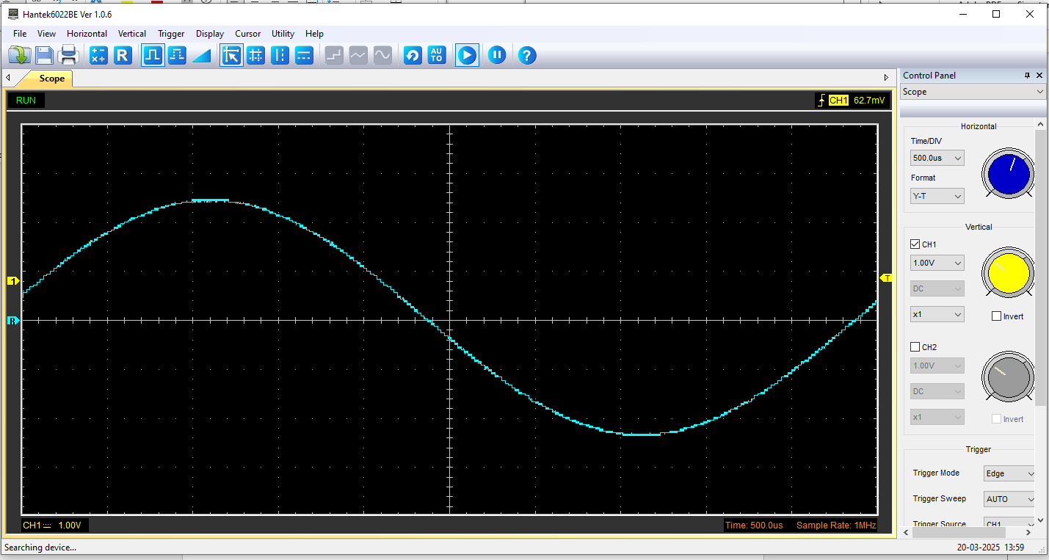
Scope Wave across the capacitor output

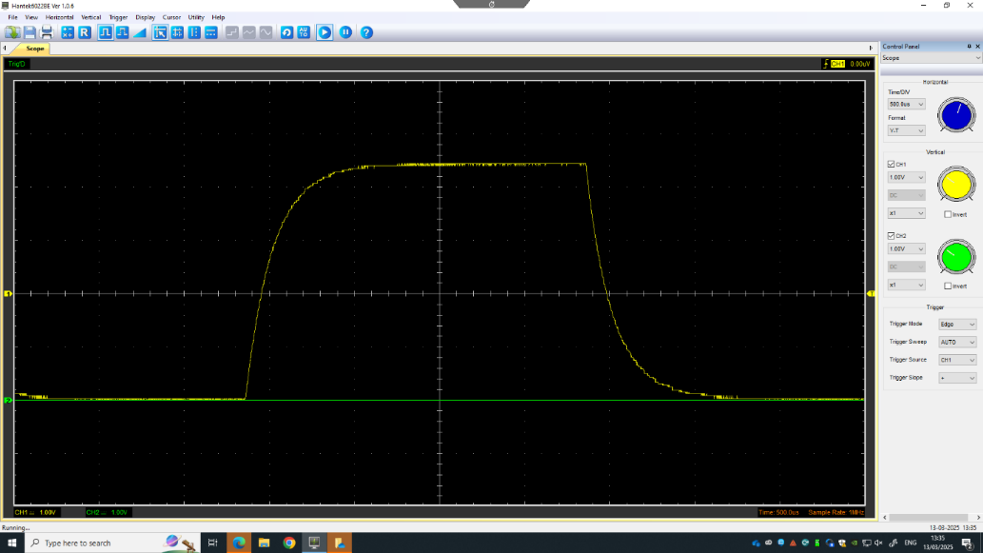

Basic Capacitor calculations
T = R * C
C = t / R
T = time
R = resistance
C = (6 * 10 ^ - 9) / 500 = 1.2e-11
C = 1.2 pF

Table of Data for gradient calculations

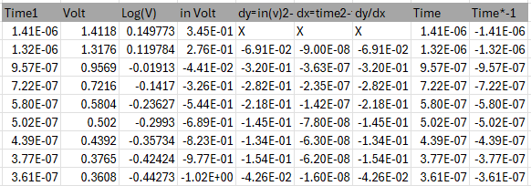

Plot log(V) against time
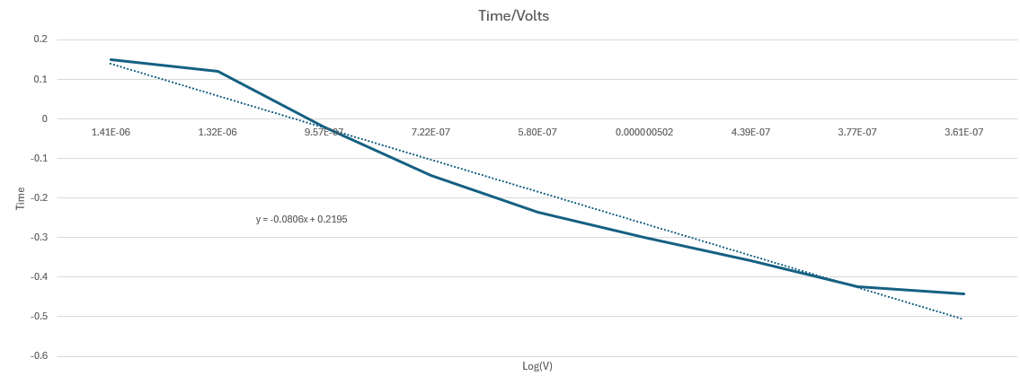

y = -0.0806x + 0.2195

Gradient Calculations
Linear Regression (Log(V) vs. Time):
The discharge of a capacitor follows:
ln(V)=−1/RC⋅t+ln(V0)

Slope (m) of the best-fit line:
m=−4.96×105 s−1m=−4.96×105 s−1

Capacitance Calculation:
C=−1/R⋅m=−1/110,000×(−4.96×105)=2.02×10−10 F= 202 pFC

So

Time-Constant (τ=RC) | 1.2 pF
Logarithmic (Log-V) | 202 pF

Absolute Difference: ∣202 pF−1.2 pF∣=200.8 pF
Percentage Difference: 16,733% (Just a bit off)

Capacitor uses

- Power Supply Smoothing (Electrical): Capacitors store and release energy to smooth out voltage fluctuations in power supplies, ensuring stable electricity for devices like computers and TVs.
- Engine Ignition Systems (Automotive/Motorcycle): Capacitors in ignition systems store a quick burst of energy to create a strong spark, helping engines start smoothly.
- Noise Filtering (Electrical/Auto): They block electrical noise in circuits, preventing interference in radios, sensors, and control systems.
- Electric Motor Starters (Automotive): Capacitors provide an extra power boost to start motors in fans, pumps, and HVAC systems.
- Signal Coupling (Electrical): In audio and radio circuits, capacitors allow AC signals to pass while blocking DC, improving sound quality.
- Timing Circuits (Electrical/Auto): Capacitors control timing in turn signals, wipers, and ECU (Engine Control Unit) functions.
- Energy Storage (Hybrid/Electric Vehicles): Supercapacitors help store and quickly release energy in regenerative braking systems.
- Surge Protection (Electrical/Auto): They absorb voltage spikes, protecting sensitive electronics from damage.
- LED Light Stabilization (Motorcycles/Cars): Capacitors prevent flickering in LED lights by maintaining steady current flow.
- Fuel Injector Systems (Automotive): Capacitors ensure precise voltage delivery for fast, efficient fuel injection.

Question inaccuracies
The massive inaccuracy is from the time constant calculation as I was not to sure if it in the first place and with comparing it to the logarithmic calculation, it confirmed my doubts.

