Organizational Culture and Structure
IULIA-ANDREEA FLITA
Student ID no.2027759

Executive Summary
Morrison operates as a retail superstore in the United Kingdom to gain customer attention. The Company has offered a wide range of products and services to meet customer demand. The main purpose of this report is to analyze the organizational culture and structure with its impact on organizational performance. The report has described the behavioral approach at Morrison that helps to encourage the employee to gain a customer's attention. At last, the report has explained the different factors that can influence individual behavior at the workplace.

Table of Contents
Introduction 4
Company Background (Morrison) 4
Organizational Structure and Its impact on Organizational Performance 5
Organizational Culture and It influence on organizational performance 7
Behavioral Approach and Different Factor can influence individual Behavior at work place 9
Conclusion 10
Reference List 11

Introduction
Organizational behavior is mainly considered a set of people who work at an independent place to accomplish the desired goals (Belei et al., 2017). The report has described the company overview of the Morrison that is retail superstore at the UK. It has explained the organizational structure that helps to improve the ability of the employee. This report has discussed the organizational culture of Morrison and its impact on the performance of the employees. Moreover, this report has discussed the behavioral approach at Morrison. In the end, the report has described the factors that can impact individual behavior at the workplace.

Company Background (Morrison)
In 1899, Morrison was started by William Morrison as a counter seller in Bradford. At present, it is the 4th largest supermarket in the UK and operates business across the world. The Company has a wide range of products and services such as fresh food, bread, and other seafood to meet customer demand effectively (Chai et al., 2021). The Company has operated more than 491 stores across the world. In 2020, the Company has revenue is £17.6 billion with the increased demand for food. Morrison has more than 145,000 employees working in their store and factors to gain customer attention. The Company mainly focuses on carbon energy and effective utilization of resources. With the help of organizational structure, Morrison has encouraged the employee to meet the customer's needs and expectations.
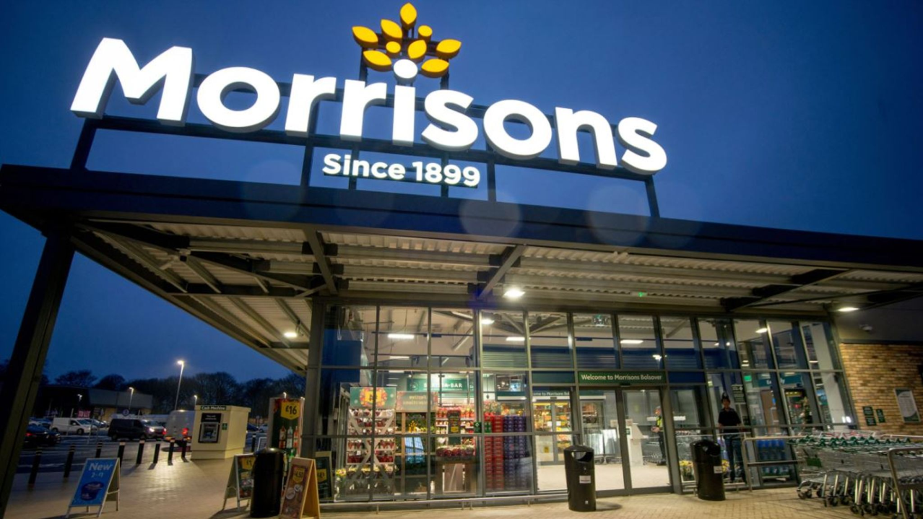
Source: (Belei et al., 2017)

Organizational Structure and Its Impact on Organizational Performance
Organizational structure is mainly considered as activities such as allocation of tasks, coordination, and supervision to accomplish the desired goals (Chai et al., 2021). An effective organizational structure's main aim is to operate processes and set routines to reach the desired goal within the estimated time. Morrison mainly engages in the operation of the retail superstore under the Morrison brand and related activities to gain customer attention. The company has engaged in a wide range of products such as fish, meat, bakery, fruit, and veggies. Morrison has coordination with necessary to link with different tasks such as administrative and specialized to assist the business operation to gain customer attention (Chen et al., 2021). The span of control may affect the organizational structure because of the number of subordinates to each manager of the different departments to accomplish desired goals.
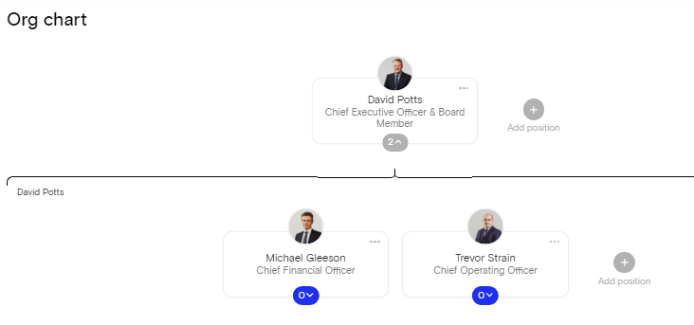
Source: (Chen et al., 2021)
Morrison has followed a flat as well as tall structure to allocate the roles and responsibilities among employees (Bratton et al., 2021). The manager of Morrison has delegated the task as per the roles and responsibilities of the staff members. In the centralized, the manager has the right to make a decision and convey it to a lower level of employees. For a successful organization, Morrison has allowed employees to constantly update the firm and it slowly to gain customer attention. With the help of hierarchical structure, Morrison has properly communicated with each other to make public confidence and public image (Belei et al., 2017). The manager of Morrison has the responsibility to gain customer attention. Morrison has also tried to a new structure for better performance of the workplace. Within a competitive marketplace, the company mainly focuses on the customer to make their work smarter. At the workplace, Morrison mainly focuses on create 1000 jobs at a local store and 3000 in new superstores to become successful in the competitive market (Lubis and Hanum, 2020).
With the help of organizational structure, Morrison has developed a new market kitchen concept with proper improvement and learns to gain customer attention (Chai et al., 2021). The Company has played an important role to maintain a good team and recognize the performance to reach a accomplish goals. With the supportive structure, communication helps managers to help employees to deal with contingent issues. Morrison has planned to make an effective organizational structure to motivate the employee as well as customer to remove barriers and develop a new idea to deal with contingency (Bratton et al., 2021). It mainly includes the Executive Director, Chairman, Managing Directors, Board of Directors, and Board of Management to gain customer attention.
The Board of Directors of Morrison has the main responsibility for setting and approving the strategy to monitor the progress of the firm (Wijaya, 2021). With the help of organizational structure, the Manager mainly focuses on products categories such as fresh food and non-food around 500 chains to gain customer attention. The Board of directors has focused on monitored the financial information to reduce the operational risk (Chen et al., 2021). The Company mainly focuses on circulars, listing, resolution, and correspondence to deal with continent situations. With organizational structure, Morrison has got rid of format stores to make their customer happy and satisfied. The Company mainly focuses on competitors to gain customer attention (Wang et al., 2021).
Morrison has served customers across the UK through more than 500 stores. The company has operated more than 10 production sites around Britain (Bratton et al., 2021). Morrison mainly focuses on more than 50 production sites that help to manufacture products and services to gain customer attention. With the help of a friendly environment, Morrison has celebrated, attract, and retain great talent and care of local communication for future success (Lubis and Hanum, 2020).

Organizational Culture and It influence on organizational performance
Organizational culture is considered a set of beliefs, values, assumptions, and ways to interact that contribute to a social environment for a local community (Bratton et al., 2021). At Morrison, organizational culture mainly includes expectation, experience, and guide the member to maintain a strong brand image among customer minds. The culture of Morrison mainly includes vision, norms, systems, and symbols to become a successful leader in the marketplace (Belei et al., 2017). In the competitive marketplace, the organizational culture at Morrison ensures to all employees share the common purpose to accomplish desired goals. In the marketplace, Morrison has developed a culture to increase knowledge, ability, and performance. The company has support skills and knowledge to reduce customers and meet their expectation (Salameh and Zamil, 2020).
Moreover, the organizational culture of Morrison has employees to develop a culture to increase the experience as well as skills. With the help of culture, the Manager of Morrison has provided guidance and direction to deal with changing environment. The leader has the desired role in maintaining their culture to engage people at the workplace (Chai et al., 2021). Leader motivated their employee as well as subordinate to focus on goals to become successful in the marketplace. Positive workplace culture has brought trust, coordination, and more efficient decision-making. Morrison has played an instrumental role in shaping and sustaining an organizational culture to gain customer attention (Spicer, 2020). At Morrison, the manager has developed a value of excellence, passion, integrity, and collaboration to reach desired goals. The company mission and values help employees to achieve personal as well as professional objectives. With the culture, the company mainly focuses on protecting the environment from unwanted waste and carbon emissions (Sartipi, 2020). The Company has promoted a workplace culture and make sure the environment for all employees may develop their potential and capabilities.
Morrison has developed an incentive development plan to encourage people and shared knowledge to deal with the contingent situation (Wang et al., 2021). The Company has become capable to deal with greater ROI and make sure to attain long-term success. The manager of Morrison has engaged employees to enjoy the work and retain them for future development. The Company has introduced new training and development program to improve the staff knowledge. In the culture, the company is supposed to invest in training and learning programs to enhance the competency level of employees at the workplace. If the organization has maintained a healthy environment or culture helps to promote a vision of excellence. Morrison has properly analyzed the working experience and ability of the employees to deal with changing market environment (Salameh and Zamil, 2020). With an effective organizational culture, the Manager maintained strong coordination with the employees to increase their performance and productivity of the firm. A strong culture mainly focuses on the values and growth of the business (Spicer, 2020).
The managers of Morrison display a strong organizational culture to share the value, and goals of the business to gain customer attention (Wang et al., 2021). With the help of communication, Morrison has motivated their employee to share a new idea, and opinions to take the right decision for future development (Belei et al., 2017). Through promoting diversity, the company mainly focuses on creativity and provides information to deal with a diverse workforce.

Behavioral Approach and Different Factor can influence individual behavior at workplace
Individual behavior is considered the way that an individual reacts or behaves at the workplace with other people. Morrison has maintained a good working environment, so the employee freely is happy and satisfied while doing their job (Sartipi, 2020). Positive behavior may lead to improve the performance and productivity of the firm. Furthermore, the negative behavior of employees may destroy the market position as well as customer confidence. At the workplace, Manager as well as leader performs their role to influence the behavior of an individual to meet the set goals. Leader's main responsibility is to sets a direction and guidance among team members to deal with different types of employees (Salameh and Zamil, 2020). As a leader of a successful organization, the Manager has conducted a training and development program for new skills and upgrade their knowledge to make the right decision for future success. The different factors that can influence individual behavior at the workplace are discussed as under:
- Work culture: It is very important to the employee feels comfortable at the workplace. Morrison has developed rules and regulations for everyone to motivate them (Warrick, 2017). A weak or a negative working environment may demotivate the employee and they are not capable to perform their task effectively. The Company mainly focuses on job safety and security of employees that make a positive influence on employee behavior at the workplace.
- Job Responsibilities: At the workplace, each employee has their roles and responsibilities to survive and meet the expectation of the leader. Morrison has focused on the skilled and experience of an employee as per their knowledge allocates the task, so they effectively perform it (Sartipi, 2020). The Company has maintained coordination among employee, so an employee does not feel overburden. At Morrison, Leader has organized training and learning programs to upgrade their skill with the latest trends.
- Effective Communication: The manager of Morrison has required communicating with team members to accomplish desired goals. The employee is free to express their feeling, opinion, and idea to deal with the market problem during the pandemic (Warrick, 2017). To deal with the pandemics, the company has developed new strategies to deal with different types of an employees at the workplace (Wijaya, 2021).

- Relationship at Work: It is very important for the employees to deal with a different staff member. With the help of employee behavior, the company has share experiences to reduce frustration and stress at the workplace (Salameh and Zamil, 2020). The manager has argued with team members to take the right decision for future success.

Conclusion
In conclusion, the report has discussed the organizational structure and its impact on organizational performance. It has examined the organizational culture and its influence on the performance of the employee. The report has discussed behavioral approaches to make their employee happy and satisfied at the workplace. It has illustrated the different factors that can impact on the individual workplace to gain customer's attention.

Reference List
Belei, O.A., Heredea, E.R., Boeriu, E., Marcovici, T.M., Cerbu, S., Mărginean, O.T.I.L.I.A., Iacob, E.R., Iacob, D., Motoc, A.G.M. and Boia, E.S., 2017. Verner-Morrison syndrome. Literature review. Rom J Morphol Embryol, 58(2), pp.371-376.
Bratton, J., Callinan, M., Forshaw, C. and Sawchuk, P., 2021. Work and organizational behaviour. Red Globe Press, Macmillan International Higher Education.
Chai, P., Zhang, J., He, R., Lin, W. and Shu, X., 2021. Application of Sherman-Morrison formula in adaptive analysis by BEM. Engineering Analysis with Boundary Elements, 128, pp.244-256.
Chen, Y., Bretschneider, S., Stritch, J.M., Darnall, N. and Hsueh, L., 2021. E-procurement system adoption in local governments: the role of procurement complexity and organizational structure. Public Management Review, pp.1-23.
Lubis, F.R. and Hanum, F., 2020, December. Organizational culture. In 2nd Yogyakarta international conference on educational management/administration and pedagogy (YICEMAP 2019). Atlantis Press (pp. 88-91).
Salameh, A. and Zamil, Z., 2020. The effects of reward systems and organizational structure on tacit knowledge sharing. Management Science Letters, 10(10), pp.2229-2236.
Sartipi, F., 2020. Organizational structure of construction entities based on the cooperative game theory. Journal of Construction Materials, 1(2).
Spicer, A., 2020. Organizational culture and COVID-19. Journal of Management Studies, 57(8), pp.1737-1740.
Wang, Y., Xiao, S. and Ren, R., 2021. A moral cleansing process: How and when does unethical pro-organizational behavior increase prohibitive and promotive voice. Journal of Business Ethics, pp.1-19.
Warrick, D.D., 2017. What leaders need to know about organizational culture. Business Horizons, 60(3), pp.395-404.
Wijaya, N.H.S., 2021. Proactive personality, voice behavior, and the roles of team social exchange. Jurnal Siasat Bisnis, 25(2).

