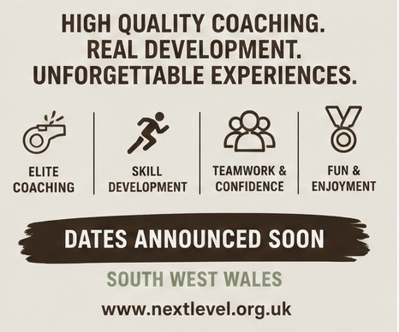
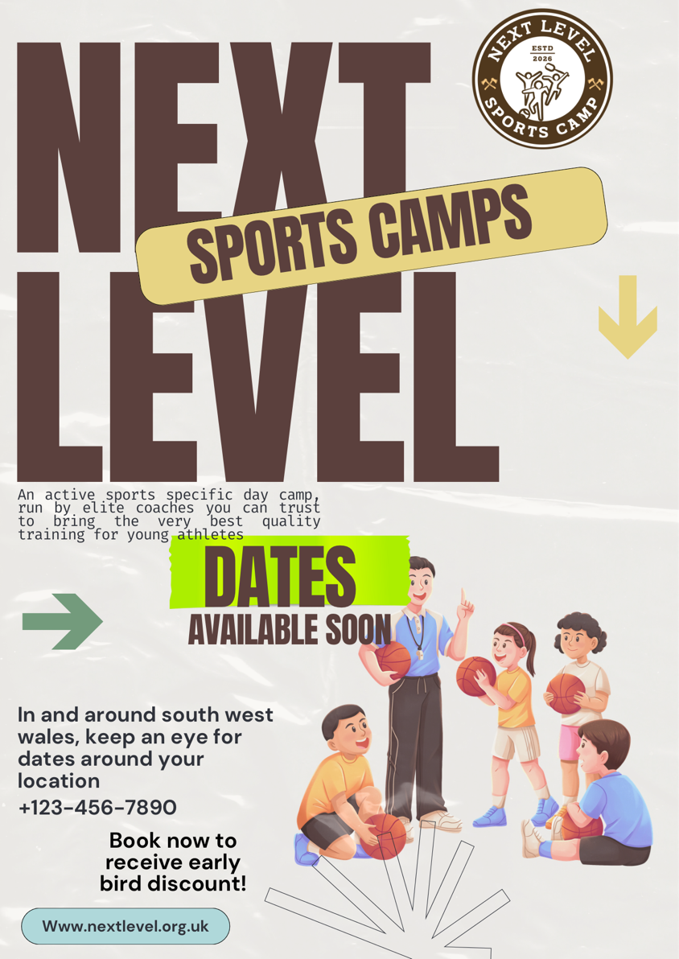
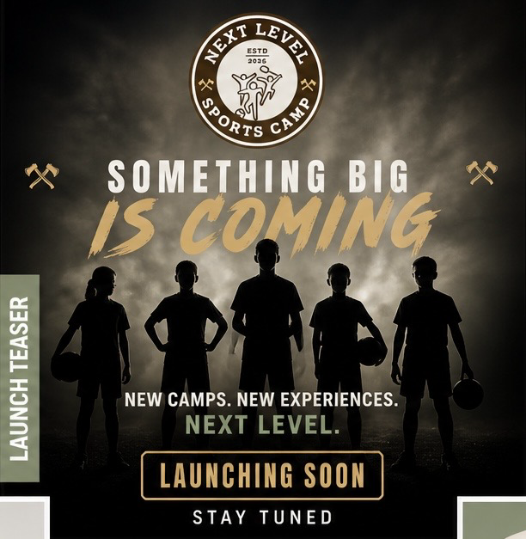

Marketing material
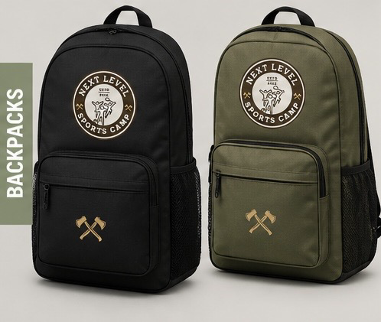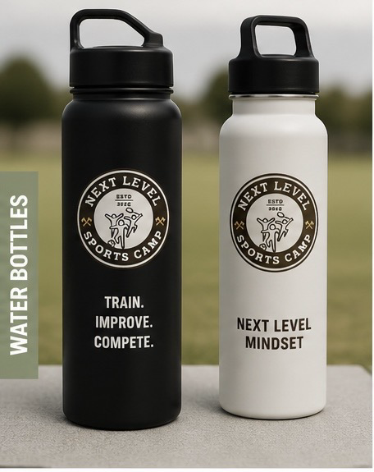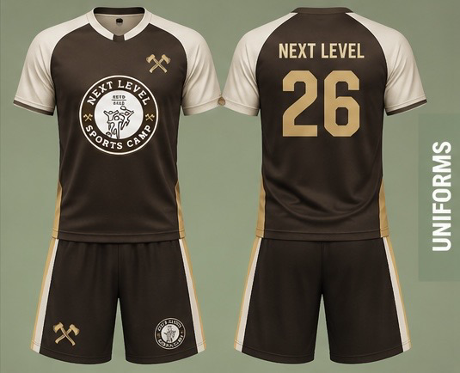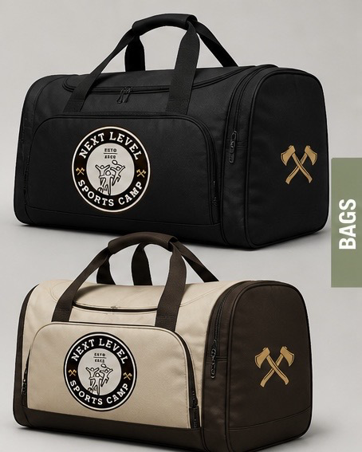

Promotional Media:

Next Level - Activities
https://youtube.com/shorts/a65xRqC7QQM

Next Level – Registration
https://youtube.com/shorts/DJAV6FVadeg

Next Level – Classroom
https://youtube.com/shorts/I8VI3ea-OpE

Next Level – Feedback
https://youtube.com/shorts/T1jT-Xr7lpg

