
Name: Oliver Bowcott

Student Number: 1908074

Module: Material Science and Building Services

Module Code: ACBA4006

Assignment Title- Construction Materials

Contents Page

- Introduction

- Climatic Resistance and Durability

- Environmental Impacts

- Ease of Assembly and Adaptation

- Conclusion

- Appendix

- Bibliography

Material Science and Building Services
Construction Materials
Introduction
There are many ways in which a building, dwelling and all other forms of the built environment can be constructed, by way of construction type and materials. In this response I will be selecting two habitable buildings from around the world, these being the Leadenhall Building that is a steel framed structure situated in the heart of London and the Burj Khalifa a concrete framed building in the busy heartland of Dubai, United Arab Emirates. With the two buildings in question I will find comparisons and contrasts in their durability and climatic resistance. The likely impact of the frame material’s original production process on the environment, with particular mention to embodied energy in the construction process. Lastly, I will detail and explain the ease or difficulty in the assembly and possible adaptation of the building shape and use. Throughout the response I will provide detailed analysis and balanced viewpoints on the aforementioned points.
Climatic Resistance and Durability
Beginning with the Leadenhall building in London, where this fifty storey tower opposite Lloyd’s of London with a height of 224.5 metres, is a slender form that creates its own distinctive profile within an emerging cluster of tall buildings in the Central Business District of London. Where its durability and climatic resistance is concerned as London is the Capital City of England there are certain materials and construction methods that are suitable for a temperate climate to withstand mild winters and cool summers. In a way this will not prove as difficult when compared to the Burj Khalifa as the climatic condition are far more prevalent in Dubai than in England, albeit, the climatic conditions will still need to be considered in the deign process- in this case being Richard Rogers the main architect in the design of the Leadenhall building. The use of steel is fundamental to the value of this building, as it is visibly integrated into the architecture as well as the pleasing aesthetics the steel will provide a great durability and climatic resistance. In way of durability steel is excellently classed and somewhat unrivalled and is amongst the most attractive property of steel. When steel structures are properly designed and constructed to the exact specification they will provide long- term durability, the Leadenhall building is a great testament to this. Also, when further protection is needed zinc coatings are readily available, to provide sacrificial protection as well as a barrier protection, this makes the steel far more durable and allows a longer life span for the building.
https://www.steelconstruction.org/design-awards/2017/award/the-leadenhall-building-london/
A further advantage in climatic resistance of steel in construction, can be seen through the ability to withstand immense pressure when faced with earthquakes. A ductile building in the form of steel construction will have the ability to bend, sway and deform without collapsing. Building failures during earthquakes are often due to poor construction methods, in the lesser developed countries poor mixture of the concrete will have an adverse effect on the structural stability of the building- thus buildings are more susceptible to failure under seismic loading, this is easier to avoid when using steel framed as there are certain ways in which steel can be formed to provide a more structurally sound base. As seen below in the Leadenhall Building See Appendix A. Through the construction style as seen in the Leadenhall Building the joint where the diagonal steel members meet provide excellent structural support in the way of wind protection. This approach is used widely in eastern countries such as Japan, as this will protect widely against earthquakes and tremors.
By contrast the concrete frame of the Burj Khalifa which was first thought up by Emaar, where construction began in January 2004, resulting in tallest man- made structure in the world. By using over forty- five thousand metres cubed of concrete and weighing more than one hundred thousand tonnes the extraordinary building is the epitome of concrete construction excellence. Where climatic resistance and durability is concerned the Burj Khalifa was in need of superb stability from the base upwards to its two thousand seven hundred- and seventeen-foot height. (Architectural Height). The main reason the Burj Khalifa was in need of sound structural ability is the presence of high winds in the middle of the UAE desert. This was achieved through special design to conquer the wind, in way of a buttress core. Which is buttressed in three directions, which is a unique solution to a particular problem. This allows the building to achieve its height whilst being able to remain structurally sound. BY using concrete which is extremely malleable and unrivalled in terms of being able to create and shape to whichever design is necessary. The concrete used in this case was formed by twenty-five different components and ingredients. The use of concrete in the construction of this building is paramount to its durability and ability to withstand the climatic conditions of the United Arab Emirates. With concretes ability to be set and worked to whichever shape is necessary, the building becomes narrower as the building grows higher, thus combatting high winds and further climatic challenges of the Dubai desert.
https://www.youtube.com/watch?v=GA3Ak7ZaNUo

Environmental impacts of Construction Materials

The environmental impacts of the Leadenhall Building can be seen clearly through this quote by British Land “The team at The Leadenhall Building in the heart of London's insurance district is putting our community commitments into action and exceeding several of our sustainability targets”.
By deciding to construct using a steel frame many environmental advantages over concrete construction were achieved. The metallurgic properties of steel allow it to be recycled. This in turn allows steel to be melted and reused an infinite amount of times, with little to no compromise in its material capability. When looking at the recycled element of steel use in the Leadenhall building had upwards of twenty five percent recycled material rate. Which when compared to the Burj Khalifa, which has next to no recycled material as concrete is far inferior of Steel where recyclability is concerned.
Albeit steel does had disadvantages in terms of environmental impacts as where the Leadenhall building was constructed using two hundred and twenty five metre high worth of steel will have used a vast amount of energy in way of electricity to melt the steel and form into the shapes necessary for the assembly of the building. The amount of electricity used for Steel production is arguably its greatest disadvantage. Also, about one half of all steel industry’s total energy consumption comprises coal, which is largely used as a reducing agent to fire the blast furnaces in which the steel is melted. A further emission created in the production of steel is where Nitrogen Oxides are concerned. The high temperatures that are a necessity for the production means the formation of nitrogen oxide are extremely difficult to avoid during the fuel combustion processes since the nitrogen is in the air.
Lastly a large amount of dust is formed in the majority of steel production process, although the development of dedusting technology, filters and ventilation systems meaning that dust emissions has been greatly reduced in the most recent years of steel production.
https://www.jernkontoret.se/en/the-steel-industry/production-utilisation-recycling/environmental-impact-of-the-processes/
By contrast the construction of the Burj Khalifa which consumed 330, 000 metres cube of concrete throughout its construction. With this vast amount of concrete needed to provide the structural stability of a building to this magnitude there are somewhat environmental impacts that are left behind in the trade off. The main problem with concrete is its high embodied energy as can be shown in Appendix B; Where the inventory of Carbon and Energy at Bath University estimates that it takes four million British thermal units to produce one ton of Portland Cement. As high as these numbers are, they must be taken into perspective, as cement has a lower embodied energy per pound than steel, alluminium, fiberglass insulation also concretes embodied energy is significantly less around the same amount as cellulose insulation.
Cradle-to-gate measurements of embodied energy taken from University of Bath Inventory of Carbon and Energy (ICE), Version 1.6a, 2008.
The most prevalent disadvantage of the use of concrete in construction is the fact that it is the most abundantly used material. Therefore, its production has a huge impact on the atmosphere. Albeit According to the EPA’s report, "Quantifying Greenhouse Gas Emissions from Key Industrial Sectors in the United States," energy-intensive steel and iron production uses more carbon dioxide than that of cement and concrete, although fifty percent of the steel aforementioned is used for construction compared with ninety- five percent of cement, meaning construction based emissions approximately fifty seven mmt for iron and steel compared to seventy nine mmt for cement and concrete.
https://www.buildinggreen.com/feature/reducing-environmental-impacts-cement-and-concrete
https://steelfabservices.com.au/the-environmental-benefits-of-structural-steel/

Ease of Assembly and Adaptation

The possibility of extending the cradle to grave of a working material has never been further at the forefront of any architect’s design agenda, albeit that it was the tight working area that superseded this in terms of the Leadenhall building. As a byproduct of this the building has the potential to be adapted. With the tight working area provided in the CBD of London, this meant that the majority of the work was achieved off site in the North of England being Bolton, this provided a very small margin for error as the components of the building were fabricated offsite and then transported to site. As shown in the Leadenhall documentary referenced in the bibliography. The beneficial reason of ease in assembly off site provides a contrasting problem on site, with specific deadlines and problems with the tight working areas.
The cradle to grave timeline of steel will far surpass that of concrete. Main reason being is that the steel will be able to be recycled come the end of the building’s lifetime. Once the steel will be melted it can be re shaped and set to be used in whichever way is necessary, therefore extending its cradle to grave span. Meaning steel is the most versatile material to recycle.
https://www.steelsustainability.org/recycling
By contrast the Burj Khalifa, was by majority cast in situ concrete, with a tremendous amount of concrete used, as previously stated. The problematic aspect with concrete use as a material in construction is that once it has set there is very little possibility to be re used, apart from use in aggregate for concrete in the future. The main advantage of concrete use in terms of ease of construction, is that it can be constantly poured, where the Burj Khalifa is concerned, the concrete could be mixed on site with the unique mixture and then laid in situ, thus speeding up the process of construction.

Conclusion
Overall in conclusion the material choice is not a binary choice, there are many different viewpoints and conditions that need to be established. Where concrete was ideal for the Burj Khalifa in terms of ease in construction, due to its ability to be pored constantly, this will not have been possible when building the Leadenhall building due to the constraints of working space. Where in turn steel was the for more efficient choice by way of being able to fabricate off site and transport when needed.
When environmental impacts of construction are evaluated both Buildings have equal trade- offs, where Steel uses more energy in the production, it can at least be recycled, compared with the Burj Khalifa, as the concrete will use less energy and emissions in the conception of the material, it cannot be re- used as easily as steel.
Lastly in terms of ease to adapt, the Leadenhall Building far surpasses that of the Burj Khalifa, majorly due to steel having the ability to be recycled and re used once melted, whereas once the structure of the Burj Khalifa was erected there is Littlemore that can be done to achieve an adaptation.

Appendix

Appendix A-
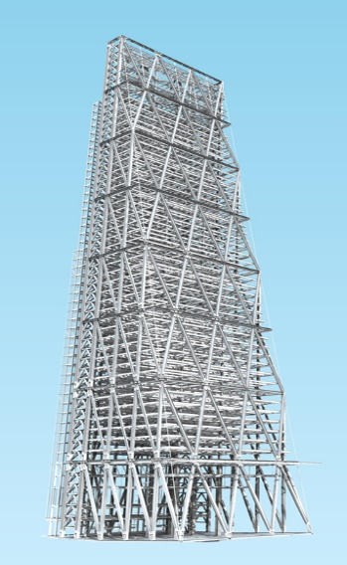
https://www.tekla.com/uk/model-comp-2011/images/pics/entry12_big_pic2.jpg

Appendix B;
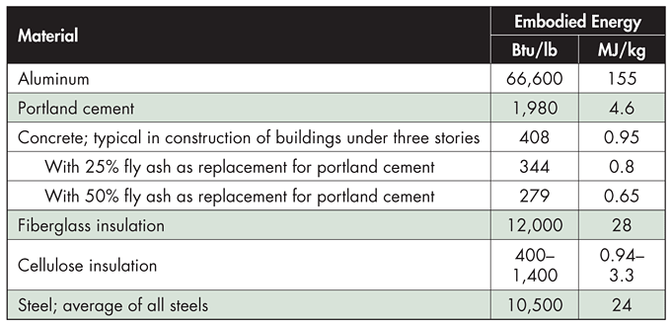
https://www.buildinggreen.com/feature/reducing-environmental-impacts-cement-and-concrete

Bibliography
https://www.steelconstruction.org/design-awards/2017/award/the-leadenhall-building-london/
https://www.burjkhalifa.ae/en/the-tower/design-construction/
https://www.youtube.com/watch?v=GA3Ak7ZaNUo
https://www.youtube.com/watch?v=eg0PqkwPzVA
https://steelfabservices.com.au/the-environmental-benefits-of-structural-steel/]
Cradle-to-gate measurements of embodied energy taken from University of Bath Inventory of Carbon and Energy (ICE), Version 1.6a, 2008.
https://www.buildinggreen.com/feature/reducing-environmental-impacts-cement-and-concrete
https://www.steelsustainability.org/recycling

