UWTSD
MPI Assignment
[Document subtitle]
Rowan Patey (2317629)
1-13-2025

Table of Contents
1. Hardware 2
1.1 Circuit 2
1.2 Power circuit and sounder 2
1.3 Buttons and MCLR 5
1.4 Clock circuit 7
1.5 7-segment display 8
1.6 16F84A microcontroller 8
2. 7 segment display calculations 9
2.1 0 9
2.2 1 9
2.3 2 10
2.4 3 10
2.5 4 10
2.6 5 10
2.7 6 11
2.8 7 11
2.9 8 11
2.10 9 11
2.11 A 11
2.12 B (b) 12
2.13 C 12
2.14 D (d) 12
2.15 E 12
2.16 F 12
3. Assembly programming 13
3.1 0-F display cycle 13
3.1.1 Assembly code 13
3.1.2 Pseudocode 14
3.2 L and r buttons 16
3.2.1 Assembly code 16
3.2.2 Pseudocode 17
3.3 On/Off buttons 18
3.3.1 Assembly code 18
3.3.2 Pseudocode 19
References 21

1. Hardware

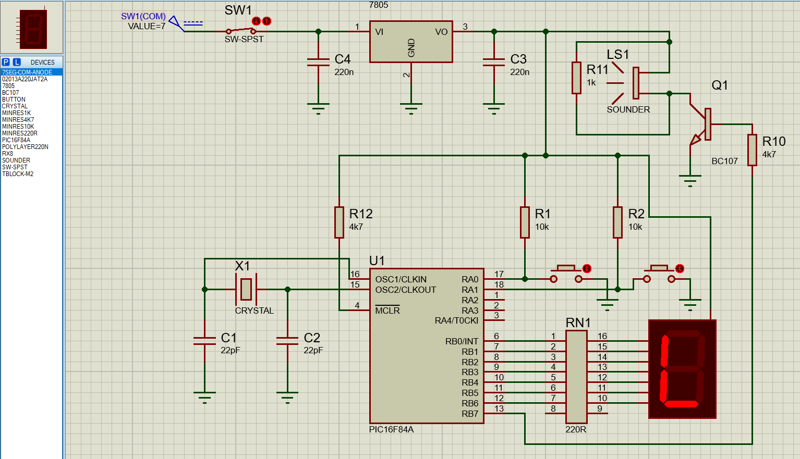
1.1 Circuit
Figure 1. The full outlined circuit of “HND/BENG PIC16F84 Assignment Board” has been recreated in Proteus 8, using the PIC16F84 as the microcontroller for the circuit that can be programmed. Pin B7’s output highlighted in figure 2.
The whole circuit is controlled by the PIC16F84A microcontroller.

1.2 Power circuit and sounder
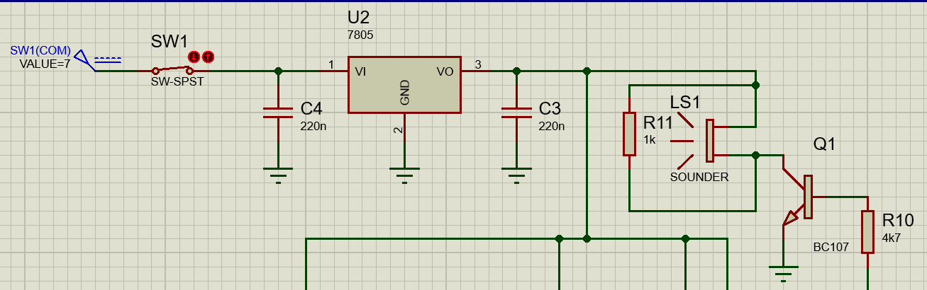
Figure 2 shows the power circuit for the assignment board. The power line has a +7V D.C. current input going through an SPST switch, SW1. Proteus will power the circuit without adding a power source, however this more accurately represents the real circuit layout of the assignment board. SPST stands for single-pole, single-throw and is the least complex configuration for a switch where only a single input and output are being connected [1]. This switch acts as a basic ON-OFF switch, where current can flow if the poles are connected and cannot if the switch isn’t making contact i.e. in the OFF position. It is perfectly suited to this application where only a single power circuit is being controlled by the switch, compared to say an SPDT switch that could switch between two potential outputs and two potential circuits to power [1]. The switch has a modelled ‘closed’ resistance of 0.01Ω and a modelled ‘open’ resistance of 100MΩ, meaning current will flow when closed with minimal resistance while practically not flowing (beyond negligible) when the switch is open. The example assignment board uses an SPDT switch, but for the purposes of this recreation an SPST switch is more representative given the SPDT switch of the example board only has a single output connected [2].
Figure 2. Power circuit for “HND/BENG PIC16F84 Assignment Board” with pin B7 output circuit included
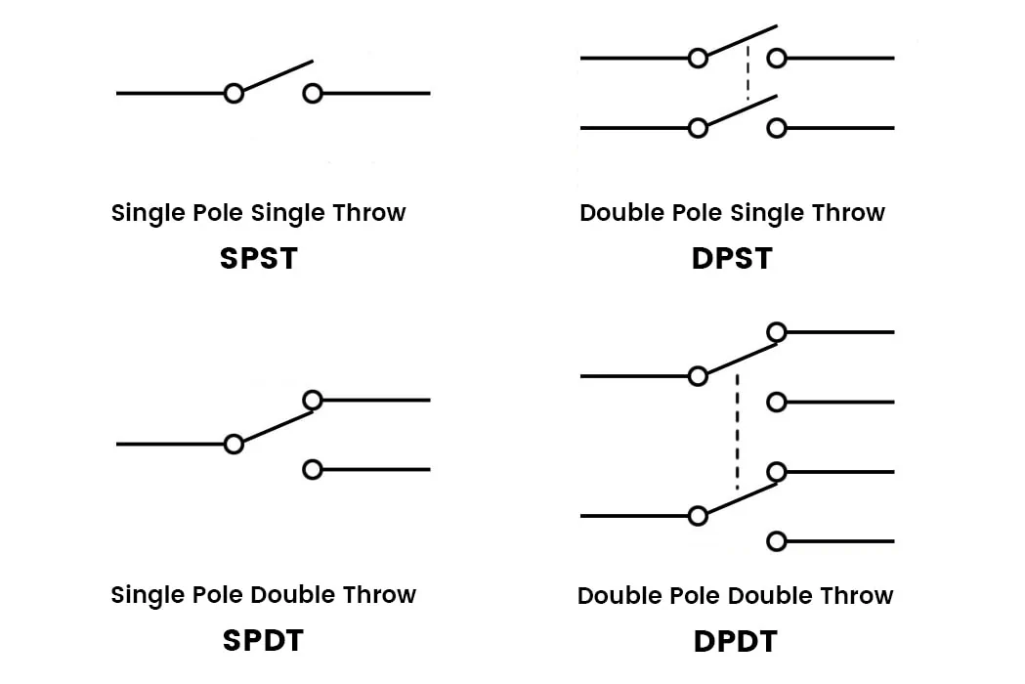

Figure 3. Different switch configurations, with SPST shown left. Switches differ by the number of inputs and outputs they have. [2]

U2 is a 7805 positive linear voltage regulator IC, part of the 78XX series of regulators [3]. Microcontroller’s typically have small tolerances for voltage input, therefore it is important to regulate the power being input to the circuit to ensure the desired +5V is fed into the PIC16F84A. Regulator’s themselves have a drop-out voltage, the 7805 in particular having a drop-out of 2V, therefore 7-25V is needed as an input to produce a stable regulated +5V output [3]. This dumped voltage is dissipated as waste thermal energy, therefore the IC has a metal heat sink for aiding in the removal of this heat, see figure 3 for the heatsink. Capacitors are needed on either side of the regulator to produce a fixed-voltage regulator effect, per the specifications document [3]. Therefore two ‘generic primitive’ non-polarised capacitors have been placed at the input (Vi) and output (Vo) pins, both with a value of 220nF. On paper, the 7805 regulator uses an NPN Darlington power transistor, meaning it can be robust enough not to require surrounding capacitors compared to newer LDO (low drop-out) regulators that depend on output capacitors of match ESR (equivalent series resistance) [4]. The purpose of these capacitors is primarily smoothing, where the capacitors will charge and discharge slowly to smooth out any fluctuations in power flowing around the regulator [5]. For example, the switch before the input will experience ‘switch bounce’, a phenomenon where in the switch physically bounces against the contact due to the change in momentum of the metal plate meeting the contact over typically ~1ms [6]. Without the input capacitor, about these rapid spikes and troughs of voltage would be input before the voltage settles to +7V. The input capacitor slowly charges and discharges during this short period, creating a smoother and more definitive ‘switch on’ of input voltage to aid the regulator in maintaining a clean +5V regulated output.

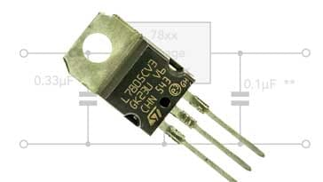
Figure 4. 3-pin 7805 voltage regulator with an inbuilt heat sink for dissipating waste energy [5]

The power circuit then connects to the +5V rail to supply power to the rest of the circuit.

On the right of figure 2, the spare register port B pin of the PIC16F84A microcontroller, B7, outputs to the transistor, Q1, and sounder, LS1, first through a 4700Ω primitive resistor (R10). Pin B7 is an I/O pin of port B of the PIC16F84A with no other functionality. The I/O pins have the ability to either be inputs or outputs for the controller but crucially only input/output digital signals of 0V to 5V. They cannot be inputting and outputting at the same time, therefore B7 will be set within the TRISB data direction register to be an output pin for outputting a digital signal to the sounder [7]. The BC107 transistor and preliminary 4700Ω resistor behave like an amplification system for the sounder. The resistor acts to limit the current of the incoming +5v digital signal from B7 to provide a suitable base current to drive the BC107, while being substantial enough to ensure the pin is otherwise not driving the base when not intended to be set. BC107 is an NPN transistor that is used as a ‘low noise general purpose audio amplifier’ [8]. As a BJT it is current driven, the BC107 will ‘switch’ when sufficient current is supplied to the base. Far greater current can flow from the collector to the emitter, driving the sounder by creating a complete circuit to ground through the sounder down to the emitter [9].

The circuit uses a piezoelectric sounder, LS1: Sounders such as this typically consist of a metal backing plate with a layer of piezoelectric element, usually ceramic, on top with a plastic resonator chamber around it [10]. relying on the piezoelectric effect to function. When a piezoelectric element is physically deformed, it generates a small A.C current [11]. Placing an alternating voltage across the same piezoelectric element causes it to flex and vibrate against the metal plate, creating a buzz at the frequency of the input signal [11]. The whole circuit requires a D.C. voltage input from the power rail, as such it is assumed that the piezo sounder module within Proteus is an IC that can alternate an input signal, given the simulated sounder produces a clean single sound when testing with this configuration. The D.C. power rail is feeding into the sounder directly but a tone is still produced when the BC107 has a saturated base, contrary to the theory outlined for piezo sounders requiring an A.C. voltage to vibrate. D.C. can even depolarize the ceramic element of the sounder in a real circuit [10]. Often piezo sounders need to be driven by flipping the polarity of the two pins, however the sounder in this simulated configuration appears to be sufficiently powered by setting one of the sounder’s pin’s low while connecting the other to the power rail, contrary to sources [10].

1.3 Buttons and MCLR
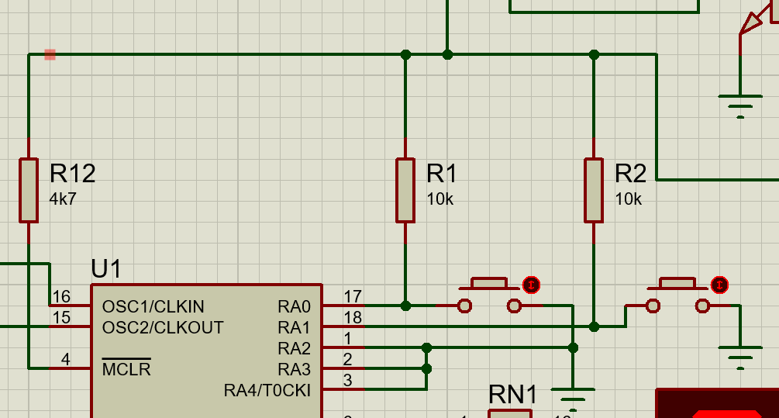
Figure 5. Interfacing circuit, fed from the power rail above, with two ‘push to break’ buttons connected to pins A0 and A1 of port A, with a connection line to the master clear pin MCLR.

Feeding in from the power rail above, described in 1.2, register port A of the PIC16F84A is shown. Two pushbuttons have been connected to pins A0 and A1 of port A. To have this configuration, like pin B7 of port B both of these pins must be set using the internal register for port A [7]. In this scenario, the two pins will function as input pins as these will serve as the controls of the system. However, this configuration utilises ‘push-to-break’ buttons, seen though the pull up resistors and grounding connection on each side of the buttons [12]. Pressing the buttons completes the circuit to ground from the power rail through the pull up resistors, R1 and R2. Pins A0 and A1 will be held logical high when the buttons are not depressed and brought to logical low when the buttons are depressed in turn [12]. The 10kΩ pull-up resistors cause little voltage drop across their pins, meaning almost all of the +5V input signal from the power rail is received at the pins; when the buttons are pressed, the high resistance ensures that the current flowing through to ground from the power rail is small enough to not short the whole circuit [12]. If the pull-up resistor values are too great, a variety of issues can arise: Of particular note here, the resistors form R-C circuits with the output capacitor of the regulator, meaning the time constant, τ, will increase proportionally with the magnitude of the resistance [13]. This will directly slow signal transition speeds where the output capacitor will discharge slowly upon a button press, causing noticeable delay to the pin state transition. The capacitor recharging slowly after a button press drains the stored charge would exacerbate switch bounce where multiple inputs may be registered from the low to high transition taking much longer. Larger resistors make the pins more susceptible to electrical interference due to the increased impedance at the pin. Alongside this, internal impedance at the pin and the external resistor form a voltage divider, dividing the input signal too heavily to read as a logical high input [14].

All of the unused register port A pins are connected to ground given they are not in use and need to complete a circuit to ground to ensure they do not introduce interference into the microcontroller.

The power rail is also connected to the MCLR pin: MCLR stands for ‘master clear’ and acts as a reset pin [7]. The bar over the top implies that you the pin must be brought low, an active low reset, therefore in this configuration the MCLR pin will be held high until power from the power rail is disrupted. This is an appropriate function for cases where the circuit loses power, where the MCLR reset will reset all of the internal registers and reset the PIC controller to a known state, where the drop of power may have caused corruptions or overwrites in the memory registers. The 4700Ω resistor behaves similarly to the button pull-up resistors, ensuring that little voltage drop occurs over the component to have the full +5V input from the power rail, whilst heavily limiting current in the scenario that the pin is dropped low [12]. This in turn will protect the microcontroller. All three of the pull-up resistors provide protection against noise interference with the pin there are respectively protecting [12].

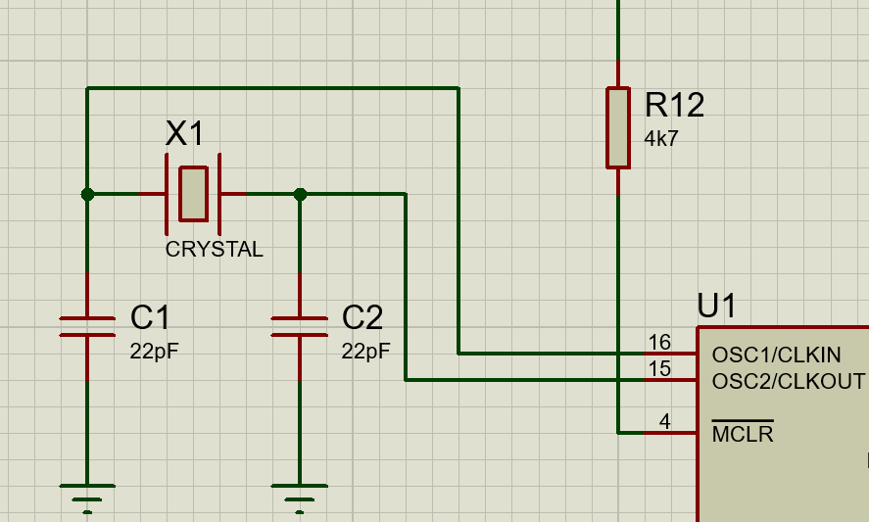
1.4 Clock circuit
Figure 6. Clock circuit for the PIC16f84A simulated circuit, with a crystal oscillator for robustness and accuracy.

The PIC16F84A microcontroller is clocked to 4MHz in the simulation. To achieve this an external oscillator circuit is incorporated. A crystal oscillator, X1, is connected to the CLKIN and CLKOUT pins of the PIC controller [7]. The PIC controller specification outlines that a parallel cut crystal is required for this function and connection style. Once the crystal oscillator unit is turned on, through the same piezoelectric effect (described in 1.2), it will produce a consistent +5V square wave clock signal [15] that feeds into OSC1 [7]. Between OSC1 and 2 internally there an inverter amplifier that ensures any minor losses when going through the clock circuit will be regained, as well as maintaining the fundamental frequency required [7].

An RC oscillator circuit could have been used for this clock circuit. This can be achieved by feeding an RC component into OSC1, which internally has a Schmitt inverter for this purpose [7]. However, the accuracy and stability of this type of circuit is worse than a comparative crystal oscillator circuit. This is caused by the low tolerances of resistance and capacitance typically found on resistors and capacitors, meaning frequency can’t be guaranteed. Temperature increases can also cause drifting in the clock frequency produced by an RC circuit.

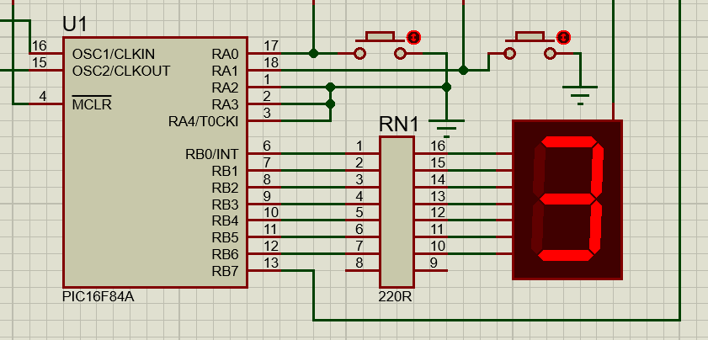
1.5 7-segment display
Figure 7. 7 segment display connected to port B of the PIC16F84A with a series resistor network to adjust for the voltage drop of the display LEDs.

A 7-segment display inhabits 7 of the 8 register port B output pins. Port B is a data register that is 8 bits, a byte, wide, each bit corresponding to one of the I/O pins [7]. Port B can be written to, hence changing the output on each output line. All of the B pins here must be set to output pins by setting the TRISB register, another byte wide register that determines the I/O setting of each I/O pin in port B [7]. RN1 is a dual inline resistor network that simply functions to apply the determined 220Ω resistance to each output line. The resistance is based upon the voltage drop of the LEDs in the display that each line will drive. This particular display is a common anode display, indicating that the individual cathode outputs are fed by a shared anode terminal [16]. This common anode is connected to the +5V power rail. Therefore, this display requires lines to be pulled low to turn on relevant LEDs, where they are otherwise held high; 0V are required on the I/O pins because they are sinking the current/voltage from the LED display. Despite sinking current, the pins are still output pins given they are controlling the flow of current through the display’s LEDs by transitioning between states. As alluded to, each segment is labelled with a letter and is directly fed by an I/O pin, therefore the binary value written to port B will determine the shape created on the display. Figure 8 in 2. shows the most common arrangement, where a is the LSb, driven by pin B0, with the other letters increasing in binary order magnitude up the output pins until reach g, the MSb, driven by pin B6. This display does not have an eighth bit, sometimes seen as a decimal point, therefore only the 7 pins are required to drive it.

1.6 16F84A microcontroller

Important features of the microcontroller relating to the functioning of this circuit have largely been covered in previous sections so to avoid redundancy, only features not mentioned prior will be outlined here.

The 16F84A is a RISC architecture computer IC that functions on a greatly reduced instruction set of just 35 instructions [17]. It carries a working (W register) that can be used to store values for ALU operations, a 13 bit program counter for storing instruction addresses, an 8 level stack for storing return addresses and POP’ing them back out as well as a status register [18]. All of these memory features will be useful when programming the circuit.

Internally, the controller carries hardware configuration ‘fuses’ that can be set in registers to modify the behaviour of the controller. Crucial configuration settings for this purpose include: Disabling the watchdog time, setting the clock frequency to (4 MHz), power-up timer on, MCLR being set on as well as the OSC pin settings for managing and receiving an external clock source with the oscillator [7] [19].

2. 7 segment display calculations
This circuit will eventually output a 7 bit value to port B of the controller, setting corresponding output pins from LSb to MSb on B0 to B6 respectfully and finally outputting to a 7 segment display as detailed in 1.5. Each segment of the display will correspond to a bit of the B register output, seen in figure 8. Therefore the display pattern required for each value from 0 to F (hexadecimal) will need to be determined before calculating what the required input hexadecimal value is to achieve each pattern. Given the display is a common anode display, setting the corresponding bit turns off the desired LED segment, clearing the corresponding bit turns on the desired LED segment. A logical inversion, NOT, must be applied to the determined binary value to find the value that needs inputting to port B. The values calculated will be for 7 bit values despite port B being a byte wide, due to the used seven segment display not having an eighth input alongside port B7 being used for the sounder instead.

2.1 0

Segments required: A, B, C, D, E, F, 0
Binary output: NOT(0b0111111) = MSb 0b1000000 LSb
Hexadecimal value:
High nibble = X100
Low nibble = 0000
Hex = 0x40

2.2 1

Segments required: 0, B, C, 0, 0, 0, 0
Binary output: NOT(0b0000110) = MSb 0b1111001 LSb
Hexadecimal value:
High nibble = X111
Low nibble = 1001
Hex = 0x79
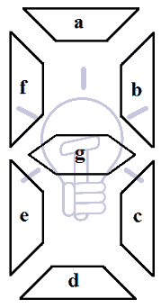

2.3 2

Segments required: A, B, 0, D, E, 0, G
Binary output: NOT(0b1011011) = MSb 0b0100100 LSb
Hexadecimal value:
High nibble = X010
Low nibble = 0100
Hex = 0x24

2.4 3

Segments required: A, B, C, D, E, F
Binary output: NOT(0b1001111) = MSb 0b0110000 LSb
Hexadecimal value:
High nibble = X011
Low nibble = 0000
Hex = 0x30

2.5 4

Segments required: 0, B, C, 0, 0, F, G
Figure 8. Common configuration for 7 segment display, a = LSb, g = MSb [16]
Binary output: NOT(0b1100110) = MSb 0b0011001 LSb
Hexadecimal value:
High nibble = X001
Low nibble = 1001
Hex = 0x19

2.6 5

Segments required: A, 0, C, D, 0, F, G
Binary output: NOT(0b1101101) = MSb 0b0010010 LSb
Hexadecimal value:
High nibble = X001
Low nibble = 0010
Hex = 0x12

2.7 6

Segments required: A, 0, C, D, E, F, G
Binary output: NOT(0b1111101) = MSb 0b0000010 LSb
Hexadecimal value:
High nibble = X000
Low nibble = 0010
Hex = 0x02

2.8 7

Segments required: A, B, C, 0, 0, 0, 0
Binary output: NOT(0b0000111) = MSb 0b1111000 LSb
Hexadecimal value:
High nibble = X111
Low nibble = 1000
Hex = 0X78

2.9 8

Segments required: A, B, C, D, E, F, G
Binary output: NOT(0b1111111) = MSb 0b0000000 LSb
Hexadecimal value:
High nibble = X000
Low nibble = 0000
Hex = 0x00

2.10 9

Segments required: A, B, C, D, 0, F, G
Binary output: NOT(0b1101111) = MSb 0b0010000 LSb
Hexadecimal value:
High nibble = X001
Low nibble = 0000
Hex = 0x10

2.11 A

Segments required: A, B, C, 0, E, F, G
Binary output: NOT(0b1110111) = MSb 0b0001000 LSb
Hexadecimal value:
High nibble = X000
Low nibble = 1000
Hex = 0x08

2.12 B (b)

Segments required: 0, 0, C, D, E, F, G
Binary output: NOT(0b1111100) = MSb 0b0000011 LSb
Hexadecimal value:
High nibble = X000
Low nibble = 0011
Hex = 0x03

2.13 C

Segments required: A, 0, 0, D, E, F, 0
Binary output: NOT(0b0111001) = MSb 0b1000110 LSb
Hexadecimal value:
High nibble = X100
Low nibble = 0110
Hex = 0x46

2.14 D (d)

Segments required: 0, B, C, D, E, 0, G
Binary output: NOT(0b1011110) = MSb 0b0100001 LSb
Hexadecimal value:
High nibble = X010
Low nibble = 0001
Hex = 0x21

2.15 E

Segments required: A, 0, 0, D, E, F, G
Binary output: NOT(0b1111001) = MSb 0b0000110 LSb
Hexadecimal value:
High nibble = X000
Low nibble = 0110
Hex = 0x06

2.16 F

Segments required: A, 0, 0, 0, F, E, G
Binary output: NOT(0b1110001) = MSb 0b0001110 LSb
Hexadecimal value:
High nibble = X000
Low nibble = 1110
Hex = 0x0E

3. Assembly programming

3.1 Hex display program

3.1.1 Assembly code
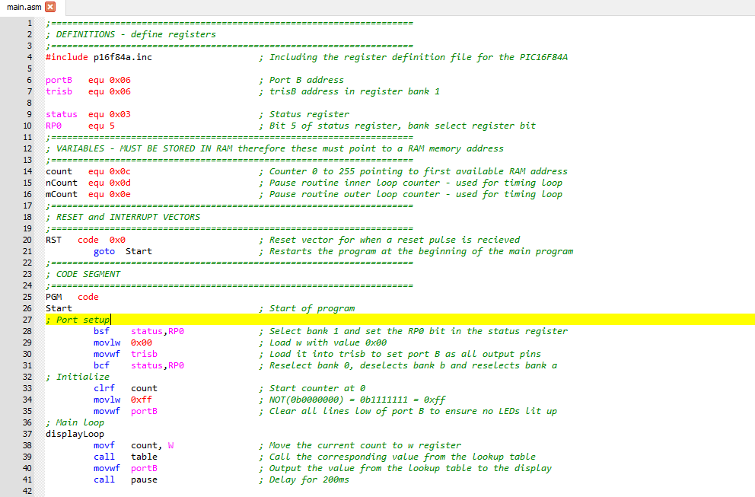
Figure 9. Line 1 to 42 of the hex display program

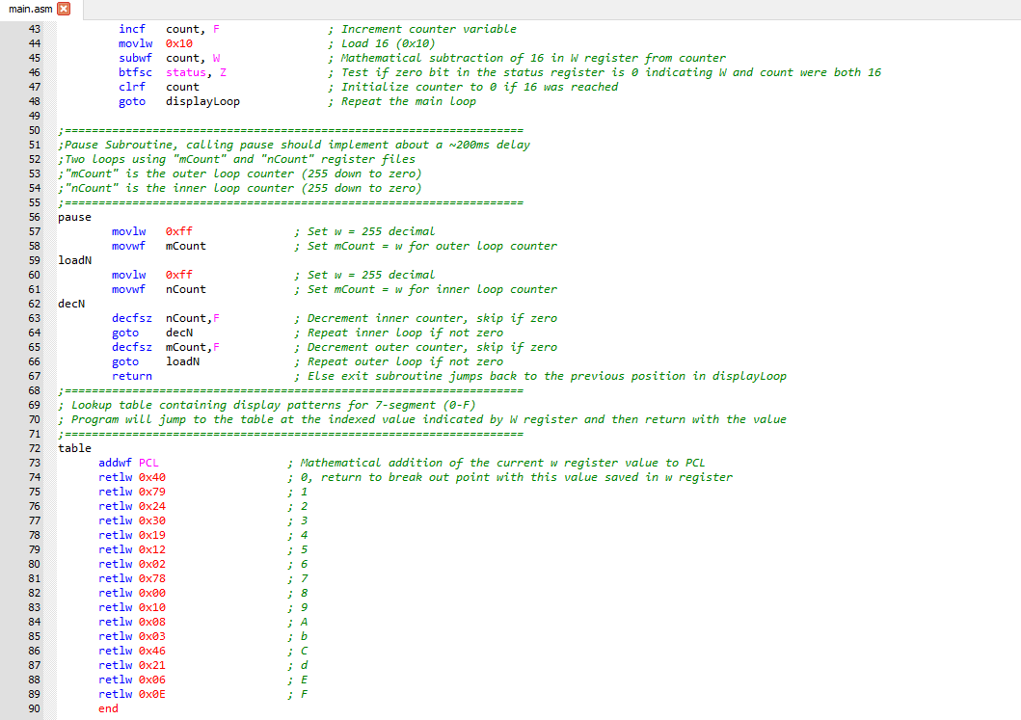
Figure 10. Line 43 to 90 of the hex display program

3.1.2 Pseudocode

BEGIN HexDisplay Program
Variables
DECLARE INTEGER counter
DECLARE INTEGER InnerCount
DECLARE INTEGER OuterCount
DECLARE ARRAY DisplayPatterns[16]

Initialize display patterns for hex digits 0-F
SET DisplayPatterns[0] TO 0xC0
…

Initialize ports
SET status_RP0 TO 1 (select bank 1)
SET port B direction TO 0x00 (output)
SET status_RP0 TO 0 (reselect bank 0)

Clear initial values
SET counter TO 0
SET port B TO 0xFF to turn off the LEDs

Main program loop
WHILE TRUE
READ counter value TO W register
GET pattern FROM DisplayPatterns[W register] (index based on W register value)
WRITE pattern TO port B

Delay subroutine (~200ms)
SET OuterCount TO 255
WHILE OuterCount > 0
SET InnerCount TO 255
WHILE InnerCount > 0
SUBTRACT 1 FROM InnerCount
ENDWHILE
SUBTRACT 1 FROM OuterCount
ENDWHILE

Update counter
ADD 1 TO counter
IF counter = 16 THEN
SET counter TO 0
ENDIF
ENDWHILE

END HexDisplay

3.2 L and r buttons

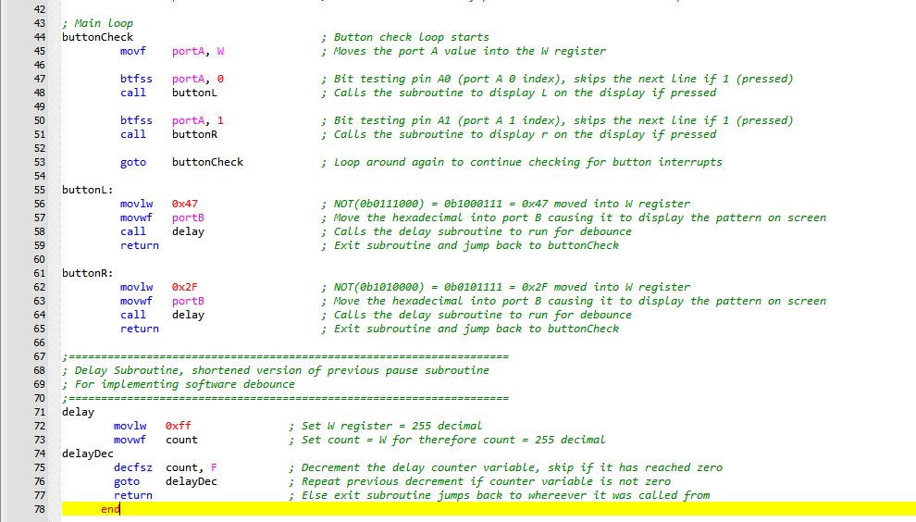
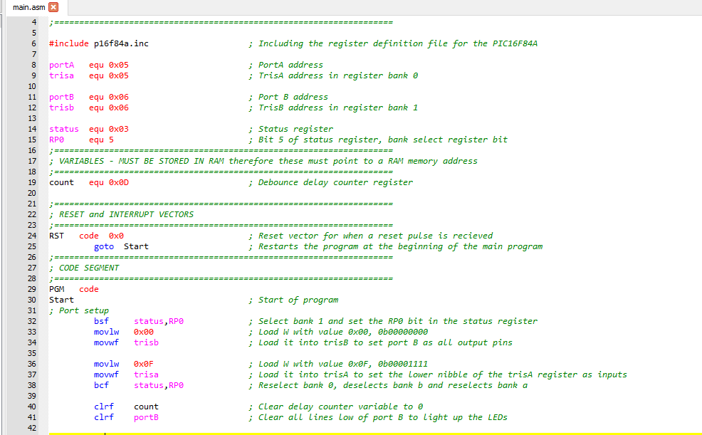
3.2.1 Assembly code
Figure 11. Full L/r button press program.

3.2.2 Pseudocode

BEGIN LRbutton program
Variables
DECLARE INTEGER counter
Initialize ports
SET status_RP0 TO 1
SET port B direction TO 0x00 (output)
SET port A direction TO 0x0F (input on the lower nibble of the register)
SET status_RP0 TO 0

Clear initial values
SET counter TO 0
SET port B TO 0x00 (turn the LEDs on)

Main program loop
WHILE TRUE
READ port A TO W register
IF index0 port A bit = 0 THEN
CALL DisplayLetterL (as left button has been pressed)
ENDIF
IF index1 port A bit = 0 THEN
CALL DisplayLetterR (as right button has been pressed)
ENDIF
ENDWHILE

L button
SUBROUTINE DisplayLetterL
SET W register TO 0x47
WRITE W register TO port_b
CALL Debounce
RETURN
END SUBROUTINE

R button
SUBROUTINE DisplayLetterR
SET W register TO 0x2F
WRITE W register TO port B
CALL Debounce
RETURN
ENDSUBROUTINE

Debounce delay
SUBROUTINE Debounce
SET counter TO 255
WHILE counter > 0
SUBTRACT 1 FROM counter
ENDWHILE
RETURN
ENDSUBROUTINE
END LRbutton program

3.3 On/Off buttons

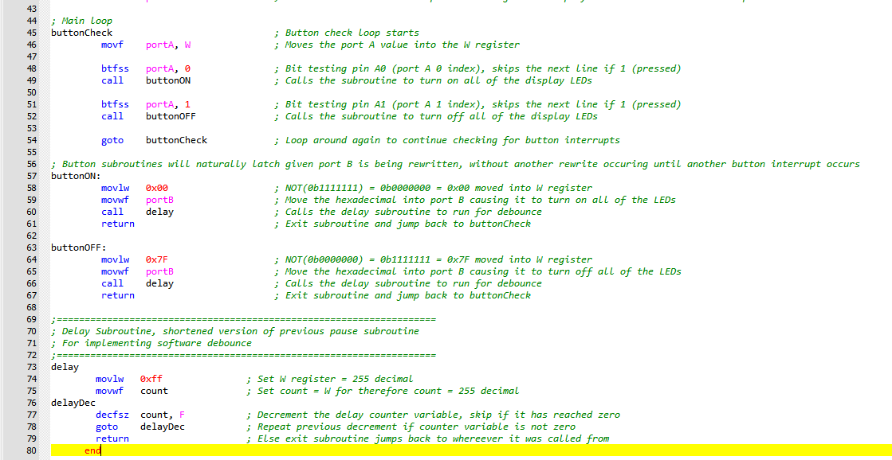
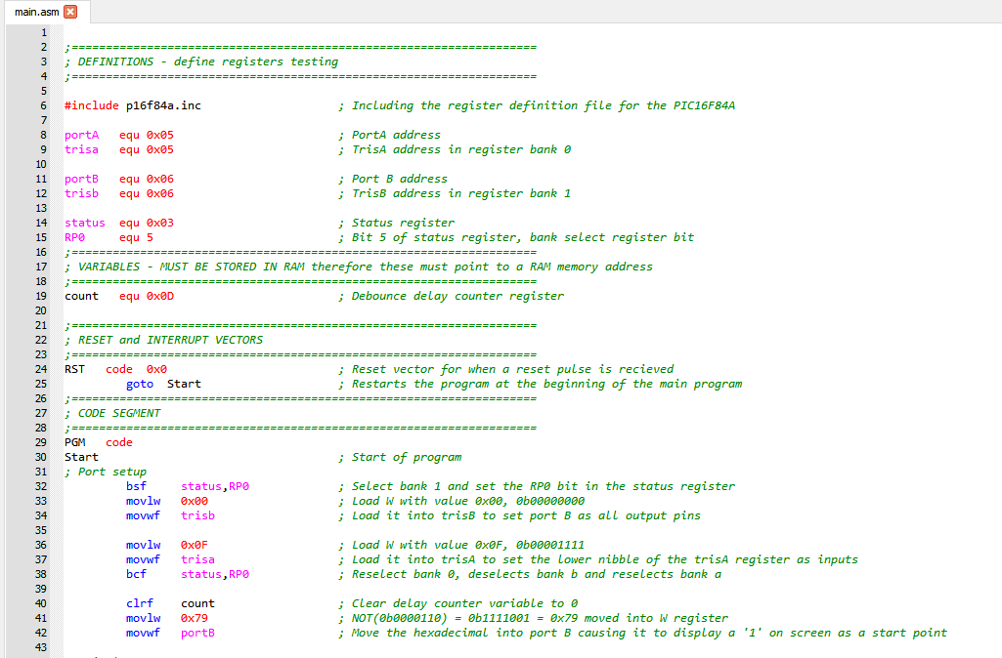
3.3.1 Assembly code
Figure 12. Full ON/OFF buttons program.

3.3.2 Pseudocode

BEGIN ONOFFButtons program
Variables
DECLARE INTEGER counter
Initialize ports
SET status_RP0 TO 1
SET port B direction TO 0x00 (output)
SET port A direction TO 0x0F (input)
SET status_RP0 TO 0

Clear initial values
SET counter TO 0
SET W register TO 0x79
WRITE W register TO port B (sets the starting display pattern as 1 for easy differentiation)

Main program loop
WHILE TRUE
READ port A TO W register
IF index0 port A bit = 0 THEN (checking if the left button has been pressed)
CALL AllLEDsOn
ENDIF
IF index1 port A bit = 0 THEN (checking if the right button has been pressed)
CALL AllLEDsOff
ENDIF
ENDWHILE

Turning all LEDs on
SUBROUTINE AllLEDsOn
SET W register TO 0x00
WRITE W register TO port B (common anode display therefore 0x00 turns on all LEDs)
CALL Debounce
RETURN
ENDSUBROUTINE

Turning all LEDs off
SUBROUTINE AllLEDsOff
SET W register TO 0x7F
WRITE W register TO port B (common anode display therefore 0x7F turns off all LEDs)
CALL Debounce (small delay introduced to make each button press reading discrete)
RETURN
ENDSUBROUTINE

Contd.

Debounce delay
SUBROUTINE Debounce
SET counter TO 255
WHILE counter > 0
SUBTRACT 1 FROM counter
ENDWHILE
RETURN
ENDSUBROUTINE

END ONOFFButtons

3.4 Counter controlled by buttons

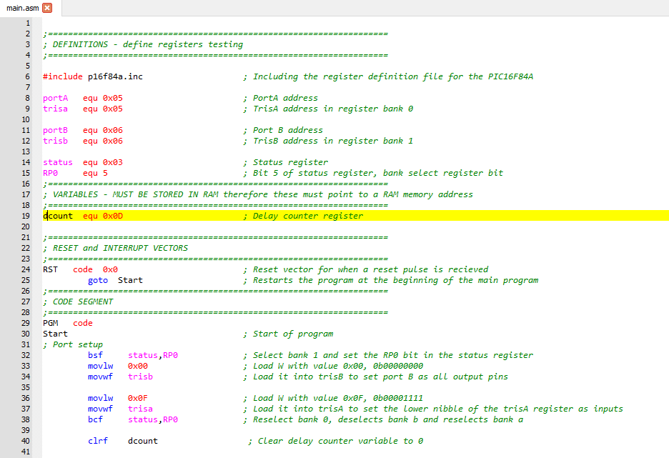
3.4.1 Assembly code

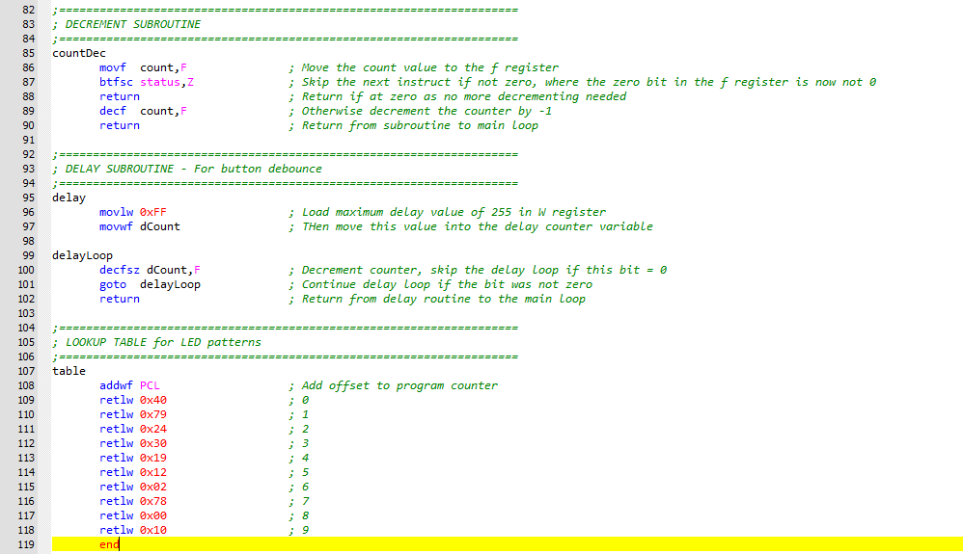
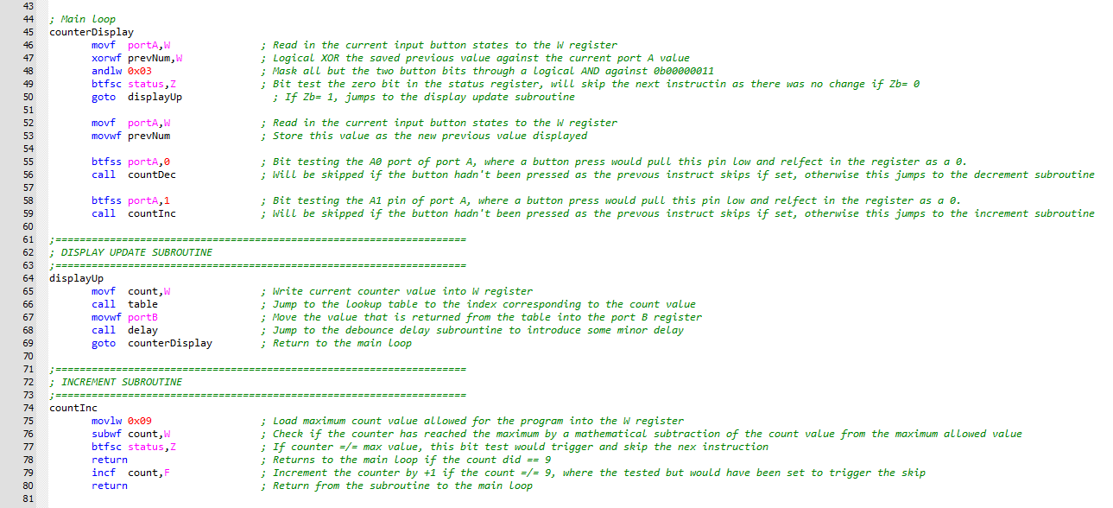

3.4.2 Pseudocode

BEGIN SevenSegmentCounter program
Variables
DECLARE INTEGER count
DECLARE INTEGER previousState
DECLARE INTEGER delayCounter

Initialize ports
SET status_RP0 TO 1
SET port B direction TO 0x00 (output)
SET port A direction TO 0x0F (input)
SET status_RP0 TO 0

Set initial values
SET count TO 5
SET previousState TO 5
WRITE DisplayPatterns[5] TO port B (sets initial display pattern to 5)

Main program loop
WHILE TRUE
READ port A TO W register
XOR W register WITH previousState
AND W register WITH 0x03 (mask to check only button bits)
IF result = 0 THEN
GOTO DisplayUpdate
ENDIF
SET previousState TO current port A value
IF port A bit0 = 0
THEN (check decrement button)
CALL DecrementCounter
ENDIF
IF port A bit1 = 0
THEN (check increment button)
CALL IncrementCounter
ENDIF
ENDWHILE

Display update subroutine
SUBROUTINE DisplayUpdate GET pattern FROM lookup_table[count]
WRITE pattern TO port B
CALL Debounce RETURN TO main loop
ENDSUBROUTINE

Increment counter subroutine
SUBROUTINE IncrementCounter
IF count = 9 THEN
RETURN
ENDIF
ADD 1 TO count
RETURN
ENDSUBROUTINE

Decrement counter subroutine
SUBROUTINE DecrementCounter
IF count = 0 THEN
RETURN ENDIF
SUBTRACT 1 FROM count
RETURN
ENDSUBROUTINE

Debounce delay subroutine
SUBROUTINE Debounce
SET delayCounter TO 255
WHILE delayCounter > 0 SUBTRACT 1 FROM delayCounter
ENDWHILE RETURN ENDSUBROUTINE

END SevenSegmentCounter

3.5 Piezo sound on button press

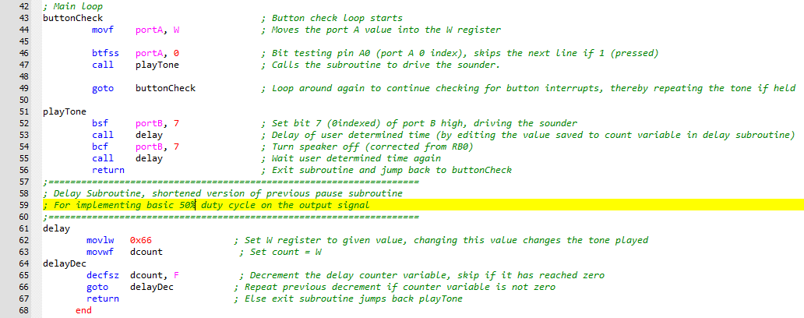
3.5.1 Assembly code

3.5.2 Pseudocode

BEGIN SoundOnPress
DECLARE INTEGER delay_counter
Initialize ports
SET status_RP0 TO 1
SET port_b_direction TO 0x00
SET port_a_direction TO 0x0F
SET status_RP0 TO 0

// Clear initial values
SET delay_counter TO 0

// Main program loop
WHILE TRUE
READ port_a TO working_register

IF port_a_bit0 = 0 THEN
CALL GenerateTone
ENDIF
ENDWHILE

// Subroutine for generating square wave tone
SUBROUTINE GenerateTone
SET port_b_bit7 TO 1
CALL ToneDelay
SET port_b_bit7 TO 0
CALL ToneDelay
RETURN
ENDSUBROUTINE

// Tone timing delay subroutine
SUBROUTINE ToneDelay
SET delay_counter TO 0x66
WHILE delay_counter > 0
SUBTRACT 1 FROM delay_counter
ENDWHILE
RETURN
ENDSUBROUTINE

END SoundOnPress

- Write a piece of code that sends a fixed frequency pulse train to drive the speaker on the demo board/proteus simulation. This pulse train should not have a fixed pulse width however - it should comprise of a constantly changing PWM waveform such as one would find on a music synthesiser with such a feature. See the following to illustrate the concept: PWM should be software based by bit bashing and then maybe hardware based- can replace it with the larger PIC suggested to be able to get the module needed.

References

[1] | Ariat Technology, “Understanding Switch Poles and Throws: An Analysis of Common Mechanical Switches,” 12 01 2025. [Online]. Available: https://www.ariat-tech.com/blog/understanding-switch-poles-and-throws-an-analysis-of-common-mechanical-switches.html.
[2] | Setick, “Types of Light Switches,” 13 01 2025. [Online]. Available: https://www.setick.com/types-of-light-switches/.
[3] | Texas Instruments, “µA7800 SERIES POSITIVE-VOLTAGE REGULATORS,” 2004. [Online]. Available: https://cdn.sparkfun.com/assets/1/7/7/3/2/LM7805.pdf. [Accessed 12 01 2025].
[4] | Texas Instruments, “Engineers note: Capacitors are key to voltage regulator design,” 2011. [Online]. Available: https://www.ti.com/lit/wp/snoa842/snoa842.pdf?ts=1736721034909. [Accessed 12 01 2025].
[5] | I. Poole, “7800 Series Voltage Regulators: 7805, 7812, 7824, etc,” ElectronicsNotes, N/A. [Online]. Available: https://www.electronics-notes.com/articles/analogue_circuits/power-supply-electronics/7805-7812-voltage-regulator.php. [Accessed 12 01 2025].
[6] | W. H. Paul Horowitz, The Art of Electronics 3rd Edition, New York: Cambridge University Press, 2015.
[7] | Microchip Technology Inc., “PIC16F84A 18-pin Enhanced FLASH/EEPROM 8-Bit Microcontroller,” 2001. [Online]. Available: https://www.mouser.co.uk/datasheet/2/268/35007C-3442610.pdf. [Accessed 12 01 2025].
[8] | Multicomp PRO, “NPN Silicon Planar Transistors BC107 / BC108 Series,” 20 07 01. [Online]. Available: https://www.farnell.com/datasheets/3094291.pdf. [Accessed 12 01 2025].
[9] | WatElectronics, “BC107 Transistor : PinOut, Specifications, Circuit, Working, Datasheet, Equivalents & Its Applications,” WatElectronics.com, 30 09 2024. [Online]. Available: https://www.watelectronics.com/bc107-transistor/. [Accessed 12 01 20215].
[10] | IBEX Technology Development Specialists, “Piezo Sounders,” IBEX Technology Development Specialists, N/A. [Online]. Available: https://ibex.tech/resources/geek-area/electronics/sounders/piezo-sounders. [Accessed 12 01 2025].
[11] | RS Online, “How Do Piezo Buzzers Work?,” RS Online, 30 10 2023. [Online]. Available: https://uk.rs-online.com/web/content/discovery/ideas-and-advice/how-do-piezo-buzzers-work. [Accessed 12 01 2025].
[12] | Electronics Tutorials, “Pull-up Resistors,” Electronics Tutorials, N/A. [Online]. Available: https://www.electronics-tutorials.ws/logic/pull-up-resistor.html. [Accessed 12 01 2025].
[13] | EE Power, “Pull-up and Pull-down Resistors,” EE Power, N/A. [Online]. Available: https://eepower.com/resistor-guide/resistor-applications/pull-up-resistor-pull-down-resistor/#. [Accessed 12 01 2025].
[14] | BITSMASHED, “Pull-up Resistors,” SparkFun, N/A. [Online]. Available: https://learn.sparkfun.com/tutorials/pull-up-resistors/all. [Accessed 12 01 2025].
[15] | ECS INC International, “Crystal Oscillator Design Application Note,” ECS INC International, N/A. [Online]. Available: https://ecsxtal.com/crystal-oscillator-design-application-note/. [Accessed 12 01 2025].
[16] | Electrical Technology, “BCD to 7-Segment Display Decoder – Construction, Circuit & Operation,” Electrical Technology, N/A`. [Online]. Available: https://www.electricaltechnology.org/2018/05/bcd-to-7-segment-display-decoder.html. [Accessed 12 01 2025].
[17] | Microchip, “Section 29. Instruction Set: PICmicro MID-RANGE MCU FAMILY Instruction Set,” [Online]. Available: https://moodle.uwtsd.ac.uk/pluginfile.php/983052/mod_resource/content/0/PIC%20instruction%20set.pdf. [Accessed 12 01 2025].
[18] | WatElectronics, “PIC16F84A Microcontroller : PinOut, Specifications, Interfacing, Datasheet & Its Applications,” WatElectronics.com, 18 06 2024. [Online]. Available: https://www.watelectronics.com/pic16f84a-microcontroller/. [Accessed 12 01 2025].
[19] | Melanie, “Thread: Presetting Configuration Fuses (PIC Defines) into your Program,” Crownhill Associates, 12 07 2004. [Online]. Available: https://www.picbasic.co.uk/forum/showthread.php/543-Presetting-Configuration-Fuses-(PIC-Defines)-into-your-Program. [Accessed 12 01 2025].

