Effective Team Working and Communication

UniVersity of trinity saint david
London campus

Assignment Term 1
2019
Student Name: | Saira Munshi
Student Number: | 1813715
Module Number: | BMSK4002
Module Name: | Effective Team Working and Communication
Lecturer | Benedict Maher

Contents
Introduction: 3
Communication: 4
Common Barriers: 5
Cultural Noise: 5
Problems with Constructional Design: 5
Jumping to Conclusion: 5
Example of How the Employer’s communicate at workplace: 6
More Ways and Barriers to Effective Communication: 6
Verbal: 6
Nonverbal: 7
Active Listening: 7
Conclusion: 7
References 8

Introduction:

Communication skills are perhaps the most vital in the workplace but, often get little attention. The most wanted skills employers are looking for is communication. Education system is putting its effort in building up the skills of good Teamwork, by group based designed course work, which will help an Individual graduate to attain a position in the market efficiently (Griffith, B & Dunham, E 2015).
In this assessment I will explore the barriers to communicate effectively that impact on the company prestige and once they are figured out, how a route to clear communication can be put in practice by giving a workplace example.

Communication:
Communication is a flow of information, feelings or thoughts that are conveyed from a sender to a receiver or a group of receivers with an intention of understanding. To get the right outcome, ensuring the reason the communication took place, it is essential to be clear and to the point. There are many ways to communicate and mostly the burden relies on the person who begins the communication to choose the best medium where his audience can easily get connected so a virgin message is transmitted and received (Atufunwa, B. 2009).
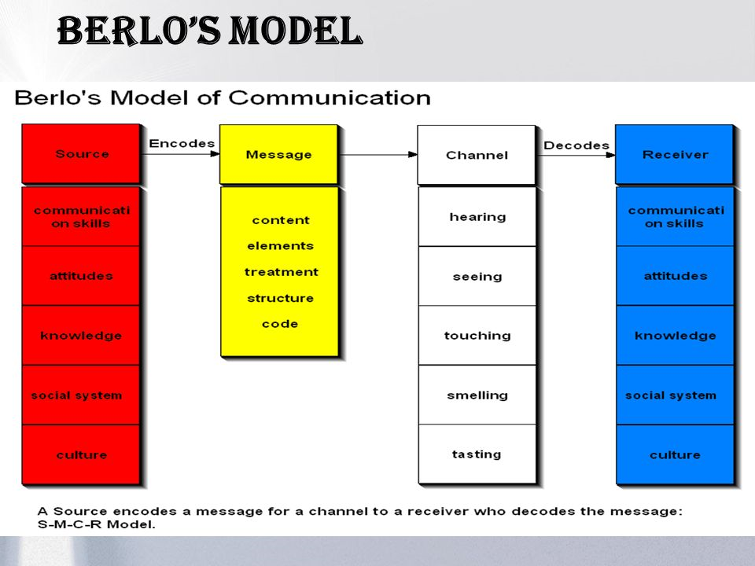
Let us consider Berlo’s model of communication:
The above Berlo’s model clearly displays the how the communication science works but, according to my observation sixth sense is missing, this is a sense that which needs to be on the same level of the two people to understand the message fully.
Checking with the receiver for the message received is same as was intended by the sender is very important for the productivity in workplace (Morgan 2017).Mediums to communicate could be many for e.g. face to face, through social media, emails, leaflets, Newspaper, Television, voice calls etc.(Morgan 2017) suggests face to face communication is the best of other ways of communication when one or a small group of people are involved, so your facial expressions, body gestures and tone of voice can help to convey the message correctly. However, it cannot always be the case as it also depends on the person who decodes the message. According to (Young Entrepreneurs forum, 2016) there may be many barriers that may corrupt the meaning of the original message for e.g. Cultural Noise, Information overload, Lack of Common Experiences, Language, Physical Barriers, Attitudes, Problems with Constructional Design, Ambiguity, Overuse of Abstractions and Jumping to Conclusions.

Common Barriers:
According to Equality Act 2010, all employers are required to comply with the following:
Employers duties under the Equality Act 2010
When recruiting, the Equality Act 2010 gives a duty to consider the need to:
• Eliminate discrimination, harassment and victimisation
• Advance equality of opportunity
• Foster good relations between different parts of the community
This covers, age, disability, gender reassignment, marital or civil partnership status, pregnancy and motherhood, race (including ethnic or national origin, colour and nationality), religion or belief (including lack of belief), sex and sexual orientation (Gov.UK, 2010).
Progressing with a team of diverse backgrounds can be very challenging, where communicating effectively is the most obvious obstacle. To clear the way to communicate we need to understand the obstacles of better communication.

Cultural Noise:
Judging through our own perception may distort the message we give and receive, when dealing with different cultures as it is reflected in our gestures and words (Tedx Talks, 2015) which may lead to differences within the team and may impact on our ability to achieve one goal. “Knowledge of cultural customs can help avoid misunderstanding and enable practitioners to provide better care” (Galanti, G., 2000). Health professionals are trained to treat a patient as an individual to avoid misinterpretation, by listening attentively and keep checking back that the message is understood by asking verifying questions during the conversation.

Problems with Constructional Design:
Within the context of meetings, the purpose of conversation needs to be clearly defined at the outset, and be to the point.The audience shouldn't have to try to figure out what your agenda or focus is. Your emails should have a clear subject, and you should get right to the point (SAXTON, E., 2018). Companies that do not keenly focus on communication may not have the appropriate mediums of communication in place. To forward or disseminate the right message, on the right time a Communication Network is very important. This includes briefing, debriefings, clear complaints procedures, feedback panels, and relevant updates through social media and email.
Technology, such as automated email applications can be used to promote effective communication when face to face meetings are not possible.
There are several tools like Facebook, Skype for voice conferences when one or more of the relevant people are not available to attend the meeting in person. WhatsApp can also be used to inform certain changes or updates to the staff, in a friendly unformal manner. Staff should be trained to use these medium so no one is left out of any information process which others can have access to.

Jumping to Conclusion:
Productivity is compromised when an outcome is reached without enough data. We make assumption errors based on our own understanding, experience and rumours without realising the fundamental reality behind any act, thus putting up a barrier wall to openness. This than creates an environment where people resist opportunities to speak frankly, and holding back information and feedback, which can negatively influence the workplace environment.

Example of How the Employers communicate at workplace:
‘S’ work in a food franchise, where teenager or young people love to hang out. One day customer complained about getting less topping on ice-cream. Having checked the complaint ‘S’ apologised to the customer and took it in, to the duty manager ‘E’ informing her that the customer had complaint about the low level of topping ‘not enough’, on the ice-cream. However before ‘S’, completed the full incident, including her own observations, she was cut short by ‘E’, and instructed to go back to the customer and ask for an additional 20p, for the topping.
’S’ did as she was instructed, and predictably the customer became angry at her, stating ‘’I would have paid if i was asking for extra but here I have paid already for what I did not get’’. The customer then asked for the manager and spoke to him. The manager did not only provide extra topping, he also gave him another ice-cream as a gesture of apology.
The manager called ‘E’ and ‘S’ into his office, to enquire what happened, ‘E’ said that, “she thought that the person complaining is a stereotype teenager, who might be trying to have more topping for free and further that ‘S’ does not know the procedure”.
Having listened to both, the manager concluded that “ it was too early to reach to a conclusion from the ‘E’ and potentially a non-assertive approach from ‘S’ may have created the conflicting messages given to the customer. This then escalated into becoming a threat to the reputation of the franchise, which he expects not to happen in future.
This example shows that, although the Duty Manager ‘E’ holds good understanding and knowledge regarding the procedures, she was not very helpful and was affected when by her potentially prejudicial assumptions resulting in a conclusion. On the other hand, if ‘S’ had been more assertive and had stated the position more tactfully but firmly, the situation could have been averted. Thus, If the core problem had not been addressed by the manager at the right time, the relationship between ‘E’ and ‘S’ could have broken down, particularly as the customer then focussed his anger on ‘S’ due to the unsubstantiated assumptions of ‘E’.
The above example also indicates communication is a two-way process, in which other than speaking clearly, you must make sure that, you are being well understood (FROSCHHEISER, L., 2008). If communications are ineffective, then one needs to look deep for more barriers.

More Ways and Barriers to Effective Communication:
There are certain ethics for a sender to communicate right. It means to be considerate enough of the factors that are barriers to mis interpret the message been send from the origin (sender)to the destination(receiver).
Often sender who encodes the message to receiver is not been decoded, the way it was sent originally as the process requires skilful presentation of Verbal and Nonverbal communication with active listening.

Verbal:
There is a more to just sending of words while conversing, it is more to ensure that, right words are conveyed to the right person with the right medium and in exchange you receive the words that moves the conversation forward. Tone of voice is one of the key factors where the same words can be heard differently, it is very important to choose the right pitch in accordance with the context to get the message through correctly (Morgan, P., 2017). Preparing and thinking ahead of the meeting, using appropriate language and simple words can capture the attention of the audience. Relevant questions should be asked to maintain the flow and progress of the meeting.

Nonverbal:
According to Mehrabian’s research (1981) most of the listener uses the combination of verbal and nonverbal elements to understand the message fully. The ratio to which is 55% people understand the message is through observing facial expression, body language and hand movements, 38% from the tone of voice and 7% percent are words only. This clearly indicates that Nonverbal communication takes over most of the understanding. A message spoken can only have the best impact, if the combination of nonverbal gestures can support it (Quintanilla, 2017). On the other hand, it can be a barrier to good communication for example crossing arms across the chest might mean the patient is not comfortable to open up but in another case, it might be the patient is feeling cold and wanted to fold arms to warm the body temperature. Instead of focusing on crossing arms, a professional should focus more on the whole number of gestures that appeared instantly during the session with understanding the occurred anxious behaviour of the first session ( National Center for Biotechnology Information, 2010).

Active Listening:
Willingness to listen to understand the speaker is Active listening that, requires attentiveness, discipline and clear focus. According to (TED, 2016)"There's no reason to learn how to show you're paying attention if you are, in fact, paying attention.” Listening requires devotion, being present, giving the opportunity to extract the motive of the conversation. Being present is not being physically present, it is also to relate to the context avoiding any noises and thoughts that come to your mind.

Conclusion:
Verbal and nonverbal communication are interdependent to each other and a good listening is a way to hold coherent conversation with staff, clients, patients, customers, a good communicator can be a good leader only. However, no single act or gesture can be exact similar in every situation. There is no rule book to follow, it can only be read by observing combination of gestures.
Professional need to learn to think Globally and not stereotype their patients. Barriers to communicate effectively impact on the company prestige and once these are identified a route to clear communication should be put in place.
Group activities should be taken place in every workplace to figure out the shortfall in social and interpersonal skills. Appropriate training should be provided. Messages should be related to the greater vision and corporate ethics of the company , making sure employees feel listened to . This will directly impact the positive morale of the company.

References
ATUFUNWA, B., 2009. The art of Effective Communication, 40(4), p. 47.
FROSCHHEISER, L., 2008. communication, communication, communication the most important key to success in business leadership. Supervision, 69(10), pp. 9-11..
Galanti, G., 2000. Asn Introduction to cultural differences. Wesstern Journal of Medicine, 172(5), pp. 335-336.
Gov.UK, 2010. Equality and diversity. [Online]
Available at: https://www.gov.uk/government/organisations/department-of-health-and-social-care/about/equality-and-diversity
[Accessed 07 05 2019].
Griffith, B. &. D. E., 2015. Communitation. In: Working in teams: moving from high potential to high performance . London: Sage Publication, pp. 91-111.
Morgan, P., 2017. Communicating Effectively. In: K. Smy, ed. The Business Student's Guide to Study and Employability. London: SAGE, p. 250.
Morgan, P., 2017. The Business Student's Guide To Study and Employability. London: Sage Publication.
. Non-verbal Communication in Psychotherapy. [Online]
Available at: https://www.ncbi.nlm.nih.gov/pmc/articles/PMC2898840/
[Accessed 13 05 2019].
Quintanilla, 2017. Listening. In: M. S. a. P. K. T. Andrew Maund, ed. Certificate in Higher Education: Skills for the Workplace Student Yearbook. London: Sage Publication Inc, p. 89.
Saxton, E., 2018. COMMUNICATION IS SO IMPORTANT TO SPONSORSHIP. National Dragster, 59(9), p. 32.
TED, 2016. 10 ways to have a better conversation | Celeste Headlee. [Online]
Available at: https://www.youtube.com/watch?v=R1vskiVDwl4
[Accessed 10 05 2019].
Tedx Talks, 2015. How Culture Drives Behaviours | Julien S. Bourrelle | TEDxTrondheim. [Online]
Available at: https://www.youtube.com/watch?v=l-Yy6poJ2zs
[Accessed 07 05 2019].
Young Entrepreneurs forum, 2016. 10 Barriers to Effective Communication. [Online]
Available at: https://www.youtube.com/watch?v=slq1nAhZuqE&t=62s
[Accessed 07 05 2019].

