Student Name: Alana Jones
P Number: 1700817
Programme of Study: Fine Art: Studio, Site and Context
Module: ADAD5001

Task: Write a proposal = 2398 words

Body, Self, Gender
This Independent Research Document proposal will be exploring three key words, body, self, and Gender. I’ve chosen these words as I feel they fit my painting practice the best due to the fact I generally explore myself as a female within my work. All three words are equally important to me and my practice. After researching these three key words I have chosen, I am hoping to come up with a question which I will answer in my Independent Research document next year.
Body
The body has been an extremely important aspect of painting practice throughout history, whether it’s a self-portrait, or a portrait of someone else. The fascination with the body is shown in various artist’s work; from the Renaissance paintings to the works of Lucien Freud and Jenny Saville. Saville’s work is some of the most experimental and controversial regarding the body.
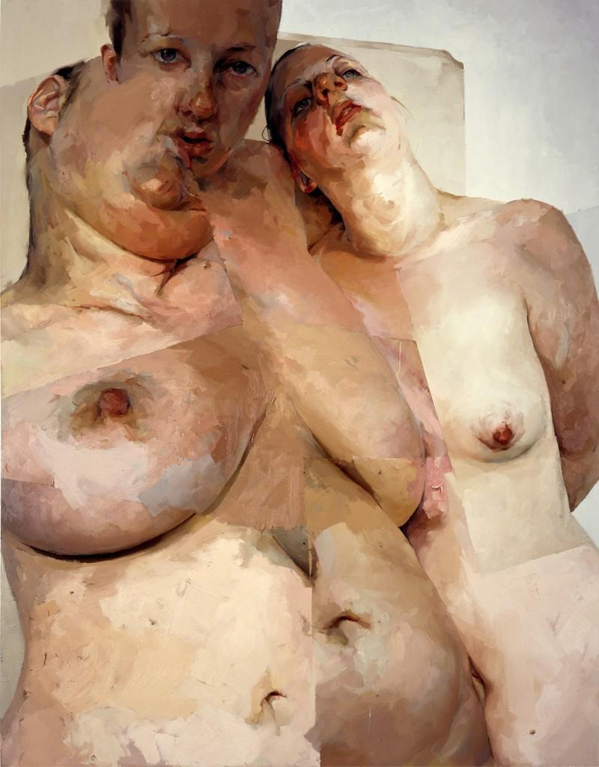
Saville’s view on flesh and the body is an interesting one; she likes to explore the extremes of the human form. She’s “drawn to bodies that emanate a sort of state of in-betweeness: a hermaphrodite, a transvestite, a carcass, a half-alive/half-dead head.” Saville in an interview (Schama, 2005, p.124.)⁸ She’s also learnt “a lot from observing plastic surgery and looking at medical books and specimens. The paintings like Ruben’s Flap and Hyphen with grafted flesh sections resulted from looking at these things.” Saville (Schama, 2005, p.124.)⁸
Jenny Saville. Ruben’s Flap, 1998-99, oil on canvas 10x8ft

To Saville It is important to paint an honest picture. “The effect of Saville’s work is to break up and tear apart self-image” (Schama, 2005, p.9.)⁸ self- image is one of the hardest things to “tear up”. Saville’s honesty with her own body is terrific, as shown in her painting Propped, a “self-portrait in which the artist sits naked (albeit wearing pointy white flats on her feet) atop a phallic post. Her nails dig into her legs, pushing her ample breasts together.” (Cohen, 2018)². “Saville proclaimed herself as “anti-beauty” and focused instead, on exaggerating bodily elements that society generally deemed unsightly.” (Cohen, 2018)². This emphasises Saville’s bravery in depicting the human body as the grotesque and unattractive form it can sometimes be, with lumps, stretchmarks, curves, cellulite etc.; she’s not afraid of her work being judged by mainstream society and she seems to strive to get a reaction from the viewer with her large scale grotesque paintings.
According to The book of Tracy Emin, written by Mandy Merck and Chris Townsend, for the female artist due to women being viewed as passive objects historically and men being viewed as an active subject, it meant dealing “intimately with her own eroticized and even sexually objectified body, it’s shifting shape and it’s objectification through morals, customs and rapidly changing sartorial fashions.” (Merck and Townsend, 2002, p.64/65.)⁶ Mary Cassatt Is depicted by Edgar Degas in the Louvre looking at paintings, “he contemplates the techniques and themes of the old masters.” (Merck and Townsend, 2002, p.65)⁶. When you look at his depiction of her you can see he has represented her as a very fashionable woman. Although, Degas did not view her as a fellow artist, her body became the subject of the painting. Within her own work she conveys herself differently. “But again, in her various guises as a mother or guardian who is cuddling babies or tending to children, what is integral to her subjectivity is her body and not the autonomous creation that led to the work of art in the first place.” (Merck and Townsend, 2002, p.65.)⁶

Lucien Freud had a way of completely analysing the female form, in the painting Benefits Supervisor Resting (1994) Sooke (2015) notes that, Freud tried to capture every last curve, stretchmark, sag, wrinkle and blemish of his very curvy model Sue Tilley. Freud once said, “I want the paint to feel like flesh.” (Sooke, 2015)¹⁰ Although the painting conveys a morbidly obese lady, we do not feel amused or extremely disgusted by the form; “Instead we are shown a sympathetic figure with a remarkably palpable presence, flinging back her head as though lost in ecstasy” (Sooke, 2015)¹⁰. His paintings very often defy conventional standards of beauty, which makes them so truthful and endearing; yet some people may define them as ugly.

Around the time Freud started painting Tilley, Young British artist Sarah Lucas created “Fat, Forty and Fabulous” (1991). This show “lays bare the tabloid’s glaring misogyny and draws attention to the language which, while the words alone might be empowering, loses all meaning when juxtaposed with an objectifying image of a fat naked woman”, (Dazed, 2018)¹. Lucas didn’t initially intend her work to be Feminist but after leaving Goldsmiths she realised that she needed to “mobilise this thing that’s being woman.” (Dazed, 2018)¹. Dazed (2018) states that her work helped define a new generation of Feminist artists’ using humour to bring attention to the sexism of our visual environment.

Self
Exploring and understanding yourself as an artist is essential to your practice. Many famous artists have represented themselves through self-portraits, giving us a slight understanding of what their lives are like through the means of colour, texture and composition. Some of these artists’ include Van Gogh, Egon Schiele and Frida Kahlo. Frida Kahlo, “understood the power of a selfie well before it became a pervasive part of popular culture.” (Nytimes.com, 2016)³ Kahlo’s self-portraits often expressed ideas of loss, love and ideas around beauty standards.
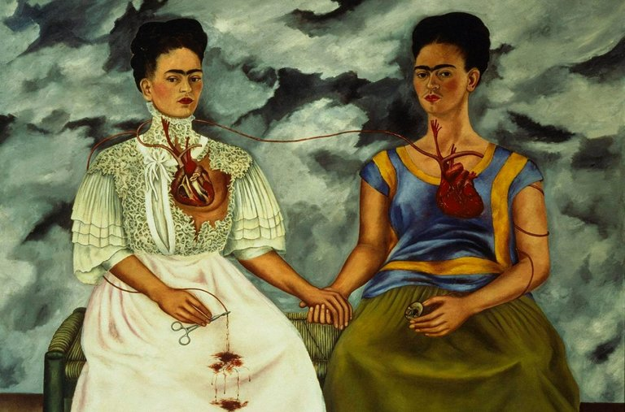
Frida Kahlo “The Two Frida’s” 1939 oil painting

This piece shows two very similar representations of Kahlo herself interacting. Both figures with the hearts exposed, connecting with one another; the left side one seems to be broken and the other intact with blood pumping into a photograph of Diego Rivera; her husband who she had divorced that year. Nytimes.com (2016)³ “Together, the two Frida’s suggest the physical and emotional toll of the divorce.”(Nytimes.com, 2016)³. Frida explored the self deeply and all together made fifty-five self-portraits. It is a powerful and brave thing to be honest with yourself and the way that you may feel or look and no one has done this better than Frida Kahlo.
I feel Egon Schiele had a less literal approach to his self-portraits than Kahlo. Schiele wasn’t afraid to experiment with himself within his self-portraits. “The nude study depicting a rigid member in the act of masturbation went a step further and shows he was a man fascinated by his own sexuality.” (Selsdon and Zwingerberger, 2011, p.43.)⁹ It’s clear to see that Schiele wanted to be noticed and to intrigue his audience with his unconventional portraits. Gutersloh described Schiele as “exceptionally handsome” yet he painted himself as ‘ugly’, he painted himself in a way that almost made him look like a skeleton, his eyes looked heavy, his body skinny and frail, creating an atmosphere of death and pain. Schiele perceived himself as a man of pain, he once said; “That I am true, I only say, because I […] sacrifice myself and must live a martyr-like existence.” Schiele (Selsdon and Zwingerberger, 2011, p.43)⁹ Depicting himself in this manner throughout his self-portraits clearly show that he was trying to emote this pain he felt in everyday life through is artworks, as if it was a relief for him to do this. In this century many of us are obsessed with ‘selfies’ and our own faces, Schiele was no different, and he very often drew and painted his own figure and face (p.99.)⁹ In the painting Seated Male Nude (Self-portrait) 1910, oil and gouache, “He is, almost certainly, alluding to the piteousness of the image of the image of Christ on the cross and yet here he has an eroticised this figure.” (Seldon and Zwingerberger, 2011, p.99.)⁹ Schiele is placed at the centre of the image “where Expressionist ugliness is omnipresent but highly personalised and specifically designed to engender compassion for the painter as subject.”(Selsdon and Zwingerberger, 2011, p.99.)⁹ His paintings push the boundaries of what it’s like to be human, tackling subjects of sexuality, death and pain, his portraits are truly captivating and generate questions around the psychology of humans.
Moving on to the modern day selfie, why do we take them? It seems as if almost everyone is involved e.g. teenagers, parents, hipsters. According to a recent study by Petya Eckler, of the University of Strathclyde, that ‘selfies’ are not good for our health. “After speaking to several hundred female students, the team found that spending time on Facebook looking at selfies, is linked to negative feelings about body image.” (Sanghani, 2014)⁷. When you stop yourself and ask yourself, why have I just posted this selfie? The answer is something usually like “I thought my outfit was cute” etc. But that’s not truthful. According Dr Terrie Apter, psychology lecturer at Cambridge University, we post selfie’s because we are trying to find out who we are, and project this onto other people through the use of social media; “It’s a kind of self-definition.”(Sanghani, 2014)⁷ “We all like the idea of being sort of in control of our image and getting attention, being noticed, being part of the culture.”(Sanghani, 2014)⁷ After looking at self-portraits throughout history, I have come to realise that nothing much has changed; back then the self-portraits were all about status and importance, portraying a certain image of yourself and it’s still the same now. “Self-portraits have merged into selfies.”(Sanghani, 2014)⁷
Gender
The last and final key word for this dissertation proposal is gender. Gender can be a very controversial subject in modern society. With more and more people coming out as transgender, gender-fluid, bigender etc. the subject of gender is becoming more complicated and harder to understand with many varied views and opinions on it.
By some, gender is taken in biological reality so, having testicles and a penis means you’re a male and having a vagina, ovaries, uterus and breasts makes you female. In this case, there are only two genders, male and female. “Feminists, among others, have identified gender as a primary category that suffuses all aspects of life.” (Juschka, 2016)⁵. Feminist theorists, argued “sex, that is sexual difference, may be a biological category and unchangeable, but gender is not. Gender it was argued, is a social category and consequently subject to vagaries of social and historical change.” (Juschka, (2016)⁵.
Feminist Monique Wittig believes that lesbians, feminists and gay men have been oppressed by heterosexual society. She says, “When the general state of things is understood (one is not sick, or to be cured, one has an enemy) the result is for the oppressed person to break the psychoanalytical contract.” (Wittig, 1992, p.52.)¹¹ Also, that the “psychoanalytical contract was not a contract of consent but a forced one.” (Wittig, 1992, p.52)¹¹ essentially heterosexual society has been refusing to accept non heterosexuals and therefore instead of accepting them, they instead try to change and oppress them e.g. conversion therapy; which is often very traumatic for the individual who is non heterosexual. “They prevent us from speaking, unless we speak in their terms.”(Wittig, 1992, p.53.)¹¹ Throughout history society has been very ignorant to change, which results in hatred for people who fall outside of the mainstream society. Luckily in 2019, people are more accepting.
Wittig uses pornography as an example of the immediate effects of the material oppression of individuals by discourses. She says that pornography “constitutes a discourse, and this discourse covers our world with its signs” she believes that this discourse “signifies that women are dominated.” (Wittig, 1992, p.53.)¹¹ She claims that “The pornographic discourse is part of the strategies of violence which are exercised upon us: it humiliates, degrades, it is a crime against our “humanity”.”(Wittig, 1992, p.53.)¹¹ Although, heterosexual society and experts in semiotics don’t necessarily realise that they are doing this; they believe that their oppression is a result of their mistaken level of analysis.
Contemporary artist Grayson Perry has helped change many opinions about gender and masculinity; Perry is a transvestite. Perry is a man who questions masculinity and the stereotypes of it. He says during an interview, “Often men don’t even realise they’re sad.” “Boys are brought up to unconsciously feel they would be breaking their man contract if they were to cry too much.” (Jonze, 2016.)⁴ Perry believes that we urgently need to address our view on what being a man should involve due to the suicide rates of men in the UK.
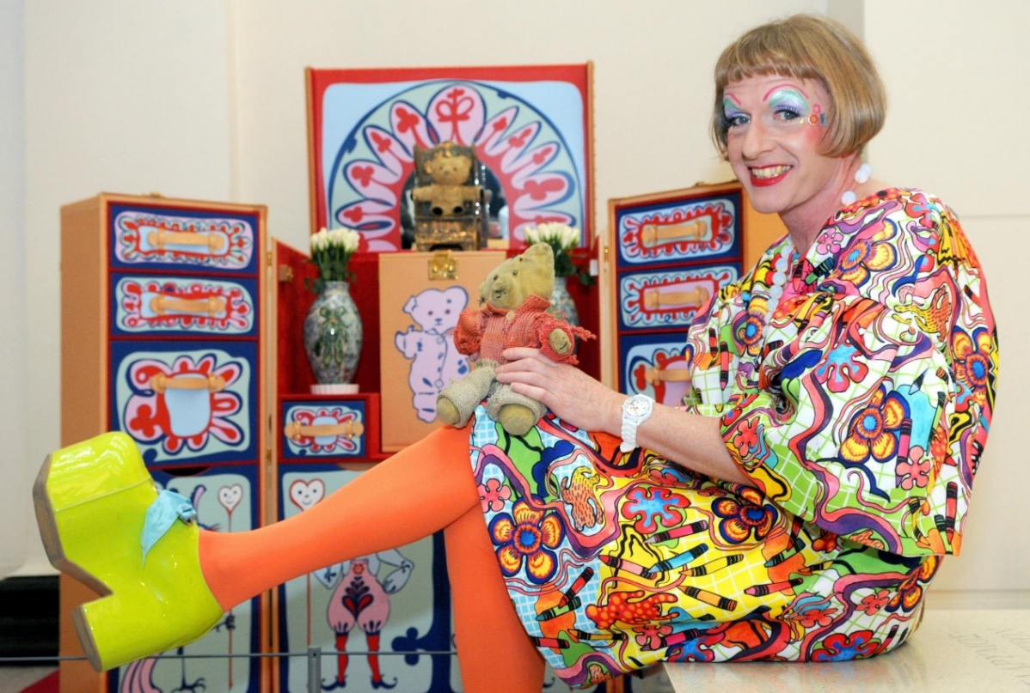
Claire is an alter-ego in which Perry has embraced as shown in the photograph below; although the words “alter-ago” is not what he himself uses to describe it, he says “it’s just me in a dress.” (Jonze, 2016)⁴. He believes that if people just “loosened” up about their gender that they could be “freer”. “Gender is great”. Referring back to what Wittig said about oppression, you could say that men are being oppressed by society in terms of being stereotyped as strong, fearless, and unemotional; resulting in many men committing suicide and having mental health issues because, as Perry says, they “bottle up” their feelings out of fear of being judged by the rest of society. Perry’s television documentary All Men, jumps into the subject of masculinity. During this documentary Grayson Perry visits men living out some of the most stereotypical masculine roles in British society; he visits cage fighters, to teenagers in gangs. Perry’s presence encourages the men to open up about the struggles they’ve been facing in life, which, by the looks of it, was a well needed relief. The documentary faces the serious effects of emotional repression.
After my in depth research on these three key words, I have come up with a question in which I would like to research and write about next year for my Independent Research Document. The question I have chosen is, “How does modern social media effect the way that I view myself as a female?”, I have chosen this question because I feel it is relevant to all of the three key words that I have explored throughout this proposal. These words that I have written about are extremely important to me and my personal painting practice. I have always explored myself, my body and my personal experiences through my practice. I have a strong interest in feminism and the way in which women view themselves and I wish to analyse my own struggles with body image as a woman living in the age of the internet.

Bibliography
Dazed. (2018). A guide to the controversial works of YBA Sarah Lucas. [online] Available at: http://www.dazeddigital.com/art-photography/article/41690/1/guide-to-controversal-yba-sarah-lucas-au-naturel-new-museum-exhibition [Accessed 8 May 2019].
Cohen, A. (2018). Jenny Saville Changed the Way We View the Female Form. [online] Artsy. Available at: https://www.artsy.net/article/artsy-editorial-jenny-saville-changed-way-view-female-form-painting [Accessed 8 May 2019].
Nytimes.com. (2016). Frida Kahlo, Whose Self-Portraits Spoke to the Soul. [online] Available at: https://www.nytimes.com/interactive/projects/cp/obituaries/archives/frida-kahlo [Accessed 8 May 2019].
Jonze, T. (2016). Grayson Perry: ‘Boys think they’re breaking the man contract if they cry’. [online] the Guardian. Available at: https://www.theguardian.com/artanddesign/2016/may/04/grayson-perry-all-man-boys-breaking-man-contract-if-they-cry [Accessed 8 May 2019].
Juschka, D. (2016). Feminism and Gender Theory. [online] Oxford Handbooks Online. Available at: https://www.oxfordhandbooks.com/view/10.1093/oxfordhb/9780198729570.001.0001/oxfordhb-9780198729570-e-10 [Accessed 8 May 2019].
Merck, M., Townsend, C. and Emin, T. (2002). The art of Tracey Emin. New York, N.Y.: Thames & Hudson.
Sanghani, R. (2014). Why we really take selfies: the 'terrifying' reasons explained. [online] Telegraph.co.uk. Available at: https://www.telegraph.co.uk/women/10760753/Why-we-really-take-selfies-the-terrifying-reasons-explained.html [Accessed 8 May 2019].
Saville, J., Gray, J., Nochlin, L., Sylvester, D. and Schama, S. (2005). Jenny Saville. New York: Rizzoli.
Selsdon, E. and Zwingenberger, J. (2012). Egon Schiele. New York: Confidential Concepts.
Sooke, A. (2015). Lucian Freud and the art of the full-figured nude. [online] Bbc.com. Available at: http://www.bbc.com/culture/story/20150512-is-this-nude-really-shocking [Accessed 8 May 2019].
Wittig, M. (1992). The straight mind and other essays. New York: Harvester Wheatsheaf.

