  Why Innovation is Essential for Business Success | Sanjeedah Rahman (1816790)  Module: Developing Innovation and Creativity for Business Advantage  University of Wales Trinity Saint David  Date: 25th March 2022

Executive Summary

Contents
Executive Summary 1
1.0 Introduction 3
1.1 What is innovation? 3
1.2 What is creativity? 3
1.3 Differences between Innovation and Creativity 3
2.0 Main Findings 4
2.1 Overview of the Innovation Opportunity 4
2.2 Type of Innovation 4
2.3 The Creativity Thinking Process 4
2.4 Models of Innovation 5
2.4.1 Open and Closed Innovation 5
2.4.2 The Innovation Process 6
2.4.3 4P’s to Innovation 7
2.5 Assessment of the Effectiveness 7
2.5.1 Barriers & Risks 8
2.6 Leadership & Management 8
Task 2 8
1. How innovation and creativity support business advantage. 8
2. Review and evaluate one lecture and reflect how this has support understanding of innovation and creativity. 9
3.0 Conclusion 11
Appendices 12
Appendix A 12
Appendix B 12
Appendix C 13
Appendix D 14
Reference 15

1.0 Introduction

The purpose of this report is why innovation is essential for business success? This report will contain innovation of Microsoft opportunities and type of innovation. Utilising the innovation process, Models of innovation which includes open and closed innovation and 4Ps of innovation. Implementing Lewin’s Force Field to analysis the effectiveness and the barriers and risk

Microsoft is the world’s leading software company since the company first operated in 1975 by Bill Gates and Paul Allen two childhood friends. Microsoft is currently the world's largest software corporation. It is also one among the world's most valuable corporations (Cowling, 2016).

1.1 What is innovation?

Innovation can be defined differently by different individual. As a researcher innovation is upgrading or changing from one thing for better. According to Piperopoulos (2016) innovation is relevant for all types of organisation and the country as whole is undeniable in management literature and the corporate world of the twenty-first century. According to Tidd and Bessant (2014), innovation is the process of generating value for ideas.

1.2 What is creativity?

In business, creativity is a method of thinking that motivates, challenges, and assists individuals in finding new solutions and creating opportunities out of issues. This is why some businesses wonder individuals with fresh and exciting ideas, while others just walk the path. Innovation and inspiration is the source (Anastasia Shch, n/a).

1.3 Differences between Innovation and Creativity

Creativity and innovation are two linked but different ideas that are necessary for professional success. Innovation leads an organisation to inventions and growth but creativity does not. However, innovation cannot occur without the participation of creative individuals. Allowing individuals to think outside the box and occasionally go against the norm is one way to foster creativity. Allowing the bureaucracy to stifle creativity, the company's innovation will suffer, allowing the competitors to gain additional market share (Peek, 2021). Innovation and Creativity both reply on each other, both are different, innovation will not be able to innovate with out the help of creativity.

2.0 Main Findings

2.1 Overview of the Innovation Opportunity

Innovation opportunity which Microsoft has been focusing on is the Artificial Intelligence (AI). AI refers to a computer system's capacity to imitate human-like cognitive capabilities such as learning and problem-solving (Microsoft, 2022). As the digital technology is rising rapidly changing lives, businesses and the world, therefore causing an exponential increase of data and information. This opportunities was first identified in 1991 which was under investigation by the Research and Development team (Fast Company, 2019).

2.2 Type of Innovation

According to Davila et al (2012) there are four types of innovation which are technology innovation, business model innovation, incremental innovation and radical innovation.

- Technology Innovation – Technology as an innovation source can be considered as a vital success factor for greater market competitiveness. Technological innovation entails the incorporation of new or improved technology, such as a new type of machinery, or the modification of some form of technology into a product, process, or way of service delivery.

- Business Model Innovation – A major shift in how a firm delivers value to its customers or obtains value from the market is referred to as business model innovation. In practice, it frequently occurs as a result of the establishment of new pricing systems, income sources, or distribution channels, although it is not restricted to these.

- Incremental Innovation – The majority of innovations are incremental, slow, and continual enhancements to current market concepts, goods, or services. Incremental innovations are just marginally better than the prior edition of a product or service and include only minor changes to an existing product formulation or service delivery technique.

- Radical Innovation - Radical innovation solves global problems and addresses requirements in radically different ways than what accustomed to, and even gives solutions to demands and problems which were unaware that was there, drastically reshaping the market or perhaps the whole economy (Kylliäinen, 2019).

2.3 The Creativity Thinking Process

In the 1920s, a British psychologist Graham Wallas established a four-stage model of the creative process. Graham Wallas detailed a theory of the creative process in his book The Art of Thought, based on many years of observing and studying inventors and other creative types at work. The four stage are Preparation, Incubation, Illumination and Verification.

- Preparation – Microsoft creativity process begins with research arm to investigate on the AI. Microsoft Research (MSR) has employed a disproportionate number of computing's most imaginative and successful scientists. For a long time, nevertheless, this was known for challenging to translate their inventions into features and products that customers desired.

- Incubation – Microsoft Research and product teams comes together to share what they are working on. The teams meeting happens every six months to exchange ideas.

- Illumination - Microsoft finding the source to make the innovation, bouncing ideas from the experts which then is put forward to innovate the AI production.

- Verification – Microsoft bring the product to the platform for the company and customer to use. By using the AI service Microsoft can then analyse the service from the data information. This is where Microsoft put the product in trial to analyse the feedback of AI to make improvement or analyse the impact (Fast company, 2019).

Creativity thinking process can be implemented by using the Six Thinking Hat which Edward de Bono approach, this approach is viewed differently from other point of view for problem and opportunities (Schramm, 2017).

2.4 Models of Innovation

2.4.1 Open and Closed Innovation

According to Markman (2016), open innovation is an acknowledges that organisations or certain divisions within enterprises, may not have all of the required resources to create successfully in-house. As an alternative, procedures are required to extend a company's capabilities as needed in order to bring new technologies and processes to market. In larger corporations, this may need enabling participation from many divisions inside the organisation. For all companies, open innovation may extend outside the firm to make use of the knowledge of others.

Closed innovation is initiated on the understanding that innovations are created by businesses themselves. The innovation process occurs entirely within the organisation, from concept generation through development and marketing (Zapfl, 2019).

Microsoft AI is a closed innovation as the company research and development team have been working hard to make the AI service for the companies and for the customers. Microsoft appoints experts from external to join their research and development teams, having all experts working on the AI before sending out to the market.

2.4.2 The Innovation Process

According to Tidd and Bessant (2018), the 'Model of Innovation Process' is one of the processes of innovation. It is a model for the fundamental renewal process within an organisation, which is a common activity associated to survival and growth. The model include searching, selecting, implementing, and capturing the value of innovation. There are four stage of innovation process, applying the innovation to Microsoft to analyse how Microsoft followed the stages to obtain their opportunities (see Appendix B).

Recognise opportunities – At this stage Microsoft recognised their opportunities, as the organisation produce software, the increase of computer and technology advance Microsoft seeks opportunities which will help the other organisation and their customers. Microsoft has always improving their software for modern technologies.

Finding Resources – Many organisations have established guidelines to guide the appropriate development and deployment of AI systems, but it is mostly up to practitioners to put these ideas into action. As a result, several companies have created AI ethics checklists, including checklists for particular ideas such as fairness. The fairness checklist research project investigates how checklists might be constructed to aid in the creation of more equitable AI products and services. To do this, we collaborate with the AI practitioners that the checklists are designed to help, soliciting their feedback on the checklist design and facilitating the checklist's acceptance and integration into the AI design, development, and deployment lifecycles.

Microsoft research in this project resulted in the creation of a fairness checklist in collaboration with practitioners, as well as insights into how organisational and team procedures influence how AI teams manage fairness harms.

Develop Venture – Researcher and development team analysis the new opportunities, how will the AI be benefit for the company. Having the experts to develop the software for uses for an organisation and for the customer.

Create Value – Given the substantial capital outlays required for advanced equipment and constructing work locations, as well as mineral rights in the case of mining, the efficiency AI can provide will have a significant influence on value creation in the industrial and resources industries. Data integration and sharing of data insights are crucial initial steps. Data insights that drive increased efficiency, higher yields, and greater worker safety are powerful value creation levers in manufacturing that serve as a springboard for further sophisticated AI deployment in the sector.

2.4.3 4P’s to Innovation

The 4Ps of Innovation is a well-known framework that facilitates the identification of innovation potential in any organisation. It is also known as the 'Four Dimensions of Innovation Space' concept. This approach facilitates any organisation to mind map the accessible innovation area (Tidd and Bessant, 2018). The 4Ps to Innovation are paradigm, product, position and process as shown on the diagram (see Appendix C) the 4Ps divided to incremental and radical. Incremental is where the area can do better and radical is area of doing something different.

By utilising the 4Ps of Innovation for Microsoft AI, the innovation opportunities are:

- Paradigm – AI autonomous and personal digital assistant.
- Product – Microsoft upgrades software’s or innovates the product for better.
- Position – Microsoft AI for every organisation and customers.
- Process – growth in technology software and product advancement.

2.5 Assessment of the Effectiveness

Analysing the advantages of Microsoft AI by utilising Lewin’s Force Field Analysis. Forces for change of the AI, increased revenue - to get to know their consumers, artificial intelligence gives the breadth and depth of data mining and analysis. Users can dramatically improve client experience, customise the products and services, and predict purchasing intents with AI, promoting customer loyalty. Cost reduction - the strength of artificial intelligence enables optimal operational performance, such as predictive maintenance, route and stock management optimization, and real-time activity management, all of which considerably reduce operating expenses. Risk containment - Artificial intelligence will help the company to identify and analysing possible fraud threats, as well as in establishing dependable cybersecurity practices that provide a complete risk management policy (Prodware, 2020).

2.5.1 Barriers & Risks

Referring to Lewin’s Force Field Analysis (see appendix D) the barriers and risk that Microsoft would need to consider are the commercial - impacting how the AI will be to customer, customer may not consider investing in the new products as to not having the understanding how it come about making success.
Skills - AI can have an influence on every function in every department in every organisation. That is why it is critical to re- and upskill the entire staff.
According to our AI analysis, 29 percent of employees polled believe AI adoption will allow them to take on additional duties. What is currently lacking is sufficient training; just 11% of workers claim to have undergone any type of training.
Partner to partner - One of the most significant impediments to AI adoption is the belief that one must 'go it alone.' However, some partners may feel unprepared to respond to consumer complaints and concerns (Microsoft Partner Network, 2020).

2.6 Leadership & Management

By utilising Lewin’s leadership style to identify which leadership does Microsoft AI are to be considered, the leadership style which has three categories Autocratic, Democratic and Laissez-Faire (MindTools, 2016).
Microsoft AI team are to be Democratic style, as all the expert come together to analyse the potential innovation opportunities which is set by the leader of the Microsoft. Researcher and development team are motivate and creative to investigate the innovation opportunities, the team is important for the organisation as they are expert in the field understanding what will be good for the company. Microsoft AI team can be also Laissez-Faire as to the team having experts and the decision is made from the analysing the information that the researcher and development team have gathered.

Task 2

1. How innovation and creativity support business advantage.

Innovation and Creativity advantages for the businesses are enhanced competitiveness, providing higher-quality products in a more efficient and cost-effective manner. Improved staff retention, employees prefer jobs that encourage teamwork and problem solving. Positive approach to business, the company can maintain up with industry changes. Additional customers, delivering new or improved existing products or services, or moving into new markets. More efficient use of all resources. Approach to innovation will be guided by the business strategy, capacity, market knowledge, and dedication to the process. Often, these processes will increase the company's capability for little or no additional expense (Business Victoria, 2022).

According to Info Entrepreneurs (n/a), states that the effective implementation of new ideas is critical to a company's capacity to enhance its processes, bring new and improved goods and services to market, boost efficiency, and, most crucially, increase profitability. Local, regional, national, and global markets are getting increasingly competitive. As a result of greater access to new technology and the enhanced trading and knowledge-sharing opportunities provided by the Internet, competition has intensified. Make innovation a critical company process and highlight the many techniques available. It advises businesses on how to prepare for innovation and create the suitable business environment in which to explore their ideas. It also describes the resources and assistance accessible to creative firms.

As mentioned in an article by changeboard (2019), it takes time to increase creativity in the workplace and this is how senior managers and employees can all benefit from the self-development, new perspectives, and shared ownership that creativity delivers. Reducing paying external for creativity instead boost creativity within the workplace. Increase employee trust essentially, creativity is thinking beyond the status quo. When a company encourages and empowers its people to think outside the existing quo, it demonstrates trust. That faith in the personnel is likely to be rewarded. Increase employee motivation - giving workers a sense of agency and ownership over their responsibilities and duties is a strong approach to encourage them. Encouraging creativity in the workplace gives employees a sense of agency and allows them to submit new ideas that, if implemented, may help define the firm and its goods and services. Implementing the creativity in workplace is beneficial for the businesses.

2. Review and evaluate one lecture and reflect how this has support understanding of innovation and creativity.

The one lecture from the module which has supported the understanding would be what is innovation? The lecture made me understand about the innovation and invention. Understanding why innovation is important for organisation. Read about what is the difference between innovation and invention to understand more. The production of a completely new product or equipment is referred to as invention. In contrast, innovation is the act of making modifications to a current product or process by adding new methods or ideas (Surbhi, 2017). By doing an activity how innovative I am the score showed I can improve on my innovative mindset. The part where the lecture talked about type of innovation, understanding of this topic was not making sense to me. I have tried researching to understand more but was not getting closer.

3.0 Conclusion

This report for why innovation is essential for business success, Microsoft found the opportunities within the Artificial Intelligence (AI). AI was first recognised in 1991 when the technology was not in advance but Microsoft kept the research and development team to investigate further. Utilising the innovation process how AI was first recognised to when the product is in market. Innovation is vital for the organisation to stay in the market.

Appendices

Appendix A

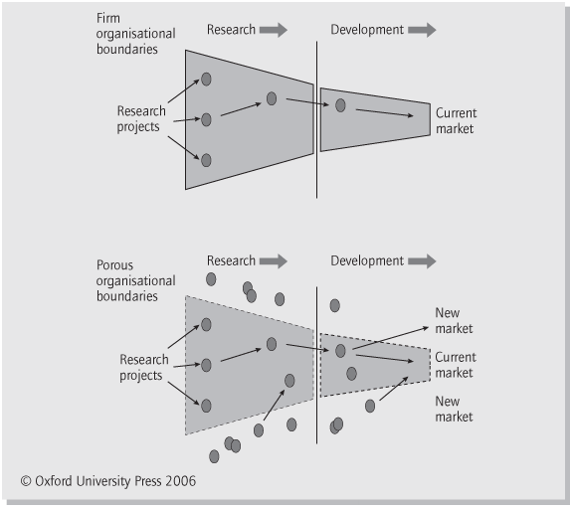

Appendix B

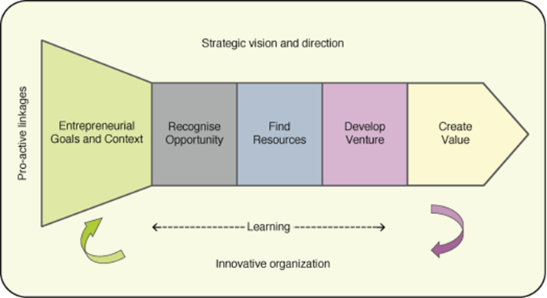

Appendix C

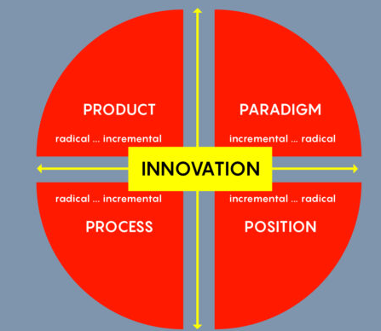

Appendix D

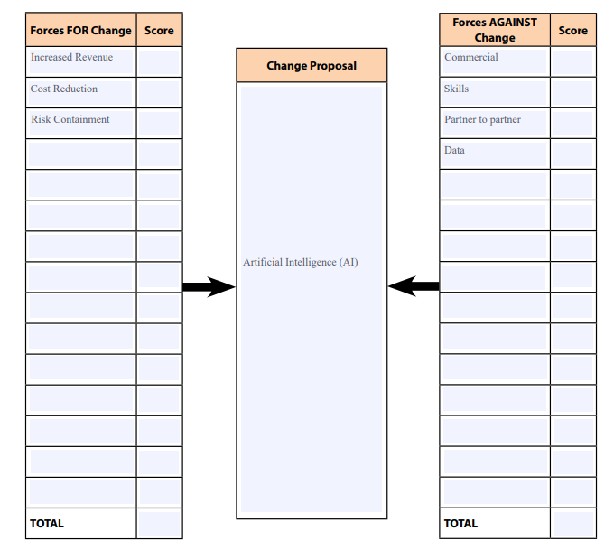

Reference

Adamo, A. (2018). Open Innovation: Models and Best Practices. Available at: https://medium.com/alan-advantage/open-innovation-models-and-best-practices-e2e732a38155 [Accessed on: 23rd March 2022].

Anastasia Shch. (n/a). The Importance of Creativity in Business. Available at: https://www.anastasiashch.com/business-creativity#:~:text=Creativity%20in%20business%20is%20a,merely%20follow%20the%20beaten%20path. [Accessed on: 23rd March 2022].

Business Victoria, (2022). Improve employee innovation. Increase profitability and staff retention with an innovative culture. Available at: https://business.vic.gov.au/business-information/grow-your-business/improve-employee-innovation [Accessed on: 23rd March 2022].

Changeboard, (2019). The 8 benefits of increasing creativity in the workplace. Available at: https://www.changeboard.com/article-details/16967/the-8-benefits-of-increasing-creativity-in-the-workplace/ [Accessed on: 24th March 2022].

Cowling, J. (2016). A Brief History of Microsoft - The Worlds Biggest Software Company. Available at: https://content.dsp.co.uk/a-brief-history-of-microsoft-the-worlds-biggest-software-company [Accessed on: 23rd March 2022].

Fast Company, (2019). Available at: https://www.fastcompany.com/90305091/this-is-microsofts-ai-pipeline-from-research-to-reality [Accessed on: 18th March 2022].
Info Entrepreneurs, (n/a). Use innovation to grow business. Available at: https://www.infoentrepreneurs.org/en/guides/use-innovation-to-grow-your-business/#1 [Accessed on: 24th March 2022].

Kylliäinen, J. (2019). Types of Innovation – The Ultimate Guide with Definitions and Examples. Available at: https://www.viima.com/blog/types-of-innovation [Accessed on: 23rd March 2022].

Markman, A.B (2016). Open innovation: academic and practical perspectives on the journey from idea to market. Oxford University Press.

Microsoft Partner Network, (2020). 5 barriers to AI adoption: opportunities to talk to your customers. Available at: https://blogs.partner.microsoft.com/mpn-unitedkingdom/5-barriers-to-ai-adoption-opportunities-to-talk-to-your-customers/ [Accessed on: 23rd March 2022].

Microsoft, (2022). What is artificial intelligence? Available at: https://azure.microsoft.com/en-gb/overview/what-is-artificial-intelligence/#how [Accessed on: 9th March 2022].

MindTools, (2016). Leadership Styles Choosing the Right Approach for the Situation. Available at: https://www.mindtools.com/pages/article/newLDR_84.htm [Accessed on: 23rd March 2022].

Peek, S. (2021). Creativity Is Not Innovation (But You Need Both). Available at: https://www.businessnewsdaily.com/6848-creativity-vs-innovation.html [Accessed on: 23rd March 2022].

Piperopoulos, P. G. (2016). Entrepreneurship, Innovation and Business Clusters. United Kingdom: Taylor & Francis.

Prodware, (2020). Microsoft Azure AI. Available at: https://www.prodwaregroup.com/our-solutions/microsoft-azure-artificial-intelligence-services/#:~:text=BENEFITS%20%E2%80%93%20ARTIFICIAL%20INTELLIGENCE&text=Artificial%20intelligence%20provides%20the%20breadth,buying%20intentions%2C%20fostering%20customer%20loyalty. [Accessed on: 24th March 2022].

Schramm, L. (2017). Technological Innovation: An Introduction. Germany: De Gruyter.
Surbhi, s. (2017). Difference Between Invention and Innovation. Available at: https://keydifferences.com/difference-between-invention-and-innovation.html [Accessed on: 24th March 2022].

Tidd, J. and Bessant, J. R. (2014). Strategic Innovation Management. United Kingdom: Wiley.

Tidd, J., Bessant, J. (2018). Managing Innovation: Integrating Technological, Market and Organizational Change. United Kingdom: Wiley.

Wallas, G. (2018). The Art of Thought. United Kingdom: Solis Press.

Zapfl, D. (2019). LEAD Innovation Blog Read our latest articles on innovation management and innovation in a wide range of industries. Available at: https://www.lead-innovation.com/english-blog/open-innovation-vs.-closed-innovation [Accessed on: 20th March 2022].

