Part A
Poster of Passenger Flow

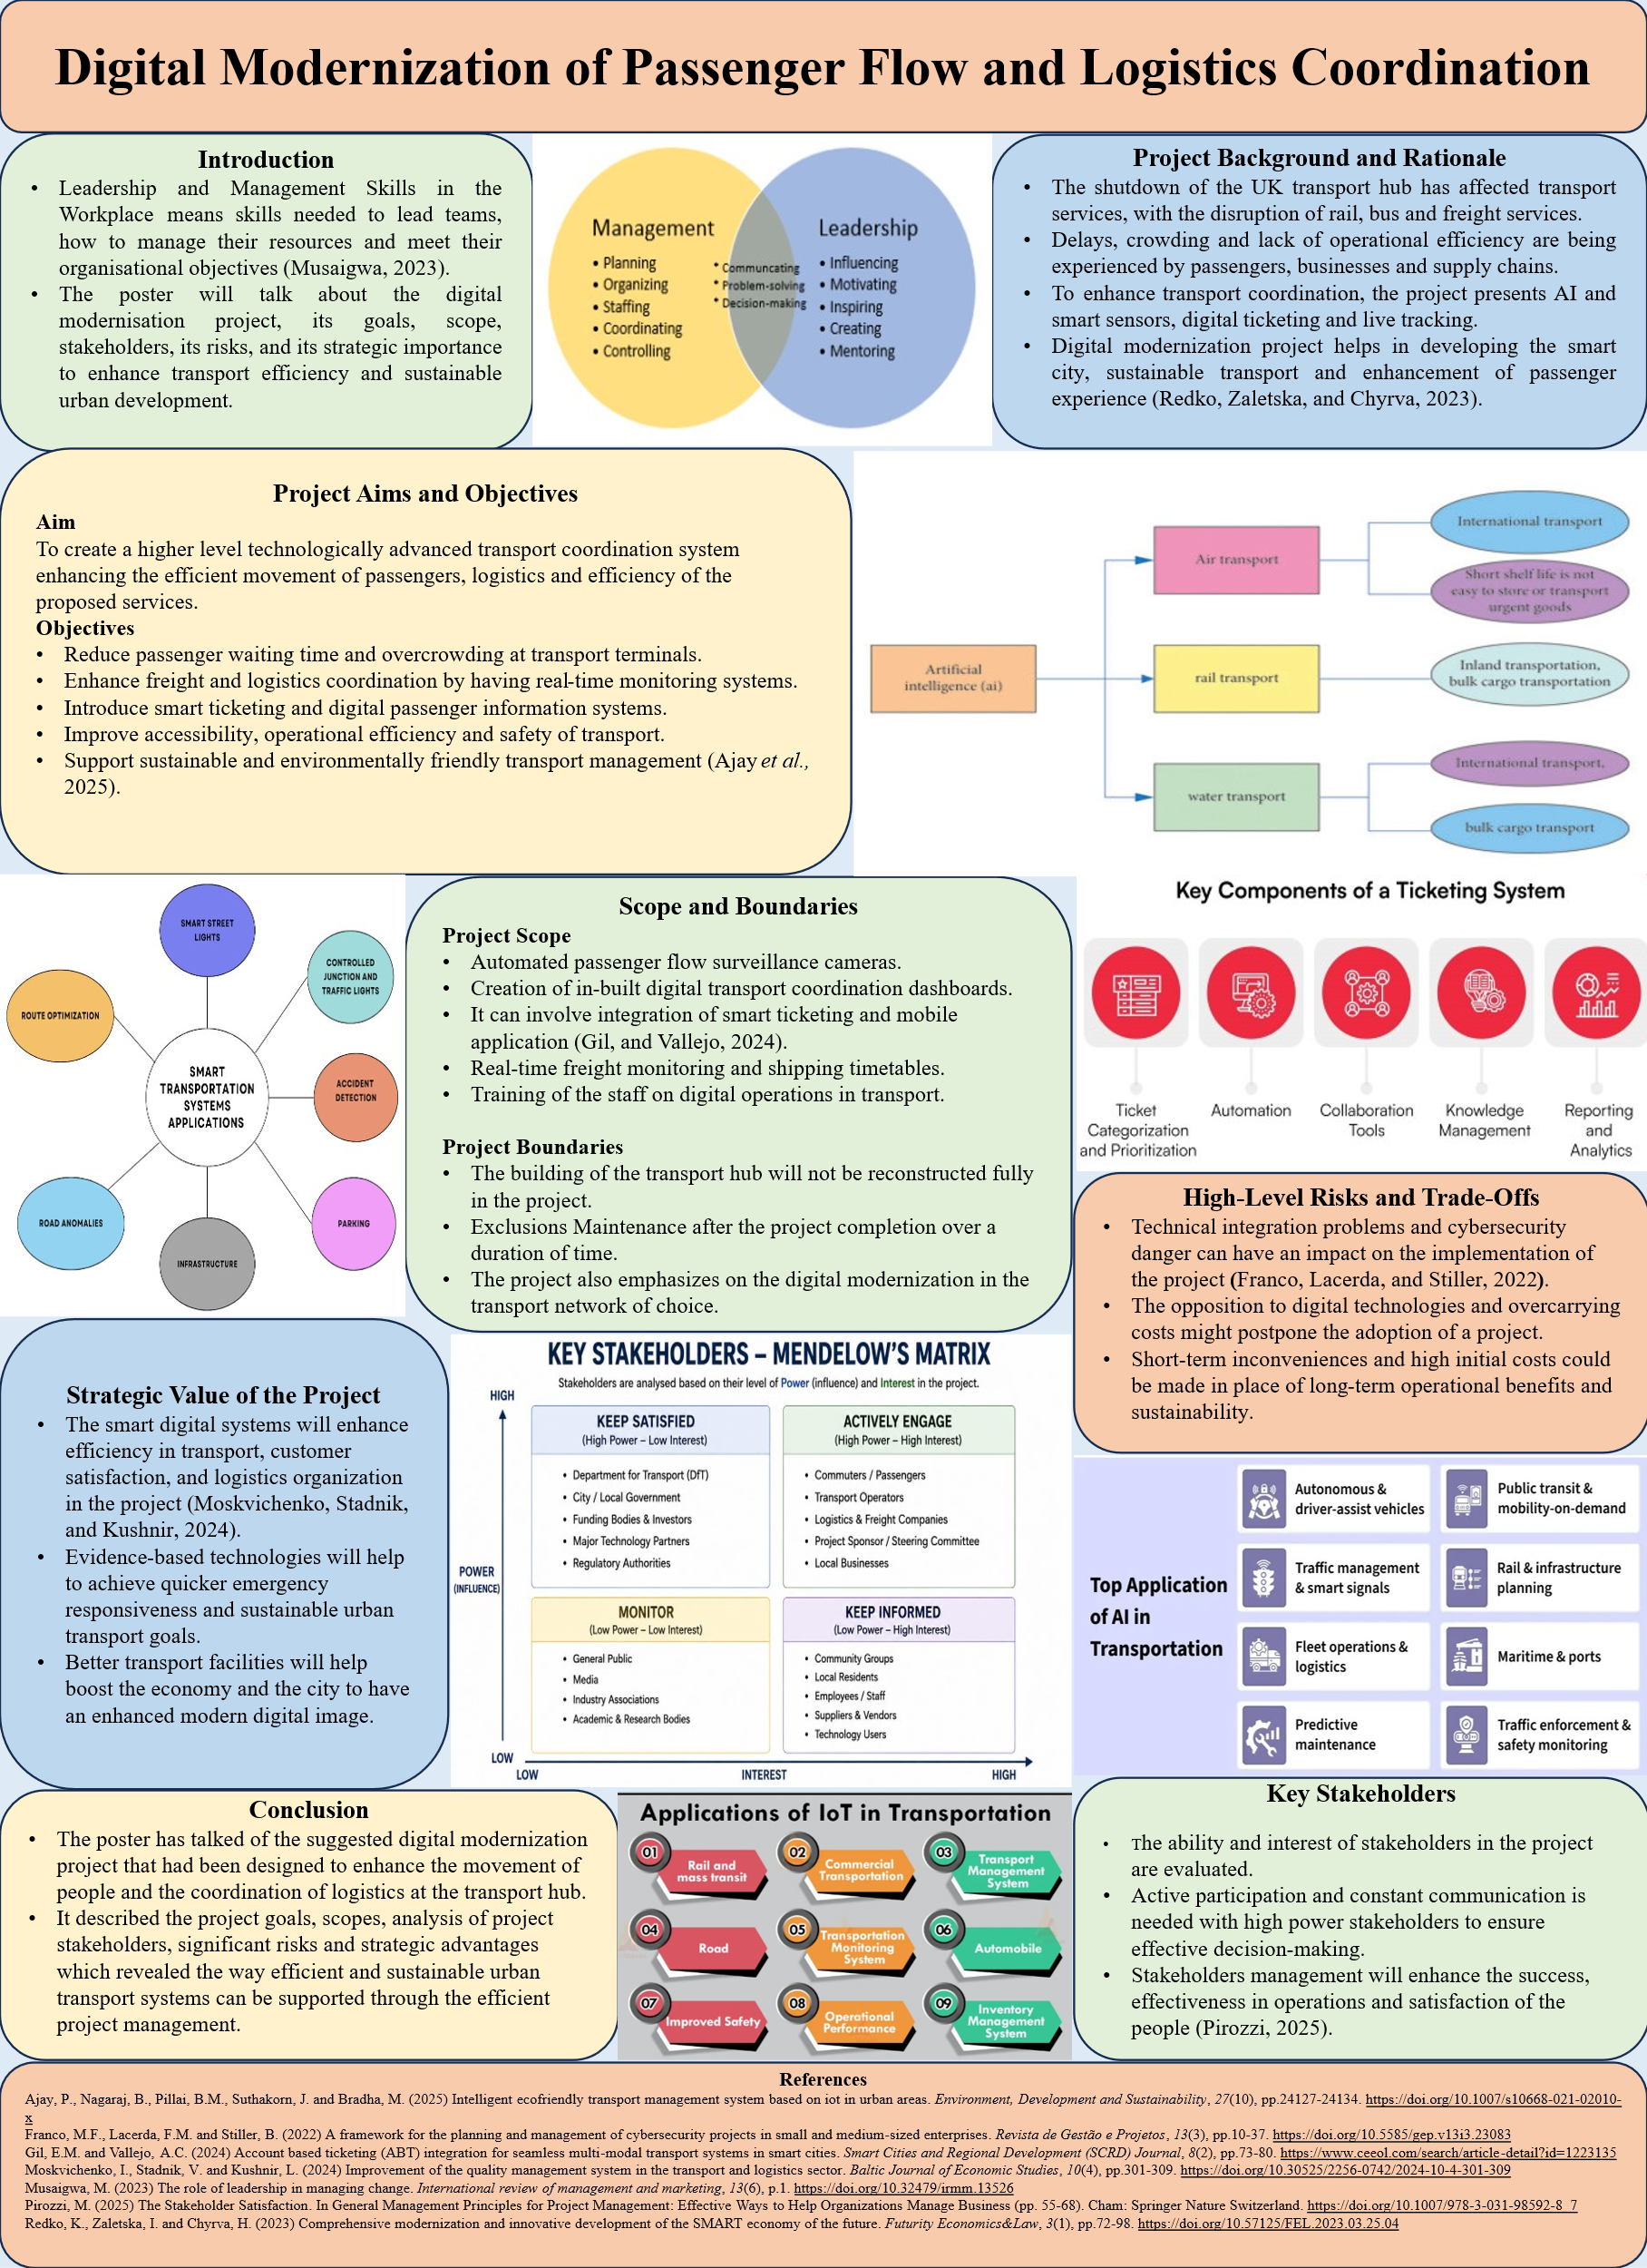

Part B
Feedback

Part B - Critical Reflection
The evaluation that I got in regard to my project proposal poster by both my tutor and my peers provided me with the chance to critically review the poster and to find out what is good and what can be improved in the poster. Considering the feedback also pushed me towards getting beyond description to adopt more analytical, practical approach to the project management.
Among the strengths, which have been identified in the feedback was my project selection and the focus on clear goals of the digital modernization of the passenger flow and the logistics coordination. I was glad that my tutor and peers realized that my project aims and objectives were applicable in the case scenario and that they showed an idea of how digital technologies can enhance transport efficiency and sustainability. My presentation of the project scope, boundaries and strategic value was also valued by them. This feedback made me feel that I had laid a great groundwork to the project. According to Hillson, 2024 establishing the scope and boundaries of a project helps avoid uncertainty, scope creep, and achieve a successful project delivery .
Although these were positive remarks, I have realized that I need to improve on some areas of my poster. One of the main areas was the stakeholder analysis. Following my reflection on the feedback, I realized that it was important also to identify the stakeholder groups. I had to articulate their interests, level of influence and appropriate engagement strategies. Thus, to reinforce my final project management plan, I added the Matrix by Mendelow and a table of the stakeholder analysis. In my opinion, these additions evidenced a more deliberative and effective stakeholder management.
The other significant concern in the feedback was that I was speaking about project risks and trade-offs. I also realized that I have simply outlined the risks without critically assessing how this has affected the success of the project. This made me realize that it is essential to analyze risks, and not an identification of the risk itself. Numan,2024 suggests that successful risk management also involves organizations evaluating the probability and severity of risks and taking necessary mitigation measures with the help of such tools as risk registers and risk heat maps. I therefore integrated the two into my completed project management plan to come up with a more organized way of managing risks.
Another feedback that I received was that my project objectives were highly ambitious and unquantifiable. This opened my eyes to discover that what I was trying to achieve was not a clear indication of how success in the project would be measured. Thus, I changed the objectives attaching them to the performance measurements and achievable time frames to make the project performance more regularly checked and examined.
On balance, I greatly appreciated the feedback since it provoked me to think more critically about my work and enhance practical implementation of project management tools. It also made me identify areas that I have to improve on as well as my strengths. Consequently, I have come up with an improved stakeholder analysis, improved my risk management strategy and have more quantifiable project goals. In my opinion, these enhancements have created a more evidence-based and professionally designed project management plan, which is more aligned with the assessment requirements.

References
Hillson, D. (2024) Managing risk in projects. Routledge. https://doi.org/10.4324/9781003431954
Numan, M. (2024) BIM and risk management: A review of strategies for identifying, analysing and mitigating project risks. Journal of Engineering Research and Sciences, 3(1), pp.20-26. https://www.jenrs.com/v03/i01/p004/

Module Code: LCLM5003
Module Title: Project Management Plan
Daulphin Bessong: 2421621
Chosen option: Digital modernisation of passenger flow and logistics coordination

Table of Contents
1. Introduction 5
2. Project Description 6
3. Scope 6
3.1 Project Scope 6
3.2 Project Boundaries 7
4. Work Breakdown Structure (WBS) 7
5. Quad Chart 8
6. Gantt Chart 10
7. Stakeholders’ Involvement 11
8. Allocation of Resources 12
9. Risk Analysis 13
10. Conclusion 16
11. References 17

List of Tables
Table 1: Quad Chart 8
Table 2: Gantt Chart 10
Table 3: Stakeholder Analysis 11
Table 4: Risk Analysis 13
Table 5: Risk Heat Map 14

List of Figures
Figure 1: Work Breakdown Structure 7
Figure 2: Mendelow's Matrix 11

1. Introduction
The Leadership and Management Skills in the Workplace is a set of skills needed to lead a team, manage resources within an organisation and fulfil project goals in a workplace (Adham, and Sukkar, 2024). To be able to deliver complex infrastructure and digital transformation projects, effective leadership and project management are critical. The shutdown of the central transport hub of the city in the UK has posed major problems in transportation and passenger flow, as well as logistics coordination. Thus, in this project management plan, the priorities will address the digitalisation of the passenger traffic and logistics organisation by implementing smart technologies, AI-based solutions and real-time monitoring. The plan will cover the project description, scope, work breakdown structure, stakeholder involvement, allocation of resources, risk analysis, Gantt chart and project management techniques that will enable successful project implementation and aid in sustainable and smart urban transport development.

2. Project Description
The chosen project is based on the process of digital transformation of passenger traffic and stream coordination of logistics at the closed transport centre of a large city in the United Kingdom. The closure of the transport hub has extremely disrupted bus, freight and rail services, which have adversely affected the passengers, local businesses, and supply chains. The project will assist in addressing these issues through the introduction of new hi-tech digital technologies, which will contribute to the increase of transport efficiency, regulating the flow of people, and organising logistics. The project will bring in the use of Artificial Intelligence (AI)-powered passenger surveillance systems, smart cameras, electronic ticketing systems and real-time transport tracking systems. The technologies will also aid in the effective management of crowds, besides easing the waiting time of passengers, and decision-making (Giannopoulou et al., 2026). Also, freight scheduling, route planning and supply chain visibility will be improved with digital logistics coordination systems. Both integrated digital dashboards will also be included in the project, enabling the transport authorities and players to keep track of transport activities in real time and respond promptly to operational problems or emergencies. The associated project management strategies to be adopted in the project will include planning, scheduling, stakeholder management and risk management to ensure a successful implementation of the project (Eyieyien et al., 2024). Agile and conventional approaches to project management will be integrated to enhance flexibility and project management during the lifecycle of the project. Moreover, the project is in line with the UK government's smart city and sustainable transport aims, in that it will facilitate the efficient movement of people in towns, digitalisation and transport activities that are environmentally aware. On the whole, it can be stated that the digital modernisation initiative is likely to enhance the level of passenger satisfaction, efficiency of operations, reliability of transport and economic activities in the city and provide a novel digitally-linked transport space.

3. Scope

3.1 Project Scope
Digital Modernisation of Passenger Flow and Logistics Coordination Project is the sphere of work to introduce modern digital technologies to enhance the efficiency of the transport and passenger traffic, as well as logistics organisation in the chosen transport centre. The project includes the implementation of AI-controlled passenger trackers, smart sensors, digital ticketing and real-time tracking technologies to aid in the actions of managing and decision-making within the operational context. Also, integrated digital dashboards will be designed to allow transport authorities to track transport operations, cope with emergencies and respond swiftly to breakdowns in services. Employee training programmes and system awareness training activities will also be done to guarantee a seamless implementation, operational preparedness and useful application of the digital systems (Kalli, Abba, and Bukar, 2023).

3.2 Project Boundaries
Project boundaries give a clear idea of what the project will not do to prevent scope creep and to be in control of the project. The regeneration will be digital modernisation only, and will not cover the physical redevelopment or rebuilding of the transport hub infrastructure. The project does not include long-term maintenance, future upgrading and expansion processes of the system. Moreover, the implementation will not be implemented equally in all transport networks and logistics-related operations within the metropolitan setting, but only in the chosen setting. Well-established boundaries of the project will facilitate effective allocation of resources, cost management, and completion of the project on time.

4. Work Breakdown Structure (WBS)

Figure 1: Work Breakdown Structure
(Source: Self-generated, 2026)

The hierarchy is the Work Breakdown Structure (WBS), which breaks down the Digital Modernisation of Passenger Flow and Logistics Coordination Project into mini and manageable activities. It assists the project managers to plan their tasks in an orderly manner and enhance project planning, project coordination and monitoring in a project lifecycle. Project Planning is a requirement analysis, feasibility study and budget planning stage to provide a solid foundation to the project (Raharjo, 2022). System Development is the second step and involves the intelligent transportation solutions such as AI passenger monitoring systems, smart ticketing and real-time tracking integration to enhance transport efficiency and passenger control. The third stage, Infrastructure and Installation, entails the use of smart sensors and the installation of networks to facilitate the functionality and connectivity of the digital system. Testing and Training stage fourth: This stage involves testing of all systems to ascertain that they are healthy in terms of functionality, security and performance, and the employees are also trained on how to use this system effectively. Lastly, Project Deployment involves the actual implementation of the system and monitoring of the performance to deliver the project successfully and efficiently. All in all, the WBS enhances the allocation of tasks, management of resources, communication and schedule, as well as aids the successful and timely digital modernisation project completion.

5. Quad Chart
Table 1: Quad Chart
TITLE: Digital Modernisation of Passenger Flow and Logistics Coordination Project
PURPOSE (Aims/Objectives) | CUSTOMERS (Stakeholders)
- Minimise the time and effort required to transfer passengers and transport using AI-based solutions.  - Implement ticketing through digital means, intelligent sensors and real-time tracking systems (Nampalli, 2023).  - Lessen the time passengers wait in lines and enhance logistic coordination.  - Favourable, sustainable, and intelligent urban transportation. | - Local governments and regulators.  - Logistics service providers and operators.  - Passengers and commuters  - Local investors and businesses.  - Employees, technical personnel and the media.
DESIRED END RESULT (Critical Success Factors) | MEASURES OF SUCCESS (Standards/Criteria)
- Effective delivery in a timely, cost-effective manner.  - Enhanced passenger satisfaction and efficiency.  - Improved real-time monitoring and decision-making.  - Less service interruption and better logistics arrangement. | - Less waiting time and congestion of passengers.  - More reliable transport and efficiency of the services.  - Effective system testing and compliance with cybersecurity.  - Improvement of operational performance and positive feedback from the stakeholders.

The Quad Chart represents a brief overview of the Digital Modernisation of Passenger Flow and Logistics Coordination Project as it arranges the core objectives of the project, its stakeholders, anticipated performance results and measures in an orderly manner. It will make the stakeholders learn the purpose and strategic nature of the project within a short time. As it is pointed out in the chart, the principal goal of the project involves enhancing passenger movement, traffic control and the logistics organisation with the help of installing AI-based surveillance mechanisms, intelligent sensors, electronic ticket sales and real-time monitoring technologies. It also establishes some important stakeholders like local authorities, transport operators, passengers, businesses and government regulators that will ensure that projects are implemented and decisions are made. Additionally, the targeted final outcomes aim at enhancing operational efficiency, passenger satisfaction, safety and reliability of transport, as well as the completion of the project on the budget and time plan. The success measures would be used as benchmarks in judging project performance, such as a decreased time spent in passengers' waiting areas, an increase in the reliability of the services, successful system testing and favourable feedback. Altogether, effective communication, project monitoring and decision-making during the project lifecycle, as well as successful delivery of the project on the digital modernisation, are supported by the Quad Chart (Kudyba and D Cruz, 2023).

6. Gantt Chart
Table 2: Gantt Chart
Project Activities | June | July | August | September
Project Planning and Feasibility Analysis
Budgeting and Resource Allocation
Development of AI Monitoring Systems
Smart Ticketing and Tracking System Development
Infrastructure Installation and Cybersecurity Setup
System Integration and Testing
Staff Training and Operational Preparation
Final Deployment and Project Closure

The Gantt chart will show the schedule and timeline of activities employed during the Digital Modernisation of Passenger Flow and Logistics Coordination Project. It offers a graphic display of project activities, times and additional capabilities of the projects to guarantee positive planning and project oversight (Wadhwa, 2024). The project starts with planning, feasibility analysis and budgeting activities, which set the stage towards successful project implementation. Once the first planning phase is complete, the creation of AI-based monitoring systems and smart ticketing technologies is performed in parallel to enhance the project's efficiency and decrease delays. The second step is to install the infrastructure, build the cybersecurity and system integration to make every digital system function properly. Before the last development phase, activities such as testing and staff training are carried out to reduce the risk of not getting the system operational and to enhance the system's preparedness. The Gantt chart assists project managers to keep track of project progress, efficiently allocate resources, determine task dependencies, and ensure project activities are done within the budget and schedule that has been set.

7. Stakeholders’ Involvement
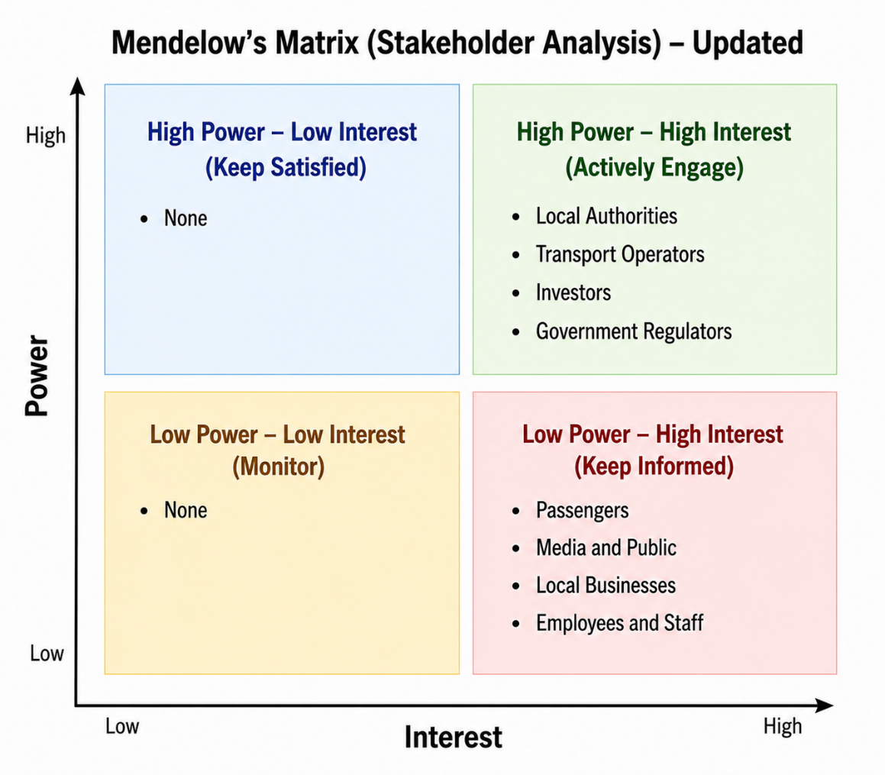
Figure 2: Mendelow's Matrix
(Source: Self-generated, 2026)

Table 3: Stakeholder Analysis
Stakeholder | Interest | Power Level | Strategy
Local Authorities | High | High | Frequent meetings and participation in the decision-making processes.
Transport Operators | High | High | Ensure the active communication and coordination of operations (Verma et al., 2024).
Passengers | High | Low | Communicate using online platforms and feedback channels.
Local Businesses | High | Medium | Make frequent consultations on transport improvements.
Investors | High | High | Frequent financial reporting, performance audit and participation in key project decision making.
Government Regulators | High | High | Ongoing consultation to achieve regulatory compliance, safety requirements and sustainability.
Employees and Staff | High | Medium | Develop training programmes and participate.
Media and Public | High | Low | Get updated on the news using the public announcements, social media updates, consultations and feedback culture.

The Digital Modernisation of Passenger Flow and Logistics Coordination Project are dependent on stakeholder involvement in order to be successfully implemented. The stakeholders possess different degrees of power, interest and influence relating to the results of the project. The most important stakeholders are local authorities, transport operators, investors and government regulators due to their high power and high interest as these stakeholders directly affect the funding of the project, project approvals, regulatory compliance and strategic choices. The interest of passengers, the general population, local businesses, and workers is high too, as the project has a direct impact on transport services, processes and everyday experiences when travelling. The normal meetings will be done, digital communication will be used to communicate with the stakeholders, and a consultation and feedback system will be put in place to reduce resistance to change. The Matrix developed by Mendelow assists the project manager in prioritising needs among the stakeholders and using the right management approaches (Kumar, 2022). Proper interaction facilitates collaboration, decision-making, and the successful delivery of the project.

8. Allocation of Resources
The allocation of resources is critical to realise that the digital modernisation project will be accomplished effectively within the scheduled budget and resources. Human, financial and technological resources will be allocated in terms of project demands and the steps of implementation. The project manager will ensure that all activities in the project are monitored and liaise with all the stakeholders, those in the technical team and the transport authorities. The development and integration of digital transport systems will be done by IT specialists, software developers and cybersecurity experts. The allocation of the financial funds will be on the acquisition of AI software, smart sensors, digital ticketing and network infrastructure. This budget will also fund staff training, testing and technical maintenance in the implementation process. The system will also need physical resources like computer systems, servers and monitoring devices to operate the systems and manage real-time data. Resource allocation methods will be employed to prevent resource scarcities, time schedules, and needless expenses on projects. The right distribution of resources will enhance productivity, efficiency of operations and quality of the project. Also, the efficient management of the resources will facilitate a timely completion of the project and the support of the realisation of the strategic objectives of the project concerning the transport efficiency, the satisfaction of the passengers and the sustainable urban movement (Du et al., 2023).

9. Risk Analysis
Table 4: Risk Analysis
Risk ID | Risk Description | Likelihood | Impact Severity | Degree of Risk | Mitigation Strategy
R1 | Security of passenger and transport data may be impacted by cybersecurity threats. | 5 | 4 | 20 | Introduce powerful cybersecurity programs, firewalls and frequent surveillance processes (Aslan et al., 2023).
R2 | Resistance from staff and passengers towards new digital technologies. | 4 | 4 | 16 | Carry out training programmes, awareness, and change management programs.
R3 | Problems in the implementation of the system can be caused by technical integration issues. | 4 | 3 | 12 | Carry out frequent testing and system compatibility checks.
R4 | Budget overrun can impact the completion and running of projects. | 3 | 4 | 12 | Implement good cost management and financial oversight.
R5 | Temporary inconvenience of transport services during works on installation issues. | 3 | 2 | 6 | Prepare contingency measures and plan installations when there is not much traffic.

Table 5: Risk Heat Map
Impact | 5 | 5 | 10 | 15 | 20  (“Cybersecurity Threats”) | 25
Impact | 4 | 4 | 8 | 12  (“Technical Integration Issues”) | 16  (“Resistance to New Digital Technologies”) | 20
Impact | 3 | 3 | 6 | 9 | 12 (“Budget Overruns”) | 15
Impact | 2 | 2 | 4 | 6 (“Temporary Service Disruptions”) | 8 | 10
Impact | 1 | 1 | 2 | 3 | 4 | 5
Impact |  | 1 | 2 | 3 | 4 | 5
Impact |  | likelihood

The risk register is a critical project management tool that is used to help in identifying, evaluating and controlling potential risks that could impact the digital modernisation project (Pomaza-Ponomarenko et al., 2023). It gives more details about the risk descriptions, probability, severity of impacts and the mitigation measures. Cybersecurity threats, unwillingness to embrace digital technology, technical integration obstacles, budgetary excesses, and temporary service interruptions are some of the key risks in this project. Every risk is analysed based on its likelihood and the extent of the effects it may cause towards the project performance in order to establish the level of the overall risk. Proper risk mitigation guidelines like cybersecurity tools, employee development, technical testing and financial controls are implemented to lessen the intensity of risk and enhance the stability of the project. The risk register is also useful in making good decisions and following up on risks during the project life cycle. Effective risk management will eliminate operational setbacks, enhance the control of the project and enhance the chances of implementing a project successfully within the planned time and budget.

10. Conclusion
To sum up, the Digital Modernisation of Passenger Flow and Logistics Coordination Project is an effective solution to transport disruption issues the metropolitan city in the United Kingdom faces. The project is aimed at using innovative digital solutions like AI-based passenger monitoring, smart sensors, digital ticketing and real-time tracking to enhance passenger flow, logistics organisation and efficiency. The project management plan has illustrated how key project management tools and techniques such as scope management, Work Breakdown Structure (WBS), Quad Chart, Gantt Chart, stakeholder management, resource allocation and risk analysis have been put into use. These are used to facilitate planning, communication, scheduling and project control of the project lifecycle. Moreover, the stakeholders' engagement, resource management and risk minimisation strategies will add to the successful project implementation within the scheduled plan and budget. In general, the project promotes smart city and sustainable transport goals and enhances passenger satisfaction, transport reliability and economic activities. Thus, the project will help to establish a contemporary, functional and digitally connected urban transport environment.

11. References
Adham, T.K.I. and Sukkar, A. (2024) Effective management of construction project team: Identifying leadership qualities and responsibilities. Scholars Journal of Economics, Business and Management, 11(2), pp.63-73. 10.36347/sjebm.2024.v11i02.003
Aslan, Ö., Aktuğ, S.S., Ozkan-Okay, M., Yilmaz, A.A. and Akin, E. (2023) A comprehensive review of cyber security vulnerabilities, threats, attacks, and solutions. Electronics, 12(6), p.1333. https://doi.org/10.3390/electronics12061333
Du, J., Wang, W., Gao, X., Hu, M. and Jiang, H. (2023) Sustainable operations: A systematic operational performance evaluation framework for public–private partnership transportation infrastructure projects. Sustainability, 15(10), p.7951. https://doi.org/10.3390/su15107951
Eyieyien, O.G., Idemudia, C., Paul, P.O. and Ijomah, T.I. (2024) Effective stakeholder and risk management strategies for large-scale international project success. International Journal of Frontiers in Science and Technology Research, 7(1), pp.013-024. https://doi.org/10.53294/ijfstr.2024.7.1.0044
Giannopoulou, E., Demestichas, P., Katrakazas, P., Saliverou, S. and Papagiannopoulos, N. (2026) AI-Powered Service Robots for Smart Airport Operations: Real-World Implementation and Performance Analysis in Passenger Flow Management. Sensors, 26(3), p.806. https://doi.org/10.3390/s26030806
Kalli, K.A., Abba, Y.B. and Bukar, A.G. (2023) An assessment of the effect of training and development on employee performance: A review perspective. World Journal of Advanced Research and Reviews, 18(2), pp.258-270. Article DOI: https://doi.org/10.30574/wjarr.2023.18.2.0748
Kudyba, S. and D Cruz, A. (2023) Understanding project success involving analytic-based decision support in the digital era: a focus on IC and agile project management. Journal of Intellectual Capital, 24(6), pp.1429-1446. https://doi.org/10.1108/JIC-03-2022-0054
Kumar, M. (2022) Tools and techniques of project management. Available at SSRN 4072538. https://papers.ssrn.com/sol3/papers.cfm?abstract_id=4072538
Nampalli, R.C.R. (2023) Moderlizing AI applications in ticketing and reservation Systems: Revolutionizing passenger transport services. Journal for ReAttach Therapy and Developmental Diversities. Green Publication. https://doi. org/10.53555/jrtdd. v6i10s (2), 3280.
Pomaza-Ponomarenko, A., Kryvova, S., Hordieiev, A., Hanzyuk, A. and Halunko, O. (2023) Innovative risk management: identification, assessment and management of risks in the context of innovative project management. Economic Affairs (New Delhi), 68(4), pp.2263-2275. 10.46852/0424-2513.4.2023.34
Raharjo, D.S. (2022) How feasibility study guides an execution of project development. International Journal of Business and Applied Social Science, 8(1), pp.43-55. DOI: http://dx.doi.org/10.33642/ijbass.v8n1p5
Verma, S.K., Verma, R., Singh, B.K. and Sinha, R.S. (2024) Management of intelligent transportation systems and advanced technology. In Intelligent transportation system and advanced technology (pp. 159-175). Singapore: Springer Nature Singapore. https://doi.org/10.1007/978-981-97-0515-3_8
Wadhwa, K. (2024) The Role of Gantt Chart in the Project Management. https://www.theseus.fi/handle/10024/865913

