Student name: Yama Kanteh
Student ID: 2428898
Module name: Introduction to Physiology
Module code: BMHP5023
Lecturer name: Dr Soban Sadiq

Assessment:
This scenario discusses the increasing number of patients being diagnosed with diabetes. Diabetes has been defined as a chronic health condition that affects how your body turns food into energy. There are three categories of diabetes; type 1 diabetes is where the body cannot naturally produce little to no insulin and that in turn causes high blood sugar levels. Gestational diabetes is a category of diabetes that mainly manifest itself within pregnant women and normally goes away after pregnancy. Type 2 diabetes however is caused by poor diet, lack of exercise and lifestyle choices that can affect the body such as smoking that can affect the body’s ability to naturally produce the amicable amount of insulin needed for the body to not reach high blood sugar levels.
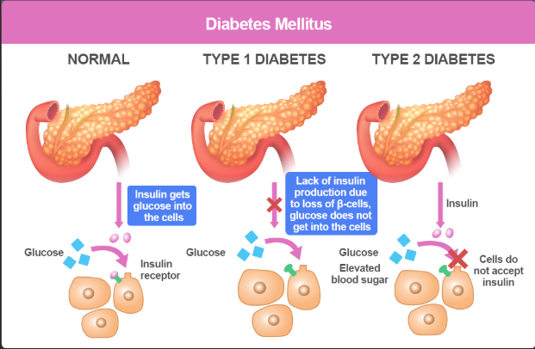
Diabetes is an illness that is not discussed in enough depth as many are unaware and uneducated on how diabetes manifests itself into people and how it can truly affect a person’s day-to-day life. The high blood sugar levels caused by diabetes effects a patient’s energy levels, causes dehydration and can cause lifelong complications. It can cause complications within the endocrine system that serves the purpose of regulating hormones and regulating many biological processes that occur within the body at really low levels. One of the hormones that the endocrine system regulates is insulin, it is not discussed enough how the endocrine system is being affected within diabetic patients as they are either not producing enough insulin for the body to naturally combat high blood sugar levels or not producing insulin at all. The thyroid gland is responsible for regulating the metabolism of the body but with factors such as poor diet and lifestyle choices the body’s metabolism is affected and there has been a link between diabetic patients and the prevalence of hypothyroidism (underactive thyroid) and hyperthyroidism (overactive thyroid). This relates to the thyroid regulating metabolism and how those with diabetes, type 2 diabetes to be exact, and their choices in diet and lifestyle choices can affect the activity of the thyroid, causing fluctuations in the body’s weight and ability to control how the body uses energy.
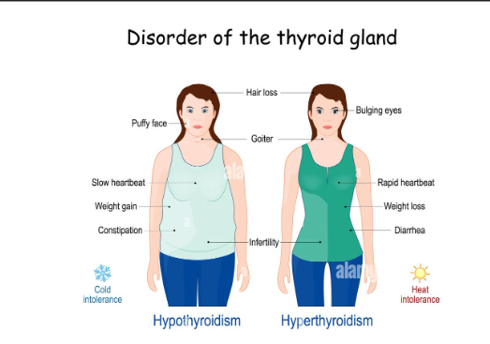
The lack of knowledge surrounding diabetes can be seen to be a contributing factor to the rise of those getting a diabetes diagnosis. Diabetes education is an important component diabetes treatment as the goals of diabetes education include not only providing knowledge and skills but also changing the patients behaviour, increasing their motivation to comply to therapeutic recommendations, improving their quality of life, establishing a partnership with the treatment process, preparing the patient for self-care, increasing their awareness of cardiovascular risk factors and increasing their psychological resistance. [Natalia Świątoniowska et al, 2019] Hence why in this report, I aim to educate patients on diabetes. I will be discussing the main factors that contribute to getting diabetes to create an understanding on how one may have been diagnosed with this illness and to help emphasise how easily preventable developing diabetes is if the right preventative measures are put in place. I will also be discussing how to manage living with diabetes such as keeping record of blood sugar levels and what changes to everyday lifestyle can be made to make living with diabetes more manageable.
To understand diabetes and the everlasting effects it has on the body we need to delve into what diabetes targets. Diabetes is a disease that impacts the glucose levels in the blood. Blood sugar levels are normally maintained within a tight and regulated range through the endocrine system, primarily through a series of hormones. Hormones fulfil the role of controlling and regulating many biological processes which includes the regulation of blood sugar. For instance, insulin is a hormone that is released from the pancreas and that hormone focuses on lowering the blood glucose levels within the body. It is a hormone that is responsible for regulating how sugar is used and converted to energy for the body or how it can be stored for later, the glycogen that is to be used is converted into glucose for the blood to carry to cells within the body. It plays a very important role as it keeps the blood sugar levels within the body stable and the consequences of low insulin levels consist of low energy levels, dehydration and further complications within the body.
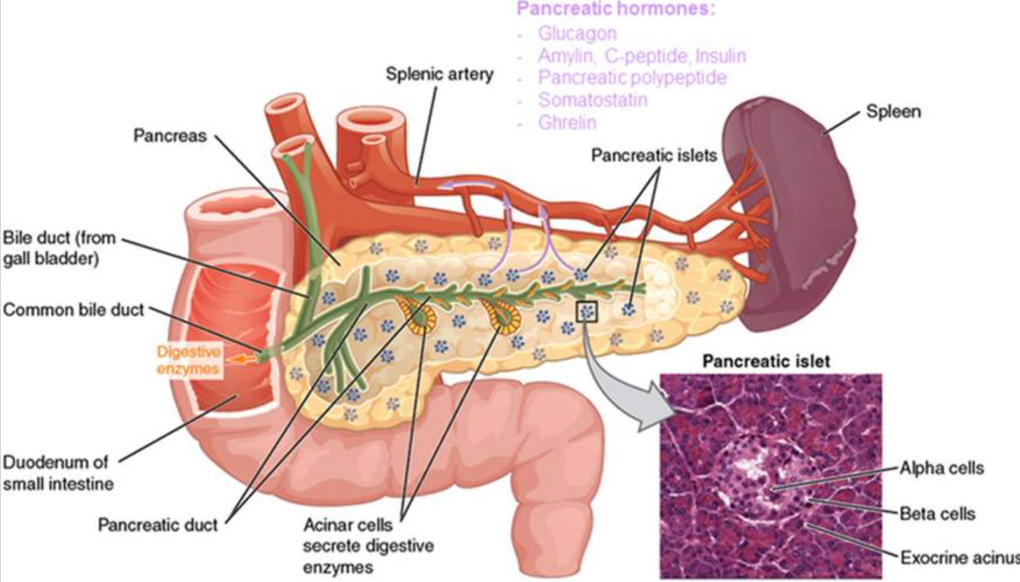
Another hormone that is responsible for blood sugar regulation is glucagon. Glucagon works contrastingly to how insulin works. It is mainly a hormone working in between mealtimes where the body is not being given glucose, it signals the liver and muscle cells to convert the stored glycogen within the muscles to glucose in order for energy to be distributed to areas that have lower glucose levels.
It is important to understand how to body organically regulates blood sugar as diabetes affects the regulation of blood sugar, causing blood sugar spikes that can lead to serious complications, changes in lifestyle such as more frequent exercise and a balanced diet helps these hormones function effectively.

Cellular metabolism is the total collection of chemical reactions occurring within every living cell to maintain life. This chemical reaction within the body are separated into two different categories: catabolism and anabolism. Catabolism is responsible for the break down of large molecules within the body such as glucose into smaller units, releasing energy in the process. On the contrast, anabolism uses that energy deposited from the catabolic reaction to build, grow and repair essential cellular components within the body, for example, the assembly of amino acids into proteins.
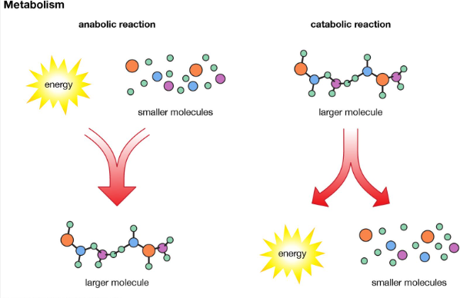
A key component of cellular metabolism is the production and use of energy for the body in the form of adenosine triphosphate (also known as ATP). ATP essentially is the energy-carrying molecule in cells. Cells generate ATP mainly through processes such as glycolysis and the citric acid cycle. Glycolysis is a process in the cytoplasm as a glucose molecule is broken down into a pyruvate molecule. If oxygen is present, pyruvate enters the mitochondria, where it is to be further processed in the citric acid cycle which generates electron-carriers and are then used in oxidative phosphorylation to produce a large amount of ATP.
Enzymes are a biological catalyst that speed up reactions without being used up. The best way to explain how enzymes operate is to use the ‘lock and key’ analogy where the enzyme acts as the lock on the molecule it is working on, the substrate, is the key. With this analogy in mind, only a substate with the exact complementary shape can fit into the enzyme’s active site to initiate the chemical transformation. This ensures that each enzyme only used for its intended reaction. Enzymes play a crucial role cellular metabolism as it allows the cell to go through the process of metabolism quickly and efficiently.
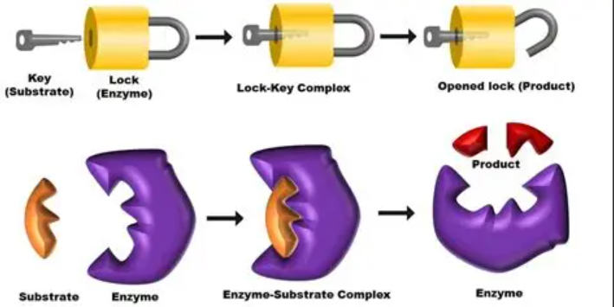
Cell metabolism is also carefully controlled through feedback mechanisms. For instance, if a cell has ample amount ATP, certain metabolic pathways will slow down to prevent excess energy production. Contrastingly, when energy levels are low, these pathways are activated to produce more ATP.
Overall, cell metabolism is essential for growth, repair, and maintaining cellular balance, enabling organisms to function and survive in changing environments.
This explanation of how diabetes has a deep effect in the regulation set within the body helps really breakdown the importance of medication to help combat diabetes and makes the rehabilitation transition a lot smoother for patients.
A part of the rehabilitation process includes recording and tracking blood sugar. Tracking and recording your blood sugar as someone that lives with diabetes is crucial as it provides a constant insight into how the body responds to foods, activities, medication and lifestyle habits. By constantly monitoring the glucose levels in your blood, it can help identify what could be responsible for spikes and drops within the body. Keeping a record of these patterns and trends displayed within the body helps understand how certain lifestyle choices can affects you as the patient as well as helps inform healthcare professionals to make decisions on diet, exercise and medication for the patient.
A key reason as to why keeping a track of your blood sugar is to help bridge that gap of ambiguity between you as the patient and the healthcare professionals responsible for assisting you with your diabetes. By keeping a record of how the body responds to certain medication will allow adjustments to be made where it suits. It also helps prevent complications such as hypoglycaemia or hypoglycaemia which refers to the dangerously high or low blood sugar levels a body can enter that can cause secondary health issues such as dizziness, fatigue and blurred vision.
If blood sugars are not to be tracked, it can essentially have patients combating diabetes blindly which can be life threatening. This would not only leave the patient unaware but also the healthcare professionals responsible for a patient’s care unable to form the care plan necessary for the patient.
With diabetes changes within your day-to-day life is imminent. Improving a person’s way of life requires a mixture of health and social care-based approach. These strategies curated by health and social care specialists evidently take a person-centred approach meaning the person’s care plan will be tailored to the individual and their needs.
One key recommendation to a person is a balanced diet. A balanced diet where the person includes more fruits and vegetables, wholegrains and healthy protein has proven to help manage a healthy body weight but also helps stabilise blood glucose levels. Revital Gorodeski Baskin and Kimberly A Karp [2025] found that Mediterranean and plant-based diets have demonstrated benefits for the prevention and treatment of type 2 diabetes, weight reduction, lipid movements and overall risk of cardiovascular risk reduction. Portion control and regular meal timings are also important to make blood glucose levels recorded more accurate. Regular activity comes highly recommended for those tackling diabetes as it can promote insulin sensitivity and have all cells working requiring more glucose and energy. Physical activities such as running, swimming, dancing can help with this as well as encourage weight management and lower the risk of cardiovascular disease.

It is also crucial to focus on the social aspect of tackling diabetes. It is important to destigmatise diabetes and encourage patients to have a positive outlook on this diagnosis. Support allocated to communities to educate people on diabetes and how it is not the end of the world if you are to be diagnosed with it, it would not just educate those with the diagnoses but families and friends making sure they can also contribute to the person not feeling isolated and demotivated. Thomas Rosemann et al [2012] emphasise how the concept of social support is crucial to patients but there has not been enough training given to the multidisciplinary team such as nurses and general practitioners.This is clearly an aspect of care that is not covered but clearly is an important aspect to include in a patient’s care.
These carefully constructed strategies do not only improve the physical health of a person but also assist in the emotional and psychological aspects of life that can be affected by having diabetes, creating that smooth transition into their new lifestyle with diabetes. These recommendations promote the importance of health maintenance with upkeep of medication, diet and exercise. However, it also promotes confidence and empowers patients with diabetes with the instilled education given to voice how life does not come to an end just because of the diagnosis.
To summarise, this report highlights the importance of effective blood sugar as it links to how the body processes glucose as a patient with diabetes. Especially when discussing type 2 diabetes that can be developed during a lifetime this zooms into the importance of tracking blood sugar to monitor sugar levels and what to do with the findings. Most importantly it teaches people that developing diabetes does not mean life comes to an end and that you can be just as fulfilled in life with this diagnosis.

Reference List:
Baskin, R.G. and Karp, K.A. (2025). Navigating the Spectrum of 4 Evidence-Based Nutrition Options for Type 2 Diabetes Management. The Journal of Clinical Endocrinology & Metabolism. Available at: https://academic.oup.com/jcem/article/110/Supplement_2/S112/8042170 [Accessed 18th February 2026]

Biology Insights. (2025). How Does Diabetes Affect the Endocrine System? [online] Available at: https://biologyinsights.com/how-does-diabetes-affect-the-endocrine-system/.[Acccessed 27th Feburary 2026]

CDC (2024). Diabetes Basics. [online]. www.cdc.gov. Available at: https://www.cdc.gov/diabetes/about/index.html[Accessed 2nd March 2026]

Goetz, K., Szecsenyi, J., Cambell, S., Rosemann, T., Rueter, G., Raum, E., Brenner, H. and Miksch, A. (2012). The Importance of Social Support for People with Type 2 Diabetes- a Qualitative Study with General Practitioners, Practice Nurses and Patients. GMS Psycho-Social-Medicine, [online]. Available at: https://pmc.ncbi.nlm.nih.gov/articles/PMC3413874/ [Accessed 2nd March 2026]

Morris, S.Y. (2014). How Insulin and Glucagon Work. [online] Healthline. Available at: https://www.healthline.com/health/diabetes/insulin-and-glucagon.[Accessed 12th March 2026]

ScienceInsights. (2025). What Is Cellular Metabolism and How Does It Work? [online] Available at: https://scienceinsights.org/what-is-cellular-metabolism-and-how-does-it-work/.[ Accessed 22nd March 2026]

CDC (2024). Diabetes Basics. [online]. www.cdc.gov. Available at: https://www.cdc.gov/diabetes/about/index.html
Biology Insights. (2025). How Does Diabetes Affect the Endocrine System? [online] Available at: https://biologyinsights.com/how-does-diabetes-affect-the-endocrine-system/.
Morris, S.Y. (2014). How Insulin and Glucagon Work. [online] Healthline. Available at: https://www.healthline.com/health/diabetes/insulin-and-glucagon.
ScienceInsights. (2025). What Is Cellular Metabolism and How Does It Work? [online] Available at: https://scienceinsights.org/what-is-cellular-metabolism-and-how-does-it-work/.
Baskin, R.G. and Karp, K.A. (2025). Navigating the Spectrum of 4 Evidence-Based Nutrition Options for Type 2 Diabetes Management. The Journal of Clinical Endocrinology & Metabolism. Available at: https://academic.oup.com/jcem/article/110/Supplement_2/S112/8042170
Goetz, K., Szecsenyi, J., Cambell, S., Rosemann, T., Rueter, G., Raum, E., Brenner, H. and Miksch, A. (2012). The Importance of Social Support for People with Type 2 Diabetes- a Qualitative Study with General Practitioners, Practice Nurses and Patients. GMS Psycho-Social-Medicine, [online]. Available at: https://pmc.ncbi.nlm.nih.gov/articles/PMC3413874/

