MODULE NAME: DATA HANDLING AND BUSINESS INTELIGENCE
MODULE CODE: LCBB5000
LECTURER: AMATIVE BANIK
MODULE TITLE: ASSESSMENT 1
STUDENT: LACHEZAR DIMITROV
STUDENT NUMBER: 1915922

Executive summary
Business Intelligence is concerned with collecting your data files and turning them into commercial advantages. Exposure, online analytical running, analytics, data mining, process mining, intricate event processing, organization performance management, comparisons, textual content mining, predictive analytics, and prescriptive data analysis are all common capabilities of business intelligence technologies. Business intelligence (BI) is a collection of techniques and tools for transforming raw data into useful and pertinent data in business research.
The process of data mining is storing vast amounts of information. It aids in drawing conclusions from large amounts of data. This is a method for quickly managing and processing information.
While researching for the topic, the benefits of Business Intelligence for businesses were found. Some of the advantages include cost benefits, lead generation, better decision making by the top management and also time saving while compiling data for reports.. The various trends of the current decade around business intelligence, artificial Intelligence and data manipulation are also explained in this report.
Keywords: Business Intelligence, Artificial Intelligence, Natural Programming Language, data mining, data visualisation.

Table of Contents
- Introduction
  - Literature Review
  - Trends in BI
- The Benefits of Business Intelligence (BI) for Businesses
- Conclusion
- References

- Introduction
Today's business processes are extremely complex and constantly changing. Organizations in both the public and commercial sectors are under extreme pressure to explain to management the ever changing trends of the market. Because of technological advancements, the way businesses work has changed considerably (Los Angeles Magazine, 2003). Technology has had a major influence on the business sector, from how firms connect with consumers and clients to how they advertise and market their products and services (Ramu & Haldorai, 2020). Furthermore, the corporate life cycle has been shorter in recent years. To achieve a competitive advantage in the future, organizations must make prompt and analysed decisions. For making the decisions at the right time , decision makers need reliable data that is provided by the dataset providers (Farjami, 2015).
The concept of business intelligence (BI) emerged in the 1950s alongside the introduction of decision support technology, aiming to assist businesses in gaining a competitive advantage through strategic decision-making (Williams & Williams, 2010). BI has gained popularity in recent years due to advancements in data collection and technology, resulting in increased storage capacity at lower costs. This has enabled organizations to store large volumes of data, including smartphone data, internet history, and social media activity, providing them with a wealth of information. By utilizing BI, these organizations can analyze the data to identify patterns and trends (Raisinghani, 2004).
  - Literature review
BI structures are characterized as frameworks collecting, manipulating, and presenting structured information that is scattered in many different places, reducing the time essential to acquire significant business data and helping the management make effective decision(Den Hamer, 2004).
Tyson (1986) explained that business intelligence is the gathering, processing, and presentation of information on customers, rivals, business sectors, technology, and subject matters. According to Pirttimäki (2007), BI is a strategy that comprises of a sequence of actions and steps taken by decision makers. Business’s data demands and the purpose of achieving a competitive edge is what drives these strategies.
According to Zeng, “BI technology is classified "based on the method of information delivery; reporting, statistical analysis, ad hoc analysis, and predictive analysis." The concept of "BI" is defined as the use of tools and analyse such as "J2EE", "DOTNET", "Web Services", "XML", "data warehouse", "OLAP", "data mining", "representation technologies" and other similar engineering to upscale an enterprise's performance”.
By disaggregating data from diverse sources, BI supports management in providing better fundamental leadership at both the frontlines and top levels. While traditional data processing tools are no longer used for customary utilization, new tools are required for hierarchical and functional planning (Rasoul and Mohammad, 2016).
These business intelligence statistics demonstrate the true potential of BI.
- Globally, the percentage of BI usage is roughly 26%. (Wiiisdom)
- Cloud BI is important to 54% of organizations' ongoing or future activities. (Forbes)
- Cloud BI is considered required by 95% of corporate software suppliers. (Finances Online)
- The United States will experience a shortfall of 250,000 data science specialists by 2020. (Springboard)
- By 2028, the global BI market is expected to be worth $43.03 billion. (Globe Newswire)
- By 2024, the mobile BI industry is expected to exceed $20 billion. (Dataversity)
- Data analytics are used by 49% of small firms more than they were before COVID-19. (TechRepublic)

  - Trends in BI
There are several trends that can be seen growing in business intelligence. Data has exploded immensely which has lead the businesses to use these trend for various purposes like growing business, sales reports, lead generation and many more.
Here are 5 Business Intelligence and Analytics trends for 2023:
- Artificial Intelligence:
The Artificial Intelligence (IA) which drives all of the real-world applications is there. It engages in an ongoing process of sense-think-act interaction with the environment. It investigates the incoming data (big data) to find appropriate depictions at various levels, learn correlations, extract characteristics, and identify commonalities. (Christiansen & Škrinjari?, 2020)
Data exploration necessitates the use of AI or machine learning methods such as support vector machines (SVM), decision trees, statistical analysis, deep learning networks (DLN), and ensemble configurations. In recent years, DLNs have become the most prominent approach among them. In 2011, total global investment in startups with artificial intelligence was $25.88 million (in about 7 start-ups), which climbed phenomenally to $1866.6 million (in 64 start-ups) in 6 years (2011 to 2016) (Soni et al., 2020).
The success and enthusiasm produced by DLNs in recent years have spurred numerous firms to become AI companies, spawning a slew of AI-based start-ups.
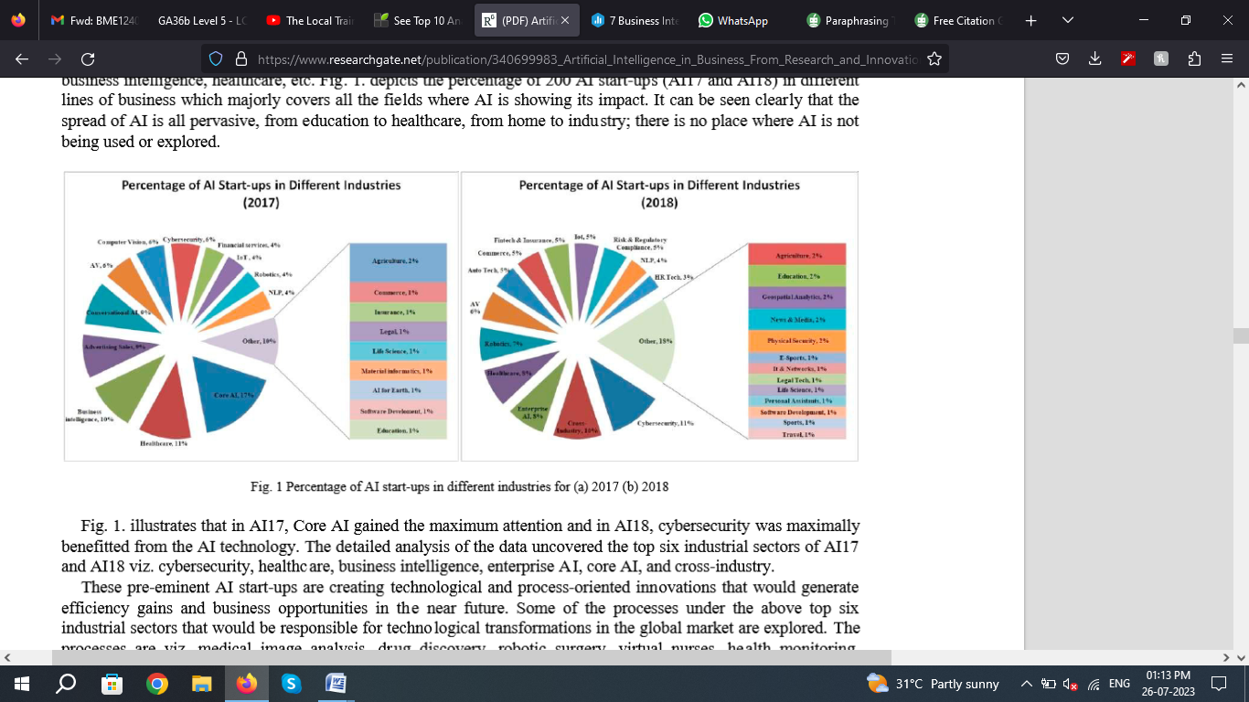

- Cloud BI:

Since the pandemic, businesses hhas moved their datasets and most of the working to clouds. This gave them accessibility to their data even when they are working from home. Many companies were compelled to reconsider their previous BI strategy. Companies restructured their budgets to allow way for migration to cloud BI and analytics platforms since on-premise solutions couldn't meet the challenge of a primarily remote workforce.

According to Gartner “We believe 40% of all business workloads are already deployed on the cloud. Businesses today see analytics as a mission-critical capacity, and corporations are not hesitant about using data solutions”.

The act of connecting to cloud data, organizing it into a data model, and analyzing it to obtain useful information that could be used to help decision making is known as cloud BI. The most valuable cloud business intelligence systems go even farther, enabling users to not only find insights, but to additionally use those insights to automatically drive actions.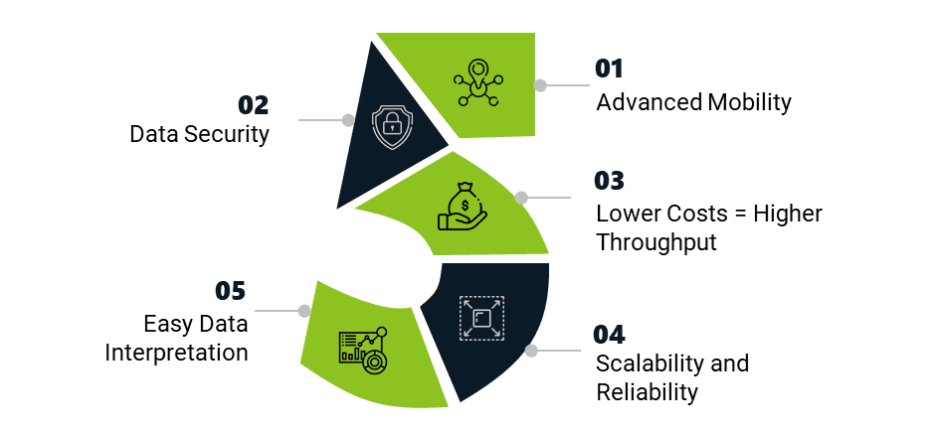

- Collaborative BI
The usage of social media platforms or collaboration softwares, such as Zoom or Google Meet along with BI tools, such as Power BI, Tableau is referred to as collaborative business intelligence. This is accomplished by cooperation among multiple business users and subject matter experts (SMEs) inside a company, with an emphasis on reports and dashboards generated by BI software.
While tools like Zoom and Slack make it easier for workers to work remotely and provide a forum for discussion of various organizational choices, Collaborative business intelligence enables staff to work together on data and reports from wherever they are, improving context, trust, and corporate visibility.
- Data Visualisation
Data storytelling is one of the most prominent business intelligence trends, as firms strive to use visual analytics to communicate with stakeholders. By incorporating data stories into client systems and online applications, time-consuming traditional reporting is eliminated.
Data visualization is the technique of visually portraying information that explains and contextualize it. It emphasizes key differences/shifts, patterns, and trends by employing visual presentation such as ‘charts’, ‘graphs’, ‘maps’, and ‘plots’ that can help the management in the interpretation of data and to derive meaningful insights. Data visualization specialists are in high demand in a variety of areas, including banking, marketing, healthcare, and government.
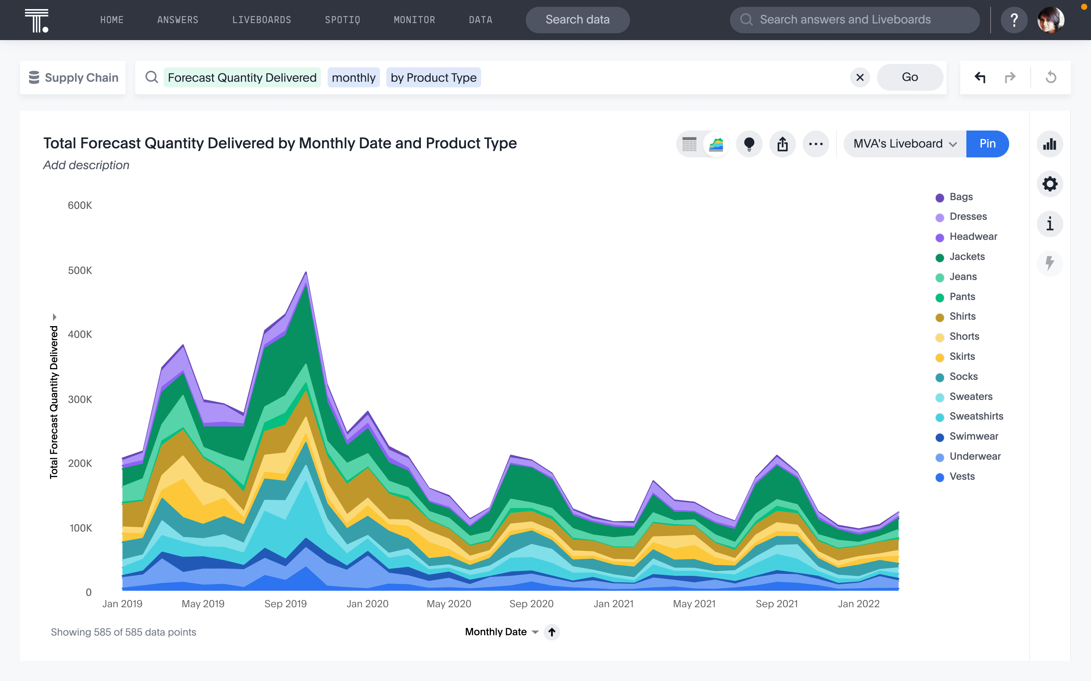
- Natural Language Processing (NLP)
NLP applications are fast expanding. Conversational AI (chatbots) in contact centers and other consumer-facing businesses; unstructured text analysis (such as topic detection, document summarization, and link analysis across document collections); and voice-assisted BI applications, such as voice-driven dashboards and question-answering BI tools, are examples. It is envisioned that by Dr. Borne (2014) that a significant 'friendly' competition between computer vision and natural language processing (NLP) to become the dominant AI application in businesses, which will drive both of these AI technologies to wider acceptance and into even more applications.
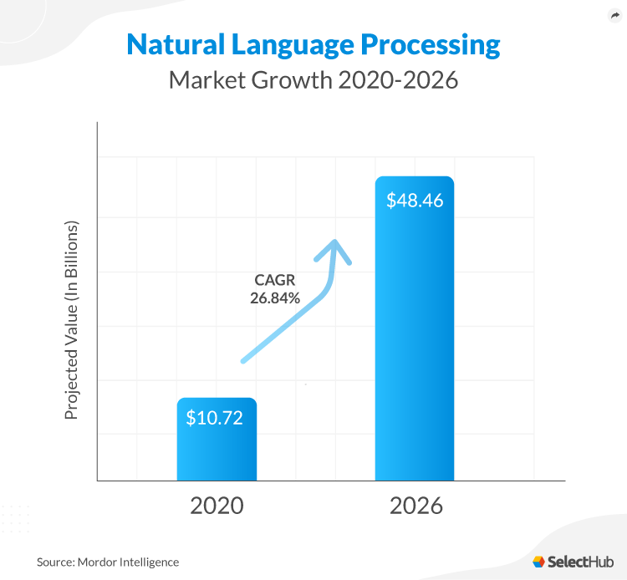

The Benefits of Business Intelligence (BI) for Businesses
- Business experts may examine actionable data about an organization's overall performance through business process analysis (BPA).
- Business executives might receive information from business intelligence that they can utilize to produce precise reports.
- Business Intelligence can discover opportunities for boosting growth by showing the areas of improvement or better opportunities.
- BI with the help of AI can find and rectify human errors and find areas for saving costs.
- Making informed decisions with the help of precise analysed data to minimize the threats and losses in the business so that losses can be eliminated.
- Business executives can get information from business intelligence to utilize in proper report-writing.

- Conclusion
Even though the notion of Business Intelligence is an old concept, it has most definitely grown its root to the point where it has become a essential for the businesses to adopt it. This gives them an edge over their rivals to be faster in analysing the data and give their customers and stakeholders a better satisfaction. .BI has become a commercially beneficial tool for the businesses. Many global firms have implemented BI systems, to have interactive analytical tools for their multiple offices across the globe. There are still many debates happening on how much these intelligence and tools can be trusted or the question of data security remains. With the rise in business Intelligence tools, the threat of cyber crimes have also increased. Hence small firms are in dilemma of investing a huge part of their budget on this technology. The installation and integration of BI in businesses also depend on their need and requirement as well as resources, quality of management.

- Reference
- Akerkar, R. (2019). Introduction to Artificial Intelligence. In: Artificial Intelligence for Business. SpringerBriefs in Business. Springer, Cham. https://doi.org/10.1007/978-3-319-97436-1_1.
- Soni, N., Sharma, E. K., Singh, N., & Kapoor, A. (2020, January 1). Artificial Intelligence in Business: From Research and Innovation to Market Deployment. Procedia Computer Science; Elsevier BV. https://doi.org/10.1016/j.procs.2020.03.272
- Lopes, A.B. and Boscarioli, C., 2021. Business intelligence and analytics to support management in construction: a systematic literature review. Revista Brasileira de Computação Aplicada, 13(1), pp.27-41.
- Lohr, Steve. (2013) “The origins of ‘Big Data’: An etymological detective story” New York Times 1(1).
- Bloem, Jaap, Menno Van Doorn, Sander Duivestein, David Excoffier, René Maas, and Erik Van Ommeren. (2014) "The fourth industrial evolution." Things Tighten 8.
- Freddi, Daniela. (2018) "Digitalisation and employment in manufacturing." AI & Society 33(3): 393-403.
- A. (2023, June 9). Emerging Trends in AI and ML in 2023 &#038; Beyond. Analytics Vidhya. https://www.analyticsvidhya.com/blog/2023/05/emerging-trends-in-ai-and-machine-learning.
- Hu, H. and Yin, M., 2022. Evolution of business intelligence: an analysis from the perspective of social network. Tehni?ki vjesnik, 29(2), pp.497-503.
- Adamala, S. & Cidrin, L. (2011). Key Success Factors in Business Intelligence. Journal of Intelligence Studies in Business, Vol. 1(1).
- Alaskar, T., & Efthimios, P. (2015). Business Intelligence Capabilities and Implementation Strategies. International Journal of Global Business, Vol. 8 (1), pp. 34-45.
- Ashrafi, R., and Murtaza, M. (2008). Use and Impact of ICT on SMEs in Oman. The Electronic Journal Information Systems. Vol. 11(3), pp. 125-138.
- Carlo, V. (2009). Business Intelligence: Data Mining and Optimization for Decision Making. Politecnico di Milano, Italy; John Wiley & sons Ltd.
- Clark, T. D.; Jones, M. C., & Armstrong, C. P. (2007). The dynamic structure of management support systems: theory development, research focus, and direction. MIS Quarterly, Vol. 31 (3), pp. 579–615.
- Davenport, T. H. (2006). Competing on analytics. Harvard Business Review.
- Den Hamer, P. (2005). The organization of Business Intelligence. The Hague: SDU Publishers.
- Farjami, Y., & Molanapour, R. (2015). Business intelligence (from Idea to Practice), Ati-Negar Press, 1st Edition.
- Harding, W. (2003). Business Intelligence crucial to making the right decision. Financial Executive, Vol. 19 (2), pp. 49–50.
- Hostmann, B.; Herschel, G., & Rayner, N. (2007). The Evolution of Business Intelligence: The Four Worlds.
- Isik, Ö.; Jones, M.C. & Sidorova, A. (2013). Business intelligence success: The roles of BI capabilities and decision environments. Information & Management, Vol. 50(1), pp. 13-23.
- Jack, H. (1971). The Private and Social Value of Information and the Reward to Inventive Activity. The American Economic Review, Vol. 61, pp. 561-574.
- Jermol, M., Lavrac, N., & Urbancic, T. (2003). Managing business intelligence in a virtual enterprise: A case study and knowledge management lessons learned. Journal of Intelligent & Fuzzy Systems, Vol. 14(3), pp. 121-136.
- Kimball, R.; Ross, M.; Thornthwaite, W.; Mundy, J., & Becker, B. (2008). The Data Warehouse Lifecycle Toolkit. 2nd edition. Indianapolis: John Wiley & Sons McMurchy, N. (2008). Take These Steps to Develop Successful BI Business Cases.
- Mihaelia, F. T., & Rozalia, V. R. (2012). Business Intelligence Solutions for SMEs. Economics and Finance. Vol. 3, pp. 865-870.
- Nofal, M., & Yusof, Z. (2013). Integration of Business Intelligence and Enterprise Resource Planning within Organizations. Technology, Vol. 11, pp. 658-665.
- Oyku, I.; Mary C. J.; and Anna, S. (2012). Business intelligence success: The roles of BI capabilities and decision environments. Information & Management, Vol. 50, pp. 13–3
- Darius, Hedgebeth. (2007). ARTICLES Data-driven decision making for the enterprise: an overview of business intelligence applications, the journal of information and knowledge management systems, 37(4), 414-420.
- Devlin, B. (1996). Data Warehouse: From Architecture Implementation. Boston: Addison-Wesley Professional.
- Dhar, V., Stein, R. (1996). Seven Methods for Transforming Corporate Data into Business Intelligence, Prentice Hall.
- Eckerson Wayne, W. (2005). Performance dashboards: Measuring, monitoring, and managing your business,Wiley.
- Gangadharan, G.R. & Swamy, N.S. (2004). Business intelligence systems: design and implementation strategies, Proceedings of 26th International Conference on Information Technology Interfaces, Cavtat, Croatia, Retrieved March 15, 2007 from: http://ieeexplore.ieee.org/xpls/abs_all.jsp?arnumber ¼ 1372391.

