BA BUSINESS MANAGEMENT

INTRODUCING THE MODERN WORKPLACE

Assignment 1

Organisational Structure & Culture in the airline industry

Code: LCBB4003

Lecturer: HOANG DANG NGUYEN

Student name: MARICELA BROASCA

Student ID: 2125147

Submitted on: 6/01/2023

Table of Contents
Introduction 3
The specific organisational structure that is followed by TUI Airways in their organisational operations 4
The impact of this organisational structure on the organisational performances 4
The specific organisational culture that is followed by TUI Airways in their organisational operations 5
The impact of this organisational culture on the organisational performances 5
Different factors in TUI Airways influencing their employees’ behaviours 5
Maslow’s theory of Motivation 6
Herzberg’s Two-Factor Theory 8
Conclusion 9
References 10

Introduction

The following report will outline the importance and effectiveness of the implementation of organisational structure that affects organisational performance. The report has taken the profound airline industry TUI Airways for further discussion. Apart from that, the report will also focus on the application of a specific organisational culture that is effective for improving organisational performance. The impact of these organisational structures and cultures on the higher performance growth of the organisation will also be described in this report. Further, the different factors that are influencing the employee behaviour will also be described through two different motivational theories.

Brief description of TUI Airways

TUI Airways is a British airline company that is a part of TUI Group, which is one of the largest multinational travel companies in the world. It offers flights from all major airports, including London Gatwick, London Luton and Manchester to more than 100 destinations in Europe, Africa and Asia. TUI Airways also operates charter flights for holiday companies and other clients.
As a major airline company, TUI Airways employs a large number of people in a variety of roles, including pilots, flight attendants, maintenance technicians, customer service representatives, and support staff. The company has employees in management and administrative positions as well as in sales and marketing.

The specific organisational structure that is followed by TUI Airways in their organisational operations

As most business industries try to promote specific organisational structures in their organisational operations, the management of TUI Airways also maintains a matrix organisational structure in their business operations. This is a type of typical organisational structure, in which the entire organisational operations follow a specific systematic hierarchy. The team members working for an organisation are reporting to the professionals working as a higher authority. The higher authority or the team leaders inform the departmental heads about any responsibilities that need to be maintained to ensure that they are carried out effectively. This type of management structure assists the organisation to execute newer projects or assignments without rearranging the entire setup of the team (Mullins, 2019). The higher authority of TUI Airways tries to maintain this organisational structure, in order to support the balance of work pressure in the organisational structure. Workers of each department, share their working progress and issues with the departmental head and execute their responsibilities in a sensible manner (Hirsch, 2018, pp. 340-356).

The impact of this organisational structure on the organisational performances

Maintains the objectives of the project

The implementation of the matrix organisational structure in the organisational operations of TUI Airways can help the entire workforce, to design the organisational objectives and also tries to ensure the clarity of the objectives to the workers. When the employees are working on behalf of the organisation and reporting the progress of their work to the departmental heads, the objectives for the work are getting solidified and clarified. The organisational goals and objectives are getting significant priority from the leaders and the higher management. The working process of the organisation gradually enhanced and developed more quickly through this organisational structure (Kim, 2018).

Effective implementation of resources

The matrix organisational structure tries to allow the effective usage of resources in the workplace. Each team of employees that are working for the organisation recruits expertise from different departments. This can help the organisation to decrease the overhead costs and the time needed to complete a project also reduces due to this impactful usage of human resources. The involvement of different experts in conducting specific projects can help the organisation to deliver quality outcomes in a lesser time span. Organisational growth has also been enhanced with the effective maintenance of this structure (Sihombing, 2018).

Team retention

An effective application of matrix organisational structure can help the management of TUI Airways to retain the existing team in a significant manner. When the various experts from different departments come together and work to fulfil common objectives the team performance is getting enhanced. The team members and the functional heads are working all together and are also assigned to the project managers. In this type of organisational structure, the workers are getting much influenced to work together and the team performances are also getting enhanced in the long run (Lam, 2021).

The specific organisational culture that is followed by TUI Airways in their organisational operations

Impactful maintenance of organisational culture is most important for any kind of organisation to follow. In order to improve organisational growth and workplace culture, following an effective organisational culture is most important. Similarly, the higher authority of TUI Airways, follows the hierarchical organisational culture in their workplace, in order to maintain their workplace environment. This type of organisational culture can enhance the long-term stability of the workplace structure and improves the set of values throughout the organisation. The workers can effectively understand their duties and the management can also emphasises the importance of the opinions of other professionals during the time of decision-making process. The initiatives taken by the higher authority follow a methodical manner (Abualoush, 2018).

The impact of this organisational culture on the organisational performances

Importance of organisational values

This type of organisational culture tries to focus on maintaining the organisational values and also influences each employee to maintain the code of conduct and the organisational ethics effectively. This kind of initiative taken within this organisational culture can help the entire organisation to fulfil and maintain the organisational values (Mullins, 2019).

Getting opportunities to grow

The employees working in this organisational culture can expect consistent promotions given by internal mentors. Maintaining this culture in the organisational operations of TUI Airways can provide more opportunities to the long-term and existing employees to grow more and getting success in the organisation. In this organisational culture, the team members can work up to their mark and collaboratively in their workplace (Joseph, 2020, pp.267-302).

Initiating strong corporate working culture

The hierarchical working culture followed in the organisational structure of TUI Airways maintains the corporate working environment in the workplace. Fostering this working culture can help the organisation to maintain its brand identity and organisational reputation in the competitive market. The employees are also influenced by the management to follow the corporate working culture in the workplace. This can also improve the organisational performance of TUI Airways (Christensen, 2020).

Different factors in TUI Airways influencing their employees’ behaviours

The higher management of the organisation has noticed that several factors within their organisational workplace are influencing employees’ behaviour effectively. For this reason, TUI Airways is focusing on the factors so that they can help their employees to stay motivated. It helps the overall organisation to higher its sales margin and generate greater revenue than its competitors. The factors can be understood through two different motivational theories, which are as follow:

Maslow’s theory of Motivation

The theory proposed by Abraham Maslow describes the needs of the employees from the employers during their working hours. The theory has been demonstrated in a pyramid shape that contains the most fundamental needs at the bottom and the needs of self-actualisation at the top. The first four stages from the bottom of the pyramid describe the deficiency needs such as safety, physiological, esteem needs and love or belongings. An employee only wants the next needs when their basic needs are fulfilled by the employer (Fogel, 2020).

Physiological Needs

This is the first stage of the entire pyramid that explains the physical requirements of the human body to survive in nature. If the organisation does not fulfil the physiological needs of their employees, they cannot work freely for the organisational benefit. These needs include breathing, food, water, clothing, sleep, shelter and many more. These all are the basic needs that should be provided to every individual during their working hours. The leaders of TUI Airways are always trying to provide all the physiological needs of their employees so that they will contribute on their best level to the organisational growth (Mullins, 2019).

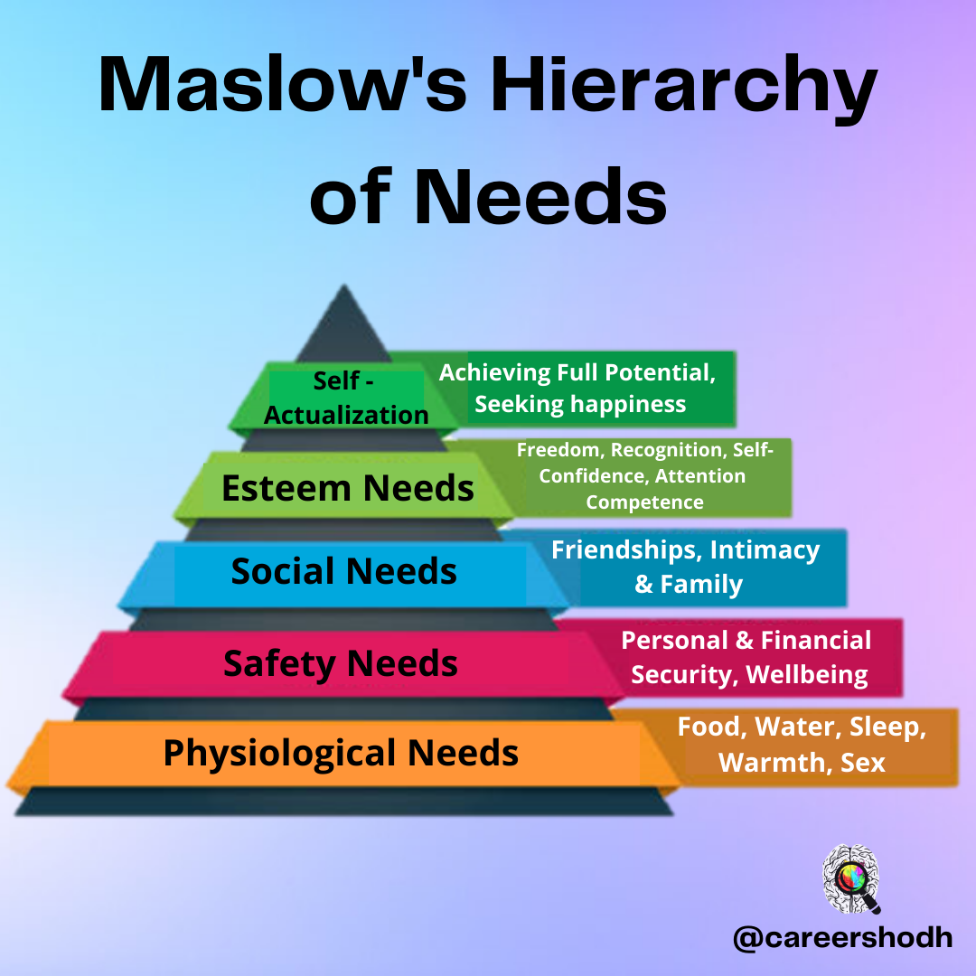
Source- (Fogel, 2020)
Safety Needs

After getting all the physiological needs completed the employees of an organisation seek their safety needs. This explains the security of the employees while working within an organisation. Apart from physical safety mental stability, predictability, salary-related safety and many more. Sometimes it can be seen that the employees of TUI Airways get exhausted due to limitless working hours that lead them to poor work-life balance. Along with this, the lack of employees’ work-life balances the organisation faces a huge number of employee losses in their business that hampers their overall performance (Morgan, 2020).

Love or Belongings

This is the third level of the entire pyramid that describes the belongings and love of the employees. If an employee faces that the organisation is caring for them, they can work more for the organisational benefits. Social love includes friendships among colleagues, family and loved ones. For this reason, TUI Airways is providing huge value to their employees so that they can work freely (Waida, 2022).

Self-esteem Needs

Self-esteem refers to one’s belief that is based on their self-evaluation. Esteem needs also describe the status needs, ego needs that can bring recognition, respect, and good status to an employee. When an employee finds that they are getting respect from their colleagues and higher management they automatically urge to do better for the business.

Self-actualisation Needs
The last stage of the pyramid explains the individual needs that would help them to develop their own potential drastically. Along with this, it creates a belief in employees that they can perform better within their workplace. The managers of TUI Airways play a crucial role in uplifting their employees’ potential (ASHBURNER, 2022).

Herzberg’s Two-Factor Theory

The two-factor theory helps to understand all the components that are responsible to keep employees motivated or demotivated within their workplace. The leaders and the managers of the organisation critically evaluate all the factors so that they can eliminate the single possibility of dissatisfying factors in their workplace. It can lower the performance rate of TUI Airways in the competitive market. The factors have been divided into two parts those are motivating factors that use to motivate the employees of the organisation and the hygiene factors that create demotivation of the employees (Nickerson, 2021).

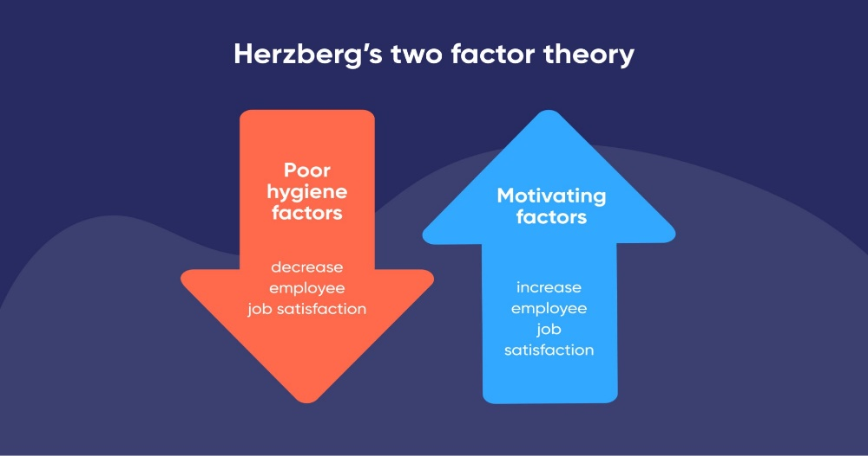
Source- (bluedonkey, 2022)
Motivating Factors

This particular part includes all the motivating factors that use to lead the employee base of an organisation to work more for the employers. Along with this, the motivating factors are the performance and achievement of an individual employee. Whenever an employee finds that they are getting achievements for their enhanced performance from the organisation. They will want to work more to achieve all the business goals of the organisation. TUI Airways is also focusing on the matter so that every employee would get enough recognition in their workplace due to their performance level. The opportunities for growth, the job role of the employees, the job status of the employees and many more. All the factors use to boost the performance and competencies of the employees enable them to get a better future career.

Hygiene Factors

This is the second factor of the two-factor theory that makes employees demotivated within their workplace. Many employees of TUI Airways are facing such types of situations that harm the working level of the employees. For example, the quality of supervision of the organisation creates issues for the employees as they cannot get familiar with the higher management. The low pay scale of the employees is also hampering the morale of the employees during their working hours. Along with this, the organisation should have to focus on creating an ethical workplace for the employees so that they can work freely with their colleagues (Strick, 2022).

Conclusion

The above concluded report has described the organisational structure and the benefits of the structure to the organisation. TUI Airways has been selected as the organisation to carry forward the discussion in the report. Along with this, the organisation operates their business in the airline industry of the United Kingdom. The higher management of the organisation uses to follow hierarchical culture to run their business in the market. Further, the report has also elaborated on all the factors that are influencing the employees’ behaviour within the workplace.

References

Abualoush, S., Bataineh, K. and Alrowwad, A.A., (2018). The role of knowledge management process and intellectual capital as intermediary variables between knowledge management infrastructure and organization performance. Interdisciplinary Journal of Information, Knowledge, and Management, 13, p.279.

ASHBURNER, W., (2022). INTRODUCING THE MODERN WORKPLACE. [Online]Available at: https://blog.verde.co.nz/blog/introducing-the-modern-workplace[Accessed 23 12 2022].

bluedonkey, (2022). Herzberg two-factor theory and Lead generation marketing. [Online]Available at: https://www.bluedonkey.co.uk/herzberg-two-factor-theory-lead-generation/[Accessed 23 12 2022].

Christensen, T., Lægreid, P. and Røvik, K.A., (2020). Organization theory and the public sector: Instrument, culture and myth. Routledge.

Fogel, A., (2020). Using Maslow’s Hierarchy of Needs to Motivate Yourself and Your Team. [Online] Available at: https://www.elegantthemes.com/blog/business/maslows-hierarchy-of-needs[Accessed 23 12 2022].

Hirsch, P.M., (2018). Processing fads and fashions: An organization-set analysis of cultural industry systems. In The sociology of economic life (pp. 340-356). Routledge.

Joseph, J. and Gaba, V., (2020). Organizational structure, information processing, and decision-making: A retrospective and road map for research. Academy of Management Annals, 14(1), pp.267-302.

Kim, T. and Chang, J., (2018). Organizational culture and performance: a macro-level longitudinal study. Leadership & Organization Development Journal.

Lam, L., Nguyen, P., Le, N. and Tran, K., (2021). The relation among organizational culture, knowledge management, and innovation capability: Its implication for open innovation. Journal of Open Innovation: Technology, Market, and Complexity, 7(1), p.66.

Morgan, D., (2020). APPLYING MASLOW’S THEORY ON MOTIVATION TO BUSINESSES TODAY. [Online] Available at: https://www.businessbutleruk.com/blog/management/applying-maslows-theory-on-motivation-to-businesses-today[Accessed 23 12 2022].

Mullins, L. J. (2019) Organisational behaviour in the workplace. 12th Ed. Harlow: Pearson Education Limited.

Nickerson, C., (2021). Herzberg’s Motivation Two-Factor Theory. [Online] Available at: https://www.simplypsychology.org/herzbergs-two-factor-theory.html[Accessed 23 12 2022].

Sihombing, S., Astuti, E.S., Al Musadieq, M., Hamied, D. and Rahardjo, K., (2018). The effect of servant leadership on rewards, organizational culture and its implication for employee’s performance. International Journal of Law and Management.

Strick, J., (2022). Applying Herzberg's Two-Factor Theory to the Workplace. [Online]Available at: https://www.ecoportal.com/blog/two-factor-theory[Accessed 23 12 2022].

Waida, M., (2022). Maslow's Theory of Motivation in Project Management. [Online] Available at: https://www.wrike.com/blog/maslows-theory-motivation-project-management/[Accessed 23 12 2022].

