Creating a virtual network:

First I copied the windows 7 and windows server to my computer from the file server.

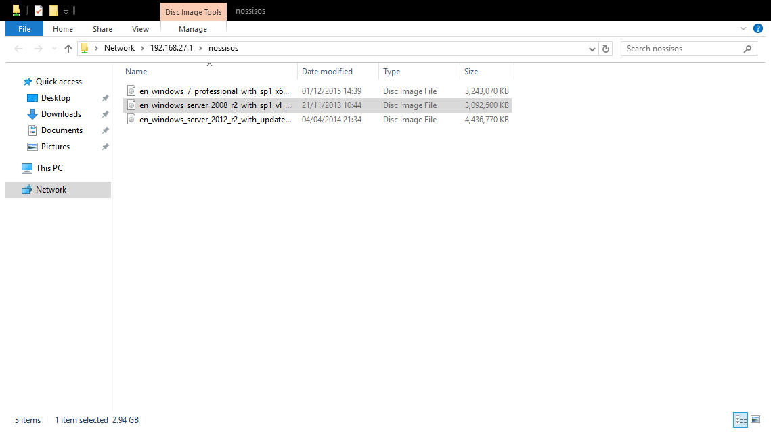
Next I opened virtual box and created a virtual server and pc.
Entered the required system settings for the processer (enabled Pae/nx.
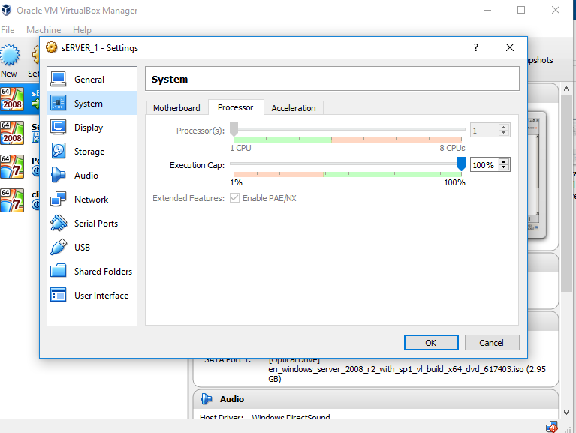

Disabled enable nested paging.
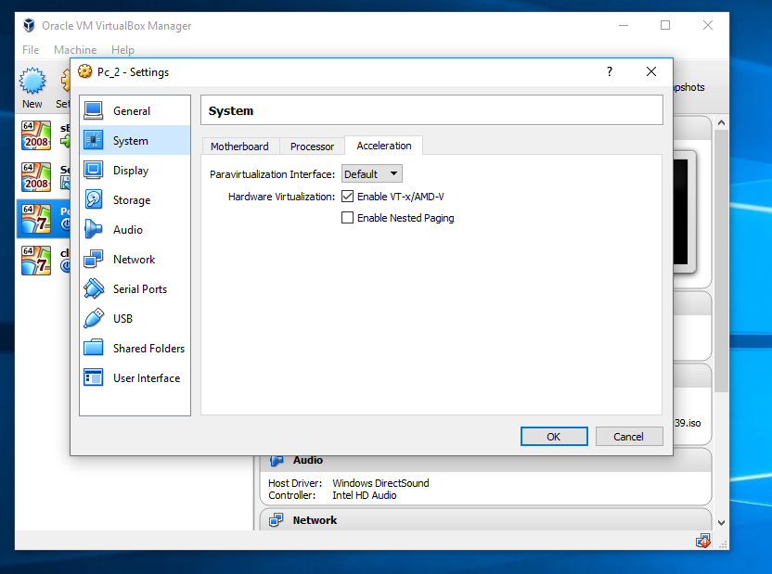

Configured the network adapters.
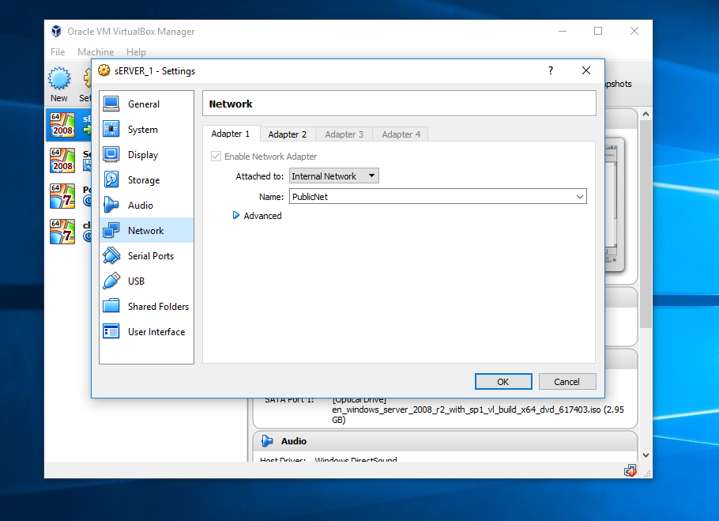

I then cloned both the server and pc to create an additional two networks.
The screenshot below shows the storage settings that were configured.

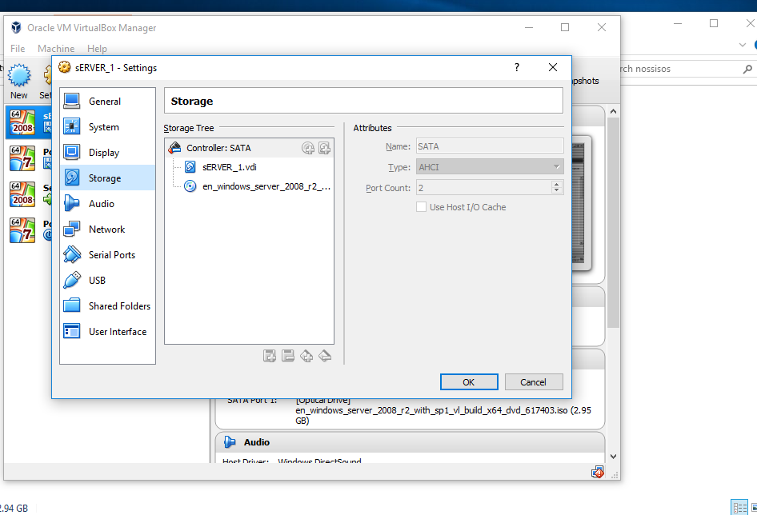
This process was then repeated for the other 3 virtual machines.

Next I double clicked on each of the virtual machines to complete the installations.
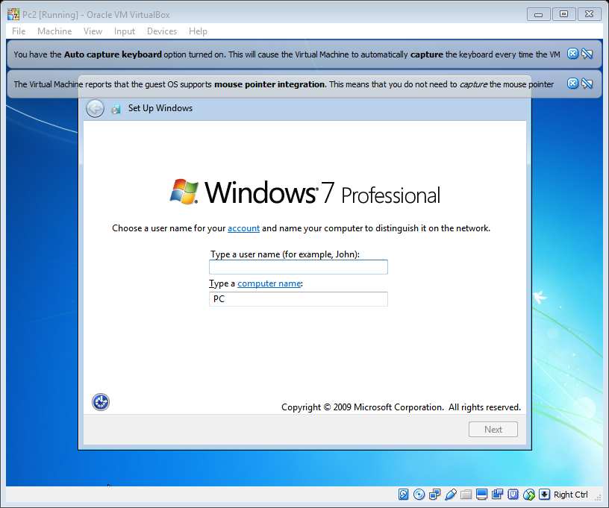
Manually configured ip address, subnet mask and dns settings for server 1.
(Repeated the process for client 1 server 2 and client 2)
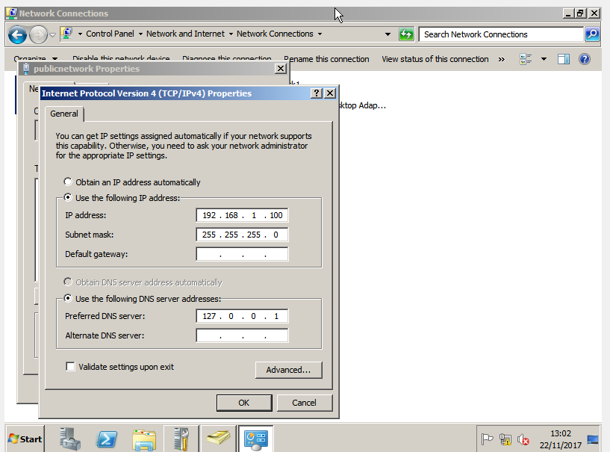

Next I pinged the servers and clients to confirm connectivity. Example below:
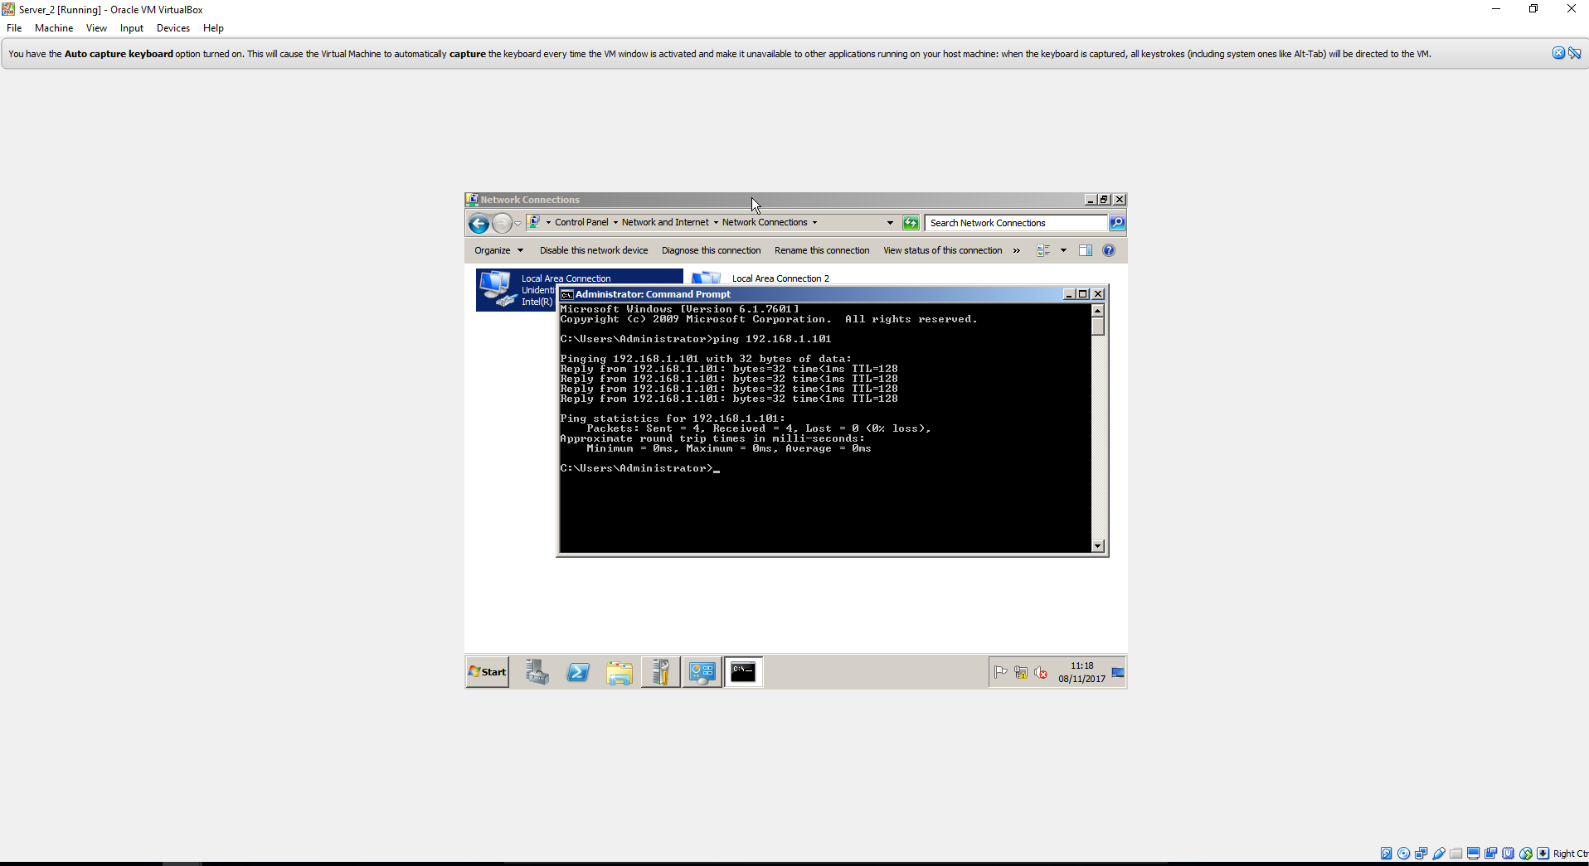

Configured active directory
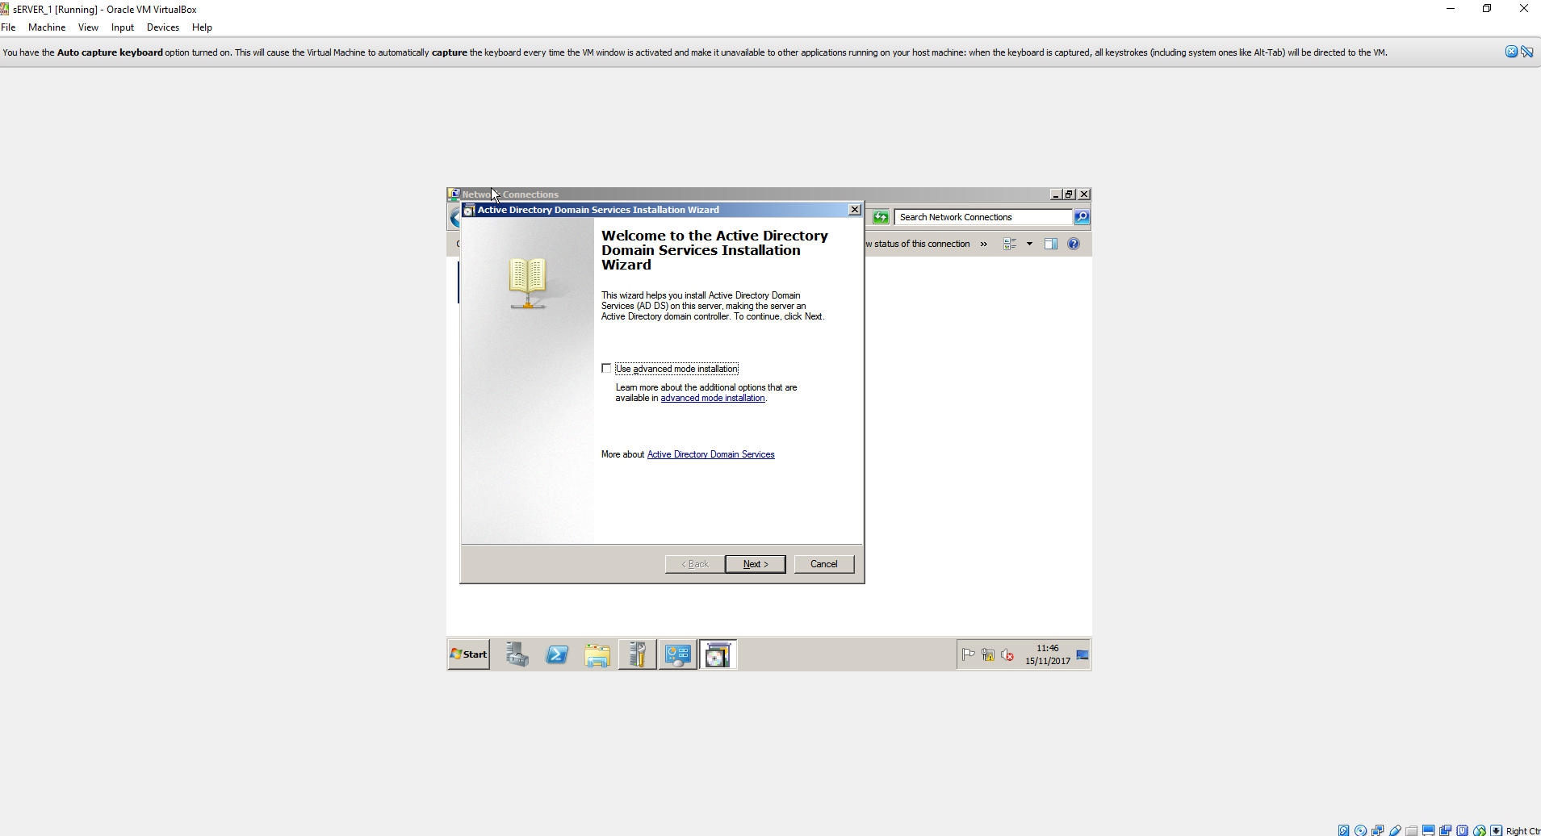

Added domain to active directory.
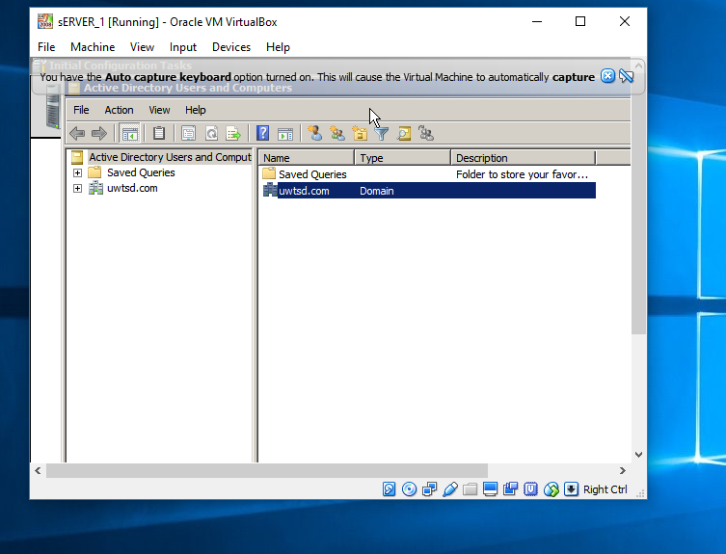

Observational tasks 1
A.}
The benefits of a type 2 hypervisor software like virtual box include:
Virtual box is free to use.
Memory and processer utilisation is low.
Adding multiple virtual machines is possible.
Some of the weaknesses of virtual box include:
Connecting the virtual machines could be a difficult process if not done before.
One of the virtual machines became corrupt on installation.
Understanding the virtual box software.

B.)
Explain with the use of diagrams the significance of the following terms: Active directory Forests, Trees, Parent and Child Domains
Below is an example of an active directory domain and forest with Domain server at the top level. This is followed by the domain controller(Parent) that is above and enforces the lower level objects(Child) computers, users and security policies.
Domain (Tree)

Domain Controller (Parent)
(P
p

Computers (Child)
Users (Child)

Security policies (Child)

C.)
The main roles and responsibilities of an active directory domain controller include:
It provides for example a central point for computers and servers to connect within a domain. It provides authentication and security policies and user account information.

D.) What action could we take in the event of a domain controller becoming unavailable?
An administrator could designate an alternative domain controller to assume the role through active directory. This could be configured in administrative services and by adding an alternative dns.

