

LOCATION: Swansea | LLEOLIAD: abertawe
LEVEL 5 | LEFEL 5
EXAMINATION PERIOD | CYFNOD ARHOLIADAU

MODULE CODE: M5X02201
MECHANICAL PRINCIPLES
PHASE TEST 2 RESIT
TIME: 2 HOURS
answer all questions

Equipment or materials required – None
Adnoddau neu ddefnyddiau sydd eu hangen – Dim

Calculators are permitted –show your working

A ‘formula sheet’ is provided for reference.

Assume ‘g’ = 9.81 m/s².

and 1 bar = 10⁵ N/m² (P_{a})

ANSWER ALL QUESTIONS

Show all your workings and state any assumptions or approximations you have made.

QUESTION ONE

Calculate:

  - The maximum torque and power which can be transmitted at 1800 RPM by a brand new clutch if it has an outer diameter of 120mm, an inner diameter of 40mm and a coefficient of friction of 0.45. The axial force may be taken as 900N.
(5 Marks)

  - The reduction in torque and power which can be transmitted by the same clutch at 1800 RPM when worn by 1.55mm, if the axial force is provided by 6 springs, each with a rate of 25 N/mm.
(5 Marks)

QUESTION TWO

A belt drive must transmit 5 kW of power at 2500 rev/min. The pulley wheel is 130 mm diameter and the coefficient of friction is 0.4. The lap angle is 128º. Assuming the initial belt tension is 250 N and the belt mass may be taken to be negligible;

- Calculate the linear velocity of the belt
(2 Marks)
- Calculate the maximum and minimum belt tensions
(4 Marks)
- Calculate the maximum power transmitted per belt
(2 Marks)
- Calculate the number of belts required
(2 Marks)

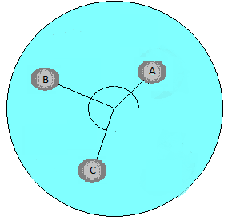
QUESTION THREE

Three masses A, B and C are placed on a balanced disc as shown, at radii of 80 mm, 120 mm and 95 mm respectively.
45°
95°
110°

The masses are 0.87 kg, 0.55 kg and 0.58 kg respectively.

A fourth balancing mass, D, is to be added at a radii of 40mm to statically balance the system.

- Construct a table to calculate the magnitude of the forces created by the rotating masses
(2 Marks)

- Construct a vector diagram using a suitable scale to represent the resultant force.

(4 Marks)
- Calculate the mass of the unknown mass D
(2 Marks)

- Calculate the angular position at which the balancing mass D should be placed
(2 Marks)

QUESTION FOUR

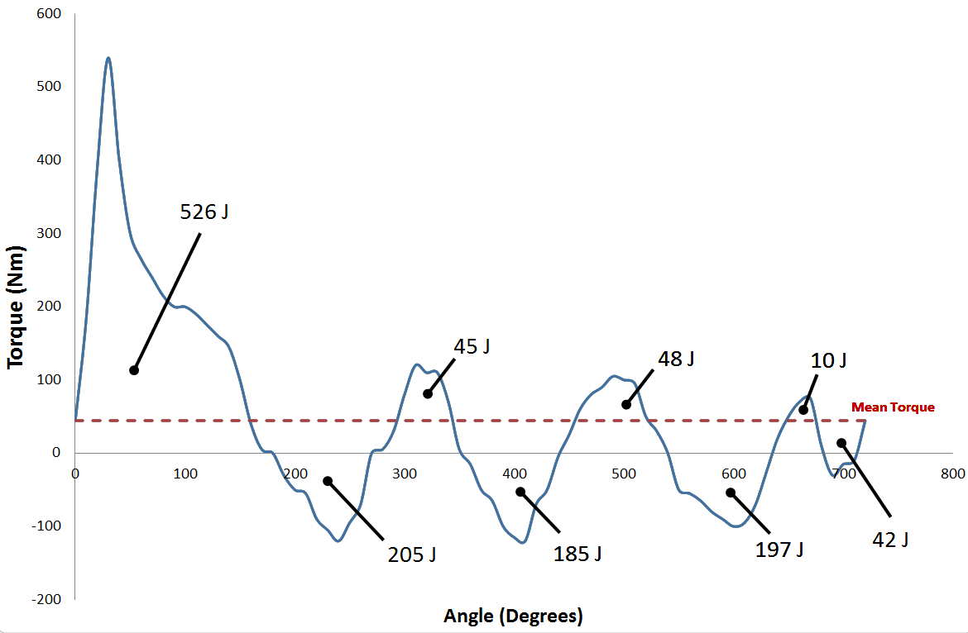

The diagram above shows a torque - angle diagram for a certain machine. If the speed of the shaft must be maintained between 2400 and 2500 rev/min, calculate

- the coefficient of fluctuation of speed (2 Marks)
- the maximum fluctuation of energy (βW) (3 Marks)
- the moment of inertia of a suitable flywheel. (2 Marks)
- The mass and thickness of the flywheel if it is to take the form of a simple steel disc of radius 150 mm and density 7850Kg/m3.

(3 Marks)
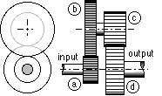
QUESTION FIVE

The diagram below shows a compound gear train.

Gear A has 32 teeth
Gear B has 64 teeth
Gear C has 24 teeth
Gear D has 36 teeth

Gear A is the input gear and revolves at 2500 rev/min anticlockwise when viewed for the left end. If the input torque is 20 Nm and the gear train efficiency is 85%

- State which gears must have the same module/pitch
(1 Mark)
- Calculate the output speed and direction
(3 Marks)
- Calculate the output power
(3 Marks)
- Calculate the holding torque required
(3 Marks)



