Assignment title: Hotel Handbook and for intercultural competence
Student Name & No: Saifun Hossain, 2016122
Lecturer Name: Rodrigo Aguilera

Executive summary
Globalisation and advanced technology have increased the hospitality industry. Now people from one country visit or explore another country’s food, people, place and so on. This industry greatly contributes to the economy too, so people need to respect other cultures. Many people learn a foreign language to understand their demands so that they can serve them to gain value.
This report has focused to analyse how the difference between UK and South Korean culture impact service quality. A meeting occurred in the G hotel. Hofstede's six dimensions framework has been used to define culture and processes to measure them. Critical analysis has been included to help them by understanding differences in value sets and behaviour.

Table of Contents
Executive summary 2
Introduction 4
Country A 4
Assessing UK’s Culture 4
Country B 6
Assessing SOUTH KOREA’s Culture 6
Critical Analysis 7
Handbook 8
Conclusion 9
References 10

Lists of Figure
Figure 2 : Hofstede’s Cultural Dimension framework 4
Figure 3: UK Cultural Dimension analyses 5
Figure 4: South Korean Cultural Dimension analyses 7

List of table
Table 1: Do’s and Don’t in both UK and South Korean Culture 9

Figure

Introduction
Intercultural competency refers to the ability to communicate and operate effectively across cultural cultures (Leung et al., 2019). It helps to respect the perception, morality, and values of a different culture. This report will analyse the cultural variation between the UK and South Korea in their hospitality industry with Hofstede’s cultural dimension framework. It will show how UK workers can serve South Korean people and adjust to that culture. It will also analyse Do’s and Dot’s cultural competency.

Country A
Selected Country A is the UK and the venue is The Guardsman hotel, address is, 1 Vandon St, London SW1H 0AH, United Kingdom. Hofstede’s Cultural Dimension are discussed below-

Assessing UK’s Culture
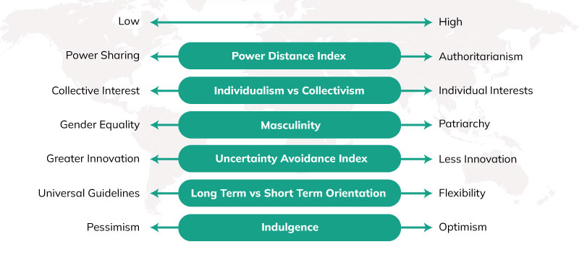
Figure 2 : Hofstede’s Cultural Dimension framework
Source: Manrai and Manrai (2017)
Power Distance: In the UK, the PD score is 35, which is a positive sign that their citizens support equality in their society. Hotel authority treats every type of guest from different backgrounds, castes and religious fairly (Sarala and Vaara, 2019).
Individualism: This score it indicating that hotel staffs only focus on their jobs, they do not try to make a good relation with other employees because they do not feel the necessity of it.
Masculine: In the UK, most of the hotel personnel are male and companies prefer male employees to females in the hotel; because they feel that male workers will provide better output than females (Nazarian et al., 2017).
Uncertainty Avoidance: According to the score, the UK hotel's capabilities of avoiding challenging or uncertain event or situation is good (Chen et al., 2016). They are very innovative, which helps them to solve critical issues quickly.
Short/Long-term Orientation: It is equal, which means hotel managers prioritise both short and long-term orientation based on the value and benefits of the organisation. It helps to improve customer service quality.
Indulgence: UK hotels are optimistic about their service quality (Wenxin and Yue, 2022). Most of their guests look for a hotel to spend their leisure, authorities should design their service based on this demand.

Figure 3: UK Cultural Dimension analyses
Source: Rahimi and Gunlu, (2017)

Country B
Here chosen Country B is South Korea, based on Hofstede’s cultural dimensions their culture is analyzing below-

Assessing SOUTH KOREA’s Culture
Power Distance: People receive service based on their power and social-economic position. Workers must follow their manager or supervisor, which is why work life in there is negative and often stressful. But workers have to choose, they must work without complaining.
Individualism: In South Korean culture, they prefer to work in a team than alone but there are not strict laws in it. So they prefer collectivism.
Masculinity: The presence of male workers are lower than female workers because the new labour market is more prevalent more female. The contribution of women to the Korean GDP is significant.
Uncertainty Avoidance: South Korean hotels are less innovative so it is difficult for them to handle challenging and uncertain situations (Kim, 2018).
Long-term Orientation: South Korean hotels prefer long-term orientation to short-term because it provides sustainability and the company can gain a competitive advantage for a long time (Monocello, 2017). It increases both customer experience and employee satisfaction.
Indulgence: This score is very low, 29. Because of stress in the work life, the majority of workers think negatively about their life and work. It tends a negative outcome from the output.

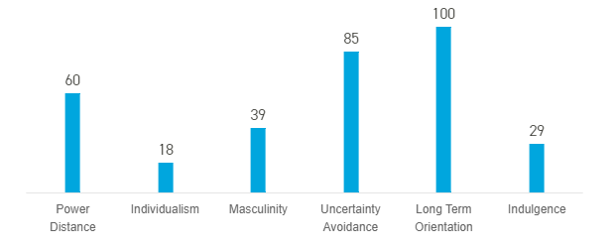
Figure 4: South Korean Cultural Dimension analyses
Source: Kim et al. (2019)

Critical Analysis
UK society is more equal to the South Korean culture, here everyone will get the same treatment in the hotels. People in the UK think that everyone should get the same hospitality service. But the positive thing is in South Korea, so when a visitor will go there they will get service according to their wealth and social status. In this situation, UK hotels do not need to change this habit because it is a good practice, it will help to provide customer service to Korean guests.
UK culture is highly individualist, on the other hand, Korean prefer collectivism. British believes individual freedom because it helps employees to enhance their personal performance. As Korean prefer collectivism, UK-based hotels and related organisations must consider this behaviour for them.
Korean culture is equal for both females and males, but in the UK hospitality industry is male-dominated. Here British can recruit female employees to represent their gender equality. There are some activities where women can perform equally to male.
UK’s hospitality industry is short-term orientation but the Korean industry is long-term orientation focused. The UK should change this approach because do not provide long-term value to the company. Korean employees have less ability to handle the challenging situation than UK employees, long-term orientations cannot help it.
The indulgence level is high for UK employees, it will help them to handle stressful situations patiently and they will be able to serve customers from different backgrounds.

Handbook
The following things will help both the employees of the UK and South Korea-
Etiquettes |  | Do’s | Don’ts
Greetings | UK | - They offer a handshake to their customers in the first meeting.  - They use the title or last name to address guests. | - Avoid long eye contracts with customers
Greetings | South Korea | - They slightly bow their head and say "annyeong"  - For handshake, use two hands not one. | - Do not shake hands with women  - Sneezing is considered rude in Korean culture (Min, 2018). Try to avoid greeting  - Avoid pointing with a finger while talking with the customers
Nonverbal-communication | UK | - British culture is very reserved, so provide personal space to the guests (Joo et al., 2019). | - Do not speak loudly, that disturbs others
Nonverbal-communication | South Korea | - Serve the oldest customers first and show them respect | - Never cross legs while talking with customers
Attire | UK | - Wear formal clothes in the workplace | - Avoid wearing a suit while working
Attire | South Korea | - Formal dress clothes for both men and women | - Never wear revealing cloths  - Avoid wearing tight clothes  - Avoid colourfully and eye catchy dress
Dining | UK | - Offer food when the guests are ready with their knives and fork on the plate | - Avoid taking the order of the same thing and asking the repetitive question
Dining | South Korea | - Offer food to the oldest member first  - Offer chopsticks with a spoon | - Korean people eat so quickly, so do not take it unusual, and bother them
Others | UK | - Friendly with every culture | - Do not try to sound British, which may be uncomfortable for the guest
Others | South Korea | - Positive with other culture | - Avoid staring at people

Table 1: Do’s and Don’t in both UK and South Korean Culture
Source: Own

Conclusion
Cultural difference plays a critical role in the behaviour and gesture of both British and South Korean people. But everyone should respect all cultures and in the business market, it is essential to serve customers based on their cultural beliefs, norms and system. Hofstede's six dimensions have shown that there is a huge difference between both these countries and critical analyses have been included to clarify each difference. Finally, Do's and Don’ts have been analysed to understand and improve cultural competency.

References
Chen, R.X., Cheung, C. and Law, R., 2016. A review of the literature on culture in hotel management research: what is the future?. International Journal of Hospitality Management, 31(1), pp.52-65.
Joo, B.K.B., Bozer, G. and Ready, K.J., 2019. A dimensional analysis of psychological empowerment on engagement. Journal of Organizational Effectiveness: People and Performance.
Kim, H., Coyle, J.R. and Gould, S.J., 2019. Collectivist and individualist influences on website design in South Korea and the US: A cross-cultural content analysis. Journal of Computer-Mediated Communication, 14(3), pp.581-601.
Kim, S.Y., 2008. Hotel management contract: impact on performance in the Korean hotel sector. The Service Industries Journal, 28(5), pp.701-718.. Hotel management contract: impact on performance in the Korean hotel sector. The Service Industries Journal, 28(5), pp.701-718.
Leung, K., Ang, S. and Tan, M.L., 2019. Intercultural competence. Annual Review of Organizational Psychology and Organizational Behavior, 1(1), pp.489-519.
Manrai, L.A. and Manrai, A., 2017. Hofstede’s cultural dimensions and tourist behaviors: A review and conceptual framework. Journal of Economics, Finance & Administrative Science, 16(31), p.23.
Min, P.G., 2018. Cultural and economic boundaries of Korean ethnicity: A comparative analysis. In Asian American Family Life and Community (pp. 269-285). Routledge.
Monocello, L.T., 2017. Flower boys and muscled men: Comparing American and South Korean cultural models of the ideal male body using cultural domain analysis. The University of Alabama.
Nazarian, A., Atkinson, P. and Foroudi, P., 2017. Influence of national culture and balanced organizational culture on the hotel industry’s performance. International Journal of Hospitality Management, 63, pp.22-32.
Rahimi, R. and Gunlu, E., 2017. Implementing customer relationship management (CRM) in hotel industry from organizational culture perspective: case of a chain hotel in the UK. International Journal of Contemporary Hospitality Management.
Sarala, R.M. and Vaara, E., 2019. Cultural differences, convergence, and crossvergence as explanations of knowledge transfer in international acquisitions. Journal of International Business Studies, 41(8), pp.1365-1390.
Wenxin, Z. and Yue, W., 2022. An Analysis on Sino-UK Cultural Differences in Education from the Perspective of Hofstede’s Cultural Dimensions Theory (A Case Study of Are Our Kids Tough Enough?). Journal on Education, 4(2), pp.373-384.

