Learning in the Digital Era
PROFESSIONAL DEVELOPMENT PLAN (PDP)
Sukhpreet Kaur
ID:2542000

Table of Contents
Task 1 Self Evaluation 3
Task 2 Professional Development Plan 3
Task 3 Summary of Unit 4 6
Task 4 Video Link 7
References 7

Task 1 Self Evaluation
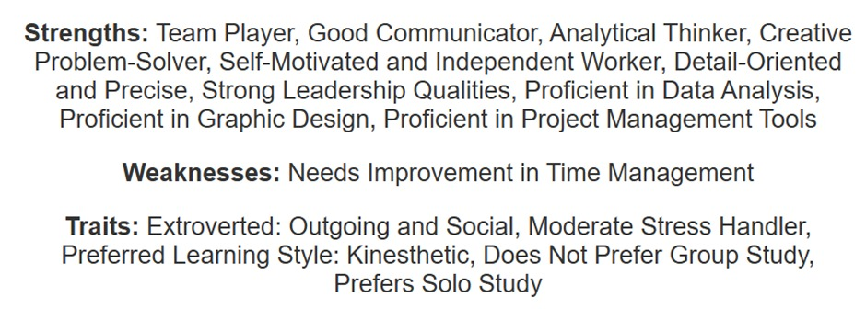

Task 2 Professional Development Plan
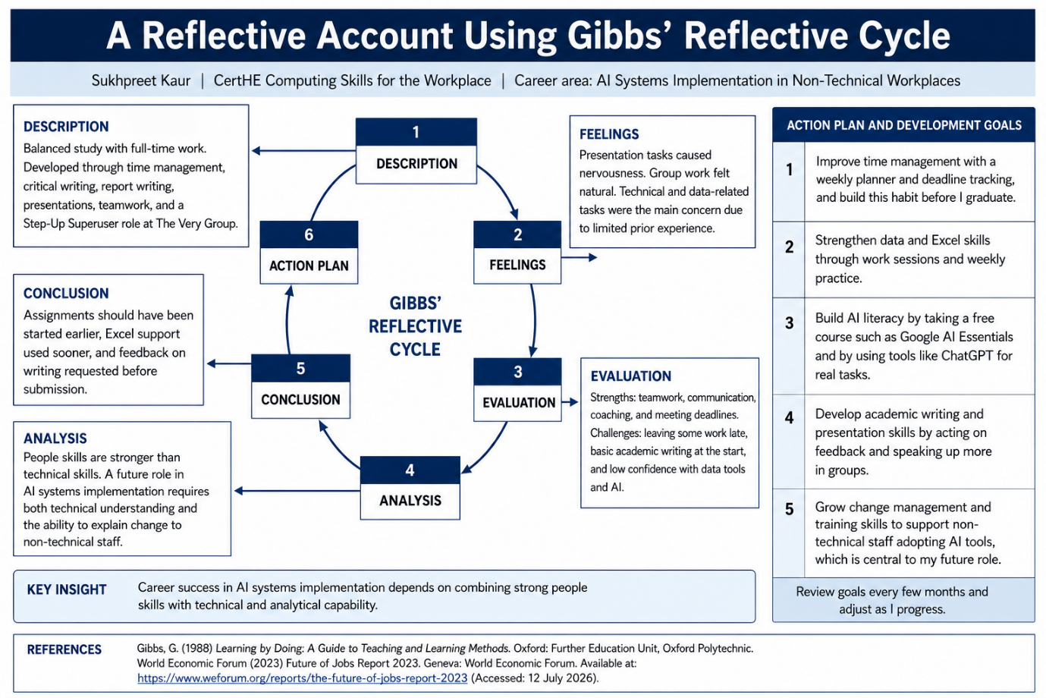
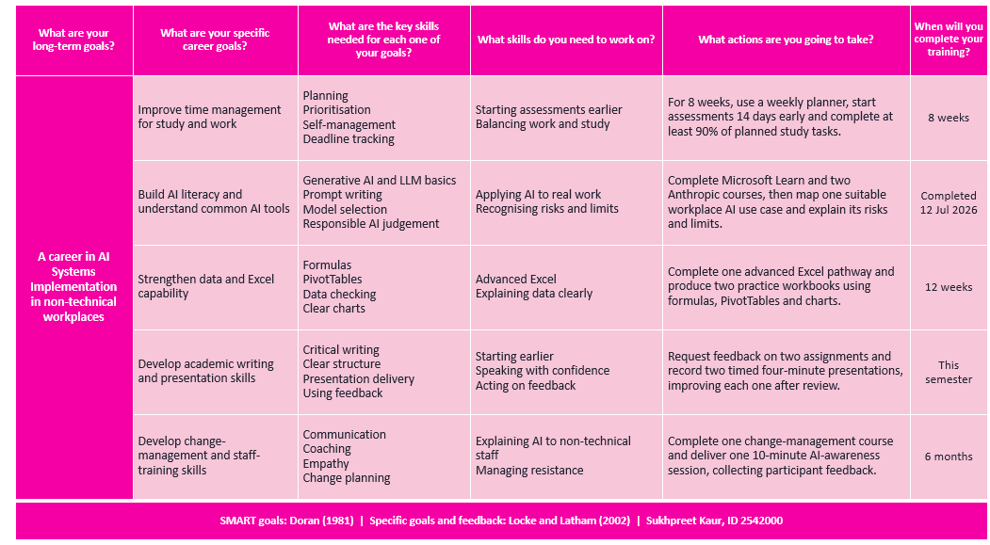
Courses of Anthropic and Microsoft Lean
Claude Platform 101
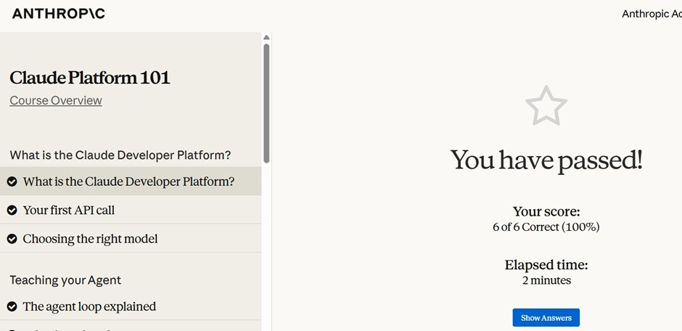
AI Fluency: Frameworks & Foundations
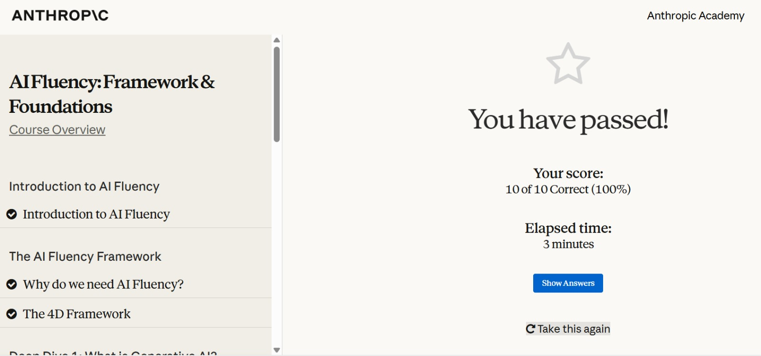
Microsoft Introduction to Gen AI and Agents
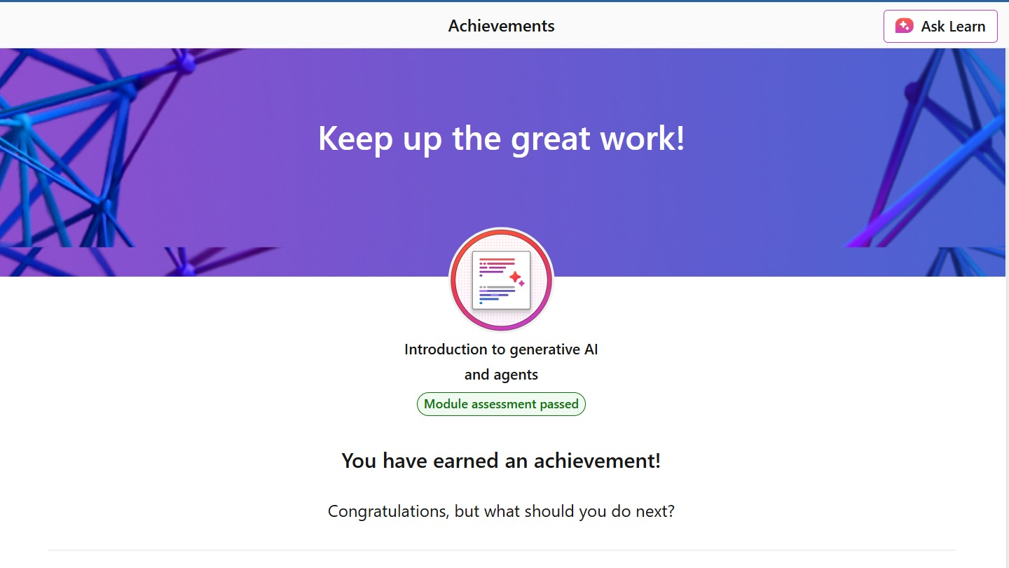
Document1.docx

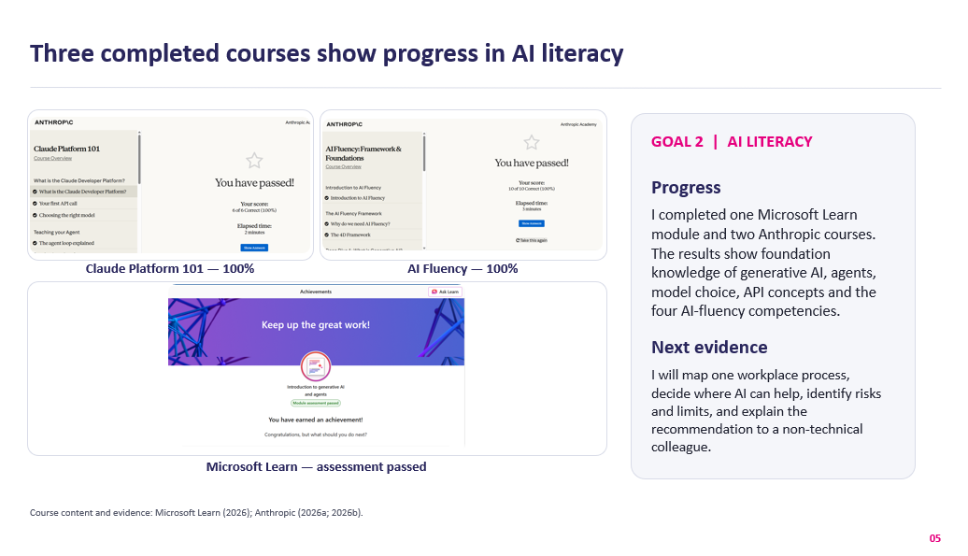

Task 3 Summary of Unit 4
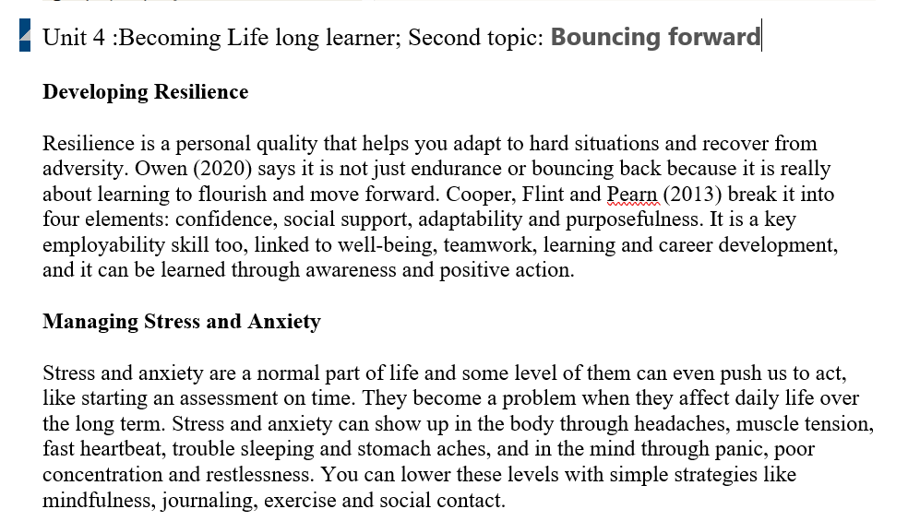
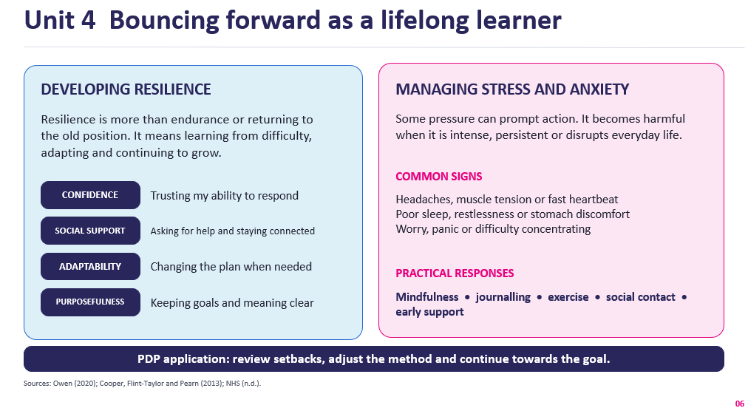

Task 4 Video Link
Video link below for PDP
Recording-20260718_133932 (1).webm

References


