LCBB4003: Introducing the Modern Workplace

Table of Contents
Introduction 3
Description of the company 3
Background of the leader 3
Leadership style 4
Different types of intrinsic and extrinsic motivation in the workplace along with the theories 9
Suggestion of the ways in which intrinsic and extrinsic motivation used for the employee’s performance 13
Conclusion 14
Reference List 15

Introduction
The purpose of the study is to introduce the modern workplace of the organization. For identifying this context, the supermarket chain Sainsbury’s has been chosen. Sainsbury’s is the second largest supermarket chain all over the UK and they have the plan for establishing the sustainable goals globally. Here the motivational approach related to the workplace of Sainsbury’s is described through Maslow’s Hierarchy of needs as well as Herzberg's two factor theory. Simon Roberts is the CEO or the leader of Sainsbury’s who had a great experience and it helps the team in the development of the organization. The leadership approach of Sainsbury’s is described through the theory of situational leadership and also the transformational leadership theory. These theories are helpful to understand the relationship of the leader with the employees and the employees’ psychological needs in the workplace and how it is effective for the organization. It is also described through the report how Sainsbury's is able to fulfill the needs of their employees.

Description of the company
J Sainsbury plc, which is known as Sainsbury's, is the second largest chain of supermarkets in the UK. In 1869, it was founded by John James Sainsbury. They have a strong sense of environmental, social and economic responsibility and the understanding that the success of Sainsbury’s depends on the success of the society (Sustainability, n.d.). Sainsbury’s has the plan to set up a better sustainability goal for the whole business. They are helping their customers to choose sustainable as well as healthy diets. Sainsbury’s committed to Net Zero and tackling plastic as well as food waste. They ensured that they are making a difference to their communities and also to their colleagues (Sustainability, n.d.). Recently Sainsbury’s has introduced the first electric refrigerated trailers. It makes them carbon friendly and helps to reduce the air pollution in the local communities (About. Sainsburys, 2021). Sainsbury’s has rolled out the largest flexible recycling system of the packaging.

Background of the leader
The CEO of Sainsbury’s is Simon Roberts. In 2020, 1st June he was appointed as CEO in Sainsbury’s. He was joined as the director of Retail & operations and heroes responsible for the stores, central operations as well as the logistics. He is also a member of the CR&S committee. Simon brought the experience and the leadership skills with a wide range of the experience as well as the leadership skills to the Board from the roles of previous executive and also non-executive. He has 30 years of experience in the leading retail sector in the UK. He has 15 years of experience in the Mark and Spencer and he stayed 13 years in Boots UK and Ireland. From Mark and Spencer, he started his career (Our management, n.d.).
Simon Robert led the structure of the industry leading stores operations restructure and also digitalization throughout the 2018 that is now helping to deliver improved satisfaction of the consumer, market leading productivity and also the further investment in value for the consumers. He enabled the significant transformation in the leadership and also the capabilities around the operation of Sainsbury’s (Our management, n.d.).

Leadership style
The leadership style is the process of the leader to provide direction as well as to implement the plans and it is also helpful to motivate the employees within the workplace of the organization. Leadership styles are the classifications of how the person behaves when he/she is leading a group (Xie et al. 2018).
Roberts is trying to put teamwork and stores at the heart of his strategies. Simon Robert is a very optimistic and resilient leader that makes it easy for the people to follow him. He can create positive and real energy in the teams (Devlin, 2020).
Simon Robert is the Chief Executive Officer of Sainsbury's. He is determined, enthusiastic as well as a dedicated champion of the colleagues and the consumers. In Sainsbury’s he is the Operating Board Sponsor of the inclusion as well as the diversity (Our management, n.d.).
Situational Leadership Theory
Situational leadership is the process to adjust the management style for adapting every task or the situation and the needs of the team members in the workplace. In 1969, the theory was developed by Paul Hersey. This model is providing a framework for the leaders for diagnosing the development level of the team or the employees for the task and adaptation of the approach of the leadership (Wolf, 2021). The situational leader is responsible for the growth of the team in the workplace of the organization. Here this leadership approach is described related to the leadership style of Simon Robert in the workplace of Sainsbury’s.
Through this leadership approach the CEO of Sainsbury’s included multiple types of the leadership style as well as the flexibility in his leadership approach. He develops different types of characteristics of the situational leadership that are included with -
Flexibility - In the Situational Leadership approach there is no single fixed or best type of leadership. The organization’s requirements are changing according to the time and situation (Cote, 2017). Leaders are able to maintain flexibility and can adapt their style of leadership to both the maturity level and the situation. The Leader of Sainsbury’s is paying close attention to the changing needs of the task, organization as well as the team. This leadership style of Sainsbury’s helps to make a successful outcome.
Clear direction - Situational leadership becomes high on the “directive” aspect when the team members are inexperienced and for this reason, they are expecting lots of direction and they have to be provided with the right knowledge and the motivation for completing the task. With this leadership style, the leader in Sainsbury’s is providing a clear direction and he supports the team members in the workplace when they want.
Coaching skills - The style of coaching is the directive approach’s extension. For being a most effective leader, Simon Roberts is developing the ability for coaching with a wide range of the levels of the development and by this he can engage with his team members. Simon Robert is a very optimistic and resilient leader that makes it easy for the people to follow him. He can create positive and real energy in the teams (Devlin, 2020).
Active listening - For identifying what is going on in the workplace and to diagnose with accuracy the CEO of Sainsbury’s listens to the employees' needs actively and tries to understand what they want.
Encourage participation - With the situational leadership style, the leader in the organization is creating the opportunities and psychological safety for the team members and this helps to the employee engagement.
Integrity - Situation leaders are prioritizing the organization’s sustainability and can encourage the followers of them without manipulation of the situation. Simon Robert has also the characteristic he is committed to the organization that was mentioned by Sainsbury’s. For this reason, this leadership style is helpful to improve the structure of the organization in the business and the leader (Simon Robert) can care about the longevity of the organization.
Transformational leadership Theory
It is the theory of leadership where the leader is working with the followers of the team beyond immediate self-interest for identifying the essential changes and creating the vision for guiding the change through the inspiration, influence and executing the changes with the commitment members of the group. It is the leadership theory or model that helps to encourage and motivate the employees for participating in the organization's success (DiFranza, 2019). Transformational leadership style is serving for enhancing the moral, job performance as well as the motivation of the followers through the different types of mechanisms, these can include the following sense of the identity and also to the collective identity of the organization (Ghasabeh et al. 2015).
With this leadership style the leader of Sainsbury’s can create a positive culture for the employees. Transformational leader is creating a collaborative environment in which the employees feel free to work, express their opinions and thoughts. Innovative ideas as well as creative thoughts are picturized in the organization that helps in the benefits of the organization. The leader is providing the comfort zone that helps their employees feel motivated, the transparency level in the organization helps to better employee engagement in Sainsbury’s, by meeting the employee needs the employees help to better productivity in the organization. The leader of Sainsbury’s following the characteristics of this type of the leadership style -
Visionary - Transformational leaders are using their sharp understanding for looking forward toward a better future (Montgomery, 2018). The leaders of Sainsbury’s following this style can see the obstacles of their operation and can execute the major setback.
Team First Attitude - Transformational leaders are following through on the shared vision by engaging all of the team members (Montgomery, 2018). The leader leverages the emotional intelligence for understanding the interpersonal dynamics for driving collective as well as individual performance in Sainsbury’s.
Simplicity - Simplicity is the important characteristic of the transformational leader. In Sainsbury's the leader is speaking clearly and can communicate consciously for articulating vision. Simplicity is providing the structure and also enables the staff to execute the plan to achieve the goal without any type of confusion.
Tolerance for the risk - There is no ordinary way of innovation. Transformational leader understands that risk taking is important and it is the vital part of the job.
So, J Sainsbury’s plc is going through the modern leadership style that affects the employee engagement and also the employee motivation that helps in the workplace of the organization.
Personality traits of the leadership
Personality traits or the character traits are the aspects of the behavior of someone on their ethical responsibilities, belief, moral and the overall personality. People usually notice the character traits when they see how well the leader approaches the opportunities or the situations. Many leaders value their employees with the professional and positive character traits because they can use the traits on a regular basis for completing the tasks and submitting the work (Zona et al. 2013). If the leader is included with the impressive character traits, the leader can easily develop them to perform more effectively in the career.
Successful leaders are the intellect as well as the power behind the organization. Here the leader of Sainsbury’s is making the sustainable business as well as playing an important role for the motivation of the employees (Patel, 2017).
The leader of Sainsbury’s is included with the leadership traits like -
Self-managing - It means that the leader is able to prioritize the goals of the organization and the leader is responsible to complete the objectives of the organization (Patel, 2017). Being the effective leader, the leader of Sainsbury’s can regulate the time. Emotions as well as attention.
Effective communicator - Powerful leaders know that when he/she needs to talk. In Sainsbury’s the leader follows this properly. The leader is the effective communicator in the organization. By this the leader can explain the task perfectly.
Strategic acting - An open-minded, forward-thinking approach is important for the leader. The leader of the organization is curious as well as genuinely interested in improving the culture of the workplace and making the business environment effective. The mindset of the leader is flexible, that is important for the motivation of the employees and it makes the success of the business. Sainsbury’s is always focusing on the future and thinking about the condition of the operation and they are trying to maintain the positivity in the workplace that makes a huge benefit for the organization.
Clear goal setting and achieve them - The leader of the organization always sets positive goals and they always give motivation to their employees for achieving these. Sainsbury’s has the plan to set up a better sustainability goal for the whole business (About. Sainsburys, n.d.).
Complexity management - Leaders in the organization are the problem solvers and can make the decisions rapidly in different types of circumstances. The effective leaders of the organization can choose the appropriate course of the action in the workplace of the organization.
Innovation and creativity - Leaders of the organization have to manage the risk and have to make innovation. The leader should encourage creativity. (Patel, 2017). In Sainsbury’s the leader is always encouraging the people to bring the new ideas in the organization and it helps to achieve new goals of the organization.
Team building and teamwork - Team building is the important part of the workplace of an organization. It is important to lead a unique and diverse group of people with distinct personalities, skills as well as motivation (Dyer et al. 2013). In Sainsbury’s strong teams as well as the team works are the major source to achieve different types of things like fostering innovation, achieving the organizational goal as well as effective communication.
Creating a positive Relationship - Sainsbury’s is maintaining a positive relationship with their employees. They are committed to achieve diverse representation in the positions of leadership by 2024. Every person in the organization can access to the well-being and mental health support through the tools and other types of the resources that enable the employees for making proactive as well as the positive choices for thriving all types of aspects of life (Diversity and inclusion, n.d.).
So, the leadership approach of Sainsbury’s ensured that the people are feeling good in the workplace. The people in the organization said that they got a reward and they are enjoying the organization. The leadership approach of Sainsbury’s is very modern.

Different types of intrinsic and extrinsic motivation in the workplace along with the theories
Maslow’s Hierarchy of needs
The theory was proposed by Abraham Maslow. It is the theory that is included with the five steps - physiological needs, safety needs, belongingness needs, esteem needs and the self-actualization needs (Hopper, 2020). The hierarchy is suggesting that people are motivated and try to fulfill their basic needs before moving on to the other advanced needs. The hierarchy is portrayed as the pyramid. The lowest level of the pyramid is made up with the basic requirements of the people and the most complex needs are situated at the top level of the pyramid. As the people are progressing up the pyramid, the requirements are becoming increasingly social as well as psychological (Cherry, 2021). So, the need for friendship, intimacy and love are becoming essential in the workplace of the organization. Maslow told that these needs of the people are playing an important role in motivating the behavior of the people.
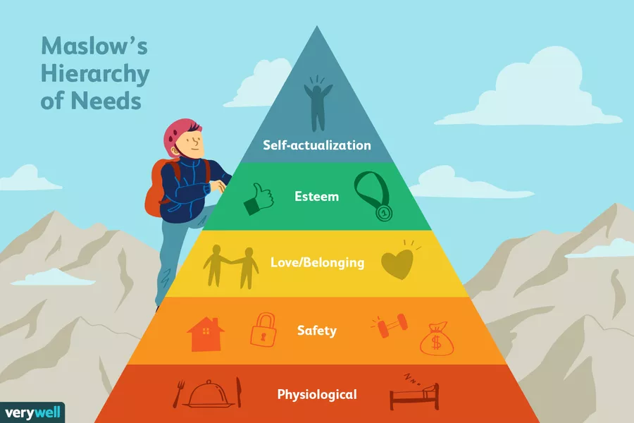
Figure 1: Maslow’s Hierarchy of needs
Source: (Cherry, 2021)
Physiological or the basic needs - The basic needs or the physiological needs are included with the things that are important for survival. These things can be included with food, breathing, water, clothing etc. (Cherry, 2021). A comfortable and pleasant environment in the workplace is provided by the management of Sainsbury’s that makes the employees motivated and the organization is offering a suitable salary that makes employee-engagement.
Security needs (safety) - In the second level of the hierarchy, the needs of the people became a little bit complex. In this level, the needs for safety and security become primary. People want to control their lives. So, these stages are contributing to the behaviors (Cherry, 2021). Security or safety are too important that can be impactful for the overall satisfaction in the workplace of the organization. The employees of Sainsbury’s are feeling protected and safe emotionally. By avoiding threatening behavior and negative stroking, Sainsbury’s maintains an effective workplace and the employees are motivated and they are feeling safe in the workplace.
Social needs (love and belonging) - The social need in the theory can be included with the things like acceptance, love as well as belonging. In this level, emotional intelligence or emotional relationships drive the behavior of the human (Lester, 2013). The leader of Sainsbury’s encourages the concepts of the team for executing the projects. They are also encouraging participation in community as well as professional groups. Close personal leadership is provided by Sainsbury’s in this stage that makes the motivation in the organization and it leads to the work-life balance.
Self -esteem needs - In the fourth level the hierarchy is the need for respect as well as appreciation. After the satisfaction of three levels, the esteem needs are beginning to play the important role to motivate the behavior of the people. It is important for gaining the appreciation as well as respect of the others (Hopper, 2020). Esteem is a type of belief where the people are contributing to the higher goal as well as the contributions. The leaders of Sainsbury’s ensured that the employees are growing, achieving and advancing the results. When the employees are receiving encouragement and positive feedback from the leaders of the organization they will go forward for another step of success. The esteem of the employees is impacted on the overall employee engagement of the organization.
Self-Actualization needs - It is the final level of the Maslow’s Hierarchy. As per the view of Maslow, it can be described as the exploitation and full use of the talents, potentials as well as the capabilities. It refers to the maximization of the work of an individual in the organization. In Sainsbury’s it is provided for the decision-making process as well as the goal setting. In this stage, the supportive leadership is providing encouragement to a high degree with self-control. The company is providing compensation as the reward for the performance that is exceptional. For motivating employees, they are providing gift cards (Motivation - Sainsbury's Business Direct, n.d.). Sainsbury’s is providing the external and internal opportunities of the development and also encourages the communication of direct-access with the consumers, supplier, clients and the vendors that make motivation.
Hertzberg’s two factor theory -
The motivational theory of Herzberg or the Two factor theory is providing two factors that can affect the motivation of the workplace of the organization. The factors are the motivating factors and hygiene factors. Hygiene factors will, cause the employees to work less and the motivating factors will encourage the employees to work harder. Frederick Herzberg, the behavioral scientist, inaugurated the motivator-hygiene theory or the two-factor theory in 1959 (Alshmemri et al. 2017). The theory is included with two types of the factors -
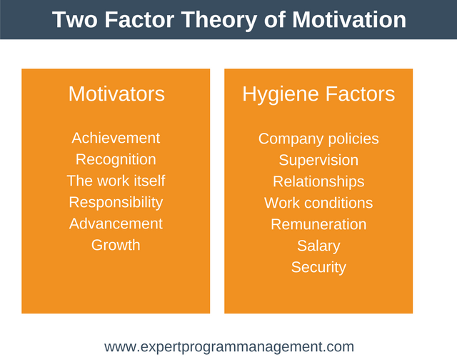
Figure 2: Herzberg’s Two Factor Theory
Source: (Alshmemri et al. 2017)
Hygiene factors - It is also known as the extrinsic motivators. It is the job factors that are important for the workplace of the organization. It cannot create positive satisfaction for a long time but, if the organization doesn’t use it, it can lead to the dissatisfaction of the employees in the workplace.
By these factors Sainsbury’s does not disappoint their employees. By these factors leaders of the organization are describing the scenario or environment of the job. Hygiene factors are the symbolization of the psychological needs of the employees. This can be included with -
Pay - The salary structure of Sainsbury’s is reasonable and appropriate. They are providing competitive salary to the employees that encourage the employees
Administrative and company policy - Sainsbury’s is providing clear and fair policies for the employees that are included with the dress code, flexible working hours, holidays, vacations etc.
Fringe benefits - Sainsbury’s has the system to provide Mediclaim for the employees and the family members that make the employees motivated. They have the voluntary benefits scheme to get advantages for the employees (Motivation - Sainsbury's Business Direct, n.d.).
Status - The status of employees in Sainsbury’s is retained and safe.
Physical working condition - The working condition of the organization is clean, hygienic and safe that helps the employee to be more productive.
Interpersonal relations - The relationship of the staff with the leaders is the important factors for the success of the business and high percentage of the employee engagement in the workplace. The leader helps to avoid any type of conflict in the organization.
Job security - Sainsbury’s ensured that the jobs of the employees are secure and they are safe in the organization.
Motivational factors - It is also called the intrinsic motivators. As per the view of Herzberg, hygiene factors are not noted as the motivators. The motivational factors make positive satisfaction in the organization (Bexheti and Bexheti, 2016). These factors of Sainsbury’s are inherent to the work. In Sainsbury’s, these factors motivate the employees for the high performance. Motivational factors of the company are included with -
Recognition - In Sainsbury’s the employees are recognized and praised for accomplishments by the managers.
Sense of the achievement - In the organization, the workers have the achievements sense and that are improved by the leaders or the management team of the organization. It depends on the jobs of the employees.
Promotional and growth opportunities - Sainsbury’s is providing different types of the opportunities in the organization that helps to motivate the employees and they are performing well in the workplace (Motivation - Sainsbury's Business Direct, n.d.).
Responsibility - Leaders of the organization are looking at the response of the employees, how they are responsible with their job role. The leader gives them the ownership of the works.
Meaning of work - The work of the organization itself is challenging, interesting as well as meaningful for the employees to get motivation and to perform also.
These types of extrinsic and intrinsic motivation theories are used by the CEO or the leaders of Sainsbury’s for motivation in the workplace.

Suggestion of the ways in which intrinsic and extrinsic motivation used for the employee’s performance
It is not easy to get the clear or exact answer when the leader is asking about the goal of the employees. So, for motivating the employees intrinsically the organization can follow some of the steps like - It is important to evaluate the work or life stage of the employees in the workplace. It is the stage where the possibilities of the promotion of the younger worker is increased. The organization has to focus on the personalities of the employees that helps to understand the approach of the employees. The leader of the organization can use flexibility as the process of motivation. The leader in the workplace should be helpful in learning different types of the working methods in the organization. It can encourage them to face challenges in different types of situations.
Extrinsic motivation is also important for the workplace improvement as well as it makes the business sustainable in the workplace because the employees can learn different types of things with it and it leads to productivity. The organization should create the awareness it leads to the attention in the task and the leader should be enthusiastic that helps the employees to get the energy in doing the task, the organization can always set good examples that help to get motivation.

Conclusion
The entire report has described the introduction to the modern workplace. The workplace of the organization has been described through the context of Sainsbury’s. It is included with different types of the leadership style and also included with a motivational approach that helps to improve the employee performance. Simon Robert is the leader as well as the Chief Executive Officer of Sainsbury’s who is a very optimistic and resilient leader and it is easy for the people to follow him. He can create positive and real energy in the teams. Through this report it is understood that the leadership approach of Sainsbury’s is effective and the leader is maintaining a better relationship with the employees. The situational leadership is followed by the leader of the organization and it helps to motivate the employees. In the workplace of the Sainsbury’s a better interpersonal relationship has also been maintained that makes the organization successful and it leads to high employee-engagement in the organization. However, Sainsbury’s is maintaining a modern approach of leadership.

Reference List
About.sainsburys.co.uk. 2021. Sainsbury's introduces first Electric Refrigerated Trailers to its fleet. [online] Available at: <https://about.sainsburys.co.uk/news/latest-news/2021/08-07-2021-sainsburys-introduces-first-electric-refrigerated-trailers-to-its-fleet> [Accessed 19 July 2021].
About.sainsburys.co.uk. n.d. Diversity and inclusion. [online] Available at: <https://www.about.sainsburys.co.uk/sustainability/better-for-everyone/diversity-and-inclusion> [Accessed 19 July 2021].
About.sainsburys.co.uk. n.d. Our management. [online] Available at: <https://www.about.sainsburys.co.uk/about-us/our-management#operating-board> [Accessed 9 July 2021].
About.sainsburys.co.uk. n.d. Sustainability. [online] Available at: <https://about.sainsburys.co.uk/sustainability> [Accessed 9 July 2021].
Alshmemri, M., Shahwan-Akl, L. and Maude, P., 2017. Herzberg’s two-factor theory. Life Science Journal, 14(5), pp.12-16.
Bexheti, L. and Bexheti, A., 2016. The impact of Herzberg's two factor theory and efficiency at work. European Journal of Multidisciplinary Studies, 1(2), pp.378-385.
Cherry, K., 2021. How Maslow's Famous Hierarchy of Needs Explains Human Motivation. [online] Verywell Mind. Available at: <https://www.verywellmind.com/what-is-maslows-hierarchy-of-needs-4136760> [Accessed 19 July 2021].
Cote, R., 2017. Vision of effective leadership. International Journal of Business Administration, 8(6), pp.1-10.
Devlin, E., 2020. Does Sainsbury’s new boss Simon Roberts have what it takes to succeed?. [online] The Grocer. Available at: <https://www.thegrocer.co.uk/sainsburys/does-sainsburys-new-boss-simon-roberts-have-what-it-takes-to-succeed/601810.article> [Accessed 9 July 2021].
DiFranza, A., 2019. Transformational Leadership: How to Inspire Innovation in the Workplace. [online] Northeastern University Graduate Programs. Available at: <https://www.northeastern.edu/graduate/blog/transformational-leadership/> [Accessed 9 July 2021].
Dyer Jr, W.G., Dyer, J.H. and Dyer, W.G., 2013. Team building: Proven strategies for improving team performance. John Wiley & Sons.
Ghasabeh, M.S., Soosay, C. and Reaiche, C., 2015. The emerging role of transformational leadership. The Journal of Developing Areas, 49(6), pp.459-467.
Hopper, E., 2020. Maslow’s Hierarchy of Needs Explained. ThoughtCo, ThoughtCo, 24.
Lester, D., 2013. Measuring Maslow's hierarchy of needs. Psychological reports, 113(1), pp.15-17.
Montgomery, A., 2018. Transformational Leadership Style: 7 Traits Of Transformative Leaders. [online] Eml.usc.edu. Available at: <https://eml.usc.edu/blog/transformational-leadership-style> [Accessed 19 July 2021].
Patel, D., 2017. 11 Powerful Traits Of Successful Leaders. [online] Forbes. Available at: <https://www.forbes.com/sites/deeppatel/2017/03/22/11-powerful-traits-of-successful-leaders/> [Accessed 19 July 2021].
Sainsbury's Business Direct. n.d. Motivation - Sainsbury's Business Direct. [online] Available at: <https://www.sainsburysbusinessdirect.co.uk/solution/motivation/> [Accessed 9 July 2021].
Wolf, J., 2021. Situational leadership examples and how to develop this management style | BetterUp. [online] Betterup.com. Available at: <https://www.betterup.com/blog/situational-leadership-examples> [Accessed 9 July 2021].
Xie, Y., Xue, W., Li, L., Wang, A., Chen, Y., Zheng, Q., Wang, Y. and Li, X., 2018. Leadership style and innovation atmosphere in enterprises: An empirical study. Technological Forecasting and Social Change, 135, pp.257-265.
Zona, F., Minoja, M. and Coda, V., 2013. Antecedents of corporate scandals: CEOs’ personal traits, stakeholders’ cohesion, managerial fraud, and imbalanced corporate strategy. Journal of Business Ethics, 113(2), pp.265-283.

