Managing People

LCBB5004

Prepared by: Ludmila Rosu
Student ID: 2114963

Nishi Ramsurrun
University of Wales Trinity St David
Date: 09.01.2023

Contents
Introduction 3
Task 1 3
a) Importance of CIPD profession map behaviours for effective HR professionals working in the UK. 3
b) The extent to which the professional map could be applied to HR professionals working on a global scale 5
Task 2 6
a) Why the public sector in the UK is facing skills shortages despite the high unemployment 6
b) Long-term labour market developments which can address the skills shortages in healthcare sector professions in the UK 7
Conclusion 8
References 9

Introduction
The human resource management (HRM) function plays a significant role in organisations as they focus on selection, recruitment, training and development, compensation, and employee welfare among others. For the HRM to ensure that they operate professionally, they are guided by the CIPD profession map. The map lists behaviours which are crucial for every HR professional to follow to ensure effective working with others (CIPD, 2022). This report reviews the CIPD map behaviours and explains how important they are for HR professionals. It further explains the extent to which those behaviours should be followed. The second part of the report reviews the issue of labour shortage in the UK’s public sector. It discusses why there are skill shortages even though unemployment rates are high and recommends labour market developments which can help address the shortages in the healthcare sector.

Task 1

Importance of CIPD profession map behaviours for effective HR professionals working in the UK.
The CIPD profession map behaviours list ways in which the HR professionals need to think and act to ensure they create value among the employees. Each of these behaviours is important and should be practised by all the professionals working in the UK. Below is a discussion on how important ethical practice, insights-focused, valuing people, passion for learning, inclusive working, commercial drive, situational decision making and professional courage behaviours are.
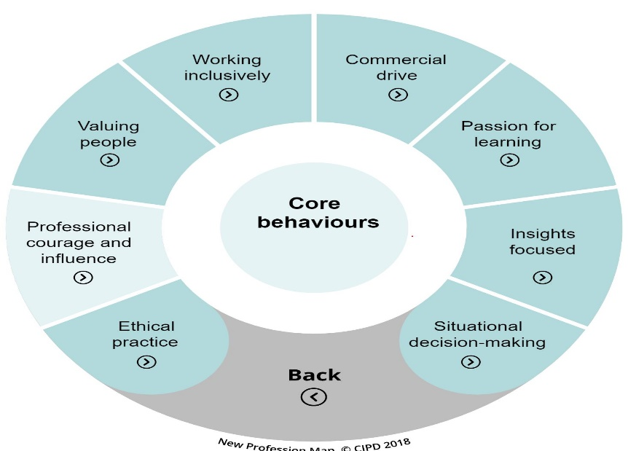
Figure 1Source: (CIPD, 2022)

Ethics define what is right and wrong in any setting more so in a workplace. Ethical practice behaviour is important as it allows HR professionals to focus on cultivating and following the right values, an aspect which promotes trust with other people. Furthermore, ethical behaviour allows professionals to follow the required principles which include transparency and integrity, among others (CIPD, 20122).
Insights-focused requires professionals to notice the rising issues and utilise the evidence that is available to get solutions (Ulrich et al., 2013). This behaviour is important as it states that professionals should focus on understanding the issues first before making any decision. Therefore, HR professionals in the UK need to use evidence to make decisions to ensure the most effective ones are made, which amicably solves any issues present.
Valuing people entails creating a shared purpose with the intention of allowing other people to develop well. This behaviour guides HR professionals on how they should treat employees to make them feel valued (CIPD, 2022). For example, they allow them to air their opinions regard to issues which affect them at work. Thus, the behaviour enables the HR professionals to have a better understanding of the people and focus on improving them by enhancing the skills they possess, allowing personal and professional development.
Passion for learning is important as it focuses on development to enable people to improve their knowledge and skills (Ulrich et al., 2013). As such, it guides HR professionals on how they should cultivate the need for continuous learning among the people to promote development which is vital at personal and professional levels.
Commercial drive entails focusing on remaining committed to what one is doing to meet the set objectives. This behaviour enables HR professionals to focus on their roles and responsibilities of ensuring that they encourage employees to work towards attaining organisational goals (Ulrich et al., 2013). Therefore, the behaviour is important as it advocates for employee engagement and the HR ensuring that the jobs are executed effectively to promote better performance.
Situational decision-making is an important behaviour that guides how HR professionals should make decisions as per the situation and avoid making generalised ones, which are not effective. The behaviour advocates for a better understanding of the situation, and an evaluation of the possible solutions so that the best one is opted for (CIPD, 2022). As such, it allows the professionals to make decisions which align with situations and organisational values.
Professional courage advocates for the professionals executing their roles and responsibilities without any fear. The behaviour is significant for the HR function as it encourages the professionals to focus on doing what is required and influencing other employees to follow suit (CIPD, 2022). Ideally, the behaviour allows the HR professionals to unapologetically follow what is required to ensure there is fairness between the employees and the organisation.

The extent to which the professional map could be applied to HR professionals working on a global scale
The profession map consists of core knowledge, core behaviours and specialist knowledge and is guided by the purpose of being outcomes-driven, evidence-based ad principles-led (CIPD Manchester, 2022). Human resource professionals need to apply the map in their operations to ensure that they perform effectively. The map should be utilised fully in various organisations despite the size and scope to guide in the provision of training and development, exploring talent and reviewing gaps in the organisation as elaborated herein.
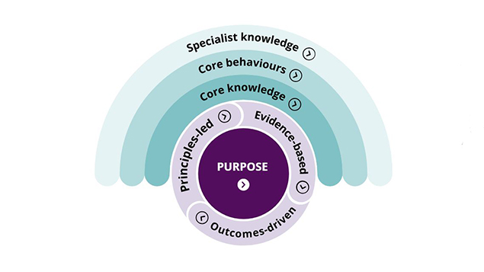
Source: (CIPD, 2022).

In the provision of training and development, the map guides the HR professionals on important areas that they should focus on to enable employees to learn and develop to attain important skills needed to execute roles. The map guides the knowledge that is important for employees to possess to allow better operation, hence, it should be used by all organisations to ensure they train employees well to allow better productivity (Ulrich et al., 2013).
In exploring talent, specialist knowledge in the profession map helps HR professionals to know aspects of talent management. It helps in making decisions on the talents to acquire for the organisation and how to develop them for the benefit of the organisation and the individuals. Concerning reviewing gaps in an organisation, the map helps in determining the values that the HR professionals should look for to ensure the best match is obtained to fill the skill gaps (Darwish, 2013). Ideally, the map guides matters relating to human resource management to ensure the resources are well utilised and managed to allow better performance in all organisations, regardless of size.

Task 2

Why the public sector in the UK is facing skills shortages despite the high unemployment
In the UK, the unemployment rate stands at 3.5%, a rate which is significantly high (ONS.uk, 2022). Even so, the UK’s public sector is still facing skill shortages despite the fact that there are many people who are qualified but unemployed. Various reasons which contribute to the skill gaps are discussed herein.
Poor handling of new recruits is one of the reasons why the UK public sector faces skill shortages. After recruitment, the recruits need to be inducted and trained on how they should work to maximise their potential ((Emmott, 2016). However, in the public sector, training that is carried out is minimal, implying that the new recruits lack knowledge of what they are expected to do to fill the skill gaps. Besides, the new recruits are often mishandled as they are given a lot of work and the companies have high expectations that they will deliver. Due to the work pressures, the recruits feel overwhelmed and their productivity is affected, an aspect which depicts skill shortages.
Unfavourable salaries are yet another reason why there are skill shortages. After spending most of their time learning and expanding their knowledge base, people expect that they get compensated well for the work they are doing (Emmott, 2016). However, in most cases, the public sector does not offer favourable salaries more so for the highly demanded skills, an aspect which forces people to turn down the opportunities to work. For instance, in the healthcare sector, the professionals such as nurses are expected to do a lot of work and ensure better care provision, however, with the salaries offered in the public sector, these professionals opt to work in the private sector, an instance which leaves skill gaps in the public sector (Harris, 2014).
Lack of job security is also attributed to skill shortages. Among the needs of people as stated in Maslow’s hierarchy of needs is the security need (Darwish, 2013). However, when the need is not met, people who are supposed to work do not get satisfied, thus, they seek employment opportunities elsewhere. With examples from the healthcare sector, employees expect guaranteed job security. However, without the assurance, the professionals look for opportunities in smaller organisations where they feel valued and are sure of job security. As such, most people end up working in the private sector and gaps in the public sector remain unfilled, resulting in labour shortage issues.
Additionally, poor working conditions contribute to skill shortages in the UK’s public sector. Employees expect to work in favourable conditions which give them peace of mind to fully concentrate on their work. However, if they feel uncomfortable due to various reasons such as overworking and lack of flexibility, they lose morale to work and opt for other jobs (Darwish, 2013). Besides, with the poor conditions, employees can still be present in the organisations but fail to offer the expected quality of services, resulting in a skills shortage. For instance, if a nurse is expected to attend to 15 patients a day but due to poor working conditions such as exhaustion from the long working hours, he or she may end up offering poor services with which the patients feel dissatisfied. In such situations, the employee is considered incompetent and turnover rates increase, resulting in a shortage of skills.

Long-term labour market developments which can address the skills shortages in healthcare sector professions in the UK
To address the issue of skill shortages, there are various labour market developments that the public sector can consider to ensure they solve the issue in the long run. Below is a discussion of some of the developments to solve skill shortages.
Investing in training and development can help solve the issue of skill shortages in the healthcare sector. With training, employees develop personally and professionally, an aspect which motivates them to work and fill the gaps. Development plays the same role as employees feel valued and part of an organisation, hence, focus on offering the best services (Gordon, 2013). This technique will help both the new recruits and already existing employees to acquire the knowledge and skills they require to fill the existing gaps. For the existing employees, knowledge keeps evolving and training them will help them remain updated hence, ensuring the required services are offered and that there is no gap left unbridged. For the new recruits, training and development help them know what is expected of them, thus, offering the best services as required by their job descriptions. A good example of the training which can be offered is on the use of technology to allow healthcare professionals to utilise it and enhance the efficiency of the services. A gap could be created if, for example, the professionals use manual ways in offering services, and a professional in technology will be required to update the information in the systems.
Focusing on staff retention can equally help in solving the skill shortage issue. When people are aware that they have job security, they give it their all to ensure that they perform well so that they continue working (Emmott, 2016).

Conclusion
Human resource professionals need to ensure that they behave well while executing their roles. The professionals need to follow the behaviours listed in the CIPD map so that they work effectively. HR professionals also need to understand why there are skill shortages in various organisations so that they set effective strategies to help in solving the issue. In particular, they should ensure that there are good relations between the employer and the employees to allow effective working and provision of services in various industries.

References
CIPD (2022). CIPD People Profession map. [Online] Available at: https://peopleprofession.cipd.org/profession-map [Accessed November 4, 2022].
CIPD Manchester (2022) How much do you know about the CIPD profession map? CIPD Manchester. Available at: https://cipdmanchester.com/2021/12/05/how-much-do-you-know-about-the-cipd-profession-map%EF%BF%BC/ (Accessed: November 4, 2022).
Darwish, T.K. (2013). Strategic HRM and performance: Theory and practice. London: Cambridge Scholars Publishing.
Emmott, M. (2016). CIPD. In Encyclopedia of Human Resource Management. London: Edward Elgar Publishing Limited.
Gordon, E.E. (2013.) Future jobs: Solving the employment and skills crisis: Solving the employment and skills crisis. ABC-CLIO.
Harris, M. (2014). The STEM shortage paradox. Physics World, 27(10), p.56.
ONS.uk (2022). Unemployment - Office for National Statistics. Available at: https://www.ons.gov.uk/employmentandlabourmarket/peoplenotinwork/unemployment (Accessed: November 4, 2022).
Ulrich, D., Younger, J., Brockbank, W. and Ulrich, M.D. (2013). The state of the HR profession. Human Resource Management, 52(3), pp.457-471.

