Exploring the relationship between sensation seeking and the likelihood of engaging in risky driving behaviours.

1702887

University of Wales Trinity St. David

Abstract
The study was formed to support the hypothesis of higher levels of sensation seeking correlating with higher levels of risky driving behaviour. In the study, twenty-six participants were given two questionnaires, one relating to Risky Driving Behaviour and one relating to Sensation Seeking. Each response on the questionnaires was scored which were then accumulated and created the results for the study. The higher the score on the questionnaire the higher level of the behaviour. The results showed no positive or negative correlation and contrasted the original hypothesis.

Introduction
Sensation seeking is described as “a personality trait believed to have a biological basis that expresses as a need for physiological arousal, novel experience, and a willingness to take social, physical, and financial risks to obtain such arousal” (Bardo, Donohew, & Harrington, 1996). Examples of risky driving behaviour include “driving at excessive speed; failure to use occupant restraints; and the involvement of alcohol” (Fergusson, Swain‐Campbell, & Horwood, 2003). Studies have shown that there is a correlation between higher levels of sensation seeking and higher levels of risky driving behaviour. (Jonah, Thiessen, & Au-Yeung, 2001). The results indicated that people with higher levels of sensation seeking were significantly more likely than lower level sensation seekers to exhibit risky driving behaviours such as speeding, driving under the influence and not wearing seat belts. They were also more likely to exhibit aggressive driving tendencies. With this information, it is my hypothesis that there will be a positive correlation between higher levels of sensation seeking and higher levels of risky driving behaviour.
Method

Participants
There were 26 participants, 5 males and 21 females aged 18-60, the mean age of the participants was 27.58, with a standard deviation of 11.13. The participants were University of Wales Trinity St. David first year students recruited during a seminar for their Research Methods module. 24 participants owned full driving licenses, and 2 owned provisional.
Design
The within-subject study included the completion of two online questionnaires, each focusing on gauging the likelihood of one variable. The first questionnaire focused on risky driving behaviour and the other focused on sensation seeking behaviour. All participants were required to complete both questionnaires. Information on the study was provided on the consent form and was reiterated in the debrief form.

Materials
Information about the study was included on a consent form provided at the beginning of the study (Appendix 1). The participants were then given two questionnaires.

Risky Driving Behaviour, The Drive Study (Ivers, et al., 2009) (Appendix 2)
This questionnaire measured the likelihood of engaging in risky driving behaviours. The questionnaire uses tailored statements that relate to risky-driving behaviours to gauge this. Participants were asked to read 14 statements related to risky driving behaviour, and rate how often they perform said statement; the possible responses were ‘Very Often’, ‘Often’, ‘Sometimes’, ‘Hardly Ever’ and ‘Never’. The responses were scored; ‘Very Often’ = 4, ‘Often’ = 3, ‘Sometimes’ = 2, ‘Hardly Ever’ = 1, ‘Never’ = 0. The possible scoring range was between 0-56, the higher the score the higher indication of risky driving behaviour.
Brief Sensation Seeking Scale (Stephenson, Hoyle, Slater, & Palmgreen, 2003) (Appendix 3)
This questionnaire measured the potential for greater sensation seeking tendencies. Like the previous questionnaire, it included tailored statements that relate to sensation seeking tendencies to gauge this. Participants were given 8 statements related to sensation seeking behaviour and asked to choose a response which related most to them. The responses were scored as followed; ‘Strongly Agree’ = 5, ‘Agree’ = 4, ‘Neither Agree or Disagree’ = 3, ‘Disagree’ = 2, ‘Strongly Disagree’ = 1. The possible scoring range was between 8-60, the higher the score the higher indication of sensation seeking behaviour.
The study then ended with an online debrief form (Appendix 4). All the above materials were posted on the universities Research Methods module Moodle page.
Procedure
All participants were introduced with a consent form which included information on the study. All participants were then asked to complete two questionnaires, one focusing on risky driving behaviour and the other focusing on sensation seeking behaviour. All the participants were then given a debrief form to conclude.

Results

Figure 1

Figure 1 is a scatterplot graph displaying the correlation between Risky Driving Behaviour and Sensation Seeking using the data collected in the study. The graph presents the accumulated score of the Risky Driving Behaviour questionnaire on the x-axis and the score of the Sensation Seeking questionnaire on the y-axis. Risky Driving Behaviour (M = 14.58, SD = 7.89). Sensation Seeking (M = 25.88, SD = 4.49). There was no correlation between the two variables, r = 0.076, n = 26, p = > 05. (Appendix 5 & 6) The null hypothesis can be rejected based on these statistics.

Discussion
The study does not support the hypothesis of there being a correlation between sensation seeking behaviours and risky driving behaviours. The results show no positive or negative correlation. The findings do not match the previous research (Jonah, Thiessen, & Au-Yeung, 2001). I believe the findings differ due to many factors. Firstly, not all the participants in the study were fully licensed drivers, and so they’re experience of driving would be substantially less than those who have full driving licenses, and as such could not give a supported response to the risky driving related statements. Previous researchers into this area have accumulated a greater sample size, and in research the greater the sample size the greater the power of the test. The original ‘DRIVE study’ for example had a sample size of over 20,000 people (Ivers, et al., 2009). Another limitation of the study was the presentation of the questionnaires. The questionnaires were provided via a link in an email, for the participants to complete voluntarily at their own leisure. Due to this, external factors present as the participants completed the questionnaires may have influenced how they responded to the statements. Factors such as environment, noise, the presence of others and the lack of time scale can affect the responses to the statements. If the study was repeated, to combat this I would place all participants are in the same environment at the same time to complete the questionnaires, therefore limiting the amount of environmental influences that may impact the responses. During the study I would recommend holding it in a seminar setting with a timescale of 10 minutes for both questionnaires, ensuring every participant has the same time to process and respond to the statements efficiently, time to ponder on each statement may result in an overthought response. The presence of others may affect the responses to the statements, as the questionnaires were completed at the participants own leisure, outside influence may come in the form of family and friends providing their opinion. The response to the statements in front of a friend may differ to the response in front of a family member. Young people (most participants in this study) can be subjected to negative peer pressure to behave in a morally irresponsible way by their peers. Studies have shown that the effect of negative peer pressure is prevalent in influencing risky behaviours, and that the presence of a parent can decrease the potential for more violent behaviours. (Tomé, de Matos, Simões, Camacho, & AlvesDiniz, 2012).
To conclude, the two variables did not display a significant relationship in this particular study, but it is my belief that if repeated with a bigger sample, a more controlled environment and the ensuring that every participant completes the questionnaire under the same conditions, that the results would suggest a significant relationship between sensation seeking and risky driving behaviours. I also believe a variable such as age is an important factor to include when discussing risky driving behaviour, research has shown that older people drive safer, and feel this would be an interesting point to include in the research. (Davis, 2016)

References
Bardo, M., Donohew, R., & Harrington, N. (1996). Psychobiology of novelty seeking and drug seeking behavior. Behavioural Brain Research, 23-43.
Davis, N. (2016, September 6). Elderly drivers not more dangerous than younger motorists, study claims. Retrieved from The Guardian: https://www.theguardian.com/science/2016/sep/06/elderly-drivers-not-more-dangerous-than-younger-motorists-study-claims
Fergusson, D., Swain‐Campbell, N., & Horwood, J. (2003). Risky driving behaviour in young people: prevalence, personal characteristics and traffic accidents. Australian and New Zealand Journal of Public Health, 337-342.
Ivers, R., Senserrick, T., Boufous, S., Stevenson, M., Chen, H.-Y., Woodward, M., & Norton, R. (2009). Novice drivers’ risky driving behaviour, risk perception, and crash risk: Findings from the DRIVE study. American Journal of Public Health, 1638-1644.
Jonah, J. A., Thiessen, R., & Au-Yeung, E. (2001). Sensation seeking, risky driving and behavioral adaptation. Accident Analysis & Prevention, 679-684.
Stephenson, M. T., Hoyle, R. H., Slater, M. D., & Palmgreen, P. (2003). Brief measures of sensation seeking for screening and large scale surveys. Drug and Alcohol Dependency, 279-286.
Tomé, G., de Matos, M., Simões, C., Camacho, I., & AlvesDiniz, J. (2012). How Can Peer Group Influence the Behavior of Adolescents: Explanatory Model. Global Journal of Health Science, 26-35.

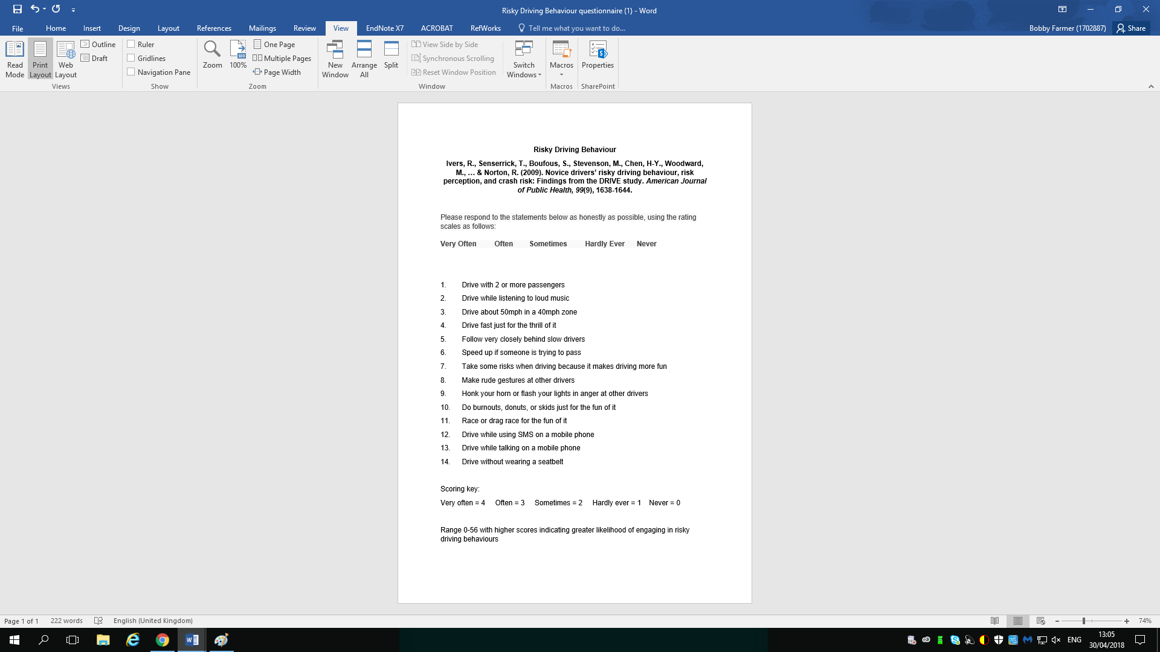
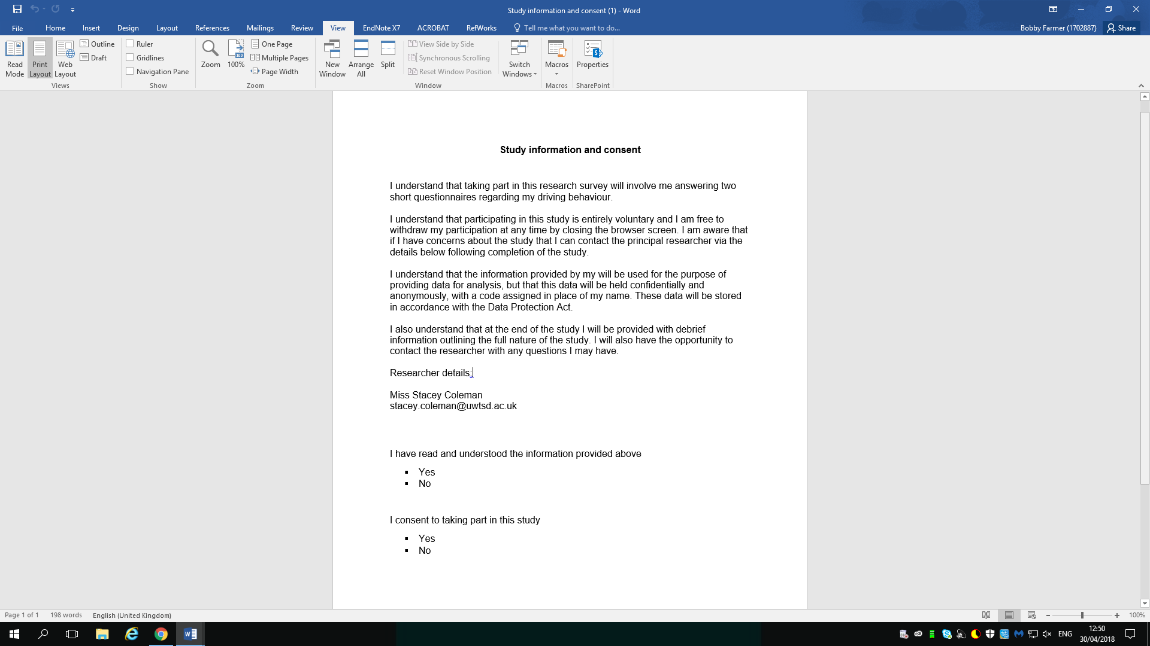

Appendix 1 Appendix 3
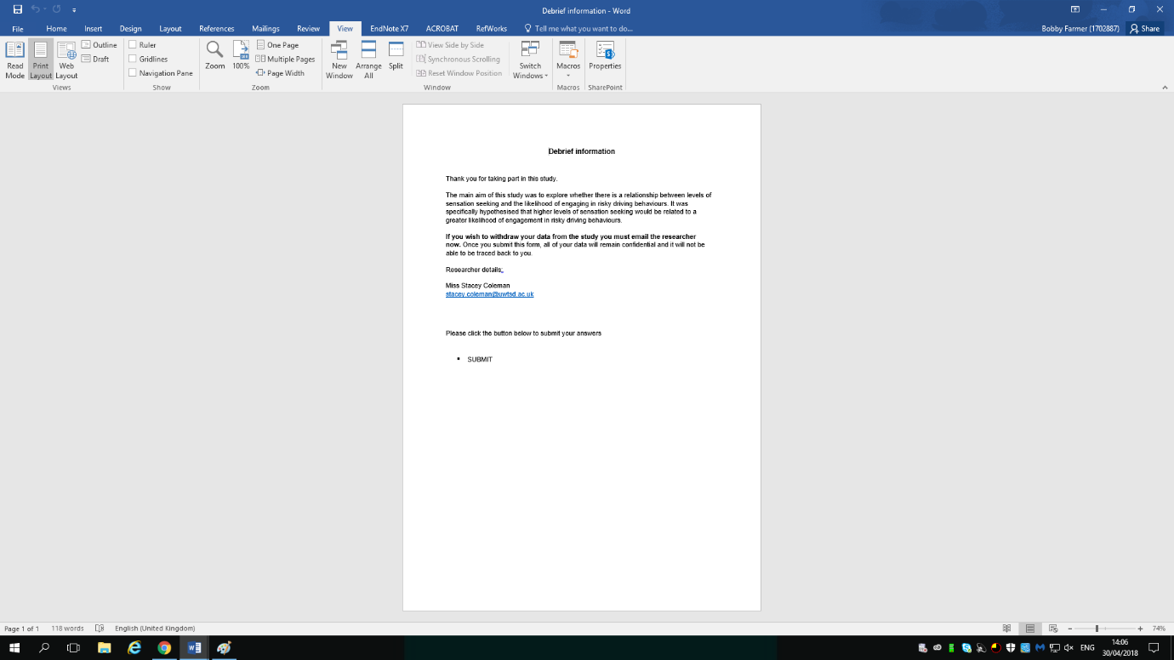

Appendix 3
Appendix 2

Correlations
 |  | TotalRDB | TotalSS
TotalRDB | Pearson Correlation | 1 | -.076
TotalRDB | Sig. (2-tailed) |  | .712
TotalRDB | N | 26 | 26
TotalSS | Pearson Correlation | -.076 | 1
TotalSS | Sig. (2-tailed) | .712
TotalSS | N | 26 | 26
Appendix 5
Descriptive Statistics
 | N | Minimum | Maximum | Mean | Std. Deviation
TotalRDB | 26 | 2.00 | 31.00 | 14.5769 | 7.88504
TotalSS | 26 | 17.00 | 36.00 | 25.8846 | 4.49290
Valid N (listwise) | 26
Appendix 6

