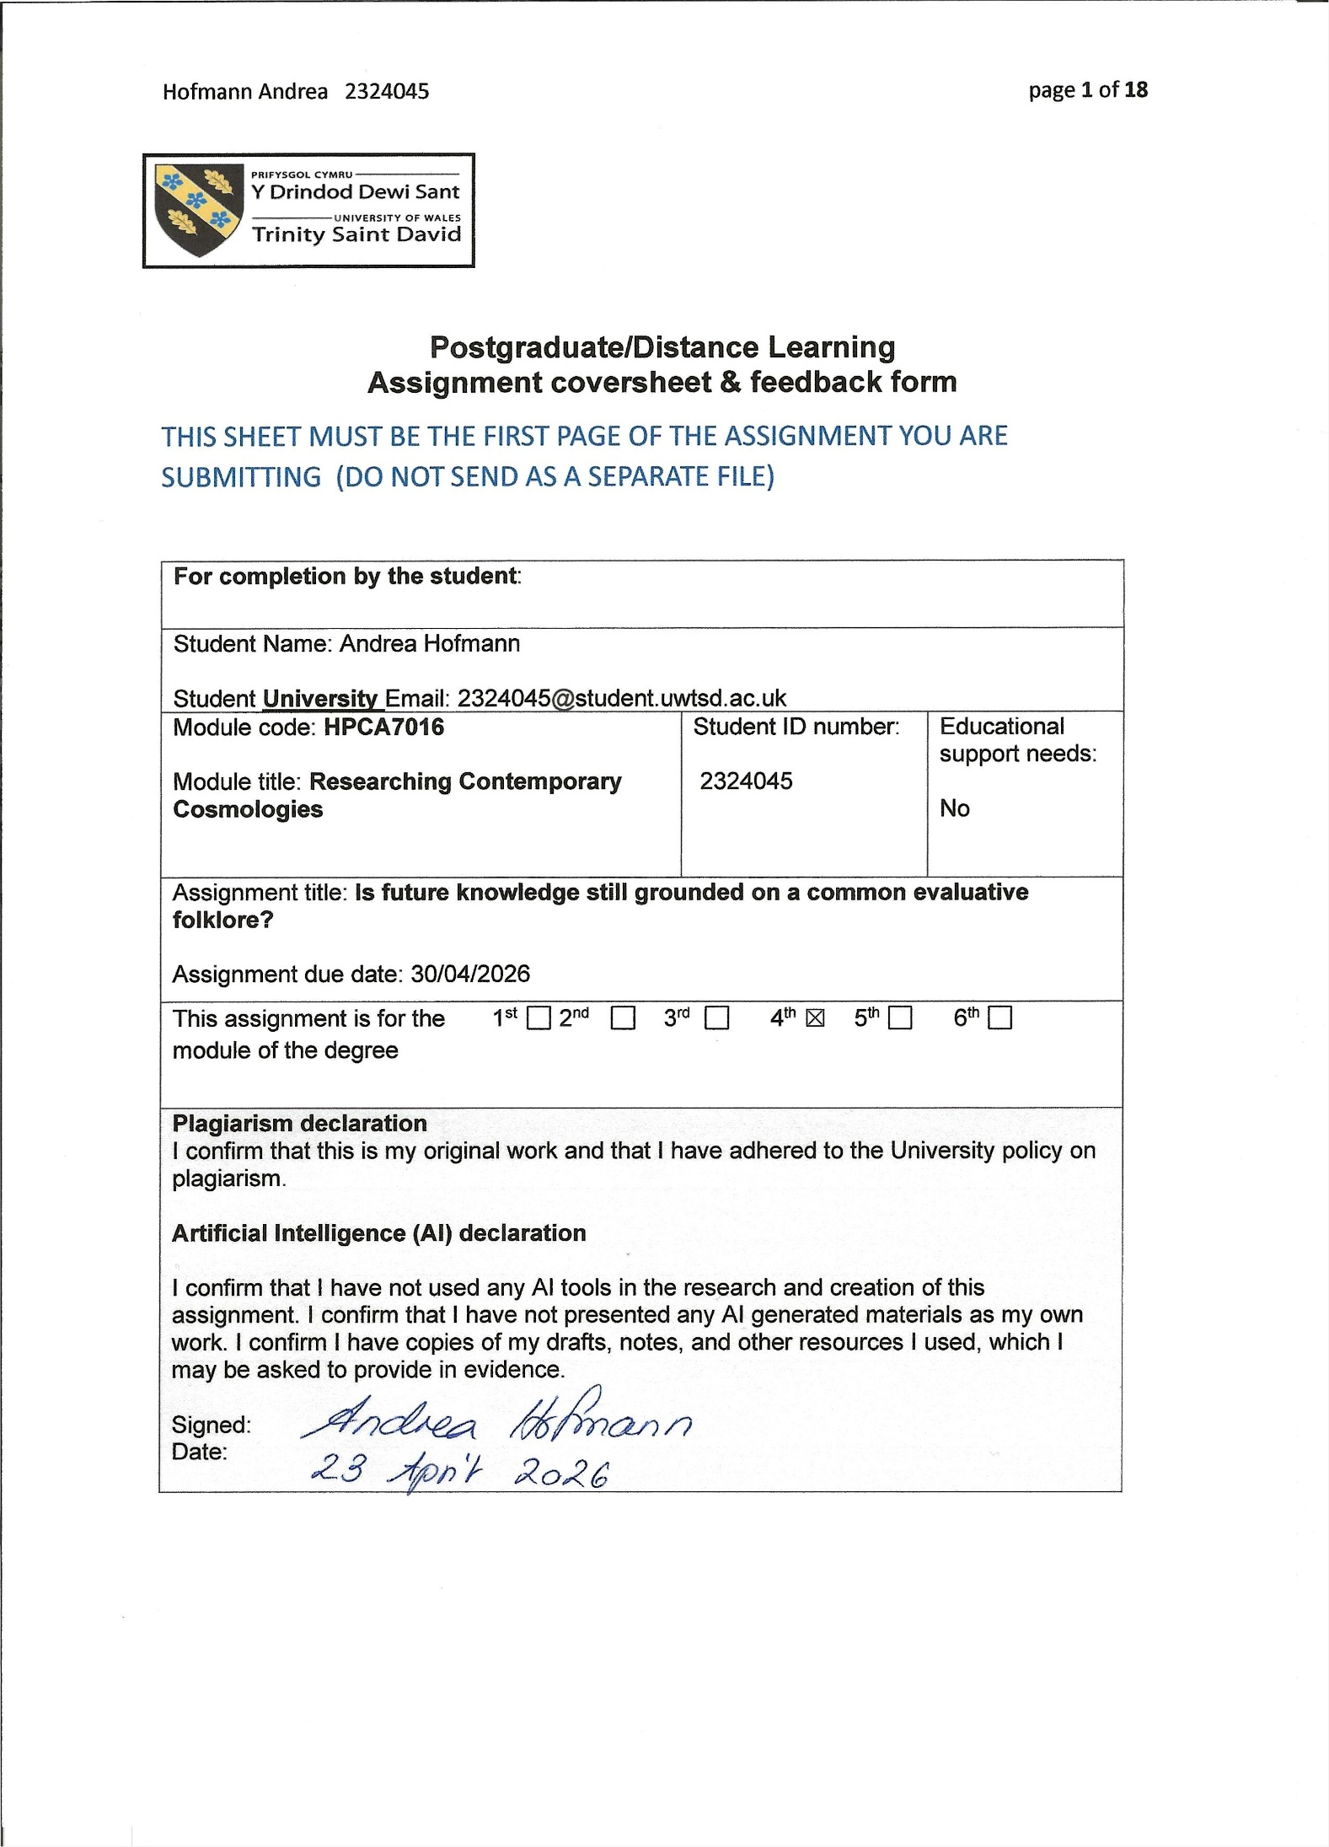
Assignment Mark
1st Marker’s Provisional mark
2nd Marker’s/Moderator’s provisional mark
External Examiner’s mark (if relevant)
Final Mark

NB. All marks are provisional until confirmed by the Final Examination Board.

For completion by Marker 1 :
Comments:

Marker’s signature: |  | Date:
For completion by Marker 2/Moderator:

Comments:

Marker’s Signature: | Date:
External Examiner’s comments (if relevant)

External Examiner’s Signature: | Date:

Research Project 6:
Is future knowledge still grounded on a common evaluative folklore?
Wordcount: 4971 words

Introduction
This essay reports on my study of 58 individuals who shared their views on future knowledge in a questionnaire. It aimed at answering the question whether there is still ‘a common evaluative folklore’ regarding future predictions, as Gillian Bennett stated in her 1995 article ‘If I knew you were coming I'd have baked a cake’. Therefore, my survey aimed to provide new data for comparison and to contribute to the understanding of how knowledge about the future is handled today, 45 years after her 1981 interviews. A significant transformation has occurred during that time, as the digital revolution has begun to redefine the cultural human experience, as examined by Ilya Levin and Dan Mamlok. The questions were primarily intended to gauge whether a distinction was still made between visionary and divinatory events. The women interviewed in 1981 attached much greater value to unintended visionary events obtained through dreams, visions, or intuition than to predictions obtained through consultation with a divinatory system such as card reading or astrology. Bennett argued that these two strands were strands of folklore that had persisted into the twentieth century. My question, therefore, was whether they are still valid, as I believe that human experience has shifted towards subjective issues over the last 45 years, as Bennett had already noted in 1995. She had observed a gradual shift towards the internalisation and personalisation of supernatural experiences. This is consistent with the findings of Levin and Mamlok, who identified emerging trends, such as individualisation, that are driven by the digital revolution. When views on future predictions are examined, philosophical questions will inevitably arise: Is life predetermined? Can fate be changed? Such questions, according to Levin and Mamlok, touch upon personal values and are matters of spiritual culture, which finds expression, next to art, in religion and philosophy. Consequently, my study will address the questions of spirituality, religion, and philosophy.
Literary Review
Barbara Tedlock argued that divination practices are deeply embedded in every culture around the world. She suggested that our desire to understand what the future holds is rooted in our history, and that divination methods help explore the unknown and answer questions that go beyond normal human understanding. It is a very old tradition, also Euan Cameron pointed out, which prioritises experience over analysis. According to him, people claim access to an invisible reality, seeking to fathom and control the unknown through divination – or at least to find protection from it. Simon J. Bronner, referencing Alan Dundes’ examination of folklore, pointed out that folklore reflects people's thoughts and behaviours, expressing emotions or ideas that may be difficult to communicate in everyday conversations. In contrast to other modes of communication, he argued, folklore unveils a community's deeper self-perception. However, there are gaps in the literature that must be addressed: only a few current studies have examined beliefs about people’s attitudes on future predictions and their stance on the malleability of the future. Levin and Mamlok recently examined the evolution of spiritual culture and noted that it is currently being reshaped by the digital revolution. According to them, it is changing the way people experience life and, in turn, their dealings with values and knowledge. Bernadette Brady studied modern Western astrologers' views on fate, stating that the concept of fate is often marginalised in this society. However, this is a matter of great importance and leads to the idea that a predetermined life means that people are destined to encounter certain events, Brady argued. Joseph O. Baker and Scott Draper stated that individuals who strongly believe in the paranormal often exhibit moderate levels of religious faith and engagement, along with a low degree of ideological exclusivity. In an earlier study, Charles F. Emmons and Jeff Sobal argued that paranormal beliefs should be categorised as religious or nonreligious, and that a strong belief in one category should typically correspond to a weak belief in the other, supporting the idea that they serve as functional alternatives. Interest in paranormal topics has often been examined in relation to religious attitudes and from sociological viewpoints. Mike Sosterics, for instance, claimed that the term ‘belief in the paranormal’ could also be described as a sociological focus on esoteric culture. Astrology, divination, and premonition were topics that were examined as a newly emerging interest in paranormal determinism, according to Robert Wuthnow, who stated in 1976 that the increasing fascination with astrology could be understood as a component of the ‘counterculture,’ attracting young individuals who, although accustomed to more scientific perspectives, feel dissatisfied with the worldviews these perspectives provide. This corresponds to Nicholas Campion’s statement about John Addey, who argued in 1971 that astrology was undergoing a rebirth. Around the same time, Carl Gustav Jung was exploring the implications of predicting the future, as well as questions relating to the paranormal from a psychological perspective. However, there is a lack of recent studies directly investigating attitudes towards future knowledge.
Methodology
As part of my methodology, I created a questionnaire comprising 26 questions in my native language, German, using Google Forms. 58 people aged 18 to over 80 participated anonymously: 44 women, 13 men, and 1 person who did not specify their gender. The questions were structured in different formats, including multiple-choice, Likert scale, and open-ended text boxes. At the beginning of the questionnaire, participants were made aware of who I am, my study's objectives, and that their responses would remain entirely anonymous at all times and that all personal identifiers would be automatically removed. The questionnaire was designed so participants could skip or leave any question unanswered at any time. This enabled them to make an uninhibited and well-informed choice regarding their participation. The link to the questionnaire was distributed via informal networks using what could best be described as a snowball approach. Monique Hennink et al. suggested this strategy as effective for recruiting individuals who were hard to access. In my case, I intended to reach out to people of all ages in three countries – Switzerland, Germany and Austria – who were mostly strangers to me and did not necessarily share my views on these issues. I sent the WhatsApp message with the link to 16 acquaintances and family members, which seemed to be a good strategy, as, according to Mohammed Alenezi, ‘the global spread of social media is unparalleled both in growth of take-up and content’. Since this topic relates to spiritual culture as defined by Levin and Mamlok, I considered David Hufford's argument in my reflections on research methodology and ethics. Specifically, Hufford asserts that impartiality is impossible when dealing with matters of spirituality. As a professional astrologer, I was aware that at least the first 16 people to whom I sent the link would be aware of my profession, but did not necessarily agree with it. Brady pointed out that astrology opens up a different perspective on the universe by lending life a deeper meaning or understanding, and that many people are reluctant to engage with it. To spare my participants any discomfort in this regard, I opted for an anonymous questionnaire. In this essay, I have translated all responses into English, and they are available in both languages as an appendix to this essay.
Findings and Discussion
Foklore
When Bennett conducted her interviews in 1981 with elderly English women, exploring their attitudes toward future knowledge, she identified a common folklore which was influenced by their social circumstances and moral values. Bennett argued that two strands of folklore regarding future knowledge continued into the twentieth century. They were passed down and discussed, and were therefore part of a ‘constantly negotiated folklore’, as she noted. One strand relied on the interpretation of ‘internal events’, the other on ‘external stimuli.’ The internal events included dreams, visions or intuition, the external stimuli included fortune-telling methods such as card reading and astrology. Bronner, in referring to Dundes’ analysis of folklore, noted that folklore shows people's thoughts and behaviours, conveying feelings or ideas they may struggle to articulate in regular conversations. Serving as basic assumptions, they influence how people think and express themselves. Bronner further argued that, unlike other forms of communication, it reveals the hidden self-perception of a community, as underlying beliefs or cultural principles. In comparing the interviewees’ shared views, Bennett focused on how the social circumstances and moral principles influenced their attitudes towards these two strands. The results showed that they attached greater value to insights into the future obtained through dreams, visions, or intuition than to those obtained through fortune-telling methods. Bennett, therefore, observed a general trend that there is ‘a preference for the visionary over the divinatory tradition’. I have thus grouped my questions accordingly. The results of my survey showed that, out of 58 participants, only 9 did not trust either of these two strands, whilst 49 trusted both. Nevertheless, 28 participants continued to favour dreams, intuition or visions, whilst 21 were also open to divination methods such as tarot or astrology. This confirmed the general trend identified by Bennett, whereby the visionary tradition is preferred over the divinatory tradition, although trust in divinatory methods is now significantly greater than it was in 1981. Upon closer examination of why internal stimuli were favoured, Bennett found that the elderly women she interviewed earned admiration within their social group for sharing visionary experiences. I therefore asked how the participants felt when sharing their premonitions with their surroundings. 11 participants felt happy, 4 even felt proud, but 4 of them reported feeling embarrassed. (Figure 1). Thus, there seems to have been a shift, with only a quarter of participants reporting explicitly positive feelings when sharing their visionary events. Remarkably, the range of emotions I offered as answers, such as ‘happy’, ‘embarrassed’, ‘proud’, and ‘neutral’, seems not to have been sufficient, as there were many individual notes in the textboxes. This suggests that some participants were not satisfied with the options I provided, leading me to believe the question elicited a wide range of emotions. Jung argued that due to its transcendent nature, parapsychology plays a nuanced role in psychology, and, given its challenging nature, its theoretical side is even more difficult to pin down. This seems to be the case, as participants' comments in the text fields indicated that defining how they felt was challenging.
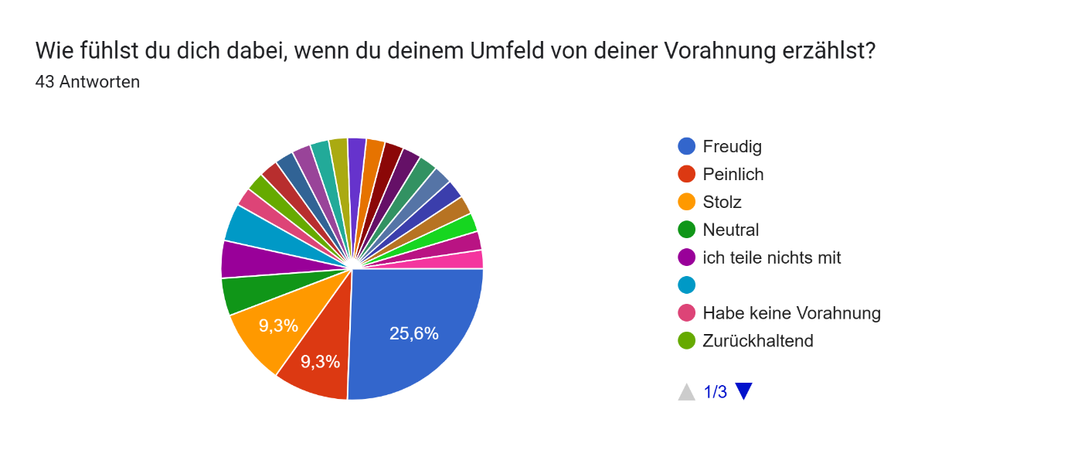
Figure 1: Wie fühlst du dich dabei, wenn du deinem Umfeld von deiner Vorahnung erzählst?
(How do you feel when telling your surroundings of your premonition?) (author’s translation)
Actively sought-after divinatory events were viewed sceptically by Bennett’s interviewees. As a deliberate act, it conflicted with their modest position as devoted members of their community and congregation and conferred an unwarranted power upon them that they were hesitant to embrace. Contrary to this, almost half of my survey’s participants, 22 individuals, felt either happy or proud when sharing insights gained through external stimuli such as tarot or astrology with those around them (Figure 2). Only 5 participants felt embarrassed. However, again, the question evoked a range of emotions.
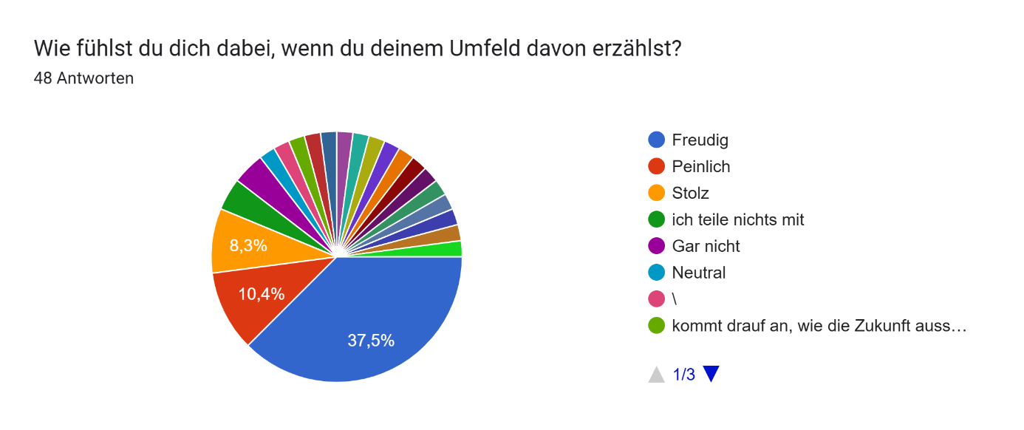
Figure 2: Wie wohl fühlst du dich dabei, wenn du deinem Umfeld davon erzählst?
(How comfortable do you feel when you share your insights [gained from external stimuli] with those around you?)
(author’s translation)
These findings suggest that cultural principles and the underlying folklore have changed over the past 45 years, and divinatory methods such as tarot or astrology have become more socially accepted. According to Sosterics, today the prevailing perspective on tarot divination is that it is a means of gaining insight into the world when scientific explanations are inadequate. It is a way to enhance one's intuitive abilities, or a method for tapping into knowledge from the unconscious mind, he argued. According to Jung, the C.G. Jung Institute in Zürich began experimenting with synchronistic methods, such as astrology and tarot cards, as early as the 1960s. This was based on the view, which Barbara Hannah found in Jung’s lecture notes, according to Angela Graf-Nold, that astrology and alchemy served as forms of psychology in antiquity. When specifically asked about astrology, 39 participants in my survey reported having consulted it before. Thus, John Addey’s 1971 prediction, to which Campion referred, also appears to hold true: astrology is experiencing a renaissance. It therefore seems that folklore is undergoing a shift towards a new form of collective tradition which, whilst more accepting of divination, is also turning more towards psychology than prediction.
Spirituality
Wuthnow investigated whether astrology might serve as a substitute for traditional religious practices. He suggested that because astrology is seen as an outsider belief, it might act as a replacement for religion. If astrology does take on religious roles, its followers may be less committed to traditional religions, he claimed. This was reflected by my survey, in which 33 of the 44 individuals with experience in astrology reported being barely religious, and 28 were not members of a church. Those who claimed to be religious did not necessarily consider themselves spiritual (Figures 3 and 4).
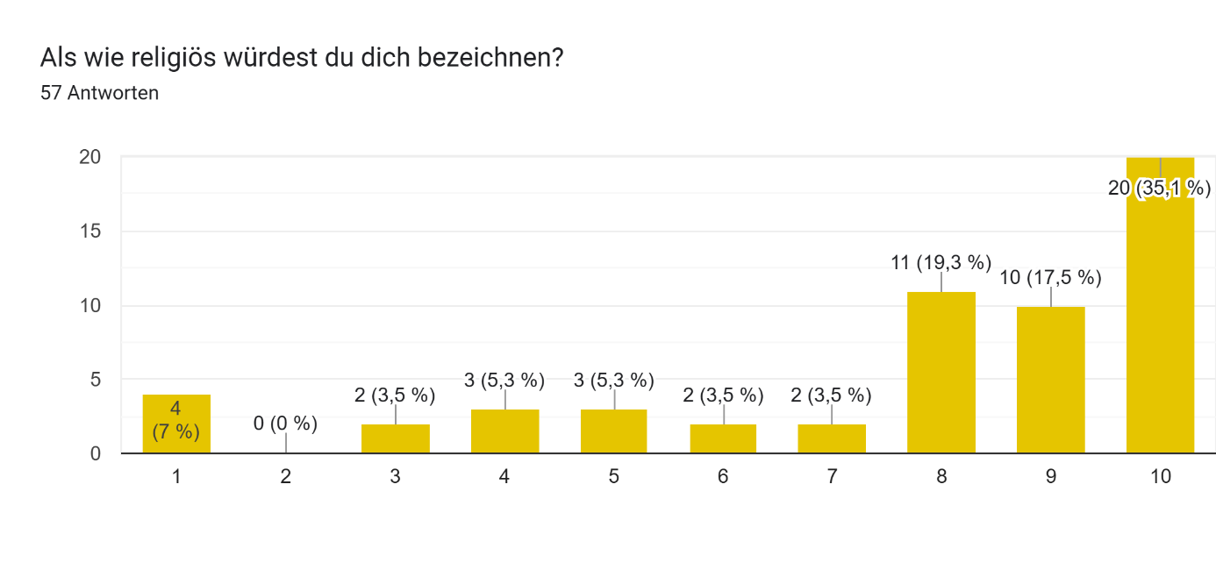
Figure 3: Als wie religiös würdest du dich bezeichnen? (As how religious would you consider yourself?)
(translated by the author)
1 = very religious, 10 = not religious at all
The elderly women in Bennett’s study regarded their divination practices as deliberate acts that ran counter to the values of their congregation. It seems, however, that today, the values of a congregation have lost importance. Baker and Draper suggested that both supporters of religious beliefs and those with nonreligious supernatural beliefs hold a similar view of the spiritual. My study seems to confirm this. In my survey, among the 48 participants who described themselves as moderately to not at all religious (Figure 3), only 14 reported being members of a church. Nevertheless, not being a member of a church does not imply that the participants did not feel spiritual. 35 participants viewed themselves as average to very spiritual, and 23 as less spiritual, of whom 7 reported being not spiritual at all (Figure 4). One person stated to be ‘a realist’.
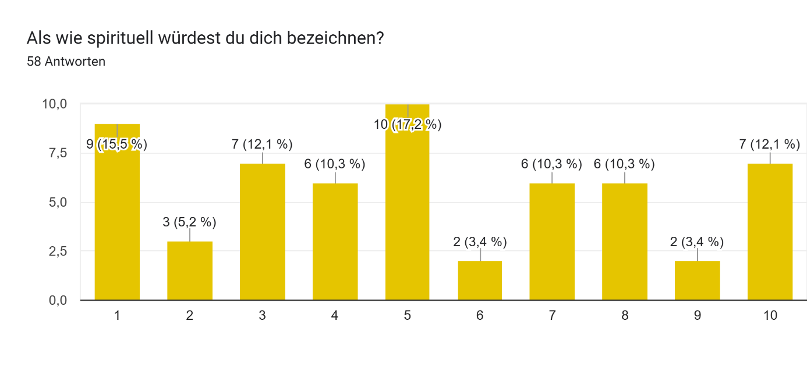
Figure 4: Als wie spirituell würdest du dich bezeichnen? (As how spiritual would you consider yourself?)
(translated by the author)
1 = very spiritual, 10 = not spiritual at all
Emmons and Sobal proposed to divide paranormal beliefs into two groups: religious and nonreligious, arguing that a strong conviction in one category usually relates to a weaker conviction in the other, therefore serving as functional alternatives. My survey reflected this, and the explanation might lie in what Baker and Draper’s study revealed: a strong belief in the paranormal is most prevalent among those who preferred spiritual explanations over materialistic ones and engaged in moderate levels of religious practice.
Something lurks beneath the surface
The urge to gain knowledge about the future is a fundamental aspect of human nature, Tedlock claimed. A spiritual culture, according to Levin and Mamlok, represents the cognitive and value dimensions within the cultural landscape. A defining aspect of all types of spiritual culture, they claimed, is the emphasis on the interplay between knowledge and values. Consequently, discussions about future knowledge are deeply intertwined with values, personal beliefs, and spiritual philosophies. The elderly English women in Bennett’s study, as noted, felt quite comfortable with visionary events because they provided reassurance within their cultural surroundings. When I asked the participants in my survey, a different picture began to emerge. They explicitly stated that they did not feel comfortable with visionary events. Some noted that they have had gut feelings, hunches, or premonitions in the form of dreams and déjà vu, descriptions similar to Bennett’s interviewees’ insights that came to them unbidden.’ Of the 29 participants who indicated having experienced such events, more than half, 16 participants, did not feel at ease about them. Specifically, they wrote ‘insecure’, ‘curious but fearful’, or, as one person stated in the open text box: ‘I think it is better to face the future with a light heart’. In my view, the reason for this lies less in social constraints within their cultural environment than in the feelings such events triggered in them. Consulting a divinatory event is a consciously chosen act, and the underlying philosophy, as well as the possible implications, are considered in advance. Whereas when a prediction of the future arises unsolicited in a dream, a vision or an intuition, one is prompted to unintentionally consider the possible implications, just as one participant commented at the end of the questionnaire: ‘What would I do with that knowledge if I knew something about the future? Would it paralyse me, or would it help me live my life more consciously?’ Another commentator experienced consequences after having ignored a not deliberately chosen internal event: ‘There have been times when I’ve ignored my gut feelings, only for something to happen that I could have prevented.’ Dealing with future predictions has always served individuals in asserting their connection to an unseen reality, in an attempt to understand and manipulate the mysterious, Cameron argued, or, at the very least, to safeguard themselves from it. Predictions about the future, particularly those based on unsolicited internal events, evoke a sense of uncertainty today, presumably because the underpinned shared folklore on how to deal with parapsychology is diminishing. Jung put his finger on it when stating, ‘parapsychology plays a subtle part in psychology because it lurks everywhere behind the surface of things’.
Fate
Behind the participants’ unease may also lie a broader philosophical question, namely, whether the future is predetermined. The discussion of future predictions, therefore, cannot be led without considering the question of fate. Brady argued that fate resides within the overlooked aspects of contemporary Western society. The idea of a predestined life means that people are destined to experience certain events, Brady argued. I therefore asked the participants of my survey: ‘Do you believe that the future can be predicted?’ (Figure 5) and ‘Do you think that the future can be changed?’ (Figure 6). If the future is predictable, it consequently becomes unchangeable. 23 participants in my survey did not believe that the future can be predicted, 19 were not sure, and 13 thought that the future is indeed predictable. Besides the clear yes-or-no answers, the topic again seemed to stir various emotions and prompted many individual philosophical statements expressing insecurity. One participant indicated that the future could not be clearly predicted; some things could, others not, and that it could only be viewed individually. Another participant compared the future to a prewritten book:
I’m also a bit insecure because I often take the view that every ‘book’ (as a metaphor for life) is already written – do I really want to know the last two chapters? Or should I just enjoy life as it is? Some chapters may be more complicated to understand, whilst others are easier to read.
Another commentator revealed quite a pragmatic approach to this question:
I suspect that there are both individual and collective milestones that are so important that they simply cannot be ignored and that you have to face up to them eventually.

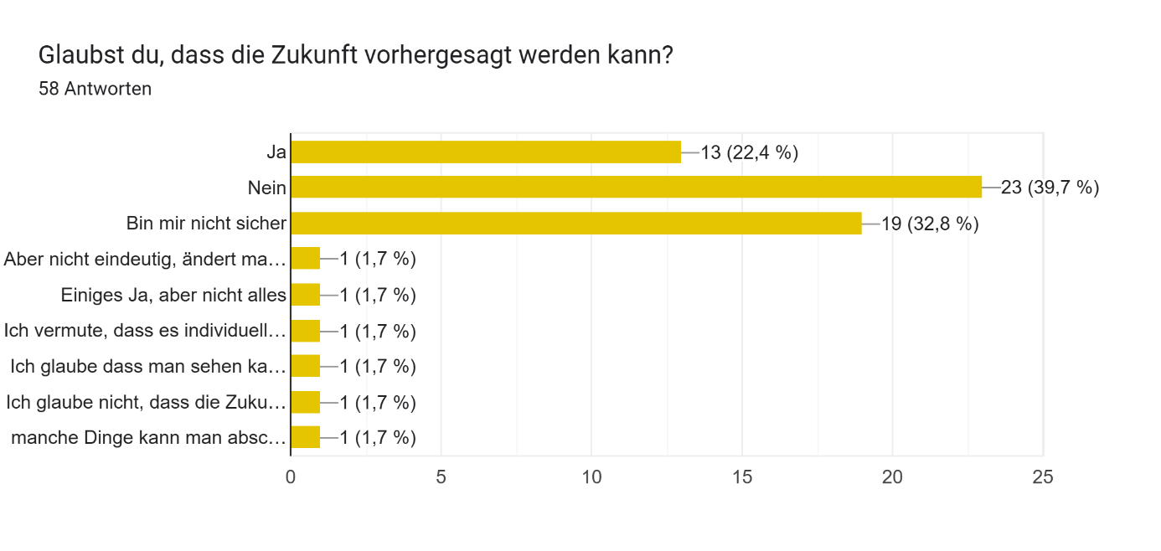
Figure 5: Glaubst du, dass die Zukunft vorhergesagt werden kann?
(Do you believe that the future can be predicted?) (translated by the author)
The second philosophical question I asked, ‘Do you think that the future can be changed?’, was, by contrast, answered with little hesitation and mostly positively: 43 participants thought that the future could be changed. Only 10 participants thought it could not, and 4 gave individual answers expressing concern while also allowing for the possibility. (Figure 6)
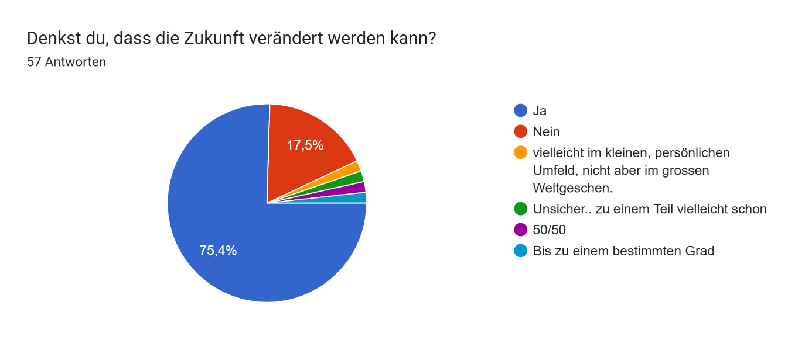
Figure 6: Denkst du, dass die Zukunft verändert werden kann?
(Do you think that the future can be changed?)

The argument over whether the future is a prewritten book or can be changed conceals the question of freedom. Jung noted that if everything were predictable, freedom might be called into question. The participants in my questionnaire felt, so it seems, mostly free to create their own future. One participant stated:
I don’t believe that the future is set in stone and can therefore be predicted with certainty. However, I do believe that one can identify trends and must then act on one’s own initiative.
Other participants wrote at the end of my questionnaire: ‘I have the future in my own hands’, ‘In my view, the future is shaped in the present, by our thoughts, feelings and actions’, ‘I trust that things are right just as they come’, ‘If you change your behaviour, the future changes’, and ‘Some things can be estimated or deduced from past experience’. Therefore, whether the future can be foreseen and changed is a deeply philosophical question about fate and touches on mankind's freedom.
A gradual internalisation
Bennett’s interviewees could rely on a tradition, a hierarchy of how to deal with future knowledge. Omens were considered the most serious kind of visionary event, followed by forewarnings, and premonitions. All of these named and categorised the paranormal that lurked beneath the surface so it could be dealt with. Bennett, however, observed that such classification began to diminish, making room for a gradual internalisation and subjectification of the traditional supernatural beliefs. My survey findings point in the same direction. When asked about how visionary events, such as dreams, visions and intuition were used, 31 indicated as ‘inspiration’, 28 as ‘message from my soul’, 26 as ‘psychological information’, and 16 as ‘premonition’. (Figures 7) Even though multiple mentions were possible, it still showed that visionary events are now used in a more internalised way. 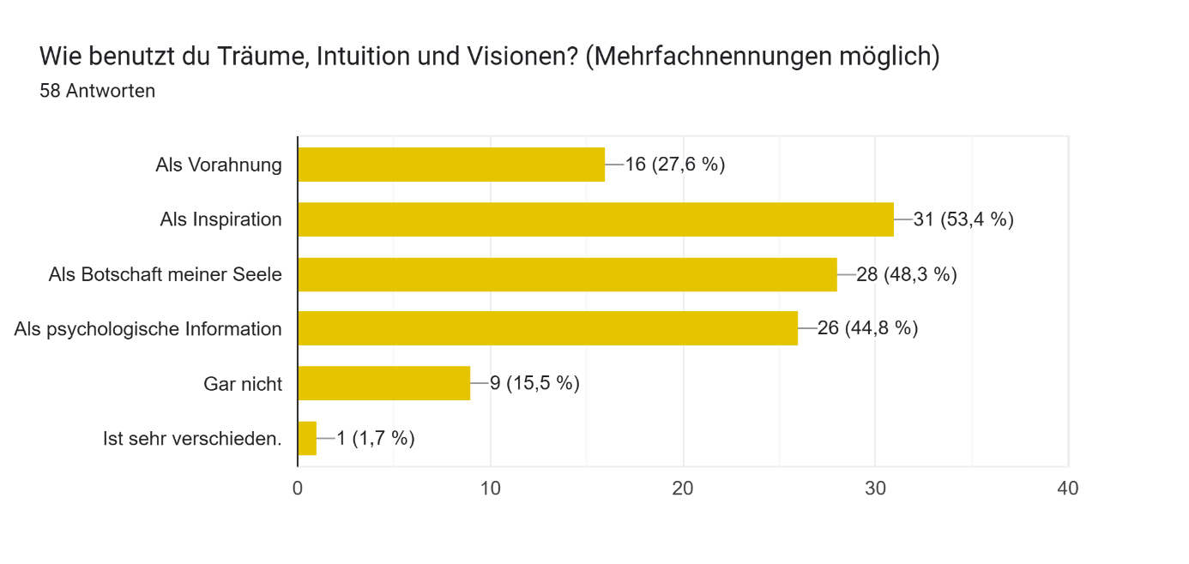
Figure 7: Wie benutzt du Träume, Intuition und Visionen? (How do you use dreams, intuition and visions?)
(translated by the author)
When asked about how external stimuli, such as tarot or astrology, were used, the answers were similar: 29 participants viewed it to ‘solve problems’, 28 as ‘inspiration’, 20 as ‘message from my soul’, 17 as ‘psychological information’ and only 12 as ‘a glance into the future’ (Figure 8).
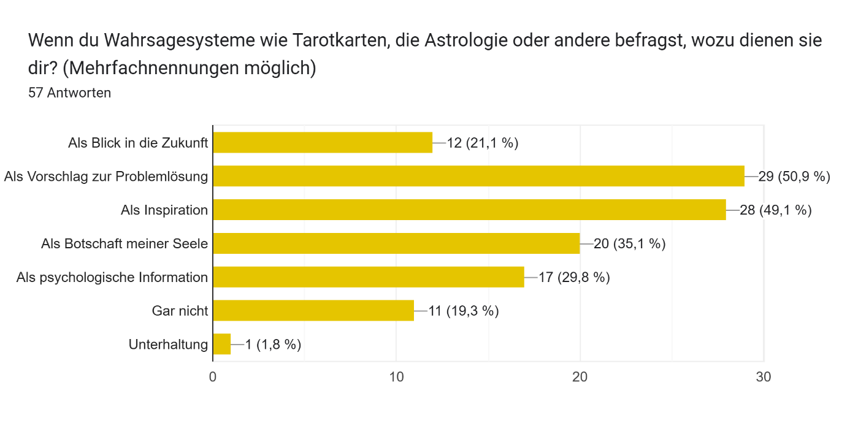
Figure 8: Wenn du Wahrsagesysteme wie Tarotkarten, die Astrologie oder andere befragst, wozu dienen sie dir?
(When you consult divination methods such as tarot cards, astrology or others: what purpose do they serve for you?) (translated by the author)
In their theoretical analysis of the digital revolution as a cultural phenomenon, Levin and Mamlok argued that the ability to access any desired information digitally is changing how individuals construct their worldview and understand life. According to them, this brings about a shift in spiritual culture, because everything is individualised and may thus run counter to traditional structures. This inward-looking orientation is confirmed by my survey, in which visionary or divinatory events no longer hold the exclusive significance of predicting the future. Sosteric, too, noted that tarot is now utilised not only as a mystical or spiritual instrument, but also as a therapeutic resource, including the Jungian approach in psychology, to ultimately uplift the human spirit. When considering Bronner’s statement that folklore is a form of communication that sheds light on a community's hidden self-perception, my survey results indicate that individuals today use both strands, visionary and divinatory events, as tools to explore what is hidden in and from the self. According to Jung, to consider such events, which he called ‘parapsychology’, may help clarify how we are influenced and constantly transformed by the unconscious mind. One participant's comment perfectly illustrates this:
I wouldn’t call it a premonition, but dreams have often shown me something – it is more like my subconscious has conveyed something to me, and then I’ve acted on it.
My survey findings, therefore, reveal that people today use both internal and external stimuli primarily to explore their inner selves, equally valuing visionary and divinatory events for personal transformation.
Conclusion
This essay presented my findings on current trends regarding future knowledge. I examined whether the typical human desire to know and thus influence the future is still grounded in a common evaluative folklore, as identified in Bennett’s 1995 article ‘If I Knew You Were Coming I'd Have Baked A Cake’. 58 adults completed my questionnaire, whereby the general trend identified by Bennett, that the visionary tradition is preferred over the divinatory tradition, was confirmed. However, in contrast to Bennett’s study, trust in divinatory methods has grown substantially. On the other hand, visionary experiences, such as dreams, visions, or intuition, no longer seem to elicit as much admiration from the social environment as before. On the contrary, such internal events now sometimes generate a sense of uncertainty, likely due to the decline of a common folklore that once helped classify parapsychological phenomena. However, where once actively sought-after divinatory events were viewed with scepticism, today insights gained through tarot or astrology are more widely accepted. It was revealed that astrology, tarot, and belief in the paranormal could even serve as functional alternatives to religion. Yet, discussion of future predictions cannot take place without considering the philosophical question of fate. If the future is predictable, it means that it is predetermined. One third of the participants believed the future is predictable, one third was ambivalent about it, and the rest believed it is not. What Bennett anticipated in 1995, a shift in how individuals perceive and utilise knowledge of the future, has indeed happened. She had observed a gradual movement away from a structured classification of omens, warnings, and premonitions towards a more internalised approach to supernatural beliefs. My survey confirmed this trend towards internalising and personalising conventional paranormal beliefs. Digital technologies have begun to redefine human cultural experiences. A shift towards greater subjectivity and internalisation reflects how knowledge of the future is handled today. It seems that folklore is undergoing a transition towards a new type of shared tradition: the psychological tradition. No longer are divinatory systems just used for predictive purposes, but also as therapeutic resources that resonate with psychological approaches. Therefore, when folklore is viewed as reflecting a community’s self-perception, my survey findings show that folklore is shifting: visionary and divinatory events are now mainly used to look inward and explore one’s inner self. They are now mostly used for problem-solving and inspiration, aimed at personal growth, and no longer necessarily tied to spiritual or religious traditions.
Bibliography
Alenezi, Mohammed, ‘Researching Social Media in Digital Age: Reflections on ‘’Observation’’ as a Data Collection Method’, International Journal of English Language & Translation Studies, 8, 3 (2020), pp. 38-44.

Baker, Joseph O. and Draper, Scott, ‘Diverse Supernatural Portfolios: Certitude, Exclusivity, and the Curvilinear Relationship Between Religiosity and Paranormal Beliefs’, Journal for the Scientific Study of Religion, 49,3 (2010), pp. 413-424.

Bennett, Gillian, ‘”If I Knew You Were Coming I'd Have Baked A Cake”: The Folklore of
Foreknowledge in a Neighborhood Group,’ in Out Of The Ordinary: Folklore And The
Supernatural, ed. by Barbara Walker (Logan, Utah: Utah University Press, 1995) pp. 122-142.

Brady, Bernadette, Cosmos, Chaosmos and Astrology (Ceredigion, Wales: Sophia Centre Press, 2014).

Brady, Bernadette, The Shape of Fate: From Classical Philosophy to Astrological Practice (Ceredigion, Wales: Sophia Centre Press, 2025).

Bronner, Simon J., Meaning of Folklore: The Analytical Essays of Alan Dundes (Denver, Logan: University Press of Colorado; Utah State University Press, 2007).

Cameron, Euan, Enchanted Europe: Superstition, Reason, and Religion (Oxford: Oxford University Press, 2011).

Campion, Nicholas, A History Of Western Astrology, Volume II: The Medieval and Modern Worlds (London, New Delhi, New York, Sydney: Bloomsbury Academic, 2009).

Emmons, Charles F. and Sobal, Jeff, ‘Paranormal Beliefs: Functional Alternatives to Mainstream Religion?’ Review of Religious Research, 22, 4 (1981), pp. 301-312.

Graf-Nold, Angela, ‘Swiss Federal Institute of Technology (ETH): Collating the Text of The Course
“Modern Psychology”’, Jung History: a semi-annual publication of the Philemon Foundation, 1.1 (2005)

Hennink, Monique, Inge Hutter and Ajay Bailey, Qualitative Research Methods, (Los Angeles, London: SAGE Publications Ltd, 2020).
Hufford, David J., ‘The Scholarly Voice and the Personal Voice: Reflexivity in Belief Studies’, in The Insider/Outsider Problem in the Study of Religion, ed. by Russell T. McCutcheon, (London: Cassell, 1999)

Jung, Carl Gustav, Jung on Synchronicity and the Paranormal (Princeton: Princeton University Press, 1997).

Levin, Ilya and Mamlok, Dan, ‘Culture and Society in the Digital Age’, Information, 12, 68, (2021), pp. 1-13.

Sosterics, Mike, ‘A Sociology of Tarot’, The Canadian Journal of Sociology, 39, 3 (2014), pp. 357-39.
Tedlock, Barbara, ‘Divination as a Way of Knowing: Embodiment, Visualisation, Narrative, and Interpretation’, Folklore, 112:2 (2001), pp. 189-197.

Wuthnow, Robert, ‘Astrology and Marginality’, Journal for the Scientific Study of Religion, 15, 2 (1976), pp. 157-168.

Appendix 1
Original German answers to Research Project 6: Is future knowledge still grounded on a common evaluative folklore?
(translated by the author)
- ‘Was mache ich damit, wenn ich etwas über die Zukunft weiss? Lähmt es mich, oder gestalte ich mein Leben bewusster?’
‘What would I do with that knowledge if I knew something about the future? Would it paralyse me, or would it help me live my life more consciously?’
- ‘Ich hatte auch schon Bauchgefühle die ich mal ignoriert habe und dann ein Ereignis passiert ist, was ich hätte verhindern können.‘
‘There have been times when I’ve ignored my gut feelings, only for something to happen that I could have prevented’.
- ‘Ich bin mir etwas unsicher, weil ich oft auch die Haltung lebe, dass jedes "Buch" (sinnbildlich für das Leben) geschrieben ist, und will ich schon die letzten beiden Kapitel wissen? Oder das Leben geniessen wie es ist? Einige Kapitel sind vielleicht komplizierter zu verstehen, andere hingegen lesen sich leichter.’
‘I’m also a bit insecure because I often take the view that every ‘book’ (as a metaphor for life) is already written – do I really want to know the last two chapters? Or should I just enjoy life as it is? Some chapters may be more complicated to understand, whilst others are easier to read.’
- ‘Ich vermute, dass es individuelle aber auch kollektive Meilensteine gibt, die so wichtig sind, dass man an ihnen nicht vorbeigehen kann und sich erfüllen.’
‘I suspect that there are both individual and collective milestones that are so important that they simply cannot be ignored and that you have to face up to them eventually.)
- ‘Ich glaube nicht, dass die Zukunft in Stein gemeisselt ist und somit sicher vorhergesagt werden kann. Ich glaube aber, dass man Tendenzen wahrnehmen kann und dann eigenmächtig handeln muss.’
‘I don’t believe that the future is set in stone and can therefore be predicted with certainty. However, I do believe that one can identify trends and must then act on one’s own initiative.’
- ‘Habe meine Zukunft selbst in der Hand.’
‘Have the future in my own hands.’
- ‘Die Zukunft wird meiner Meinung nach in der Gegenwart bestimmt, durch unsere Gedanken, Gefühle und Handlungen.’
‘In my view, the future is shaped in the present, by our thoughts, feelings and actions.’
- ‘Ich vertraue darauf, dass die Dinge so, wie sie kommen, richtig sind.’
‘I trust that things are right just as they come.’
- ‘Ändert man sein Verhalten, ändert sich die Zukunft.’
‘If you change your behaviour, the future changes.’
- ‘Manche Dinge kann man abschätzen oder aus vergangenen Erfahrungen ableiten ‘
‘Some things can be estimated or deduced from past experience.’
- ‘Ich würde es keine Eingebung nennen, aber Träume haben mir schon oft etwas aufgezeigt - mehr dass mein Unterbewusstsein so an mich herangetragen wurde und dann habe ich in diese Richtung gehandelt.’
‘I wouldn’t call it a premonition, but dreams have often shown me something – it is more like my subconscious has conveyed something to me, and then I’ve acted on it.’

Appendix 2
Questionnaire to Research Project 6: Is future knowledge still grounded on a common evaluative folklore?
(printed and scanned from Google Forms)

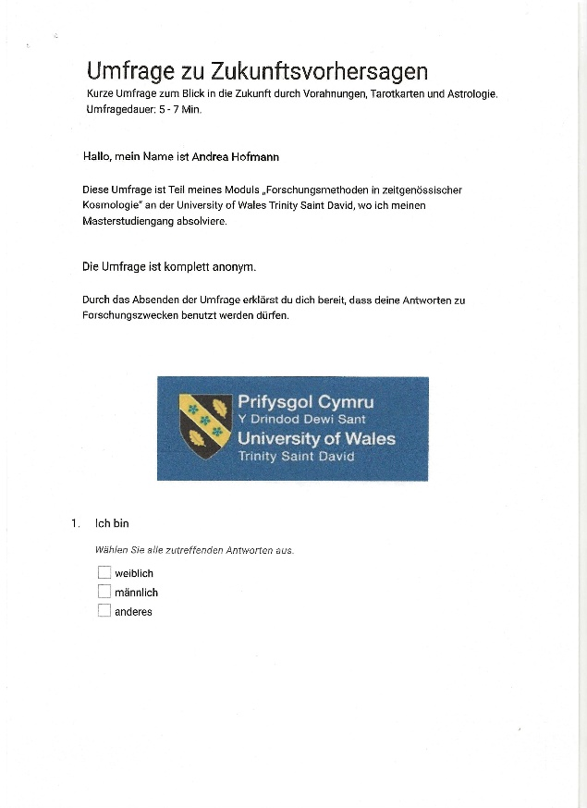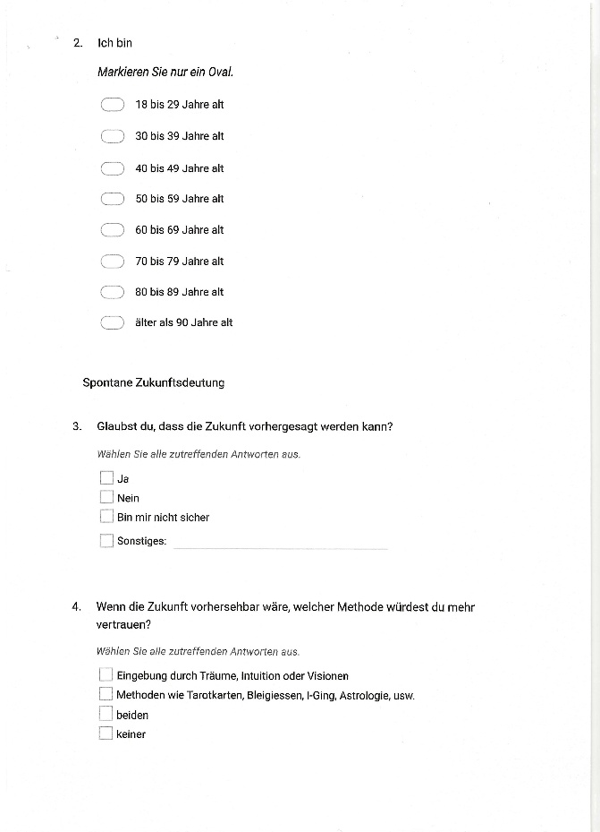
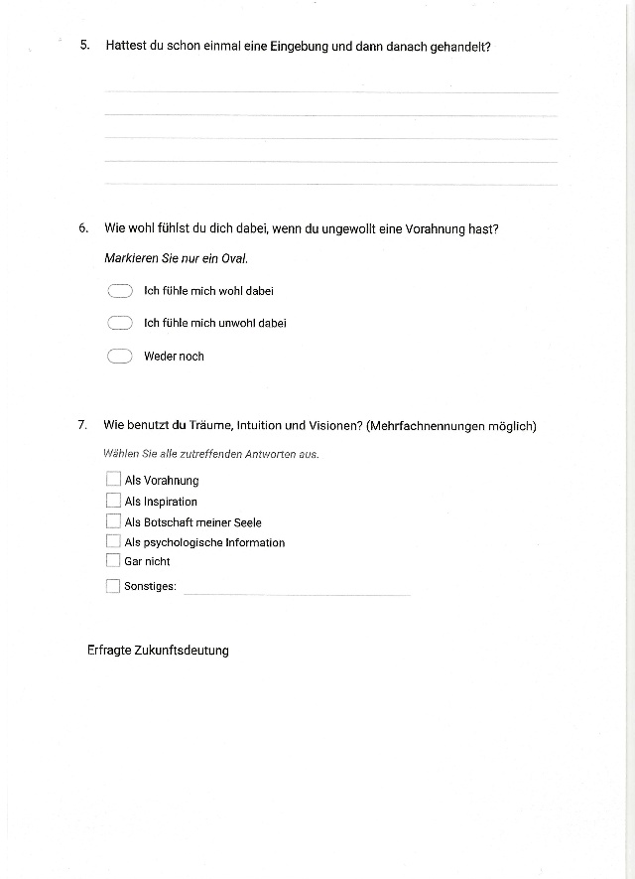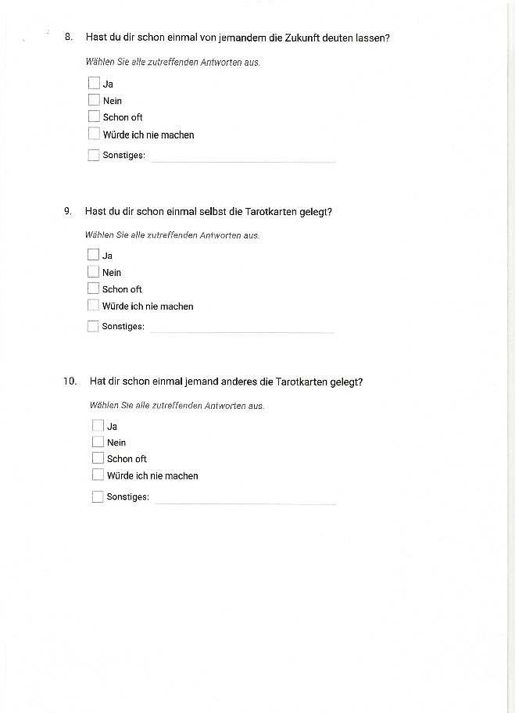
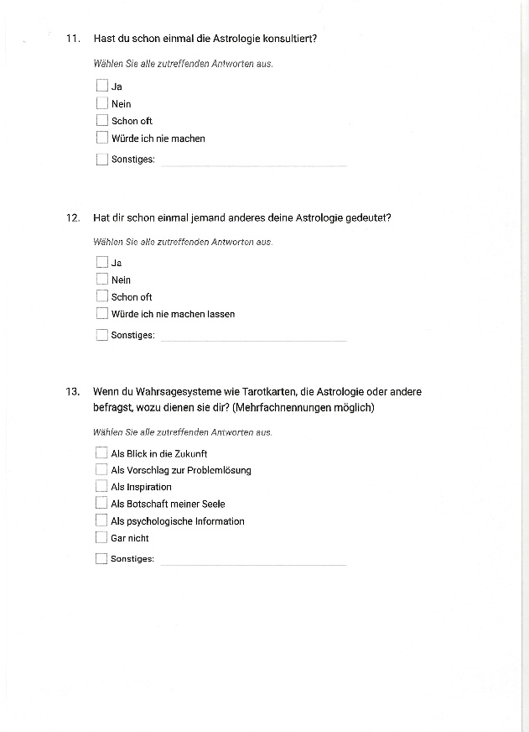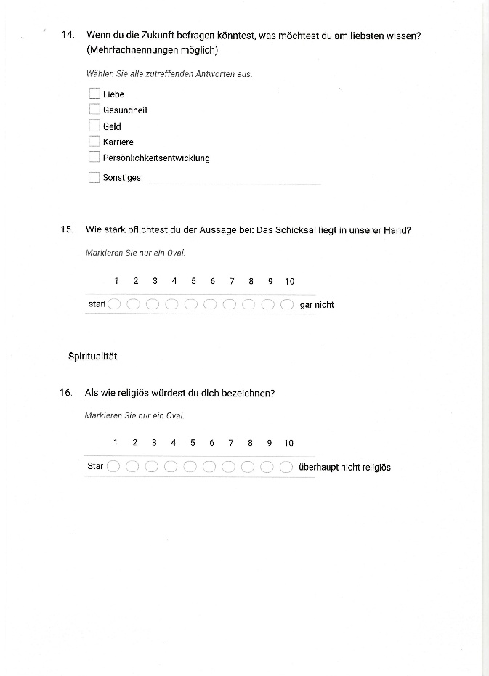
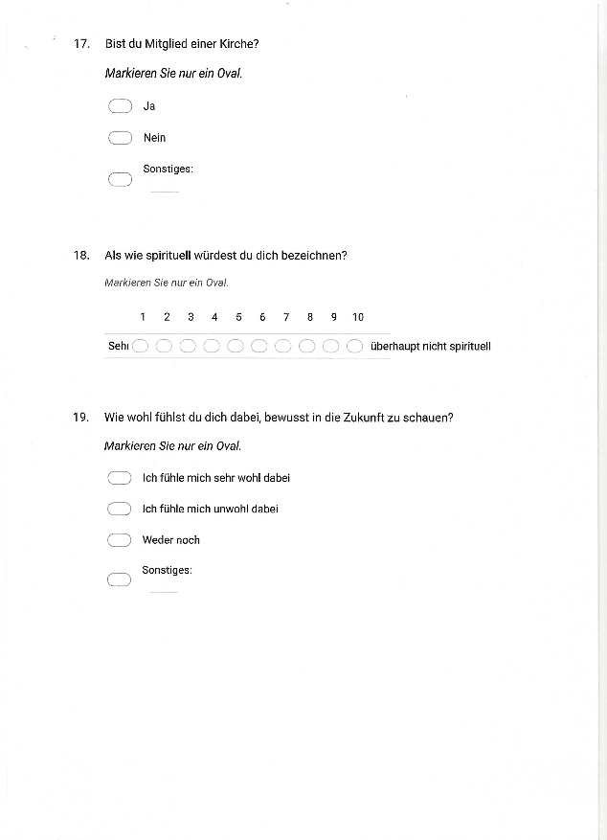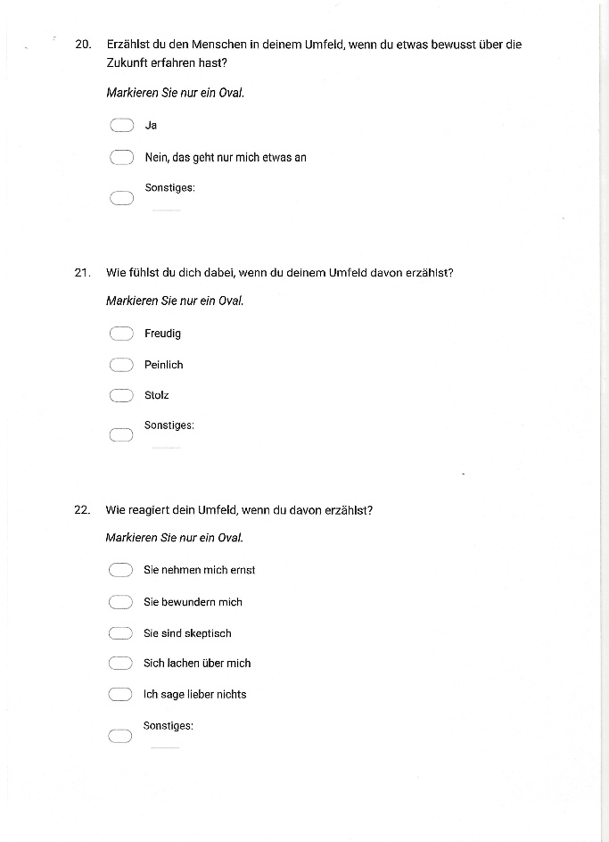
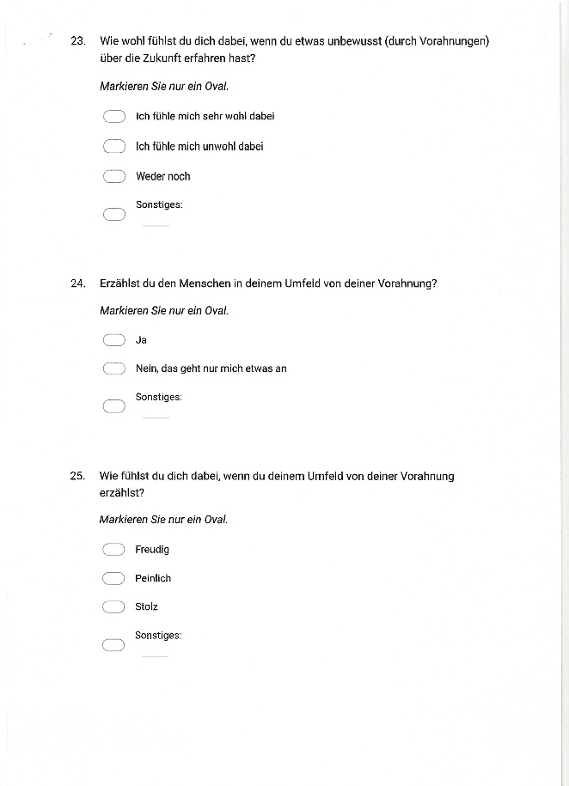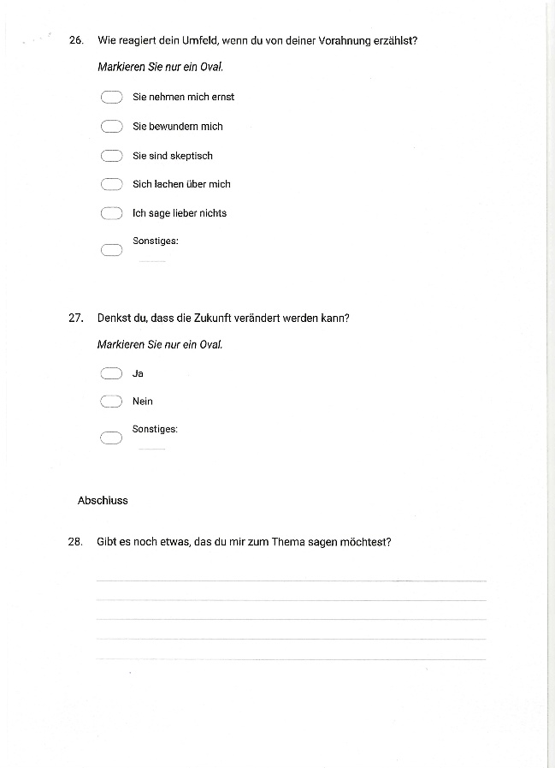

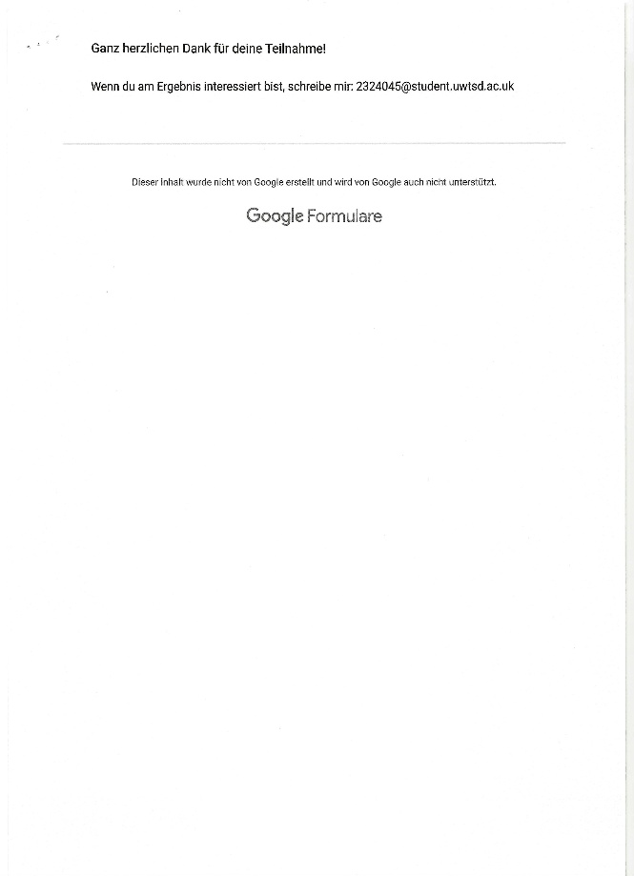

Gillian Bennett, ‘”If I Knew You Were Coming I'd Have Baked A Cake”: The Folklore of Foreknowledge in a Neighborhood Group,’ in Out Of The Ordinary: Folklore And The Supernatural, ed. by Barbara Walker (Logan, Utah: Utah University Press, 1995) pp. 122-142.
Ilya Levin and Dan Mamlok, ‘Culture and Society in the Digital Age’, Information, 12, 68, (2021), pp. 1-13 (p. 1).
Bennett, ‘If I knew’, p. 126.
Levin and Mamlok, ‘Culture and Society’, p. 1.
Levin and Mamlok, ‘Culture and Society’, p. 6.
Barbara Tedlock, ‘Divination as a Way of Knowing: Embodiment, Visualisation, Narrative, and Interpretation’, Folklore, 112:2 (2001), pp. 189-197(p. 189).
Euan Cameron, Enchanted Europe: Superstition, Reason, and Religion (Oxford: Oxford University Press, 2011), p. 5.
Simon J. Bronner, Meaning of Folklore: The Analytical Essays of Alan Dundes (Denver, Logan: University Press of Colorado; Utah State University Press, 2007), p. 1.
Levin and Mamlok, ‘Culture and Society’, p. 1.
Bernadette Brady, The Shape of Fate: From Classical Philosophy to Astrological Practice (Ceredigion, Wales: Sophia Centre Press, 2025), p. 1.
Bernadette Brady, Cosmos, Chaosmos and Astrology (Ceredigion, Wales: Sophia Centre Press, 2014), p.85.
Joseph O. Baker and Scott Draper, ‘Diverse Supernatural Portfolios: Certitude, Exclusivity, and the Curvilinear Relationship Between Religiosity and Paranormal Beliefs’, Journal for the Scientific Study of Religion, 49,3 (2010), pp. 413-424 (p. 413).
Charles F. Emmons and Jeff Sobal, ‘Paranormal Beliefs: Functional Alternatives to Mainstream Religion?’ Review of Religious Research, 22, 4 (1981), pp. 301-312 (p. 301).
Mike Sosterics, ‘A Sociology of Tarot’, The Canadian Journal of Sociology, 39, 3 (2014), pp. 357-39 (p. 358).
Robert Wuthnow, ‘Astrology and Marginality’, Journal for the Scientific Study of Religion, 15, 2 (1976), pp. 157-168 (p. 157).
Nicholas Campion, A History Of Western Astrology, Volume II: The Medieval and Modern Worlds (London, New Delhi, New York, Sydney: Bloomsbury Academic, 2009), p. 277.
Carl Gustav Jung, Jung on Synchronicity and the Paranormal (Princeton: Princeton University Press, 1997).
Monique Hennink et al., Qualitative Research Methods (Los Angeles, London: SAGE Publications Ltd, 2020), p. 96.
Mohammed Alenezi, ‘Researching Social Media in Digital Age: Reflections on ‘’Observation’’ as a Data Collection Method’, International Journal of English Language & Translation Studies, 8, 3 (2020), pp. 38-44 (p. 1).
Levin and Mamlok, ‘Culture and Society’, p. 1.
David J. Hufford, ‘The Scholarly Voice and the Personal Voice: Reflexivity in Belief Studies’, in The Insider/Outsider Problem in the Study of Religion, ed. by Russell T. McCutcheon, (London: Cassell, 1999), p. 61.
Brady, The Shape of Fate, p. 121.
Bennett, ‘If I knew’, p. 122.
Bennett, ‘If I knew’, p. 125.
Bennett, ‘If I knew’, pp. 136 and 137.
Bronner, Meaning of Folklore, p.1.
Bennett, ‘If I knew’, p. 153.
Bennett, ‘If I knew’, p. 129.
Jung, Jung on Synchronicity, p. 104.
Bennett, ‘If I knew’, p. 129.
Sosteric, ‘A Sociology of Tarot’, p. 360.
Jung, Jung on Synchronicity, p. 107.
Angela Graf-Nold, ‘Swiss Federal Institute of Technology (ETH): Collating the Text of The Course “Modern Psychology”’, Jung History: a semi-annual publication of the Philemon Foundation, 1.1 (2005), p. 13.
Campion, A History, Volume II, p. 277.
Wuthrow, ‘Astrology and Marginality’, p. 166.
Bennett, ‘If I knew’, p. 133.
Baker and Draper, ‘Diverse Supernatural Portfolios’, p. 414.
Emmons and Sobal, ‘Paranormal Beliefs’, p. 301.
Baker and Draper, ‘Diverse Supernatural Portfolios’, p. 422.
Tedlock, ‘Divination as a Way of Knowing’, p. 189.
Levin and Mamlok, ‘Culture and Society in the Digital Age’, p. 6.
Bennett, ‘If I knew’, p. 129.
Bennett, ‘If I knew’, p. 132.
Cameron, Enchanted Europe, p. 5.
Jung, Jung on Synchronicity, p. 104.
Brady, The Shape of Fate, p. 1.
Brady, Cosmos, Chaosmos, p.85.
Jung, Jung on Synchronicity, p.104.
Bennett, ‘If I knew’, p. 126.
Levin and Mamlok, ‘Culture and Society in the Digital Age’, p. 8.
Sosteric, ‘A Sociology of Tarot’, p. 363.
Jung, Jung on Synchronicity, p. 105.

