Design and Manufacture Case Study
ACDA5021
Luke Malcolm (2030773)
2024
Contents
1. Executive Summary 2
2. Background 2
3. Systems Engineering Methodology 2
4. Requirements 3
5. Stakeholders 3
6. QFD 1 4
7. Function Means Analysis 4
8. QFD 2 5
9. Report Assumptions 5
10. Cartridge Case 5
Anatomy 5
Basic Information 6
Customer Requirements - Ammunition 6
Functions 6
11. Manufacturing 6
12. Process Flow 7
13. Failure Modes 7
14. Manufacturing Requirements 8
15.Manufacturing QFD 1 9
16. Process Function Means Analysis 11
17. QFD 3 12
18. Cartridge Case Drawing 13
19. Parameter Diagram 15
20. What-Why Table 16
21. Recommended Measures 18
Control Factors 18
Noise Factors 19
22. QFD 4 19
23. Limitations of the Systems Toolset 19
24. Conclusion 20
25. Future Work 20
Bibliography 21

1. Executive Summary
This report explores the application of the systems engineering toolset to the manufacturing of cartridge cases. The manufacturing steps will be decided on and discussed; and a most critical process identified. Once this process has been identified, key noises and controls will be identified, and measures to negate their effects proposed.
The drawing of the cases from a brass blank is deemed to be the most important process step. The most important control factors that require monitoring relate to the material hardness, annealing oven temperature, and the ram & die dimensions. The most important noise factors requiring control are the material hardness, annealing oven temperature, and the overall clearance of the ram & die. Measures to monitor and control these, respectively, are listed in section 21 of the report.

2. Background
Using a typical small-calibre centrefire brass cartridge case (rimless, boxer-primed) as an example, this report aims to propose a solution for manufacture and assist in the design of the case itself using the systems toolset, up to (but not including) the QFD 4 stage.
The following will be explored:
- Key customer requirements
- Critical system functionality
- Derivation of concept and design choices
- Failure modes
- Critical design features
- Manufacturing processes
  - Process steps
  - Process control measures

3. Systems Engineering Methodology
An outline of the “systems approach” will be covered in the following report. This will involve an overview of the entire process, and a case study involving a cartridge case from the QFD 2 point onwards.
Systems engineering is an interdisciplinary engineering and management field that focuses on design, integration, and management to manage a system over its life cycle. It defines a “system” as a combination of elements that function together to produce the capability required to meet a need [1]. It looks closely at the way the parts come together and interconnect (inputs and outputs) to deliver a function. When a project is guided by a systems approach, a coherent and correct end product should be achieved, without that end product being wholly dominated by the perspective of a single engineering discipline.
Key to the systems engineering approach is the identification of issues earlier in a project or system life cycle, allowing for significant cost savings down the line. Research has shown that increasing the percentage of systems engineering effort in a project leads to better project success rates, with a correlation of up to 80%. It is important to note, however, that the optimum proportion of overall project costs that should be allocated to the systems engineering process is between 10% and 14%. Beyond this, the return on investment diminishes sharply due to unwarranted process [2].

4. Requirements
Key to the systems process is the concept of the “requirement”. While this may seem initially straightforward, there are three broad sets of requirements (which can be further broken down into subsets in some instances. These are as follows [3]:
- Operational Requirements
- Functional Requirements
- Non-functional Requirements
  - Non-functional Performance Requirements
  - Non-functional System Requirements
  - Non-functional Implementation Requirements
An Operational Requirement defines the major purpose of a system (what it does at its core) together with any key overarching contextual constrains.
A Functional Requirement specifies what the system must do in order to satisfy the Operational Requirement. This should typically be a “verb-noun” relationship, describing an action.
A Non-functional Requirement specifies how (or how well) the system does something. This is split into three further categories:
Non-functional Performance Requirements are linked to functional requirements. They generally specify target values linked to a certain functional characteristic.
Non-functional System Requirements define constraints that affect the entire system – often including physical attributes (size, weight, maintain, etc etc).
Non-functional Implementation Requirements dictate how the system is built with regards to specific technologies, compliance with specific legislation, etc etc.
For example, in the case of a round of 5.56x45 small arms ammunition:
Operational Requirements: Round must deliver a terminal effect at distance
Functional Requirement: Round must kill or incapacitate a human target
Non-functional Performance Requirement: Round must carry X Joules of energy at 300m when fired from the L403A1 Rifle System
Non-functional System: Round must be operable in climatic zones A1 and C2
Non-functional Implementation Requirement: Round must comply with STANAG 4172

5. Stakeholders
A key step at the conception of a programme in which a systems approach is being taken is the development of a stakeholder influence map. This is a simple tool for capturing the stakeholders (and potential stakeholders) of a system, and their associated interactions and influences [4]. This is performed in three steps –
- Brainstorm all potential stakeholders. A stakeholder is defined as anybody who comes into contact with, has an interest pertaining to, or is affected by the system at any point in its life cycle.
- Identify natural “groups” of stakeholders, who have similar views and requirements. Name each group.
- Using the groups identified in step 2, draw a map capturing their interactions
The map can then be reviewed, and a decision can be made as to who requirements must be sought from, who requirements should be sought from, and who can be ignored.
It should be noted that in the world of munitions – particularly within the extremely polarised world of anything related to small arms – that everyone has an opinion, and everyone is an “armchair expert”. Unfortunately, those who shout the loudest (who, more often that not, are members of the user community) are heard the most. The author has extensive personal experience of this and has seen systems procured by users - for reasons which can more often than not be boiled down to “we want to be different” or “unit cool factor”– fall flat under real use conditions, which a properly-procured system would have successfully endured.
The stakeholders are then consulted as to their requirements. These requirements should be “sanity checked” and a bid/no-bid decision made from a commercial standpoint (if relevant).
Following this, the requirements can be input into Quality Function Deployment (QFD) 1 framework.

6. QFD 1
The QFD 1 process shows the customer’s needs (requirements) against the necessary functionality of the system. Often, customer requirements will be woolly. These must be translated into concise technical requirements when being placed in QFD 1 – performance must always be measurable. Translating vague requirements is something that care must be taken over, lest one be inadvertently be changed or misconstrued. Any errors will be carried forward, which in part defeats the object of the systems engineering process.
The output of QFD 1 is a graph showing the importance of each function relative to the others. This output is important because (for example) one function may not be exceptionally important in any one individual requirement - and be overlooked as such - but it may outperform all other functions cumulatively. The same principle applies across other QFD stages. The overall “big picture” view given by QFD is valuable because of this. QFD also ensures that requirements can easily be traced back throughout the process and that the needs of the customer stay at the forefront.

7. Function Means Analysis
After QFD 1, a Functional Means Analysis (FMA) should be carried out. This is where all functions are listed, and their associated means of being carried out are also listed. From this, a “winning concept” can be picked using a Pugh (or other multi-criteria analysis). This is outside the scope of this report. Subject Matter Expert input should be considered throughout the FMA, but also not overly-relied on, lest a potentially good concept be ruled out due to the misgivings of one individual.

8. QFD 2
Following QFD 1 (which has dictated a critical function) and the first FMA, QFD 2 can be performed. This compares the functions (given in QFD 1) to the winning means selected in the FMA. This then ensures that the chosen design satisfies the technical requirements of the project and gives a ranking of critical system subcomponents.

9. Report Assumptions
This report assumes that a functional analysis and QFD 2 (on the all-up round) has been performed, resulting in the cartridge case being deemed the most important subsystem of the round. Whether or not this is the case in practice is debatable (although the author suspects that the case is likely to be one of the top two subcomponents were a QFD 2 to be performed), although the manufacturing steps and surprising amount of potential noise and associated control factors associated with the case make it uniquely well-suited to be used as an example of the systems toolset.

10. Cartridge Case

Anatomy
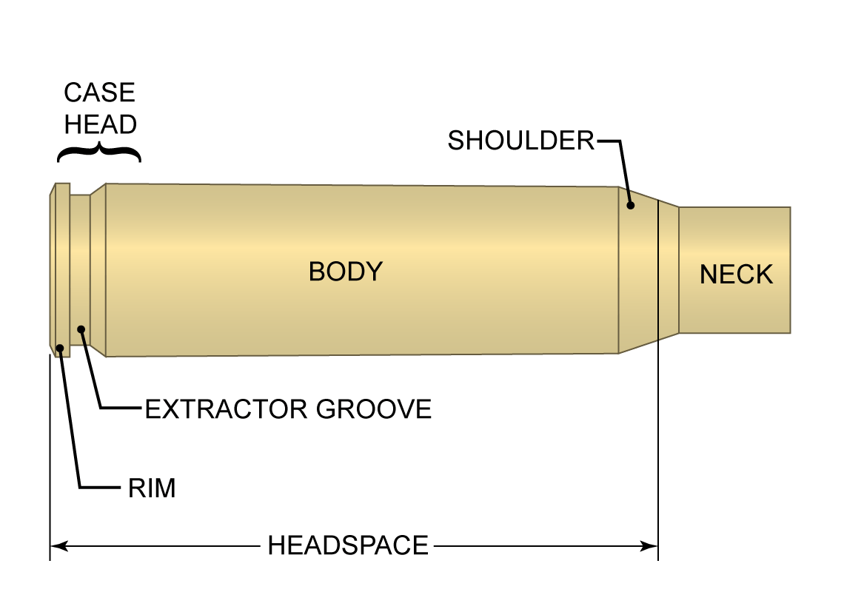
Figure 1 - Cartridge Case Anatomy [5]

Basic Information
The cartridge case in a small arm is responsible for much more than may initially meet the eye. Not only must it hold the primer, propellant, and bullet; it must also contain the pressures of firing, expand to form a gas-tight seal around its axis, and following this, contract enough to allow reliable extraction. The neck of the case must be thinner and more ductile, though the case head – only centimetres away, and formed from the same brass cup, must be thicker, harder, and tougher - to withstand being violently pulled from the chamber by an aggressive extractor claw. As such, careful attention must be paid to the manufacturing process, and tolerances must be tightly controlled. On top of this, cartridge cases must be made in enormous quantity, and doing so must remain cost-effective. In the Afghanistan conflict, some sources state that American forces fired over 250,000 rounds for every insurgent killed [6] – thus, driving home the bottom line with respect to cost.

Customer Requirements - Ammunition
The customer requirements for ammunition would generally consist of some operational requirements, non-functional performance, and non-functional implementation requirements. These would pertain to the all-up round (or a part thereof) and not focus on the case specifically (specific requirements for hybrid or polymer cases, etc notwithstanding). Generally, the requirements would focus on ammunition conformity to CIP or NATO standards – these dictate dimensions, pressures, tolerances, headspace, etc etc. While the case has a large part to play in fulfilling many of these requirements, aside from dimensional limits, it is responsible for tying the other components together in such a way that the all-up round will meet its requirements.

Functions
The basic functions of a cartridge case are as follows:
- Houses projectile, propellant, and primer
  - Protects propellant charge and primer from environmental factors
- Obturates to seal the chamber when firing
- Aligns the bullet in the chamber
- Acts as a heat sink (removing combustion heat from the chamber)
- Feed and extract smoothly

11. Manufacturing
The manufacturing of a cartridge case, from a pure metalworking standpoint, is relatively straightforward. Raw brass sheet must be turned into a tubular brass case with a hole at either end, and the stress relief processes along the way must be adequate to ensure the integrity of the brass throughout the process and ensure it is suitable as a finished product. It is the tolerances involved and the volume at which cases must be manufactured that poses the largest issues in manufacture.
The first step is to decide how the case shall be made from a basic function standpoint. This is done in a process flow.

12. Process Flow

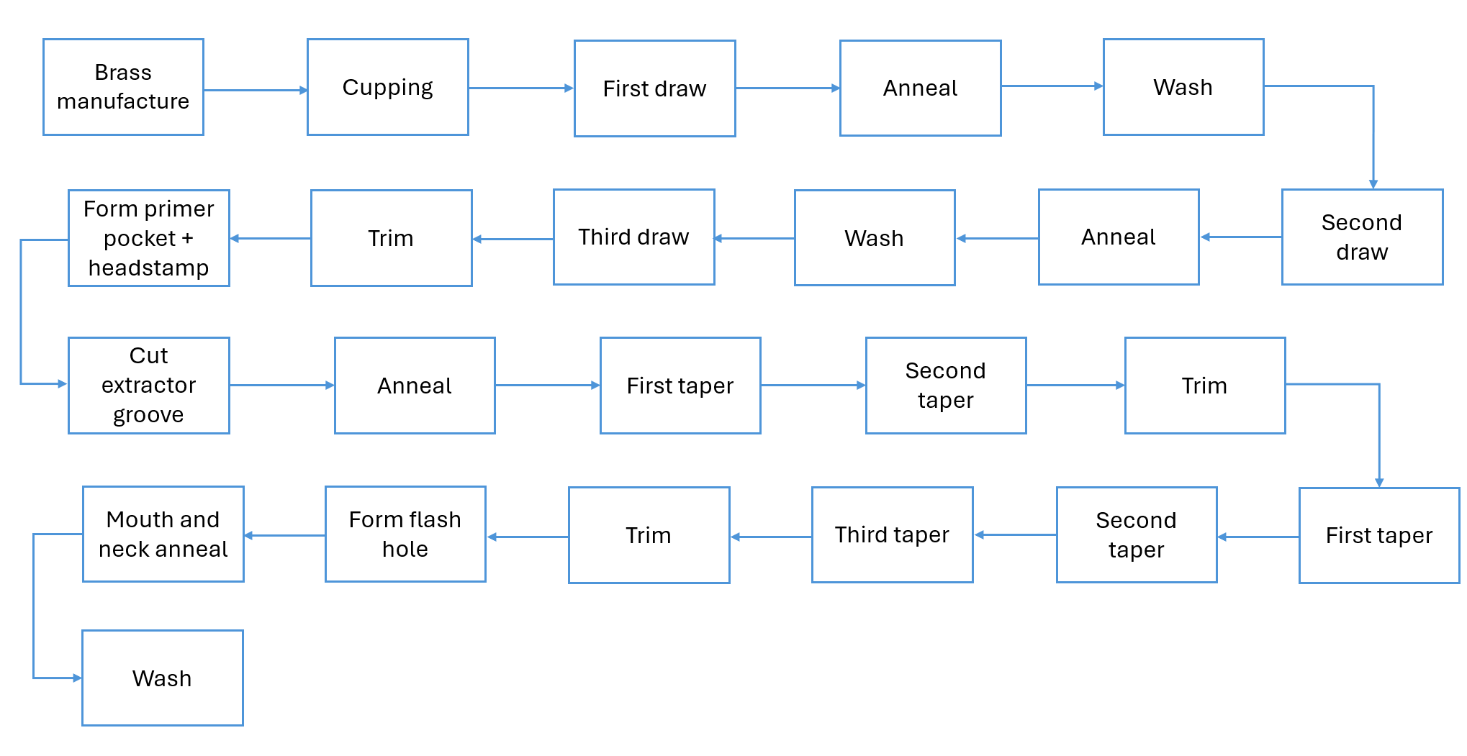
Figure 2 - Process Flow for Cartridge Case Production

The Process Flow defines the process functionality – in other words, what each step of the process must do. At this stage, avoid going into specific manufacturing methods, unless there is absolutely no other feasible way. Terms like “create”, “fill”, “form”, “join”, “attach”, etc. should be used.
In the FIGURE 2 example, the author has extended the process by featuring the various different draw stages (as the material must be annealed and washed after each stage). As there are no even remotely reasonable alternative manufacturing methods applicable to small arms cases, the drawing process has been listed at this stage. Drawing results in a part with no seams, high levels of uniformity, which are able to be produced rapidly, with relatively little technical labour [7]. There is no process that is better suited – traditional alternatives to deep drawing are hydroforming, spinning, or fabrication, none of which are suitable alternatives.
Following the process flow, manufacturing requirements must be gathered – however, an intermediate step is to investigate potential failure modes.

13. Failure Modes
Possible failure modes for each block of the process flow are examined and tabulated. These are examined against the effect on the system, the effect seen by the user (and associated severities), along with the mechanism, probability of occurrence, ease of detection, and a proposed detection and/or prevention method. Each is ranked on a scale from 1 to 10.
The severity, multiplied by the chances of occurrence, multiplied by the ease of detection, result in a Risk Priority Number (RPN). This aids in deciding which failure modes must be addressed first, and also tells the user which manufacturing step will have the biggest impact on the design should it fail.
This should first be performed in the design stage – known as a Design Failure Mode and Effects Analysis (DFMEA) Enormous cost savings can be made by addressing potential failure modes I the design stage rather than later on in the product lifecycle [8]. Other forms of FMEA exist (for example, Functional), but this paper focuses on design and manufacture early on in the lifecycle. Furthermore, the RPN figure feeds into QFD 4. This will be discussed later on in the document.
In the example of cartridge case manufacturing, the DFMEA with respect to the processes used is fairly straightforward. Detection is generally reasonably simple thanks to most potential failure modes being dimensional. Occurrence is wholly dependent on the quality of the manufacturing process, manning, and tooling. The severity descriptors are up for debate in this instance – does it apply solely to the process or to the finished product on the battlefield?
An initial assessment of RPNs dictated that the formation of the primer pocket and headstamp (encompassing the case head and formation of case web) was the most important to control, as the user may experience a complete case head separation, leaving the forward portion of the case stuck in the chamber, potentially mid-firefight. This would render their weapon completely inoperable without partial disassembly and special tools.

14. Manufacturing Requirements
Manufacturing requirements are the requirements of the manufacturing process itself. These may pertain to costs, capacity, reliability, quality, and safety. For the purposes of this paper, a generic set of manufacturing requirements will be used [9], which adequately covers the process. Note that no specifics regarding cost are within the scope of this paper.
Once both manufacturing functionality (from the process flow) and manufacturing requirements have been identified, the Manufacturing QFD 1 can be completed.
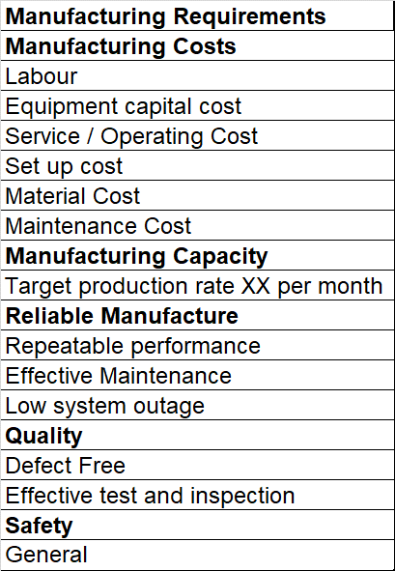
Figure 3 - Manufacturing Requirements

15.Manufacturing QFD 1
The Manufacturing QFD 1 places the manufacturing requirements against the manufacturing functionality – thus, assigning an importance to each process.
Figure 4 - Manufacturing QFD 1
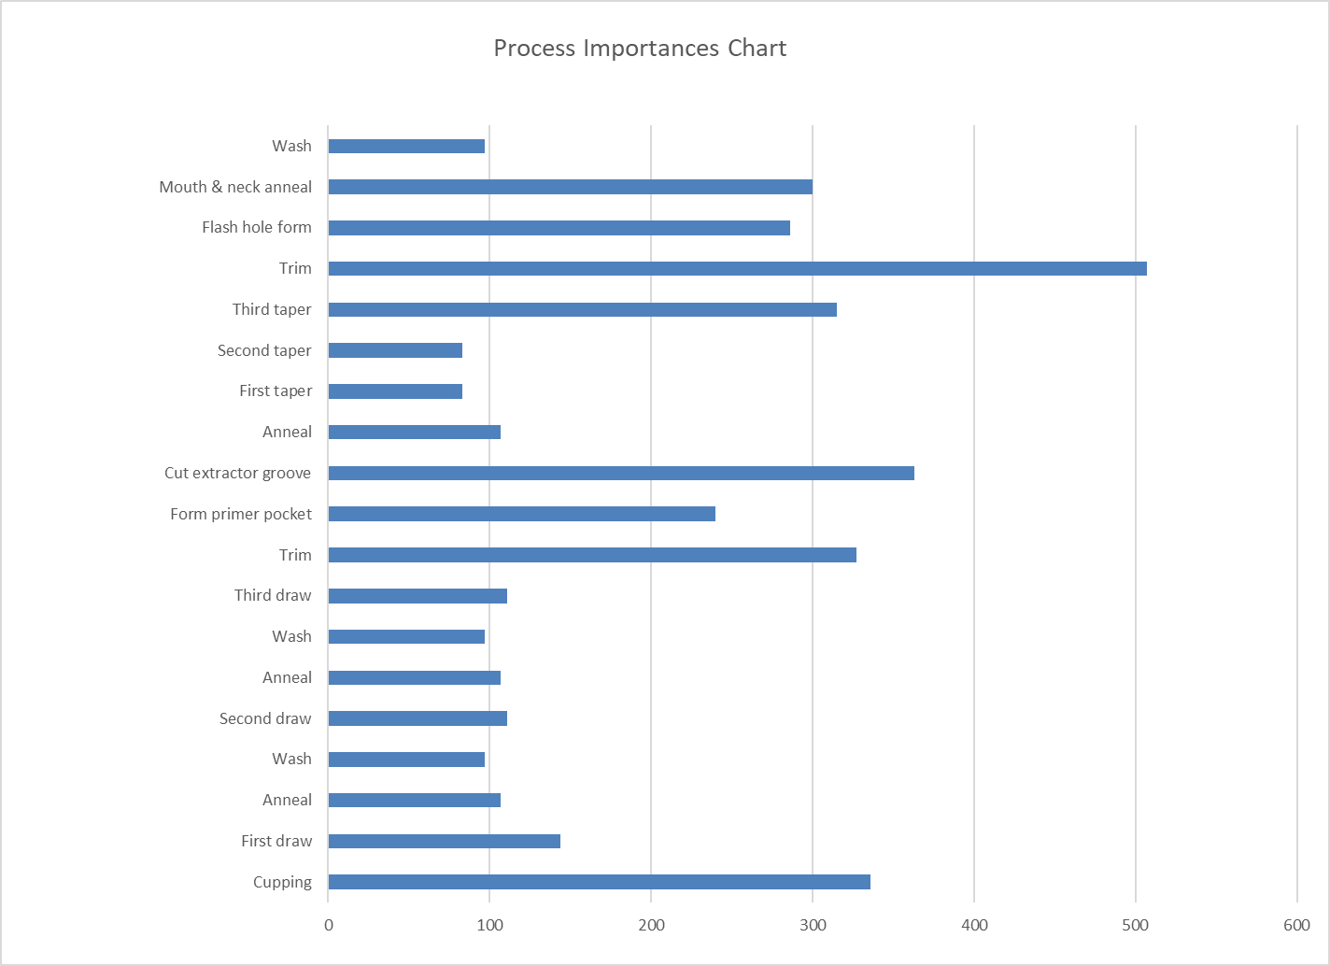
Figure 5 - Process Importances Chart

16. Process Function Means Analysis
In this step, the various processes are listed, along with a variety of possible means of accomplishing those processes.
Figure 6 - Process Function Means Analysis
Manufacturing SME advice should be sought when listing and deciding on process means, but advice from any one person should not be overly-relied on, lest a potentially good process be ruled out due to the misgivings of one individual. If no risks are taken, and no effort is made to at least investigate or research avant-garde means, no advancement will ever be made. As such, the unusual should not be ruled out for simply being different to the industry standard.
The winning means are then selected via a Pugh (or other multi-criteria) analysis. This often requires deeply specialist knowledge of a variety of processes and the local manufacturing environment – and as such, will not be covered in the report. The rationale for choosing each process will be detailed below:
Mechanical (electrically-driven) press/punch for all punching, cupping, and drawing operations. This is because they require much less permanently installed infrastructure compared to pneumatic or hydraulic tooling. They are also safer to work with and easier to maintain.
Ovens will be used to anneal the entire body of the drawn case. Flame annealing is inconsistent and induction annealing is localised within the area of a coil – and anything in the “work holding device” would not be annealed.
Chemical ultrasonic baths will be used to clean the cases between steps where relevant. Mechanical agitation is too quantity-limited, and large rotating parts also pose an unnecessary risk to personnel.
Trimming will be done by the “parting off” of a rotating case in a micro-lathe. This is easier than a mill, allows the cooling condition to be monitored visually, and minimises burrs as the entire workpiece Is rotated.
The primer pocket (and headstamp) will be formed at the same time by swaging, as this creates the web of the case at the same time, giving it strength, and doing away with an additional step in the process - as the headstamp can be formed at the same time.
The extractor groove will be cut by micro-lathe for the same reasons as the trim step.
The flash hole will be punched; drilling is unnecessary, and the bit would likely require more frequent replacement than a punch.
The mouth and neck will be annealed by an induction coil, as this allows precise control over the location and intensity of the annealing process – if the entire case is annealed at this point, case head separation may become an issue due to the brass getting too soft further towards the portion of the case unsupported by the chamber.

17. QFD 3
This step of the QFD process takes the specific manufacturing functionality and places it against the means – resulting in a means importance chart.

Figure 7 - Manufacturing QFD 2
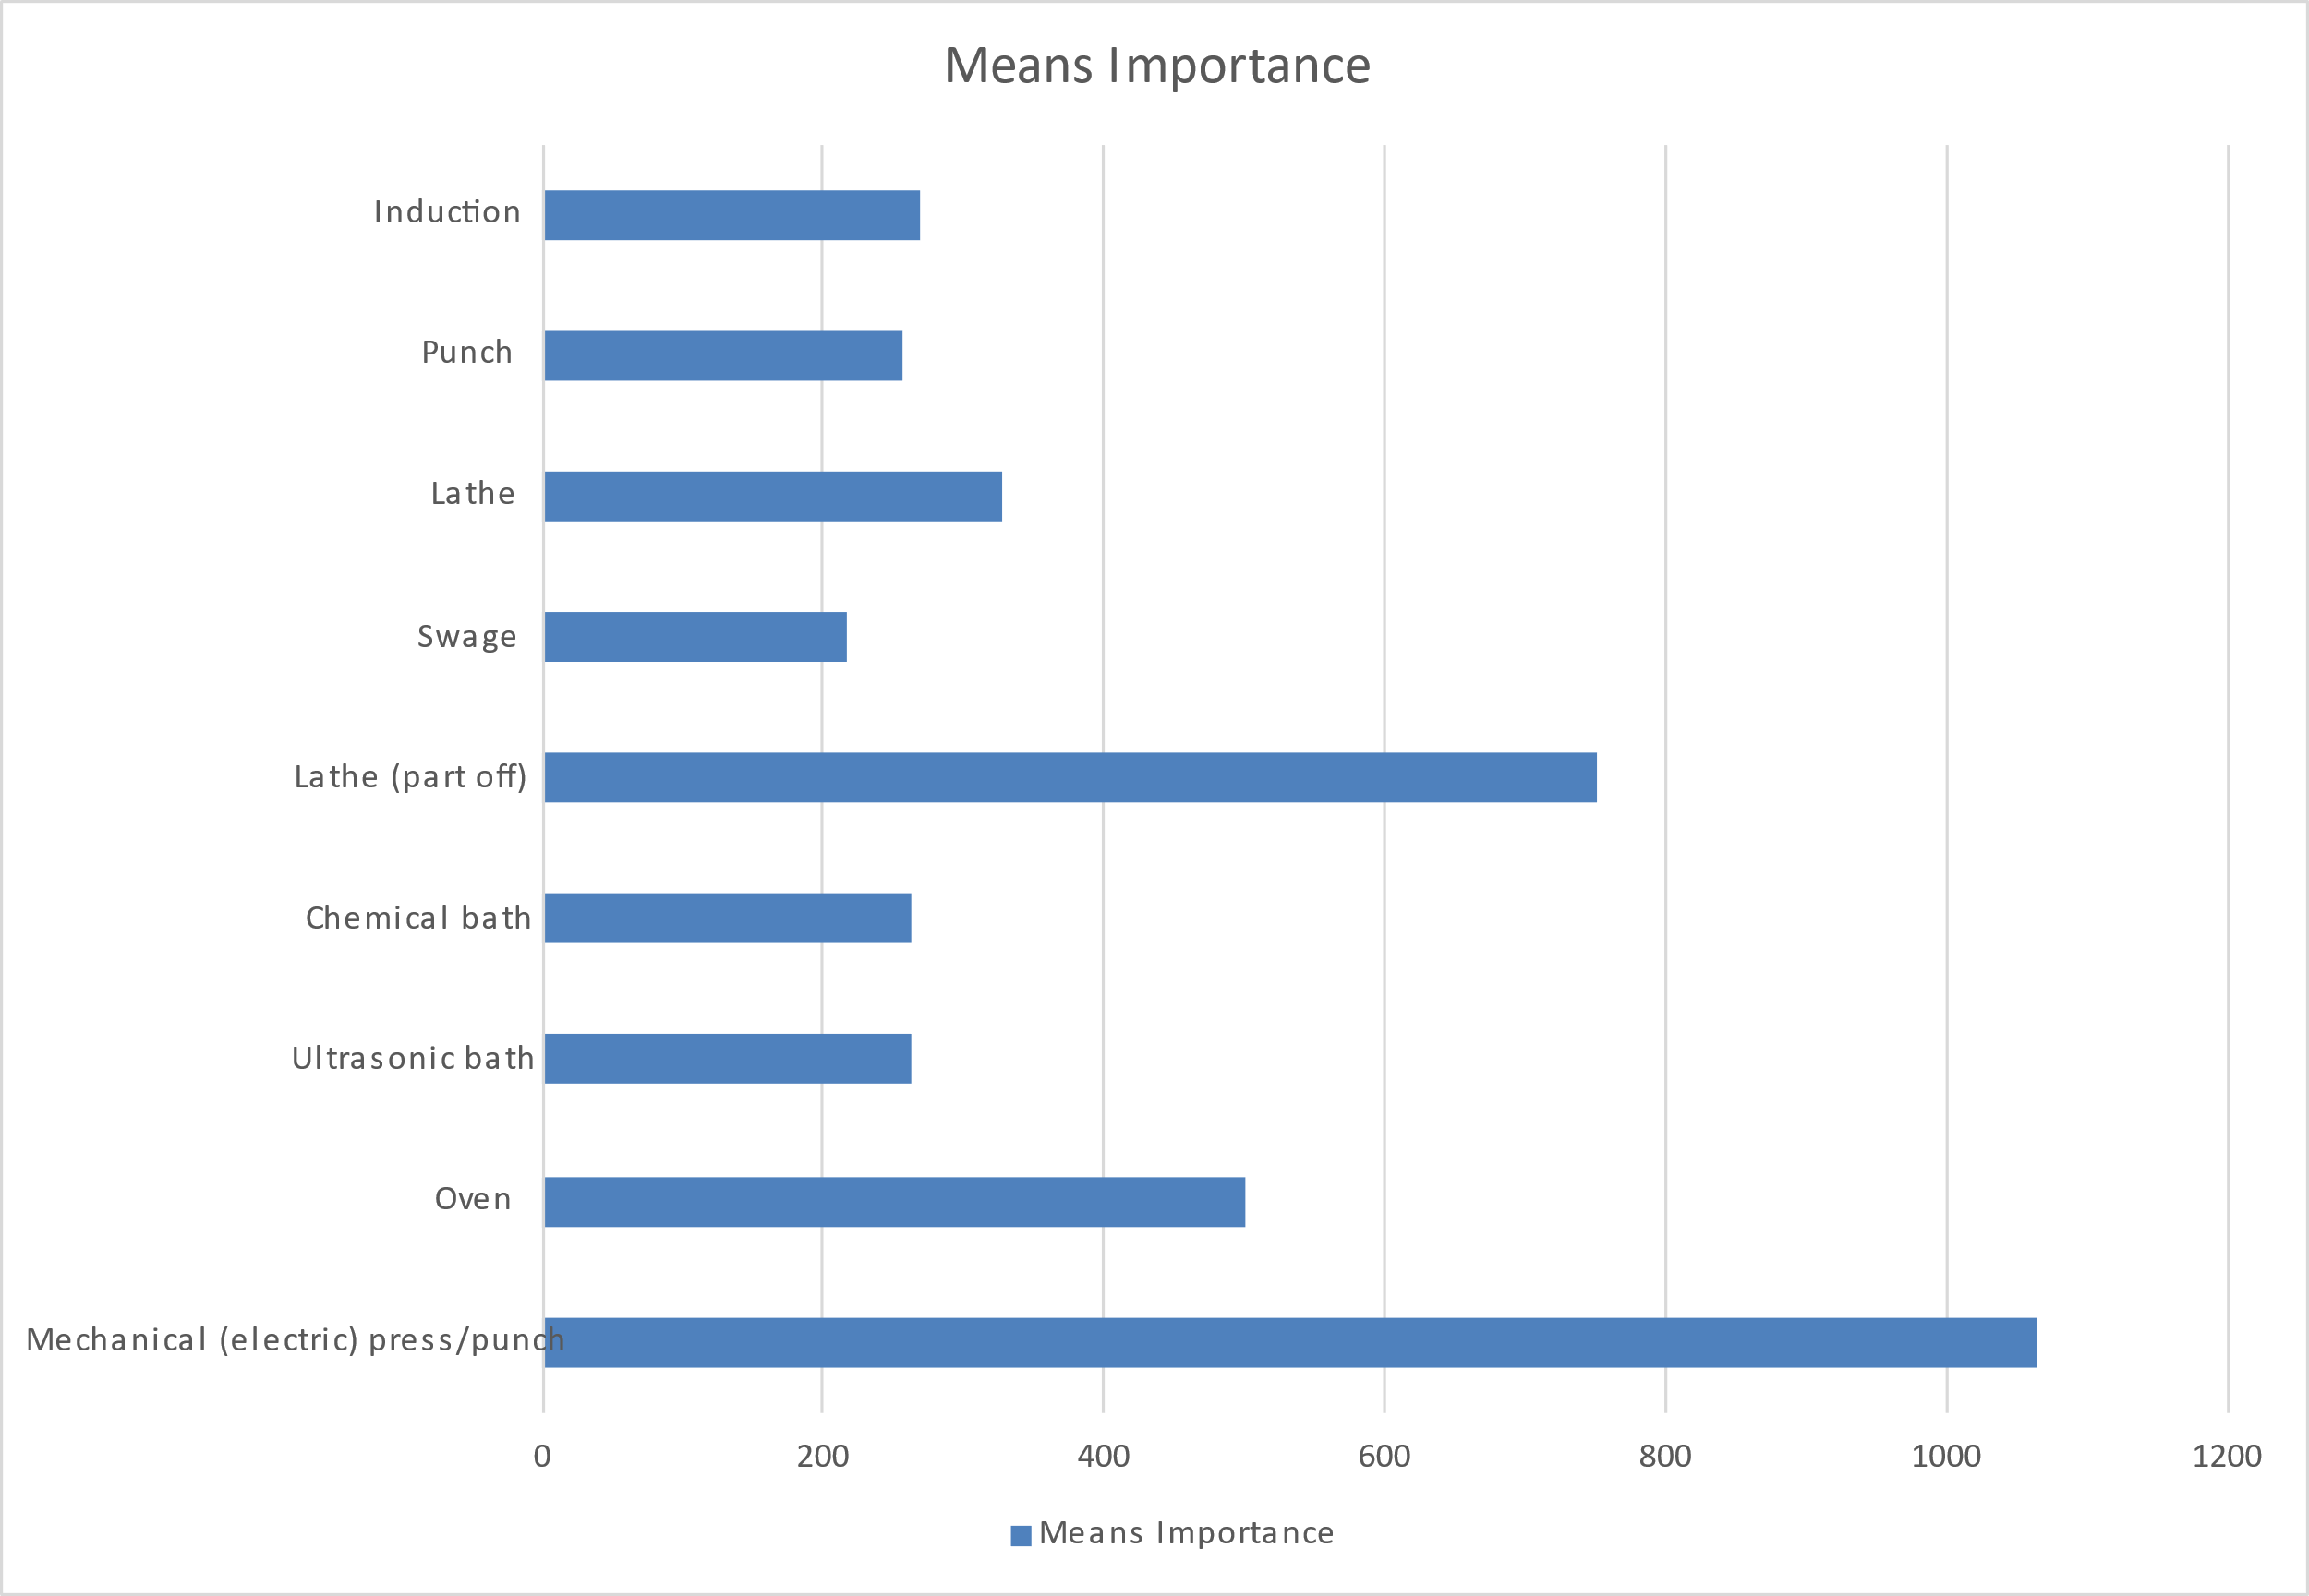
Figure 8 - Manufacturing QFD 2 Means Importance

The Manufacturing QFD 2 – often known as QFD 3 - ranks the means importance. As can be seen from Figure 8, the most important means are the electrically driven mechanical pressing, punching, and drawing aspects of the process, followed by the micro-lathe trimming.
As it was deemed to be the most important following manufacturing QFD 2, the subsequent steps in this report will pertain to the drawing process of the cartridge case, from a brass blank.

18. Cartridge Case Drawing
Cartridge cases are produced by deep drawing of a blank brass disc or cup. This process is identical to drawing, the “deep drawing” term is used to refer to the process when the depth of the finished product exceeds its diameter [7]. For the purposes of this report and for simplicity, all drawing operations will be referred to collectively.
Figures 9, 10, and 11 [10] show the drawing process in various stages. Figure 11 shows a “two-stage” die, employed so as work the blank gradually and avoid and wrinkling, thinning, or tearing – this is more critical as the blank gets thinner.
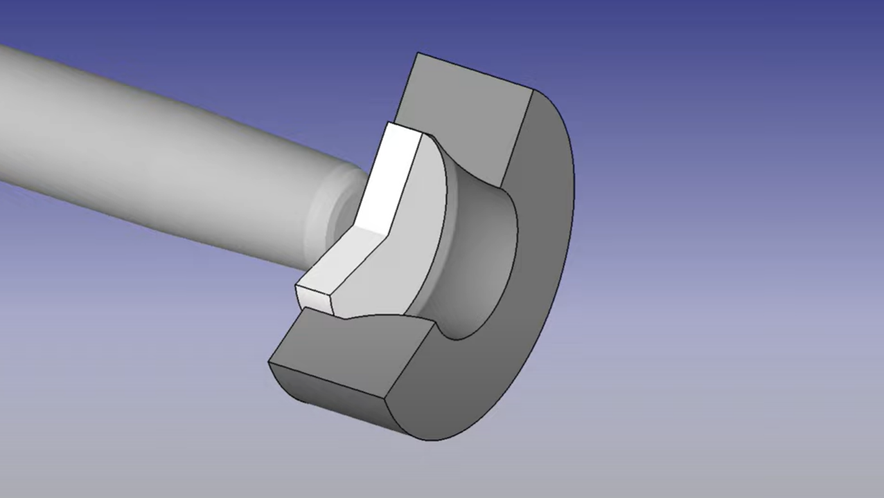
Figure 9 -Drawing - Initial
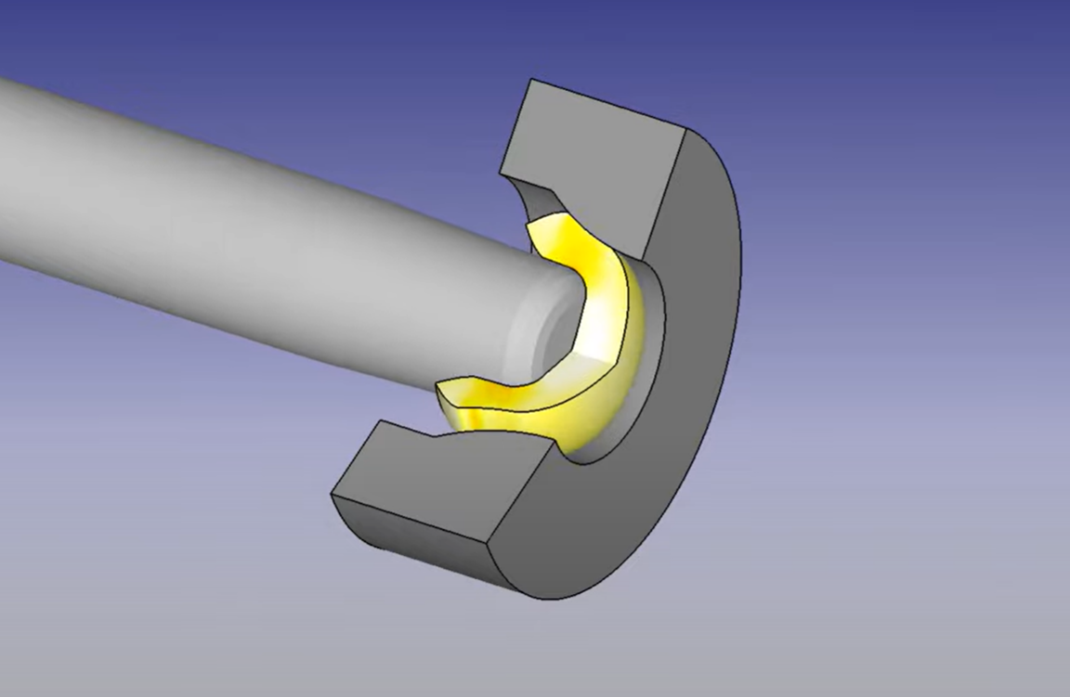
Figure 10 - Drawing, Mid Process
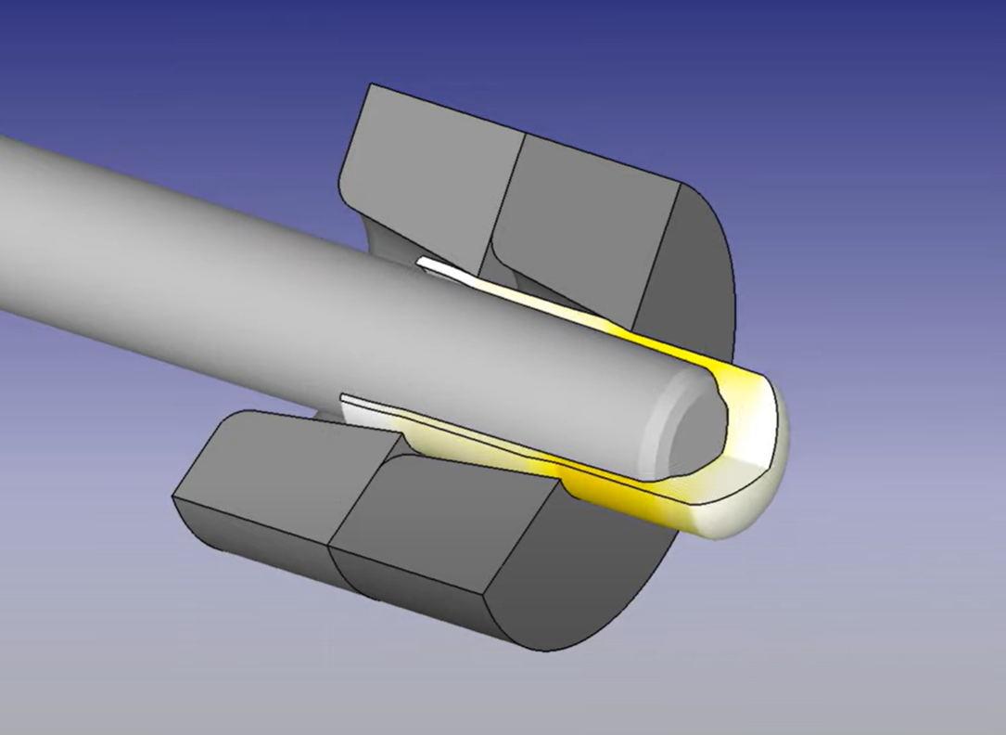
Figure 11 - Drawing - Mid Process

19. Parameter Diagram
The Parameter Diagram (P-diagram) is used to identify the inputs to a system while relating those inputs to the desired output, while considering noise and control factors. Noise factors are considered to be anything that affects the output of the system – these can be unit-to-unit variation, deterioration, or environmental factors. Control factors are what we can control – materials, tolerances, building environments, etc.
Figure 12 - Parameter Diagram for Drawing Process
Once the P-diagram has been completed, a “what-why” table can be begun, using the noise factors and control factors identified.

20. What-Why Table
The what-why table allows a controls chart and a noise chart to be generated. These show, respectively, which controls require the most care, and which noises require reducing.
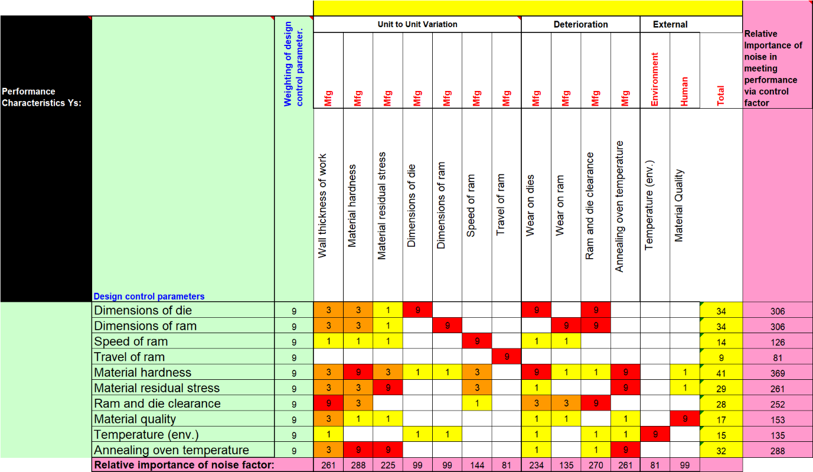
Figure 13 - What-Why Table for Drawing Process
On the left-hand side of the table, the control parameters are listed. At the top, the noises are shown. A high, medium, or low value (or, no value at all) is assigned to each noise depending on how much it affects each respective control.

Figure 14 - Key Controls Chart
As can be seen from Figure 14, the key control in the drawing process is the material hardness (and consequently the annealing oven temperature – so it is unsurprising this is the second most important control). Joint third are the dimensions of the ram and die, combined these form the ram and die clearance – consequently, it is interesting to see the specific ram and die clearance control further down the list.
It is unsurprising to the author that material hardness and annealing oven temperature come out on top. If the material hardness is not carefully controlled through consistent anneal, the material will not behave consistently (or even properly) when being passed through the various dies – wrinkling, thinning, and tearing may occur. If these defects are on the inside of the case, they nay not be easily noticed. Defects on the inside of the case will change the volume of the case (and consequently the burn characteristics of the propellant) and may introduce possible failure points into the case.

Figure 15 - Key Noise Factors Chart
The key noise chart for the drawing process shows that the main noise that needs controlling is the material hardness, followed second by (jointly) wall thickness and annealing oven temperature. Ram and die clearance comes third. Interestingly, ram and die dimensions come very low down the list here, but overall clearance is higher – this is the opposite to what is shown in the control importances chart.

21. Recommended Measures
Measures that can be taken to monitor and control the top three control factors and noises respectively are proposed below:

Control Factors
- Material hardness
  - Material acceptance testing (physical testing, chemical testing)
  - Material QC checks between annealing stages
- Annealing oven temperature
  - Properly tuned oven PID controller
  - Stationing of oven in climate-controlled building
  - Scheduled cleaning and maintenance
  - Regular calibration of controllers/sensors
- Ram and die dimensions
  - Appropriate material selection
  - Checking of ram & die dimensions against calibrated go/no-go gauge set (more consistent than manual measurement
  - Routine replacement of dies
  - Monitoring of ram & die dimensions and case quality to determine a “service life” for the ram & die
    - Accurate system to count output quantity and timely replacement when life limit approached

Noise Factors
- Material hardness
  - Material acceptance testing (physical testing, chemical testing)
  - Material QC checks between annealing stages
- Annealing oven temperature
  - Properly tuned oven PID controller
  - Stationing of oven in climate-controlled building
  - Scheduled cleaning and maintenance
  - Regular calibration of controllers/sensors
- Ram and die clearance
  - Routine inspection and checking of press system – worn guides or bushings will affect clearance
  - Routine maintenance and lubrication of press

22. QFD 4
Following this step, QFD 4 can be performed. While doing so in this example is outside the scope of this paper, a description will be given nonetheless. On the left-hand side of the QFD matrix, the critical process characteristics are listed, along with a weighting – this is based off the RPN figure gained from the DFMEA. The control measures are listed across the top. Rankings are assigned, and as a result, a determination is made as to which controls are the most useful, and consequently the development of quality targets for each control. This information is potentially useful in the development of inspection/quality documents, or work instructions [11].

23. Limitations of the Systems Toolset
Like many advanced engineering tools, the main limitation of the systems engineering toolset is the ability and understanding of the user - to understand not only the toolset at their disposal, but also the item (or process) it is being applied to. The systems toolset – at its heart – is numerical, and focuses on the relationship between parts, processes, requirements, customer needs, etc. Without a deep understanding of the process, dependencies cannot be assigned realistic values. Without realistic values, the output of each step will be incorrect. Errors can easily be carried forwards. The systems toolset itself is also complex and requires deep understanding to use effectively. As such, standard practice would be for the process to be carried out iteratively by a “panel”, consulting with various SMEs as frequently as is necessary to ensure that the process moves in the right direction from both a pure systems and a technical standpoint.

24. Conclusion
This report has given a basic overview of how the systems toolset can be applied to the manufacturing of a cartridge case, in particular, the drawing of a case from a blank. Key controls and noises have been identified, and measures to monitor the controls and control the noises have been formally identified and proposed in section 21.

25. Future Work
Future work should include the continuation of the QFD process for the drawing of the case up to the conclusion of QFD 4. Pugh analysis should ideally also be completed in the various stages to fully understand the cost and benefit associated with both different process functions and their associated control importances and noise controls. Ultimately, were this to be performed as part of a real factory line setup rather than a purely academic exercise, a key main driving factor would be cost, and as such, the associated (often severe) compromise – the impact of which has been wholly excluded from this report, and as such, this work must be taken in isolation and cost should be fully considered in any future works.

Bibliography

[1] | National Aeronautics and Space Administration, “SEH 2.0 Fundamentals of Systems Engineering,” [Online]. Available: https://www.nasa.gov/reference/2-0-fundamentals-of-systems-engineering/. [Accessed 05 2024].
[2] | Wiley, “The Importance Of Systems Engineering: Enhancing Success And Efficiency,” 2023. [Online]. Available: https://www.wiley.com/en-us/network/professional-development/careers/engineering/the-importance-of-systems-engineering-enhancing-success-and-efficiency.
[3] | D. Holley, Performing Functional/Behavioural Analysis, 2024.
[4] | S. Burge, “The Systems Engineering Tool Box,” 2011.
[5] | D. Cali, “An Introduction to Rifle Cases,” [Online]. Available: https://bisonballistics.com/articles/an-introduction-to-rifle-cases.
[6] | NZ Herald, “American troops fire 250,000 bullets for every local they kill,” 25 September 2005. [Online]. Available: https://www.nzherald.co.nz/world/american-troops-fire-250000-bullets-for-every-local-they-kill/FJ3MGCMA7QDIIKS2STPNP6D4KI/#:~:text=WASHINGTON%20-%20United%20States%20forces%20have%20fired%20so,that%20American%20ammunition-makers%20cannot%20keep%20up%20wit.
[7] | Macrodyne, “Deep Drawing 101”.
[8] | D. S. Burge, “A Systems Approach to Failure Modes, Mechanisms, Effects and Causes,” 2014.
[9] | D. Holley, Design Book Shell BLANK.
[10] | SFTC Deform, Drawn Shell Casing Simulation, 2020.
[11] | Quality-One International, “Quality Function Deployment,” [Online]. Available: https://quality-one.com/qfd.

