
Digital Innovation and Professional Practice
[Document subtitle]

06 December 2024
Emma – Jane
ECPT6006
WORD COUNT: 5372

Introduction
In this essay I will explore the roll of creativity and digital innovation, how it can expand both teachers and students learning experience preparing us as educators and learners to meet future stainability of not only education but society of our rapidly evolving digital landscape. I will explore Welsh governments digital innovation plan, media talks, academic articles and blogs including creativity and digital innovation. Welsh teaching standards will be acknowledged throughout this essay. I will be focusing on the platform Quizizz discussing the reasons behind my choice. I have included and demonstrated my knowledge through the TPACK model with annotated screen shots and lesson plan. This is a reflective critical analysis of my experience of the digital innovation project.
Literature review
The Welsh government talks about not introducing technology but cultural change to move with our evolving landscape not just in education but society by 2030. One of the ways they intend to do this with their digital competence frame work is to see digital literacy on par with literacy and numeracy skills in our curriculum. The 2030 frame work intends the infrastructure to be in place by 2030 to accommodate this digital transition in post 16 teaching (Welsh Government, 2019). Inclusivity expands beyond education in to society to support our evolution and resilience to thrive in Wales. This idea compares with Scott Widman ideas about technical innovation moving at an exponential rate. We as a society that are faced with the growing demand of adapting to this monumental change. Regardless of the paradoxical argument of technology being good and bad the relevance is most children today in education are digital natives and own a smart phone. Teachers in education have a responsibility to teach students to use this technology in a safer more productive digitally literate way to prepare them for or our rapidly growing multi verse (Widman, 2019). Technological advances are moving faster than us, Alexandra Janssen talks about how much power a smart phone holds and how fast the smart phone is evolving relating to our ability to keep up and adapt along with the implications this has on society. He expresses if we want to stay
relevant in the future we must innovate. He believes innovation is about passionate people that can drive these ideas forward the technology alone is useless (Janssen, 2015).
Janssens idea explains and combines the same idea as the Welsh government that is believing in passionate people can drive the digital incentives for 2030 forward. They realise that’s its not about the ideas or just money its what is done with their investment innovation doing something new that’s never been done before. They need new infrastructure for the long term and passionate teachers play a major part in successful innovation with technology in education. According to the International Society for Technology in Education (ISTE) Moving forward in technology drives globalisation and digital transformation and teachers help students develop the skills needed for success in their careers in the future (ISTE Standards, 2024). They talk about what we learned from the pandemic after using it as a crisis tool, it demonstrated the importance of the power it harnesses as an education tool used properly it can better engage students in lessons while also innovate teachers classroom plans more efficiently naturally building students future essential skills . They also talk about how hybrid learning is not to replace teachers (ISTE Standards, 2024).
All teachers in Wales will be encouraged to become members of a relevant national body that specialise in technology for learning and teaching. The association for learning and teaching says “It is essential we lead by example as trainee teachers buy implementing strategies for innovation of interactive learning in post 16 teaching that offers a safer smarter more dynamic and effective learning experience for the students and evolving teachers”. Interactive technology is only as good as the teacher utilising the tool. Good pedagogy maximises a learning strategy for effective delivery of adapting and transforming teaching in a digital demanding age (Gareth Evans, 2021)

Justification of chosen tool
There are many quiz platforms that use QR codes in educational settings as its quick and easy for students to join as QR codes are already integrated withing our society many students can grasp their use for example competitions to buying tickets, to ordering food. My place of work has just introduced them for incident reports My research online from Statistica.com shows that 98 percent of 16-17 year olds own a smart phone and 90 percent of children overall had access to lap tops and pcs with internet connection in the UK (Laricchia, 2024). Second question posed by me when choosing a quiz platform was, what purpose is the quiz serving? Why do I want to use it? I decided it needed to be useful and fun for measuring the students learning, and to scaffold it in some way. I decided it would be a tool for an assessment strategy. According to Aslam & Ahmed using digital platforms for assessment enhances creativity in students and it develops the more they use it and is proven to be an easy, time affective tool to collect date for assessing students’ progress and support the students with some kind of feedback to enhance their learning experience (Aslam & Khan, 2020). As research shows the value students place on feed back to scaffold learning. This helped me narrow down my choice of interactive quiz platforms more than I realised. During our time on this module we all chose and tested out various interactive platforms to experience. This is the most challenging module for me personally, coming from an era of typewriters not pcs. It posed more questions than answers . However it was a good way of eliminating platforms that did not match my intended use for assessments and feedback. Kahoot was used a few times within our testing of platforms in the digital innovation modal .while it was fun for many of my peers, it was not for me. Regarding the pace of Kahoot Chris Mcnutt the co-founder and executive director of human Restoration project, a nonprofit organisation focused on student engagement, well-being, and motivation, work centres on realising system based change. Mcnutt stresses Kahoot is not is not equitable practise, based on the importance of quick recall there may be time extensions but you can add more points by being correct faster ,it is a race to the finish line and questions are shallow .He believes the questions posed are rarely worth the effort to memorise .Competitive environments are stressful for some students like myself and can leave some students feeling left behind demotivated with no feedback and support (McNutt, 2019).
Mentimeter was another one my group experimented with and popular amongst peers . This platform contrasts with Kahoot and Quizlet, as it is less about quizzes gamification and more about interactive presentation participation in forms of polls, word cloud, Q&A which are all good collaborative strategies that can also be talked around to balance AI with teacher interaction. Assessments could be done by how the students engage with the material presented. But was not sure about how easy individual feedback could be achieved but liked the idea of mentimeter . I discovered after further research that in order to use a variation of video clips photos with text I would need to pay a subscription I settled on Quizizz founded in 2015 by Ankit Gupta and Deepak Joy Cheenath and based in California America (Quizizz, 2024).

Quizizz offers a learning platform to help people from many domains of professionals learn or teach . It has a user friendly interface, offers a 14 day free trial multiple users, using video clips, photographs presentations etc. It is not fast paced or competitive, unless it is designed by the teacher to do so. It is great for formative assessments and deeper questioning. Teachers can choose to use interactive presentations or allow for the students to learn for themselves. There is instant feedback as well as an option for teachers to add interesting information with every answered question. There is further opportunities to learn the platform if signing up with training badges on the Qui zizz platform (Quizizz, 2024).

TPACK Model
Technological pedological and knowledge model.
The use of this model is an effective way of structuring and examining the effectiveness in a teaching environment utilising the Quizizz platform, as an interactive digital tool in the classroom to enhance learning.
- Content knowledge (CK)

I identified specific subject matter according to the course criteria of the first year fine art BA. The knowledge was acquired on placement of working with teachers staff and students. The content would be an assessments quiz on specific artists in academic research that work with materiality in different ways within their work, including questions on formal elements and formal analysis. The questions are relevant to the students learning experience this term ,allowing 20 mins for students to scan bar code and answer 9 questions and re take questions with support (Welsh Government, 2019).

CK Quizizz Questions

- Match the following image of art work with artist name choice of 4 artist.
Answer El Anatsui
Interesting information added to reinforce learning after question is answered with another image.
Thousands of metal bottle caps. The journey of movement, migration of goods during the slave trade from Nigeria. El anatsui is a black artist from Africa that believes in non-fixed forming sculpture and uses materials found in his environment. Introducing artists such as Anatsui value and promote diversity and demonstrate a commitment to sustainability offering them this artist research to reflect upon (Welsh Government, 2019).

- Select 4 of the formal elements in art ? by ticking boxes
Line, colour, value, texture, are correct I added perspective as students can sometimes mistaken this for a formal element.
The interesting fact formal elements are used to create the illusion of three dimensionality. Perspective in art usually refers to the representation of three-dimensional objects or space in two-dimensional artworks.

- what is formal analysis? Multiple choice 2of 4 are correct. A an argument based on your own visual evidence that takes a stance and creates an interesting discussion. B a critical analysis of the formal elements of the work only C is descriptive only . D it’s about the narrative content and expressive nature. Answer A&B.

- open ended question share or add an image of anything you feel relevant to the art Provera movement.

- ( With image )Cornelia Parker create the installation cold dark matter 1991 by exploding a shed true? or false? True with a lovely image and information that it was exploded by the army and how she hung all the fragments from the ceiling in the gallery using darkness and lights to create the experience.

The remaining questions are in the annotated screen shots.

2 ) Pedological knowledge (PK)

I reflected how the first yr fine art BA learn , it is, a very dialogical constructivist approach to teaching. The students are active experiential learners, maybe they will adapt to this kind of platform. That said they are used to a continuous flow of response between peers and teachers in collaboration with constructivist pedagogy. There is minimal collaboration in my quiz. I am using it as an informal assessment strategy, in this instance decided not to use this particular platform for a collaborative quiz. Also did not want them to compete with each other and work at their own pace for a more accurate fare assessment of each individual. Some students working in groups may not participate equally or gain any valuable learning as a result becoming more passive or distracted, which could be rectified by observation of groups, but make the use of the digital tool not time affective. I decided to use this tool as a strategy to assess students learning of prior knowledge for the first term at the end of term. This quiz is also a good strategy to engage students learning the start of next term bring them back to the moment by drawing on their memory recall which also may be fun. Students can work together with peers or google any answers they get wrong to answer correctly. I can see on my end only, so the results are only shared with each individual student. Where feedback is concerned its instant. Quizizz shows how each individual has done on each question including re takes. This strategy helps me to see where there may be gaps in their learning. This teaching tool may deepen students ability to remember things they did not know by finding the answers for them self, scaffolding their learning not just memory recall.

This quiz platform offers many styles of questions Open ended questions are beneficial for fine art students developing their soft skills of higher order thinking Students are familiar with developing their ability to reflect, critically analyse and explore different perspectives within their developing practice. Promoting students to expressively share thought ideas and feelings. And images with open ended questions. I also choose drag and drop options as they may enjoy moving things around on the screen to participate it’s an active screen task that help them identify the correct answer offering easy user experience. Quizizz offers less emotional ups and downs with happy and sad experiences of a traditional quiz as they can get all questions right which may be a greater motivator for learning. The great feature on Quizziz is after each question is answered correctly I can write an interesting fact or more info with an image to build on their knowledge that may enhance their interest for further investigation integrating with images or video. The Swiss psychologist who studied child development in his work Jean Piaget 1896- 1890) talks about how it up to the teachers to facilitate their learning by creating engaging innovative ways. Quizizz considers the importance of integration of tools that considers pedological strategies to enhance teaching in the classroom that supporting students to learn more affectively (quizizz.com)

Cognitive psychologist lev Vygotsky believed in teacher modelling and instruction in different ways. Quizizz makes going back over some artist research more active less passive, where students must invest more attention to search for answers for them self. Teaching standards Demonstrate commitment to learners the learning safety and well-being inspiring and stretching learners taking into account their starting point and progression this idea demonstrates that there is a real possibility of enhancing the learning experience and student engagement of remembering artist research and course criteria in a new more interactive fun way, that no student can fail as there is no exclusion if the question is answered wrong first time they can take responsibility to get the answer right with support of peers and or google search. I feel this Qui zizz demonstrates good pedagogy as it a way to observe remotely the academic progress of students, for assessments. It may appeal to a range of learning styles and ALN students, with the simplicity and variety of styles of questions and mixed media and content relevant to the course content. They can work at their own pace go slow or boost the speed themselves, turn on audio mode to read the questions to help them . As it is their first experience of this kind of quiz I will allow students to retake the question as many times as they wish to find the correct answer for themselves. Making it an equitable learning platform if utilised correctly. Promotes higher order thinking like reflecting, analysing and problem solving. Good for memory recall, building on knowledge and scaffolding learning. It may also be a engaging motivator to learn with the simplicity and variety of styles of questions and mixed media and topic content..

3 ) Technological knowledge (TK) . I have tested out many tools to integrate photographs ,video, audio, and a mixture a question and answer multiple choice and interaction of moving questions into boxes and fill in the blanks, multiple choice. This will hopefully allow more engagement of individual learners students learning styles and additional learning needs. Welsh Teaching standards Value and promote diversity equal opportunity and inclusion before starting I remembered to click top right hand corner to make it full screen so the could scan the barcode easier or told them to zoom in their camera if needed. After students scan the barcode it takes them in (Welsh Government, 2019). Top right hand corner is a button to change the theme that I choose which was calm image but students may prefer to choose their own theme on their phone especially ALN students. I also showed them at the bottom of left hand screen there were some fun emoji they could press and allowed them to try out before we started. I reminded them its not a race, to take their time and they get a chance to retake question and can work together finding answer and can use internet. I also mentioned not to forget to press the submit button.

Accessibility ease of use with QR code. It flawlessly integrates with google classroom which is where my placement is, it could be uploaded for students to complete in their own time. The Quizizz interface is user friendly for someone like me with learning difficulties so was not put off to try experiment with different options. If you look to the left of figure 1 there is a drop down menu which goes all the way down there is a great choice of option. one is for uploading from the internet Its was so simple to upload this clip from YouTube as was very specific in what I searched for Bengalis is an artist from the recommended research list from my placement , who is very familiar to me. The drop down menu on the left also allows for a choice of different styles of interactive questions which were integrated in to my quiz. Once my peers finished the quiz I can see the percentage of correct answers as a grid is shown with each individual that only can be seen by me. I can reply with extra feedback. And if this was a real assessment could share it with other relevant teachers . There was also feedback that was added by participants at the end which has been informative for me, and allows students to assess their own learning experience of my session so it can be adapted to become a more creative engaging formative assessment .Welsh teaching standards Demonstrate a commitment to sustainability inspiring and motivating learners to acquire the knowledge and skills needed to promote sustainable development (Welsh Government, 2019).

Fig 1&2 I created my quiz. This is how it was done, using click on create new content top right hand corner, it will then take to a page to ask you what you want to create. Or you can select a quick action box on front screen, both will take you to select question options.
Fig 3. select question options to add new content. I chose open ended question to show the variety that is possible to achieve, with a depth to questioning for any style of assessments.
Fig 4. Typed in my question, students can answer using up to 1000 words with images. It is then saved click right hand corner to save to the previous quiz or while creating a new one.
Fig 5 shows the 1st question added, the middle purple bar click add another question.
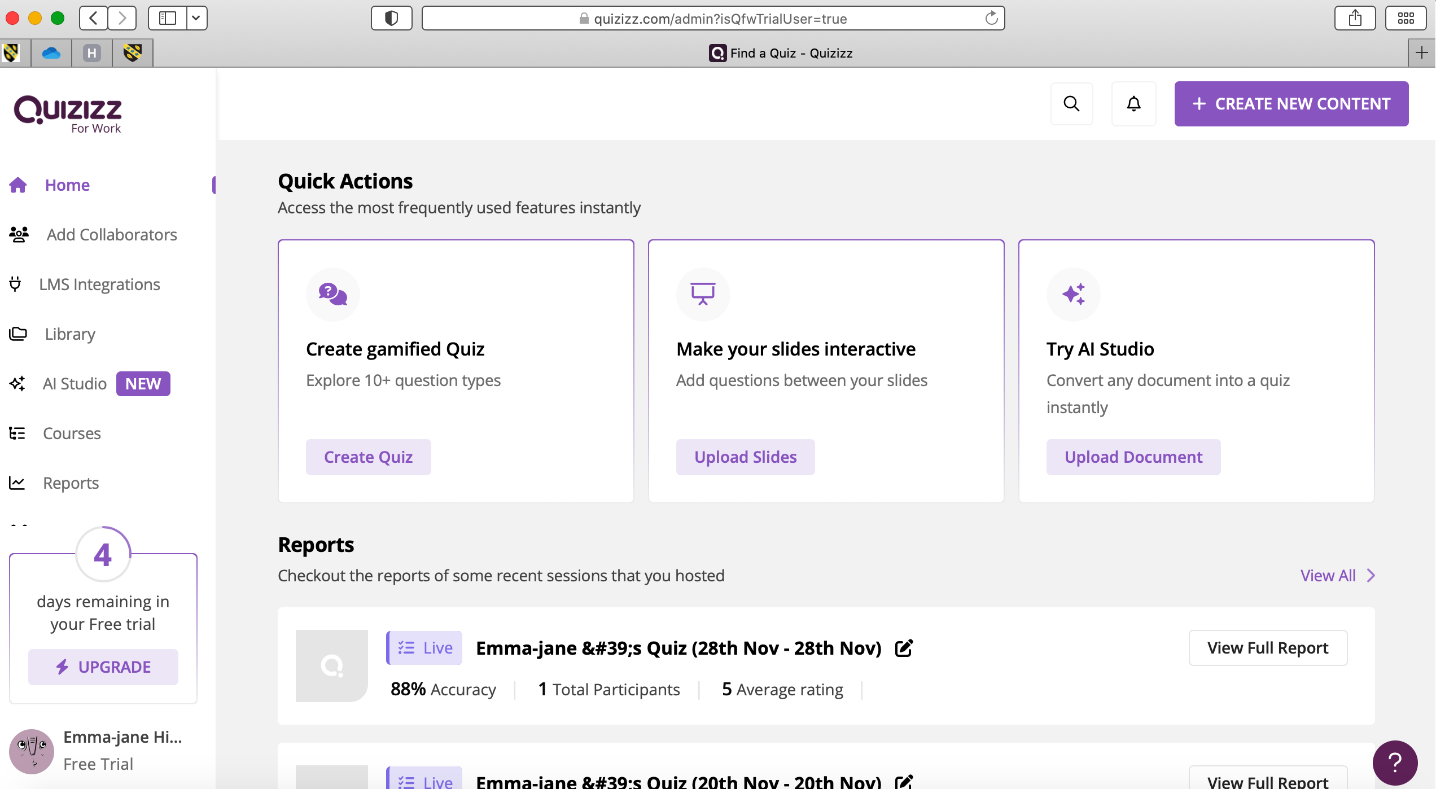
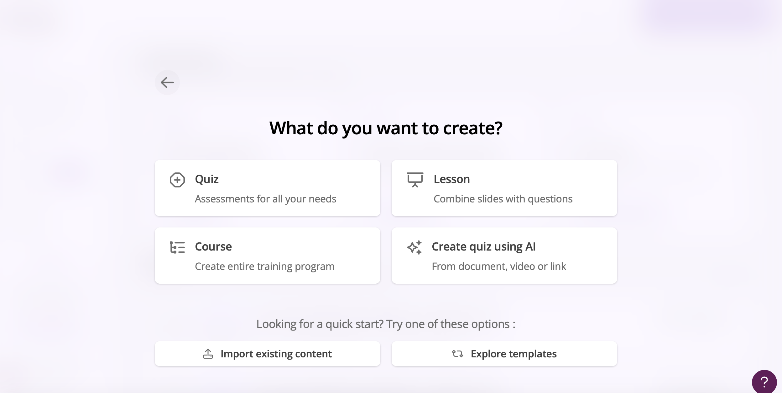
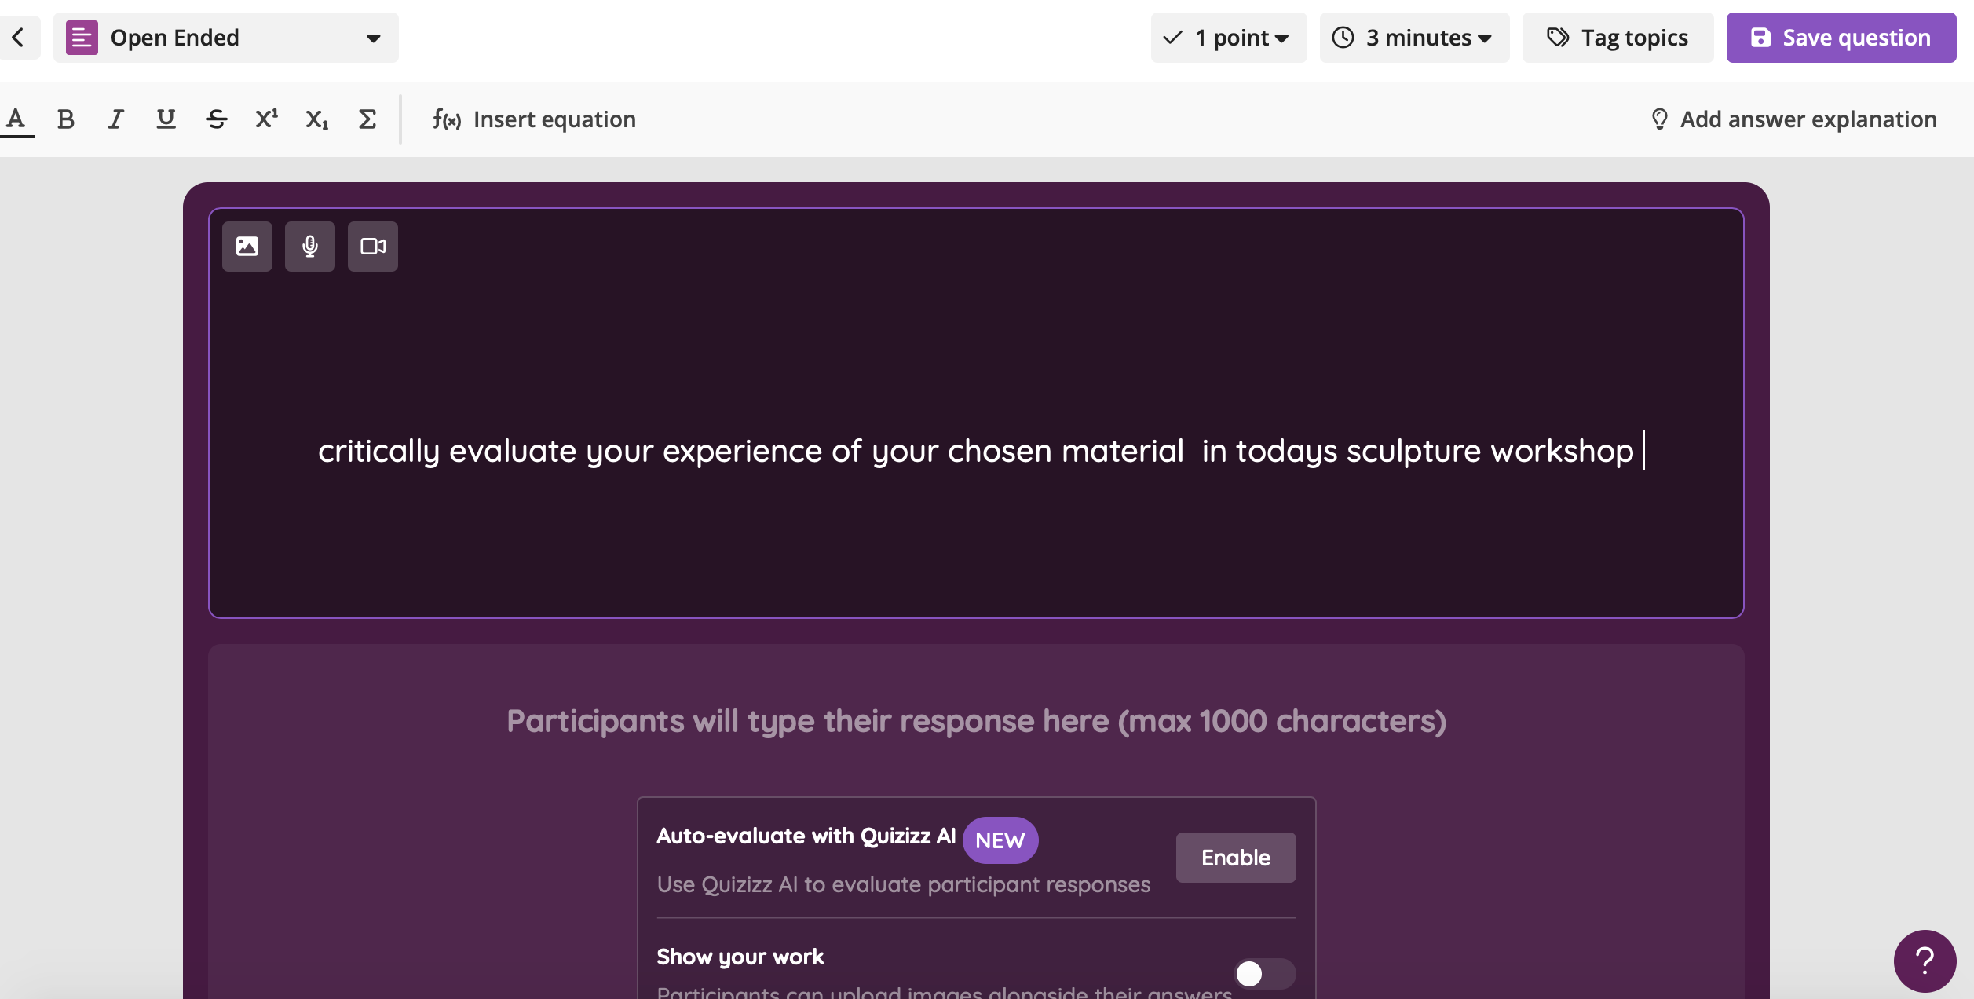
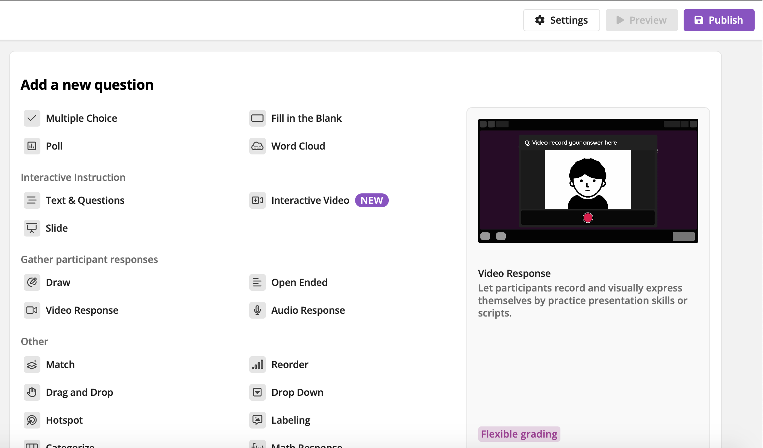
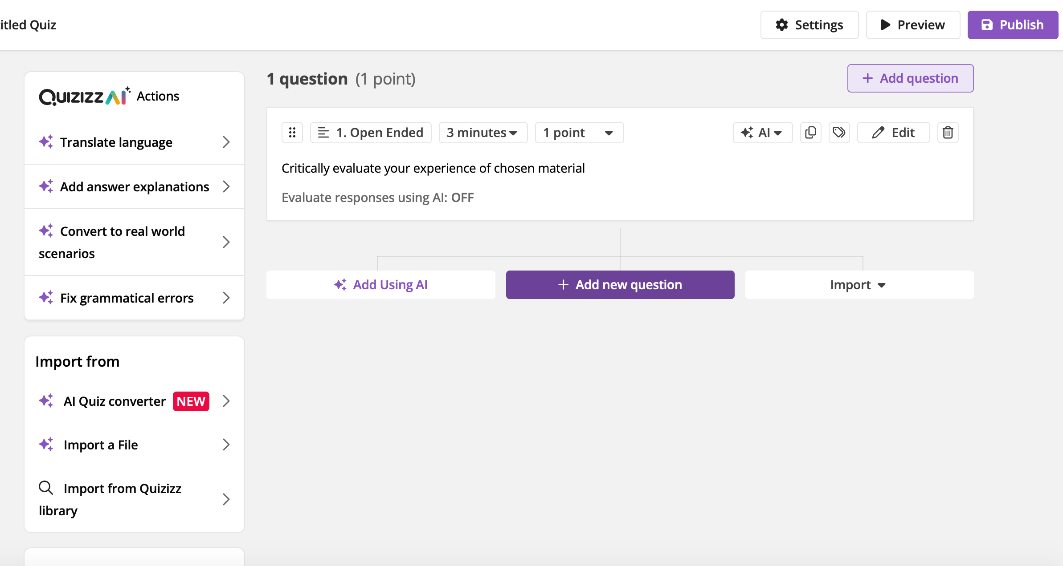
Fig 6. This is how it will look for the student on smart phone.
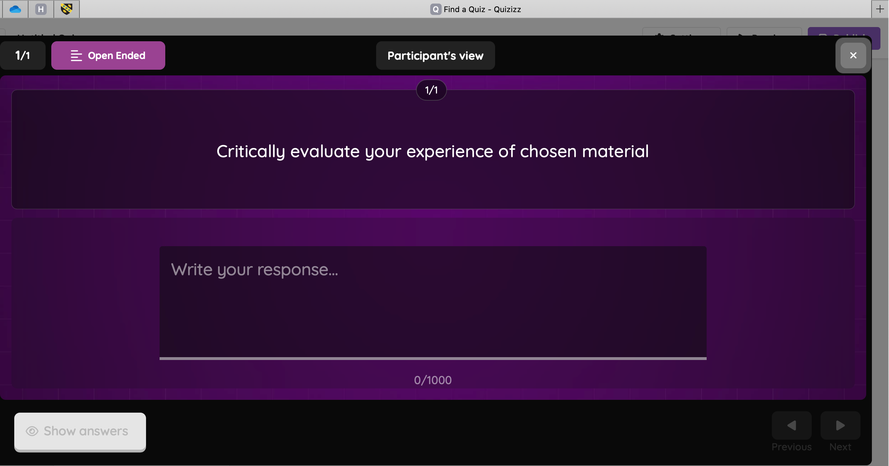
Fig 7. Screen shot of click right button to see assigned activity of my quiz. Start click left purple play button to start session.
Fig 8. Shows my choice of assessment, self-study, work at your own pace and can retake questions on this quiz.
Fig 9. Live session, changed to calm theme and turned off sound top right corner.
Fig 10. Put on big screen invited peers to scan bar code and join.
Fig 11. Scan bar code they can put their name in they can choose to read aloud or sound effects, change theme bottom left, or press fun reaction emoji through the game.
Fig 12. & 13 They can exclude question, erase answer, and try again or boost speed. click go
Fig 14.example of one of a drag and drop question created with photo image and explanation at the bottom that was added from the drop-down menu on the left. used AI to enhance image.
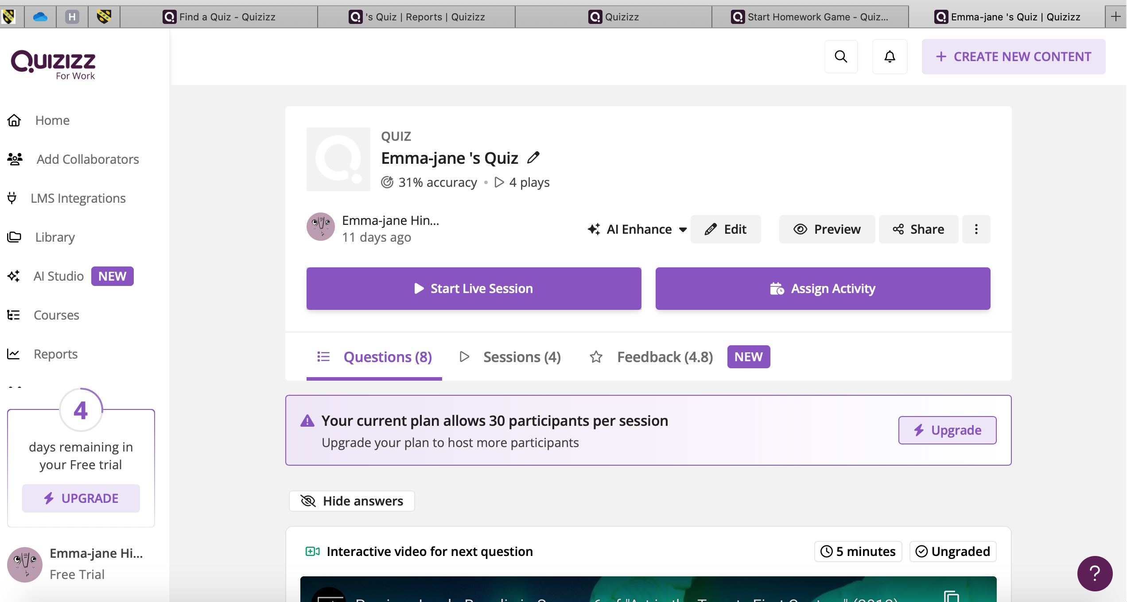
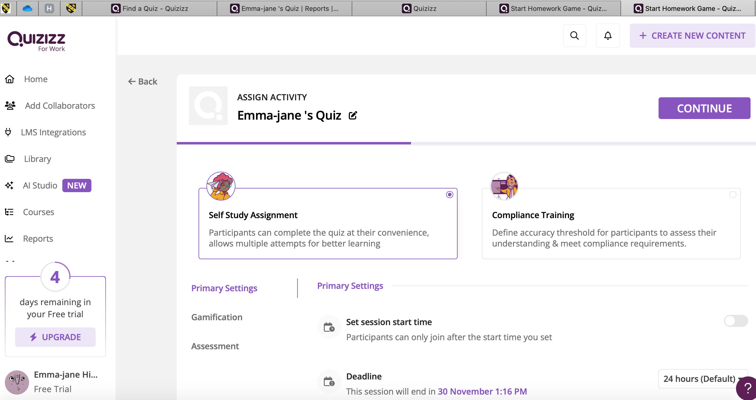
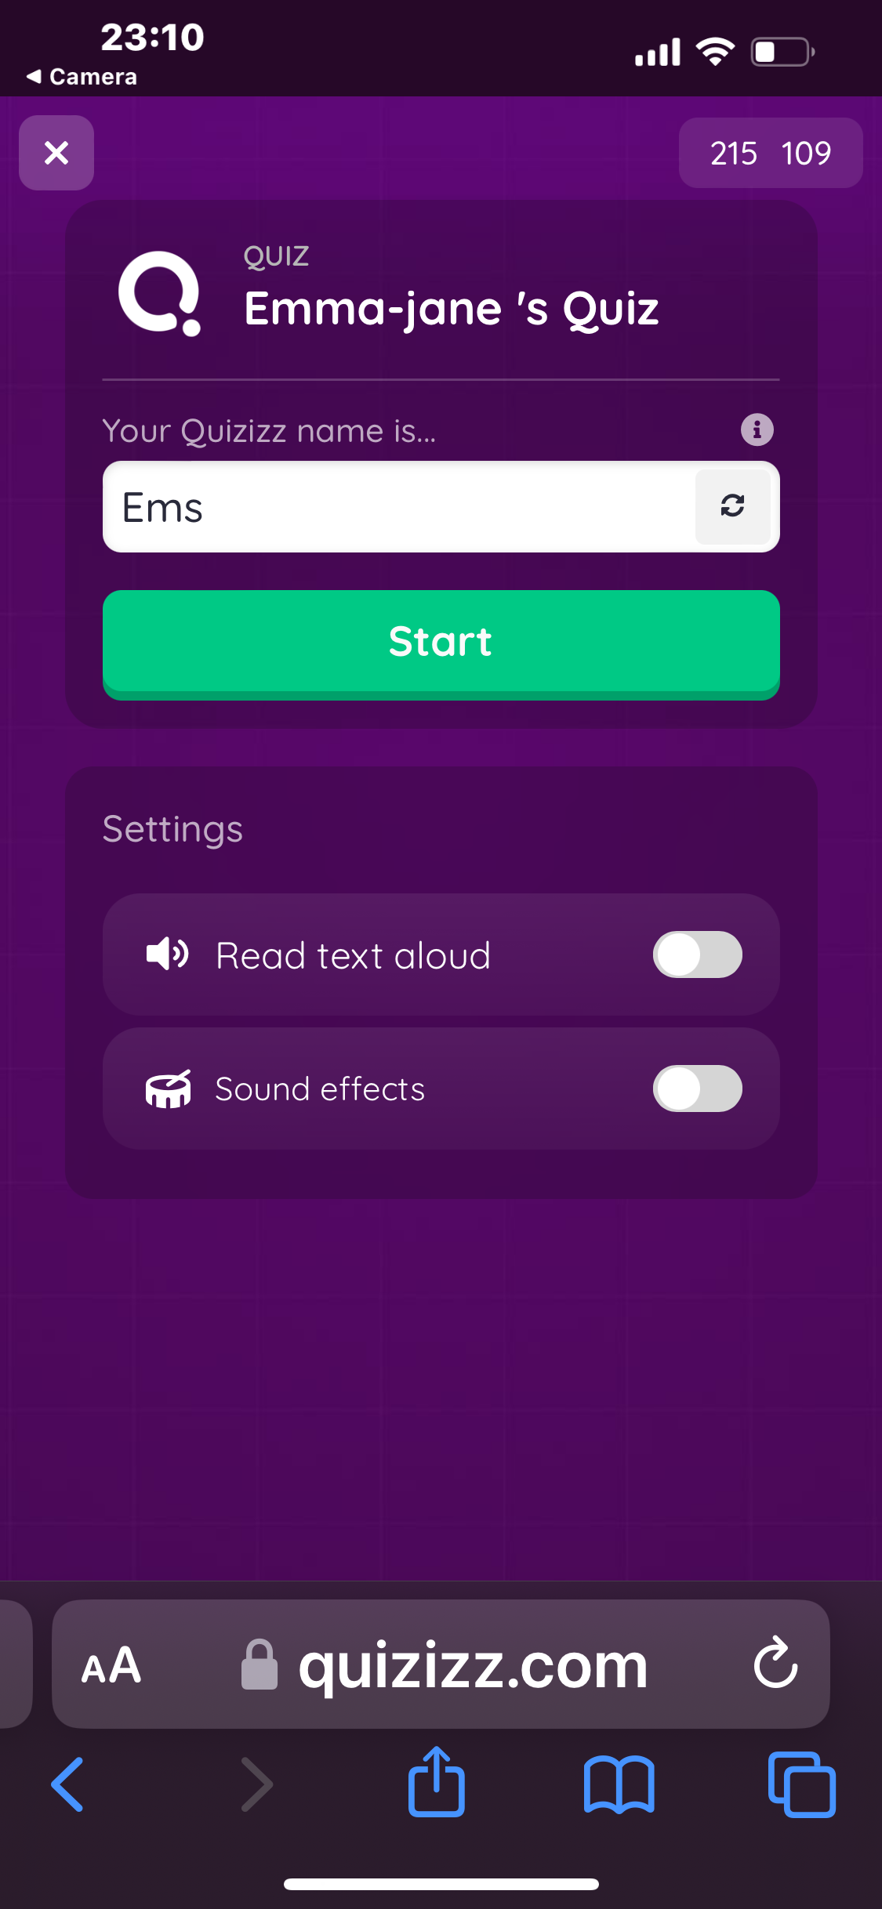
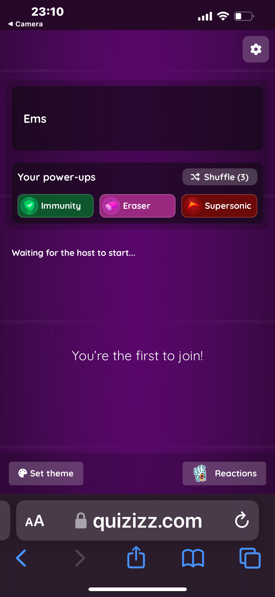
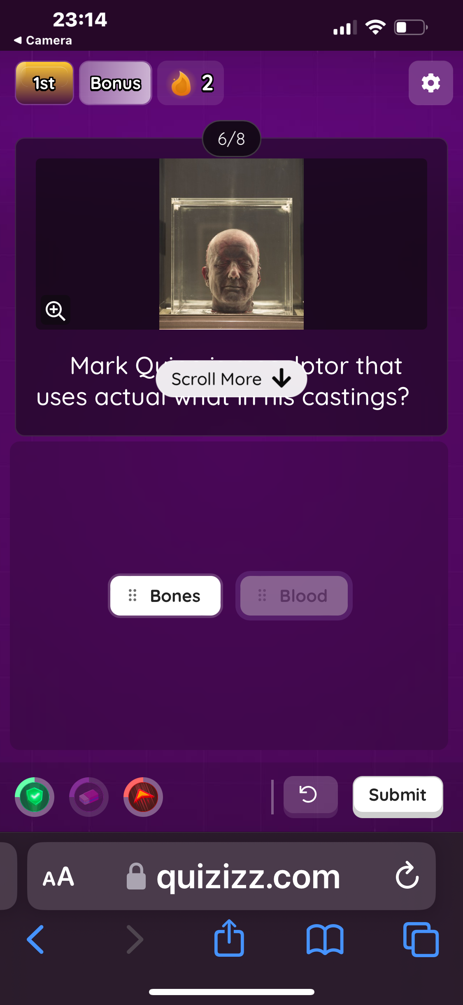
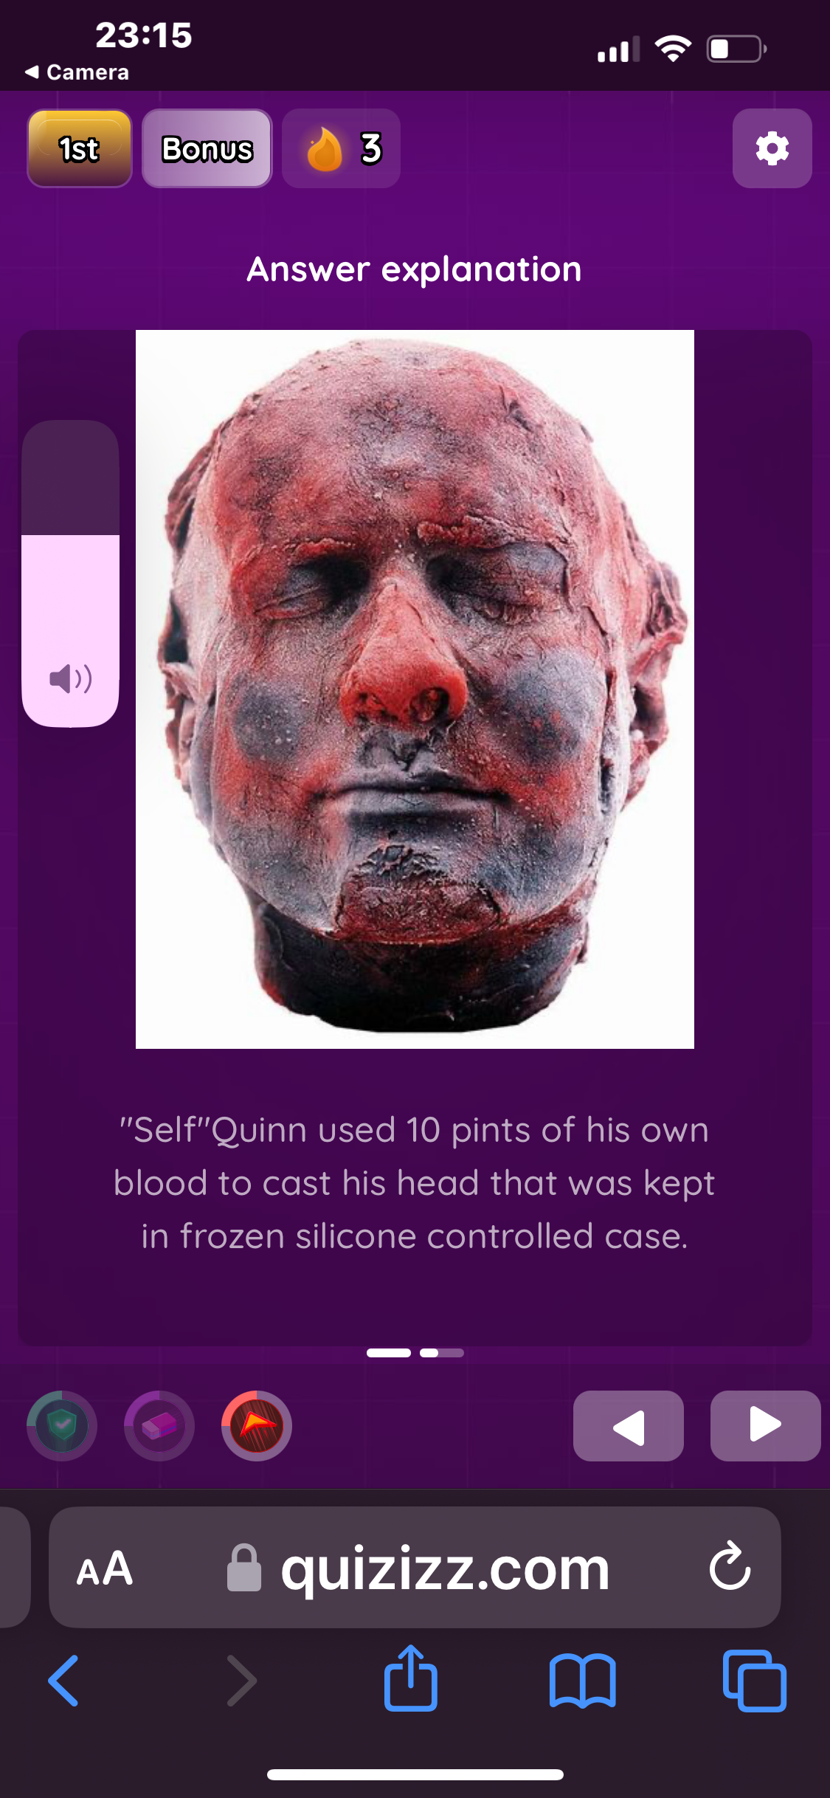
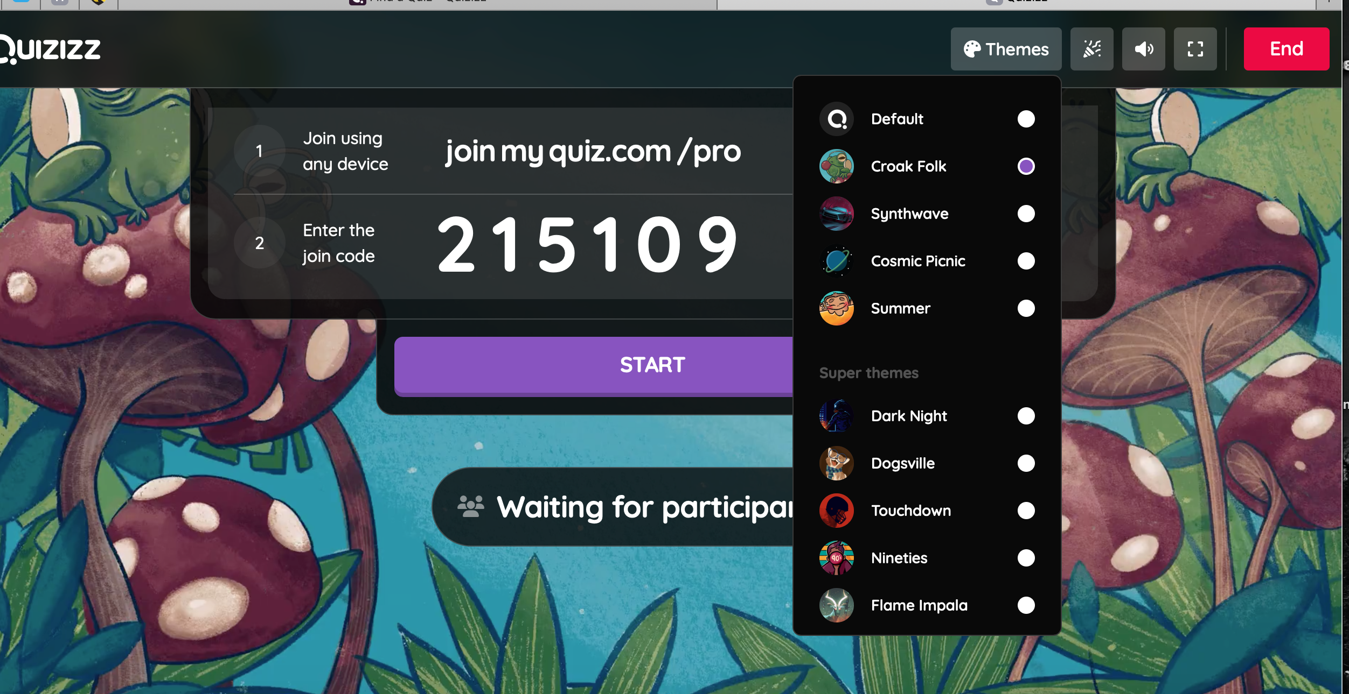
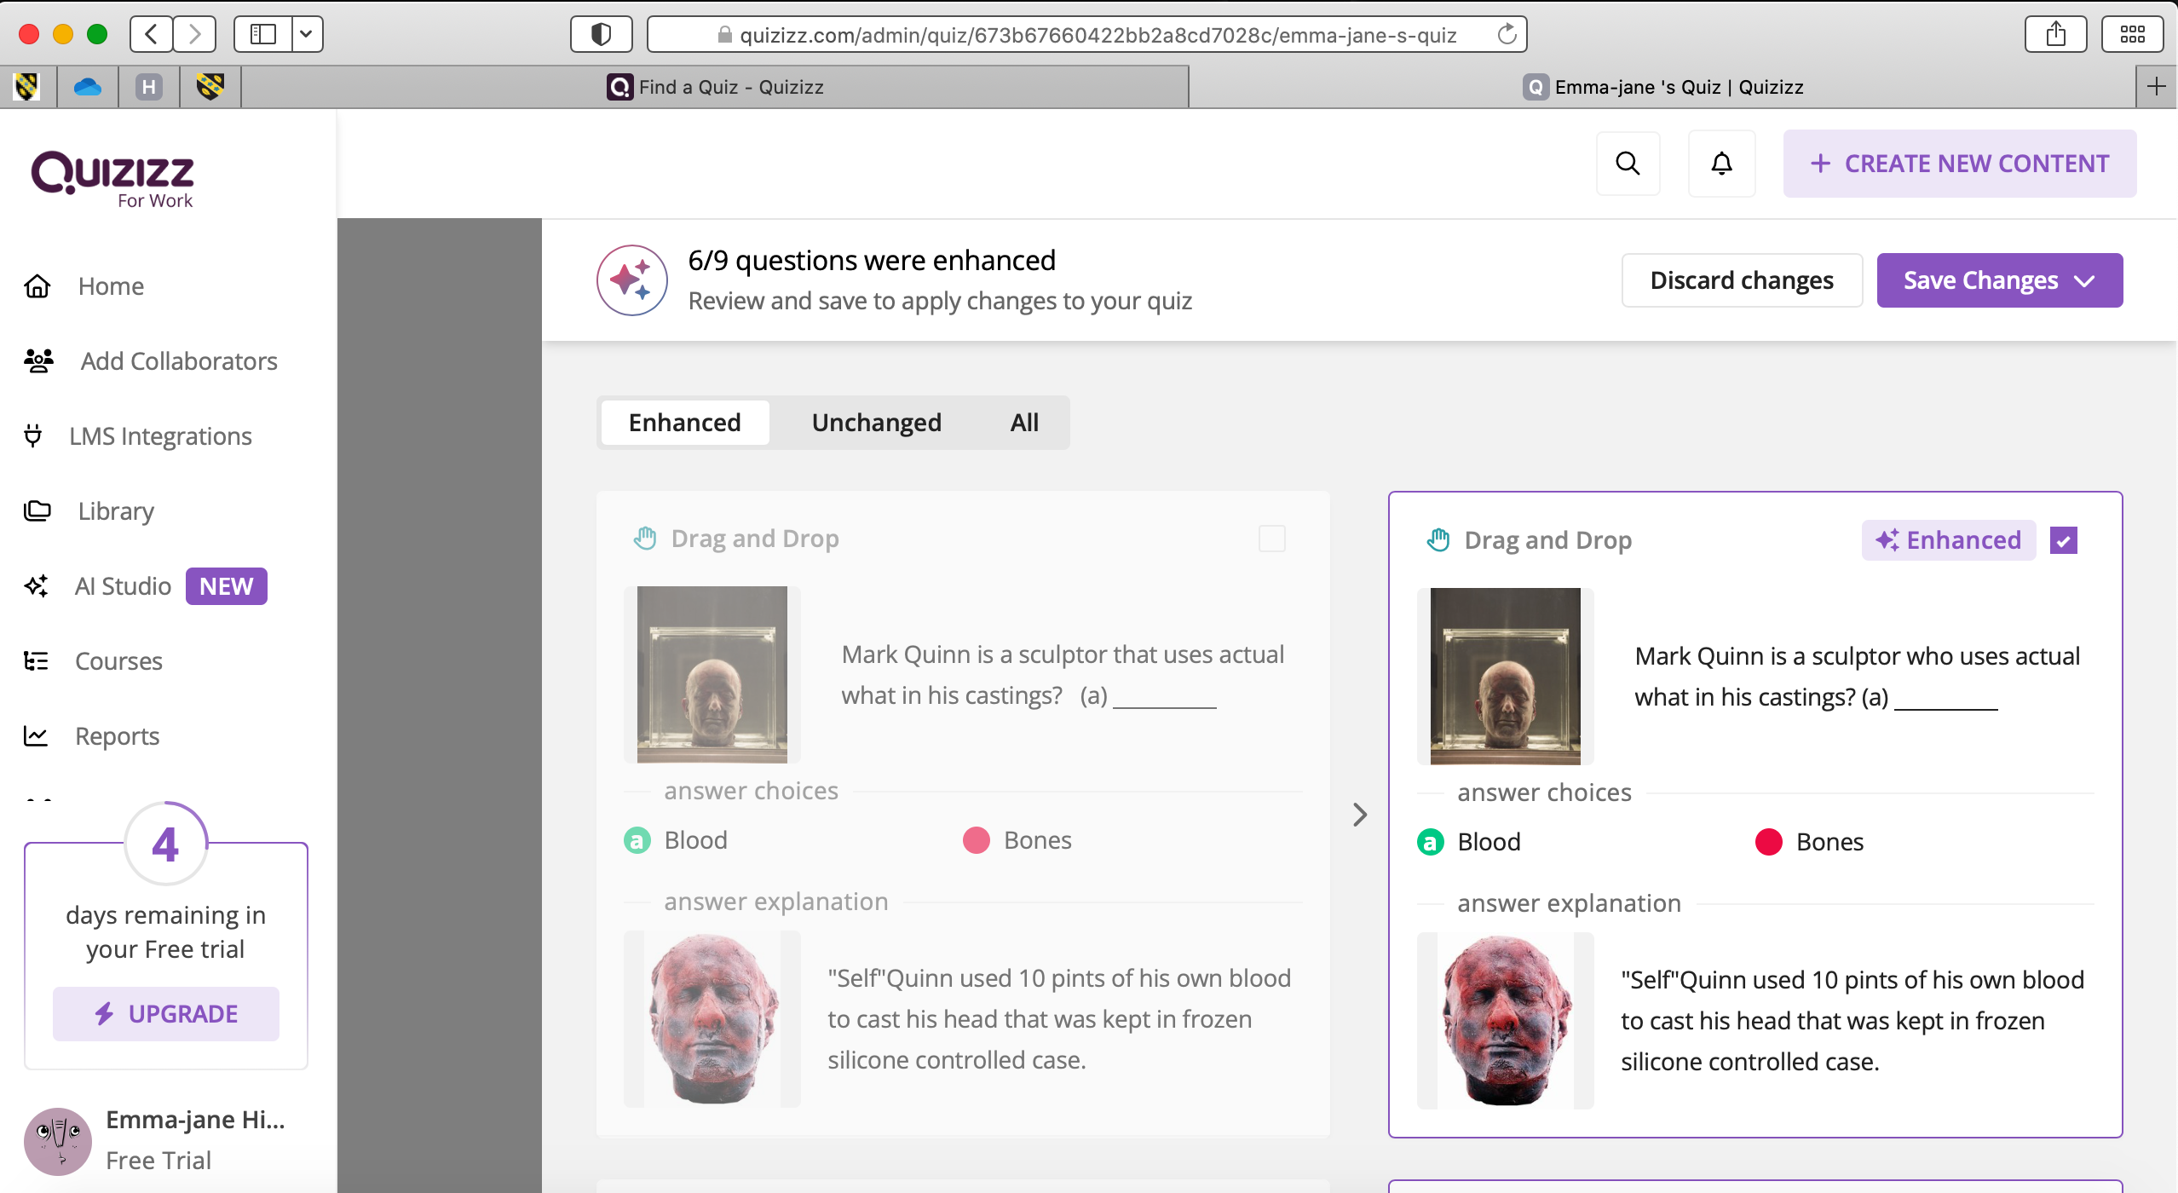
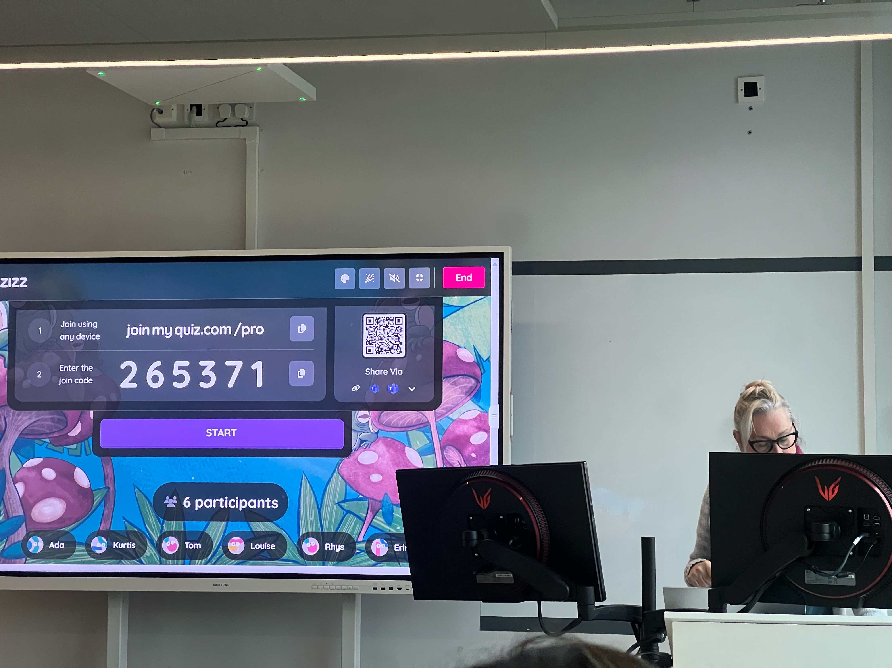
Fig 15 &16 This is how it looks to the participant with drag and drop and the explaining after answering correctly

Fig 17 My question multiple choice Ai enhanced image tool.
Fig 18 My drag and drop question with answer explanation.
Fig 19. My multiple-choice question with answer explanation.
Fig 20. My Video clip drag and drop with explanation.
Fig 21 Welsh culture question on painter how the participants see it on their phone
Fig 22 & 23 Match the following image to the artist name, how it looks to the participant
Fig 24. Peers left feedback on their experience of quiz very helpful.
Fig 25 I can review and evaluate participants first attempts. I removed names from left side of the panel for this document
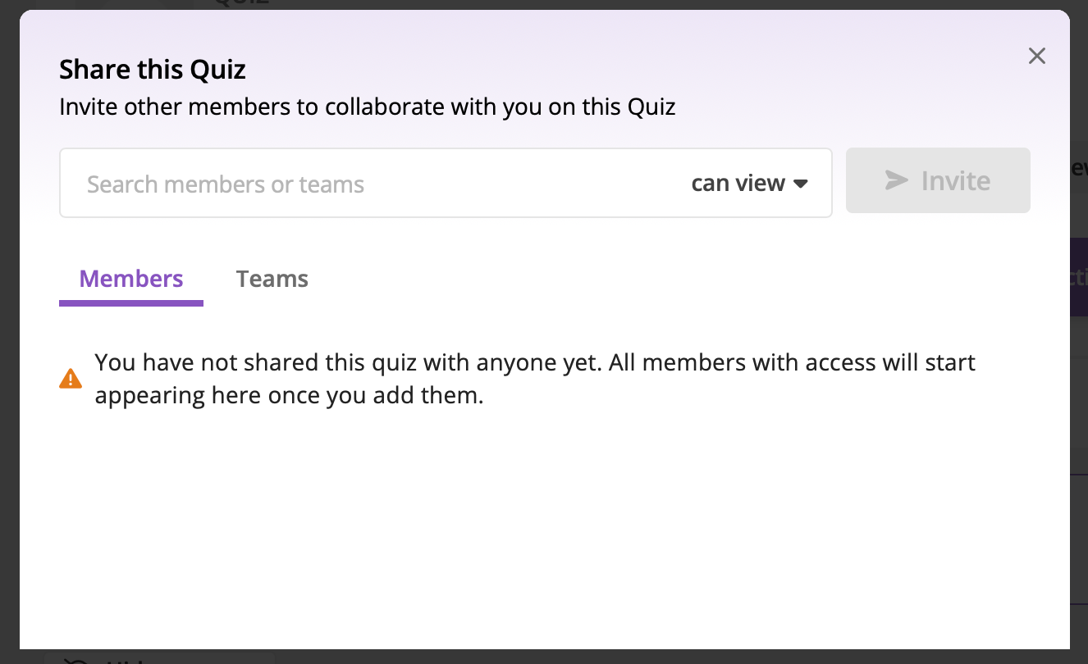
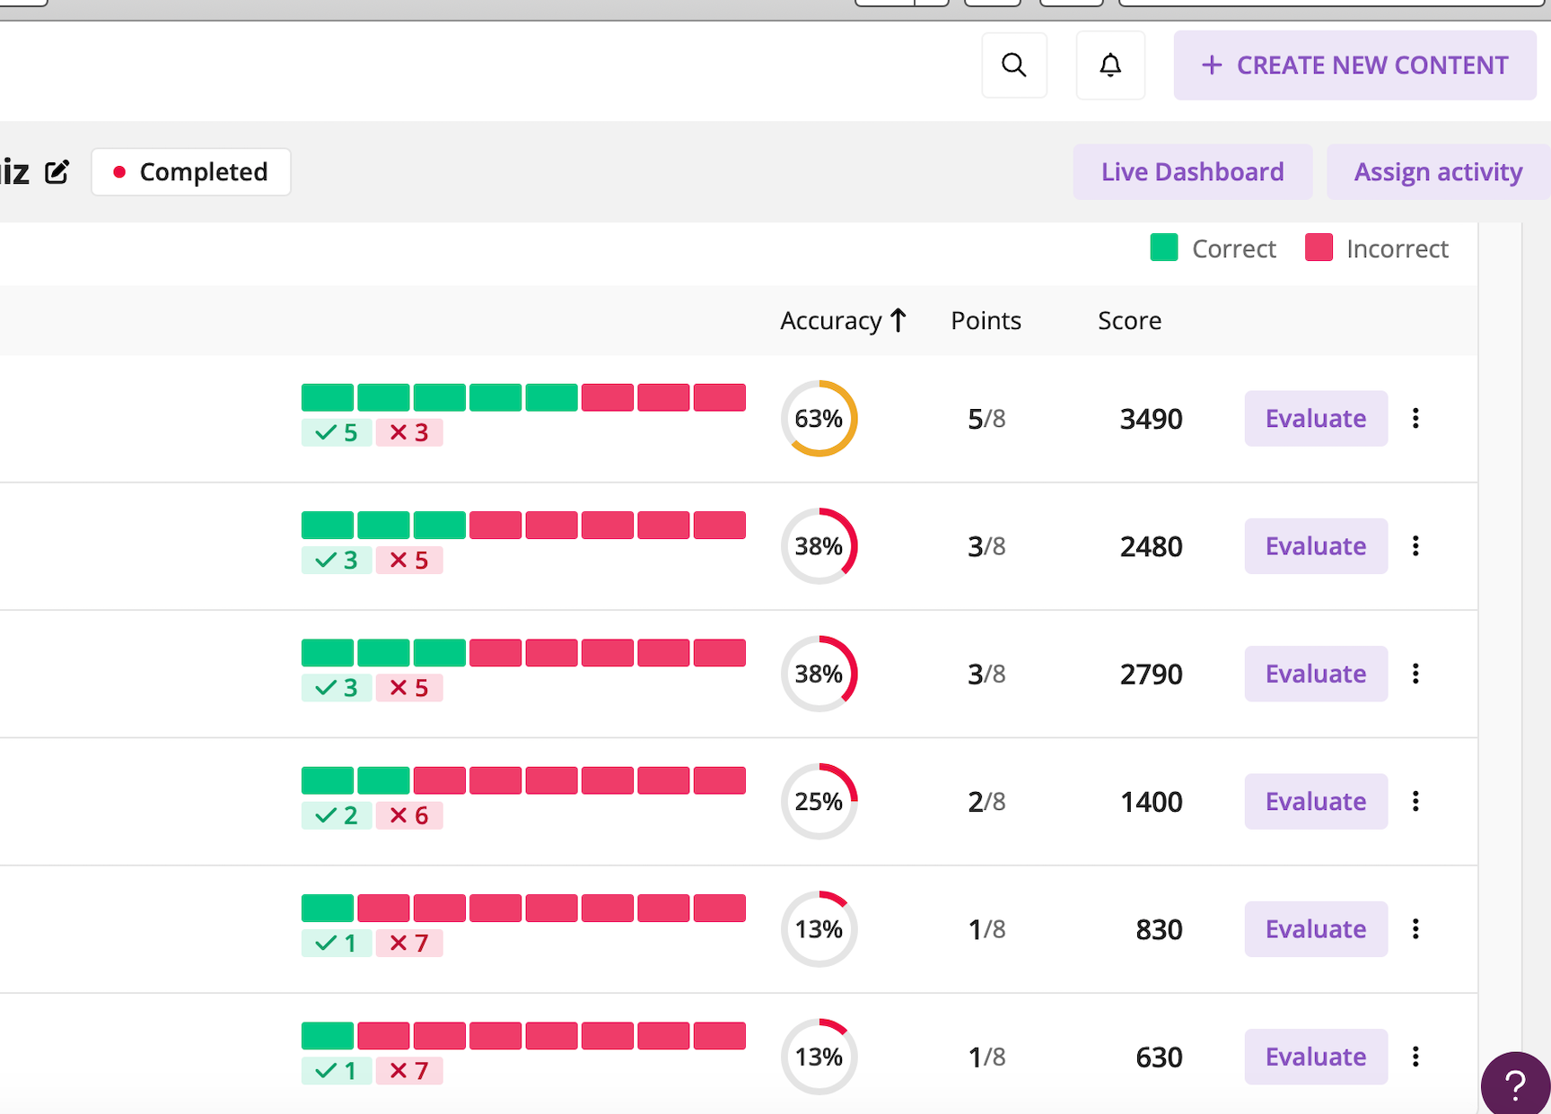
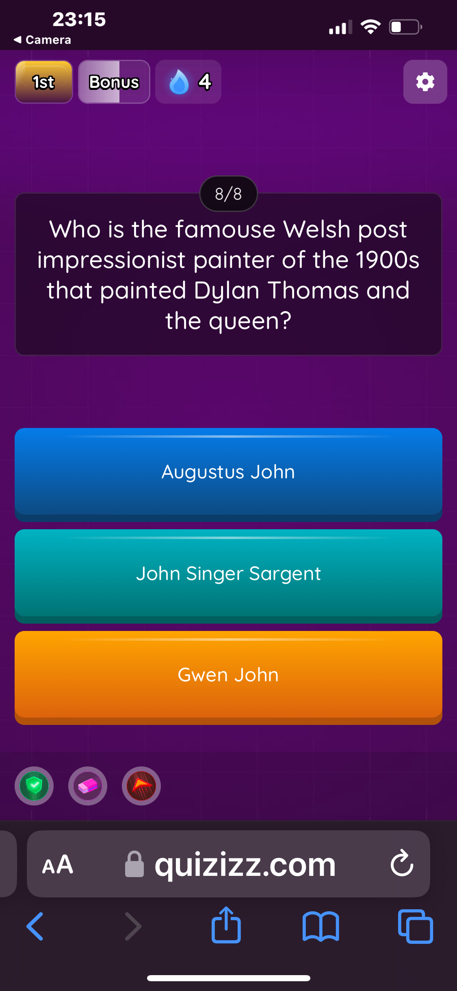
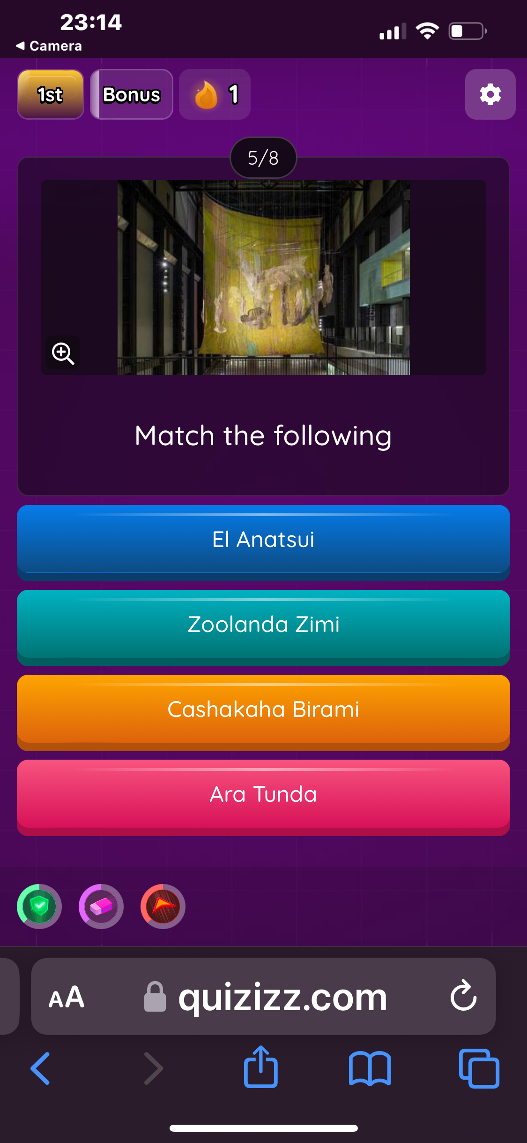
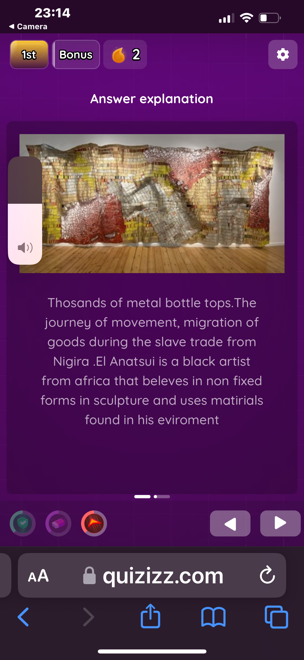
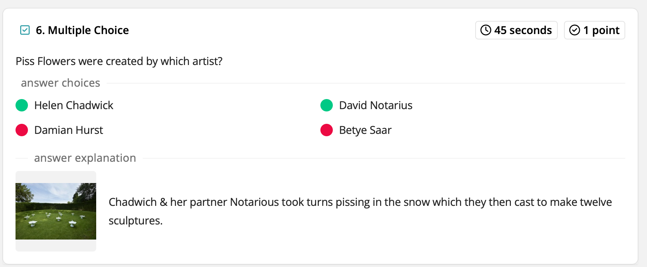
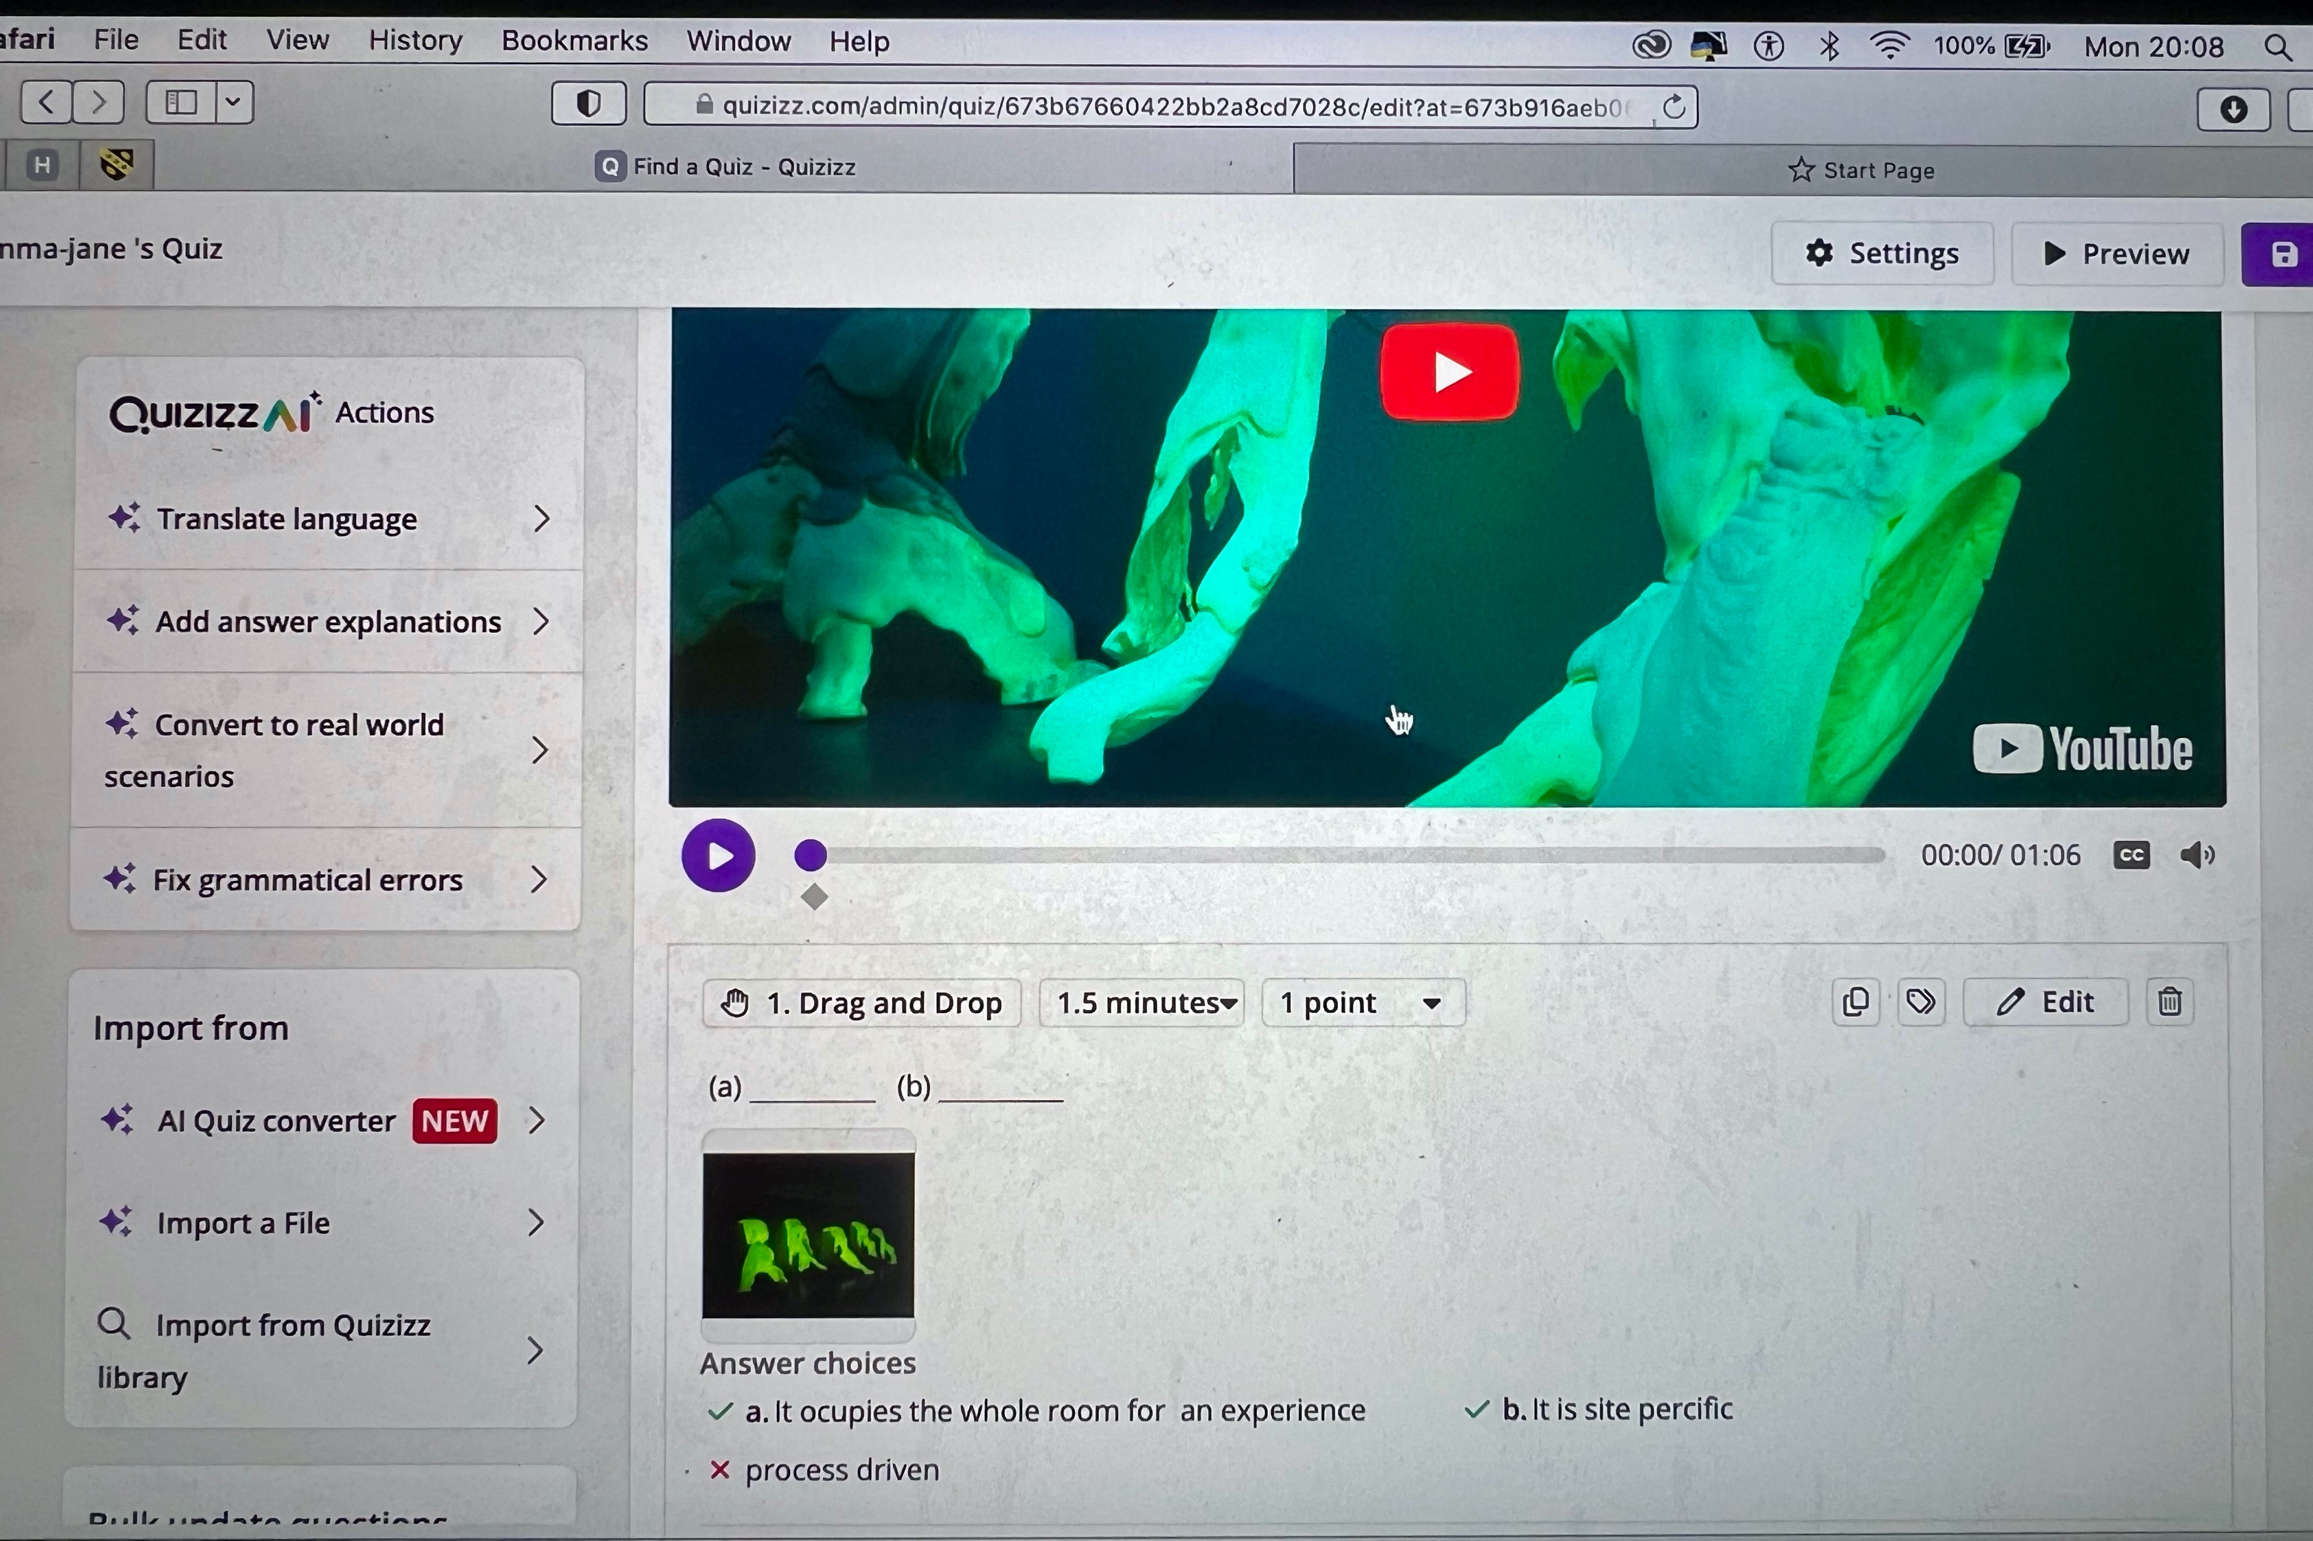
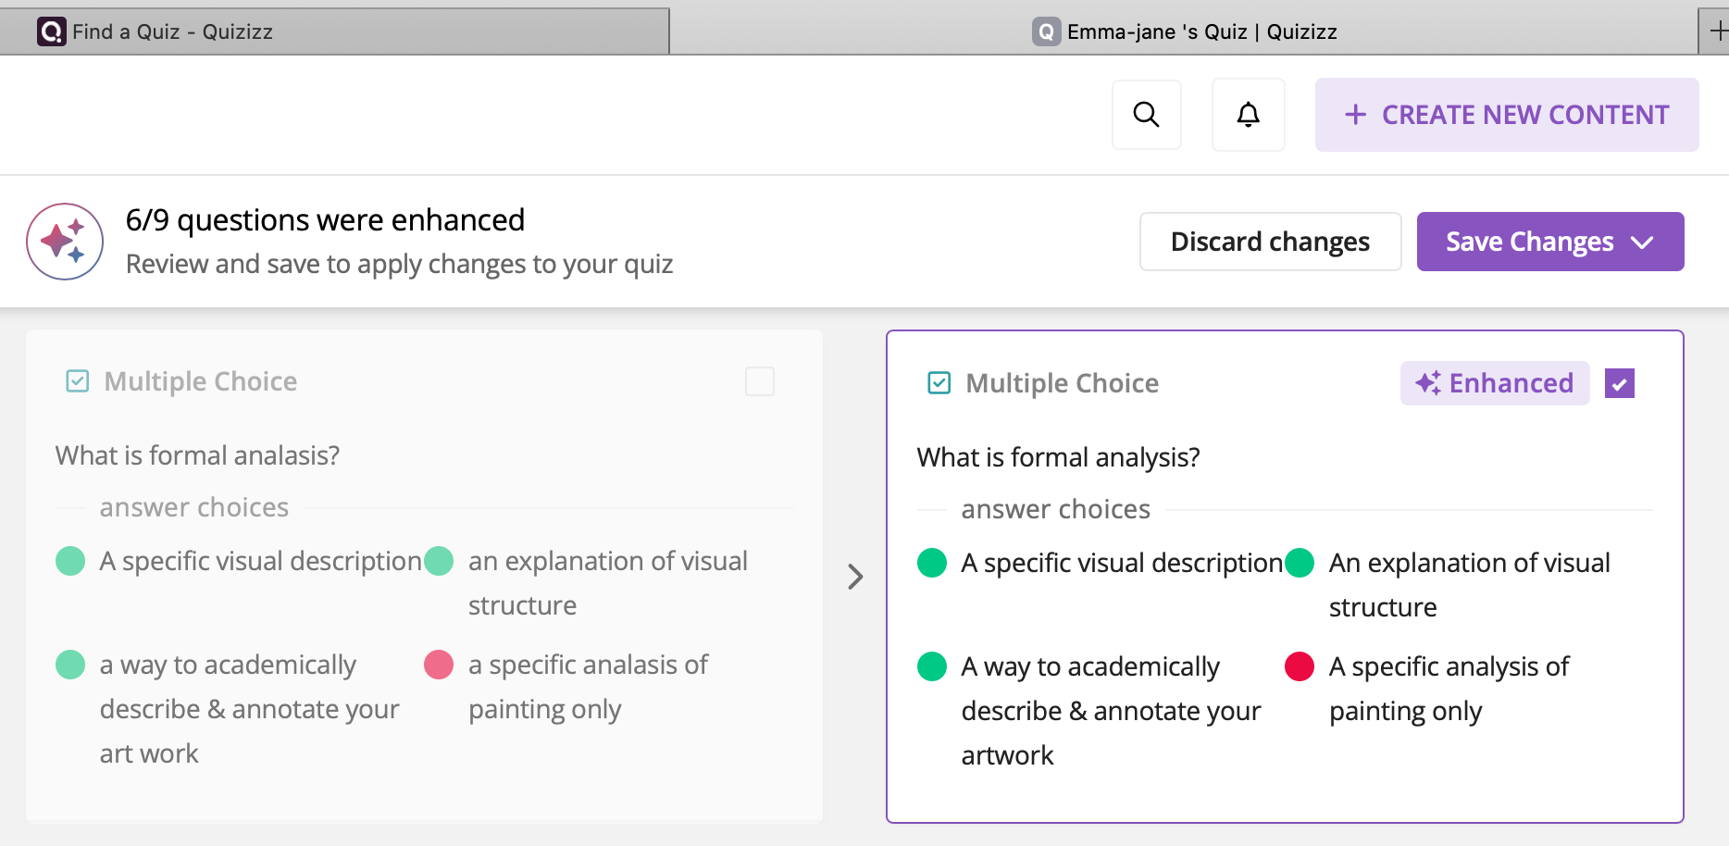
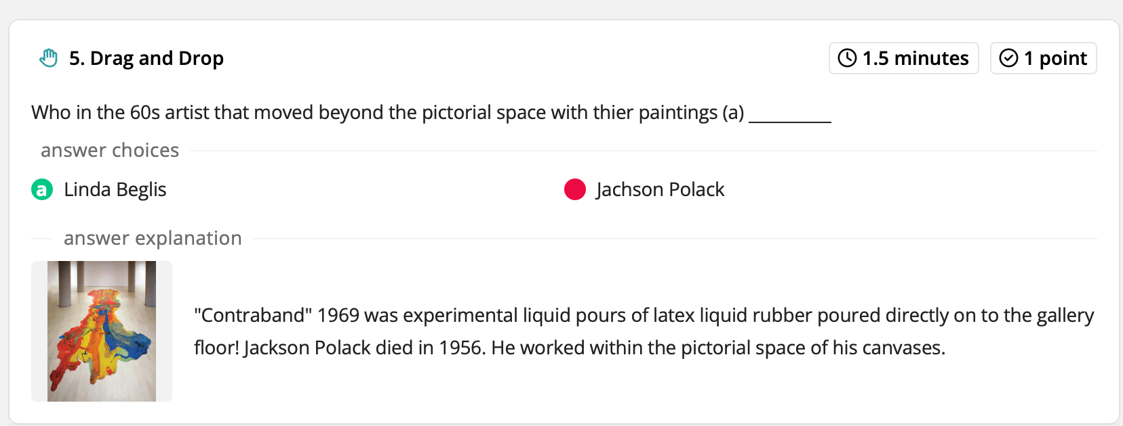
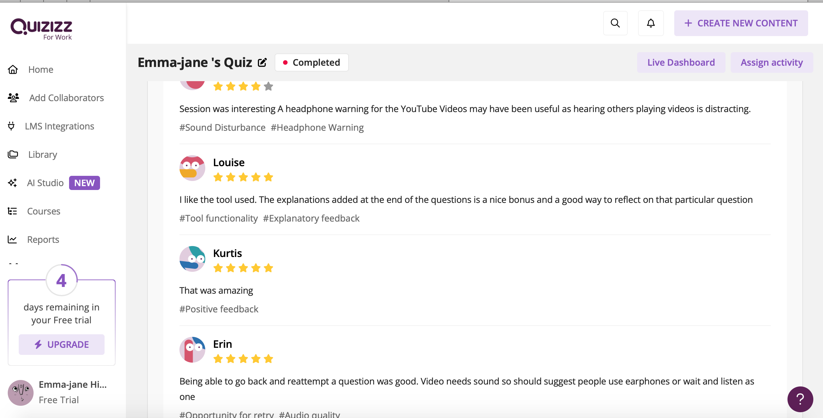
Fig 26 I can share with participants or teacher colleagues.



Lesson Plan

Topic: sculpture workshop investigation of materiality and 3d inquiry. |  | Class:  Year 1.Term 1 fine art BA.
Date:  8/12 /2024 | Length of lesson:  three-hour session. |  | Number of students:  nine students.
Resources required:
Quizizz interactive quiz + Video and audio artist research relevant to the class curriculum.
All resources available in the workshop: plaster wood hard and soft metals wire stone clay. All appropriate tools to wield materials plaster bowls, hacksaw, gloves, masks, bottle nose pliers, wire cutters, protective gloves, drills, staple gun wood glue. Nails, hammers. Retractable safety knives. This list is not exhaustible.

Aim of Lesson
To engage the three domains of learning students will be able to build on their knowledge develop higher order thinking through exploration of materiality of practical application of 3d enquiry exploring new fresh creative ways that stetches their developing soft and hard skills that also promotes their developing motivation and attitudes toward various materials.

Learning Outcomes – The Learners Should Be Able To:

Identify aesthetic and expressive qualities of various materials.
Develop ideas and concepts from the inherent qualities and process of working with materials.
Demonstrate developing soft skills of problem solving and hard skills through active construction of materials.
Demonstrate their ability to discuss, reflect and critically analyse their experience from investigating various materials.
Produce 3d forms that have been constructed or manipulated using different methods and tools.

Previous student knowledge required for the session:
Developing knowledge of art language including formal analysis. Imagination and creativity.

Anticipated difficulties (if applicable):
I may need to support some students to become more confident with experimentation and play helping them to understand there is no right or wrong good or bad, so they feel more comfortable to become self-directed some students need more positive reinforcement.

Professional Standards (where are these being met within the session)

Demonstrates commitment to learners the learning and safety and well-being inspire them to experiment stretch their learning by offering them and demonstrating possibility’s a with materials. health and safety discussion and demos. Having many materials and tools to choose from to create Moquette's or structures supporting them with positive reinforcement. Dialog with active listening to assess their needs and to support them becoming more self-directed during their 3d practice. The dialog also helps them develop their academic art language. Building on their knowledge to develop their formal analysis skills.

Lesson Detail:

Stage | Focus | Strategy | Time
Introduction  Check they are waring steel toe cap boots & overalls  Introduce myself settle them in recap what they remember from this term bringing back to the moment to be ready to start  New artist research  Demonstration of practical application health & safety  Development  Practical application  Self-directed practice  Learn for themselves about the inherent qualities of the materials  Plenary/conclusion  Developed creative growth, body of works, soft and hard technical skills Group crit  Clean up | focus is on measuring what they've learned this term on how artists engage with materiality to make meaning and their knowledge of formal analysis  building on pervious knowledge & inspire Showing them possibilities to motivate practical application & dangers to become aware of with tools& materials.  Exploration and challenge and discovery reflect and analyse  allowing them space to experiment and investigate materials using various tools and actions. Using Positive reinforcement.  Build confidence and collaboration  Allows them to take owner ship of their work share different perspectives develop their art language reflect on or find meaning in their experience. Allows them space to reflect and take notes for their reflective journal.  Wind down casual chat  Working as team Take responsibility for leaving clean space for the next class health and safety protocol. | Quizizz interactive assessment of how much they can recal this term in how some artists engage with martials and make meaning questions on formal analysis . 9 questions  Encourage dialogue collaborate on sharing their knowledge thoughts, ideas and values. To allow creativity to star flowing, demonstration can inspire them to try it in their own way but feel safe to try it after going over safety elements demo.  Safety awareness htrought.  To read the room give them space to start working make sure they have everything they need to play. Opportunity to watch and start a dialog with everyone at certain points. To measure the 3 domains of learning as they develop their structures. Intermittent demonstration is also utilized to support them to feel confidant to try new things.  Assess their learning through their interaction with peers during their critical evaluation of their own work allows for deeply informative information to be revealed what was important or interesting for them how they valued it what senses did it evoke etc. end practice from a positive thought-provoking place. | 20mins.  20mins  2hrs  10mins  10mins

Assessment Strategies: when and how are they included within the lesson?

The whole workshop is a continuous flow of informal assessment through dialogical exchange and observation. The fine art Ba has a very constructivist pedagogy that supports student to meet their objectives. And allows teachers to assess how best to support them to meeting those objectives.

Evaluation and reflection

This was complex challenge of experience for me, learning from ground zero an interactive platforms and analysing its value to maximise learning together with good pedagogy as a trainee teacher . I have met my objective in terms of finding an inclusive way for both myself and the students introduced to this platform feeling comfortable with ease of use, it felt more like a natural integration than expected. My peer feedback from all participants agreed on this . Two peers picked up on the ease of eye, changing the theme options to suite them. This was demonstrated by me in the class to accommodate any learner including ALN.
I placed value on my mixed choice of questions in the hope of it becoming more engaging and to scaffold their ability to learn, coupled with all the mix of media that was integrated with it. I met this objective, most of peers feedback enjoyed the way I placed my images and videos thought the graphics were engaging I feel it made it more interactive and fun and drew on other senses for learning styles. Three of the four of my peers hadn’t herd of Quizizz before and thought this quiz approach was a good way to test students prior knowledge which was another objective in my original plan for assessment.

I felt disappointed in myself on reflecting on feedback from peers about the video used in one question. That a headphone warning could have been given beforehand as the YouTube videos was somewhat distracting to hear a different times from other users . I did not consider this at all, but will in a session in the future especially for students that get agitated by distracting noises. This is the reason I turned down the music on the actual quiz. My peers feedback mentioned its and fun way to test students on their knowledge at home . I previously evaluated its versatility as a platform that can be used remotely and as it integrates easily in to google classroom could be put on the students college platform to complete in their own time or if they miss a session. Peers mentioned it could be utilised as an alternative way to revise . This was a good point. I would need longer to play with the program to learn and would have to subscribe to it in the future as they offer training badges to learn the platform which is appealing. On Reflection if this was available more than 14 days which is more than most quiz style learning platforms offer it is still not enough time to become familiar for free for a beginner like me.

Peer feedback from one person was other functions like clues, after careful reflection I feel that the clues were in the question style like multiple choice or drag and drop the correct answer and supporting media. That said the quiz was very specific to the students study at my placement, so my peers were at a disadvantage but did they did have an opportunity to help each other and google answers to get them right. I did apologise at the beginning of the session for this challenge. One of my favourite additions to the students getting answers right was the explanation at the end of the questions , helping to build on their previous knowledge to consolidate learning. Peers found this an informative tool seeing the value in it. Lack of collaboration was an issue for one peer, but feel justified in my choice given the context in which it was designed, with the fine art students at my placement as an individual assessment strategy. On deeper reflection no student is left alone to re take questions if they don’t want to ask for help from peers or use the internet, I could also support them to find the answers as the style of this quiz allows me time to support individuals in person. Three of the peers compared with my justification, for a no pressure on timing quiz. This was an important element in my research of finding a quiz style platform that was equitable, after my negative experience of Kahoot loosing motivation as it was so fast and could not compete or learn anything becoming de motivated. This is something that could really impact a students willing ness to participate in another quiz. Causing distress. I reflect deeply on the dangers of introduction of a digitally interactive tool into the curriculum in post 16 education without good pedagogical knowledge ,it’s about integration not segregation careful planning is paramount. The future incentive in not only in education but our society to maximising learning with technological innovation.

My experience has been thought provoking but an informative struggle. That will be other students struggle. I am now realising through the experience of this digital innovation modal that the landscape of education is changing forever we I need to move with it and get educated with it. Welsh teaching standard Critically reflect on own values knowledge and skills to improve learning (Welsh Government, 2019). I have a long way to go but surprised myself with this module, knowing practically nothing about digitally interactive platforms or the implications of my disinterest. I feel this has been the biggest challenge and my preconception’s have changed on its value in education. On deeper reflection initially thinking this was a choice to integrate digital technology it’s not, it’s a responsibly to innovate my teaching and get creative with it to lead by example to inspire students to adopt skills that are moral ethical and literate for their future survival in a multiverse of landscapes.

Reference List
Aslam & Khan. (2020). Technology Integration and Teachers' Professional Knowledge with Reference to International Society for Technology in Education (ISTE)-Standard: A Causal Study. Journal of Education and Educational Development.
Gareth Evans. (2021, March 23). Back to the future? Reflections on three phases of education policy reform in Wales and their implications for teachers. Retrieved December 3, 2024, from Springer Nature Link: https://link.springer.com/
ISTE Standards. (2024). ISTE Standards. Retrieved from https://iste.org/standards#:~:text=The%20ISTE%20Standards%20are%20a%20framework%20that%20guides,by%20all%20U.S.%20states%20and%20many%20countries%20worldwide.
Janssen, A. (2015, October 2015). Why innovation is all about people rather than bright ideas | Alexandre Janssen | TEDxFryslân. TEDX Talks. Retrieved from https://www.bing.com/videos/riverview/relatedvideo?&q=alexandra+janssen+why+innovation+is+all+about+people+ted+x+talk&&mid=BFAEC07B06FE98096ACEBFAEC07B06FE98096ACE&&FORM=VRDGAR
Laricchia, F. (2024, September 11). Smart Phones - Statistics and Facts. Retrieved December 01, 2024, from Statista: https://www.statista.com/markets/
McNutt, C. (2019, December 7). Primer: Progressive Education (2019). Retrieved from Medium: https://medium.com/human-restoration-project/primer-progressive-education-2019-6aff63365c37
Quizizz. (2024, December 4). Our Mission. Retrieved from Quizizz: https://quizizz.com/home/about?lng=en
Welsh Government. (2019). Digital 2030 A strategic framework for post-16 digital learning in Wales . Wales: JISC.
Widman, S. (2019, October 21). Technology, The best or worst thing for education | Scott Widman | TEDxYouth@BSPR. TEDX Talks. Retrieved from https://www.bing.com/videos/riverview/relatedvideo?q=scott+widman+ted+talk&mid=FF6B8C1B393C1E1CFF23FF6B8C1B393C1E1CFF23&FORM=VIRE

