 |   Trinity Greetings  We wish you a happy and healthy New Year and a Merry Christmas. We hope you and your loved ones have a wonderful holiday season and a prosperous new year. Let's anticipate better times ahead! |  |  |   TAKE AWAY (DELIVEROO, UBER EATS)  OR  EAT IN 

Payment through MasterCard and get a flat 5% Discount
 |  |  | 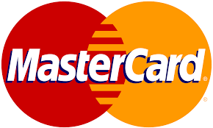
 |  |  |  | 
 |  |  | Hotel TrinIty  Swansea, South Wales  Email: trintyhotel243@gmail.com | 

 | Christmas Special menu  The menu shows special items from us and most of them are foreign dishes. So, this Christmas let’s have tried on foreign dishes.   |  |  |  |  | regular menu
SMOKED SALMON  (Special Masala) | 4.00
Scintillating scallops  Lemon Flavour | 5.50
Paela  Meat & Seafood | 20.00
prawn tikka  Tikka masala & Naan | 12.00
Apple Pie  Trinity special | 7.00
Chocolotae coffee  Chocolate & Nut | 4.00
lemonade  Taste of tart | 5.00
red wine  Wine & Malbec | 25.00
white wine  Pork & Cannellini beans | 30.00

 |  |  | Dates, Banana, Walnut & Nut Tea  Price: 5.63 | Trinity special Egg Paprika  Price: 2.46
 |  |  | Chicken Corn Soup  Price: 3.45 | Trinity Special sweet dish  Price: 5.67
 |  |  | Trinity Special Mixed Salads  Price: 4.50 | Mixed chocolate shake  Price: 3.50

