verginica caracas
1906795@student.uwtsd.ac.uk

Business Plan
Familial Restaurant

Name of business: Familiar Restaurant
Business Owners: Virginia and Oliver Caracas, Julia and Thomas Jones
Mission Statement:” Fresh homemade food in a spotless well-presented venue”
Aims and Objectives of Business:
Hospitality and Entertainment always come first for our customers
Always we make the customers to feel good.
Quality and delicious food and a selection of wines is the recipe of feeling good:
Eating better feeling better

1.0 Introduction
The first restaurants appeared in China in the twelfth century in Kaifeng, the capital of the Song Dynasty. They were like taverns and were particularly created to serve travelers. (Rawson & Shore, 2019) Nowadays people are so busy working and commuting that they do not have the time and energy to prepare their food at home. Instead they choose to go out to eat. The friendly atmosphere of a restaurant can make them feel relaxed after many hours of work. Add to this some delicious food and a tasteful selection of wines and they are bound to come back. Loyal customers make the business great, which creates a win-win situation for both parties, customers, and business owners. In other words, everybody is happy.

2.0 Product/ Service
Product means physical goods and that is exactly what our restaurant offers to its clients. What else makes people want to buy our product? They will be attracted by its high quality and freshness.
A product should fulfil consumer expectations and it may certainly be compelling so that consumers believe they need to have it and thus create more demand.
We offer to our customers a good variety of dishes exactly what they are expecting to get to satisfy their needs. All meals in our restaurant are homemade using high quality products only. Most products such as meat, vegetables, cheese, and eggs are provided by local farms from Swansea Community Farms.
The main menu consists of traditional English food and in addition we serve a range of modern dishes from international cuisine.
The Masterpiece is our chef Oliver’s homemade gravy with all the flavors our customers want: beef, lamb, chicken, and pork. Our gravy is a healthier one and is set to become a trend in restaurant kitchens worldwide.
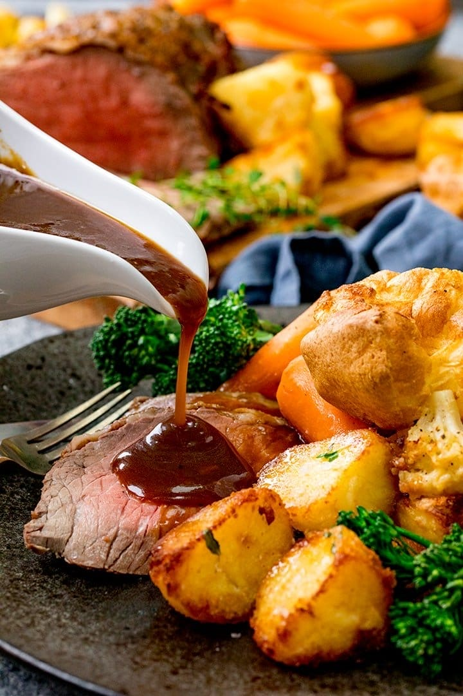

All these stunning dishes are served by a friendly staff in a very clean and relaxing dining environment.
We also offer to our customers other services, like:
- Friendly and relaxing atmosphere
- A special attention to kids
- Entertainment
- Taxi booking
- Event organisation
- Live music

3.0 Marketing Activities
3.1 Market segmentation
Identify the target market is an important step in developing a marketing plan. The target market is a small part from the entire market, the universal market. Target market represent the most likely buyers for our products. A tool for analysing and identifying the target market is questionnaire. We have designed a questionnaire and the results will help us to know better people's needs and demands. (Appendices p13)
When we design a questionnaire, we must ask the right question. About this Adair (2016, p46) said: “Questions are the spanners that unlock the mind”.
Questionnaire Analysis
This questionnaire was designed to gather information to open a new Familial restaurant in Swansea City Centre.
In this questionnaire were involved 15 respondents (64,9% women, and 36,1% men). One is between 18-25 years old, eight of them are between 26-39 years old, and five are between 40-55 years old.


Asking this question, I will know what type of customer the respondents are, how frequently they go out for dinner. So, all of them are eating out at least one a month (64%), once a week (29%) or even better for our restaurant, twice a week (7%). This information will help us make sure they will choose our restaurant and become loyal customers.
According to NPD Group (2018): “Many operators-especially newer, challenger brands- are continue to focus on expansion despite high-profile closure and re-structuring that some have describes as the `Casual Dining Crunch`.” They also said that the family segment visits more often restaurants for something different, meal deals or other promotion and they are attracted by quality of food. This is the good news for our business. However, as studies in the field show, the trend in this industry is growing.
Analysing the answers to question no 3 we can estimate the number of customers in a month:
- Once a week 4x4 = 16
- Twice a week 1x2x4 = 8
- Once a month 9x1 = 9
Total a month 33

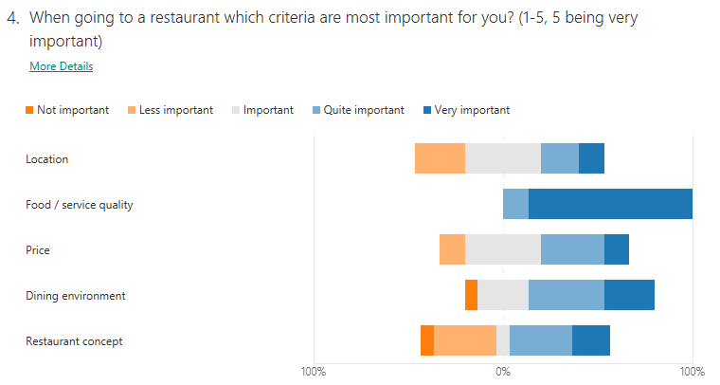
Research in restaurant business show that people are looking for quality of food and service instead price, location, or any other criteria.

As Kurtus (2008) said: “The quality of food and service in a restaurant is defined as meeting or exceeding the expectations of the customer as if promised by the restaurant.” The results from this question show us that people are expecting quality before the price and other criteria, this being the most important criteria for the customers.

3.2 Marketing Mix
Since the 1940s the Marketing mix paradigm was an important tool for managers to run and develop their businesses. In 1964 E. Jerome Mc Carthy has developed this idea and defined the principle of “4Ps”. Nowadays marketing managers must learn to deal with new marketing elements that have emerged from the online world of the internet. Marketing Mix is used by marketers to help their businesses determine a product or brand offering. According to Mc Carthy (1960): “the number of possible strategies of the Marketing Mix is infinite.”
However, the marketing mix most commonly remains based on 4Ps. This framework keeps strong and a staple of the marketing mix. (Kent and Brown, 2006) The components of the marketing mix can change an organisation`s competitive position.
The 4Ps are:
- Product
- Price
- Place
- Promotion
1.The product was presented above
2. Price
A product must be always seen as representing good value for money.
By analysing our competitors, we establish advantageous prices for customers. In the beginning we consider a low rate of profit to attract as many customers as possible. We want to make our restaurant well- known on the market. Our product will not be under-priced otherwise people may think “too good to be true”. It is not necessarily for a product to be cheap in order for it to be bought. One of the main aspects of the marketing concept is that consumers are usually happy to pay a little more for something that works well for them.
We use different strategies, like psychological pricing. For example, charge £9,99 instead £10.
According to Mealey (2019): “food cost and portion control are two things that will help us price the menu correctly.”
First of all, the location is carefully chosen. Somewhere in the City Centre, where thousands of people are shopping, or on High Street will be a good place for this business. There is also car parking close to the restaurant.
As the results of Questionnaire show us that location is important for 68,8% from respondents. They will be happy to visit our restaurant in the City Centre.
4.Promotion
Promotion means the usage of all the communication techniques to tell people about our products / services. Advertising, Sales Promotion and, in more recent times, Social Media are key communication tools for a business.
There are many ways to offer discount to our clients.
- One of them is to become partner with Just Eat, or Cashback world. These are two of many other organisations, which send customers to buy from your business, giving them a special discount. It is a win-win partnership because the discount is paid after the consumer purchased our product.
- A second way to advertise our restaurant is by the distribution of flyers. These flyers have a cost that must be considered.
- In addition, we can design a marketing promotional poster for the restaurant, which could be displayed at bus stops, or posted online on TripAdvisor. (this involves costs). For example, to display one electronic poster in bus station for one week it costs £110. It is a good opportunity and not so expensive. Before inaugurating the restaurant to keep posted the poster for one week can be very successful for our business.
- To save money we could design a website for our restaurant. The website gives many opportunities for the business:
  - Provides customers with a wealth of useful information: location, opening hours, menu, photos, reviews, etc.
  - People can book tables or organise an event.
  - People can make suggestions and talk about their experience in our restaurant.
  - People can be informed about events organized in the restaurant such as: live music, stand-up comedy, or themed evenings.
- The presence on Social Media is also a great approach for advertising our healthy options to make the familial restaurant known. It is important to satisfy this growing demand. Therefore, in addition to our website, we must have pages on Facebook, Instagram, Twitter.

4.0 Physical Resources
The equipment required should make a difference between the kitchen, restaurant room and the auxiliary spaces.
Item | Quantity | Price | Value
Exhaustion Fan with filter and lights | 1 | 730 | 730
Hoover Gas Hob with Multifunction Oven | 1 | 349.99 | 349.99
Microwave 900W | 1 | 159.99 | 159.99
Twin Professional Fryer | 1 | 39.99 | 39.99
Electrical Hand and Stand Mixer | 1 | 84.99 | 84.99
Freezer | 2 | 339.99 | 679.98
Fridge | 2 | 179.99 | 359.98
Steel table | 3 | 29.99 | 89.97
Item | Quantity | Price | Value
Saucepan 11L | 1 | 16,67 | 16,67
Steamer 3 bowls | 1 | 19,67 | 19,67
Saucepan 32 cm | 2 | 20 | 40
Non-stick Chip pan | 4 | 12 | 48
Fry pan set 3 pieces | 2 | 21 | 42
Steel bowls set 3 | 2 | 18 | 36
Trays | 6 | 12.50 | 75
Boards set 4 | 1 | 12 | 12

Total cost for kitchen equipment is £2784.23
After we spend all this money for a well-equipped and spacious kitchen, it will look
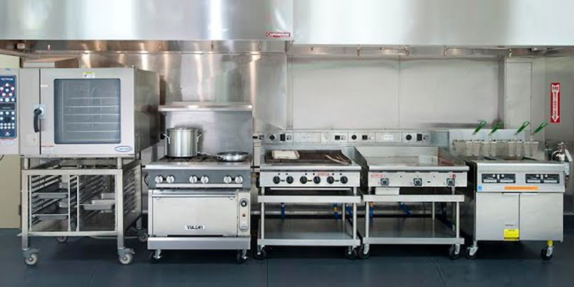

Equipment Restaurant room
Item | Quantity | Price | Value
Tables set with 4 chairs | 12 | 136 | 1632
Plates set 4 | 10 | 12 | 120
Dessert plates set 4 | 10 | 12 | 120
Bowls set 4 | 10 | 10 | 100
Item | Quantity | Price | Value
Cutlery set 24 | 10 | 5 | 50
Knives set 6 | 1 | 8 | 8
Glasses wine set 12 | 10 | 4.5 | 45
Glasses red wine set 6 | 10 | 12 | 120
Champagne flutes set 4 | 10 | 8 | 80
Soda Glasses set 8 | 5 | 12 | 60
Juice glasses set 4 | 10 | 8 | 80
Cocktail glasses set 12 | 5 | 13 | 65
Sony Audio Light up System | 1 | 179.99 | 179.99
Software for restaurant | 1 | 100/  month

Total cost for equipment restaurant is £2659.99, money which must pay immediately, plus £100 monthly for Software.
The restaurant room is looking simple, elegant and friendly.
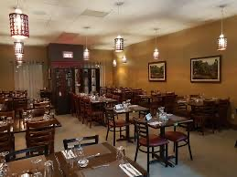

There are cost for staff uniforms:
Item | Quantity | Price | Value
Chef jacket | 6 | 9.99 | 59,94
Chef trousers | 6 | 9.99 | 59.94
Chef hat | 10 | 2.49 | 24,90
Chef apron | 10 | 2.49 | 24.90
Waiter T-shirt set 6 | 3 | 12 | 36
Waiter trousers | 6 | 9.99 | 59.94
Waiter pocket-apron | 10 | 2.49 | 24.90
Total |  |  | £514.62

So, the cost with physical resources required for our business represent an amount of £5958.84. If we consider a margin for unforeseen expenses, we could say will need about £6500.

5.0 Financial Resources
Nowadays there are many ways to raise funds for starting a small business. According to Hall (2013): “Finding finance is one of the most important tasks facing any small business owner.” This was the first point of discussion of the four entrepreneurs in the board meeting. Oliver and Virginia will participate with a capital of £ 2000, as well as Julia and Thomas with £2000. So, the owners will participate with their saving, as a personal investment, that means a total capital of £4000. This capital is not enough for opening the restaurant. We discussed about get funds from a business `angel`, but this kind of investor participate in the beginning with a capital, do not work in the business and might want to control the business. This seems too hazardous to all of us.
Therefore, we have decided to access a bank loan. Our personal investment will help us to access a bank loan, they will see our commitment in this business. Loans have the advantage a fixed rate, we will know the date and how much we must repay every month. For this we should present a feasible and complete business plan to prove that our business has a viable strategy for growing.
Analysing our expenses, we need £6500 only for equipment and uniforms. There are more costs, like: register tax, insurance, corporation tax, rent for venue, advertising costs. For covering all these expenses, we decided to access £10000 as bank loan. Julia, the finance manager went to several banks and we must repay monthly £250, which is a reasonable amount for our business.

6.0 Human Resources
All of us will involve directly in the work team of our restaurant. Oliver has been working more than 15 years chef in different restaurants and pubs around the UK. He will be our specialist in food, menu, and will interview the candidates for cook, assistant kitchen. Because he has a clear mind, he will be General Manager.
Thomas is a very good with handling things and has driving license; he will be for maintenance, and occasional driving, when is required. He will manage the cleaning team as well as security and order.
Like I said previously, Julia is the Finance Manager, she has an extensive experience as an accountant. She will manage expenses, invoices, tax, loan repayment to bank and will have relationship with suppliers.
I, Virginia will be Marketing manager managing customers service, the restaurant website, the trend in this industry, the competitors. I have to stay focus on identifying consumers` needs. Oliver, Julia and I will manage recruitment, selection and training for new staff. We established to have board meeting twice a month, Julia and I to supervise daily the incomes.

For the beginning we need for our teamwork 15 people:
  - 2 cooks
  - 2 assistants' kitchen
  - 6 waiters
  - 3 cleaners
  - 2 bartenders.
All jobs will be advertised first of all at Job Centre, on recruitment websites and on the location.
As we were informed from questionnaire results friendliness of staff is very important for consumers, as well as cleanliness into the restaurant.
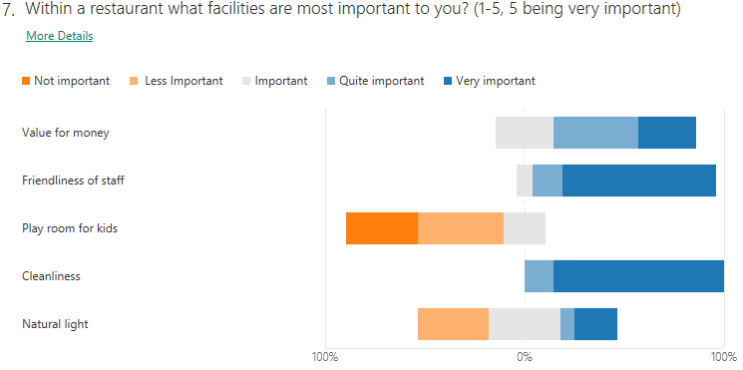
Thus, we must pay attention to recruitment process to select the right personnel and the induction time to emphasize the essential skills, like communication, professionalism, politeness.
7.0 SWOT Analysis
Strengths Weakness
- Venue in the City Centre, very good position - New business, new concept,
- Homemade and healthy meals - Starting business with bank loan, high risk
- Using only fresh, organic raw materials, - Many competitors with loyal customers,
- 15 years` experience cooking in 5 * restaurants - Without market share and loyal customers,
- Excellence in cleanliness - No market positioning, no reputation.
- Friendly and professional staff - Competitors might offer cheaper products

Opportunities Threats

- Our concept can be a success - High risk of economic times.
- Healthy and homemade food- growing demand -Changing regulation of tax because Brexit
- People are looking to clean environment, it is - Every year the salaries are rising, which is
Very important for them a most important cost in business
- Expand business with food delivery - A various range of restaurants in the area
- Keep individual relationship with the customers - Low purchasing power of the population
and make a loyal network of customers

8.0 References
- Adair, J., (2016) Decision Making and Problem Solving 3rd Edition, Kogan Page Limited: London
- Kent, T. & Brown, R. B., (2006) Erotic Retailing in the UK (1963-2003)- The View from the Marketing Mix. Journal of Management History, 12(2), 199-211.
- Kurtus, R. (2008) Quality in The Restaurant Business. Available at: http://www.school-for-champions.com (Accessed: 15 June 2020)
- Hall, J. (2013) Complete guide to small business finance Available at: http://www.simplybusiness.co.uk (Accessed/; 17 June 2020)
- Mealey, L. (2019) how to Price Your Restaurant Menu Available at: http://www.thebalancesmb.com (Accessed: 15 June 2020)
- Mc Carthy, E.J. (1960) Basic Marketing A Managerial Approach IL: Richard D. Irwin
- Mc Carthy, E. J. (1964) Basic Marketing, IL: Richard D. Irwin
- NPD Group (2018) Casual Dining still pulling in the punters. Available at: http://www.npdgroup.co.uk (Accessed: 14 June 2020)
- Rawson, K.& Shore, E. (2019) Dining Out: A Global History of Restaurants Reaktion Books: London

- www.argos.co.uk
- www.amazon.co.uk
- www.outdooradvertisingltd.co.uk

9.0 Appendices
9.1 Questionnaire New Business: Familial Restaurant

9.2 Job description
9.2.1 Cook
Cook work in a variety of setting to prepare, cook and plate food.
Responsibilities:
- Work in different section of the kitchen, helping the chef de partie
- Be responsible for food preparation and basic cooking and also learn about portion size
- Listen to instructions and work as part of a team
Skills required:
- Technical skills (cooking, store and serve food)
- Ability to work without supervisor
- Hard-working and calm approach
- Attention to details to ensure consistent, high standards
- Commitment and loyalty
- Teamwork and communication skills
- Flexibility
- Self-motivation
- An understanding of food hygiene and health and safety

9.2.2 Waiter/ Waitress
Waiters / Waitress are responsible for taking orders and serving food and beverages to customers.
Responsibilities:
- Provide excellent customer services
- Always strive towards best customer satisfaction
- Make suggestion based on customers` preferences
- Greet customers and present menu
- Take and serve food/ drinks orders
- Arrange table setting
- Keep tables clean and tidy at all times
- Check products for quality
- Deliver checks and collect payments
- Cooperate and communicate with all serving and kitchen staff
- Adhere to all relevant health department
Skills required:
- Critical thinking and problem solving
- Team player
- Good time-management skills
- Great interpersonal and communication skills
- Active listening
- Customer-centric
9.2.3 Kitchen assistant
Responsibilities:
- Properly cleaning and sanitizing all food preparation areas according to established standards of hygiene
- Washing and appropriately storing all cooking appliances, instruments, utensils, cutting boards and dishes
- Assisting the cook with the preparation of meal ingredients, which includes washing, cleaning, peeling, cutting, and chopping fruits, vegetables
- Organizing and correctly storing food supplies
- Teamwork abilities
- Excellent organizational and time management skills
- Effective communication skills
- Knowledge of food health and safety regulations.

