

Ellie Martin

Design of shape charge
ACDB5015

UWTSD
Ordnance munitions and explosives

Academic Year: 2025 - 2026

Supervisor: Professor Kelvin Donne
Academic integrity declaration
I declare that:
- the thesis submitted has been written by me alone.
- the thesis submitted has not been previously submitted to this university or any other.
- that all content, including primary and/or secondary data, is true to the best of my knowledge.
- that all quotations and references have been duly acknowledged according to the requirements of academic research.
I understand that to knowingly submit work in violation of the above statement will be considered by examiners as academic misconduct.

Abstract
This study analysis how variations in the internal cone angle of a shaped-charge liner influence jet formation, deformation behaviour, and overall performance using numerical modelling in Abaqus. Shaped charges rely on the controlled collapse of a metal liner under explosive loading to generate a high-velocity jet capable of penetrating dense materials. While material models for liner metals and explosives are well established, the geometric optimisation of the liner remains a critical design parameter. Two alternative cone angles—33.69° and 25°—were modelled and compared against reference geometries to assess their effects on velocity, strain, and stress evolution during collapse.
Axisymmetric 2D simulations showed that both designs produced high-velocity jets between 9,000–9,600 m/s. However, the 33.69° configuration demonstrated a more coherent and stable collapse, characterised by a concentrated plastic-strain region, smoother stress-time response, and a more uniform velocity gradient. Although the 25° design achieved a slightly higher peak velocity, it exhibited reduced jet mass and greater instability, indicating lower practical effectiveness. Mesh refinement and adaptive meshing attempts highlighted the limitations of purely Lagrangian formulations, with excessive distortion and node overlap frequently causing simulation failure.
A 3D extension of the model revealed additional challenges, including mesh-density constraints, boundary-condition inconsistencies, and overclosure at material interfaces, preventing full jet formation. Smooth Particle Hydrodynamics (SPH) was explored as a mesh-free alternative and successfully produced a small jet–slug structure, though with reduced velocity and incomplete simulation progression.
Overall, the findings show that moderate reductions in cone angle significantly influence shaped-charge performance, with the 33.69° design offering the most mechanically efficient behaviour. The study also highlights the need for advanced numerical techniques—such as coupled Eulerian–Lagrangian or fully Eulerian formulations—to accurately model extreme deformation and jet breakup in future work.

Table of Contents
1 Introduction 10
1.1 History and contextual applications 11
2 Literature review - 12
3 Design considerations 13
4 Abaqus Parameters 15
Abaqus - 2D designs 16
4.1 Reduced internal angle of liner 20
4.2 Comparison of 2D designs 22
4.3 Adaptive meshing 27
5 Abaqus – 3D design 30
5.1 Smooth Particle Hydrodynamics 34
6 Comparison of 2D vs 3D Design 36
7 Conclusion 38
8 References 40
Appendix A - Refined mesh D1 results 44
Appendix B - Node selection 45
Appendix C – 3D vs 2D graph comparison 46

List of Figures
Figure 1 Figure 1- Shape charge configuration [1] 10
Figure 2 - Shape charge geometry [10] 14
Figure 3 - Design 1 liner sketch 17
Figures 4.1 & 4.2 - Meshing comparison 17
Figure 5 Velocity gradient 18
Figure 6 -'optimal' SC jet velocity gradient [10] 19
Figure 7 - Overlapping nodes 20
Figure 8 - Pressure graph 21
Figure 9 - Design 2 sketch 22
Figure 10 - Velocity gradient D2 22
Figure 11 - Design 1 Velocity difference 23
Figure 12 – Velocity comparison 24
Figure 13.1 & 13.2 - Max principal comparison 25
Figure 14 - Strain comparison 26
Figure 15.1 & 15.2 - S22 comparison 27
Figure 16 - S22 time graph 28
Figure 17 - motion of mesh with different methods [16] 29
Figure 18 - ALE Job abortion 30
Figure 19 - 3D design failure 31
Figure 20 - 3D Detonation wave 32
Figure 21 - 3D Simulation 33
Figure 22 - 3D HE boundary breach 34
Figure 23 3D strain- time graph 35
Figure 24 SPH Abortion 35
Figure 25 - SPH meshing 36
Figure 26 - SPH velocity gradient 36
Figure 27 - 3D vs 2D PE comparison 38
Figure 28 - 3D vs 2D velocity gradient 38

List of Tables
Table 1 - Material parameters [11,12] 15
Table 2 - Material properties for HMX [13,14,15] 15

List of Equations
Equation 1 – Johnson-Cook Stress [19] 12
Equation 2 - The Jones, Wilkins & Lee model [15] 13

Introduction
A shape charge is an explosive configuration which concentrates large amounts of energy in one direction and has multiple applications in the military and industrial demolition space- these devices are used for cutting and penetrating aerial, land and even underwater targets [1]. Figure 1 depicts a generalised design of a shape charge consisting three of the main components which upon detonation have the capability of penetrating through extremely tough materials.
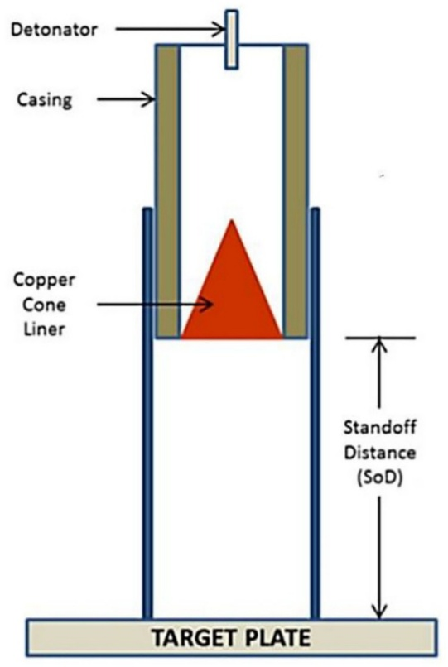

Figure 1 - Shape charge configuration [1]
Figure 1 Figure 1- Shape charge configuration [1]

The cylindrical explosive charge has a hollow cavity and a metal liner which undergoes extreme plastic deformation upon detonation [2]. Figure 1 gives the example of a copper cone being utilised, the case can be made from different metals such as steel and aluminium depending on the intended purpose of the shape charge, a thicker steel would be more appropriate for producing fragmentation a thinner aluminium case would be utilised for the primary purpose is blast. The detonator is located at the opposite end of the charge to the liner and upon detonation the detonation point will produce a detonation shockwave which pushes the case out and constrains energy down towards the cone. The detonation will hit the apex of the cone causing it to invert and produce a high-speed jet capable of penetrating material at very high velocities.

History and contextual applications
The shape charge has various different contextual applications because of their capability to focus explosive energy with extreme accuracy and uses date back as far as World War I where it is proclaimed that they were used by the Germans [3]. Weapon and the mining industry focused their attention on the use of lined cavity shape charges following the research conducted by R.W Wood who discovered that a dimpled blasting cap produced a high velocity from a copper sheath [3]. The use of these Manroe bombs and shape charges grew in popularity in defence however, the civil industry overlooked key principles into how this capability could be utilised. For example, tests were conducted using the shape charge as a secondary blast tool to break materials apart- opposed to using it so punch a hole through tough materials [3]. The military applications continued to thrive and were used in World War II in anti-tank warfare the American Bazooka being an example of this capability [4].
Civil engineering also utilises the energy output produced from shape charges as it has the ability break apart rock and create long cracks in oil exploration [4]. Due to the lack of resources and inability to precure high brisance, high velocity explosives which were required in liner cavity charged the early investigations were deemed a failure [6].

Literature review -
When a shape charge is subjected to adequate stimulus such as heat, shock or friction [8] and has been provided with sufficient energy to cause detonation, a supersonic shockwave propagates through the explosive material with the evolution of heat and gas. The detonation wave hits the cavity of the liner causing it to collapse inwards forming a high velocity jet of metal [2]. The liner which originally behaves as a solid, due to the enormous pressure wave compressing it to from the detonation causes it to behave as a fluid. The Euler equations describe the conservation of mass, momentum, and energy in a compressible fluid [8].
Due to the complexity of modelling the behaviour of the shaped charge requires both fluid and material models. The products produced by the explosive are represented typically by thermochemical equations of state, to describe their pressure–volume–energy relationships. This contrasts to the behaviour of the metal liner which experiences high strain rate plasticity [9].
Therefore, employing Johnson-Cook (JC) stress model Equation 1, as well as Largranian allows for the deformation of the jet and the extreme distortion which is experienced by the liner to be captured. The Lagranian approach is used where each finite elements of mass of material distorts Another numerical method utilised is the Eulerian approach which is a completely different paradigm. It is a fixed mesh which never moves- the material moved through the fixed mesh.

$$\text{σ}=\left(A+Bε^{n}\right)(1+C \ln{\dot{ε^{*}) (1- T^{*m})}}$$
Equation 1 – Johnson-Cook Stress [19]

The Johnson-Cook model is utilised because it captures the different behaviours which occur in the metals- the model is able to represent how metals strengthen, stiffen, and then weaken as they deform rapidly, making it well suited for shaped-charge liner collapse and other extreme-rate applications.
In addition to the Johnson-Cook model, the simulation also used the Jones, Wilkins & Lee model to describe the expansion detonation products alongside the energy and pressure [15].
$$P=A\left(1-\frac{ω}{R_{1}v}\right)e^{-R_{1}v}+B\left(1-\frac{ω}{R_{2}V}\right)e^{-R_{2}v}+\frac{ωe_{0}}{v}$$

Equation 2 - The Jones, Wilkins & Lee model [15]

Design considerations
From the literature review conducted it was apparent that the typical composition consisted of a steel casing, high explosive (HE) and a metal liner such as aluminium or copper [1]. There are multiple components which can be altered to maximise the performance from a shape charge. The aim of this paper is to explore the effect of altering the internal cone angle of the metal liner impacts the overall performance of the system opposed to changing the materials.
Figure 2 - Shape charge geometry [1] depicts a geometric configuration for optimal performance with an internal cone angle of 45˚C following the research conducted in Sandia’s Shaped Charge Analysis Program (SCAP) [10].

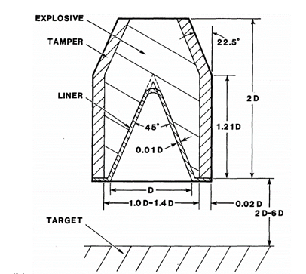
Figure 2 - Shape charge geometry [10]
A criticism from the conducted literature review, there is a lack of UK published shape charge design available. It is suggested that this is due to the sensitive nature of the use of shape charges as a system there are limited UK based research published into the effectiveness and performance. This research would have been more interesting if a comparison could have been made in the different approaches considered by multiple nations. However, due to the scarcity of UK-based published research this was not possible.

Abaqus Parameters
The material parameters displayed in Table 1 are for the JC material model- A, B and C are all linear coefficients - For this model it has no JC damage parameters have been used. Table 2 displays the material properties for HMX which is the explosive fill being used in these designs.
Table 1 - Material parameters [11,12]
Material | A  (MPa) | B  (MPa) | n | m | C | Ρ  (${kgm}^{-3})$ | E  (GPa) | V | $$θ_{transition}$$ | $$θ_{melt}$$
Magnesium | 172 | 360.73 | 0.45592 | 0.95 | 0.092 | 1780 | 45 | 0.34 | 293k | 922k
Steel | 305 | 600 | 0.234 | 1 | 0.013 | 7850 | 210 | 0.27 | 293k | 1733k
Table 2 - Material properties for HMX [13,14,15]
Ρ  (${kgm}^{-3})$ | Velocity for detonation  (${ms}^{-1})$ | A  (GPa) | B  (GPa) | R1 | R2 | ω | Pre- detonation bulk modulus  (GPa) | Detonation energy density  (${Jkg}^{-1})$
1891 | 9110 | 778.28 | 7.0714 | 4.1 | 1 | 0.3 | 12 | 5526000

No Johnson Cooke damage parameters were implemented in this modelling this would remove the distorted elements, and the jet formation would not have been visualised.

Abaqus - 2D designs
The design of a shape charge can be divided into three main components; the casing, the HE main charge and the metal liner. The materials of choice are steel for the casing, HMX for the explosive fill and magnesium for the liner. All parameters for these materials are displayed in Table 1 and Table 2. To reduce the computational time of the simulation this study has utilised the plane of symmetry as the Abacus visualizer allows you to reconstitute using mirroring. This means by sketching 180˚ of the part as seen in Figure 3 can mirror the illusion of a full 360˚ part, this is important to help reduce the amount of meshing required.
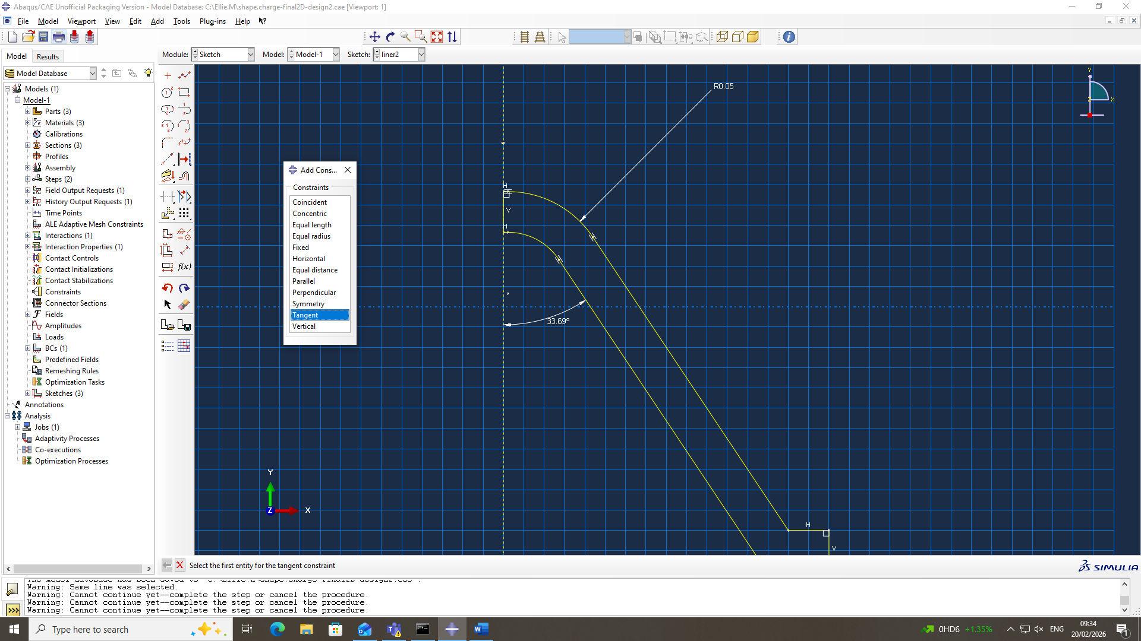
Figure 3 - Design 1 liner sketch
From the research conducted by Phillip Muligan suggests that the optimal internal angle for the liner Is 45˚ [10] as seen in Figure 2. The angle was reduced to 33.69˚ (Figure 3) to analyse the effect on the velocity, pressure and also stress rates which were achieved below what research has proven produces an effective shape charge.
The first meshing approach was using quadrilateral elements which have a node at each vertex as well as the middle of each side. As seen in Figures 4.1 shows a global mesh being applied focusing a finer mesh for the HE and the liner opposed to the casing.
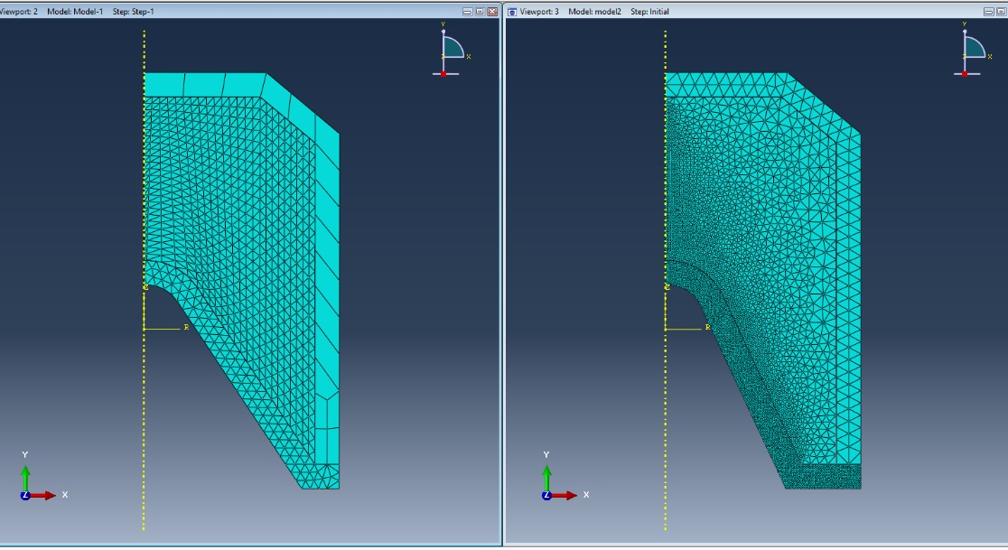
Figures 4.1 & 4.2 - Meshing comparison
Due to the simplicity of mesh, the simulation was able to run to completion. A well-defined velocity gradient characteristic of jet formation was observed from the liner with a considerable amount of mass opposed to just a singular element as seen in Figure 5. The velocity at the tip of the jet reached 9100 m/s and displays the expected jet shape observed in literature. Figure 6 depicts a jet formed from a shape charge which was considered to have the optimal parameters previously discussed and observed in Figure 2.

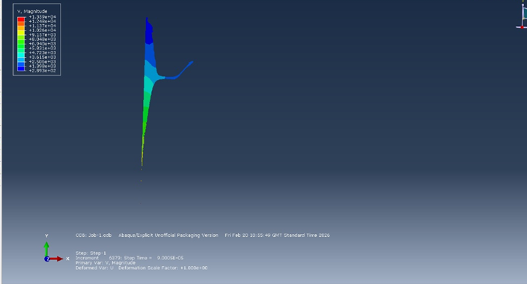
Figure 5 Velocity gradient
When comparing the velocities achieved between the reduced internal angle and the results achieved by Phillip Mulligan where the charge also reached 9000 m/s. It was apparent that the reduction in angle did not negatively affect the velocity which was produced. It is important to note the comparable data results were based on a physical trial consisting of slightly different compositions where other contributing factors were measured, such as stand of distance (SOD). This report focuses on the mathematical based simulation where the SOD was not applied and will not be mentioned further.
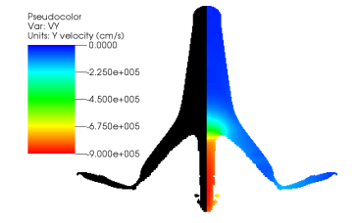
Figure 6 -'optimal' SC jet velocity gradient [10]

It was determined that a more sophisticated mesh was needed to accurately run the simulation. Refinements were made to the mesh, one of which was introducing a graduated mesh with a bias to reduce the mesh size of the HE which is in close proximity to the vortex of the liner. This is because the vortex is where the detonation will be hitting the liner first. This means a high resolution is required in that area and less time was spent on the peripheral areas such as the casing which can be seen in Figures 4.2.
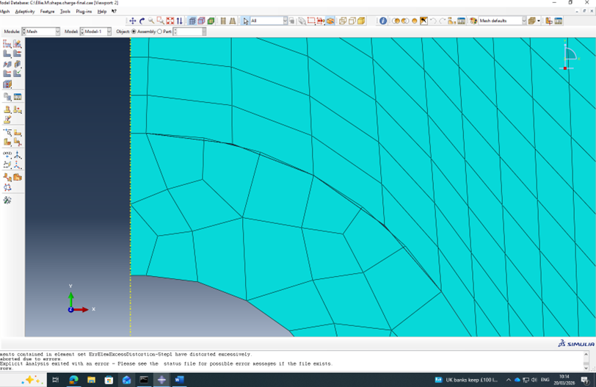
Once the meshing refinements were implemented a new simulation, however the job did not run to completion due to excessive distortion being experienced by the elements in the liner when the detonation wave hits the vortex of the liner. Upon further inspection on the mesh of the liner on the boundary of the HE there were nodes overlapping as seen in Figure 7 which was causing the simulation to abort prematurely for these resulted refer to Appendix A.
Figure 7 - Overlapping nodes

Figure 8 shows pressure time graph, where a classic transient shock wave peak is observed. The near-vertical rise to an extreme high pressure peak indication the exact moment of detonation. This is then followed by a series of dampened oscillations demonstrate the materials stress waves reflecting following the initial shock front has passed. This loses energy through the plastic deformation.
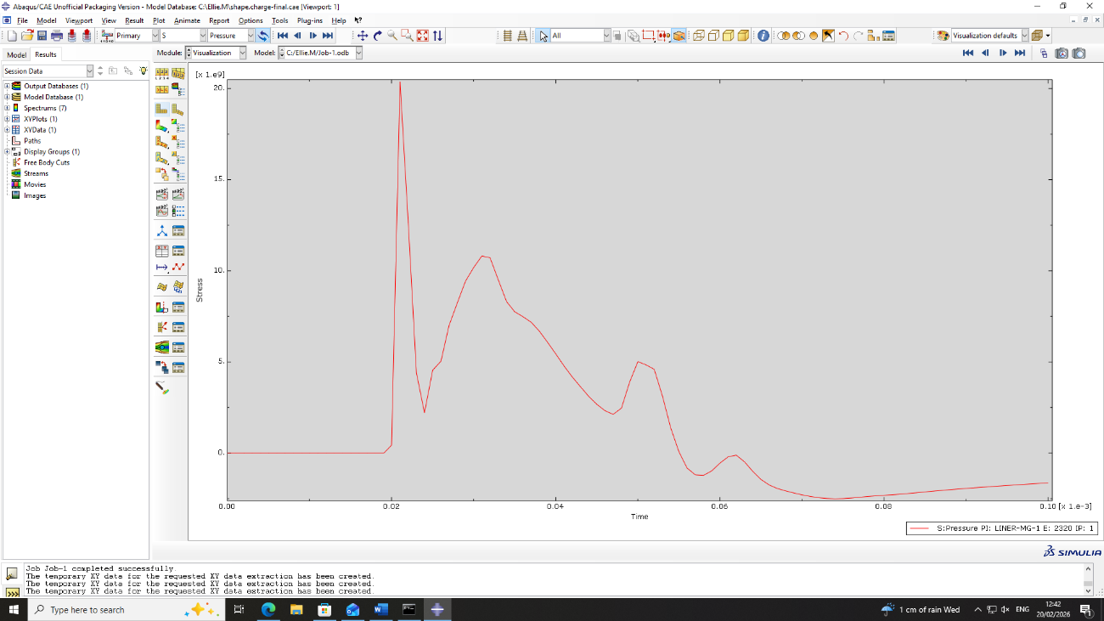
Figure 8 - Pressure graph

Reduced internal angle of liner
Following on from the intial design achieving a very healthy result, it was decied to further reduced in internal angle of the liner to 25˚ as seen in Figure 9 and compare the achived results. All of the other material parameters remain identical to the intial design in Figure 3. When generating the second design the boundary conditions wasn’t defined correctly through line of symmetry. The reference points were correlating to original 2d design so the programme unable to mirror the shape correctly.

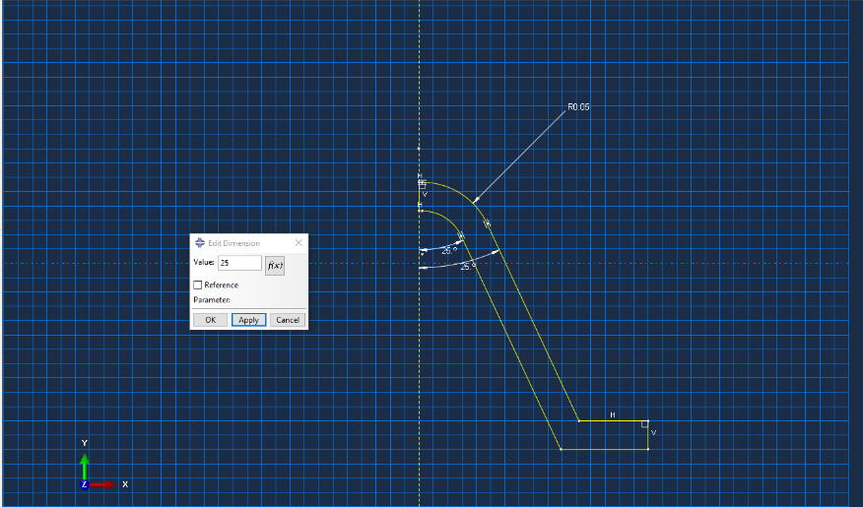
Figure 9 - Design 2 sketch
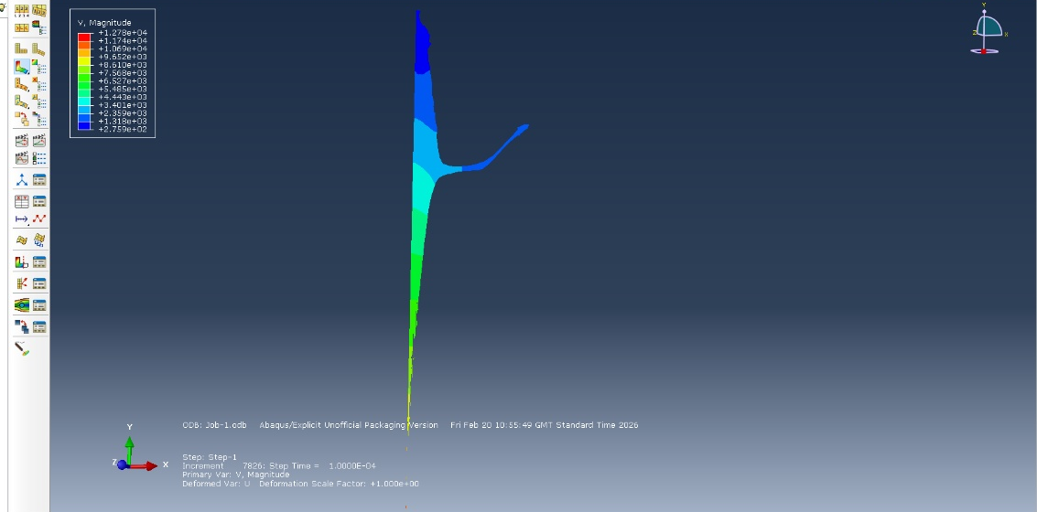
The reduced internal angle of the liner sucessfuly produced a significant velocity gradient compartive to the first design in Figure 5. The velocity at the tip of the jet reached 9600 m/s which is marginally faster however there is less mass in the jet and possess the ‘optimal’ shape demonstrated Figure 6 which has been discussed in the literature review.

Figure 10 - Velocity gradient D2
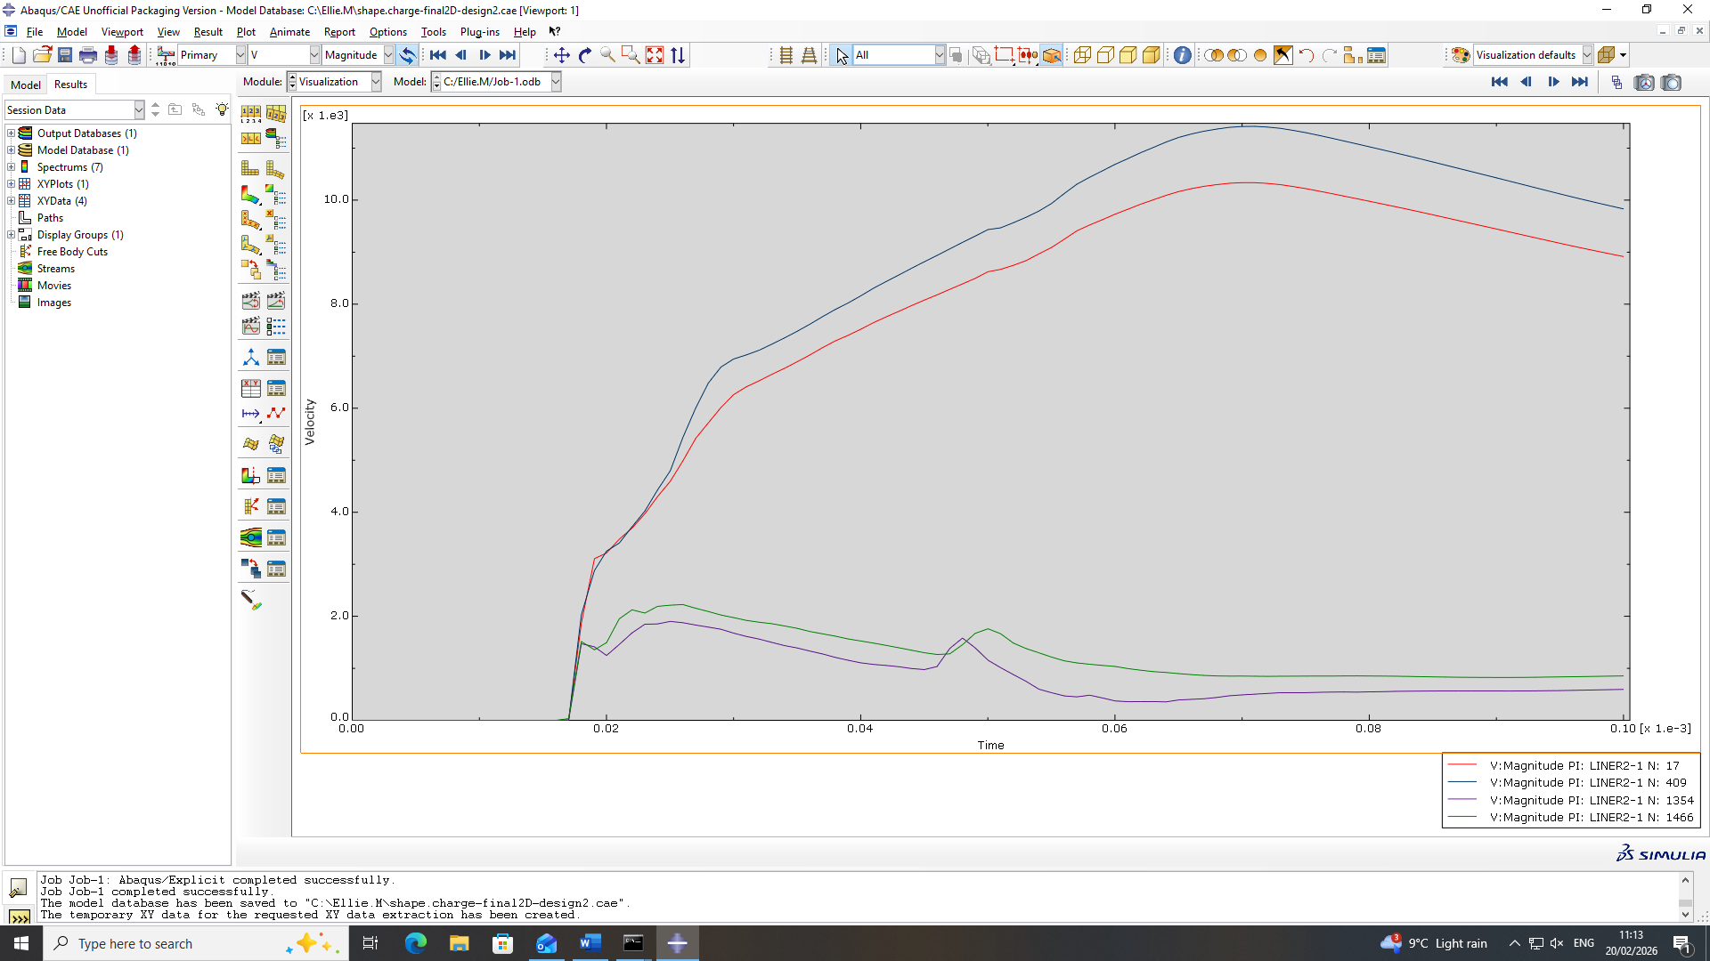
Figure 11 - Design 1 Velocity difference
Figure 11 demonstrates the velocity from the tip of the jet formed and the back of the jet. The two nodes which reach a higher peak velocity demonstrates a smooth transfer of energy from the HE into the liner. The nodes with the lower velocities depict the energy which Is reflected is less stable during the deformation of the liner.

Comparison of 2D designs
When evaluating the two alternative designs it has allowed for the accurate comparison of variations experienced in the velocity, stress, and strain rate upon detonation whilst ensuring the material parameters remained identical- thus not a variable for consideration in the results. In this section the design responses from the simulations will be compared, allowing for the design which provides a superior mechanical behaviour to be identified whilst understanding the limitations experienced.
Figure 12 depicts the velocity- time curves for both designs – The 1st design (red) experiences high peak velocity with a sharper rise that the second design (blue). Thus, indicating this shape charge allowed for a more efficient transfer of detonation energy into the liner. In contrast, the blue curve rises more slowly and peaks slight later and reaching a marginally higher peak velocity this will directly impact the quality of the jet formation and also penetration abilities- however there isn’t a large difference in the velocity output.
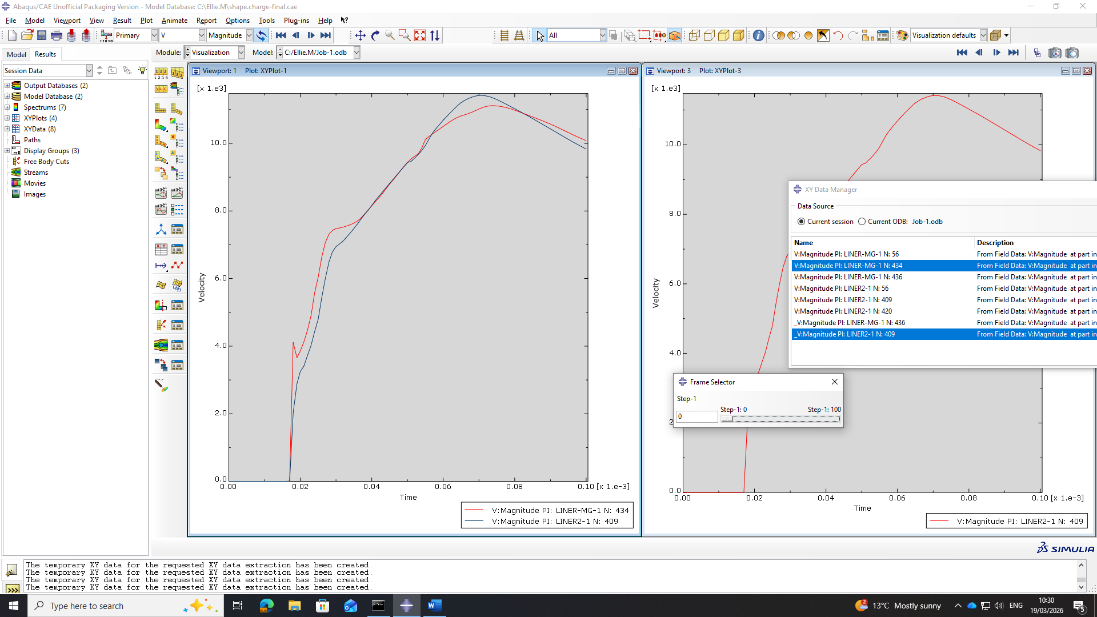
Figure 12 – Velocity comparison
When selecting the nodes for these comparisons it was identified that picking the exact same node in both designs would not be an acceptable comparison. Appendix B depicts the location of the nodes which were selected to be used for the comparison and subsequently formed part of the tip of the jet.
Below it can be observed in Figure 13 the first design in Figure 13.1 exhibits a tighter region of high plastic strain, forming a concentrated red zone. This suggests that the deformation is being channelled into a very narrow path upon collapse. The second design in Figure 13.2 shows a broader spread with the
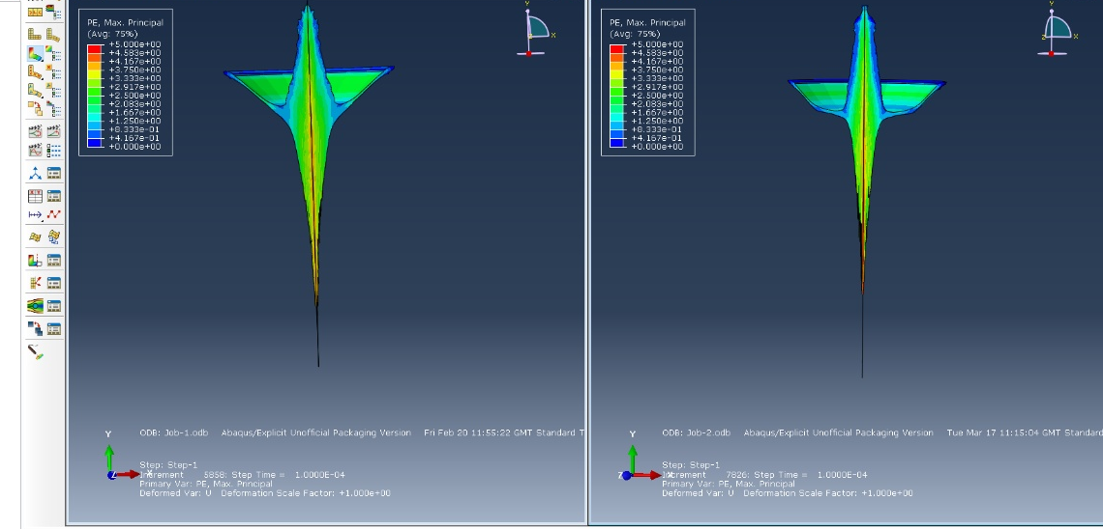
strain rate regions being distributed over a larger area. This again indicates that the 1st design is more efficient.
Figure 13.1 & 13.2 - Max principal comparison
The strain–time graph in Figure 14 below reinforces this interpretation. The red curve (Design 1) reaches its peak strain earlier and rises more sharply, showing that this design undergoes faster and more intense deformation at the measured node. The blue curve (Design 2) increases more gradually and reaches a slightly lower plateau, indicating a slower, less concentrated collapse. Both curves eventually level off, but the timing and steepness of the red curve demonstrate a more aggressive and energetically efficient response.

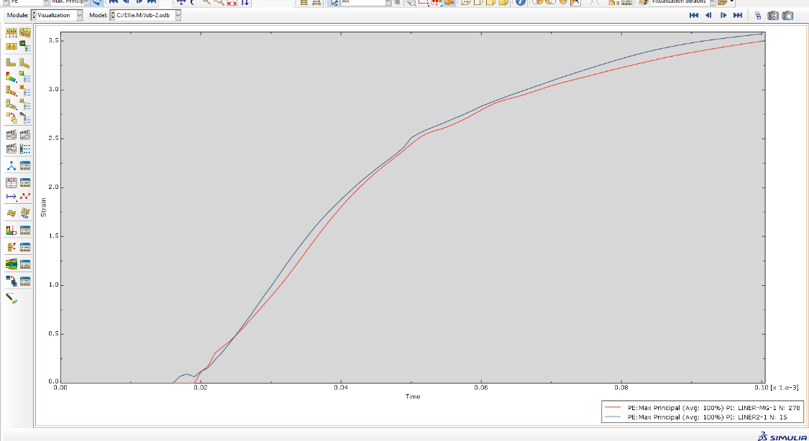
The jet is plotted in Figure 15 is referring to the stress action faces perpendicular to the y-axis and directed along the y-axis. The left jet Figure 15.1 shows a more continuous and concentrated S22 distribution along its length, indicating a more coherent, stable jet and a smoother, more symmetric liner collapse. The right jet Figure 15.2 however, exhibits a more irregular S22 pattern with stronger local variations, suggesting higher instability, earlier jet breakup, and a less efficient collapse. This contrast in S22 fields highlights that the left design is mechanically better optimized for penetration than the right.
Figure 14 - Strain comparison
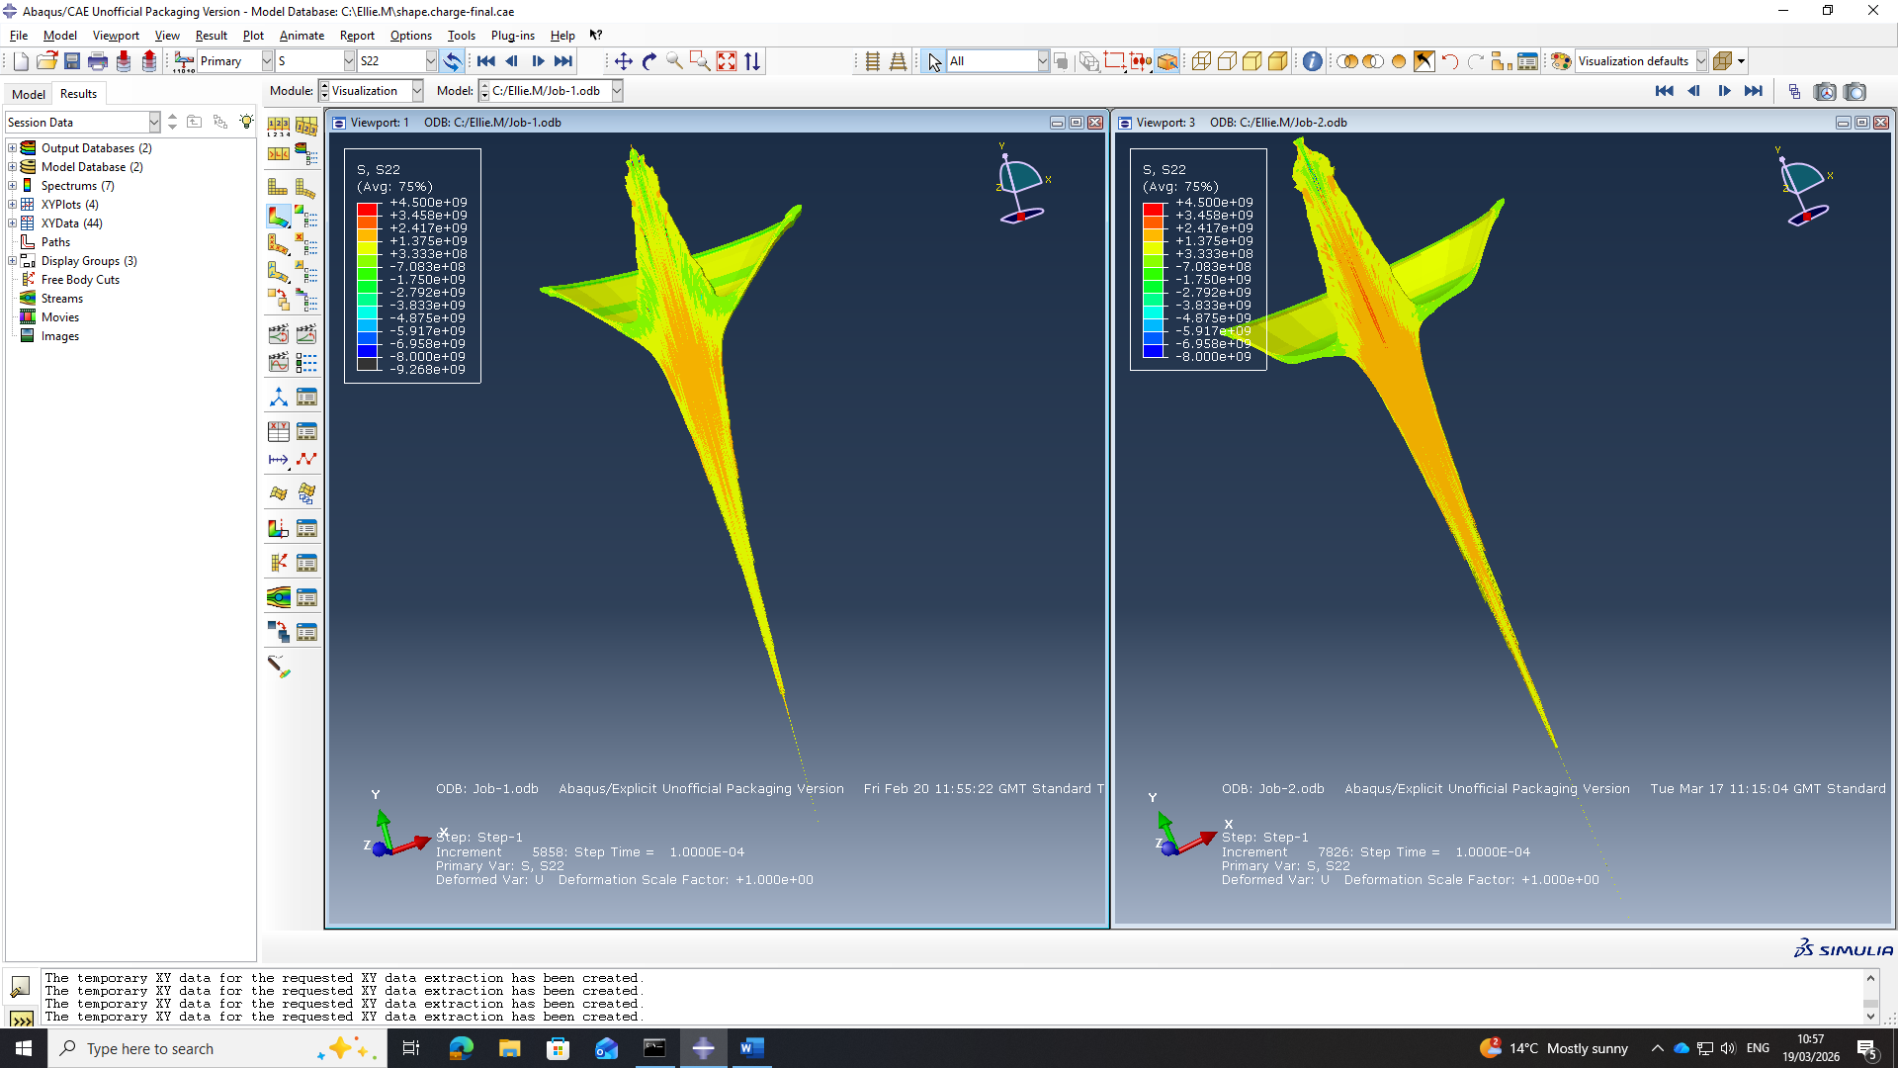
Figure 15.1 & 15.2 - S22 comparison
The stress-time graph in Figure 16 depicts that both designs undergo a uniform liner collapse and stable jet elongation. However, the first design presents a more coherent stress distribution throughout the jet. This contrasts to the second design where there is greater fluctuation, this does suggest that the liner deformation is slightly uneven and has more instability.
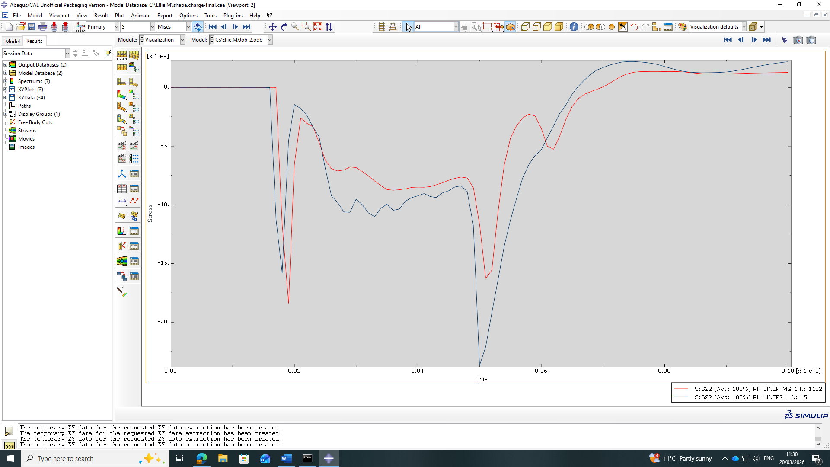
Figure 16 - S22 time graph
The most obvious finding to emerge from the analysis Is that the first design demonstrates a more efficient and uniform liner collapse. All three data sets discussed: velocity, strain and stress show the same trends. The velocity achieved from the first design even though is marginally lower as seen in Figure 11 – The second design achieves a higher velocity slower and is more sporadic in comparison. This encompassed with an uneven strain rate experienced in the liner and also more abrupt fluctuation in the stress values suggests that the first design would be a more effective shape charge in terms of penetration and efficiency.

Adaptive meshing
In both designs it was apparent that the refinement of the mesh was detrimental to the simulation and without an effective mesh the job aborts and results cannot be visualised. This is because as the mesh excessively distorts which occurs when materials undergo rapid deformation [18]. Arbitrary Lagrangian Eulerian (ALE) adaptive meshing is a technique that can be applied to a simulation just before it crashes to try and disentangle the distorted tetrahedron based on their distortion, not where they are needed, but where they are getting distorted. This occurs by selecting multiple nodes where elements distort and all share a common node, and it is moving the node so that the triangle is more equilateral around it [16]. When a node is moved, the location of the material is also moved so the mesh can be disentangled before the magnesium liner, and its material is relocated the corresponding elements.
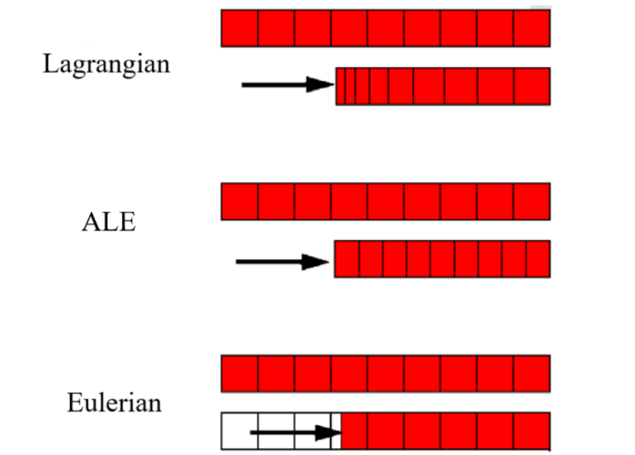
Figure 17 - motion of mesh with different methods [16]
Figure 17 provides a visual representation of the motion of mesh and the material with different methods. ALE is similar to lagrangian, as it allows the Advection concept of mass moving through a mesh but only when is necessary, typically used on conical liner (adaptive domain) but sometimes the HE also excessively distorts. This differs from Eulerian as the nodes remain fixed and the material passes through the mesh which will prevent the mesh from disporting but reduces things like the velocity experienced on the liner [17].
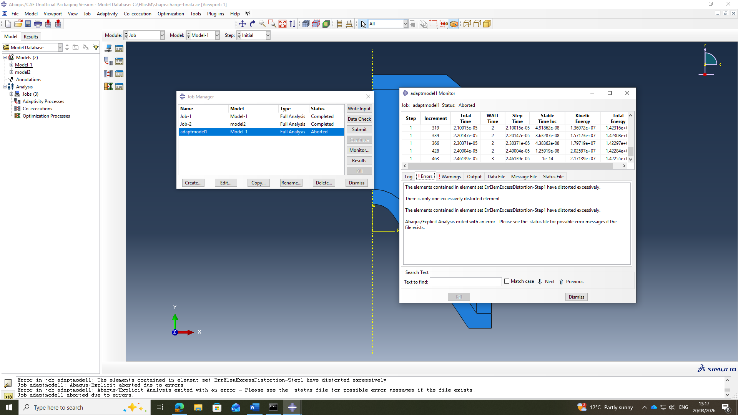
Figure 18 - ALE Job abortion
When ALE was implemented for the first design excessive distortion still occurred cause the job to abort prematurely as seen in Figure 18. Upon some further investigation, it was discovered that the issue with over lapping notes previously seen in Figure 7. The adaptive algorithm is trying to remove these nodes, but then it is realising It is going from one material to the other is conflicting with the contact between the contact pair between the HE and the liner.

Abaqus – 3D design
Following on from the completion of the 2D designs, the decision was made to use the initial design and turn this into a 3D simulation. This was done by coping the 2D design and then removing the parts, instances as well as the interactions which just relate to the 2D model.
Linear nodes were utilised for this simulation opposed to quadratic, which are not as mathematically accurate. Even though liner nodes are as accurate it was necessary to do as the student version of Abaqus is limited to 250,000 and simulations wouldn’t run if this is exceeded.
Some issues which were encountered during the 3D modelling was the plain of symmetry could not be respected due to there being no associated boundary as these were previously deleted as they related to the 2D model. Also, due to the limitation in the number of nodes resulted in the original proposed mesh was too fine for the student package so had to be adjusted to account for this.
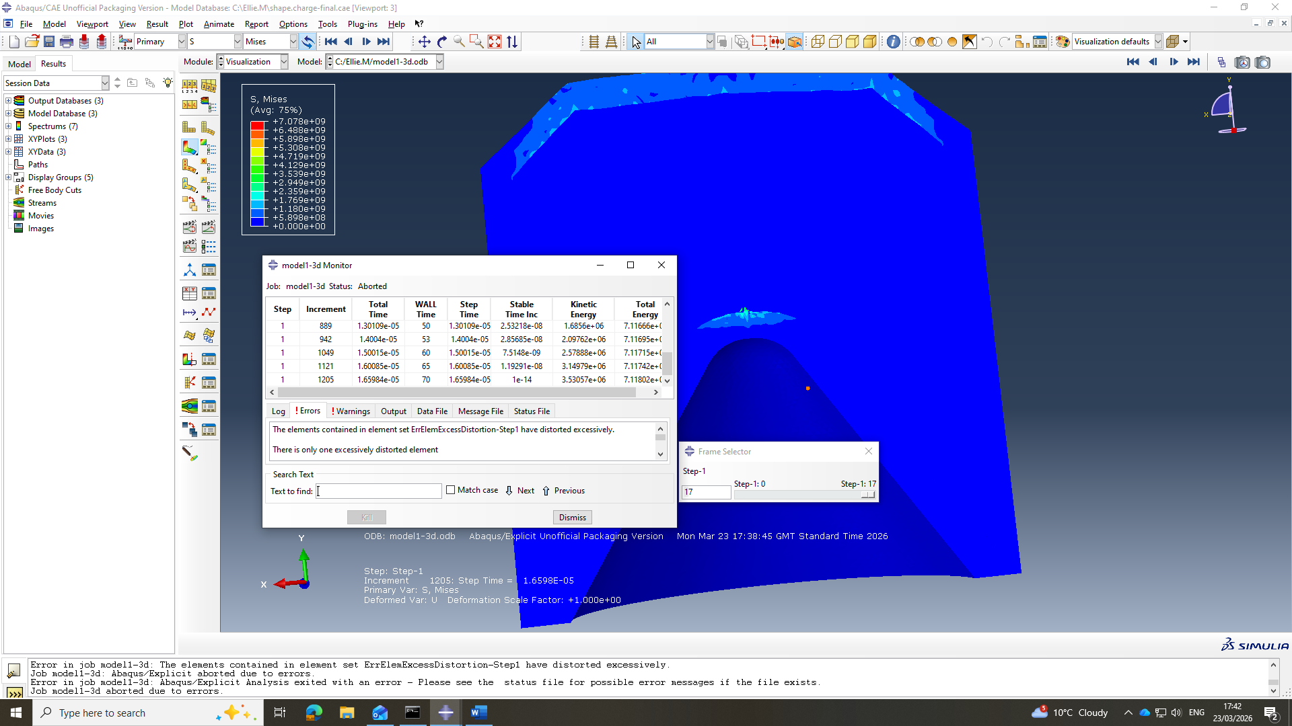
Figure 19 - 3D design failure
Although the liner mesh size was reduced, boundary condition issues persisted because this was not specified to be constant in the Z plane and also the materials were only contact with everything as well as excessive distortion seen in Figure 19. One possible reason to this is as the detonation wave hits the liner the difference in the coarse, HE mesh and the fine liner is causing them to distort excessively due to the drastic change in meshing density.
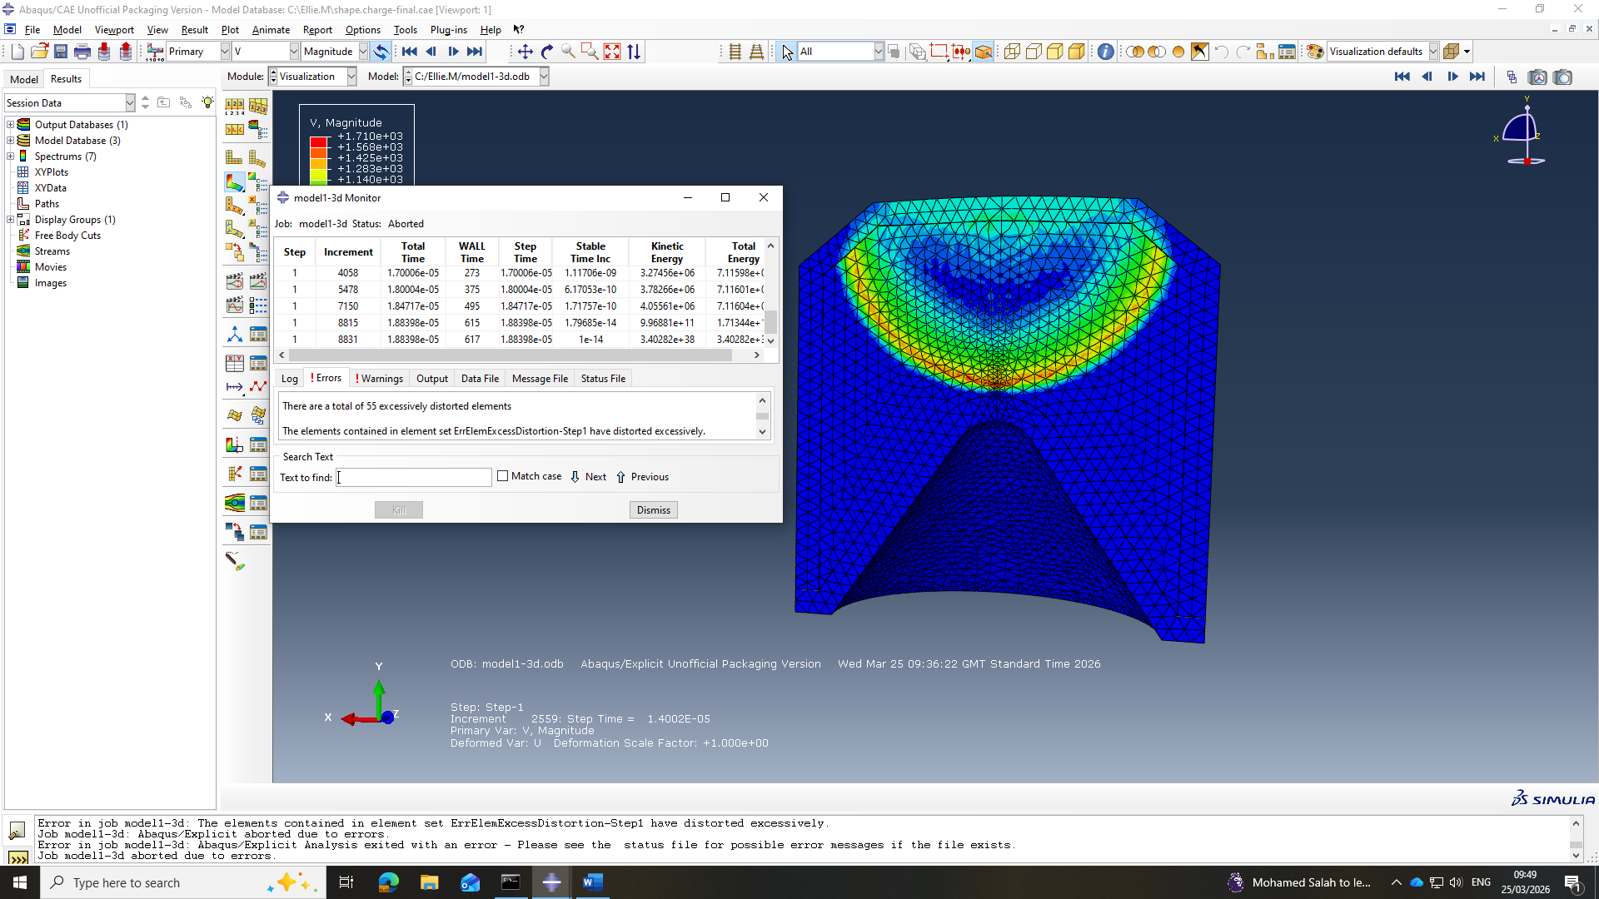
Figure 20 - 3D Detonation wave
Once the changes were made the simulation was able to run up until the point where the detonation wave touches the vortex of the liner as demonstrated in Figure 20, but wasn’t unable to proceed further because error message relating to overclosure and excessive distortion, which is likely to be caused by issues with the mesh alignment. This means that when the compression wave hits the boundary, it is reflected as a tension wave which is forcing expansion of the liner. And that small tetrahedral element is penetrating the HE, causing overclosure due to the reflected tension stress that's there once the detonation wave hits it.

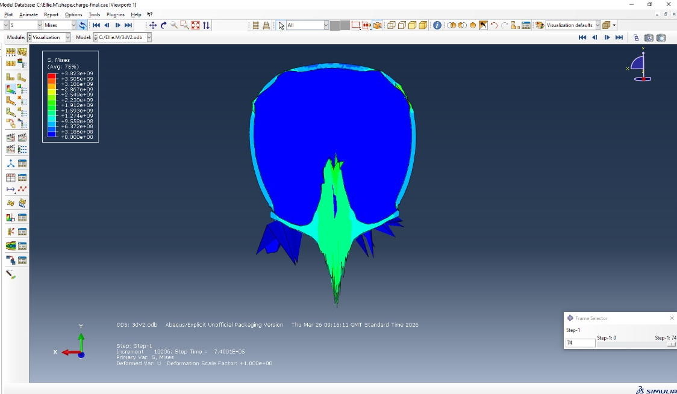
Another attempt to counteract these issues was by adding artificial viscosity so a detonation wave going through high viscosity broadens out the detonation wavefront to apply it more gradually than the sharp step change. The energy passing through the HE remains the same the detonation wave is just spread out. The boundary conditions were also changed to have primary and secondary surface to surface contact from the outside surface of the cone to the inside of the HE liner. The meshing size of the HE was also reduced to ensure that the meshing of the different components match up correctly at the contact points.
Figure 21 - 3D Simulation
Following the implementation of the above changes, Figure 21 depicts the results. This is showing the formation of the jet occurring and peak stresses reaching ${2.23x10}^{9}$ Pa. It is observed that the HE is breaching the boundary condition of the liner, another angle can be seen in Figure 22. Circled in Figure 21 is a slight gap between the case and the liner which is allows for the explosive gas product to leak out.
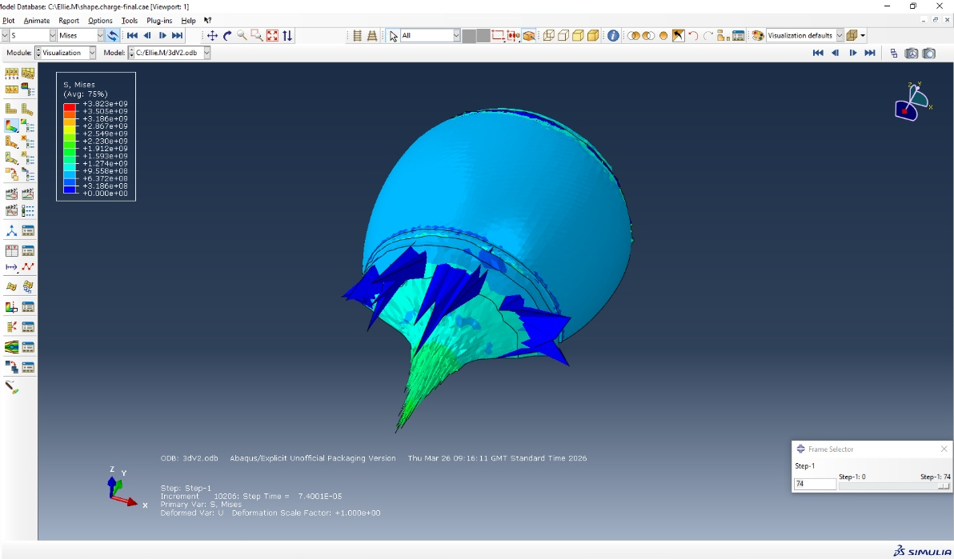
Figure 22 - 3D HE boundary breach
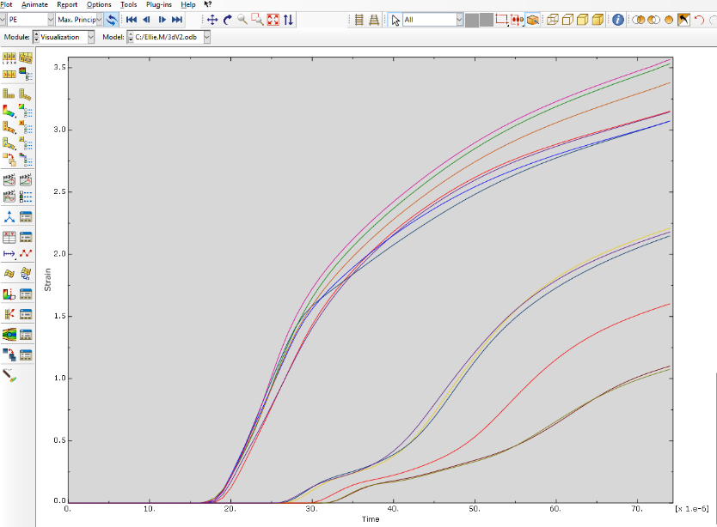
This result is interesting because if the HE explosive gas was only leaking from these highlighted points this would have been a very valid result. However, as seen in Figure 22 the contact of the liner is being violated all away the charge- This model is attempting to model the leaking of He products and is forcing them through the liner as the liner has stayed in contact with the case.
Figure 23 3D strain- time graph

Similarly to the 2D design results, Figure 23 show a steady increase in the strain rate as deformation of the liner occurs. The difference in the strain experienced from the nodes in the tip of the jet as well as the back of the slug.

Smooth Particle Hydrodynamics

Smooth particle hydrodynamics (SPH) is a mesh free technique which can be used to model fluid-structure interactions and large deformations [18]. As a mesh stretches and elements will distort and potentially crash the simulation. SPH converts highly distorted tetrahedral elements into particles, the interaction with the other materials and the liner are still there. Switching to SPH is done just before the tetrahedral mesh element gives up.
The first simulation used the same mesh which was previously used for the 3D simulation-the mesh from the HE and in the liner was slightly overlapping at the boundary causes job to abort as seen in Figure 24 as the particle distribution wasn’t correct.
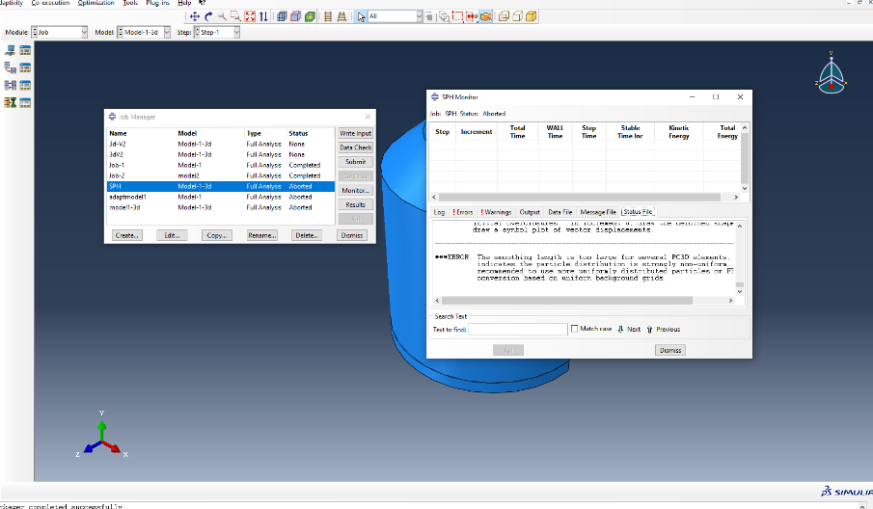
Figure 24 SPH Abortion
Based on this the mesh was changed to a global seed, and any graduations were removed in the HE mesh to mirror the mesh of the liner. The size of the mesh was also reduced to mirror the mesh in the liner, so it is more fluid as seen in Figure 25.
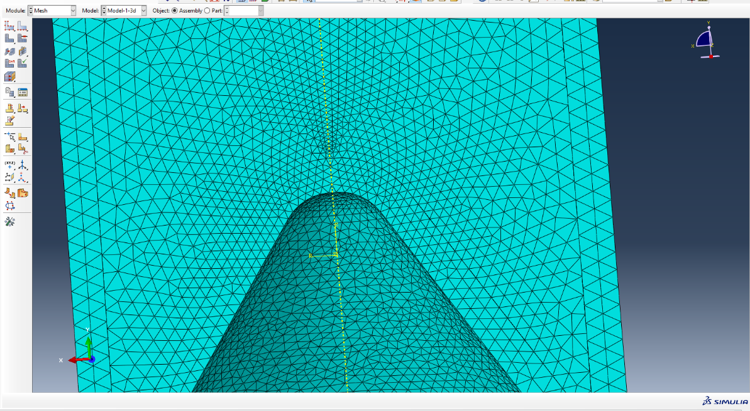
Figure 25 - SPH meshing
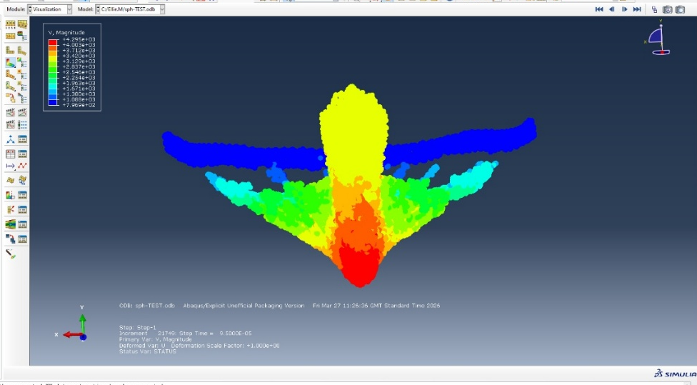
The simulation was not able to run to completion; however, a small jet- slug structure was produced as seen in Figure 26 with the velocity achieved 4295 m/s at the tip of the slug.
Figure 26 - SPH velocity gradient

Comparison of 2D vs 3D Design
When comparing the 2D and 3D designs it was assumed that the 3D model with the additional pressure which would make the liner go faster due to Hooks law however, this could be due to a dimensionality issue. It is important to caveat this could be down to tetrahedral mesh being stiffer than the 2D equivalent even for the same material. Also as previously mentioned a quadrilateral mesh is more mathematically accurate because it gives you a better structural behaviour in comparison to the equivalent of two tetrahedral meshes. This is because of the shape of the mesh itself it cannot accurately capture the same displacement stress.
In Figure 27 both the 3D and 2D designs experience extremely high plastic strain rates in excess of 1 for the majority of the jet- the 2D model having significantly higher strain rated experienced which can be explained by the difference in the accuracy of the mesh. This is important because it means that the material has undergone more than 100% deformation (the elongation of the material is double its original length)- in reality the magnesium would have fracture way before this point when undergoing the deformation.
It is known that the material would have already fractured before this point because copper, the most ductile material will facture when elongation reaches 0.6. If Johnson Cooke damage parameters were introduced in this modelling this would remove the distorted elements and the jet formation would not have been seen. However, when looking at the plastic strain values they indicate that If a more sophisticated damage model the jet would break up which is what is observed in physical experiments.
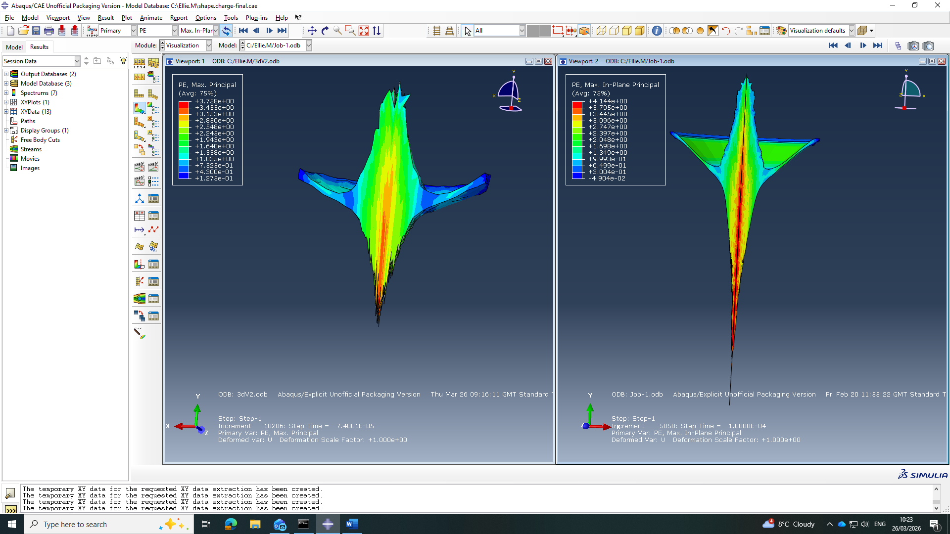
Figure 27 - 3D vs 2D PE comparison
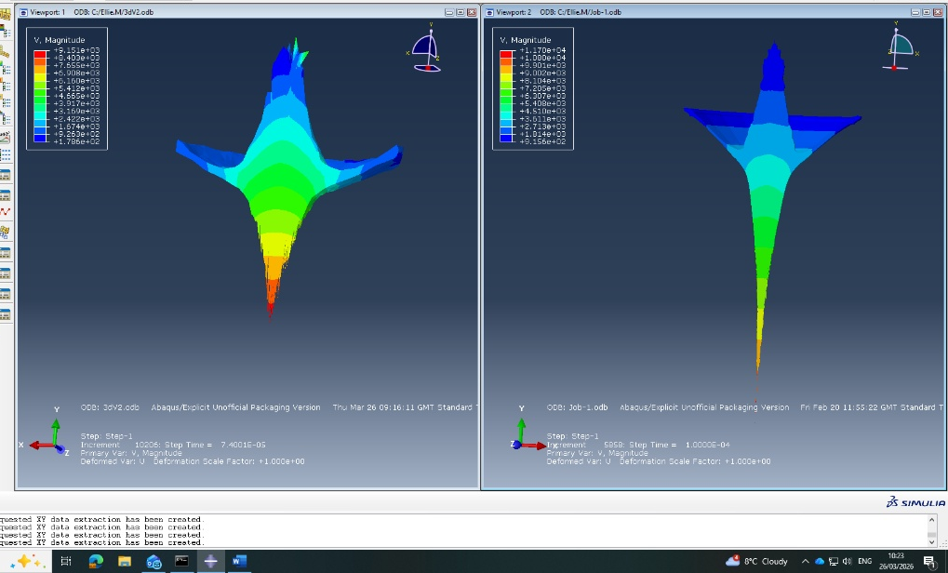
When also comparing the velocity for the 3D and 2D designs as seen in Figure 28, the 2D produces velocities which are a lot higher, with a larger jet also being produced. The explanation for this again relates to the mesh and the mathematical accuracy. For comparison of velocity graph please see Appendix C.
Figure 28 - 3D vs 2D velocity gradient

Conclusion
The study set out to analyse the effects of altering the internal cone angle of a shape charge liner and how this influences the jet formation alongside the overall performance using numerical modelling Abaqus. This was done by the comparison of two different 2D designs exploring the effects of ALE meshing and if this increased the accuracy of the simulations. The most obvious finding to emerge from this study is that the 2D designs provided the clearest more reliable results. When comparing the reduced liner angles of 33.69˚ and 25˚ demonstrated that both alternative designs were able to generate high velocity jets with peak velocities ranging between 9100-9600 m/s. The achieved velocities are comparable to those achieved in the documented literature. However, when comparing the stress and strain results it has revealed that the 33.69˚ design produced a more stable and energetically efficient liner collapse. This design had a very concentrated plastic- strain and a smoother stress time graph indicates that this design would have great performance properties. It is noted that the 25˚ design had a marginally higher peak velocity, there was less mass in the jet and some instabilities observed with the deformation of the liner.
There were multiple attempts made to refine the mesh, and adaptive meshing was also introduced. However, this highlighted the difficulty of modelling shape charge deformation when focusing on purely Lagrangian methods. Excessive distortion, node overlap, and contact instabilities repeatedly caused simulations to abort, underscoring the limitations of standard meshing approaches for problems involving extreme plastic flow.
The transition to a 3D model further amplified these issues due to mesh density constraints, boundary-condition complexities, and overclosure at material interfaces. While partial jet formation was achieved, the 3D model consistently failed at the moment of liner collapse. Upon reflection, providing there was more time a more sophisticated meshing strategies or hybrid Eulerian–Lagrangian methods would be required for a fully stable solution to more accurately model this complex problem.
The SPH approach was explored which demonstrated a mesh-free alternative capable of handling large deformation, successfully producing a small jet–slug structure. However, the reduced jet velocity and premature termination of the simulation indicate that further refinement of particle spacing, contact definitions, and transition criteria is needed before SPH can replicate the fidelity of the 2D Lagrangian model.

References
[1] H. Mehmannavaz, A. Ramezani, M. A. Nabakhteh, and G. Liaghat, “A practical review study on shaped charge in the last two decades (2000–2020),” International Journal of Protective Structures, vol. 12, no. 4, pp. 665–693, Jun. 2021, doi: https://doi.org/10.1177/20414196211017923.
[2] W. Walters, “A Brief History of Shaped Charges,” 24th International Symposium on Ballistics, vol. 1, pp. 22–26, 2008, Available: https://apps.dtic.mil/sti/tr/pdf/ADA497450.pdf
[3] M. Ahmed and A. Q. Malik, “A Review of Works on Shaped Charges,” Engineering, Technology & Applied Science Research, vol. 7, no. 5, pp. 2098–2103, Oct. 2017, doi: https://doi.org/10.48084/etasr.1532.
[4] J. Hall, “Shaped Charges: Harnessing Precision in Explosive Technology,” 2025. https://www.sciencedirect.com/topics/engineering/shaped-charge (accessed Mar. 24, 2026).
[5] C. Austin, “Lined-Cavity Shaped Charges and Their Use in Rock and Earth Materials STATE BUREAU OF MINES AND MINERAL RESOURCES NEW MEXICO INSTITUTE OF MINING & TECHNOLOGY CAMPUS STATION SOCORRO, NEW MEXICO.” Accessed: Feb. 26, 2026. [Online]. Available: https://geoinfo.nmt.edu/publications/monographs/bulletins/downloads/69/Bulletin69.pdf
[6] G.-S. Yeom, “Numerical Simulation of Conical and Linear-Shaped Charges Using an Eulerian Elasto-Plastic Multi-Material Multi-Phase Flow Model with Detonation,” Materials, vol. 15, no. 5, p. 1700, Feb. 2022, doi: https://doi.org/10.3390/ma15051700.
[7] J. Akhavan, The Chemistry of Explosives, 4th ed. London: Royal Society of Chemistry, 2015.
[8] S. R. Parveen, “Euler Equation of Motion in Fluid Dynamics and its anti-derivative Bernoullis Equation ,” 2022. https://ijrar.org/papers/IJRAR22C2565.pdf (accessed Apr. 10, 2026).
[9] K. H. Kamarudin, A. Mujahid Ahmad Zaidi, S. Abdullah, and M. Fuad Shah Koslan, “Establishment of Shaped Charge Optimum Parameters for Small Scale Hydrodynamic Penetration,” Modern Applied Science, vol. 10, no. 1, p. 82, 2015, doi: https://doi.org/10.5539/mas.v10n1p82.
[10] P. Mulligan, C. Johnson, J. Ho, C. Lough, and E. Kinzel, “3D Printed Conical Shaped Charge Performance,” ASME Digital Collection, vol. V001T03A008, no. HVIS2019-110, 2020, doi: https://doi.org/10.1115/HVIS2019-110.
[11] F. Abbassi, M. Srinivasan, C. Loganathan, R. Narayanasamy, and M. Gupta, “Experimental and numerical analyses of magnesium alloy hot workability,” Journal of Magnesium and Alloys, vol. 4, no. 4, pp. 295–301, Jan. 2016, doi: https://doi.org/10.1016/j.jma.2016.10.004.
[12] “SAE/AISI 1010 Carbon Steel - Composition and Properties,” matmake.com. https://matmake.com/materials-data/steel-1010-properties.html (accessed Apr. 25, 2026).
[13] Z. Lichen, Y. Jianping, L. Xudong, and Y. Jianya, “Study on the Influence of Composite Charge Structure Parameters on Detonation Wavefront,” Journal of Physics: Conference Series, vol. 2891, no. 5, p. 052026, Jan. 2024, doi: https://doi.org/10.1088/1742-6596/2891/5/052026.
[14] R. Liu, L. Tang, X. Jia, X. Jiao, R. Yan, and X. Jiang, “JWL equation of state parameters for ideal detonation: A comparative study of literature reports, theoretical derivation, and artificial neural network prediction,” FirePhysChem, 2025, doi: https://doi.org/10.1016/j.fpc.2025.08.001.
[15] H. Cui et al., “Determination of the JWL Parameters of Detonation Products Using Adaptive Genetic Algorithm,” Propellants Explosives Pyrotechnics, vol. 45, no. 12, pp. 1920–1930, Nov. 2020, doi: https://doi.org/10.1002/prep.202000148.
[16] M. Veidth, “Abaqus Mesh Guide | Abaqus Bottom-up Mesh, Adaptive Mesh,” CAE Assistant, Jun. 2024. https://caeassistant.com/blog/abaqus-mesh-a-guide-to-meshing/#7_What_is_Abaqus_Adaptive_mesh (accessed May 13, 2026).
[17] “Abaqus Analysis User’s Manual (6.11),” Uq.edu.au, 2026. http://abaqusdocs.eait.uq.edu.au/v6.11/books/usb/default.htm?startat=pt04ch12s02.html#usbaremesh (accessed May 13, 2026).
[18] “Abaqus SPH 101 Tutorial | FREE Example And More With Files,” CAE Assistant, Oct. 28, 2025. https://caeassistant.com/abaqus-sph/ (accessed May 15, 2026).
[19] SimLet](https://twitter.com/getwelsim, “Johnson-Cook model and its curve fitting,” WELSIM, Jul. 28, 2023. https://welsim.com/2023/07/28/johnson-cook-model-and-its-curve-fitting.html (accessed 2026).

- Refined mesh D1 results
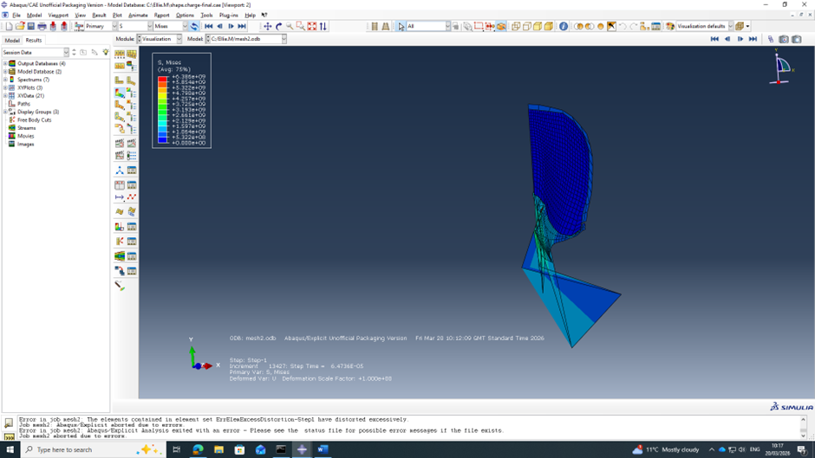
Below depicts the shape charge undergoing rapid deformation, the mesh elements are being stretched and compressed passed their stable limits causing the simulation to crash. The simulation is attempting to model the deformation correctly however; due to the limitations of the mesh, it has resulted in extreme distortion occurring.

- Node selection
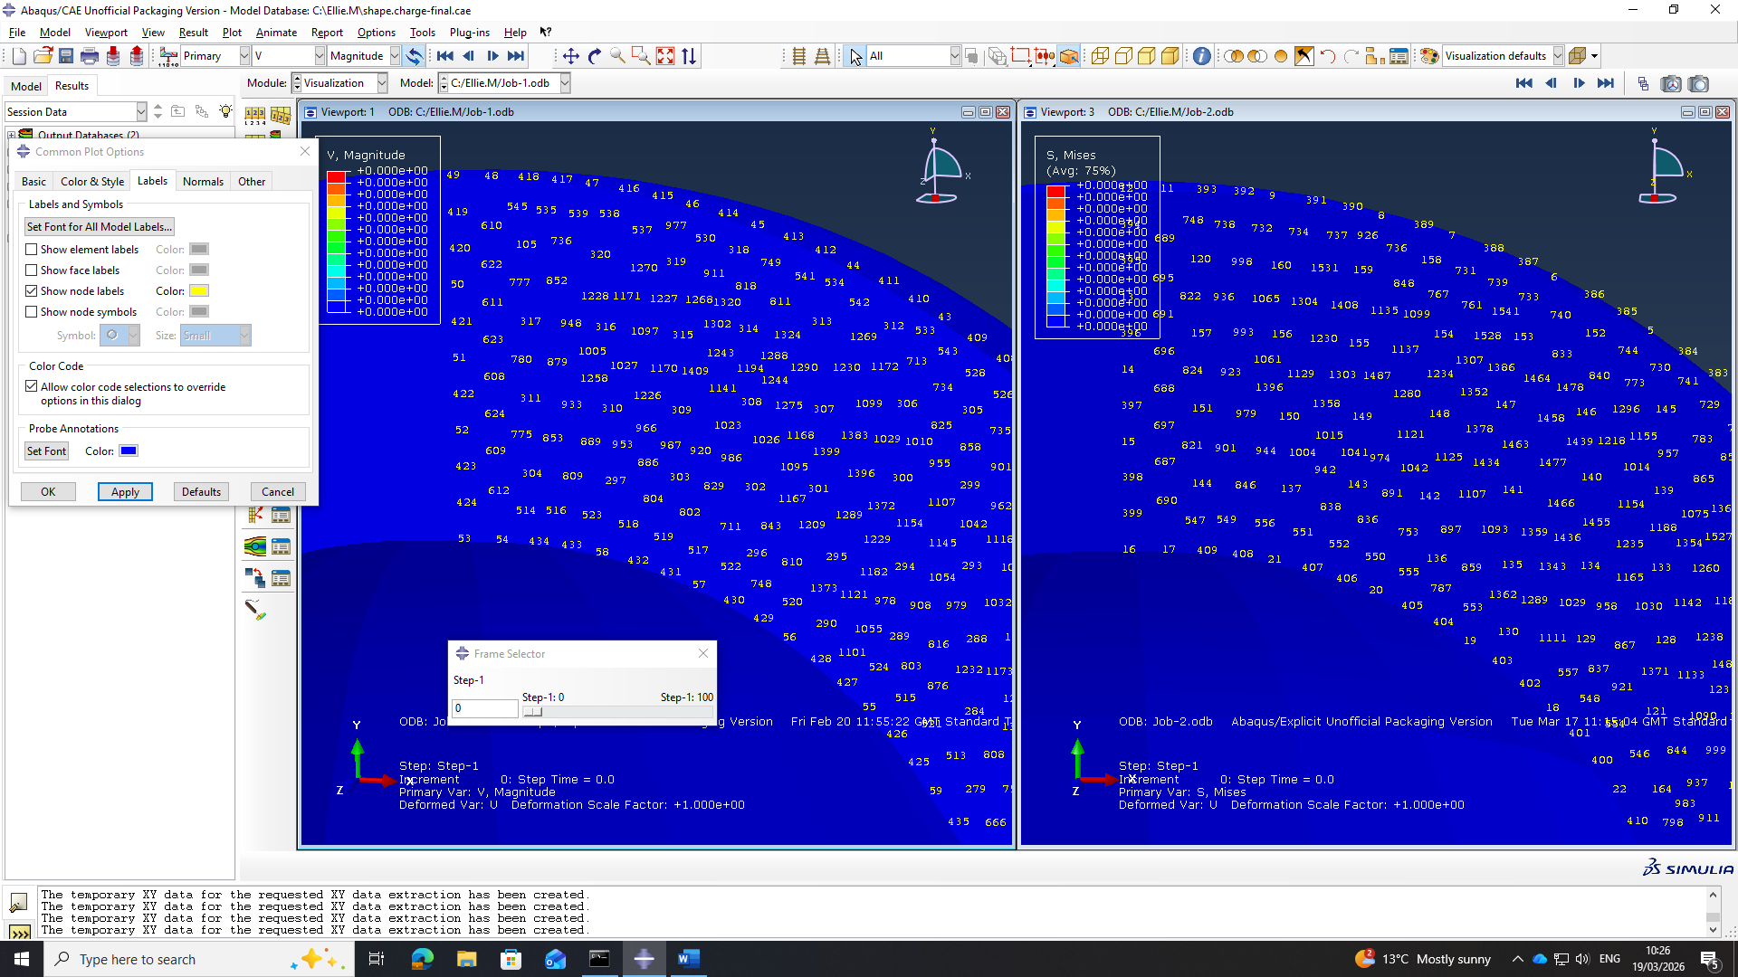
As seen below the circle nodes indicate the node which has been used in the comparison. Even though they are numerically different they are situated in the same position in their individual models making it appropriate to use them in a comparison.

– 3D vs 2D graph comparison
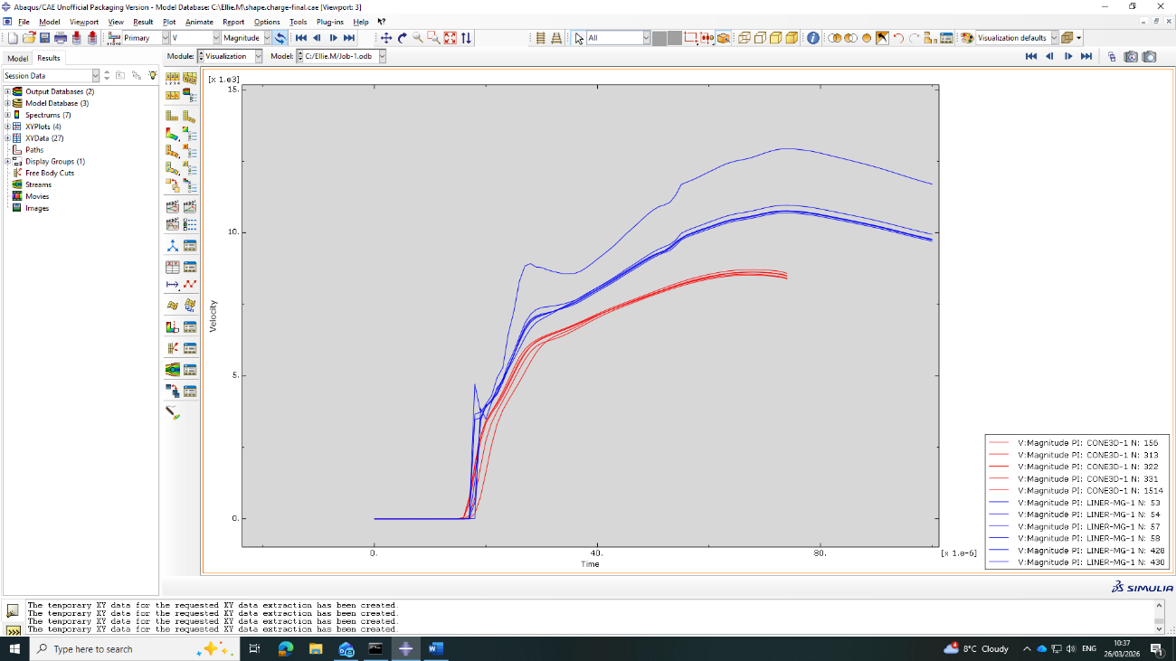
The peak velocities achieved in the 2D Model (blue) in comparison to the 3D (red) are significantly higher, it is suggested that this could be down to the more sophisticated quadrilateral mesh which was implemented allowing for the energy to transfer from the HE to the liner more fluidly in comparison to the 3d model. The 3D model has a wider curve and a lower peak velocity which is a reflection of the simplistic tetrahedral mesh and contact complexities which were experienced.
To improve the accuracy of the results, if time allowed it would be desirable to refine the 3D meshing further and also have the ability to use a commercial license which would remove the burden of limited number of nodes when meshing.

