Internet of things devices

This report will research IoT devices currently on the market and analyse risks associated with these devices. After understanding risks and functionalities presented by IoT devices, a new IoT system will be highlighted.
  - Smart and Connected Devices

Contents
Introduction 1
Research 2
IoT Design 2
Sensors 2
Actuators 2
IoT Gateway 2
Edge / Fog Computing 3
Cloud Storage 3
Current Technology 3
Ring Doorbells 3
Implementation 4
Purpose 4
Design 4
Conclusion 5
References 6

Introduction
The Internet of Things (IoT) is a concept where devices are connected to the internet so that they can record data and act upon the data generated, limiting the need for human interaction. The concept has been around since around the mid-1980s, however until the last decade or so the technology has not been available to accelerate developments of devices such as Amazon’s home assistant, Alexa.
“The term IoT is mainly used for devices that wouldn't usually be generally expected to have an internet connection, and that can communicate with the network independently of human action.” [1]
Such devices would include a heating system, the room temperature is recorded then action is taken to either cool or heat the room, based upon data generated by a sensor to detect the room temperature. Whilst these systems make use of emerging technology to add functionality to everyday living, they also possess a risk to the security of users of such devices. This report will research and discuss the current solutions which are available, along with the risks and functionality they generate.

Research

IoT Design
IoT systems, are made up of several components which are used to collect and manipulate data at different stages within the IoT architecture. The graphic below outlines the different stages, which will be discussed.
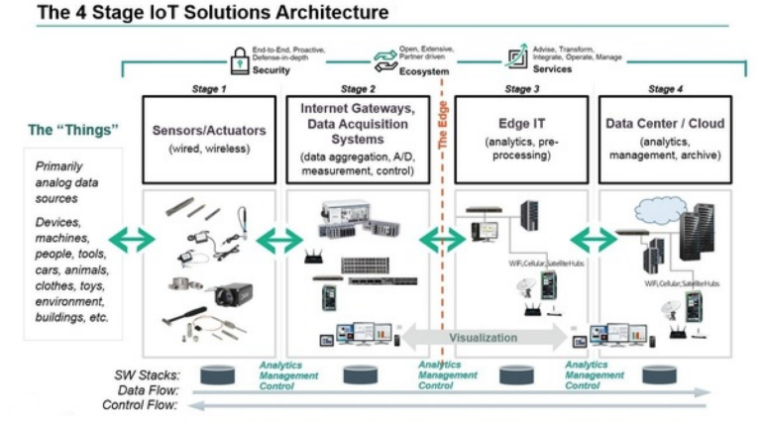
i The 4 Stage IoT Architecture [2]
The first stage is the client side, this will include sensors and actuators, both are essential in any system.
Sensors are used “ to detect, measure and report one real-world variable at a time” [3] , in the introduction the use of a sensor to capture the temperate in a room was discussed, other sensors can detect; sound, humidity, motion and light. Lots of factors in the real world can be measured by different types of sensors. One extremely beneficial use for sensors is their ability to be included within machinery and pick up on “Preventive and predictive maintenance” [4] required for factories to minimise downtime and increase productivity, as system faults are detected ahead of the point of failure.

Actuators can be considered the opposite of sensors, they are able to impact changes in the real world, such as increase the temperature or turning on the light in a room. To actuator is essentially a component which has been around in electrical circuits for many years where an electrical signal is received which causes the actuator to change its switch state which will in turn result in an action being taken. Actuators in an IoT system will receive instructions via the internet from a command component.

IoT Gateway is the next stage. The gateways have the “primary purpose of providing a bridge between different communication technologies” [5]. Sensors and actuators will only use certain methods/protocols for communication, such as Bluetooth or ZigBee. This means that backend systems cannot directly communicate with sensors to receive data and forces the need for a gateway. The gateway will also take on other task such as security, by encrypting data, as well as sorting out which data will be needed by the backend and parsing data to only send what is needed.

Edge / Fog Computing
“Fog computing and edge computing are effectively the same thing. Both are concerned with leveraging the computing capabilities within a local network to carry out computation tasks that would ordinarily have been carried out in the cloud” [6] . Edge or fog computing allows for data to be process closer to the source where data is first generated, this means that IoT systems are more efficient as they do not rely on the bandwidth as well as other networking limitations which are tied to getting data from a data centre. This enables real-time analytics for data being provided by the bulk of IoT devices which are becoming more prevalent throughout the world.

Cloud Storage
Some data will however need to be transported into the cloud for storage as well as further processing and analysis. This is where a cloud solution can provide what is needed for IoT systems. Cloud solutions take away the need to manage rack space and to be concerned about the physical needs of computer system, and place this responsibility on cloud providers, such as Microsoft with their Azure solution. Within the cloud software based solutions are available to solve a number of needs, such as firewalls, software as a service (SaaS), Virtual hardware such as database servers or high speed storage area networks. These solutions are highly scalable allowing resources to grow as and when of the service change.

Current Technology
Systems which utilize the benefits of IoT systems are already widely available. Before designing a new system, a current solution will be researched to avoid any errors that these devices present, and to ensure that any useful features that are included are also made use of in the new concept.

Ring Doorbells
The ring doorbell provides video camera at the front door to identify visitors, and to send push notifications when motion is detected at the door step. Once motion is detected the homeowner can speak to whoever is at their door regardless of whether they are in or out of the house.
One of the functionalities of this, is that delivery drivers with packages can be instructed to leave deliveries if the homeowner is away. As well as this burglar can be spotted, with footage of any attempted break-ins logged and available to provide to law enforcement. Ring systems also can integrate with other IoT devices such as Amazon’s Alexa, to announce when a visitor is at the door.
Problems have existed in the system however and been highlighted by different testers.
A security error that is widely reported is that users receive no notification when the system is accessed from IP addresses across the globe. As part of a security test,
“Motherboard logged into a Ring account (both on the app and the website) with its corresponding email and password from various IP addresses worldwide. No alert was triggered notifying the Ring owner about the suspicious login attempts – even with simultaneous logins occurring” [6]
This is of concern to users as hackers could keep trying to access the system, and through brute force crack into the system and access private data.
Ring Devices are also being ‘hijacked’. This is done by the hacker using a variety of methods to connect unlawfully to a user’s Wi-Fi network, then
“Once connected, the attacker can see audio and video as it is transmitted from the Ring video doorbell to the Ring application used by the owner.” [7]
This will be of concern to users, as footage will be unencrypted allowing easy access to view what only the owner should be able to view. The Verge [8] report that such leaks are a result of users, reusing password which have since been obtained by “data leaks from other services” and users “didn’t have two-factor authentication set up” .

Implementation

Purpose
The overall purpose of the IoT concept will be to provide a secure method for minimizing contact when opening doors, in light of the ongoing COVID-19 worldwide pandemic, where contact on shared surfaces increases the risk of infection. Other functionalities will be enabled by configuring a smart door system, such as deliveries when users are not home, workmen having access to the home to complete maintenance tasks around the house, as well as increased security for locker pickup locations where items are delivered to lockers and accessed via a single pin.

Design
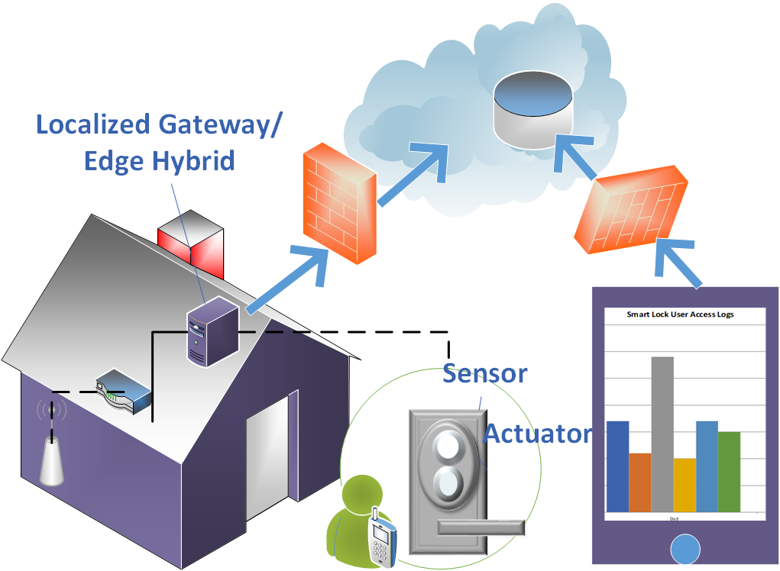
iiSmart Lock IoT Overview
The above diagram provides an overview for the Smart Lock IoT implementation. The process is outlined below:
- User signs into Smart lock mobile device, using password which must reach complexity requirements. They must also use two factor authentications, through use of biometrics or question/answer, this will authenticate that the user using the device in the correct user of the system.
- This will start a session, which will last for a default of 1 hours, but can be amended within account settings whilst advising that security is decreased.
- On first use, user would need to register device for use with the home lock, this device is then confirmed as being able to access the home once authentication standards have been met.
- The user details are then analysed by the gateway hybrid device which is plugged directly into the router via a network cable. The gateway is a hybrid device which acts as a gateway while providing other edge functionalities, this device will also include a software based firewall to only allow through certain traffic. The gateway will check if the user has temporary access or regular access to the home.
- If regular access, the ‘device footprint’ is recorded, this is then compared against a record of the devices which the user has registered against their user. The device footprint is a mixture of details such as mac address, this is then hashed to provide a unique value for the device and provide the ‘footprint’. Coupled with the two-factor authentication this increases security.
- If not regular access, then the user is checked against the temporary user database.
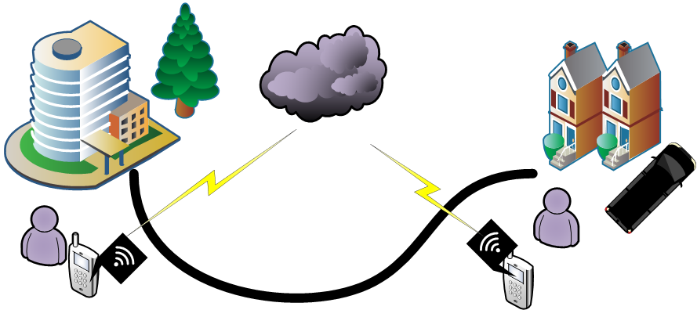
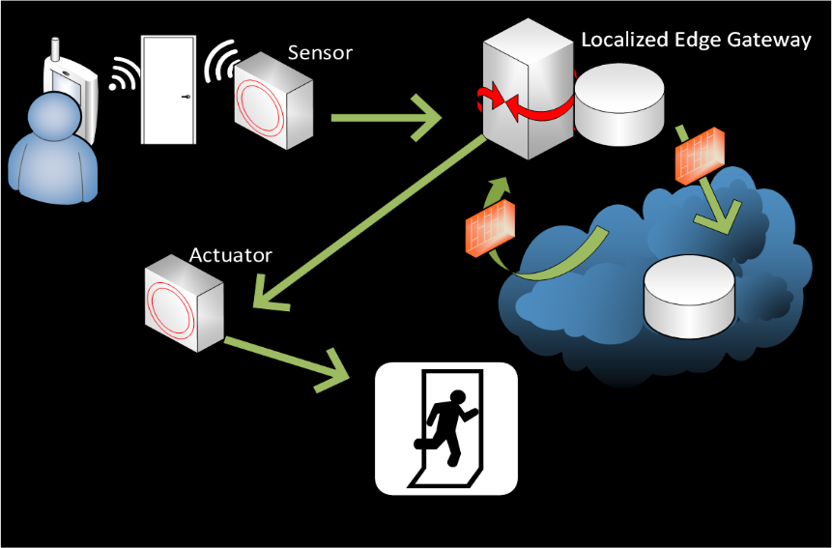
- If they are in the temporary database, then a regular user is contacted to provide authorization that access is allowed. The diagram below to the right outlines the non-regular access scenario.

Any uniquely identified data is stored in the cloud behind a firewall, which only accepts communication of specific ports.
The web facing components are also held in the cloud, in DMZ software-based solution. The user will need to authentication to bypass the DMZ firewall within the web application then can provide temporary access to any guests of workers when away from home, and provide which security measures are needed to a guest, such as registering their mobile device before there visit to confirm their identity. Another function of the web-based application is to review logs for user access. They can also configure push alerts if strange ip address try to access the system.

Conclusion
IoT devices are already widely used throughout the world and will continue to develop over time. The risks highlighted can be combatted by considering security at every level of implementation. The IoT environment does bring about a lot of potential and is already changing the world that we live in today and how humans interact with the ‘things’ around us.

References

[1] | S. Ranger, “What is the IoT? Everything you need to know about the Internet of Things right now,” ZDNET, 3 February 2020. [Online]. Available: https://www.zdnet.com/article/what-is-the-internet-of-things-everything-you-need-to-know-about-the-iot-right-now/#:~:text=The%20term%20IoT%20is%20mainly,network%20independently%20of%20human%20action.. [Accessed 2020 July 21].
[2] | P. Stokes, “4 Stages of IoT architecture explained in simple words,” 5 December 2018. [Online]. Available: https://medium.com/datadriveninvestor/4-stages-of-iot-architecture-explained-in-simple-words-b2ea8b4f777f. [Accessed 23 July 2020].
[3] | A. Pelaez, “12 IoT Sensor Types To Keep An Eye On [With Examples,” Ubidots, 16 April 2020. [Online]. Available: https://ubidots.com/blog/iot-sensor-types/. [Accessed 23 July 2020].
[4] | Hewlett Packard Enterprise, “Edge computing yields deeper insights, faster,” 2020. [Online]. Available: https://www.hpe.com/us/en/insights/reports/intelligent-edge-report-1903.html. [Accessed 23 July 2020].
[5] | SAP, “What is an IoT Gateway? (SAP EA Explorer - Short Video),” 19 October 2016. [Online]. Available: https://www.youtube.com/watch?v=6ObesqWDpEo. [Accessed 23 July 2020].
[6] | L. O'Donnell, “Ring Plagued by Security Issues, Flood of Hacks,” Threat post, 18 December 2019. [Online]. Available: https://threatpost.com/ring-plagued-security-issues-hacks/151263/#:~:text=A%20Motherboard%20report%20found%20Ring,according%20to%20a%20new%20investigation.. [Accessed 23 July 2020].
[7] | A. Dellinger, “A security flaw leaves Ring doorbells and cameras vulnerable to spying,” Digital Trends, 1 March 2019. [Online]. Available: https://www.digitaltrends.com/home/ring-video-doorbell-security-flaw-hack/. [Accessed 23 July 2020].
[8] | D. Seifert, “Ring adds privacy dashboard to app in response to security concerns,” The Verge, 30 January 2020. [Online]. Available: https://www.theverge.com/2020/1/6/21050426/ring-control-center-privacy-dashboard-app-police-security-two-factor-ces-2020. [Accessed 23 July 2020].

