Exhibition 1.0 Pro forma

Please ensure to answer all questions posed in this document. This document is used to help facilitate the assessment of your final year exhibition. Ensure to be thorough in how you address each point.

Student Name: Seren Davies

Part One: Knowledge and Understanding Skills (30%)
Artist Statement
In this section, students must provide an artist statement clearly demonstrating their understanding of key themes and ideas underpinning their photographic practice. The statement should contextualize the exhibited work. The artist statement should function to support the audience's engagement with the work durg the exhibition.
Nature has its way of presenting itself in many beautiful ways. One being through the reflections that present within bodies of water from things such as trees. This being trees and their reflections have a way of symbolising the way of life through nature and they’re passing through the seasons representing the idea of passing through time. With the passing through seasons and despite the calmness of the water or lack of, the reflections stay the same providing stability and change in life.

Part Two: Knowledge and Understanding Skills (30 continued %)
Key Research

In this section, students must provide a clear and concise overview of 3 key pieces of artwork research. This research should demonstrate how it has informed the making of your exhibition work. We aren’t concerned with knowing background information on the artist (biography), instead we are interested to understand how the work has influenced you. Please provide visuals to support your writing.

Max 3 artists, 500 – 1000 words (approx.) words.
Claude Monet uses reflections in pieces of their work however in comparison uses vibrant colour and in sense influences my work due to the style in which he produces. I am influenced by his style through the loose brush presenting a subtle scramble presentation as you can see in the water lily example, helped me with my idea as I aimed to try implement that within my photography using the breaks in the water creating similar but more sharp reflections.

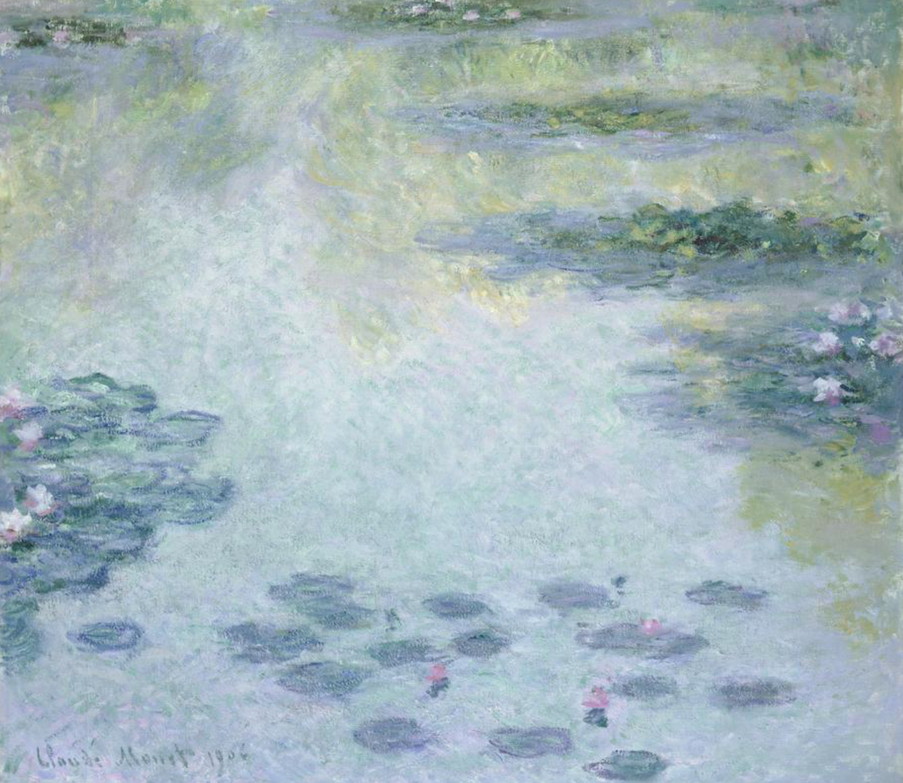

As for the work Susan Derges , I am influenced by her work as similarly to my produced photography for the exhibition she took uses dark imagery within some of her work through the uses of dull colours as opposed to bright and vibrant. I am influenced as by using the trees and their reflections in the water creates an uneasy feeling despite the blue reflective skies seen in my pieces of work. The breaks in the water of my pieces similarly to Susan gives the trees themselves a different meaning as they are presented a lot gloomier and darker through the reflections they create.

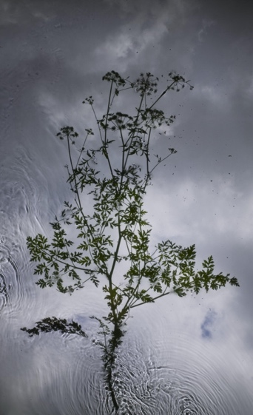

Michael Kenna is one photographer who uses water reflections within his artistic pieces of work. His work has helped influence my decisions on my own exhibition on reflections. This is partly through the presentation of his work and how it presents itself to the viewer. The idea of being black and white imagery presents a calm atmosphere along with the stillness of the water in some of his work. I am influenced by this as it inspires me to try different aspects of how colour or lack of along with the flow of water can change the mood of an image on reflection and interpretation.

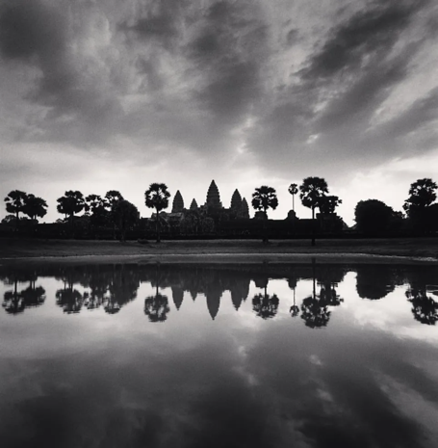

Part Three: Presentation Skills (40%)
Exhibition Methods:

How have you chosen to present your work and why? (include installation photographs of your final display).

Students should clearly articulate why their chosen method of presentation best suits their intended audience and context.

How well have you produced and installed your work (consider technical skills)?

500 – 1000 words.
For my exhibition I have decided I would like my 3 printed phonographs to be pristine and placed on the walls in the corridor. Having them individually placed in the corridor is ideal to my strategy as I feel it is the best way to best get recognition due to people passing through the corridor without restricting the capacity as it would have had I positioned the photos in a room.
As my work is clearly based around Landscape photography and nature, I think this is the best option for my work as in return it would not only attract the eyes of everyone who passes through the corridor but will also add life and atmosphere. Also, in doing so means that my exhibition is not limited to a room/room with limited capacity and therefore has the potential of the maximum amount of footfall.
Sticking to a set theme for this exhibition also helps give a sense of identity to the individual pieces that are a part of the ongoing exhibition and will attract mostly those of whom are fascinated by the different aspects of nature. This is clear in the sense that you clearly see how the breaks in the water add to the representation of the trees. While there is no exact figure it is speculated that around 50% of artists and photographers are inspired by forms of nature when it comes to art and photography further showing my exhibitions potential

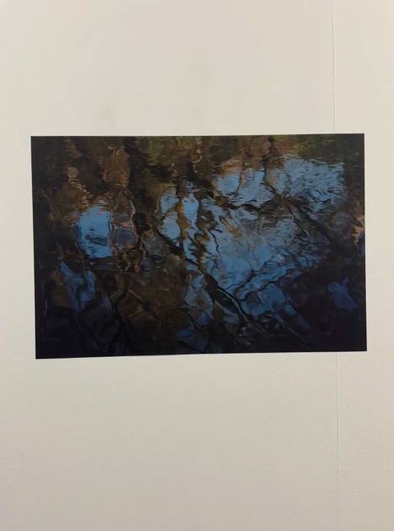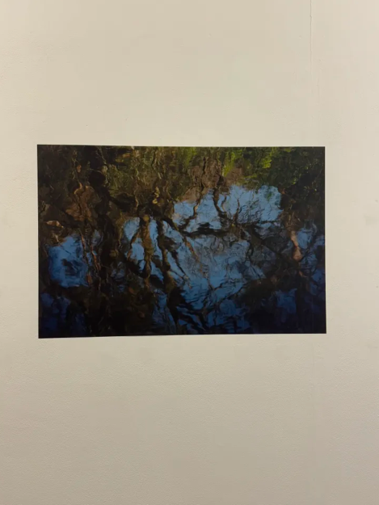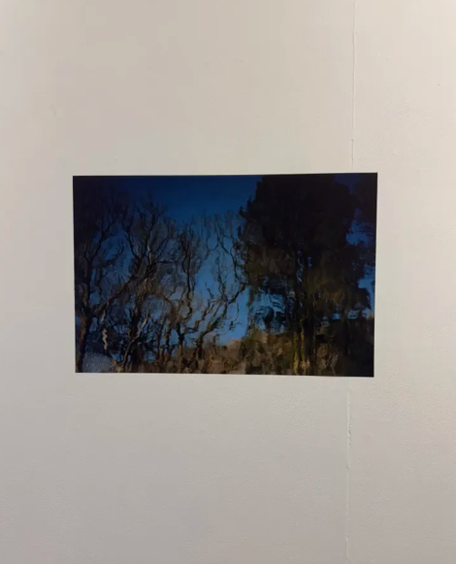

Part Four: Transferrable Skills for Life and Professional Practice. (20%)

Final Year Exhibition Evaluation

Have you participated in all tutorials, group seminar and workshops?

What role have you taken in facilitating the end of year exhibition and what have you learnt from undertaking that role?

How have you managed your workload for this module?

What new skills have you developed in producing this exhibition, and what aspects would you refine or approach differently moving forward? 500-1000 words
For the final year exhibition, I have been participating in all the tutorials. The role I had been given for the exhibition was the treasurer role and from that role I had learnt responsibility which has helped me with managing my workload. I have managed my workload for this module by setting deadlines for myself to get my work done on time and make sure everything is ready for the exhibition and planning my ideas, so I know how I want my work presented and with what images I want to use for the exhibition which responsibility has helped me to get those things done.
New skills I have developed while producing this exhibition is research and creative thinking these skills have helped me with ideas on how I wanted to present my work, and they have also helped me with the creativity of producing an image for the exhibition. Moving forward there would be some things I would like to do differently in the future and the things I would like to do differently are to try different ways to present my work differently and I would like to try different techniques with the images.

