k#
KUDHAJA KHANUM

Abstract
BUINESS PLAN OF SWEET MOMENTS
managing enterprise in 21st century
BMSW4006

BUINESS PLAN
Overview of business
Mission statement
- We specialised in home-baked cakes
- A variety selection of desserts for your special occasions.
- Bespoke table settings available for any occasions
Aim
We want to become the top 5 bakers on social media in Cardiff selling cakes and desserts by the end of 2023 and have at least 30 regular customers. For the bespoke dessert table setting to be bigger and offer at bigger events. Target is to have 20 bookings by the end of 2023.
Objectives
Our cakes and desserts are homemade with love and care. We will use fresh ingredients and free-range eggs to give you the best flavours. Our cakes are fluffy and soft, brownies gooey and fudgy which will bring a smile to your eyes. All our bakes and dessert will bring joy and a smile to your face.
We also offer bespoke dessert table settings, tailor-made for your occasion or chosen theme. It would make any occasion extra special and stress-free for the customers.

Business description
I am planning to open a home-based business of baking at home and selling cakes, desserts, and cookies through social media the first year. With bespoke dessert table setting available for any occasion set up by myself and tailored to your need. What is a bespoke table setting? It is a variety of desserts, sweets and cakes displayed out on a table usually at the front entrance of a hall or where the cake and pictures would be taken. Its aesthetically pleasing, colours matching to the colour theme of the occasion and making it’s a Instagram able picture. Looking at social media bespoke table setting is very popular and comes up on your feed every other day. But creating it yourself can be very stressful and costly, not only that after the event what do you do with all the décor and the clean-up. That is where my business come in to provide all the desserts, cakes and sweets with all the décor of the table setting, with stands for a centre feature and doing all the hard work for you. Leaving you to enjoy your day with your loved one. At the end of the event, we will tidy and clean up without you worrying about the mess and take the décor away from the venue.
We have a local community market stalls which opens in the weekend from 10am to 1pm at Mackintosh community centre. Where local business-like farmers, homebased business come to sell their products. I feel this would be a opportunity for me to show my face to the business and sell my bakes, desserts and promote my business. I would hire a stall in the weekend and try to find other stalls that pop ups around Cardiff. Such as events, schools’ fares and charity events to boost our business furthermore. This is where I will give out my leaflets and business card to promote my business.
The future plan is to open a small shop or hut at the end of 2023, as we want to keep our cost down, we will be looking for a location with low rent as we want to sell quality bakes than quantity.
What we will offer to you;
- 6 & 8-inch occasion chocolate and vanilla cakes covered with fresh cream or buttercream with choice of jam or buttercream fillings.
- Cupcakes – vanilla and chocolate flavoured cupcakes topped with fresh cream or buttercream and topping of your choice fruits or chocolate.
- Milk cakes – which a Tres les cake with is soaked with three types of milk and flavoured with Pistachio, Biscoff, Nutella and chocolate.
- Cookies – chocolate chip, double chocolate and favourite chocolate topping.
- Shortbread biscuit – can be personalised or chose a colour theme
- Brownies – our brownies are fudgy and gooey which will bring a smile to your eyes. Topped with milk chocolate, triple chocolate chunks, or one of your favourite chocolates such as Terry’s chocolate, Aero mint, Cadbury caramel and many more.
- Tray bakes – a simple a traybakes to have a party or a dinner table. The flavours we are offering are chocolate fudge, red velvet, carrot, jam and coconut cake.
- Cheesecakes – these would be in dessert shot glass for you to enjoyed in variety of flavours. Nutella, strawberry, biscoff, Oreo, vanilla, and mint flavour.
- Classic trifle of strawberry and chocolate flavour served in shot glass.
- Chocolate mousse – light, airy mousse served in a shot glass with dark chocolate and white chocolate flavour.
UNIQUE SELLING POINT
My business unique selling point would be that we will be offering a standard dessert table setting package 48 hours before booking an event. This package would include ten desserts, sweets and chosen colour theme table setting with dessert stands and table decorations. Other businesses would take a minimum of a week’s notice before the event. This package would be suitable for people who had a last-minute event or forgot to book earlier. But if you book seven to fourteen days before your event we can provide personalised desserts, cookies and favours. With extra details to the décor, colour theme and table setting.
I feel this would stand out from others as I haven’t seen any businesses offering a 48-hour dessert table setting as this can be stressful for the business to organise, I would be able to pull this off as I planned the package with simple desserts and sweets, with an easy setup table which can be done by myself. As last-minute events can be very hectic and stressful, having someone else sort this out would take the weight off their shoulder.
This service would be only offered in Cardiff, from home and would be delivered by myself and my brother. The cost of this table setting would be £300, as it includes ten desserts and sweets that would be set up on a table, with all the table décor and service of delivery and set up by myself.
Operations
All my bakes and desserts would be made in my home kitchen and delivered in my car. Using the best ingredients and equipment to produce the best bakes. Present them in white boxes with pink ribbon to follow the colour theme of our logo. If bespoke table setting requires all the décor would be taken from my home, where I have a spare room to store all the decors and table decorations. I will train for the Level 2 Food Safety and Hygiene for Catering certificate. I would recommend my customers leave reviews on my social media. Customers can call back and give me feedback or any concern they had about the delivery.
Marketing & Promotion
Market research is very important for any business where you can gather information about consumers. Which can give information about their buying, and it gives you an insight into your targeted customers. this can be done using primary research which is information gathered first hand by yourself through questionnaires, surveys, interviews or focus groups and secondary research is where the information is already collected by other people through books, articles, journals and the internet. I decided to do a questionnaire for my business as I feel it would give me an insight into who and what market we should enter. Find out what customers want, and the questions would be tailor-made to my business.” Questionnaire Design covers anything and everything you need to know about constructing the perfect questionnaire for your business” (Brace, I. 2008).
The results from my questionnaire I found out that the majority of my customers would be female, based in Cardiff. This is ideal for me as I live in Cardiff myself, also the popular occasion where customers would order cakes and desserts would be birthdays and the popular flavour was vanilla. From the results, I gathered a lot of information, which will help me to target female customers in Cardiff. Knowing which bakes and desserts are popular and finding out that 100% of people have said to bespoke dessert table has encouraged me to proceed with my business and make it happen. Here are the questions and results from my questionnaires.

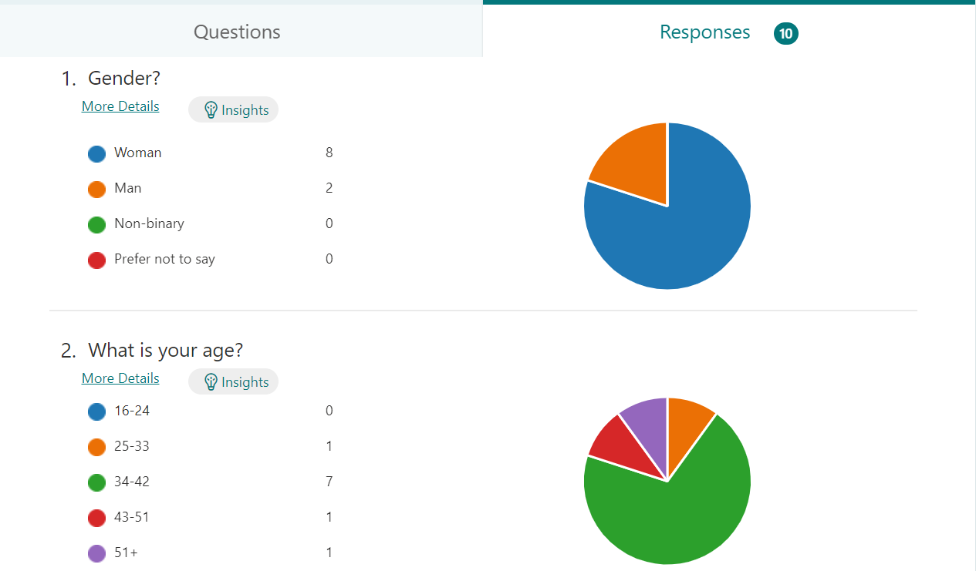

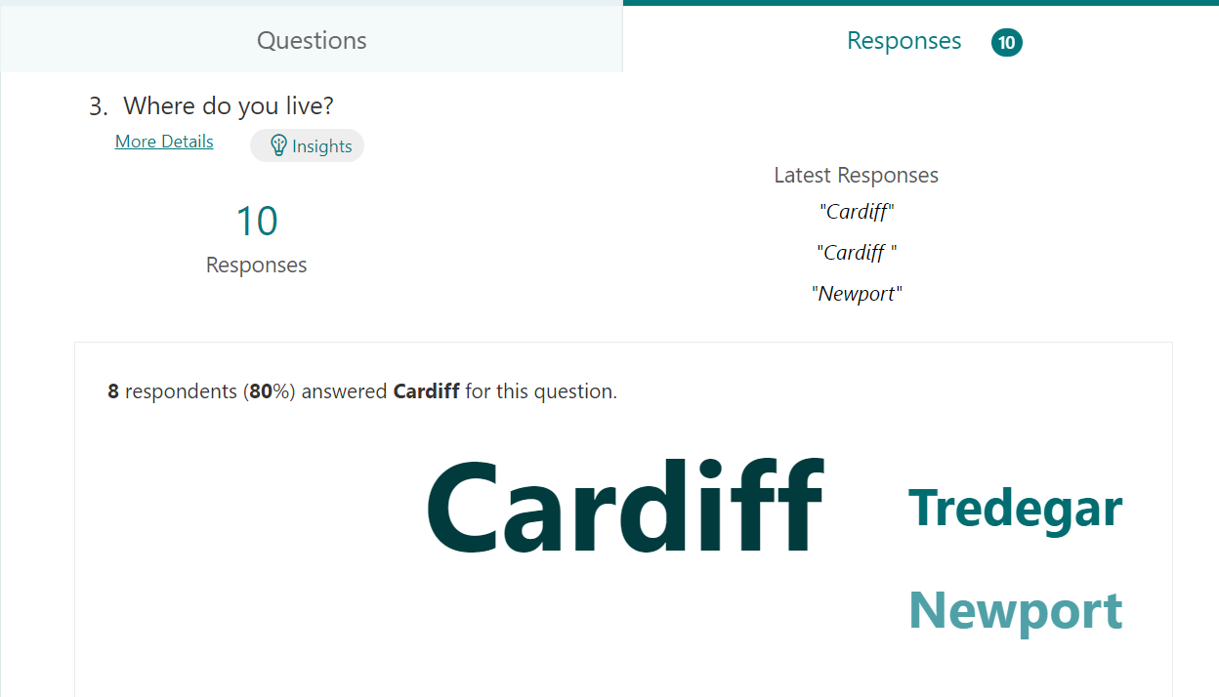

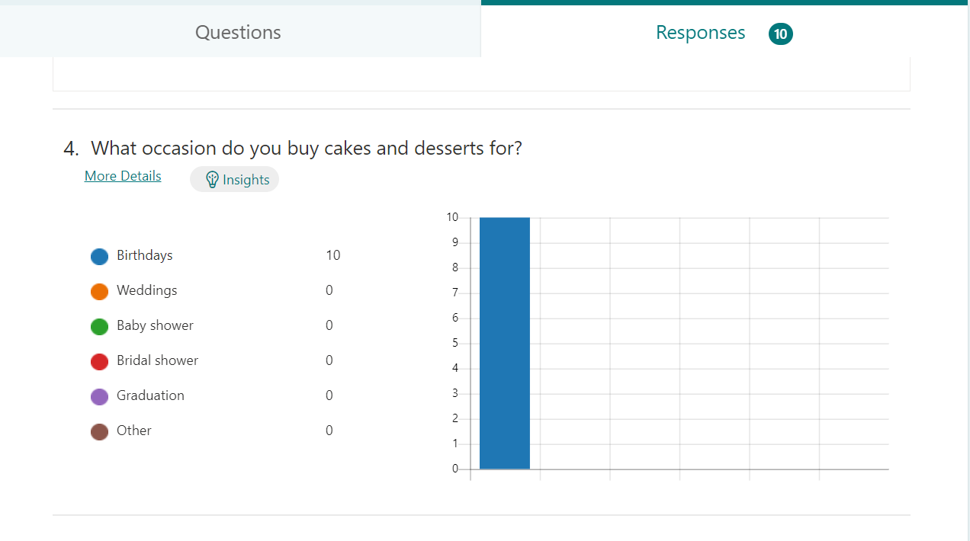
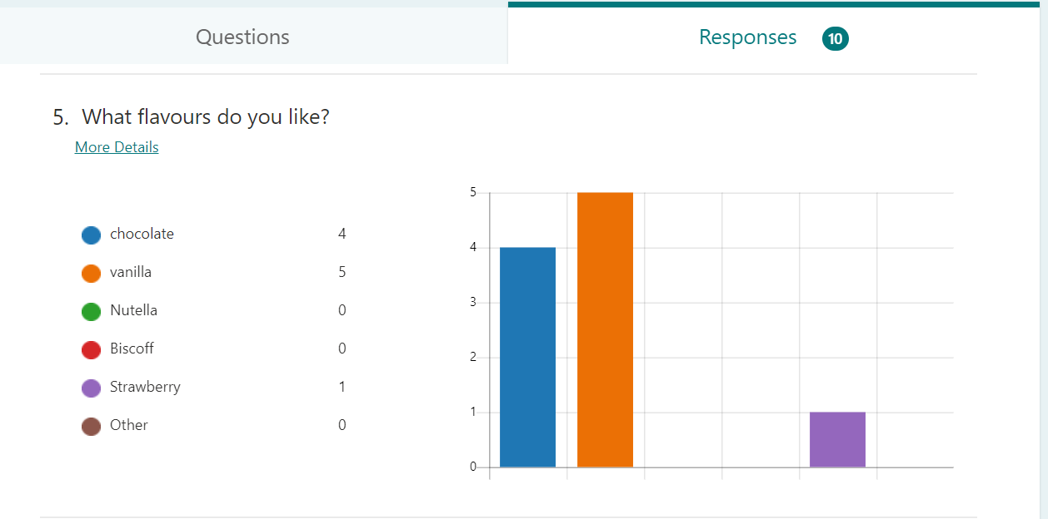

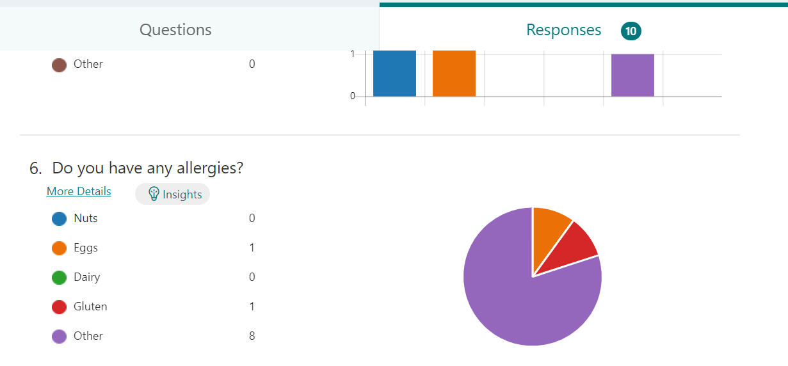

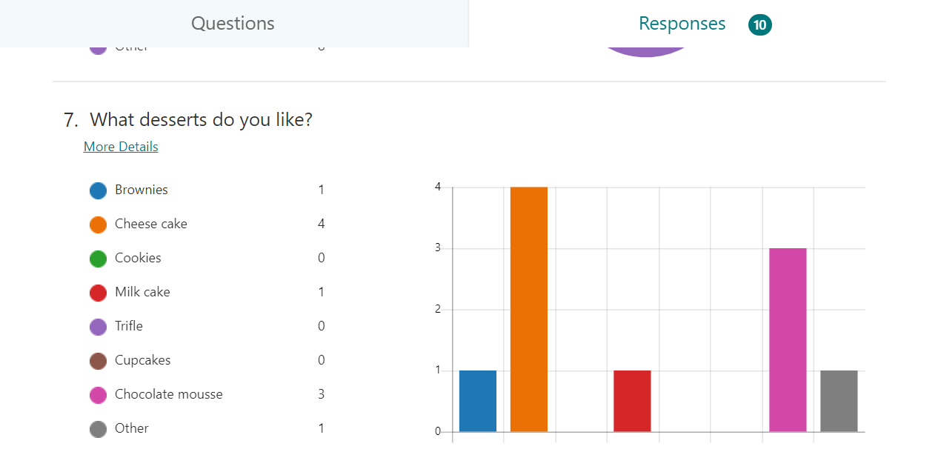
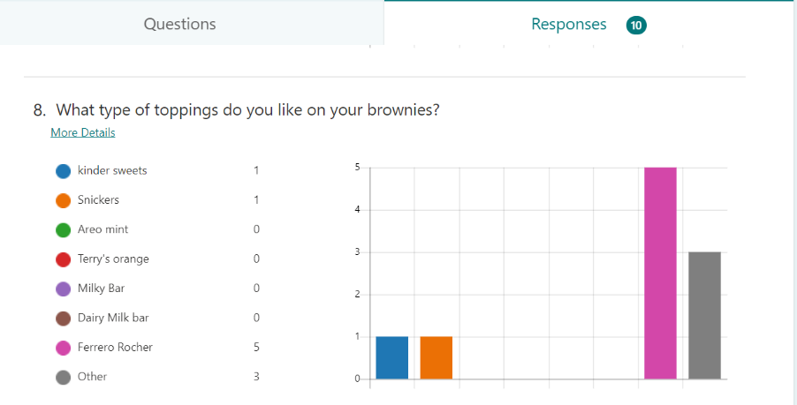

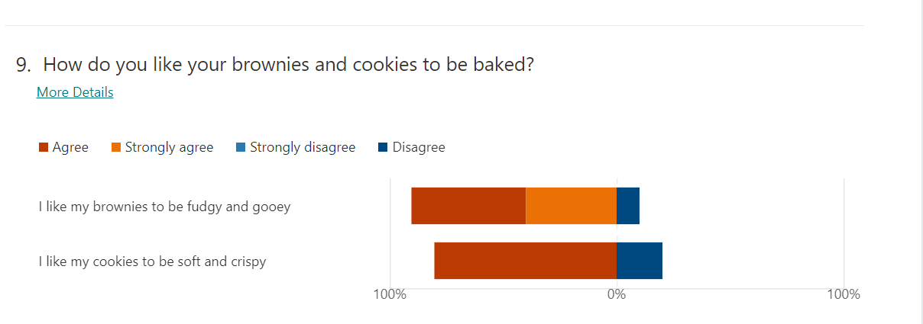
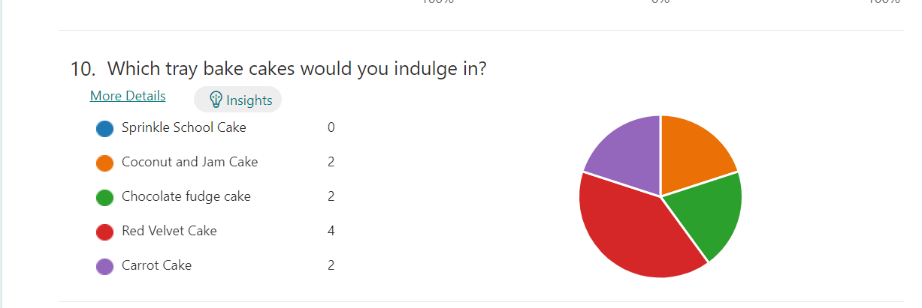

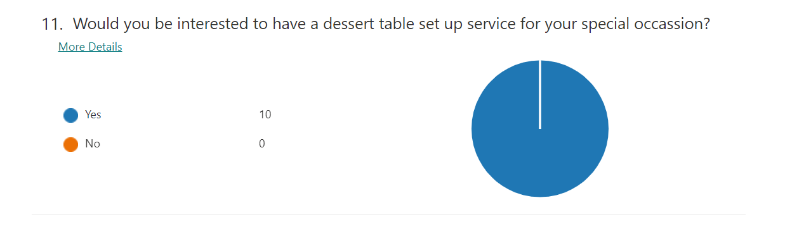
Promotion
I will promote my business on social media, create leaflets, business cards, tell family and friends to promote it on their social media. The advertisement would be about my bakes, desserts and bespoke dessert table setting. I will start promoting three weeks from opening, firstly on social media Instagram, and Facebook writing a small post of “Coming Soon” with special offers like discounts for the first day. The total cost of the promotional advertising would be £52.39p, I will get some influencers to taste the bakes and desserts and put a review on their social media and on ours too. The influencer that I will be contacting would be Dina Tokio on Instagram who has 1.2million followers who live in Cardiff. Extremely popular with young females, Shobnam Hussain again on Instagram who has 25.3k followers. I feel these influencers would allow my business to reach more customers. The promotional materials would be aimed at young to mature women living in Cardiff, my promotional material would be online, and paper-based like the leaflets and business cards. Which will be given out in coffee shops and on the market stalls that we would be held at the weekend at the local community centre.
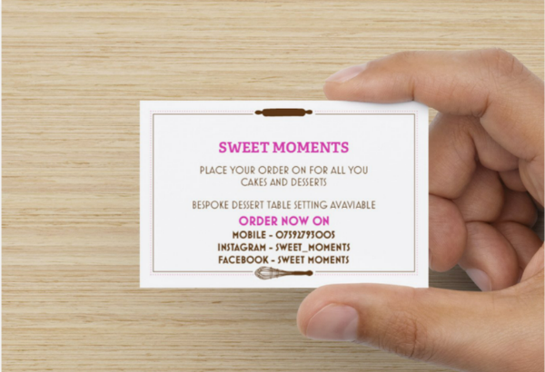
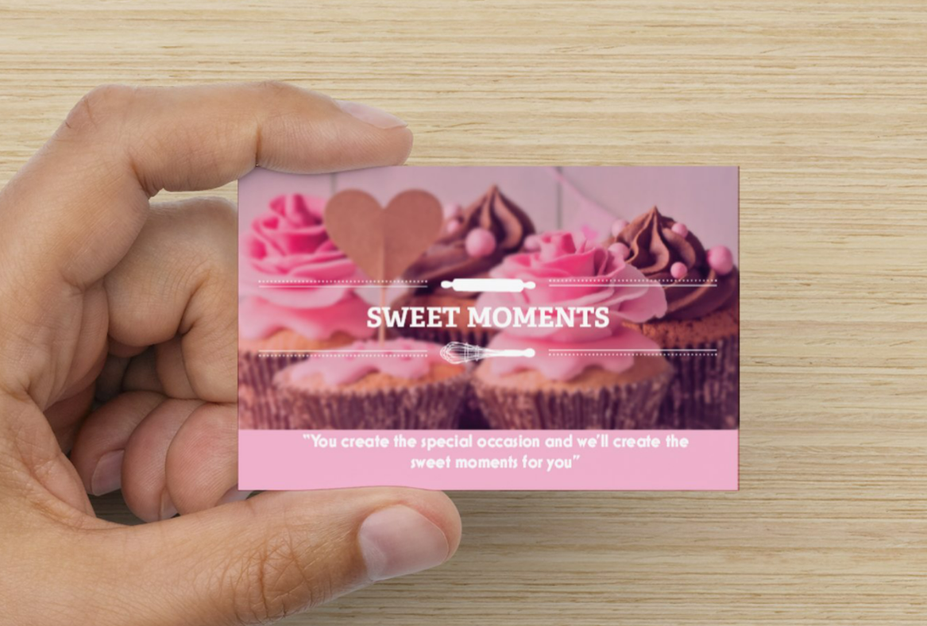
BUSINESS CARDS
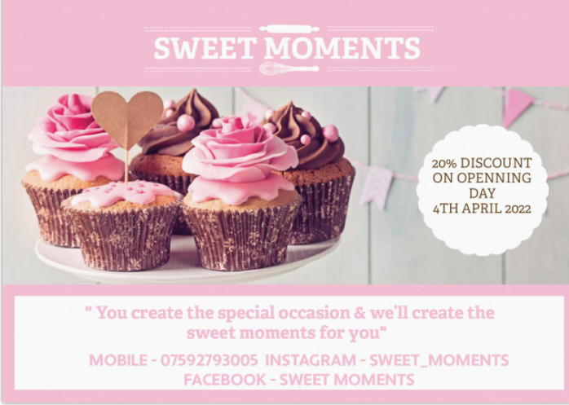
BUSINESS LEAFLETS

STICKER
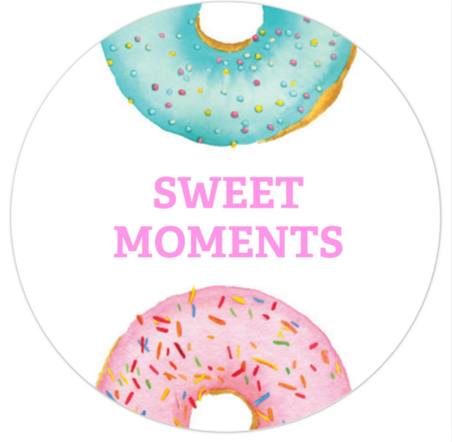

Financial Resource
Here are the sources of finance that you can get for your business
- Bank loans
- Grants
- Family & friends help
- Credit card
- Crowdfunding
- Local business funding
- Inheritance
- Savings
The source of finance that I have chosen s my savings and family help, as I calculated that my start-up cost would be £4000. I have a savings of £2000 which means it is no risk, it is my savings, and I don’t need to answer to anyone. The other £2000 I will be borrowing from my family. This would mean that I don’t need to end up paying interest and would be a long-term benefit. I know this has the disadvantage side where conflicts can happen, or rift can because. I will make a written contract that I would be lending the money for one year and would give the money back in cash.
Pricing strategy is when you price the value of the product or service that you will provide to the customers. there are four basic pricing strategies.
- Premium pricing – is a product that is priced high where the service or the product is extremely competitive and has the advantage of a brand. This is the high-end market where you would pay a lot more for the brand and the name of the product. Such as designer bags Gucci or BMW cars etc.
- Penetration pricing is when the product or service is set low to gain the market quickly, this is appropriate when the product is new to launch into the market. But the price can be raised once the promotion period is over. “It is understood that prices will be raised once the promotion period is over and market share objectives are achieved” (indiatimes.com).
- Economy pricing is when you’re marketing, and advertising cost are low, and you can price your product low and target a mass market. For example, Tesco value beans.
- Skimming pricing is a high price charged for a product like the latest iPhone for some time until the product is old then the price is dropped down as their model is old or something new is out
The pricing strategy that I have chosen is penetration as my products would be on offer for the first day and also most of the products would be reasonably priced to attract customers then when I gain customers and a business brand identity for myself, I would increase the price.

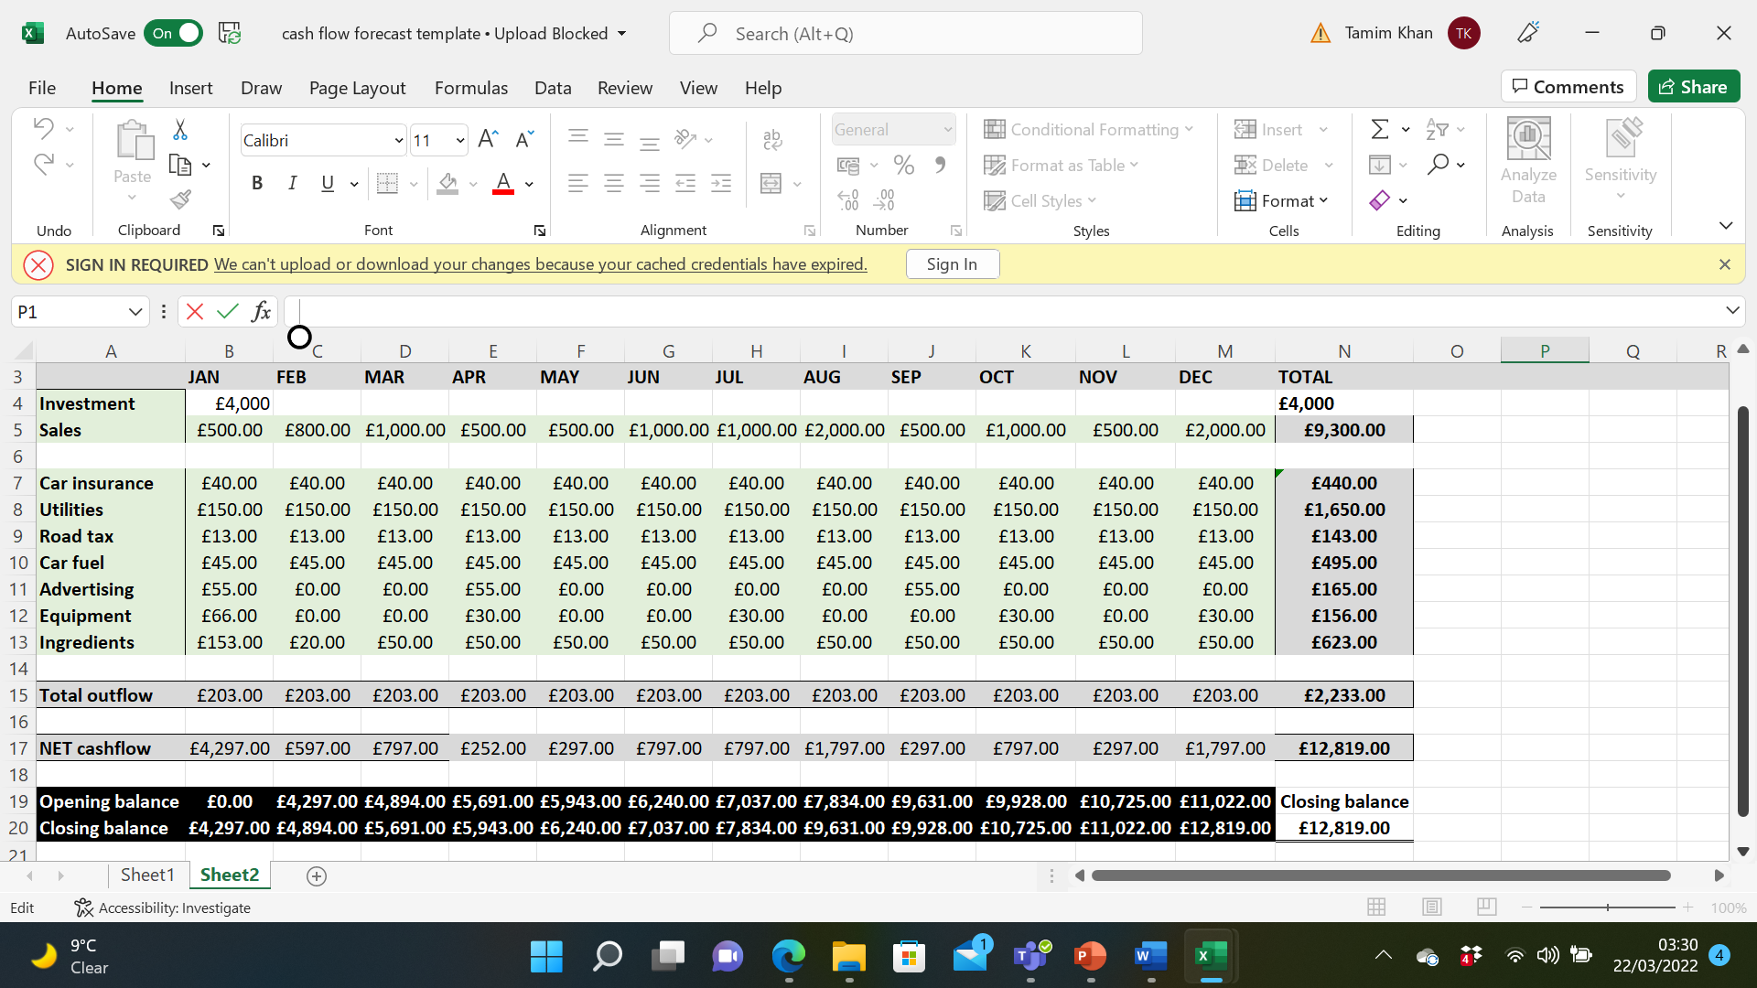
CASH FLOW FORECAST

Here is my product pricing table.
PRODUCT | INGREDIENTS + PACKAGE = COSTS OF THE PRODUCT | PRODUCT PRICE
6-inch Cakes | £8 | £20 = £12 PROFIT
8-inch cakes | £10 | £30 = £20 PROFIT
Brownies 16 pieces | £7 | £16 = £9 PROFIT
Biscoff blondies 16 pieces | £8 | £18 = £10 PROFIT
Sugar biscuits 12 pieces | £4 | £12 = £8 PROFIT
Cookies 12 pieces | £5 | £12 = £7 PROFIT
Cupcake 12 | £6 | £14 = £8 PROFIT
Chocolate mousse shot glass 12 | £5 | £14 = £9 PROFIT
Cheesecake shot glass 12 | £6 | £15 = £11 PROFIT
Strawberry trifle shot glass 12 | £5 | £14 = £9 PROFIT
Pistachios milk cake | £8 | £25 = £17 PROFIT
Biscoff milk cake | £8 | £25 = £17 PROFIT
Nutella milk cake | £10 | £28 = £18 PROFIT
Red velvet traybake | £7 | £15 = £8 PROFIT
Carrot traybake | £5 | £14 = £9 PROFIT
Chocolate fudge traybake | £5 | £14 = £9 PROFIT
Jam and coconut traybake | £4 | £12 = £8 PROFIT

SMART Analysis
A SMART analysis would be helping to create an objective for my business, which I goals for my business to achieved and where I can measure the process against the objectives, whether I have met them or not.
Specific - goal would be that by end of 2023 I would like to open a small shop or hut in Cardiff. Achieved to book at least twenty bespoke dessert table settings. Be one of the top five Cardiff social media bakers and gain a minimum of thirty regular customers who come back to order.
Measurable - is the time I gave myself by the end of 2023 to achieve to get my specific goals. I would be able to manage it, as I think I have given myself enough time to make changes if need be.
Achievable – the goal I think is achievable as I have not set the bar too high, and I think I’m mentally capable of achieving it. The time is enough, and passion is my drive to help me through to the end.
Realist – the goal is possible to achieve as by mid-2023 I should have 15 regular customers and would have an idea if the goal at the end of the year is achievable. I have plenty of family and friends support, where I can make time for the business and concentrate on the goal.
Time- my deadline is real and attainable, but not too long that I would lose interest and gives me a sense of urgency to meet the goal.

SWOT analysis
This is a method where you can identify and analysis the internal and external of your business. Which can provide a strategy for your business for the future, identify the positive and negative points of your business. You then can turn the negative points into positive ones.
Strength – the strength of my business is that I’m a sole trader where I work for myself and can make the decision on the spot. The USP of my business is that I would provide a bespoke dessert table within 48 hours of booking. As I haven’t found any business that would provide this service. Where I would provide ten desserts, sweets and table decorations. I have family and friend’s support where I can give my full attention to the business. The start-up cost is low, so I can make a profit soon.
Weakness – the business is new, can be quiet in the beginning. Not having an actual location means I’m not in the people’s view. Out of sight means out of mind, the are many competitions out there.
Opportunities- there is an opportunity for collaborations with other businesses, such as wedding event managements, florists, charities and coffee shops.
Threats- are the competition out there, to stand out and not to lose interest.
Sweet moment legal identity would be sole trader, I will be solely responsible for the business, I would have overall control, would be personally responsible for the loss or profit of my business and the would-be less paperwork. The risks would be mine; this means this can be positive or negative. As the decision is made by me without any consultation with anyone and no second opinion. The working hours can be long, and my finance is limited as there aren’t any other sources of incoming finance help. “By far the most popular way of getting into business, sole tradership is also the simplest. You simply notify HM Revenue & Customs so that they can change your income tax and NI status to self-employed” (Morris, M.J. 2011).

References

ALDI UK | Homepage
Asda.com - Online Food Shopping, George, & more
AILEXI Handmade 1 Count Glitter Cake Decorating Toppers - Happy Birthday Gold : Amazon.co.uk: Home & Kitchen
Brace, I. (2008) Questionnaire design how to plan, structure and write survey material for effective market research. 2nd ed. London ;: Kogan Page.
Box for 12 Cupcakes with Window and Tray by Turtle Products (10) : Amazon.co.uk: Home & Kitchen
Cohen, S.G. and Bailey, D.E. (1997) ‘What Makes Teams Work: Group Effectiveness Research from the Shop Floor to the Executive Suite’, Journal of Management, 23(3), pp. 239–290. doi:10.1177/014920639702300303.
DLux 50 x 3 oz Mini Dessert Cups with Spoons, Shooter - Clear Plastic Parfait Appetizer Cup - Small Reusable Shot Glass for Tasting Party Shooters Desserts Appetizers - with Recipe Ebook : Amazon.co.uk: Home & Kitchen
Flyers and Leaflets Templates & Designs | Vistaprint PINK AND WHITE DESIGN 100 from £20.16 (inc. VAT)
Flyers and Leaflets Templates & Designs | Vistaprint 100 from £20.16 (inc. VAT)
Griffiths, A. and Wall, S. (2011) Economics for business and management. Third edition. Harlow, England: Pearson Education Limited.
Home Bargains | Discount Toys, Home, Garden & more
Morris, M.J. (2011) Starting a successful business. 7th ed. London ;: Kogan Page.
PME BC715 Silver Baking Cases for Cupcakes, Mini Size, Pack of 45 : Amazon.co.uk: Home & Kitchen
Product Options (vistaprint.co.uk) £20.39 front and back 250
Tesco - Supermarkets | Online Groceries, Clubcard & Recipes
Wang, J., Shum, S. and Feng, G. (2022) ‘Supplier’s pricing strategy in the presence of consumer reviews’, European journal of operational research, 296(2), pp. 570–586. doi:10.1016/j.ejor.2021.04.008.
What is Pricing Strategies? Definition of Pricing Strategies, Pricing Strategies Meaning - The Economic Times (indiatimes.com)
Zimmerer, T. (2008) Essentials of entrepreneurship and small business management. 5th ed. Upper Saddle River, N.J: Pearson Education
2 Pack 8-Inch Non-Stick Deep Aluminum Round Cake Pan with Removable Bottom for Wedding/Birthday/Christmas Cake Baking Round Cake Tin Set with Loose Base : Amazon.co.uk: Home & Kitchen
2 Pack 6-Inch Non-Stick Deep Aluminum Round Cake Pan with Removable Bottom for Wedding/Birthday/Christmas Cake Baking Round Cake Tin Set with Loose Base : Amazon.co.uk: Home & Kitchen

BAKING SUPPLIES | PRICE | SOURCE
Self-raising flour 1.5kg | 45p | ALDI
Plain flour 1.5kg | 45p | ALDI
Baking powder | £1.19 | ASDA
Baking soda | £1.19 | ASDA
Coconut desiccated 200g | 99p | ALDI
Cooking milk chocolate 150g | 59p | ALDI
Cooking dark chocolate150g | 59p | ALDI
Cooking white chocolate150g | 59p | ALDI
Food colouring gel | £7.64 | Amazon
Strawberry jam | 99p | HOME BARGAIN
Double cream 300ml | 95p | ALDI
Cheese cream 200g | 69p | ALDI
Mascarpone 250g | 89p | ALDI
Sprinkles | £2.25 | AMAZON
Eggs 10 | £1.09 | ICELAND
Butter salted 250g | £1.48 | ALDI
Stork butter 500g | 75p | ALDI
Vegetable oil 3litres | £3 | SAINSBURY
Caster sugar 1kg | £1.35 | ALDI
Jelly | 59p | CLAREFOOD
Brown sugar 500g | 69p | ALDI
Dark brown sugar 500g | 79p | ALDI
Icing sugar 500g | 69p | ALDI
Milk 2.27 litre | £1.15 | ALDI
Nutella | £2 | ICELAND
Biscoff spread | £1 | POUNDLAND
Digestive biscuits 400g | 35p | ALDI
Oreo biscuits | 50p | HOME BARGAINS
Evaporated Milk | 52p | ALDI
Condense milk | 89p | ALDI
Cocoa powder | £1.19 | ALDI
Icing fondant 250g | £2 | HOBBY CRAFT
Pistachios | £1.49 | HOME BARGAINS
Vanilla extract | £1.35 | TESCO
Terry’s chocolate | £1 | TESCO
Ferrero rocher | £4 | TESCO
Cadbury milk chocolate 95g | 85p | ALDI

EQUIPMENT | PRICES | SOURCE
CAKE TIN 8INCH | £12.99 | AMAZON
CAKE TIN 6 INCH | £9.99 | AMAZON
CUPCAKE TIN | £3.99 | HOME BARGAINS
BAKING SHEET | £2.99 | HOME BARGAIN
BAKING TRAY | £2.99 | HOME BARGAIN
GREASEPROOF PAPER | £1 | POUNDLAND
CLING FILM | £1 | POUNDLAND
CUPCAKE BOX 10 | £11.50 | AMAZON
DESSERT SHOT GLASS | £13.49 | AMAZON
CAKE TOPPERS | £2.99 | AMAZON
CUPCAKE CASES | £1.11 | AMAZON
MIXING BOWLS | £1 | POUNDLAND

C

