Personal Awareness and Skills Exercise
Organise into to small groups and carry out exercise one as individuals and then as a group carry out exercise two
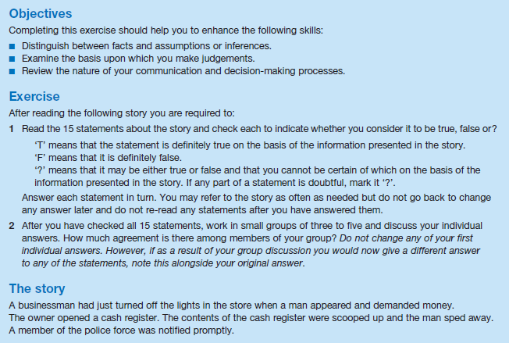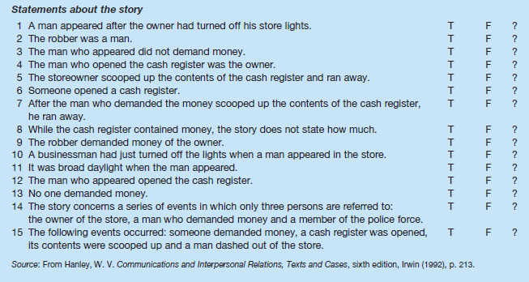
Group discussion question
- How would you explain differences in individual perceptions of the same statement?

