
KASIM HUSSAIN
Task 1 – Reading Task Template
Upload your photo of your A3 in-class notes here:
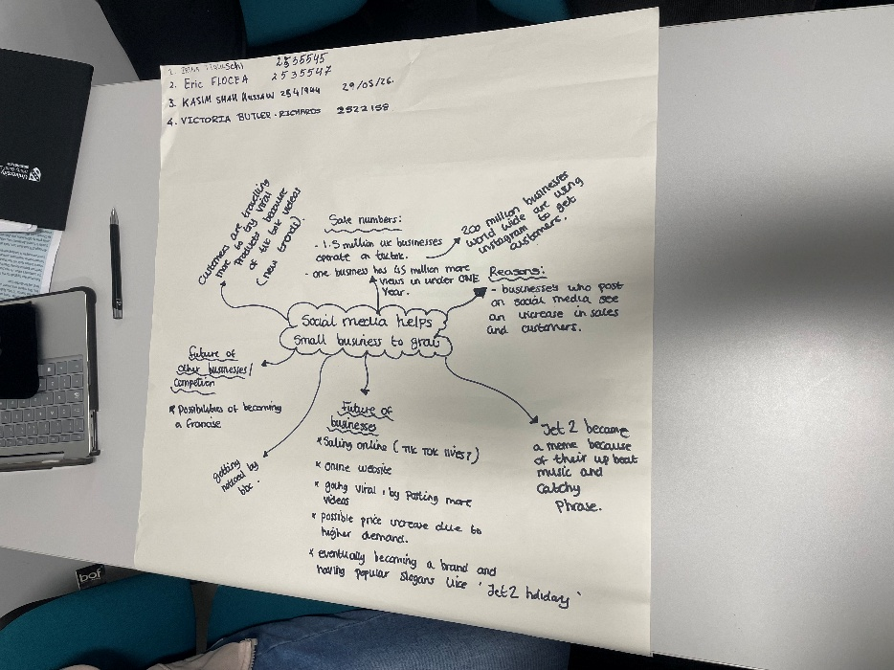

1. Answer these questions using the sentence starters below
a. What is the main idea of the text?
The main idea is that social media can help small businesses become more successful.
b. What are two key points?
One key point I social media allows businesses to connect with customers easily.
Another key point is that it helps businesses to promote products withs customers hastle free.
c. What part of the text did you find most important? Why?
The most important part is learning how social media can increase business growth because people use socials everyday.
d. Was anything unclear or difficult to understand?
I was not sure about some of the marketing used in texts.
e. How did your group help you understand the text better?
My group helped me by sharing and discussing ideas together.
3. One sentence reflection
Question: What did you find challenging about this task?
The hardest part was trying to identify the main points in the text

